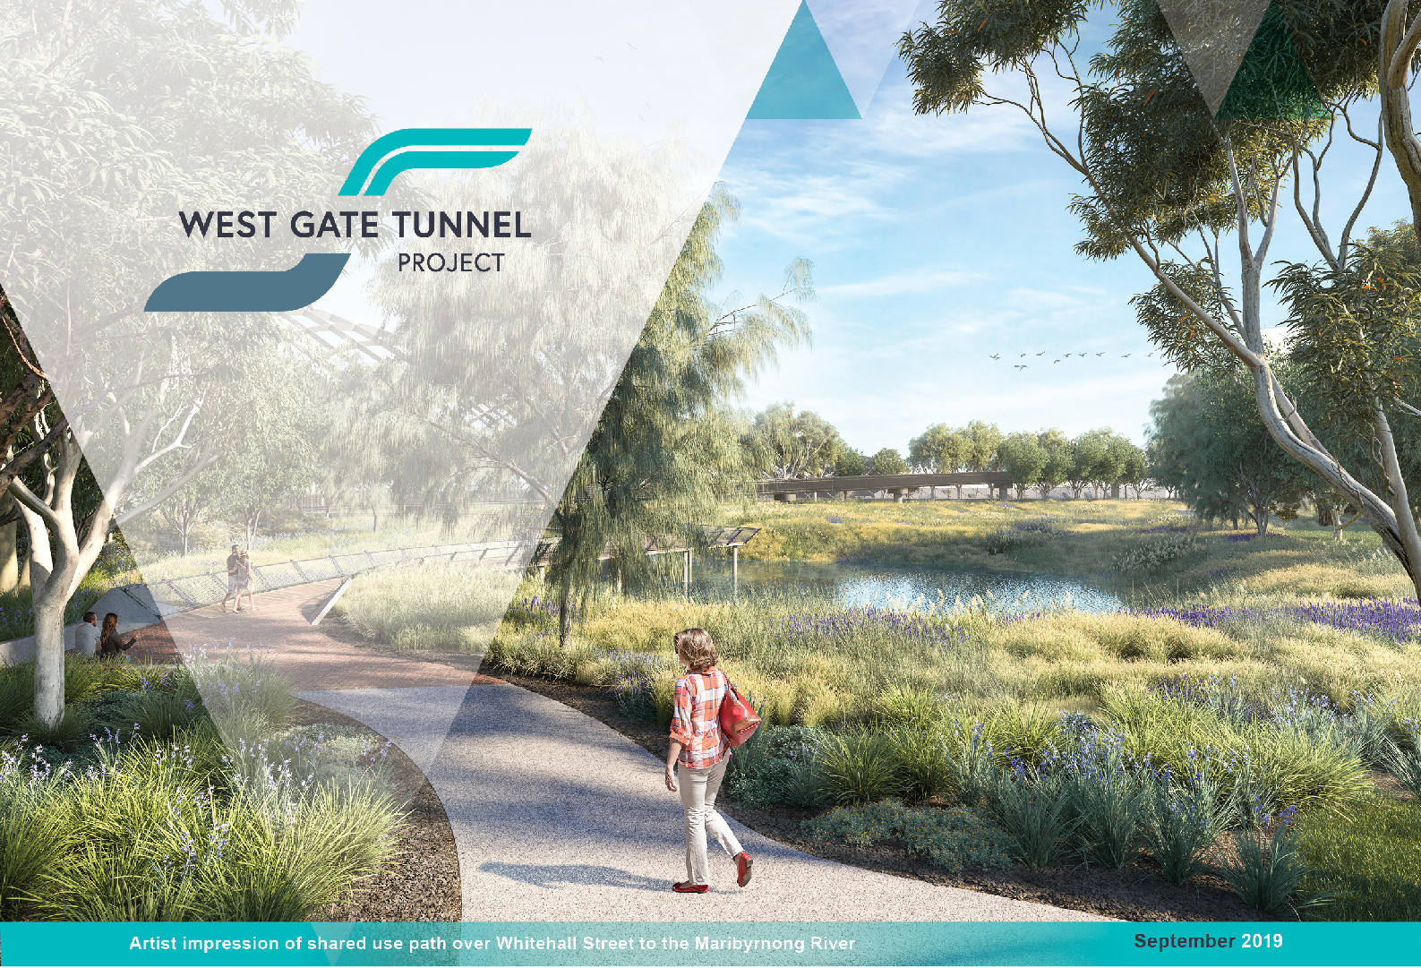

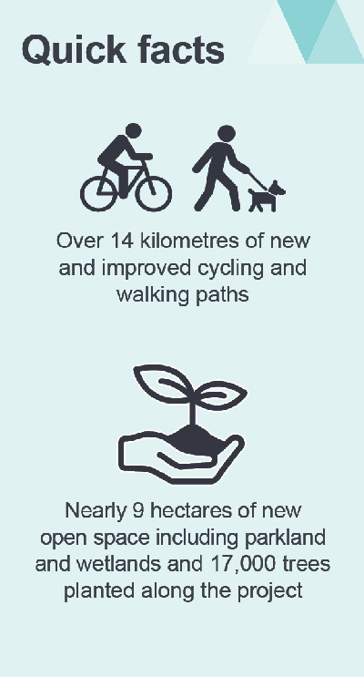Open space and a greener west

### The West Gate Tunnel Project is greening the west through creating around nine hectares

of new open space.

The new open space will turn closed-off industrial land into new parks for the community featuring playgrounds, wetlands, interpretative artwork and thousands of trees.

After years of talking with communities and our Community Liaison Groups in the inner west, we understand that landscaping is of great interest to locals. Feedback indicates that community members are keen to see vegetation replaced quickly, with a focus on native plants that will compliment and adapt well to the existing local environment, and provide a green visual screen in a range of areas, including near new noise walls.

Residents are also keen to see the project construction sites transform into open spaces for the community, creating new recreation areas along the project corridor.

New landscaping designs are now available to view on the project website – head to westgatetunnelproject.vic.gov.au to see how we’re greening your local area.

# What’s been happening?

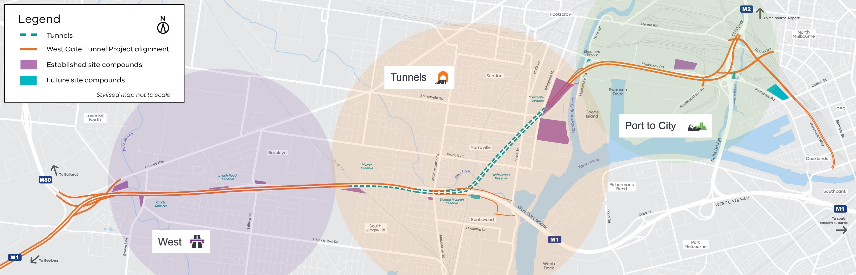

**Timeline**

**Started construction**



**2018**

**2019**

**We Are Here**

**2020**

**2021**

**2022**

**West Gate Freeway widening started**

**Construction started on Footscray Road**

**North Yarra Main Sewer completion Commissioning TBMs**

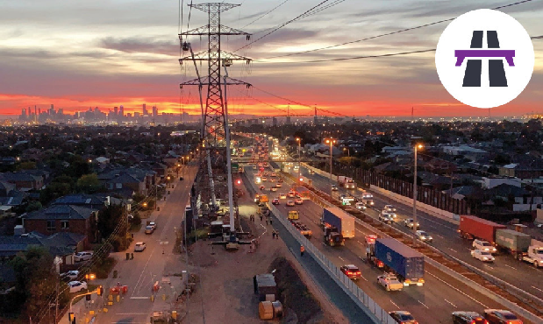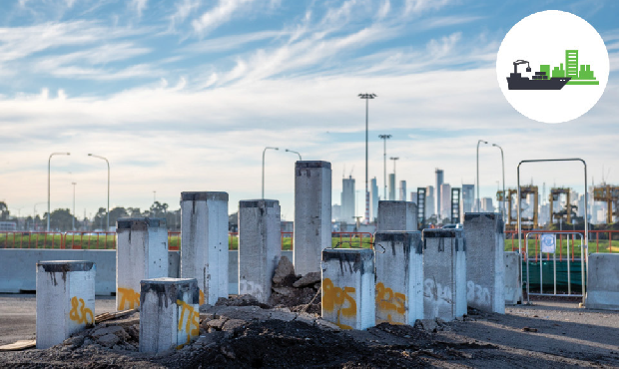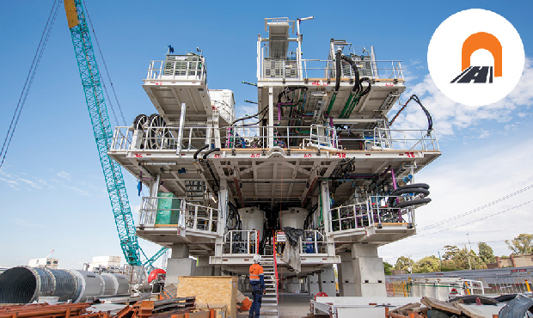**West**

Work is progressing to widen the West Gate Freeway. Works are also continuing to prepare for the new Muir Street walking and cycling bridge, with crews working on completing the foundations on Muir Street and Fogarty Avenue in preparation for lifting the bridge in to place. The new bridge will link communities north and south, have ramps that are easier to use, and high sides for safety.

Crews have also begun installing the new and permanent noise wall panels along the West Gate Freeway. In total, around 4,000 new noise walls panels will be installed along the freeway.

Work on the tunnel portals along the West Gate Freeway have now started. Crews have

established sites for the citybound tunnel entrance near the Williamstown Road interchange and the outbound exit near the Newport freight railway line.

**Tunnels**

The tunnel boring machine (TBM) launch site

is now finished.

It took 150 workers more than 300,000 hours to build the 22-metre-deep, 330-metre-long,

40-metre-wide cut and cover trench – that’s about twice the length of the MCG.

It is lined with 20,000 cubic metres of reinforced concrete, providing a strong and stable platform to launch Bella and Vida.

We have also finished building a shed to house all the rock and soil coming out of the tunnel before being transported off site. The shed will reduce dust and noise for nearby residents. We’re in the final stages of completing the conveyor system which will be about 15.5km long and can carry

a maximum 2,500 tonnes per hour. It will link the tunnels back to the shed.

**North Yarra Main Sewer diversion update**

After 12 months, work to divert the 600m section of the North Yarra Main Sewer is now complete. Whitehall Street is back to normal after removing work sites

and traffic detours. We thank the community for their

patience.

#### Port to City

Work has now started along Footscray Road where 1600 segments of road deck will make up the new two kilometre elevated road that will connect the West Gate Tunnel to CityLink, the Port of Melbourne and the CBD.

In the coming months, the section of the West Gate Tunnel Project between the port and the city will be a hive of construction activity as cranes, piling rigs and gantries arrive on site.

More than 4500 piles will be driven up to 30m into the ground to support the new structures.

Drivers will notice changes on Footscray Road as we have shifted traffic onto new lanes. We’ll be creating a new construction site down the middle of Footscray Road where we will start building the elevated road.

**Construction commences on Hyde Street ramps**

**Tunnelling continues**

**Tunnel portals complete**

**Tunnels fit out and freeway management technology installed**

**Cycling and open space upgrades complete**

**Tunnel opens**

**End of**

**2022**

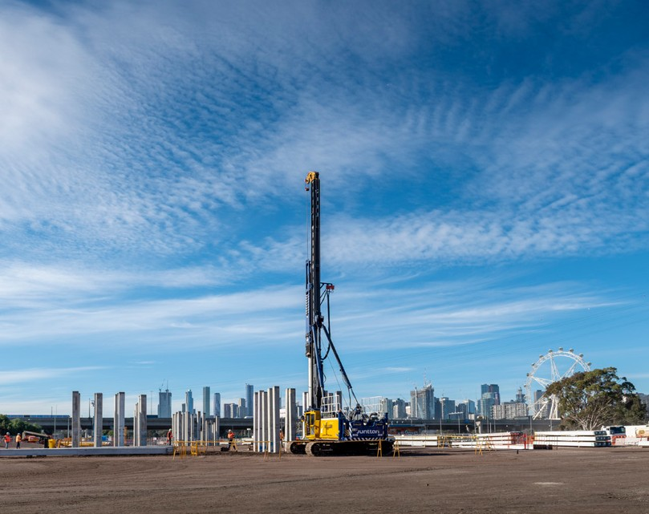

**Upcoming works in your area**

**West Gate Freeway**

Continue relocating services – power, water and sewer

Building new noise walls

Preparatory works for new walking and cycling bridges

Excavating the tunnel  
entrance and exit on the

West Gate Freeway

**Port to City**

Piling work at the former Melbourne Market, Footscray Road and Maribyrnong River

Traffic changes to

Footscray Road Relocating utility services

**Tunnel Zone**

Continue building the spoil conveyor

Continue assembling TBMs  
Bella and Vida

**West Gate Kids**

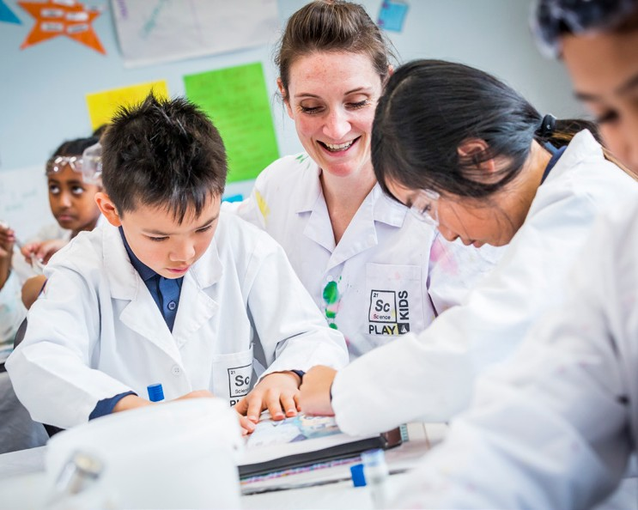Students in Melbourne’s west are learning how cities are built and how electricity is conducted, thanks to the West Gate Tunnel Project’s school engagement program – West Gate Kids.

So far, more than 1000 students have taken part in the program designed for primary and secondary school students.

Delivered in partnership with Dr Lorien Parker and SciencePlay Kids, the *Engineering Our*

*City* program informs and inspires the next generation of engineers through hands-on activities centred around STEAM subjects (science, technology, engineering, arts and maths).

Find out more at **westgatetunnelproject.vic.gov.au/westgatekids**

## Digging and recording history

Before major construction activity could start on the section of the project between the port and the city, archaeological digs were carried out to ensure that any items that might be of significance could be identified and recorded.

A recent dig near E-Gate, next to the city rail yards uncovered some of the old railways and brickwork of the North Melbourne Locomotive Depot, that dates back as far as 1888.

The bow of the Edina, a steamship constructed in 1854, which was buried

on the banks of the Maribyrnong River has also been identified by the team. Edina was stripped and broken up in 1957 and her name changed to Dina, after being sold to Victorian Lighterage Pty Ltd.

#### Contact us

**Do you have a question about the project? If you need more information or would like to provide feedback, please get in touch.**

1800 105 105

westgatetunnelproject.vic.gov.au [info@wgta.vic.gov.au](mailto:info@wgta.vic.gov.au) facebook.com/westgatetunnelproject @westgatetunnel

Info Centre

Corner Somerville Road and Whitehall Street, Yarraville.

 **Interpreter service: 13 14 50**

If you are deaf, or have a hearing or speech impairment, contact us through the National Relay Service.

For more information, visit: [www.relayservice.gov.au.](http://www.relayservice.gov.au/)