Reference: WES1809.05
26 September 2018
Works notification: Service investigations and power line relocation

To make way for the widening of the West Gate Freeway we need to complete important service investigations to safely relocate some overhead power lines underground along Beevers Street.
Service investigations
Tuesday 2 October – Saturday 13 October

These investigation works will be carried out from Monday to Friday between 7am - 6pm and Saturdays between 7am - 3pm.
These investigation works will include:

- scanning for services to gather information on utilities such as gas, electricity, stormwater, and telecommunications along Beevers Street and minor excavation to expose any underground services in the immediate area – see map below; and
- implementing short term traffic changes along Beevers Street (access to all properties will be maintained during this time).

Parking:

Important: to help us complete these investigation works as quickly as possible, please avoid parking in Beevers Street during the dates above. Footpath access will be maintained.

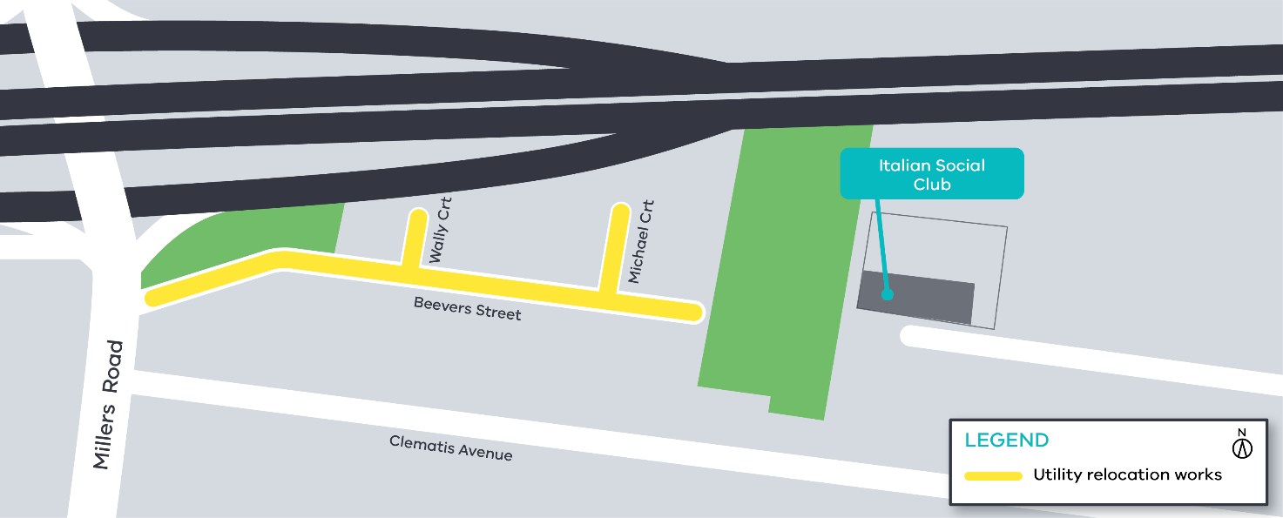
Service investigation works area along Beevers Street, Wally Court and Michael Court

How will these works impact access to Beevers Street, Wally Court and Michael Court?

We anticipate that power line relocation from overhead to underground will require excavation along Beevers Street. The service investigations will help us locate services that currently exist under the road so we can plan for their relocation.
But before any service relocation can happen, we want to talk with you to understand what the potential impacts may be on you and your family.
That is why over the coming week our West Gate Tunnel Project information van will be visiting your neighbourhood on Beevers Street.
The drop in sessions will be held on:

- Thursday 4 October from 7am – 10am; and
- Saturday 6 October from 11am – 3pm.

If you can’t make any of these times, but would like to know more, please send us an email at westgatetunnelproject@wda.vic.gov.au or give us a call on 1800 105 105 to book in a time that works for you.

For updates and more information about our works please visit westgatetunnel.vic.gov.au or contact us using the details below.

Contact us
Please contact us if you have any questions or feedback about these works.
 | westgatetunnelproject.vic.gov.au |  | facebook.com/westgatetunnelproject
 | westgatetunnelproject@wda.vic.gov.au |  | @westgatetunnel
 | 1800 105 105 |  | West Gate Tunnel Project  GPO Box 4509  Melbourne Victoria 3001
 | Interpreter service: 13 14 50

