EAS19JUL.01

05 July 2019

Works notification: Footscray Road
Construction of the new elevated road above Footscray Road is ongoing with the first stage of the traffic switch on Footscray Road anticipated to take place in late July or early August and piling works between the Maribyrnong River and CityLink continuing.
The new elevated road will link the new West Gate Tunnel to CityLink and Wurundjeri Way, and will provide drivers with greater connectivity to the Port of Melbourne and Melbourne’s west.
Traffic changes and new works area
Construction of a temporary roadway on the southern verge of Footscray Road, next to the shared use path, has progressed over the past few months. Outbound traffic will be shifted to the new roadway between Appleton Dock Bridge and Dock Link Road late July or early August 2019 and will be in place until project completion. This will create a permanent work zone in the centre median. Citybound traffic will remain as is.
Once the new work zone is created, construction activity will include:
- vegetation removal;
- utility relocations and the removal of light poles, creating a new work site; and
- installation of concrete barriers to delineate the worksite from road users.
Piling works and construction of the piers for the elevated road will then follow.
Traffic signalisation and night works will be implemented along Footscray Road to accommodate the new roadway and traffic changes and to minimise any impact to drivers.
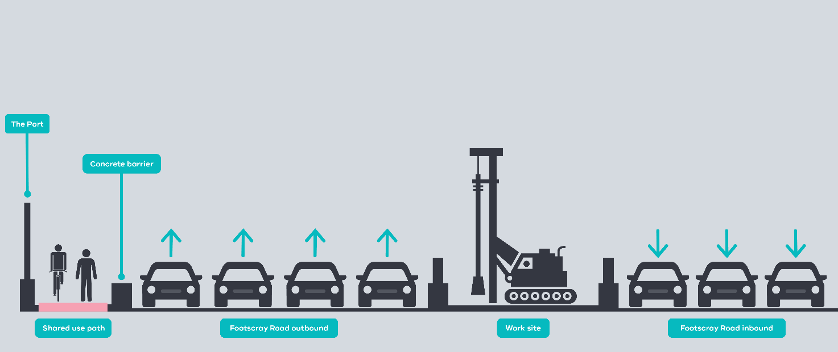
Figure 1: Stage 2 alignment of Footscray Road
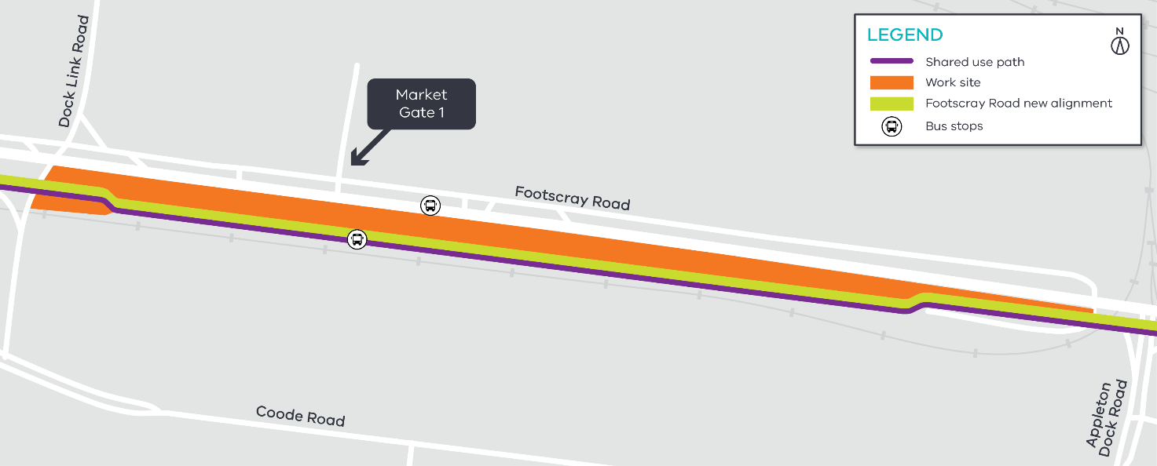
Piling works have commenced
Figure 2: Footscray Road traffic alignment
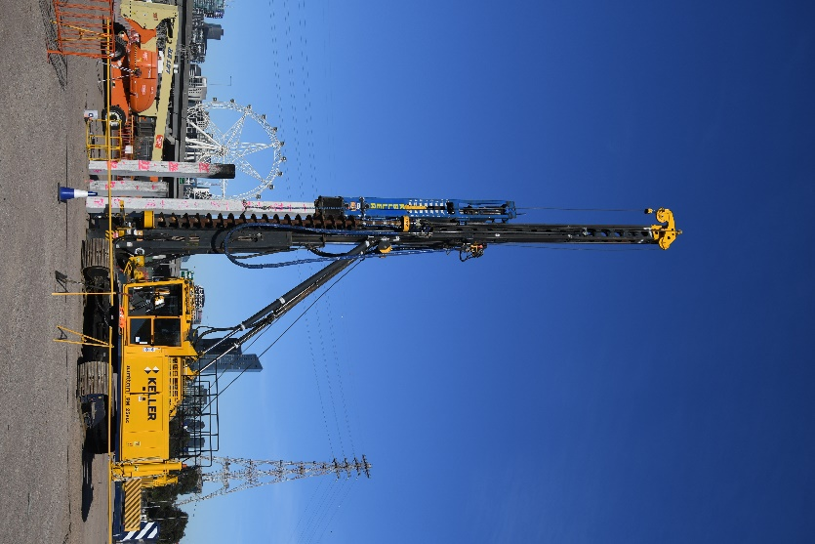
Piling works have started along Footscray Road and the old Melbourne Market areas. Pile caps are to be constructed which form the base of the piers for the elevated road. Piling works will continue as we establish new work sites in the area including the Footscray Road centre median.

Piling works are expected to take up to 14 months to complete in the Footscray Road area with over 1700 piles to be driven. Works are scheduled to take place between Monday and Saturday, 7am to 5pm.

Noise and vibration may be noticeable during these works. Please contact the project Community Relations team on 1800 105 105 if you require more information about these activities, or how to manage construction impacts during this time.

This is one of the driven piling rigs currently undertaking piling works at the old market site.

There will be approximately 5,000 piles created in the East Zone throughout the project.

Launching Gantry arrival
The elevated roadway above Footscray Road will be built using a Launching Gantry, specifically commissioned for the West Gate Tunnel Project.
What is a Launching Gantry?

A Launching Gantry is a specialist mobile bridge building machine. The Launching Gantry operates by lifting sections of precast concrete, stitching them together using cables and lowering them on top of the bridge piers.

The Launching Gantry is 120m in length, 12 metres wide, 12 metres tall and weighs over 1000 tonnes!

The Launching Gantry has been fabricated in Italy, where it will start its journey to Melbourne, arriving in approximately 70 loads. Segments of the Launching Gantry will start to be delivered to our Footscray Road site compound from late July 2019.
The Launching Gantry will be assembled in the West Gate Tunnel Project site compound and in the Footscray Road centre median. The Launching Gantry will take approximately four months to assemble before commencing work toward the end of the year.
Works to assemble the launching gantry will take place Monday to Saturday, 7am to 5pm.

Utility relocations

Utility relocation works are ongoing along Footscray Road in our work zones and roadways.
Works are undertaken during day shift between 7am to 5pm and night shift between 7pm and 5am. Night shift works are required to minimise impacts to motorists, especially when works are adjacent to the roadway.

MacKenzie Road works
MacKenzie Road works are in progress to prepare the area for piling on the east bank of the Maribyrnong River. The road will be realigned and moved closer the Port to create a new work area. These works will be completed at night to minimise impacts to motorists.

Shared use path changes
There will be some temporary changes along the Footscray Road shared use path (SUP) while we undertake works to complete the temporary pavement and piling works noted above. Changes will also be in place at Appleton Dock bridge from late August 2019 for up to six months to accommodate the piling works in the area.
Signage will be in place to advise pedestrians and cyclists of any changes.

What to expect during construction:
- Works completed both during the day and at night time.
- We will notify you if there are any significant changes to the timing of our works.
- Traffic management will be in place to manage changed conditions including temporary access changes to car parking spaces and signage to guide road users and cyclists.
- Dust managed on site.
- Piling works can create increased levels of noise and may also cause some vibration.
- Assessments have been conducted, which indicate the noise levels are expected to remain within permissible levels as documented in the project’s Environmental Performance Requirements.
Contact us

Please contact us if you have any questions or feedback about these works.
 | westgatetunnelproject.vic.gov.au |  | facebook.com/westgatetunnelproject
 | info@wgta.vic.gov.au |  | @westgatetunnel
 | 1800 105 105 |  | West Gate Tunnel Project  GPO Box 4509  Melbourne Victoria 3001
 | Interpreter service: 13 14 50

We thank you for your patience during these works.
