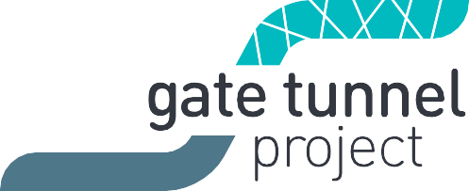
West Gate Tunnel Project
GPO Box 33312
Melbourne Victoria 3004
1800 105 105
westgatetunnelproject.vic.gov.au westgatetunnelproject@wda.vic.gov.au

Monday 19 March 2018

The West Gate Tunnel Project
The West Gate Tunnel Project is Victoria’s long overdue alternative to the West Gate Bridge that will take trucks off local roads in the inner west, create 6000 jobs and slash congestion all the way along the M1 corridor.
It will upgrade the West Gate Freeway and link it to the city and CityLink, with new tunnels under Yarraville and bridges over the Maribyrnong River. Construction is now underway.
There are three construction precincts: West Gate Freeway, Tunnels and Port to City.

You are in the Tunnels precinct.

Upcoming construction activity in the Tunnels precinct
Work has started at our main tunnel construction site on Whitehall Street in Footscray. Over the coming months, we will be clearing the site, setting up site offices, bringing in machinery and installing fencing. An adjacent site will be established shortly at 221 Whitehall Street.
Two tunnel boring machines, each measuring 15.6 metres in diameter, have been ordered and will arrive on site to begin tunnelling in early 2019.
There may be some localised changed traffic conditions both during the site establishment and construction. You can keep up to date on disruptions on the project website westgatetunnelproject.vic.gov.au
Read more about construction and how we are managing construction impacts such as dust, noise and traffic changes in the Construction Overview – Tunnels at westgatetunnelproject.vic.gov.au/tunnels.

Keeping you informed
We have a dedicated team who will keep you informed about construction activities in your area. You will hear from us through:
- Community notifications
- Regular newsletters
- Phone calls, emails and SMS
- Social media
- Local events and information sessions
- Updates in local newspapers

Our West Gate Tunnel Project Visitor Information Centre will also open this year, providing a one-stop-shop for project information and enquiries.

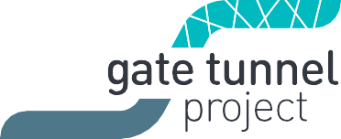

Property condition surveys
We will contact property owners closest to the tunnel alignment in the coming months to offer a property condition survey. Properties will be inspected before and after construction. If there is any damage resulting from the project, it will be fixed. Owners will be provided with a copy of the condition survey for their record.
Depending on your location, you may be contacted separately for the purposes of a property condition survey

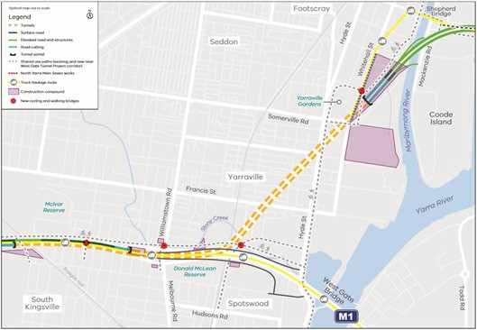
Map of the tunnels precinct
Thank you for your interest in the project. If you need more information or would like to provide feedback, please get in touch via the details below.

Contact us
westgatetunnelproject.vic.gov.au westgatetunnelproject@wda.vic.gov.au 1800 105 105
facebook.com/westgatetunnelproject
@westgatetunnel
West Gate Tunnel Project GPO Box 4509
Melbourne Victoria 3001

Interpreter service: 13 14 50

