WES1809.07
15 October 2018

Works notification: Millers Road / West Gate Freeway interchange

Works to widen the freeway and upgrade Millers Road and the West Gate Freeway interchange continues as part of the West Gate Tunnel Project.

West Gate Freeway widening

Work to build the retaining walls alongside three of the freeway ramps at Millers Road is ongoing, with construction starting on the embankment of the Millers Road outbound exit ramp.

These works will include:
- tree removal behind residential properties along sections of Beevers Street and adjacent to the outbound exit ramp from 24 October 2018; and
- construction of retaining walls, bridge structural works including excavations and piling.

Upgrading Millers Road underneath the freeway

We’re widening Millers Road by one lane in each direction underneath the freeway. Construction is continuing on the new southbound lane underneath the freeway, before work switches to building the additional northbound lane later this year.

These works will include:
- piling and retaining wall construction on the east side of Millers Road underneath the freeway; and
- utility services upgrade and relocation works around the interchange as night works from late October.
Location of works around West Gate Freeway and Millers Road interchange
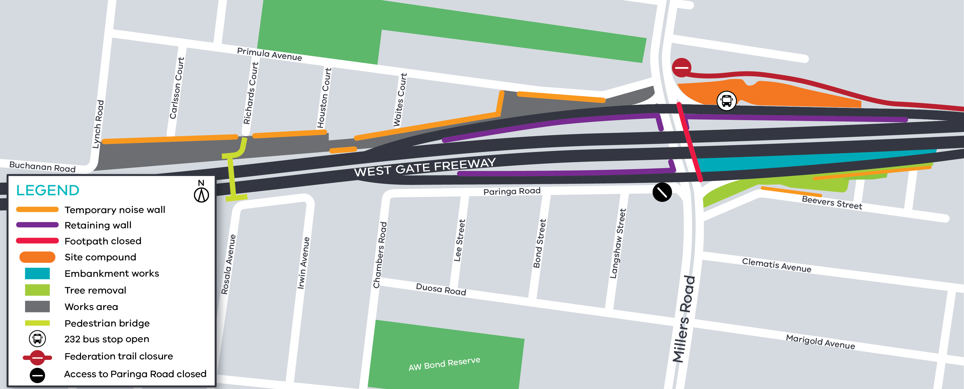
Building temporary and permanent ramps
Current – March 2019
Construction of the Millers Road temporary inbound and outbound exit ramps have started, as well as work to build the permanent inbound entry ramp.
These works will include:
- installation of temporary site fencing around the reserve from Buchanan Road to Houston Court – the footpath from Richards Court to the pedestrian bridge will remain open;
- installation of temporary noise walls throughout October and November adjacent to residential fences from the reserve near Buchanan Road through to Millers Road;
- installation of temporary noise walls at the Millers Road outbound exit ramp adjacent to residential fences and along a section of Beevers Street from 31 October 2018;
- construction site establishment on the corner of Primula Avenue and Millers Road;
- removal of existing noise walls after the installation of temporary noise walls;
- excavation and construction works for new road surfaces; and
- earthworks and general construction.

What you could expect while we undertake these works:
- construction vehicles including excavators, tandem trucks, concrete trucks and pumps, earthmoving equipment and cranes will be moving in and out of the work areas;
- construction noise from trucks, piling rigs, compaction equipment, rock hammers, road saws, chainsaws and general construction machinery;
- water spray trucks and street sweepers being used to reduce dust and dirt;
- dirt and rock being covered when it is being transported;
- traffic management will be in place when large oversized machinery, equipment and materials need to be transported into work sites;
- shared use path on the east side of Millers Road underneath the freeway will remain closed until December. It will then reopen, at which stage the west side of the shared use path will close whilst works are undertaken;
- access to the existing pedestrian bridge over the freeway will remain open at all times with access clearly signed via Richards Court;
- bus stop 232 at the inbound entry ramp will remain open; and
- traffic changes including lane, road and ramp closures may be required – latest traffic updates are available at westgatetunnelproject.vic.gov.au/traveldisruptions

These works will generally be carried out from Monday to Friday between 7am-6pm and Saturdays between 7am-3pm, however some night works will be required.

When works are scheduled out of hours, or if you are located close to the works, we will provide further information to you before these works start.

Please note that works may be rescheduled in the event of bad weather or other unavoidable circumstances.

For updates and more information about our works please visit westgatetunnel.vic.gov.au or contact us using the details below.
Contact us
Please contact us if you have any questions or feedback about these works.

 | westgatetunnelproject.vic.gov.au |  | facebook.com/westgatetunnelproject
 | westgatetunnelproject@wda.vic.gov.au |  | @westgatetunnel
 | 1800 105 105 |  | West Gate Tunnel Project  GPO Box 4509  Melbourne Victoria 3001
 | Interpreter service: 13 14 50

