Reference: WES1901.09
30 January 2019
Works update – temporary disruption to your driveway

Construction is well underway on Beevers Street to relocate some existing overhead power lines that currently run along the West Gate Freeway and works are about to move into stage two. As part of these works, vehicle access to your driveway will be temporarily disrupted.
Temporary disruption to your driveway access
Vehicle access to your driveway will be temporarily blocked from 4 February to approximately 20 February 2019.
During this time:
- parking is available for you at the Italian Social Club during the above dates;
- alternatively, you can park on the south side of Beevers Street, outside of our stage two construction area and walk to your property. Please see the map over the page for location details;
- 24hour/7 day a week transport services will be provided to take you and your belongings to and from your home
- if you wish to walk, a designated pedestrian track is available between the Italian Social Club and Beevers Street;
- security personnel will be in place 24 hours/7 day a week at the Italian Social Club and the worksite for the duration of the works; and
- footpath access to your property will remain open at all times.

If you wish to be picked up from your home and transported to your parked car at the Italian Social Club, please contact our team on 0439 779 995, 24 hours / 7 day a week during the works.

If you require any assistance with carrying items to or from your vehicle, please ask one of our friendly onsite team who will be able to assist you or feel free to use our transport service.

When you need to move your vehicle:
- if you need access to your vehicle between Monday 4 February to Wednesday 20 February, please ensure your vehicle is moved out of your driveway by 10:00pm on Sunday 3 February;
- If you are intending to move your vehicle and park at the Italian Social Club carpark on Sunday 3 February, please access via Clematis Avenue or Marigold Avenue; and
- please ensure you do not park your vehicle in the identified construction area during this time. Please see the map over the page for location details.

Where to park your vehicle when driveway access to your property is blocked:
- it is recommended that you park your vehicle at either the Italian Social Club carpark in one of the designated parking spots or on the south side of Beevers Street outside our construction area;
- we have installed a temporary pedestrian access track with lighting across the Italian Social Club grass reserve, so you are able to walk to and from your car if you choose not to be transported by vehicle.
Waste collection:
- when works are directly outside your home and vehicle access to your property is blocked, please place your rubbish bins outside your home on Tuesday mornings before lunchtime for collection;
- our project team will collect the bins and move them towards the Millers Road end of the street for you, so they can be collected by the waste contractor. Once they have been emptied, our project team will move them back to your property for you; and
- if you require a house number sticker for your bin/s, please let the team know and we can provide this for you.

What you could expect:
- an increase in construction vehicles within the area;
- an increase in construction noise during the day from our machinery and trucks; and
- water spray trucks to help manage dust and dirt and loads will be covered when dirt and rock are being transported.

These works will generally be carried out from Monday to Friday between 7am - 6pm and Saturdays between 7am - 3pm, however some night works may be required.

When works are scheduled out of hours and may have a direct impact on you, we will provide further information to you before works start.

Please note that works and timings may change in the event of bad weather or other unavoidable circumstances.
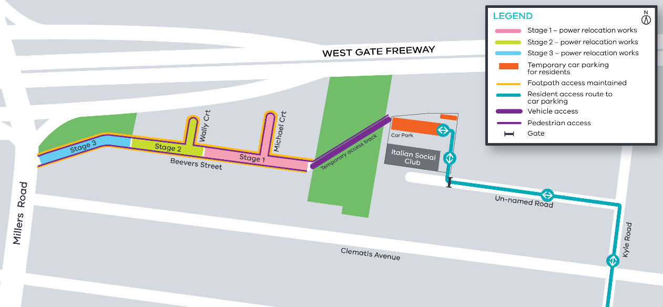
Contact us
Please contact us if you have any questions or feedback about these works.
 | westgatetunnelproject.vic.gov.au |  | facebook.com/westgatetunnelproject
 | info@wgta.vic.gov.au |  | @westgatetunnel
 | 1800 105 105 |  | West Gate Tunnel Project  GPO Box 4509  Melbourne Victoria 3001
 | Interpreter service: 13 14 50

