06/12/2019 WES1912.05

Works notification: short term closures of Paringa Road
Paringa Road will be closed from Chambers Road to Langshaw Street between 7am and 6pm between Monday 9 December and Thursday 12 December, and again on Wednesday 18 December for the delivery of new freeway safety barriers.

As part of the West Gate Freeway Project, we are building new freeway safety barriers. To facilitate the delivery of these barriers, we need to use a large crane which will require temporary closures of Paringa Road. The closures will impact access and waste collection.

The delivery of barriers will take place during our working hours of 7am to 6pm. Outside these hours, Paringa Road will re-open fully.

The crane will be set up on the freeway side of the temporary noise wall and a delivery truck will be parked near Lee Street or Bond Street. Paringa Road needs to be fully closed during the day so the trucks delivering the concrete barriers can access the area.

The footpath will remain open at all times and, depending on the location of delivery truck, we’ll do what we can to allow vehicles through on delivery days. However, if you wish to use your vehicle on the delivery days, we advise you to park it on one of the side streets before 7am each morning.

Where
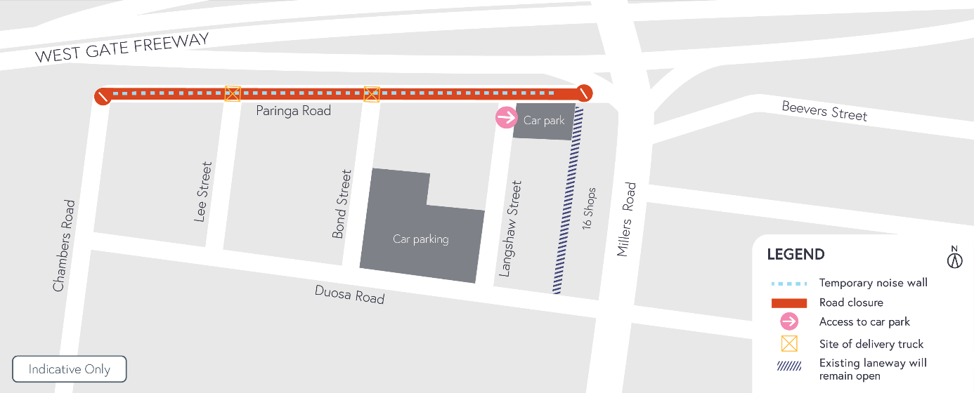

Closure of Paringa Road

When:
  - 7am to 6pm daily between Monday 9 December and Thursday 12 December
  - 7am to 6pm on Wednesday 18 December.

What to be aware of:
  - The work will involve truck movements and crane operations. The crane, which will be set up on the freeway side of the temporary noise wall, will lift concrete barriers through the site gates onto our work site.
  - Footpath access to your property and along Paringa Road will be maintained, and pedestrians will be escorted through the lifting zone when barriers are being lifted.
  - The carpark behind the 16 shops will remain open during this closure, with access from Langshaw Street.

Waste collection changes for Wednesday 11 and Wednesday 18 December:
  - Please place your rubbish bins in Chambers Road, Bond Street, Lee Street or Langshaw Street on the east side (the Millers Road side) so they can be collected.
  - Please ensure your bin is moved to this location by 11pm on Tuesday night for collection early on Wednesday morning.

Traffic changes will be required, and signed detours will be in place. The latest traffic updates are available at www.westgatetunnelproject.vic.gov.au/

Please note that works might need to be rescheduled in the event of bad weather or other unavoidable circumstances.

Thank you

We appreciate our work can be disruptive and thank you for your understanding and cooperation.

