EAS1SEP.001

25 October 2019

Works Update: E Gate and F Gate Sites October – December 2019
Construction of the new elevated road for the West Gate Tunnel Project, is ongoing as piling and pier construction works continue within E and F gate.
The West Gate Tunnel Project will provide direct link from Dynon Road to Flinders Street via the new
Wurundjeri Way extension. It will also offer upgraded shared use paths to pedestrians and cyclists in the area.

F Gate works
Extensive piling works will continue throughout this quarter (see map). Piling is one of the first steps in building the foundations for the piers that will support the bridges and ramps to be constructed in this area.

Piling preparation and piling works
Piling has commenced at a number of locations across F Gate and will be ongoing for the next six months. This includes the delivery of piling equipment and piling rigs to site.
Piles will be constructed using a combination of driven, bored and sheet piling (where required to protect open excavation areas). Once pile and pile cap works are complete, piers will be constructed using pre-cast segments.

Rail works
Rail works continue in the F Gate area including:
- Track earthworks – bulk cut and fill works under Melbourne Operations Terminal track formation (November - December)
- Track drainage – installation (December)

Civil works
- F-Gate access road works
- Cut and fill works along access road alignment (Nov – Ongoing)
- Drainage – installation (Nov – Ongoing)

Utility works
Ongoing utility relocation works include:
- 66KV installation in F Gate

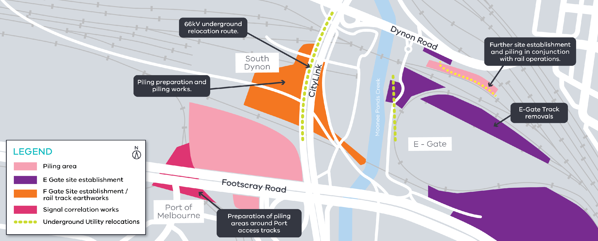

E Gate works
Rail Works
There are many rail works taking place during the next quarter including:
- Relocation of 6.6kV power lines which distribute power to all tenants in E Gate and South Dynon
- Removal of Wagon Storage Yard and South Hump Track (Oct – Dec)
- Commencement of works in and around Dynon Road precinct including piling (From November onwards)
- Relocation of V/Line from E Gate to new West Melbourne Maintenance Facility
- VicTrack to commence relocation of fiber optic cables in and around E Gate area (Nov – Dec).
Appropriate rail safe working support will be in place, ensuring the separation and safety of workers near rail traffic.

GPO Box 4509, Melbourne Victoria 3001

Interpreter service: 13 14 50

If you are deaf, or have a hearing or speech impairment, contact us through the National Relay Service.
For more information, visit: www.relayservice.gov.au.

What to expect during construction
  - Works completed both during the day and at night time.
  - We will notify you if there are any significant changes to the timing of our works.
  - Traffic management will be in place to manage changed conditions including temporary access changes to car
parking spaces and signage to guide road users and cyclists.
  - Dust will be managed on site with water carts.
  - Piling works can create increased levels of noise and may also cause some vibration.

Assessments have been conducted, which indicate the noise levels are expected to remain within permissible levels as documented in the project’s Environmental Performance Requirements.

We thank you for your patience during these works.

Contact us
Do you have a question about the project? If you need more information or would like to provide feedback, please get in touch.
westgatetunnelproject.vic.gov.au info@wgta.vic.gov.au
1800 105 105
facebook.com/westgatetunnelproject @westgatetunnel
West Gate Tunnel Project

