February 2020

Works notification: Dynon Road

Works around Dynon Road as part of the West Gate Tunnel Project is continuing with the construction of the new Dynon Road shared use path and bridges over Moonee Ponds Creek.

The West Gate Tunnel Project will provide a direct link from Dynon Road to Flinders Street via the new Wurundjeri Way Extension. It will also offer a new pedestrian and cycling bridge at Dynon Road, which will make it easier to cross Moonee Ponds Creek and the rail lines to link to the broader cycling network.

Dynon Road shared use path
The shared use path will provide a new dedicated bridge that will ensure a safe path for pedestrians and cyclists separate from vehicles to travel along Dynon Road to North Melbourne.

Stage one: Site establishment and works – February 2020
The first stage of site establishment and works will be adjacent to and in the Railway Place Reserve area. Works will include:
- Fencing works
- Closure of skate park area
- Worksite shed installation
- Pedestrian detour through the park
- Cycle detour via Dryburgh Street
- Closure of bus stop at Dynon Road Bridge
- Identification of existing services
- Piling preparations and piling works.

Stage two: Ongoing works – April 2020
From April 2020, stage two of these works will commence in the remaining park area. Works for this area will include:
- Fencing
- Vegetation removal
- Changes to the pedestrian detour
- Piling preparations and piling works
- Installation of the shared use path bridge.

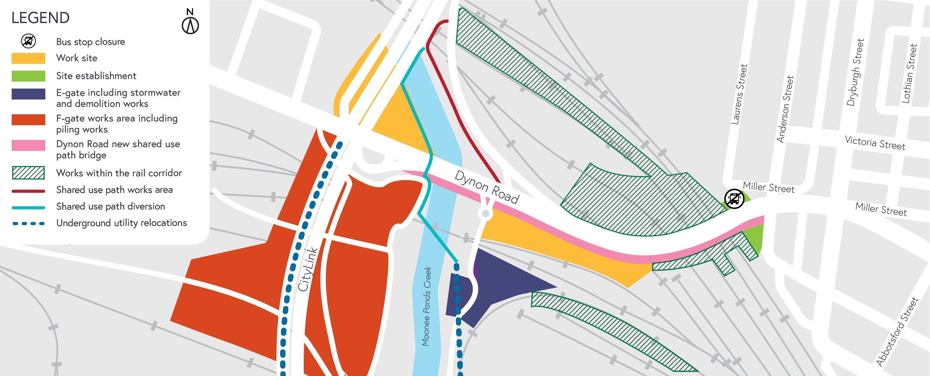

Construction areas around Dynon Road

Construction areas around Dynon Road
Once stage one and two works are complete, the area will remain occupied for the works required to upgrade Dynon Road in 2020. More information will be provided closer to the works date.
When: These works will be completed during the day between 7am and 5pm. Any night works required will be advised closer to the commencement of works.
Once construction is completed, the park and skate area will be completely reinstated.

Moonee Ponds Creek Trail shared use path changes
Construction of the temporary shared use path along Moonee Ponds Creek Trail is expected to start during February. The temporary shared use path will open in March and be in place for up to 12 months. The temporary changes will include crossing the Moonee Ponds Creek to the west bank using pontoons, keeping cyclists at a safe distance from the construction works.
Additional temporary changes along the Moonee Ponds Creek Trail and Dynon Road shared use path may be required as we complete works in the area. Shared use path switches will take place during off-peak periods and will be well signed for users.
There may be some noise associated with this activity and we will work to minimise these noise impacts as much as possible.

Piling works – ongoing
Piling works to construct the new shared use path and bridges over Moonee Ponds Creek and the rail yard will continue. Rail occupations are scheduled throughout 2020.
More information regarding the weekend rail occupations works will be advised closer to the date of works. There may be some noise associated with this activity and we will work to minimise the noise impacts as much as possible.

Utility works
Utility works taking place in the E Gate and F Gate areas will be ongoing for the next six months. Drainage works are taking place adjacent to Moonee Ponds Creek Trail.
Works may temporarily impact cyclists and pedestrians on the shared use path when we move equipment between sites across the Moonee Ponds Creek Trail. Traffic control will be in place to assist users.

What to expect during construction:
- Works completed both during the day and at night time
- We will notify you if there are any significant changes to the timing of our works
- Traffic management will be in place to manage changed conditions, including temporary access changes to car parking spaces and signage to guide road users and cyclists
- Dust will be managed on site with water carts
- Piling works can create increased levels of noise and may also cause some vibration.
Assessments have been conducted, which indicate the noise levels are expected to remain within permissible levels as documented in the project’s Environmental Performance Requirements.

We thank you for your patience during these works.

westgatetunnelproject.vic.gov.au info@wgta.vic.gov.au
1800 105 105
West Gate Tunnel Project Info Centre Corner of Somerville Rd and Whitehall St Yarraville VIC 3013

Follow us on social media Please contact us if you would like this
information in an accessible format.

Translation service – For languages other than English, please call 13 14 50.

Authorised by the Victorian Government, 1 Treasury Place, Melbourne

