16 June 2020

Works notification: Dynon Road

West Gate Tunnel Project is continuing with works on Dynon Road with utility and road works taking place between Radcliffe Street and Anderson Street.

The West Gate Tunnel Project will provide a direct link from Dynon Road to Flinders Street via the new Wurundjeri Way Extension. It will also offer a new pedestrian and cycling bridge at Dynon Road, which will make it easier to cross Moonee Ponds Creek and the rail lines to link to the broader cycling network.

Construction works along Dynon Road from June
From June and ongoing for 12 months, works will be taking place along Dynon Road. This will include water main and utilities works on the northern verge between Radcliffe Street and Moonee Ponds Creek, and stormwater drainage works on both the north and south sides of Dynon Road, east of Moonee Ponds Creek. Where possible, stormwater drainage works will be completed at night to avoid traffic impacts on Dynon Road.
When: These works will be completed during the day between 7am and 5pm, and at night between 7pm and 5am.
There may be some noise associated with this activity and we will work to minimise these noise impacts as much as possible.

Moonee Ponds Creek Trail shared use path diversion in late May
The diversion of the shared use path along Moonee Ponds Creek Trail was implemented in early June and will be in place for a minimum of 12 months. The temporary changes will include crossing the Moonee Ponds Creek from the East to West bank North of Dynon Road and from the West to East Bank South of Dynon Road using pontoons, keeping cyclists at a safe distance from the construction works.
Additional temporary changes along the Moonee Ponds Creek Trail and Dynon Road shared use path may be required as we complete works in the area. Shared use path switches will take place during off-peak periods and will be well signed for users.

Piling works – ongoing
Piling works within our existing site will be ongoing for the next 12 months. This includes ongoing works within the rail yard and rail line occupations continuing throughout 2020.
When: These works will be completed during the day between 7am and 5pm and at night between 7pm to 5am. Any noisy night works advised closer to the commencement of works.
Disruptive night works will be advised closer to the date of works. There may be some noise associated with this activity and we will work to minimise the noise impacts as much as possible.
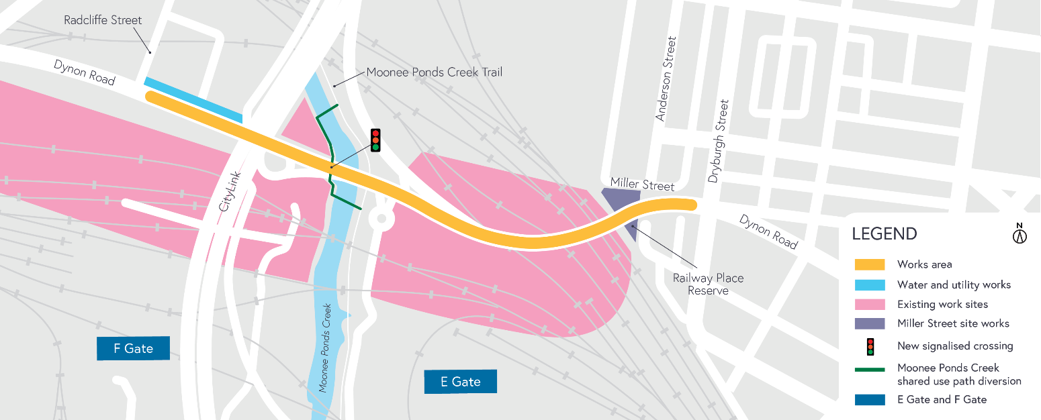

Dynon Road shared use path
The shared use path will provide a new dedicated bridge that will ensure a safe path for pedestrians and cyclists separate from vehicles to travel along Dynon Road to North Melbourne.
Stage one has now been implemented in the Railway Place Reserve and future works will include:
- piling works
- pier construction.

Utility works
Utility works taking place in the E Gate and F Gate areas will be ongoing for the next six months. Drainage works are taking place adjacent to Moonee Ponds Creek Trail.
Works may temporarily impact cyclists and pedestrians on the shared use path when we move equipment between sites across the Moonee Ponds Creek Trail. Traffic control will be in place to assist users.

What to expect during construction
- Works completed both during the day and at night time
- We will notify you if there are any significant changes to the timing of our works
- Traffic management will be in place to manage changed conditions, including temporary access changes to car parking spaces and signage to guide road users and cyclists
- Dust will be managed on site with water carts
- Piling works can create increased levels of noise and may also cause some vibration.
Assessments have been conducted, which indicate the noise levels are expected to remain within permissible levels as documented in the project’s Environmental Performance Requirements.

Please note that works might need to be rescheduled in the event of bad weather or other unavoidable circumstances.

We thank you for your patience during these works.

westgatetunnelproject.vic.gov.au info@wgta.vic.gov.au
1800 105 105
West Gate Tunnel Project Info Centre Corner of Somerville Rd and Whitehall St Yarraville VIC 3013

Follow us on social media Please contact us if you would like this
information in an accessible format.

Translation service – For languages other than English, please call 13 14 50.

Authorised by the Victorian Government, 1 Treasury Place, Melbourne

