Chapter 19
Historical heritage

Chapter 19

Historical heritage
This chapter provides an assessment of the impacts related to the construction and operation of North East Link associated with historical heritage. This chapter is based on the impact assessment presented in Technical report K – Historical heritage.

Historical heritage, encompassing places and objects of high cultural heritage value, is highly valued by the community and contributes to a sense of history and identity.
Construction activities and permanent infrastructure for North East Link have the potential to cause physical and visual impacts on the fabric, setting or character of heritage places and objects and could have an adverse impact on their heritage values.
The EES scoping requirements set out the following evaluation objective:
What is historical heritage?
Historical heritage is the places and objects that are of aesthetic, archaeological, architectural, cultural, scientific or social significance. It generally does not include places or objects that are of significance only for their Aboriginal cultural value. Equally, it does not exclude Aboriginal cultural heritage values and many historical heritage places have both Aboriginal and non-Aboriginal cultural values (shared values). Refer also to Chapter 20 – Aboriginal cultural heritage.

- Cultural heritage – To avoid or minimise adverse effects on Aboriginal and historical cultural heritage values.
To assess the potential impacts of North East Link on historical heritage, a historical heritage impact assessment was undertaken. The assessment considered statutory controls, including state registered heritage places, local planning schemes, and unlisted sites of potential heritage significance to gain an understanding of the heritage values and assets in the vicinity of North East Link. The findings of the assessment are presented below.
Other aspects closely related to the above evaluation objective include Aboriginal cultural heritage, which is addressed in Chapter 20 and Technical report L – Aboriginal cultural heritage as well as through the development of a Cultural Heritage Management Plan (CHMP). There are a number of heritage values which are discussed as shared values across the two assessments.

Method
Informed by the risk assessment described in Chapter 4 – EES assessment framework, key steps taken in assessing the impacts to historical heritage included:

- Review of relevant legislation and policy at a national, state and local level
- Establishment of a study area for historical heritage, encompassing land within approximately 300 metres of the reference project to capture all heritage places which could be affected by North East Link as shown in Figure 19-1.
- Desktop assessment and baseline data review
- Site visits undertaken to confirm findings of desktop assessment
- Consultation with relevant councils and historical bodies
What are the risk categories?
Risk levels were categorised as very low, low, medium, high or very high. When an impact is a known consequence of the project, and no longer a risk, the rating is indicated as ‘planned’. The results of the initial risk assessment were used to prioritise the focus of the impact assessments.

- Characterisation of existing conditions, being heritage places within the study area
- Risk assessment to prioritise the impact assessment
- Assessment of the potential historical heritage impacts during construction, operation and maintenance of North East Link
- Development of Environmental Performance Requirements (EPRs) in response to the impact assessment. The residual risk ratings and the assessment of impacts presented in this chapter assume implementation of the EPRs. Refer to Chapter 27 – Environmental management framework for the full list of EPRs.
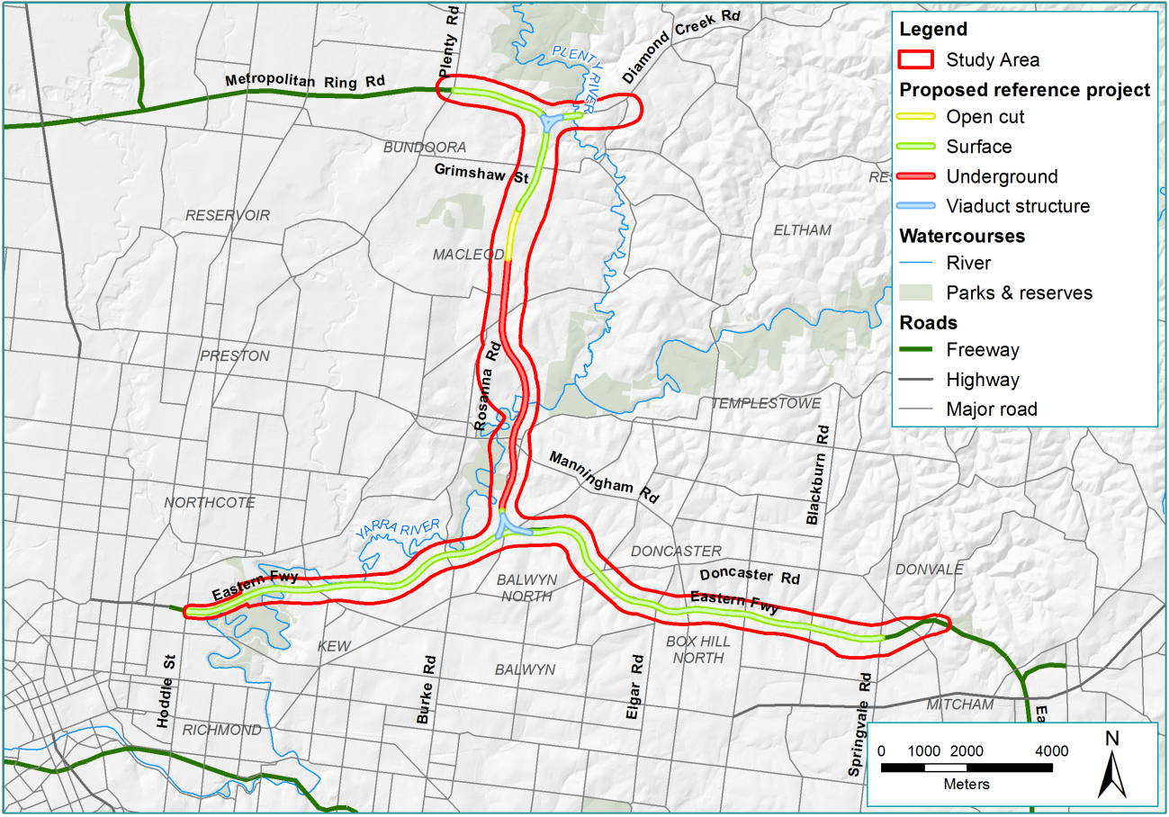
Figure 19-1 Study area for historical heritage

Existing conditions
This section outlines the existing conditions of the North East Link study area that relate to historical heritage.
The existing conditions assessment is structured to consider the following aspects and their identified heritage values:
- Victorian Heritage Register
- Victorian Heritage Inventory places and unidentified archaeological places
- Heritage overlay places
- Relevant environmental and landscape overlays
- Potential heritage places
- Yarra River and environs.
Heritage places with the potential to be impacted by North East Link are presented in this chapter and are shown in Figure 19-2, Figure 19-7, Figure 19-9 and Figure 19-16. A greater number of heritage places were identified in the study area, but are well separated from North East Link and would not be impacted. These are not discussed in this chapter, but are presented in Technical report K – Historical heritage.
A land use history of the study area was prepared to consider the broad patterns of land use and occupation to inform identification and an understanding of the significance of heritage places. To understand the broader historical context of heritage places discussed in this chapter, refer to Appendix C in Technical report K – Historical heritage.
There are a number of places addressed in this assessment which also have Aboriginal cultural heritage values. These include:
- Yarra River and environs, including:
  - Bolin Bolin Billabong
  - Yarra Flats
  - Warringal Parklands and Banyule Flats
  - Heide I and II
- Yarra River Protectorate Station site and Yarra Bend Park.
This chapter discusses these places in the context of historical heritage registrations and values, acknowledging the importance of the Aboriginal cultural heritage values. As such, these values should be reviewed in conjunction with Chapter 20 – Aboriginal cultural heritage.

Victorian Heritage Register places
The Victorian Heritage Register (VHR) is established by the Heritage Act 2017 (Vic) (‘Heritage Act’), and is the primary legislation for the protection and conservation of Victoria’s cultural heritage.
The VHR includes heritage places and heritage objects. Heritage places include buildings, trees, parks and gardens, streetscapes, archaeological sites, precincts, sites, land associated with any of these things, and shipwrecks. Heritage objects are generally moveable and could include furniture, signs, shipwreck relics, archaeological artefacts, equipment, vehicles and many other features.
Ten VHR places were identified in the study area. Of these, only four as listed in Table 19-1 and shown in Figure 19-2 have potential to be impacted by North East Link as others are well-separated from the project works.
Table 19-1 Victorian Heritage Register places
Heritage control | Name | Address | Municipality
VHR H0926  HO13 | Banyule Homestead | 60 Buckingham Drive, Heidelberg | Banyule
VHR H0687  HO160 | Heide I | 5 Templestowe Road, Bulleen | Manningham
VHR H1494  HO161 | Heide II | 7 Templestowe Road, Bulleen | Manningham
VHR H1552  HO301 | Former Fairlea Women’s Prison | Yarra Bend Road, Fairfield | Yarra

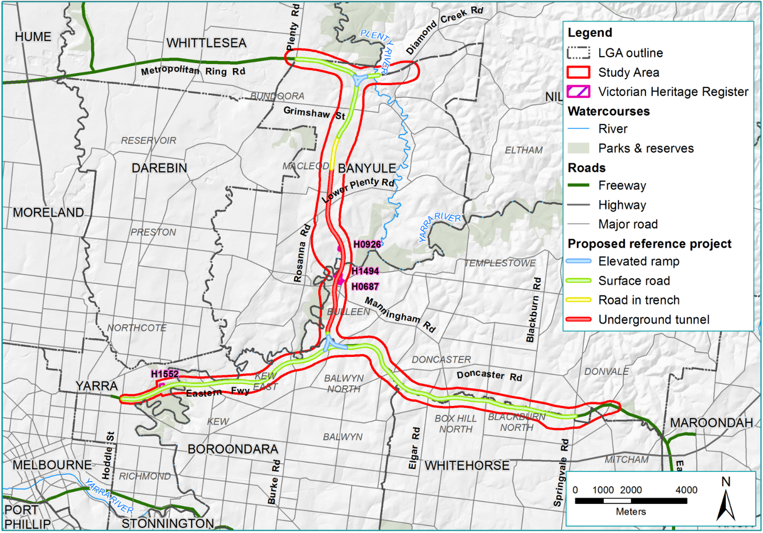
Figure 19-2 Victorian Heritage Register places

Banyule Homestead
Banyule Homestead is a prominent two-storey residence located on the escarpment above what is now the Banyule Flats parkland as pictured in Figure 19-3. The residence is broadly designed in the Gothic style, though it displays detailing typical of Tudor and Elizabethan styles.

Heide I and II
The Heide Museum of Modern Art (Heide) is a State-owned public museum and gallery located in Bulleen. The property was purchased by John and Sunday Reed around 1934, beginning as an artist residence and evolving to include galleries, a sculpture park and gardens.
Heide has two listings on the VHR; Heide I and Heide II. While the places have different histories and are entered as separate registrations on the VHR, the two Heide properties operate as a single entity.
Heide I includes an early timber farmhouse dating from the 1870s. The single-storey weatherboard residence was occupied and renovated by the Reeds and now operates as a gallery space. During the Reed’s occupation it was a focus of a circle of prominent artists of the mid-20th century, with the Reeds acting as patrons of the artists they supported including Charles Blackman, Sidney Nolan and Mirka Mora.
Heide II includes the Mt Gambier limestone art gallery which was built around 1967 and opened for public exhibition in 1981. The listing also extends to Heide’s surrounding landscape, which has aesthetic importance. Heide II and associated grounds are shown in Figure 19-4 and Figure 19-5.

Former Fairlea Women’s Prison
The Former Fairlea Women’s Prison was developed on part of the site of the earlier Metropolitan Lunatic Asylum, later Yarra Bend Lunatic Asylum, established in around 1848. The asylum was originally a much larger complex, spread over an extensive site. The majority of the site was declared a Public Reserve around 1927 and most of the buildings were demolished. A small number were re-used for the Fairlea Women’s Prison from 1956. The prison remained in operation until the mid-1990s when all remaining above-ground structures were demolished, except a single bluestone gate pillar as shown in Figure 19-6, now relocated to the west side of Yarra Bend Road. The VHR identifies the significance of the place as both historical and archaeological, as part of the original site of the earliest asylum in Victoria.
The broader area covered by the former asylum complex is reflected in a larger archaeological VHI site H7922-0142 Yarra Bend Park Northcote 1.
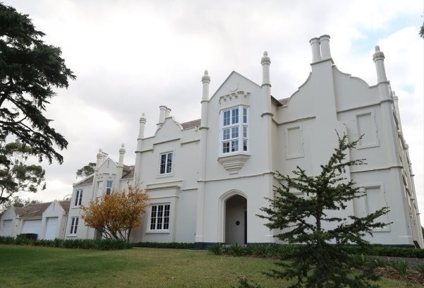 | 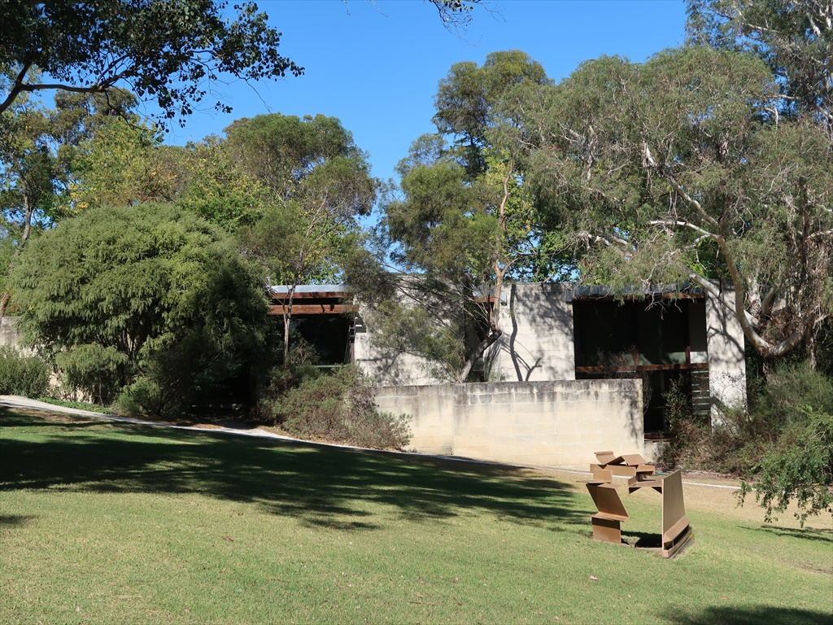
Figure 19-3 Banyule Homestead | Figure 19-4 Heide II
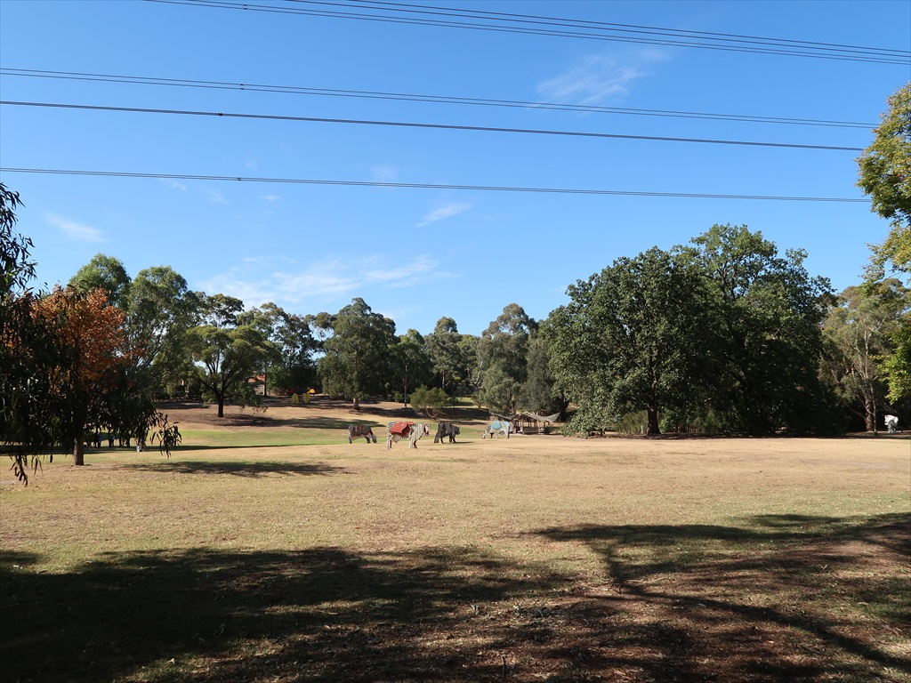 | 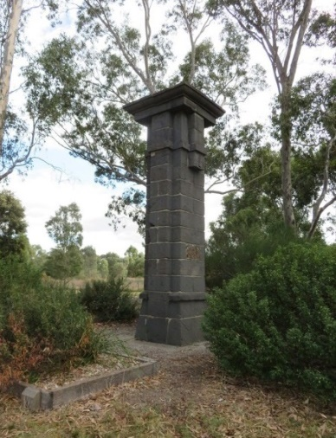
Figure 19-5 Grounds of Heidi II | Figure 19-6 Gate pillar associated with the Former Fairlea Women's Prison

Victorian Heritage Inventory and unidentified historical archaeological places
The Victorian Heritage Inventory (VHI) is established by the Heritage Act and protects registered historical archaeological sites.

The Heritage Act introduces a significance test for the VHI, where the VHI includes sites confirmed as having archaeological value. This means the VHI includes sites that contain (or are likely to contain) archaeological remains, where the remains demonstrate an association with a significant historical event, pattern of land use, or other activity. Archaeological sites determined to be of low archaeological value are not included.
The Heritage Act also protects unidentified historical archaeological places, which have not been uncovered, but may be encountered during excavations.
What is historical archaeology?
Historical archaeological sites are those heritage places that contain archaeological artefacts, deposits or features which are more than 75 years old, and that provide information of past activity in Victoria and require archaeological methods to reveal information about the settlement, development or use of the place, and are not associated only with Aboriginal occupation of the place.

Six VHI places were identified in the study area. Of these only two have potential to be impacted by North East Link as listed in Table 19-2 and shown in Figure 19-7 as others are well separated from project works.
Table 19-2 Victorian Heritage Inventory places
Heritage control | Name | Address | Municipality
VHI H7922-0142 | Yarra Bend Park Northcote 1 | Yarra Bend Road, Fairfield | Yarra
VHI H7922-0210 | Banksia Street Bridge |  | Banyule and Manningham

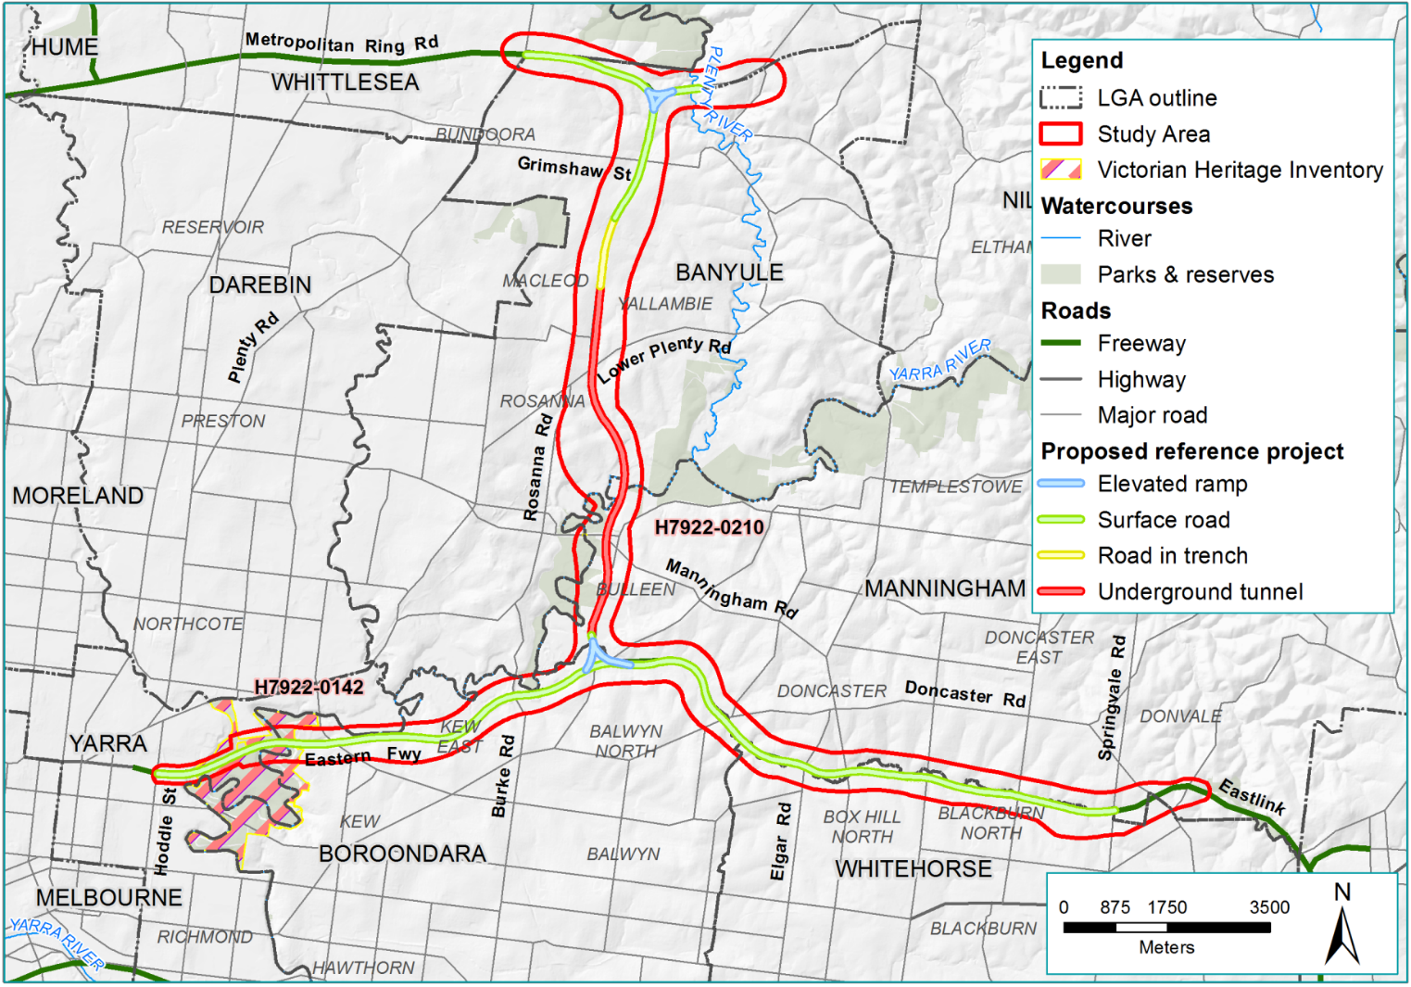
Figure 19-7 Victorian Heritage Inventory places

Yarra Bend Park Northcote 1
Yarra Bend Park Northcote 1 is a large VHI site incorporating the locations and potential archaeological remains of a number of separate historical activities including an infectious diseases hospital, a lunatic asylum and a women’s prison. While the extent and nature of archaeological remains within this place are largely unknown, works undertaken for the installation of drainage infrastructure in 1996, assumed to be in the vicinity of features indicated on historical plans as associated with the Yarra Bend Lunatic Asylum, exposed in situ bluestone footings and associated artefacts.

Banksia Street Bridge
The Banksia Street Bridge is situated directly underneath the existing bridge over the Yarra River at Banksia Street. The bridge was constructed from bluestone and wood around 1860. The current site comprises three courses of bluestone masonry (7 metres by 3 metres). The masonry is situated just above the waterline on the east bank of the river, representing the remains of an abutment of what was possibly the earliest bridge crossing of the river at this location as shown in Figure 19-8.
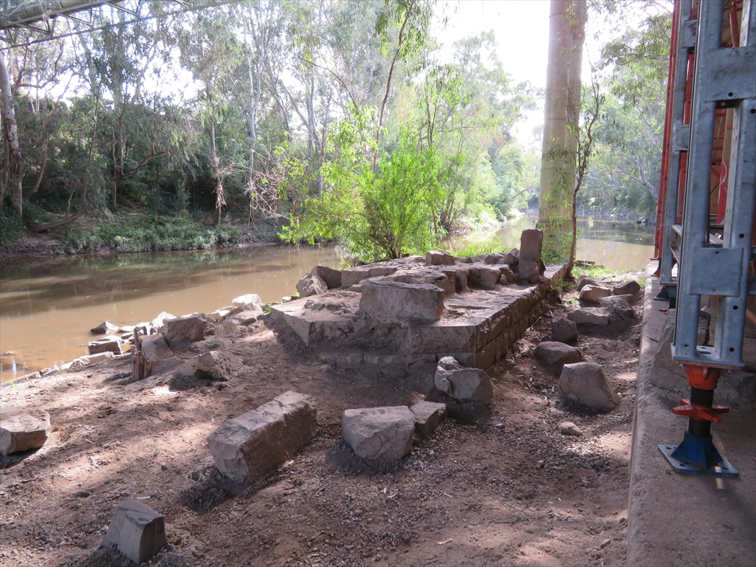
Figure 19-8 Bluestone masonry of Banksia Street Bridges

Heritage overlay places
Planning schemes govern the use, development, protection and conservation of land within each municipality as established by the Planning and Environment Act 1987 (Vic).
Planning schemes relevant to North East Link are as follows:
- Banyule Planning Scheme
- Boroondara Planning Scheme
- Manningham Planning Scheme
- Nillumbik Planning Scheme
- Whitehorse Planning Scheme
- Whittlesea Planning Scheme
- Yarra Planning Scheme.
As part of planning schemes, heritage overlays list and provide protection to heritage places in a municipality. The purposes of heritage overlays are to conserve and enhance places of natural or cultural significance and to ensure development does not adversely affect their significance. Places in a heritage overlay are included in a schedule that contains essential information about each listed place, including specific permit triggers. They are also mapped in the planning scheme.
There were 34 places within heritage overlays identified in the study area. Of these, 13 have potential to be impacted by North East Link as listed in Table 19-3 and shown in Figure 19-9.
Table 19-3 Heritage overlay places
Heritage control | Name | Address | Municipality
HO24 | River Red Gum | Bridge Street corner Manningham Road, Bulleen | Manningham
HO25 | Bridge Street Pine and Cypress plantings | Bridge Street, Bulleen | Manningham
HO26 | Journeys End | 22-40 Bridge Street, Bulleen | Manningham
HO30 | Bolin Swamp | Bulleen Road, Bulleen | Manningham
HO42 | English Oak | Doncaster Road (near Hender Street corner), Doncaster | Manningham
HO72 | Archaeological site Bulleen Drive-in (former) | 49 Greenaway Street, Bulleen | Manningham
HO134 | Yarra Flats | 340-680 The Boulevard, Eaglemont | Banyule
HO146 | Moreton Bay Fig | 1 Robb Close, Bulleen | Manningham
HO164 | Strathalan | 2-34 Erskine Road Macleod | Banyule
HO147 | ‘Clarendon Eyre’ orig. ‘Springbank | 6 Robb Close, Bulleen | Manningham
HO181 | Archaeological site (Ref. VAS 7922/202) | Wetherby Road eastern corner Eastern Freeway, Doncaster East | Manningham
HO307 | Yarra River Protectorate Station site | Yarra River, Yarra Bend Park, Yarra Bend | Yarra

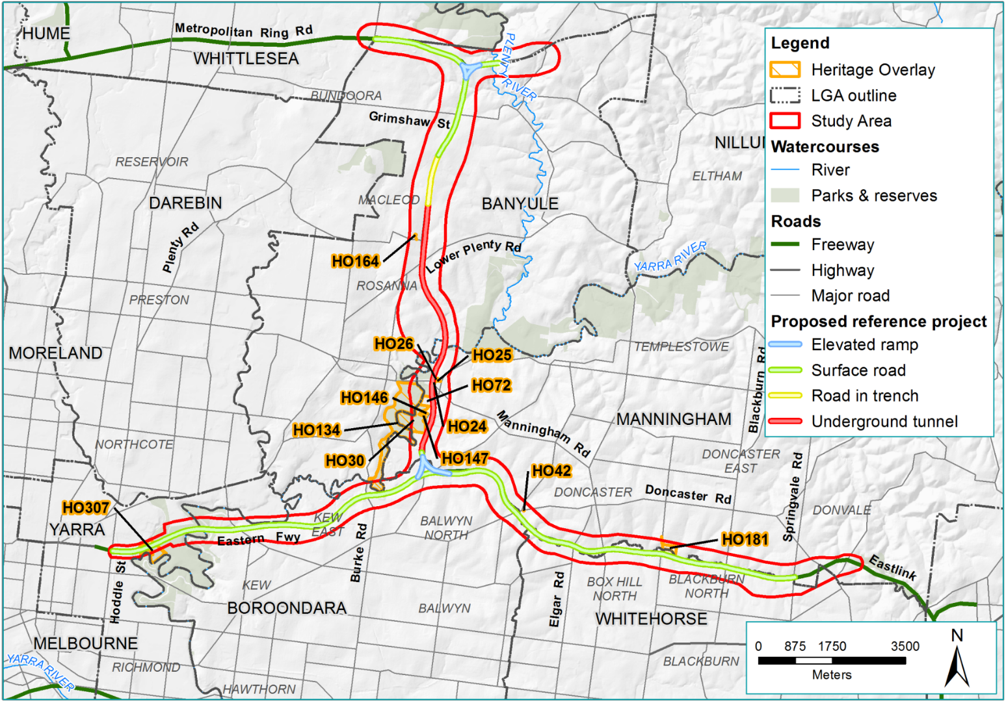
Figure 19-9 Heritage overlay places

River Red Gum
A large River Red Gum Eucalyptus camaldulensis is located on Bridge Street near a service station as shown in Figure 19-10. The River Red Gum was retained in the service station redevelopment around 1965-1970. The tree has been variously assessed (by local councils and the National Trust) as being of local and regional heritage significance and is a local landmark. The Bridge Street tree has been recognised by the National Trust of Australia and is included in its Significant Tree register. Various council citations reference the heritage values of the tree as scientific, aesthetic and historical. It may also have contemporary social value and is a landmark in the local area.

Bridge Street Pine and Cypress plantings
The Bridge Street frontage of Journeys End is subject to a separate heritage control for a row of mature to over-mature pine and cypress trees. The trees have been characterised as forming part of a cultural landscape grouping (with Journeys End and a second unlisted residence White Oaks) and as forming a strong local landmark.

Journeys End
Journeys End is located at 22-40 Bridge Street, Bulleen and is shown in Figure 19-11 and Figure 19-12. Constructed around 1933, Journeys End is a two-storey ‘Craftsmen’ style bungalow located on land that was previously a dairy farm.
It has been assessed as of historical significance as the Bulleen residence of a Northcote flour manufacturer on a site that was once part of an early subdivision of the area into farm allotments and subsequently for its architectural style, unusual in the municipality.
The heritage overlay includes tree controls in recognition of the tree-lined driveway. The heritage overlay schedule also references the entry gate on Bridge Street.

Bolin Swamp
Bolin Swamp is located to the east of the Yarra River. While Bolin Swamp is the registered name under the heritage overlay, it is more commonly known as Bolin Bolin Billabong. The heritage overlay includes the billabong and surrounding landscape that in some areas pre-dates European settlement. While locally listed, it is also identified as being of state-level significance for its natural and cultural values, including the Wurundjeri’s historical association with the place. A registered Aboriginal cultural heritage place is present within the heritage overlay along with an Aboriginal historical reference. These values are understood to be restricted to the billabong itself and to land immediately north and west of this water body. The heritage overlay citation does not reflect any historical heritage values, and is examined further in Chapter 20 – Aboriginal cultural heritage.

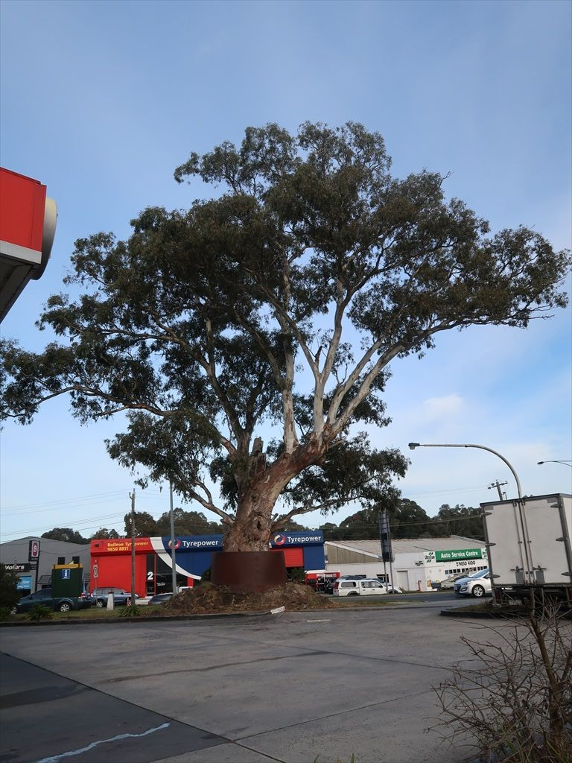
Figure 19-10 River Red Gum view from the north
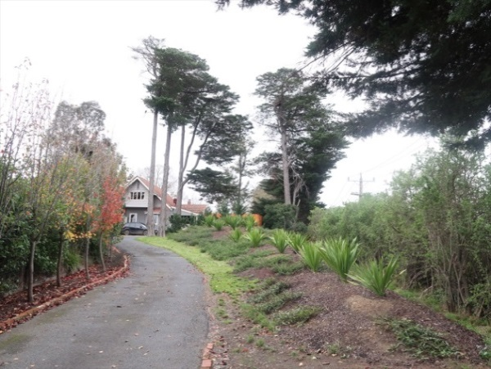
Figure 19-11 Journeys End viewed from the south west
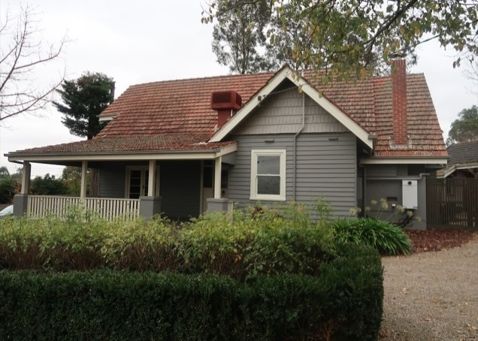
Figure 19-12 Journeys Ends viewed from the south

English Oak
A single specimen of English Oak Quercus robur is located in the nature strip on the south side of Doncaster Road, adjacent to the Doncaster Road Park and Ride as shown in Figure 19-13. This tree has been identified as being of local heritage significance; it was once part of a row of oak trees reportedly planted by John Smedley, a blacksmith who settled in Doncaster around 1860. The tree is in a compromised location and is currently in poor condition.
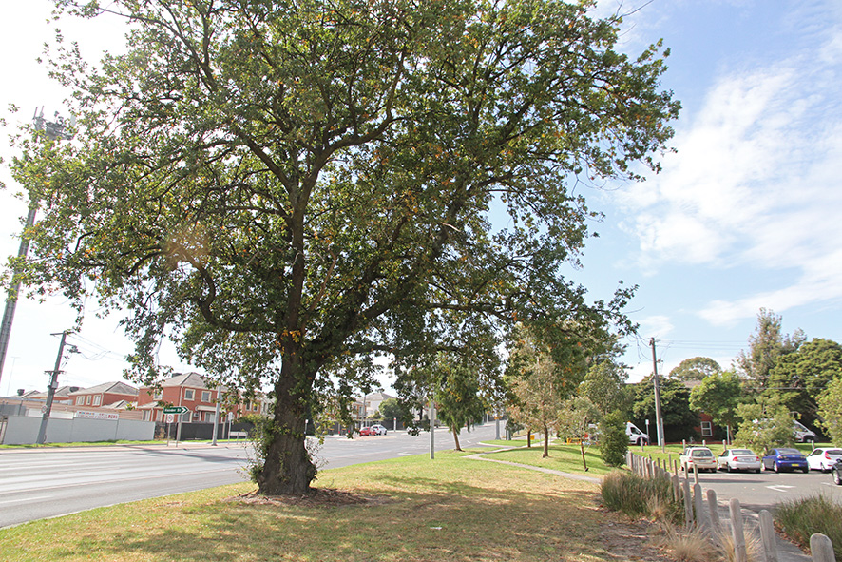
Figure 19-13 English Oak

Archaeological site Bulleen Drive-In (former)
An archaeological site is listed in the heritage overlay at the former Bulleen Drive-in site, which opened in 1966 and operated until 1984. All buildings have been demolished and all that remains of the former kiosk structure is a concrete ground slab. Manningham Council had advised the heritage overlay reflects the Aboriginal archaeological potential of the site and no documentation of historic heritage values associated with this place has been located. The Archaeological site Bulleen Drive-in (former), Bolin Bolin Billabong and Yarra Flats all form part of the Yarra River environs and can be considered in the broader context of the continuous, albeit varied, cultural landscape of the river valley.
While the drive-in site is listed as having Aboriginal cultural heritage values there are no formally registered Aboriginal heritage places within the property. The potential for significant Aboriginal cultural heritage values, or non-Indigenous archaeological values across the majority of this site, is considered to be extremely low given the likely impacts associated with the development of the drive-in.

Yarra Flats
The Yarra Flats is an extensive parkland bounded to the east and south by the Yarra River, to the north is Banksia Street and the west The Boulevard, Heidelberg and Ivanhoe. This heritage overlay covers approximately 85 hectares and consists of riparian and wetland habitats, grassy woodland and pasture. The parkland retains evidence of early occupation (Aboriginal and post-contact agrarian) and this is seen in a canoe scar tree and exotic plantings of oaks and boundary plantings of hawthorn. The Yarra Flats also includes two billabongs, and these can be seen to connect to the wider network of billabongs to the south. The Yarra Flats is of Aboriginal cultural heritage and local level historical, aesthetic and social value, the latter relating to the connection of community groups dedicated to the revegetation of the parkland.

Clarendon Eyre and Moreton Bay Fig
Clarendon Eyre is a late Victorian Italianate house in Bulleen built around 1879. The historical heritage values of Clarendon Eyre are identified as being ‘architecturally of state significance with unusual massing and details’. A photograph of the property in 1932 is shown in Figure 19-14. A Moreton Bay Fig, Ficus macrophylla, which was once part of the property is listed on a separate Manningham heritage overlay which is shown in Figure 19-15.
Both these listings relate to the theme of 19th-century residential development in the area.
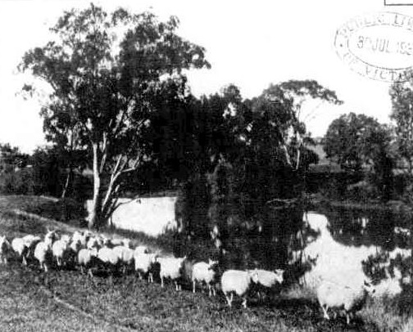 | 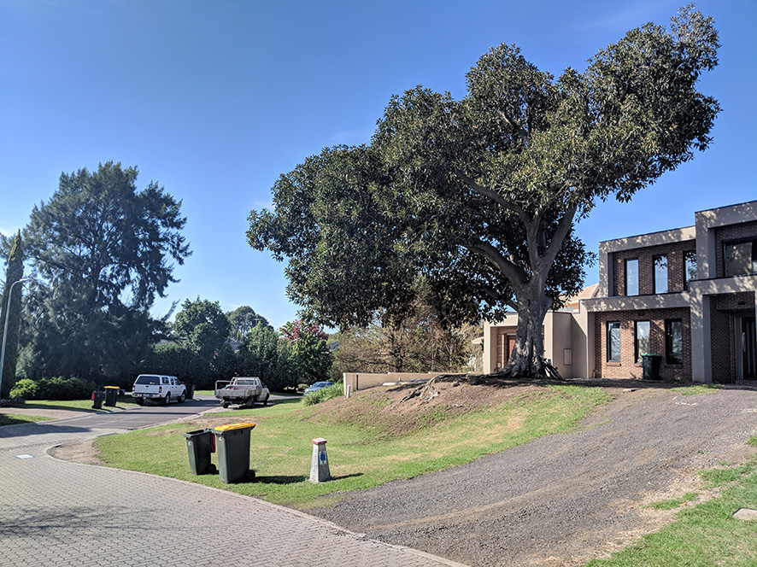
Figure 19-14 Clarendon Eyre property, 1932 | Figure 19-15 Moreton Bay Fig in Robb Close

Strathalan
Strathalan is a large Federation-era residence built in 1906-07 on Erskine Road in Macleod. The residence has been adapted and now forms part of an aged care facility, with mature pine trees at the entrance to the driveway and a mature River Red Gum. The buildings at Strathalan are well separated from the works so this place is considered only in the context of potential impacts to the trees associated with groundwater drawdown.

Archaeological site (Ref. VAS 7922/202)
A large site at Wetherby Road is described as an Archaeological site (Ref. VAS 7922/202). This item appears to have been listed due to the presence of a registered Aboriginal place (VAHR 7822-0202) comprising a small number of Aboriginal stone artefacts located to the south of and outside the heritage overlay place as mapped.

Yarra River Protectorate Station site
Yarra River Protectorate Station site represents a combination of Aboriginal cultural heritage and historical archaeological values and, broadly speaking, encompasses the locations of the Merri Creek Aboriginal School, Yarra Protectorate, Native Police Corps Headquarters and associated burials of Aboriginal people. The item is covered by a Victorian Aboriginal Heritage Register listing (VAHR 7922-1185) which incorporates a number of previously separately registered items.
The item is also covered by the Yarra Bend Park Northcote VHI place discussed above. Much of this place, particularly as it relates to the study area, has been significantly modified by works for the construction of the Eastern Freeway and the associated realignment of the Yarra River. The site is also subject to a broader Environmental Significance Overlay (ESO2) in the Yarra Planning Scheme and this overlay also reflects on similar values of heritage and archaeology.

Other relevant overlays
A range of other planning overlays were identified as having the potential to be relevant to the assessment of the impacts to historical heritage, including Environmental Significance Overlays (ESOs), Significant Landscape Overlays (SLOs), and Vegetation Protection Overlays (VPOs). The values and objectives referenced in the schedules to these overlays were reviewed to confirm those that are relevant to historical heritage. In some cases these overlays exist in addition to a heritage overlay or other statutory heritage control. The impacts of North East Link on these places are only discussed in Section 19.3 and Section 19.4 where they have relevance to historical heritage.

Environmental Significance Overlay places
Nine ESO places were identified within the study area which have relevance to historical heritage. Some of these are individual trees or areas of vegetation that are subject to ESO4 controls in the Banyule Planning Scheme, which are associated with listed or potential heritage places. These have been considered as part of impact assessment in association with the relevant heritage places. The Banyule and Yarra Planning Schemes also include Environmental Significance Overlays (ESO1 and ESO2 respectively) in relation to the Yarra River and Merri Creek.
In addition, Banyule City Council supplied a small number of additional citations describing trees which have been nominated for inclusion to Banyule ESO4 but for which an amendment to the planning scheme has yet to occur. Three nominated trees within this section of the study area were reviewed, and one tree, an English Elm (Ulmus procera) nominated for historical reasons, although this is located some distance from North East Link and so is not considered further in this impact assessment. The other two trees were not nominated for historical reasons.
Other ESOs are applied within the study area which do not address historical heritage values; places associated with those overlays are not considered within this impact assessment.

Vegetation Protection Overlay places
Schedule 5 of the Banyule Planning Scheme’s VPO has been identified as relevant to North East Link. The overlay applies to large native and exotic trees (Substantial Trees) which contribute to neighbourhood character, to local ecology and environmental conditions, and to the prominence of ridgelines in Banyule’s natural topography. VPO5 has been applied to private properties and residential streets, but excludes major arterial roads, public park reserves and some larger institutional sites. Banyule VPO5 applies equally to native and exotic vegetation and includes as an objective the management of the long-term viability of significant avenue plantings and heritage trees. The VPO5 control coincides with some heritage places or potential heritage places considered in impact assessment and is a further layer of recognition.
Other VPOs within the study area were determined to be unlikely to be impacted by North East Link, or were found to not address historical heritage values.

Significant Landscape Overlay places
The Banyule, Boroondara and Manningham Planning Schemes all include SLOs applying to valley lands and slopes along the Yarra River. These overlays have been recently amended and coordinated via Planning Scheme Amendment GC48; they apply to the entirety of the Yarra River lands within this section of the study area and are bounded by ‘top of slope’ roadways and other features. Notably in this section, Bulleen Road acts as an eastern boundary of Manningham SLO2, excluding a large area of former floodplain and billabong east of the road which are now occupied by recreational sports fields operated by Trinity Grammar School and Marcellin College. It is also notable that between Trenerry Crescent and Bulleen Road, the Eastern Freeway is entirely situated within this SLO.
The Yarra (Birrarung) River Corridor Environs SLOs are applied to achieve a variety of environmental, landscape and cultural objectives, as well as improvements to public recreational access and built form. Notably, the SLOs apply to retention of exotic vegetation which is of ‘landscape significance’, and to the protection and enhancement of the river’s riparian edge. Refer to the discussion of the Yarra River and Environs in Section 19.2.6 below.
Other SLOs within the study area were determined to be unlikely to be impacted by North East Link, or were found to not address historical heritage values.

Potential heritage places
Consideration has also been given to potential additional heritage places within the study area but not currently subject to statutory heritage controls. These are listed in Table 19-4 and shown in Figure 19-16. These include places listed in municipal, typological or thematic studies or through other means as having the potential for heritage value. The majority have not been subject to previous detailed heritage assessment. A greater number of potential heritage places were identified in the study area, but are well-separated from the project works and would not be impacted. These are not discussed in this chapter, but are presented in Technical report K – Historical heritage.
Table 19-4 Unlisted places of potential heritage significance
Name | Address | Municipality | Heritage Control
Banksia Park | Templestowe Road, Bulleen | Manningham | No
Banksia Street Pipe Bridge | Banksia Street, Heidelberg Road and Manningham Road, Bulleen | Banyule, Manningham | No
Eastern Freeway (stage 1) | Various | Yarra, Boroondara | No
Simpson Barracks | Greensborough Road, Macleod | Banyule | No
Veneto Social Club | 191 Bulleen Road, Bulleen | Manningham | No
Yarra River and environs | Various | Banyule, Manningham, Boroondara and Yarra | Not as a whole place
Yarrandoo Park windbreak planting | Springvale Road, Nunawading | Whitehorse | No

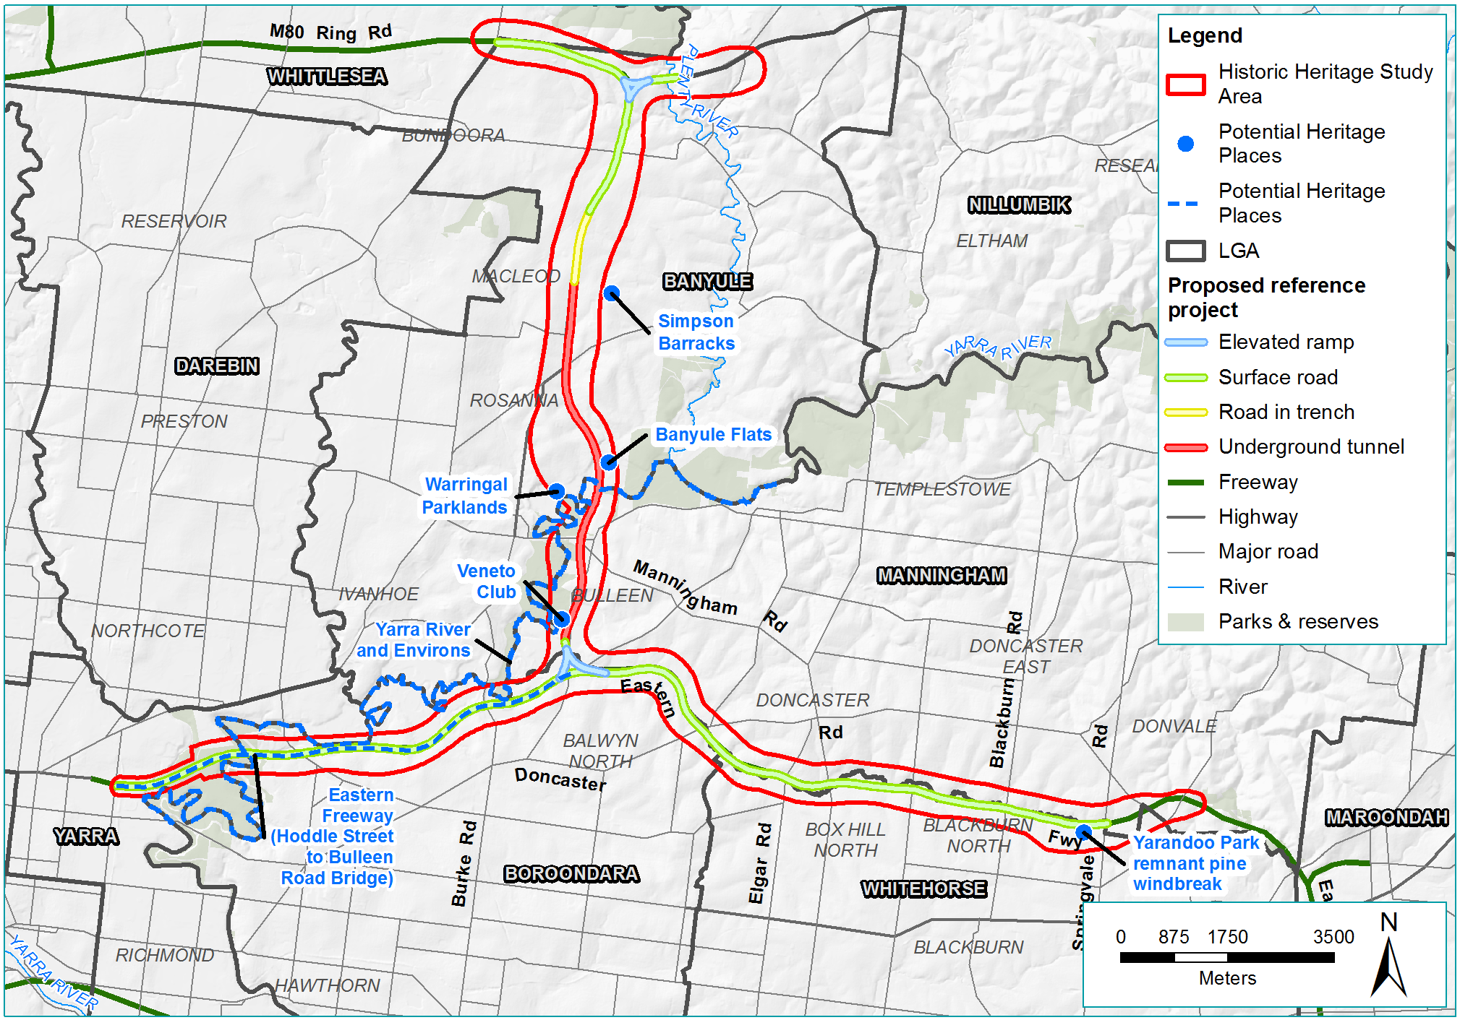
Figure 19-16 Potential heritage places

Banksia Park
Banksia Park is a regional park developed on valley land formerly grazed and farmed from approximately the 1840s. In 1991 the City of Doncaster and Templestowe Heritage Study identified Banksia Park to be of local heritage significance but it does not appear to have been further assessed and heritage controls were not introduced. The citation notes ‘an old stand of exotic trees adjacent to one memorial including Italian Poplar, Indian Bean Tree, Ash leaf Maple, Common Ash, Alder, Spanish Chestnut and Pussy Willow’. This stand of trees (and a referenced memorial) may exist but were not identified on site. The citation also suggests that fruit tree plantings (pear and quince) dating to Ricardo’s farming activities were present in Banksia Park in 1991; again, these have not been identified. Apart from the place’s general associations with the landscape character and values of the Yarra River, the park layout, architectural and planting design, and aesthetic qualities are not considered to be of note.
Along the boundary between Heide I and Heide II and Banksia Park, post-WWII canopy tree and understorey plantings within the Heide II grounds establish a strong separation between these two areas of open space. Boundary plantings in the garden of Heide I, some of which were established pre-1945, similarly separate that place from the Banksia Park entrance drive. Other trees in the area are primarily of ecological interest, but contribute to the Yarra River and environs as described in Section 19.2. A view from the boundary of the Banksia Park and Heide II site is shown in Figure 19-17.

Banksia Street Pipe Bridge
The Banksia Street Pipe Bridge was constructed around 1891 as part of a network to supply water to the eastern suburbs from the Yan Yean Reservoir in response to the expansion of Melbourne’s suburban area. The bridge was nominated for inclusion on the VHR in 2017 but was assessed by the Executive Director, Heritage Victoria as not being of state significance. The Executive Director found that the bridge may be of local significance and the recommendation was referred by the Heritage Council to the Banyule and Manningham councils for consideration for inclusion in the heritage overlay in the planning schemes. These councils have not adopted the recommendation as yet. A view of the Banksia Street Pipe Bridge is shown in Figure 19-18 looking to the west, across the Yarra River.

Eastern Freeway (stage 1)
The Eastern Freeway is a major work of transportation infrastructure planned, designed and constructed from 1971 to 2008. The first stage of the Eastern Freeway, extending from Hoddle Street to Bulleen Road, is considered to have heritage significance, potentially at the state level, for its design and aesthetic qualities. It also has a level of historical significance. The first stage of the Eastern Freeway was significant in the history of freeway design, in that it marked a shift towards an integrated architectural, urban design and landscape solution and set a new design standard in Victoria. This section of the freeway includes limited use of plantings within the corridor itself, but employs borrowed views of the adjacent areas of natural vegetation, including the Yarra River and environs. The key elements of the original design have been maintained and the aesthetic qualities remain. While not the first of Melbourne’s freeways, the planning and construction of the Eastern Freeway was the focus of significant public opposition and debate from the early 1970s, marking a shift in community attitudes to freeways and in particular the defence of the inner suburbs and parklands. Stage two and stage three of the Eastern Freeway are not considered to be of heritage significance.

Simpson Barracks
Simpson Barracks, formerly Watsonia Army Barracks, was established around 1943 on a 40 hectare site as a military training facility. Buildings and structures at Simpson Barracks, from the WWII period, have been removed and replaced through major construction programs in the 1950s and 1960s and more recently.
The Victorian War Heritage Inventory, a non-statutory register relating to Victoria’s war history, includes reference to the Simpson Barracks as a whole, as well as to two elements within the site, the former residence, Aldermaston and the Watsonia Simpson Barracks Memorial.
Aldermaston (former Ainslie Meares House) was constructed in 1936 and incorporated into the barracks in around 1951. Aldermaston was recommended to the Commonwealth Heritage List (CHL) by an unpublished heritage study in 2017. To date, the nomination has not been assessed or included in the CHL, which is administered by the Environment Protection and Biodiversity Conservation Act 1999 (Cwlth) (‘EPBC Act’).
The Simpson Barracks Memorial includes commemorative plantings (Assembly Place and Lone Pine) as well as the 138 Signal Squadron Flag Station and Memorial.
The former communications facility, Building 147, is considered to have heritage values at a local level.
Vegetation at Simpson Barracks includes areas of remnant vegetation, some of which may date from the pre-contact period. Much of it has been regenerated after grazing was discontinued around 1940. None of the landscaping was assessed as significant for historical heritage reasons.

Veneto Club
The Veneto Club is a community facility on Bulleen Road, Bulleen. It was designed by émigré architect, Ermin Smrekar and was officially opened in 1973. The Veneto Club design is one of a group of Smrekar’s early buildings which are characterised by structural elements, use of raw concrete, spatial organisation and patterning of shapes. The building references aspects of Brutalism through the adoption of materials and formal expression typical to this style, using off-form concrete and textured brickwork with expressed horizontality and a robust character. It is considered unlikely to be rated highly when compared with other successful and recognised Brutalist buildings in Victoria included on the VHR but it may be considered of local architectural significance. The club is also likely to be of high social and historical value to the Italian community as a focus for social, cultural and sporting activities over a long period. The north-west façade of the Veneto Club is shown in Figure 19-19.

Yarrandoo Park windbreak planting
Yarrandoo Park in Whitehorse contains the remains of a Monterey Pine windbreak just south of the Eastern Freeway as shown in Figure 19-20. The windbreak is associated with commercial fruit orchards that were typical of Box Hill, Blackburn North, and Mitcham throughout the first half of the 20th century. The Yarrandoo Park windbreak is considered to be of local historical significance as a relatively intact and significant example of what was once a landscape feature employed throughout the northern part of the City of Whitehorse in association with commercial orchards.
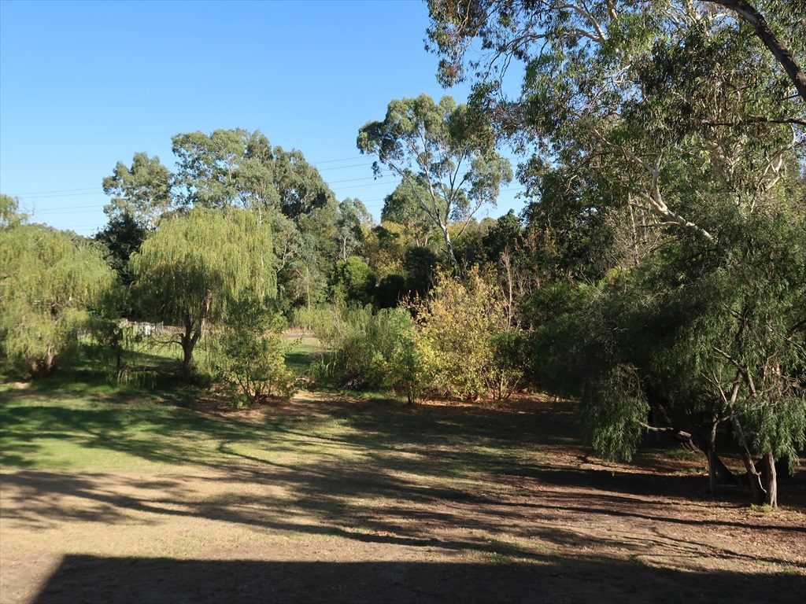 | 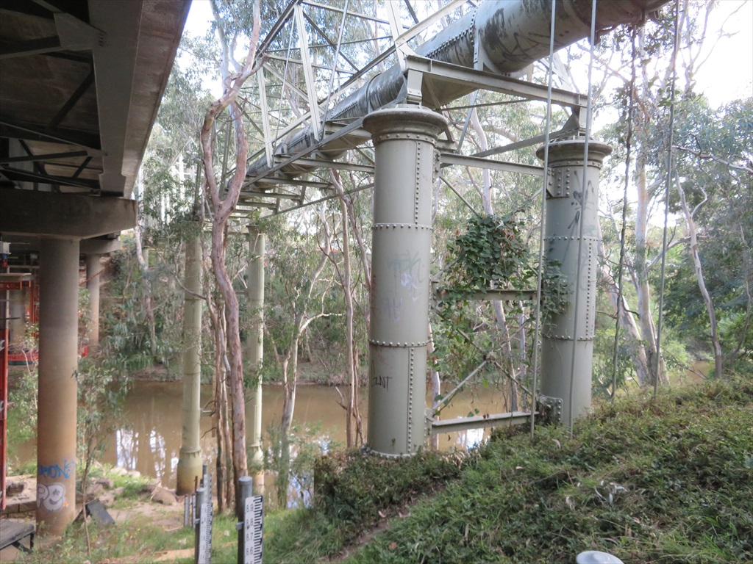
Figure 19-17 Banksia Park |  | Figure 19-18 Banksia Street Pipe Bridge
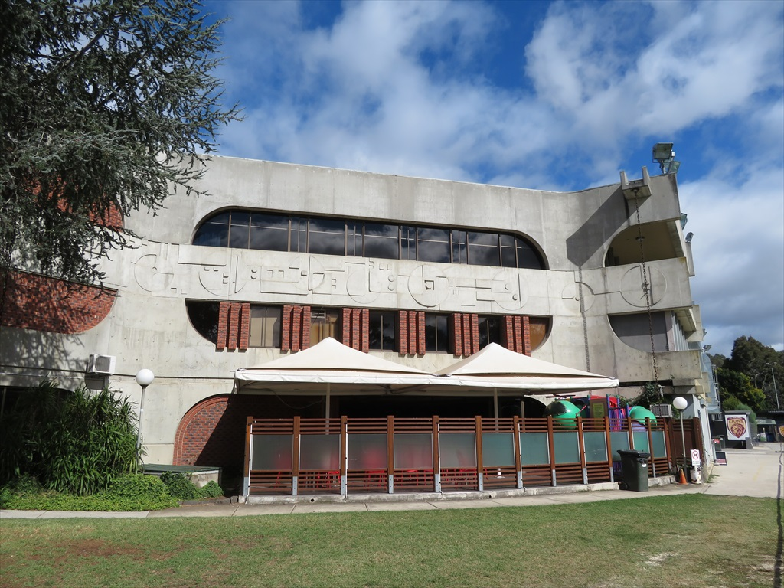 |  | 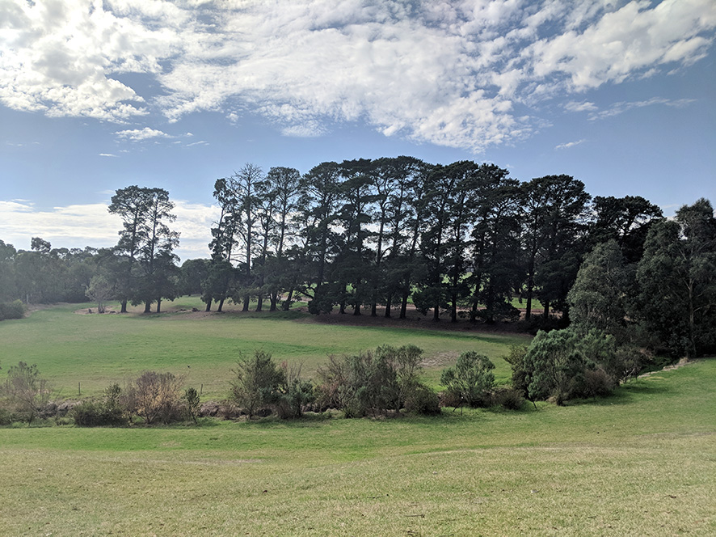
Figure 19-19 Veneto Club |  | Figure 19-20 Yarrandoo Park windbreak planting

Yarra River and environs
The Yarra River and its environs is recognised as a landscape of special significance within Melbourne. As established in the Yarra River Protection (Wilip-gin Birrarung murron) Act 2017 (Vic), the river and its associated parklands have important cultural, social, environmental and amenity values.
The cultural heritage values of the river and its environs have also been recognised more explicitly through the application of state and local heritage controls over particular sites and areas, including places in the VHR and VHI under the Heritage Act and heritage overlays in local planning schemes. These are presented in Sections 19.2.1, 19.2.2, 19.2.3, 19.2.4 and 19.2.5.
These include areas of the river environs associated with early residences and farms, institutional sites such as hospitals and prisons, historical sites of importance to Aboriginal people, and a range of other historical uses and occupations of the river corridor.
The historical values and related documentation for listed heritage places within the Yarra River environs varies significantly, and in some cases, the values are not well defined. Generally, the existing heritage controls do not necessarily reflect the broader shared cultural heritage values of the river environs. The identification of significant features and the application of statutory controls has varied substantially between parts of the river valley with similar land use histories, landscape characteristics and remnant features. Areas with a related or shared history, visual character and integrity may have heritage controls applied in some locations along the river, but not in others.
The Yarra River environs includes a variety of other places, landscape features and characteristics which may be of significance individually, or which contribute to the character and experience of the river landscape as a whole but which are not currently subject to historical heritage statutory controls. These include:
- Remnants of the pre-contact landscape which were retained and became defining visual features of the agricultural and pastoral landscape of the Yarra River during historical times
- Remnants of agricultural and pastoral land uses, and the associated residential and ornamental landscapes
- Remnants of early efforts to control or harness the flow of the river, to drain or irrigate the floodplain, and to store water for use by stock and residents
- Places associated with early recreational use of the river environs, or with other historical activities
- Archaeological sites or artefacts associated with historical land uses
- The historical heritage assessment recognises and has considered the potential in the future for the Yarra River environs as a whole to be recognised as a cultural landscape with significant heritage values.
There are currently a number of investigations underway or planned that would explore cultural heritage values of the river and its environs. These include the:
- Yarra Strategic Plan (Melbourne Water)
- Yarra River – Bulleen Precinct Land Use Framework Plan (Department of Environment Land Water and Planning).
Relevant areas and values of the Yarra River and its environs are presented in the sections above with respect to the relevant heritage controls.

Construction impact assessment
This section discusses the construction impacts associated with North East Link that relate to historical heritage.
The impacts identified for the construction phase of North East Link are grouped according to their statutory control and to the relevant risk pathway, being:
- Victorian Heritage Register places
- Victorian Heritage Inventory and unidentified historical archaeological places
- Heritage places listed in the planning schemes
- Potential heritage places without heritage controls.
The assessment considers direct physical impacts and visual impacts from permanent infrastructure close to heritage places. The assessment also considers the impacts of surface vibration, tunnel vibration, ground movement and changes to groundwater conditions on heritage places within the broader study area.
The potential impacts for the heritage places discussed in Section 19.2 are presented in the following sections.

Victorian Heritage Register places
Potential impacts to VHR places include physical or visual changes and any associated impact on the historical heritage values of a place arising from construction works.
There could also be indirect impacts; for example tunnelling works could cause vibration or ground settlement that could damage built structures. Tunnelling works can also cause changes to the groundwater system which can impact vegetation that relies on this groundwater. This could pose an adverse impact to a heritage place if vegetation or landscape contributes to the heritage values.
The risk pathways associated with VHR places are described in Table 19-5 and potential impacts are discussed below.
Table 19-5 Construction risks – Victorian Heritage Register places
Risk ID | Risk pathway | Risk rating
Risk HH01 | Construction works and permanent infrastructure have a direct physical and/or visual impact on VHR-listed places of state significance with an adverse impact on heritage values | Medium
Risk HH06 | Vibration or ground settlement as a result of construction works causes damage to significant buildings or structures | Low
Risk HH07 | Changes to groundwater conditions including groundwater drawdown cause damage to significant trees and landscapes as part of heritage places | Medium

Banyule Homestead
Banyule Homestead is located at least 30 metres from the proposed North East Link tunnels and would not be directly affected by project construction.
Associated with the tunnelling, the potential for ground movement and ground vibration causing damage or degradation to the structure was assessed (risk HH06).
Modelling undertaken, as presented in Chapter 12 – Tunnel vibration, found there would be no impacts to the homestead due to vibration caused by construction activities.
As presented in Chapter 21 – Ground movement, there would be no impact to the homestead associated with ground movement, as the site is outside the area that may experience ground movement.
Trees at Banyule Homestead are not anticipated to be impacted by groundwater drawdown during construction or operation as discussed in Section 19.4.

EPRs
While no damage to Banyule Homestead is anticipated, pre-construction and post-construction condition surveys would be undertaken for heritage places at risk of ground movement. Remedial action would be taken if required to the satisfaction of the Executive Director, Heritage Victoria (EPR HH3).
EPRs specific to ground movement and vibration would also be implemented to prevent damage to structures as presented in Technical report D – Tunnel vibration and Technical report M – Ground movement including pre-condition surveys of assets with potential to be impacted.

Heide I and Heide II
No physical works are proposed above the ground surface within the Heide I or Heide II VHR places.

Ground improvement works are proposed within Banksia Park to make the ground cover more suitable for the construction of the tunnels. There is potential these works could have an impact on the trees in Banksia Park (risk HH01) and the findings of this assessment are presented in Chapter 15 – Arboriculture. Consideration has been given to the potential for changes to Banksia Park to impact the heritage values of the adjacent Heide I and Heide II, however it was determined that the trees in Banksia Park do not contribute to the heritage values of Heide I and Heide II.
The potential for groundwater drawdown to impact on vegetation as a result of the tunnels construction is presented in Chapter 25 – Ecology, Chapter 15 – Arboriculture and Chapter 22 – Groundwater. It was determined there would not be impacts to vegetation at Heide I and Heide II due to groundwater drawdown (risk HH07).
What are ground improvement works?
Ground improvement is a construction process that is used to improve the strength, stiffness and permeability characteristics of the ground. Ground improvement is undertaken to improve the stability and safety of an excavation.

An alternative option locate the TBM retrieval structure within Banksia Park, has been considered. This option would include the excavation of retrieval shafts and the clearing and operation of an associated construction compound. Once complete, it is assumed that the disturbed area would be reinstated and replanted. Works associated with this option would extend over a somewhat longer period than those associated with the ground improvement works, however in the longer term, and assuming reinstatement of landscape character, the impacts would be comparable to those expected to result from ground improvement.

What is groundwater drawdown?
Groundwater drawdown can be caused by tunnelling works where the tunnel intersects with the groundwater table, causing groundwater to move away from the surface. Where vegetation relies on this groundwater and can no longer access it, during periods of limited rainfall or drought, this can cause degradation or death to vegetation.
Chapter 21 – Ground movement has assessed the risk of ground movement to structures on the Heide site (risk HH06). Modelling and analysis has identified two structures where there may be a risk of damage; the artwork Theoretical Matter (1999-2000) and a small building known as Crescent House (2013). The risk to these structures due to ground movement has been determined to be slight to negligible, and they should not experience damage.

Chapter 12 – Tunnel vibration has also assessed the potential effects of vibration on the Heide complex. The expected maximum level of vibration from the tunnelling activities is calculated as less than 1.5mm/s. The vibration may be perceptible to some persons along the alignment however the anticipated levels are below those which begin to cause superficial damage to buildings.

EPRs
While no impact to Heide I or Heide II is anticipated, pre-construction and post-construction condition surveys would be undertaken for heritage places at risk of ground movement. Remedial action would be taken if required to the satisfaction of the Executive Director, Heritage Victoria (EPR HH3).
While the assessment determined the reference project would not impact VHR-listed trees, should detailed design for North East Link result in risks to these trees, this would be managed through EPR HH5.
EPRs specific to ground movement and vibration would also be implemented as presented in Technical report D – Tunnel vibration and Technical report M – Ground movement including pre-condition surveys of assets with potential to be impacted.
EPRs specific to protection of trees would be implemented as presented in Technical report G – Arboriculture, Technical report N – Groundwater and Technical report Q – Ecology.

Former Fairlea Women’s Prison

The works for a proposed shared use path just skirts the southern edge of the former Fairlea Women’s Prison site. The works in this location could include vegetation clearance and some surface disturbance as part of paving (risk HH01).
What is a shared use path?
A shared use path is a pathway that may be used for walking and cycling.

EPRs
While the works may have an impact on archaeology, providing the disturbance is managed appropriately, it would be expected that any impacts could be mitigated by the realisation of the research potential of the site. This would be managed by an Archaeological Management Plan to guide appropriate investigation and management of the site to the satisfaction of the Executive Director, Heritage Victoria. The plan would detail measures to avoid, minimise, mitigate and manage disturbance of archaeological sites and values impacted by the works (EPR HH2). Works would be designed and constructed to minimise impacts to the relocated gate pier (EPR HH1).

Victorian Heritage Inventory places and other unidentified historical archaeological sites
Potential impacts to VHI places relate to physical impacts associated with construction works. Given the nature of these sites, indirect impacts such as ground movement and groundwater drawdown were determined to be unlikely to impact these places.
The risk pathways associated with VHI places and unknown places of historical archaeology are described in Table 19-6 and potential impacts are discussed below.
Table 19-6 Construction risks – Victorian Heritage Inventory places and unidentified historical archaeological sites
Risk ID | Risk pathway | Risk rating
Risk HH04 | Construction work or the establishment of construction sites disturbs historical archaeological sites listed on the Victorian Heritage Inventory (eg Yarra Bend Park H7922-0142) | Planned (minor consequence)
Risk HH05 | Construction works or the establishment of construction sites disturbs unidentified historical archaeological sites | Low

Yarra Bend Park Northcote 1
Proposed works within this site are limited to the construction of a shared use path and a water treatment facility so potential impacts are likely to be limited (risk HH04). The location of the proposed wetland is in an area which was heavily impacted during the construction of the Eastern Freeway and the associated realignment of the Yarra River to facilitate this construction. While construction of a shared use path through this site may have some impacts, particularly as the path moves further east away from the Merri Creek crossing, the impacts cannot at present be determined in relation to the known locations of archaeological features associated with the historical use of the land.

EPRs
While the works may have an impact on archaeological remains, providing the disturbance is managed appropriately, it would be expected that any impacts could be mitigated by the realisation of the research potential of the site. This would be managed by an Archaeological Management Plan to guide appropriate investigation and management of the site to the satisfaction of the Executive Director, Heritage Victoria. The plan would detail measures to avoid, minimise, mitigate and manage disturbance of archaeological sites and values impacted by the works (EPR HH2). Works would also be undertaken in compliance with the CHMP approved under the Aboriginal Heritage Act 2006 (Vic) (‘Aboriginal Heritage Act’) (EPR AH1).

Banksia Street bridge
Proposed works to the shared use path are located to the east of the Banksia Street bridge and are unlikely to impact the site (risk HH04).

Unidentified historical archaeological sites
Wherever ground disturbance works occur, there is the potential for impacts on listed and unlisted archaeological sites and relics. While Identified archaeological sites and relics may be included in the Victorian Heritage Inventory, sites and relics that have not been identified or listed previously are also protected under the Heritage Act (risk HH05).
Broadly speaking, the potential for impacts to as yet unidentified archaeological sites and places across the study area is considered to be relatively low. This is because of the highly modified and urbanised nature of most of the study area where ground surface impacts would occur.
As yet unidentified sites and features which may be present and could be impacted by the project are those associated with early pastoral occupation of what are now the eastern and northern suburbs of Melbourne. As the nature of this occupation was relatively dispersed, these remains, should they occur, are likely to be relatively localised in nature potentially surviving in small pockets of relatively undisturbed land.

EPRs
Where works would involve subsurface disturbance, an Archaeological Management Plan would be required to guide appropriate investigation and management of the site to the satisfaction of the Executive Director, Heritage Victoria. The plan would detail measures to avoid, minimise, mitigate and manage disturbance of archaeological sites and values impacted by construction works (EPR HH2). The EPR requires the development of a protocol for managing archaeological sites in the event archaeological sites are discovered during works.

Heritage overlay places
Potential impacts to heritage overlay places include physical and visual changes and any associated impact on the historical heritage values of a place arising from construction works.
There could also be indirect impacts to places. For example, tunnelling works could cause vibration or ground settlement, which could damage built structures. Tunnelling works can also cause changes to the groundwater system which can impact vegetation that relies on this groundwater. This could pose an adverse impact to a heritage place if vegetation or landscape contributes to the heritage values.
The risk pathways associated with heritage places listed in planning schemes are described in Table 19-7 and potential impacts are discussed below.
Table 19-7 Construction risks – Heritage places listed in planning schemes
Risk ID | Risk pathway | Risk rating
Risk HH02 | Construction works and permanent infrastructure have a direct physical and/or visual impact on heritage places listed in the planning schemes with an adverse impact on heritage values | Planned (major consequence)
Risk HH06 | Vibration or ground settlement as a result of construction works causes damage to significant buildings or structures | Low
Risk HH07 | Changes to groundwater conditions including groundwater drawdown cause damage to significant trees and landscapes as part of heritage places | Medium

River Red Gum
This site is located near the proposed Manningham Road interchange, which has two potential design options referred to as the ‘reference project’ and ‘alternative’ designs. These are described in Chapter 8 – Project description.
The removal of the River Red Gum on Bridge Street would occur as part of the new Manningham Road interchange design, in both the reference project and alternative design (risk HH02).
The works would result in the loss of a tree assessed (by local councils and the National Trust) as being of local and regional significance and a local landmark.
To reflect the significance of the River Red Gum, records incorporating written and oral histories could be made to capture the identified values and its status as a local landmark.
The tree has also been assessed for its Aboriginal cultural heritage value as part of the Cultural Values Mapping exercise discussed in Chapter 20 – Aboriginal cultural heritage. No evidence of cultural scarring was identified as part of the on-site CHMP assessment of this tree.

EPRs
While this loss cannot be mitigated, archival photographic records would be taken before construction (EPR HH4).

Journeys End, Bridge Street Pine and Cypress plantings
In the reference project, works would occur near the entry to Journeys End to maintain access into those sites from an altered Bridge Street configuration. It appears likely these works could be undertaken without a direct physical impact on the mature cypresses at the entry or the gates to the Journeys End property itself (risk HH02).
Requirements for tree retention and arboriculture assessments would apply, as would the requirement for a tree protection plan. If direct physical impacts occur, consideration should be given to the broader management of the row and a tree replacement strategy if appropriate. Any mitigation measures should be developed having regard for overall condition and the outcome of any arboricultural assessments.
No works are proposed within Journeys End or the tree row in Bridge Street in the alternative design for the Manningham Road interchange (risk HH02).
There are not considered to be any adverse visual impacts arising from the permanent infrastructure for either the reference project or the alternative design. There would be a change to the immediate setting of the tree row with the changes to the adjacent road layout for both options, but this change is not considered to pose an adverse impact. As for numerous windrow plantings scattered throughout Manningham, the row will continue to provide evidence of earlier land uses and road layouts (risk HH02).
In relation to Journeys End, the house is not oriented on the site in a manner that directly addresses the street and is largely obscured from view. There would not be an adverse visual impact from the changes in the road layout in proximity (risk HH02).
Tunnelling works have been assessed for potential impacts to Journeys End associated with vibration and ground movement as presented in Chapter 21 – Ground movement and Technical report D – Tunnel vibration (risk HH06). No impacts to the structures or surrounding property are anticipated. The alternative option to locate the TBM retrieval structure within Banksia Park is not anticipated to impact Journeys End.
Changes to groundwater conditions and the assessment of related effects on planted vegetation is presented in Chapter 22 – Groundwater and Chapter 15 – Arboriculture. The findings of this assessment determined that groundwater drawdown would not impact this place during construction and operation (risk HH07). This is discussed further in Section 19.4.

EPRs
Through detailed design the works and permanent infrastructure would be undertaken to minimise impacts on heritage values where practicable (EPR HH1). The works and construction methodology would be reviewed to avoid impacts on significant trees on the Bridge Street frontage (within the Bridge Street row or Journeys End). If impacts occur, landscape reinstatement and tree replacement works would be undertaken as presented in Technical report G – Arboriculture.
EPRs specific to protection of trees would be implemented as presented in Technical report G – Arboriculture, Technical report N – Groundwater and Technical report Q – Ecology.
EPRs specific to ground movement and vibration would also be implemented as presented in Technical report D – Tunnel vibration and Technical report M – Ground movement.

Sites associated with the Yarra River and environs
The three listed heritage overlay places which form part of the river environs are the Archaeological site Bulleen Drive-In (former), Bolin Bolin Billabong and the Yarra Flats (risk HH02).
The former drive-in site may potentially be used for construction, involving clearance and potential for sub-surface disturbance. The works would not extend into the vegetated riparian edge of the site and this vegetation would be retained and protected. Permanent project infrastructure would be located in the eastern part of the site including road in open cut and cut and cover tunnels, involving extensive ground disturbance. The effect would be to truncate the site on its eastern side.
The new infrastructure would be set away from the river on land that has been cleared and was previously used for a drive-in. The roads would be either in tunnel or open cut and would not have any adverse visual impact having regard for the identified values associated with the river environs.
No works are proposed within Bolin Swamp heritage overlay. There would be changes to Bulleen Road in proximity to the wetland and North East Link would come to the south and east of the wetland. The closest part of the Bolin Swamp heritage to these works does not include any significant features, nor is it accessible. The proposed ventilation structure would be located to the south of the wetland (south of the Veneto Club). Even as a structure in the order of 40 metres in height, it would have very limited visibility from within the main wetland area and would not have an adverse impact on the experience or presentation of the place.
The known or registered Aboriginal cultural heritage values of this site are more closely linked to the swamp or billabong itself. While there is a high likelihood that Aboriginal cultural heritage values are likely more broadly spread across this site than the known registrations would suggest there would no direct impact to these values as no works are proposed within the site.
In the case of the Yarra Flats, no works are proposed within the site and permanent infrastructure would be constructed across the river to the east of the site.
Given the ventilation structure would be relatively nearby, albeit on the eastern side of the river, consideration has been given to the potential visual impact of this structure. Views from the Yarra Flats site are largely screened by existing trees and the ventilation structure is unlikely to have any adverse impact on the presentation or experience of the heritage place. This is presented in Chapter 16 – Landscape and visual.
To the south, the land to the east of the Yarra River comprises a mix of sporting facilities and parkland of no identified historical heritage significance. The ventilation structure would be visible in some views within these areas, but with no adverse impacts on the Yarra River environs.
Trees in this area have been determined to be unlikely to be impacted by changes to groundwater during construction and operation as presented in Technical report N – Groundwater and Chapter 25 – Ecology. There may be some lowering at Bolin Bolin Billabong, but this would not impact the historical heritage values with implementation of mitigations and EPRs. This is discussed further in Section 19.4.

EPRs
Potential impacts on heritage overlay places would be managed by retention and protection of significant vegetation and compliance with the requirements of the CHMP. The CHMP would include protocols for Aboriginal archaeological sites discovered during works (EPR AH1).
Potential impacts to trees would be managed through EPRs as presented in Technical report G – Arboriculture.

English Oak
Construction is expected in this location subject to contractor requirements. While it is considered to be of a relatively low level of local significance, any impact should be avoided through its protection within this site (risk HH02).

EPRs
Potential impacts to trees would be managed through EPRs as presented in Technical report G – Arboriculture.

Clarendon Eyre and Moreton Bay Fig
The Clarendon Eyre site and associated Moreton Bay Fig are located near the proposed tunnels, but would not experience any construction works on the surface of the site. Associated with the tunnelling, the potential for ground movement and ground vibration causing damage to the structure was assessed (risk HH06).
Chapter 21 – Ground movement has assessed the risk of impact to structures at Clarendon Eyre. Modelling indicates the site is out of the range where movement would be experienced associated with the tunnelling works and so no impact is expected.
Chapter 12 – Tunnel vibration found that vibration associated with tunnelling at this property is not anticipated to impact Clarendon Eyre.
Changes to groundwater conditions and the assessment of related effects on planted vegetation are presented in Chapter 22 – Groundwater and Chapter 15 – Arboriculture. The findings of this assessment determined there would be no impact to the trees on the Clarendon Eyre site or the Moreton Bay Fig due to groundwater drawdown, during construction or operation, as discussed in Section 19.4.

EPRs
EPRs specific to ground movement and vibration would also be implemented as presented in Technical report D – Tunnel vibration and Technical report M – Ground movement.
EPRs specific to groundwater drawdown would be implemented as presented in Technical report Q – Ecology and Technical report N – Groundwater.

Strathalan
Surface works would not impact the buildings or significant trees at Strathalan (risk HH02).
The significant pine trees and the mature River Red Gum at Strathalan were assessed for the potential for changes to groundwater to cause damage or degradation (risk HH07). It was determined these are unlikely to be impacted during construction or operation as discussed in Section 19.4.
Changes to groundwater conditions and the assessment of related effects on vegetation are presented in Chapter 22 – Groundwater, Chapter 25 – Ecology and Chapter 15 – Arboriculture.

EPRs
Impacts to trees due to groundwater drawdown would be managed through EPRs as presented in Technical report N – Groundwater and Technical report Q – Ecology.

Archaeological site (Ref. VAS 7922/202)
It is proposed to locate a new water detention basin in the far south-eastern corner of the site. The works would affect only a very minor area on the edge of the site.
The proposed works are peripheral to the main area of the site and do not approach the registered Aboriginal cultural heritage place. While the potential for Aboriginal cultural heritage values to be impacted by the proposed works cannot be discounted, these potential impacts would be limited. The potential for impacts to any unknown historical archaeological values are considered to be extremely low given the limited extent of the works (risk HH02). This site is also discussed in Technical report L – Aboriginal cultural heritage.

EPRs
The potential for encountering heritage values through construction would be managed through the CHMP (EPR AH1).

Yarra River Protectorate Station site
The Yarra River Protectorate Station site heritage overlay may be impacted by the construction of a shared use path. This could include activities such as vegetation clearance and paving (risk HH02).
Proposed works have the potential to impact any unknown subsurface heritage values. However, previous extensive disturbance associated with the construction of the Eastern Freeway means this is unlikely.

EPRs
Subsurface disturbance at the Yarra River Protectorate Station site would be undertaken in accordance with an Archaeological Management Plan (EPR HH2) and in accordance with the approved CHMP for the project (EPR AH1) as discussed in Chapter 20 – Aboriginal cultural heritage.

Potential heritage places
Impacts to places of potential heritage value not currently protected by statutory controls have been assessed. Physical and visual changes arising from construction works which could have associated impacts on heritage values have been considered.
There could also be indirect impacts; for example tunnelling works could cause vibration or ground settlement which could damage built structures. Tunnelling works can also cause changes to the groundwater system which can impact vegetation that relies on this groundwater. This could pose an adverse impact to a heritage place if vegetation or landscape contributes to the heritage values.
The risk pathways associated with places of potential heritage value are discussed in Table 19-8 and potential impacts are discussed below.
Table 19-8 Construction risks – Potential heritage places
Risk ID | Risk pathway | Risk rating
Risk HH03 | Construction works and permanent infrastructure have a direct physical and/or visual impact on places of potential heritage significance but with no statutory controls with an adverse impact on heritage values | Planned (moderate consequence)
Risk HH06 | Vibration or ground settlement as a result of construction works causes damage to significant buildings or structures | Low
Risk HH07 | Changes to groundwater conditions including groundwater drawdown cause damage to significant trees and landscapes as part of heritage places | Medium

Banksia Street Pipe Bridge
There would be no impact to the Banksia Street Pipe Bridge as it does not intersect with any project infrastructure or proposed works (risk HH03).

Eastern Freeway (stage 1)
Extensive works are proposed within the road reservation of the stage 1 section of the Eastern Freeway (risk HH03).
The impacts on the original design and presentation of the Eastern Freeway first stage are relatively minor at the western end and become more significant further east, particularly east of Chandler Highway where there is potential for construction works to impact on the fabric and aesthetic qualities of the place. There would also be some changes as a result of the new viaduct structures crossing the freeway at the Chandler Highway and Bulleen Road interchanges.
Accepting this, many of the key attributes of the original design would be retained, including the distinctive bridge structures, the embankments and much of the landscaping. The views from the freeway to vegetation in surrounding areas would generally be maintained.
It is also recognised the freeway was designed with the wide central median and wide span bridges so this space could be taken up by heavy rail. It was not therefore necessarily anticipated that the medians would remain open as has occurred.
While there would be some impact on intactness and aesthetic qualities, subject to detailed design, it is considered that works to the earliest section of the Eastern Freeway (Stage 1, completed in 1977) could be delivered in a manner that ensures key attributes and features are largely maintained and the design origins remain legible.
Impacts on trees and vegetation along the Eastern Freeway are discussed in Chapter 15 – Arboriculture.
In the detailed design phase, efforts would be made to retain and conserve the fabric and aesthetic qualities of the Hoddle Street to Bulleen Road (Stage 1) section of the freeway consistent with its original design, as far as is possible. Within the constraints of functional and safety requirements, new freeway infrastructure such as lighting, safety and crash barriers and noise walls would be designed in a manner that has regard for the original design qualities. This would be guided by the detailed requirements and qualitative benchmarks presented in Attachment II – Urban design strategy.

EPRs
Construction and design would be undertaken in such a way to minimise impacts on heritage (EPR HH1). Archival photographic records would be made documenting areas where change would occur (EPR HH4).
Potential impacts to trees and the subsequent replanting would be managed through EPRs as presented in Technical report G – Arboriculture.

Simpson Barracks
Works for North East Link are proposed along the western edge of the Simpson Barracks site. Three temporary construction compounds are proposed, one at the north-west corner of the site, at Greensborough and Yallambie roads, and a second on the south side of Blamey Road extending south along Greensborough Road and a third extending further south, also along the western flank of Greensborough Road. Extensive cut and cover, at grade and elevated roads are proposed along the western edge of the site and extending into the site. A ventilation structure is proposed south of Blamey Road.
The buildings are generally set away from the western edge of the site, established further east. The original entry in the WWII period was from the north on Yallambie Road, with a later entrance established from Blamey Road in the post-WWII period.
The temporary construction compound south of Blamey Road would have a direct impact on one of the three memorials on the western side of the site. This is the Assembly Place and Lone Pine commemorative plantings south of Blamey Road. The proposed works may require the permanent removal of the elements comprising the Assembly Place including the mound, flagpole, commemorative tree plantings and associated plaques. If retained, the Assembly Place would be in an altered context and presentation, unsuited to the ongoing use for its original purpose. This place may hold social value to the Barracks and its personnel, however it is not of historical heritage significance, and use of this place by the Simpson Barracks is understood to have been discontinued from 2015 (risk HH03).
The removal of vegetation, and the placement of proposed works and permanent infrastructure on the western perimeter of the site, would result in a significant change in terms of the setting and character in this area. However, the generalised historical values identified for the place as a whole would not be undermined by the change. Such impacts would be restricted to the western boundary and to those buildings and facilities to which this area forms a backdrop or context, a fraction of the total complex. Contextual changes to specific heritage values are discussed as follows (risk HH03).
The 138 Signal Squadron (formerly Army Headquarters Signal Regiment) Flag Station and Memorial will be in relatively close proximity to the new infrastructure to the west, however no change to use and access to the flag station by defence personnel is anticipated. If access to this location were to become subject to change or restriction as part of the proposed action, it is expected that the flag station and memorial would be relocated. If necessary, it is expected that the key elements of this memorial could be re-established in a new location without compromising the social significance of the place. It is commented that memorials and monuments of this nature may be adapted, reconfigured and relocated, as military units are themselves the subject of relatively frequent reorganisation and relocation. In some cases, continuity of maintenance and respect for associated protocols would appear to be of equal or greater importance than the maintenance of original location or fabric (risk HH03).
The Watsonia Simpson Barracks Memorial would be proximate to the project works. However, this memorial is no longer actively used as part of the official ANZAC Day service at the Simpson Barracks, and its context has previously undergone substantial changes as a result of the recent development of a new gatehouse facility. The current level of visual and physical access to this place would be maintained, as would any casual use or private interest in the memorial that may sustain some degree of social attachment or significance for the place. No adverse impact is anticipated (risk HH03).
The assessment determined that there would be no impacts to buildings at Simpson Barracks due to ground movement or surface and tunnel vibration. One building at Simpson Barracks would experience a ‘negligible’ level of ground movement, which is unlikely to impact the building. This is not considered a heritage building however. As heritage buildings are further removed from sources of ground movement, this indicates there would be no impact to heritage values (risk HH06).
There is potential for groundwater drawdown to impact memorial trees within Simpson Barracks, however since the trees are exotic, planted species they would not be relying on groundwater and be impacted by any changes. There is potential for groundwater drawdown to impact some vegetation on the western edge of Simpson Barracks, which could further alter the context of the heritage values. However, this would be a small impact in the context of proposed land clearance, which may result in some thinning of vegetation (risk HH07).

EPRs
Simpson Barracks would be consulted in relation to the management of impacts to the Assembly Place and Lone Pine commemorative plantings. If appropriate, based on this consultation, relocation may be undertaken.
Construction and design would be undertaken in such a way to minimise impacts on heritage values (EPR HH1).
Impacts to vegetation due to groundwater drawdown and clearance would be managed through EPRs as presented in Technical report Q – Ecology and Technical report G – Arboriculture.
EPRs specific to ground movement and vibration would also be implemented as presented in Technical report D – Tunnel vibration and Technical report M – Ground movement.

Veneto Club
Significant works would be undertaken on the eastern edge of the Veneto Club site and in close proximity (risk HH03).
It is proposed to widen Bulleen Road at the frontage of the site and a new roadway providing access from Bulleen Road to sporting fields to the south would also be constructed within the site. Cut and cover works would also be required for North East Link, angling across the carpark, and the southern tunnel portal and associated ventilation facility would be located immediately to the south of the site.
While extensive, these works would be set well away from the original Veneto Club building. They would not impact on any significant fabric, nor would they impact on the presentation of the building. Minor changes to Bulleen Road directly in front of the building are unlikely to have any significant impact. More substantial permanent above ground infrastructure including the ventilation facility would be set away to the south.
The social and historical values would be retained assuming access to the site is maintained during and after works.
A suitable boundary treatment on Bulleen Road and new landscaping would be undertaken following works in accordance with Attachment II – Urban design strategy.

EPRs
Potential impacts to trees would be managed through EPRs as presented in Technical report G – Arboriculture.

Yarra River and environs
North East Link has been designed to avoid significant impacts on the river and its environs through the incorporation of tunnels at depth under the riverine environment.
Issues that were assessed in relation to tunnelling works include ground movement, changes to groundwater and ground improvement works (risks HH03, HH06, HH07).

As determined through the assessment in Chapter 21 – Ground movement, there would be minimal ground movement associated with tunnelling activities through the Yarra River and environs and therefore heritage values would not be impacted.
Changes to groundwater conditions and the assessment of related effects on groundwater dependent ecosystems is presented in Chapter 22 – Groundwater, Chapter 15 – Arboriculture and Chapter 25 – Ecology. The findings of this assessment have determined that trees in the Yarra River and environs are unlikely to be impacted by groundwater drawdown.
The impacts to Banksia Park due to ground improvement works and TBM retrieval are considered in the context of Heide I and II as discussed above in Section 19.3.1.
What are groundwater dependent ecosystems (GDEs)?
GDEs are ecosystems that rely on groundwater for some, or all of their water requirements, either on a permanent or intermittent basis. GDEs can include waterbodies such as rivers and wetlands, terrestrial vegetation through root systems and aquifer and cave systems.

While there is potential for drawdown within the Yarra Flats area, no impact to vegetation is anticipated. There may be some lowering at Bolin Bolin Billabong, but this would not impact the historical heritage values with implementation of mitigations and EPRs.
There are some shared use path improvement works proposed near the Yarra River in the vicinity of Manningham Road, but these works are generally co-located with existing shared use paths or existing roads. It is not anticipated these works would have an adverse impact on the Yarra River and environs.
On the eastern side of the Yarra River, south of Manningham Road, there is potential for impacts associated with construction works. The majority of the Yarra River and environs in this area are a no-go zone for surface works. There is potential that works outside the no-go zone involve clearance and sub surface works, but the vegetated edge of the Yarra River would be maintained.
While new infrastructure within the freeway reserve would be visible from within the Yarra River and environs, the changes are in areas where the freeway is already a major feature. No adverse impacts on the broader heritage values of the Yarra River were identified.

EPRs
To manage heritage values, works would be undertaken in accordance with the CHMP (EPR AH1) and through an Archaeological Management Plan (EPR HH2) to manage any places or sites discovered during works.
EPRs specific to ground movement and vibration would also be implemented as presented in Technical report M – Ground movement and Technical report D – Tunnel vibration.
Impacts to GDEs would be managed through EPRs as presented in Technical report Q – Ecology and Technical report N – Groundwater. This would include measures such as monitoring of GDEs and groundwater and designing tunnels to minimise drawdown through detailed design.
Other impacts to trees would be managed through EPRs as presented in Technical report G – Arboriculture.

Yarrandoo Park windbreak planting
Construction may occur near the Yarrandoo Park windbreak, but this is unlikely to impact the trees (risk HH03).

EPRs
To protect the windbreak during construction, vegetation protection measures would be implemented through EPRs as presented in Technical report G – Arboriculture.

Operation impact assessment
This section discusses the operational impacts associated with North East Link that relate to historical heritage.
There is only one risk pathway associated with historical heritage for the operation of North East Link as shown in Table 19-9. No other operational risk pathways were identified.
Impacts associated with the visual impact of permanent infrastructure have been addressed within the construction impact assessment in Section 19.3. It was determined that any visual changes from permanent infrastructure are unlikely to impact heritage values.
Table 19-9 Operation risks – trees and landscapes
Risk ID | Risk pathway | Risk rating
Risk HH08 | Changes to groundwater conditions including groundwater drawdown cause damage to significant trees and landscapes as part of heritage places | Medium

Tunnelling and excavation works have the potential to alter groundwater levels as discussed in Section 19.3 above. Changes to groundwater can cause degradation or death to trees and vegetation (risk HH08). This has potential to impact heritage trees, the Yarra River and environs and any landscapes which contribute to heritage places.
Impacts to trees due to groundwater changes are considered unlikely to impact any heritage values. Planted trees (young natives, non-native trees and exotic trees) are assumed to have relatively shallow root systems. It is only large native trees, as defined in Technical report Q – Ecology, which are likely to be accessing groundwater.

Simpson Barracks
There is potential for groundwater drawdown to impact some vegetation on the western edge of Simpson Barracks, which could further alter the context of the heritage values. However, this would be a small impact in the context of proposed land clearance, which may result in some thinning of vegetation. It is therefore not anticipated that groundwater drawdown would impact heritage values at Simpson Barracks.

Yarra River and environs
While there is potential for drawdown within the Yarra Flats area, there is no impact to vegetation anticipated. There may be some lowering at Bolin Bolin Billabong, but this would not impact the historical heritage values with implementation of mitigations and EPRs. There were no other operational risks identified for the heritage values of the Yarra River and environs.
Changes to groundwater conditions and the assessment of related effects on groundwater dependent ecosystems and planted vegetation is presented in Chapter 22 – Groundwater, Chapter 25 – Ecology and Technical report G – Arboriculture.

EPRs
Impacts to GDEs and planted vegetation due to groundwater drawdown would be managed through EPRs as presented in Technical report N – Groundwater and Technical report Q – Ecology.

Conclusion
This chapter has identified and assessed existing conditions, impacts and associated risks to historical heritage for North East Link.
Overall, the majority of impacts to historical heritage can be avoided as North East Link is in tunnel for a substantial portion of the project, including through the sensitive areas of the Yarra River and its environs. In other parts of the project, there are relatively few locations where project works would intersect or otherwise have an impact on historical heritage places or values.
The key findings of the assessment are:
- Known sites with archaeological values that may be disturbed by works have been identified (including the former Fairlea Women's Prison, Yarra Bend Park Northcote and Archaeological site Ref. VAS 7922/202). The research potential of the sites may be realised through appropriate archaeological techniques in accordance with the requirements of the Heritage Act. There is also potential for impact on unlisted archaeological sites and relics during construction. An Archaeological Management Plan would be required to guide appropriate investigation and management of such sites if encountered during construction
- The removal of a River Red Gum on Bridge Street in Bulleen would be required as part of the Manningham Road interchange
- Changes to the Eastern Freeway, although much of the aesthetic qualities and bridge structures would be retained.
Application of the project EPRs (described in full in Chapter 27 – Environmental management framework) would minimise impacts associated with historical heritage values due to groundwater drawdown, ground movement and vibration and physical impacts.
In response to the EES evaluation objective described in the beginning of this chapter, effects of North East Link on historical heritage have been assessed and EPRs have been identified so that adverse effects to historical heritage values would be avoided or minimised.

