22 March 2018

##### **Works notification: Whitehall Street and Hyde Street – April 2018**

During April we will continue a range of investigations and works in and around our two tunnelling construction sites on Whitehall Street.

**Piling and increased activity at our Whitehall Street construction sites**

**From early April**

Piling works at our construction site on Whitehall Street are expected to start from early April for approximately six months. This is to establish building foundations and the tunnel portal structure. Piling will generally be carried out during the hours: **Monday to Friday 6am-6pm and Saturdays 7am-1pm and on one Sunday, 8 April, 7am-6pm.**

Increased noise levels are expected at times and will be monitored. Strict controls are in place to make sure noise from construction activities is well managed and complies with requirements.

You may start to notice more activity at our construction sites during the day, including trucks delivering machinery and materials.

Some of the other works taking place inside our two Whitehall Street construction sites includes:

* installing buildings and facilities for work crews
* creating safe access points to and from the sites
* building internal roads and car parking
* building an electrical sub-station to power tunnelling operations.

**Utility investigations – Whitehall Street**

**4 April – 30 April**

Sewer investigations on Whitehall Street, between Leek Street and Moreland Street, will take place over approximately three days and five nights between **Sunday 8 April and Monday 30 April**.

In order to safely access the sewer which runs directly under Whitehall Street, we need to:

* close lanes on different sections of Whitehall Street while we are working
* close parking on the east side of Whitehall Street, between Somerville Road and Youell Street, when we are working at night.

Access along Whitehall Street and to properties will be maintained at all times.

Investigations along the Whitehall Street shared use path, between Somerville Road and Youell Street, will also take place over approximately **four days between Wednesday 4 April and Wednesday 18 April.** Working hours for these investigations are **Monday to Friday 7am-6pm and Saturday 7am-1pm.**

A safe and clearly signed detour for cyclists and pedestrians will be in place while we are working.

**Intersection upgrades – traffic signals and kerb works**

**8 April – 30 April**

Four intersections will be upgraded over approximately **three weeks between Sunday 8 April and Monday 30 April**. The upgraded intersections will provide safe access to our construction sites and support traffic flow and safety on detour routes.

**Night works**: **Sunday to Thursday, 8pm-6am**

* Whitehall Street / Youell Street – new traffic signals
* Whitehall Street/ Somerville Road – kerb works
* Whitehall Street / Leek Street – kerb works

Some lane and road closures will be required for these works. There will be short term detours in place while we work, which will direct traffic around the works via Hyde Street and back onto Whitehall Street at Somerville Road. Existing truck curfews will remain in place.

As part of these works, seven trees on Whitehall Street, just south of Youell Street, will be removed. Five trees will be planted for every one removed across the project area when construction is complete.

**Day works: Monday to Friday 6am-6pm and Saturdays 7am-1pm**

* Hyde Street / Leek Street – new traffic and pedestrian signals

It will take around two weeks to complete this upgrade. During this time there will be no entry from Hyde Street into Leek Street. Traffic management will be in place to manage changed conditions in the local area including signage to guide drivers, cyclists and pedestrians safely around the work area.

**North Yarra Main Sewer works**

**From late April 2018 – April 2019**

Before tunnelling for the West Gate Tunnel Project begins in 2019, we need to divert a section of the North Yarra Main Sewer. This sewer runs below the centre of Whitehall Street in Footscray/Yarraville where the new tunnels will also be located. Works to divert the sewer are planned to **start in late April 2018 and will take up to 12 months to complete**.

Two work zones will be set up on Whitehall Street – one near Youell Street and another just south of Somerville Road. This is where we will dig down to connect the existing sewer with a newly built sewerage line which avoids the path of the new road tunnels.

More details about these works and associated traffic changes will be provided in the coming weeks, ahead of works starting in late April.

**Map of April works and investigations on Whitehall Street and Hyde Street**

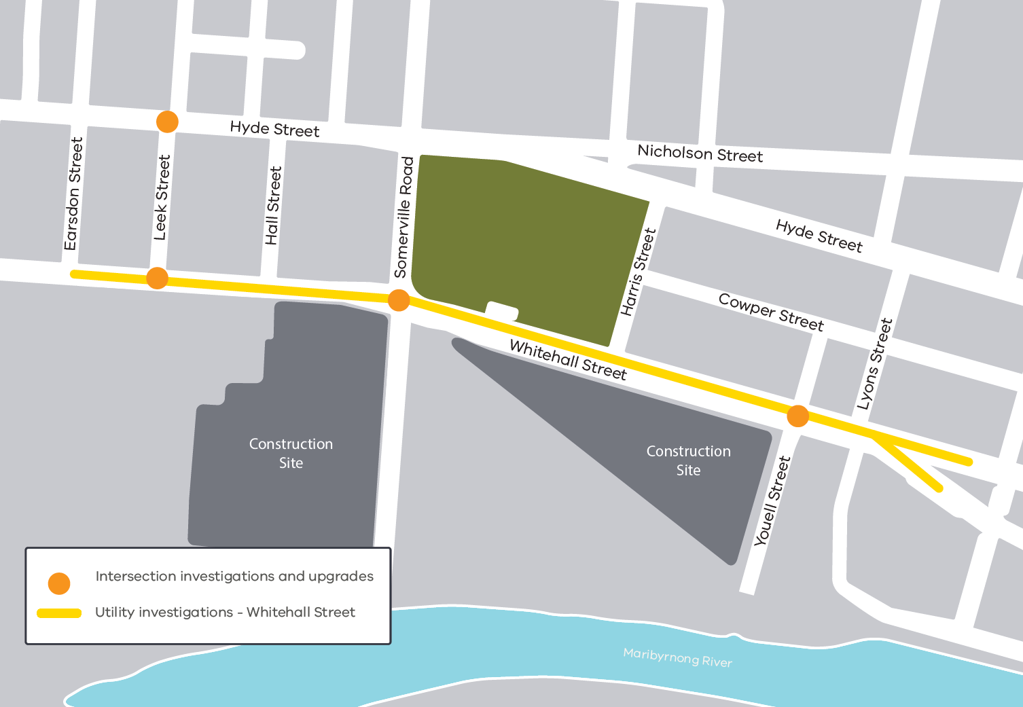

**Please note that works may be rescheduled in the event of bad weather or other unavoidable circumstances. For updates and more information about our works please visit westgatetunnel.vic.gov.au or contact us using the details below.**

|  |  |
| --- | --- |
| **Contact us**  Please contact us if you have any questions or feedback about these works. | |
|  | |
|  | westgatetunnelproject.vic.gov.au |
|  | westgatetunnelproject@wda.vic.gov.au |
|  | 1800 105 105 |
|  | facebook.com/westgatetunnelproject |
|  | @westgatetunnel |
|  | West Gate Tunnel Project  GPO Box 4509  Melbourne Victoria 3001 |
|  | **Interpreter service: 13 14 50** |