Air Quality

Overview
This chapter provides an assessment of the air quality impacts associated with the construction and operation of Melbourne Metro. The chapter is based on the impact assessment presented in Technical Appendix H Air Quality. All relevant references are provided in Technical Appendix H.
A key requirement of the EES for Melbourne Metro is that it identifies ways to minimise adverse impacts on the amenity of nearby residents and local communities. One of the ways in which Melbourne Metro could affect amenity is through dust and other emissions that could result in a deterioration of air quality.
The existing air quality within the proposed project boundary is good to fair, with the possibility of an occasional exceedance of particulate matter (PM). Regional air quality impacts from the operation of the project are considered insignificant, although the project may result indirectly in a marginal improvement in air quality through a modal shift from cars to trains.
Temporary, localised adverse impacts to air quality are expected during the construction of Melbourne Metro from dust and combustion emissions.
Dust emissions generated by construction works would be expected to have the greatest impact on local air quality in places close to construction work sites, with most impacts occurring at the proposed Fawkner Park, Arden and Domain construction work sites in Precincts 1, 3 and 7 where there would be a high number of truck movements and a high intensity of dust-generating activities.
The Parkville station precinct (Precinct 4) has been identified as a highly susceptible area due to the location of a number of highly sensitive receptors (such as health and education facilities) in close proximity to the project. Dust monitoring at sensitive receptors at these locations would be likely to be required to demonstrate compliance with the air quality criteria set for Melbourne Metro and to provide input for a reactive air quality management system that would allow site activities to be modified in response to adverse meteorological and environmental conditions.
Meeting the Environmental Performance Requirements for the construction phase of Melbourne Metro would require the adoption of well-tested dust prevention, control and suppression mitigation measures to manage and minimise the impacts of dust emissions. These measures include minimising the extent of spoil stockpiles, applying water to unsealed surfaces to suppress dust, minimising double handling of material, re-vegetating areas of disturbed soil as soon as practicable and modifying activities according to weather conditions.
The adoption of best practice mitigation measures would be required under legislation and would also be necessary to minimise the risks of exceedances, especially on days with high background particulate concentrations.
The major contributors to dust emissions are truck movements on unsealed surfaces and wind erosion of open areas. Best practice would be to minimise the potential for dust generation by reducing or eliminating these sources of emissions where possible. This would be achieved by reducing the distance travelled by trucks on unsealed surfaces, by planning stockpile locations and haul road routing to minimise the distance travelled, and by sealing haul roads where possible. Wind erosion from exposed areas would be minimised by sealing or establishing vegetation on exposed surfaces or by enclosing areas with sheds if practicable. Chapter 13 Noise and Vibration proposes the use of acoustic enclosures (sheds) at some precincts, which would assist in reducing the area of exposed surfaces subject to wind erosion and, consequently, the volume of dust emissions from the construction work site.
In addition to the mitigation measures listed in this chapter, temporary ventilation facilities would require suitable dust extraction and filtration systems where dust would be extracted to the surface from underground excavations. As the detailed design and location of these systems would be determined in the delivery phase, they have not been considered in the impact assessment.
As Melbourne Metro would use electric trains, air emissions associated with the routine operation of the tunnels would be insignificant.

EES Objective
The EES Scoping Requirements set the following draft evaluation objective for air quality:
- Amenity – To minimise adverse air quality effects on the amenity of nearby residents and local communities, as far as practicable, especially during the construction phase.
In accordance with this objective, the air quality impact assessment involved an investigation of existing air quality within the proposed project boundary and air dispersion modelling. Potential air quality risks and impacts associated with the construction and operation of Melbourne Metro were then assessed. Using this information, specific Environmental Performance Requirements and mitigation measures were identified to ensure that adverse air quality impacts would be avoided or minimised.

Legislation and Policy
As discussed in Chapter 4 EES Assessment Framework and Approach, emissions from Melbourne Metro would be managed and assessed in accordance with Commonwealth and Victorian air quality standards, goals, objectives and requirements. The main laws and policies relevant to Melbourne Metro are set out in Table ‎12–1.
Table ‎12–1 Air quality legislation and policy relevant to Melbourne Metro
Legislation | Policy/guideline | Comment
Commonwealth
National Environment Protection Council Act 1994 | National Environment Protection (Ambient Air Quality) Measure | The NEPC Act and complementary State and Territory legislation allow the National Environment Protection Council (NEPC) to make National Environment Protection Measures (NEPMs). These measures assist in protecting or managing particular aspects of the environment. The NEPMs covering air quality are the National Environment Protection (Ambient Air Quality) Measure and the National Environment Protection (Air Toxics) Measure.  The impact of emissions from Melbourne Metro would be assessed in accordance with the Ambient Air Quality NEPM, as adopted by the complementary Victorian State Environment Protection Policy (Ambient Air Quality) (SEPP (AAQ)).  As Melbourne Metro is not expected to contribute significantly to background air toxics, the management requirements of the Air Toxics NEPM would not be triggered.
State
Environment Protection Act 1970 | SEPP (Ambient Air Quality) | SEPP (AAQ) applies the standards and objectives of the Ambient Air Quality NEPM to Victoria. Emissions from Melbourne Metro would be managed in accordance with SEPP (AAQ) for six primary pollutants: carbon monoxide, nitrogen dioxide, ozone, sulphur dioxide, lead and particles (as PM10).
 | SEPP (Air Quality Management)  Protocol for Environmental Management (PEM): Mining and Extractive Industries | To meet the SEPP (AAQ) objectives, the SEPP (AQM) establishes a framework for managing emissions.  Meeting SEPP (AQM) requirements would include applying ‘best practice’ mitigation techniques, methods and processes, undertaking ongoing reporting and pursuing continuous improvement.  The PEM would not be mandatory for Melbourne Metro but it has been prepared under the SEPP (AQM) and contains the only relevant criteria for dust deposition associated with mobile equipment.
 | EPA Environmental Guidelines for Major Construction Sites (Publication 480) | These guidelines would be incorporated within the Environmental Management Plan (EMP) for Melbourne Metro’s construction phase. This would include the development of a dust prevention strategy and the implementation of dust control and suppression measures.
Local
 | Activities Local Law 2009 and Construction Management Plan Guidelines 2006 (City of Melbourne)  General Local Law 2008 (No. 1) (City of Stonnington) | These documents provide guidance for managing air emissions generally and during construction. They are guides only. However, the preparation of the Construction EMP for Melbourne Metro would take these (and other relevant local government by-laws and policies) into consideration.

Methodology

Assessment approach

Study Area
With the exception of the TBM tunnelling works (where emissions to air would be contained within the tunnels), impacts to air quality are expected in all locations where construction activities would be conducted. Accordingly, the study area for the impact assessment spans all construction precincts, with the areas of greatest risk identified as those with the highest intensity of construction works and handling of excavated spoil.
The assessment focuses on the major construction work sites at Arden, Domain and Fawkner Park. These sites would be the extraction points for removal of TBM tunnelling spoil and a high number of truck movements would be required at these sites, in addition to other construction activities.

Desktop Assessment
Using available baseline and background data (see Section ‎12.4.2 below), a desktop assessment was undertaken based on SEPP (AQM) requirements for an air quality impact assessment. This included:
- Obtaining and assessing air quality monitoring data and meteorological information to establish existing air quality conditions and characteristics within the proposed project boundary
- Reviewing the construction and operation activities proposed in each project precinct, in conjunction with a land use survey, and identifying the activities that would result in air emissions
- Confirming the locations of sensitive receptors that may be impacted by construction and operation air emissions
- Identifying the main potential air quality impacts and risks for each precinct
- Establishing measures to avoid or minimise adverse air quality impacts during construction and operation.
Details of the tools and methods used in the assessment are provided in Section 4 of Technical Appendix H Air Quality.
As post-construction air emissions associated with the routine operation of Melbourne Metro (as part of the metropolitan rail network) were assessed as being negligible compared to construction-related emissions, the baseline air quality investigation focused on issues and potential risks relevant to construction activities.

Air Dispersion Modelling
An assessment of the air quality risks associated with Melbourne Metro (summarised in Section ‎12.6) identified three locations as having a potentially high risk of air quality impacts prior to mitigation: Fawkner Park, Arden and Domain. These locations were selected for detailed assessment for construction dust based upon the level of construction activities expected and their proximity to sensitive receptors. These three locations are where TBM spoil would be extracted and would have the highest spoil volumes and haulage rates.
While Parkville is potentially the most sensitive of the Melbourne Metro precincts as it is in close proximity to a number of health and educational facilities, the truck movements are estimated to be less than half of those from sites where the TBM spoil would be extracted. The lower spoil volumes and haulage rates would result in a lower intensity of dust generating activities, meaning that, although Parkville is a highly sensitive location, it was not considered to have a high risk of air quality impacts and was not selected for detailed assessment.
The dispersion modelling methodology for this assessment was undertaken in accordance with the SEPP (AQM) using the EPA’s regulatory air pollution model (AMEROD), with consideration given to the draft EPA guidelines for use of the model. Details on the use of the model for Melbourne Metro are provided in Section 4 of Technical Appendix H.
Emissions estimates used in the modelling assume truck movements are on unsealed surfaces and that the majority of the area of each construction work site would be exposed to wind erosion. Common dust mitigation methods have been applied in the model including dust suppression using water for haul roads, stockpiles and exposed areas, and wind breaks for stockpiles and exposed areas.

Baseline and Background Data
Data sources used in the air quality assessment included:
- Air quality data from EPA’s network of monitoring sites
- EPA’s annual air quality reports (which test compliance with the NEPMs)
- Detailed air dispersion modelling (outlined in Section ‎12.4.1 above)
- Meteorological data (including wind speeds and directions) from Bureau of Meteorology monitoring sites.
Details of the baseline air quality and meteorological data provided by these sources and used in the assessment are included in Section 5 of Technical Appendix H.
In addition, this assessment was independently peer reviewed.

Existing Conditions

Regional Air Quality
Melbourne Metro would be located within the Port Phillip Air Quality Control Region, which incorporates a population of approximately 3.5 million and covers an area of approximately 24,000 km².
The EPA monitors air quality at 10 long-term monitoring locations within this region, with additional monitoring undertaken on a short-term basis at other sites. As shown in Figure ‎12-1, the main sources of air pollution in the Port Phillip Air Quality Control Region are motor vehicle emissions, industry and solid fuel combustion.
Figure ‎12-1 Sources of air pollution for Port Phillip Air Quality Control Region
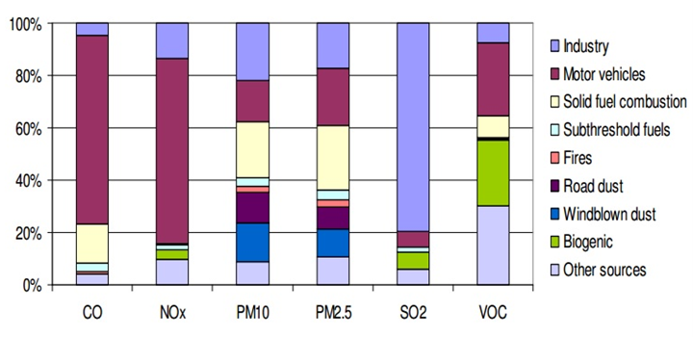
Source: EPA Victoria submission to Senate inquiry into the impacts on health of air quality in Australia, March 2013, and EPA Victoria’s 2006 Air Emissions Inventory (unpublished)

Air Quality at Melbourne Metro Sites
The closest sites monitored by the EPA in the vicinity of Melbourne Metro are Richmond (approximately 2.3 km from the eastern portal) and Footscray (approximately 4.5 km from the western portal). The EPA has monitored ambient air quality at Richmond and Footscray for over a decade, contributing to a sound understanding of ambient air quality across Melbourne.
Particulate matter emissions
Particulate matter (PM) dust emissions are likely to be the main air pollutant during construction of Melbourne Metro.
Particulate matter in the atmosphere refers to a range of particle types and sizes. The particles may be emitted from natural sources such as windblown dust, sea spray, bush fire, and pollens; or from sources such as combustion of fuels, power generation, industrial activities, excavation works, unpaved roads and the crushing and handling of materials.
Particulates are classified according to their size. PM₁₀ and PM_{2.5} are particles with diameters less than or equal to 10 and 2.5 micrometres respectively. Smaller particles (less than PM10) are more hazardous to human health as they can penetrate further into the respiratory tract and lungs. They can also cause minor health effects, such as eye irritation. Larger particles mainly cause aesthetic impacts, usually associated with particles settling on surfaces.
‘Nuisance’ dust emissions from construction activities are commonly larger than 20 micrometres in diameter. They are not harmful to human health, but can soil clean surfaces (such as cars, window ledges and household washing), collect on fruit and vegetables, and interfere with outdoor activities (such as playing sport or walking or cycling).
Given the large geographic area impacted by Melbourne Metro, the regional nature of the key air quality pollutants and the absence of significant existing local pollutant sources in proximity to the key construction work sites, no project-specific baseline air quality investigations were undertaken.
EPA air quality data from the Richmond and Footscray monitoring sites was considered to be representative of air quality for the proposed locations of Melbourne Metro. Richmond is located approximately 3 km from the CBD and is characterised predominantly by residential and commercial properties. Footscray is located a greater distance from the CBD and supports a higher proportion of industrial businesses than Richmond.
The major Melbourne Metro construction work sites are predominantly located in residential and commercial districts and Richmond was therefore considered the most representative site, being nearest to the majority of the Melbourne Metro alignment and supporting more similar land uses to the study area than Footscray.
Accordingly, monitoring data from Richmond between 2011 and 2014 was used to represent background air quality for Melbourne Metro, supplemented with data from Footscray where no data was available for Richmond.
The baseline assessment identified that existing air quality in the nine Melbourne Metro precincts is good to fair, with the NEPM air quality goals met for all pollutants at each site, except for PM10 at Footscray in 2014 where there were six days of exceedance – one more than the allowable exceedance of five days/year.
There were occasional exceedances of the 24-hour PM10 criteria at Footscray in 2012 (three days), 2013 (two days) and 2014 (six days), and at Richmond in 2014 (four days). There was one exceedance of the 24-hour PM2.5 criteria at Footscray in 2014 (one day).

Risk Assessment
An Environmental Risk Assessment has been completed for the impacts of Melbourne Metro in relation to air quality. Further information about the risk assessment approach adopted for Melbourne Metro is included in Chapter 4 EES Assessment Framework and Approach.
Impact assessment must be informed by risk assessment so that the level of mitigation action relates to the magnitude and likelihood of an adverse impact occurring.
A high risk of increased dust and combustion emissions from the handling, storage and removal of spoil was identified initially in Precincts 1, 3 and 7, with all other precincts (except Precinct 9) having a medium risk.
The impact assessment focused on those risks that were assessed as having an initial risk level of medium or above. As a result of the impact assessment, project-specific Environmental Performance Requirements – combined with the implementation of identified mitigation measures (such as dust suppression and air quality monitoring) – have been recommended to reduce the identified impacts.
Achieving these requirements would be expected to reduce the residual risk ratings of all potential air quality events to medium or lower. Depending on the degree to which haul roads and exposed surfaces can be sealed, it may be possible to reduce residual risks to low or very low.
The air quality risk associated with Melbourne Metro with a residual risk rating of medium or above is shown in Table ‎12–2. A full list of air quality risks, showing the initial and residual risk rating of each risk, is provided in Technical Appendix B Environmental Risk Assessment Report and in Technical Appendix H Air Quality.
The recommended Environmental Performance Requirements are listed in Section ‎12.16.
Table ‎12–2 Air quality risks
Impact pathway |  | Project phase | Precincts | Residual risk rating
Category | Potential event
Handling, storage and removal of spoil | Increased dust and combustion emissions to air in the vicinity of the surface construction work sites due to handling of spoil, wind erosion and operation of vehicles on unpaved surfaces, resulting in a deterioration of the existing air quality environment. | Construction | 1 – Tunnels (Fawkner Park construction work site and emergency access shafts)  2 – Western portal  3 – Arden station  4 – Parkville station  5 – CBD North station  6 – CBD South station  7 – Domain station  8 – Eastern portal | Medium

Activities with low residual risk outcomes include general earthworks and construction, station and platform construction post-excavation, the operation of construction ventilation shafts and exhaust fans, boring and excavation works, restoration of surface areas and emissions due to non-routine or emergency events such as tunnel wall cleaning or fire.

Impact Assessment
Potential air quality impacts expected from Melbourne Metro would be associated with construction activities. Some routine operational emissions would also be expected.
Potential air quality impacts from the construction and operation of Melbourne Metro would be expected at precinct or local levels only. No significant adverse impacts to regional air quality would be anticipated.
The main impacts identified in the air quality assessment are described below. Sections ‎12.8 to ‎12.15 describe these impacts as they apply specifically to each of Melbourne Metro precincts.

Construction

Construction Dust Emissions
Dust emissions would be expected to be the main air pollutant during the construction of Melbourne Metro. Construction works likely to generate dust include general earthworks and clearing activities, wheel-generated dust, wind generated dust from exposed surfaces, the on-site concrete batching plant and restoration of surface areas. The main pollutants of concern are airborne particulate matter (PM10 and PM2.5) and dust deposition (see box on page 12–7).
Dust emissions associated with construction would be likely to vary in intensity and duration, with the potential for air quality impacts at some sensitive receptors. The risk of elevated 24-hour PM10 and PM2.5 impacts and monthly dust deposition impacts at the precinct level are summarised in Table ‎12–3.
Table ‎12–3 Summary of air quality risk factors at precinct level
Precinct | Main issues | Commentary
All precincts | Receptors in very close proximity to works that have the potential to generate dust emissions | Dust emissions would likely to be intermittent in nature, with potential for short-term impacts at sensitive receptors. Some locations would be more affected than others, due to a higher volume of spoil being extracted, handled and transported.
All precincts | Construction works coinciding with days of high background PM2.5 and PM10  Intensive construction works for extended periods in close proximity to sensitive receptors | During days of high background particulate matter, the addition of incremental impacts from construction dust emissions could exceed the PM10 (24-hour) criteria set by SEPP (AQM) of 50 µg/m³.
All precincts | Potential to encounter contaminated spoil requiring high level dust containment  Intensive construction works for extended periods in close proximity to sensitive receptors | Dust and odour emissions resulting from the excavation and handling of contaminated soil and the operation of construction vehicles/equipment over existing contaminated soils could give rise to contaminated dust particles (such as heavy metals) or odours, impacting on the nearest sensitive receptors.

In general, dust emissions are likely to be intermittent, with short-term impacts occurring at receptors close to construction activities and sites depending on wind direction. Specific Environmental Performance Requirements would be included in the CEMP to minimise dust emissions at the precinct level and to manage location-specific impacts.
Deposited dust is an indicator of the effectiveness of site management practices and the potential for nuisance dust. While the criteria for deposited dust set out in the PEM: Mining and Extractive Industries are used typically in Victoria to protect the amenity of populations near mines or quarries, they also apply to major construction work sites with significant dust emissions.
Dust control measures
Dust control measures available for Melbourne Metro fall into three broad categories:
- Design controls – measures such as physical barriers (screens and wind breaks), revegetating areas of disturbed soil as soon as practicable and applying water or dust suppression agents on exposed surfaces and stockpiles
- Planning controls – measures such as concentrating dust generating activities at locations where adequate buffer distances to sensitive receptors can be maintained
- Operational controls – varying activities when adverse meteorological and seasonal conditions occur, such as windy days or lengthy dry periods in summer.
As these are common practices, the air quality modelling undertaken for the impact assessment assumes the following dust control measures would be incorporated into Melbourne Metro:
- Water trucks would be used to suppress dust on all unsurfaced roads.
- Wind breaks would be used to protect stockpiles and unsealed surfaces from wind erosion.
- Water sprays would be used periodically to protect stockpiles and unsealed surfaces from wind erosion.
On the few days each year when background particulate matter would be high (see Section ‎12.5.2), the additional incremental impacts from construction dust emissions from Melbourne Metro could exceed the PM10 (24-hour) or PM2.5 (24-hour) criteria set by SEPP (AQM). This risk would be likely to be highest at the major construction work sites in Precincts 1, 3 and 7.
Modelling of dust emissions at higher risk construction work sites has demonstrated that with appropriate mitigation, air quality could be maintained within SEPP criteria even for a conservative assessment scenario where haul roads are unsealed and a majority of the site is exposed to wind erosion.
However, well-tested dust prevention, control and suppression measures would be used to manage and minimise the impacts of dust emissions from construction dust (see box at right). These measures would be part of a dust management and monitoring plan incorporated within the CEMP developed for Melbourne Metro. The CEMP would contain Environmental Performance Requirements to manage and mitigate dust impacts, would be prepared giving consideration to EPA Victoria’s Environmental Guidelines for Major Construction Sites and would apply to all locations where construction works would be undertaken.

Dust Emissions from Spoil
The excavation, storage and transport of tunnelling spoil would occur during the construction of Melbourne Metro. The greatest impacts would be likely to occur in Precincts 1, 3 and 7. Well-tested dust prevention, control and suppression measures are available to manage and minimise the impacts of spoil related dust emissions.
Most large inner city construction projects have the potential to encounter contaminated soil, rock and sediment. In most cases, contaminated soil would be managed using well-tried and effective mitigation methods such as wetting down of materials and/or covering trucks and stockpiles with high density polyethylene sheeting or tarpaulins – in other words, by adopting typical construction dust mitigation methods.
Prior to commencing excavation works, further sampling may be required by the contractors to finalise spoil waste categorisation and management plans. It is also anticipated that data gathering (and monitoring) would be ongoing for the duration of the project’s construction. Where a contaminant is identified and ascertained to require additional mitigation, an appropriate strategy would be developed and implemented by the contractor, and documented in the contaminated land management plan. Chapter 20 Contaminated Land and Spoil Management provides detail on the project’s potential to encounter and disturb contaminated soil and proposed mitigation measures.

Exhaust Emissions
Exhaust emissions (CO and NOx) from combustion would be generated from on-site plant and equipment, temporary ventilation stacks and construction traffic movements. Increased or more concentrated vehicle exhaust emissions have the potential to occur as a result of road closures or traffic diversions during construction.

Odorous Emissions
Odorous emissions from boring and excavation works, and from the transport and disposal of contaminated or acid sulfate soils (ASS), could also impact air quality during the construction of Melbourne Metro. The implications of encountering and disturbing ASS are discussed in Chapter 20 Contaminated Land and Spoil Management.

Operation
Routine operational emissions would be likely to include:
- Exhaust emissions from plant/equipment used in permanent ancillary operations (such as generators, boilers and heaters)
- Exhaust emissions from transport-related operations (such as transportation of materials, movement of maintenance vehicles, employee travel and waste removal)
- Exhaust emissions from periodic track maintenance activities
- Thermal emissions associated with venting heat from the tunnels and stations (a low risk for electrified rail tunnels).
These emissions would be negligible in comparison to construction-related air emissions and impacts. Overall, the potential regional impacts from the operation of Melbourne Metro would be insignificant but could result indirectly in a marginal improvement in air quality through a modal shift from cars to trains.
Non-routine operational emissions assessed as potentially resulting in a low residual risk are:
- Particulate matter within air extracted during cleaning of the walls of the tunnels (expected at five to 10 year intervals). Particulate matter composition and concentration during this operation would be unknown and it would be possible that wall cleaning would not be undertaken. Preliminary investigations indicate this activity would be unlikely to cause a significant air quality impact due to the likely wall cleaning processes that would be adopted and the operation of the tunnel ventilation systems
- Particulate matter (mainly smoke) from ventilation shafts in the event of a tunnel fire – Normally, such events are not assessed using standard ambient air quality assessment methodologies, as they would be rare events.

Precinct 1: Tunnels

Construction
Construction activities that have the potential to impact air quality in Precinct 1 are the tunnelling works (using TBMs, mined tunnels and cut and cover techniques) and the construction of emergency access shafts.
As most of the tunnels would be constructed using TBMs, which use electricity as their power source, air emissions from these works would be expected to be negligible, confined to below ground and unlikely to impact on nearby sensitive receptors. Tunnel spoil would be transported wet to other precincts for removal and dust generated underground would be managed in-situ using water suppression measures or extracted to one of the other precincts.
Above ground construction works would take place at the proposed emergency access shaft sites in Queen Victoria Gardens and Fawkner Park. While these activities would generate dust emissions, the relatively low intensity of activity at these locations means there would be a correspondingly small likelihood of air quality impacts.

Fawkner Park
Construction activities at Fawkner Park with the potential to result in air quality impacts in Precinct 1 are the possible TBM launch site (in tandem with Domain) for the southern section of Melbourne Metro (the other option being considered is at Domain only), as well as the site for other activities such as materials laydown, equipment storage and maintenance, site office and amenities, and spoil removal and handling.
Should the TBM be launched from Fawkner Park, there would be a high intensity of dust generating activities at this site, primarily related to spoil management and truck movements on unsealed surfaces.
An estimated 243,000 m³ of spoil could be extracted and stockpiled from the southern TBM sites (Domain and Fawkner Park). At Fawkner Park, maximum spoil handling and material deliveries are predicted to be 42 daily truck round trips.
During construction, there would be short-term, localised increases in dust emissions, with the following activities presenting the greatest risks:
- Handling, stockpiling and transport of excavated materials
- Wheel-generated dust from daily truck movements on unsealed site roads and local sealed roads
- Windborne erosion of exposed surfaces.
The potential TBM launch site is located within 50 m of the Fawkner Park Community Centre, which includes a Child Care Centre and Kindergarten and a Senior Citizens Centre. Other sensitive receptors include residences along the northern side of Toorak Road West, residential properties on the eastern side of St Kilda Road and other park users to the south, west and east of the work site. There would be potential for these receptors to be affected by dust emissions for all wind directions, with residences immediately to the north of the TBM launch site along Toorak Road West being at a higher risk of impact due to stronger southerly winds tending to occur during the afternoon.
Air dispersion modelling results for maximum 24-hour average PM10 ground level concentrations (GLC), including the background concentration (of 20.9 µg/m³), predicted no exceedances of the NEPM and SEPP objective (50 µg/m³). There were no predicted exceedances of the NEPM objective for maximum 24-hour average PM2.5 GLC (of 25 µg/m³), NEPM objective for annual PM2.5 GLC (of 8 µg/m³) or the EPA objective for monthly average dust deposition (of 4g/m²/month).
Dispersion modelling has shown that with management, construction activities would be unlikely to result in air quality impacts at sensitive receptor locations. Consequently, air quality would be maintained within SEPP criteria. However, given that background particulate concentrations can occasionally approach and exceed SEPP criteria, there would still be the potential for exceedances on days when background particulate concentrations are high.
Dust control measures would be required as specified in the recommended Environmental Performance Requirements in Section ‎12.16. The adoption of best practice mitigation measures is required under legislation and is necessary in order to minimise the risks of exceedances, particularly on those days with high background concentrations.
Best practice would be to minimise the potential for dust generation by reducing or eliminating sources of emissions where possible. This would be achieved by reducing the distance travelled by trucks on unsealed surfaces, by planning stockpile locations and haul road routing to minimise the distance travelled, and by sealing haul roads where possible. Wind erosion from exposed areas would be minimised by sealing or establishing vegetation on exposed surfaces or by enclosure with sheds if practicable. Chapter 13 Noise and Vibration recommends the possible use of acoustic enclosures (sheds) at some precincts, which would assist in reducing the area of exposed surfaces subject to wind erosion and, consequently, the volume of dust emissions from the work site.
In addition to adopting these measures, temporary ventilation facilities would require suitable dust extraction and filtration systems where dust is being extracted to the surface.
Dust monitoring at sensitive receptors is also likely to be required to demonstrate compliance with air quality criteria set for Melbourne Metro and to provide input for a reactive air quality management system that would allow site activities to be modified in response to adverse meteorological and environmental conditions.

Operation
During routine operation of Melbourne Metro, air quality impacts would be minimal. Electric trains operating on the network would emit few pollutants, resulting in a low probability of air quality impacts under normal operating conditions. While ventilation of the tunnel and stations would be required, the use of electric trains means that ventilation rates are expected to be low.
Emissions to air may occur in emergency conditions (for example, smoke would be emitted if there is fire in the tunnel) or during infrequent maintenance activities such as tunnel wall or track cleaning, when particulates may be emitted.
As noted in Section ‎12.7.2, while the potential impacts due to tunnel wall cleaning are unknown at this stage, preliminary investigations indicate they would be unlikely to have a significant air quality impact.

Alternative Design Options
The alternative emergency access shaft location at Tom’s Block would have identical sensitive receptors and would have no significant advantage or disadvantage over the Concept Design in terms of air quality impacts.
The alternative emergency access shaft location at the proposed Fawkner Park TBM launch site would have identical sensitive receptors as the TBM launch site. However, this option may offer some advantage over the Concept Design due to the elimination of an additional construction work site (assuming the TBM launch was to occur from this site).
Figures showing the results of air dispersion modelling for the Domain and Fawkner Park construction work sites operating concurrently are provided in Section ‎12.13.

Precinct 2: Western Portal (Kensington)

Construction
The main construction activities that may influence air quality in Precinct 2 would be the piled structure, decline structure, cut and cover tunnelling works, the TBM retrieval box and a major construction work site at 1–39 Hobsons Road in Kensington.
An estimated 57,000 m³ of spoil would be extracted from the western portal precinct. Maximum spoil handling and material deliveries are predicted to be 31 daily truck round trips.
During construction activities, there would be short-term, localised increases in dust emissions, with the following activities presenting the greatest risks:
- Handling, stockpiling and transport of excavated materials
- Wheel-generated dust from daily truck movements on unsealed site roads and local sealed roads
- Windborne erosion of exposed surfaces.
The western portal precinct contains housing, public open space and an industrial estate to the north-east. JJ Holland Park − to the north of the portal – is a popular recreational facility used by schools and sports clubs. Dust emissions from construction activities may affect these receptors, with residences and sporting facilities immediately to the north of the site along Childers Street at a higher risk of impact due to a tendency for stronger southerly afternoon winds.
These emissions would be managed in accordance with the recommended Environmental Performance Requirements (see Section ‎12.16).
Given that the frequency of truck movements and the distance travelled on unsealed surfaces is the greatest contributor to dust emissions, the lower intensity of these activities at the western portal is expected to result in air quality being maintained within SEPP criteria. The sealing of haul roads in line with best practice principles, would further reduce the likelihood of exceedances.

Operation
The same operational issues would arise in this precinct as for Precinct 1 – Tunnels (see Section ‎12.8.2).

Alternative Design Options
The alternative design option of the TBM retrieval box would provide a greater separation distance to residences on Childers Street, Ormond Street and Tennyson Avenue, and commercial properties in the 50 Lloyd Street Business Park. However, the sporting facilities immediately to the north of the site would be at a higher risk of impact. This option would require construction of a new rail bridge over Kensington Road, which is in close proximity to the Melbourne Seafood Centre and other food industry businesses, possibly outweighing any benefits from the greater separation from residential properties.

Precinct 3: Arden Station

Construction
Potential air quality impacts in this precinct would be associated with the tunnel excavation, TBM launch and the use of publicly owned (VicTrack) land as a major staging and construction work site for the northern section of the Melbourne Metro.
The proposed Arden construction work site would be the extraction point for removal of spoil from TBM tunnelling works, and would also include site offices and staff amenities, fabrication sheds, major storage areas and spoil handling facilities. A new concrete batching plant would be established on the site to produce pre-cast sections for the tunnels (the existing Boral facility on the site is proposed to be removed). Consequently, a high number of truck movements and a high intensity of dust-generating activities are anticipated in this precinct.
An estimated 479,000 m³ of spoil would be extracted from tunnel excavation and station works, and managed from the Arden site. Maximum spoil handling and material deliveries are predicted to be 182 daily truck round trips.
Air dispersion modelling for this precinct indicates that trucks transporting spoil, raw materials and pre-cast products on unsealed surfaces (both onsite and off the site) would result in the highest emissions, followed by wind erosion of exposed areas. Handling, stockpiling and transport of raw material for the concrete batching plant would also generate dust and exhaust emissions.
The sensitive receptors for the Arden precinct include a residential property on the corner of Laurens Street and Queensberry Street and the North Melbourne Recreation Centre in Arden Street. Dust emissions could affect these receptors during southerly and westerly winds.
The results of air dispersion modelling for the Arden station precinct are shown in Figures ‎12-2 to ‎12-5.
Figure ‎12-2 Air dispersion modelling results for Arden station precinct for maximum 24-hour average PM10 GLC
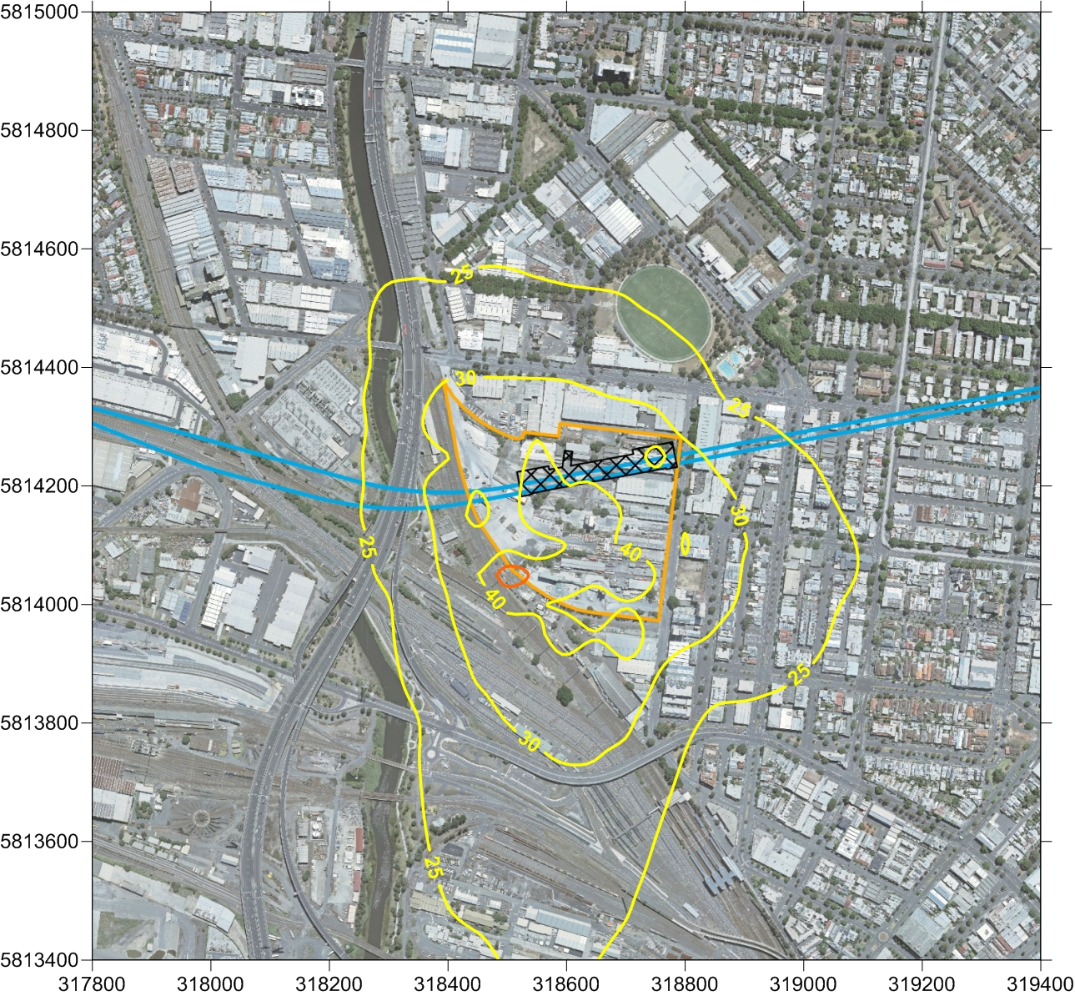

As Figure ‎12-2 shows, the air dispersion modelling results for maximum 24-hour average PM10 ground level concentrations (GLC), including the background concentration (of 20.9 µg/m³), found a small area of existing railway reserve adjacent to the south-west corner of the proposed construction work site with predicted exceedances of the NEPM and SEPP objective (50 µg/m³) − indicated by the red contour line.
Figure ‎12-3 Air dispersion modelling results for Arden station precinct for maximum 24-hour average PM_{2.5} GLC
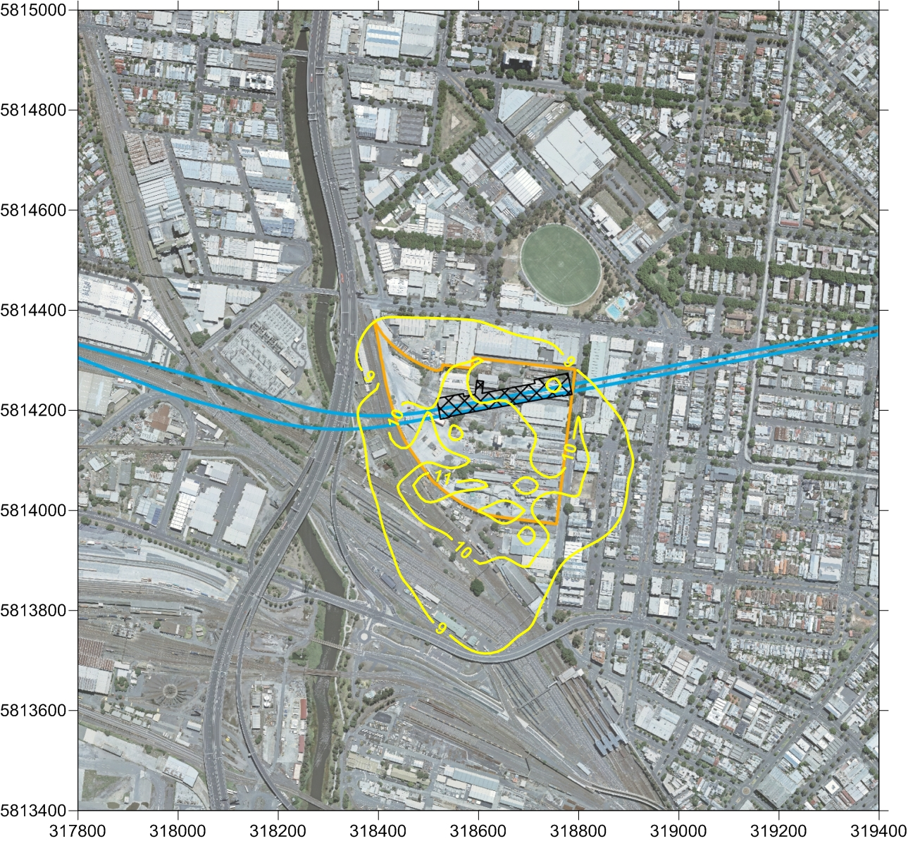

As Figure ‎12-3 shows, there were no predicted exceedances of the NEPM objective for maximum 24-hour average PM2.5 GLC (of 25 µg/m³).
Figure ‎12-4 Air dispersion modelling results for Arden station precinct for annual PM_{2.5} GLC
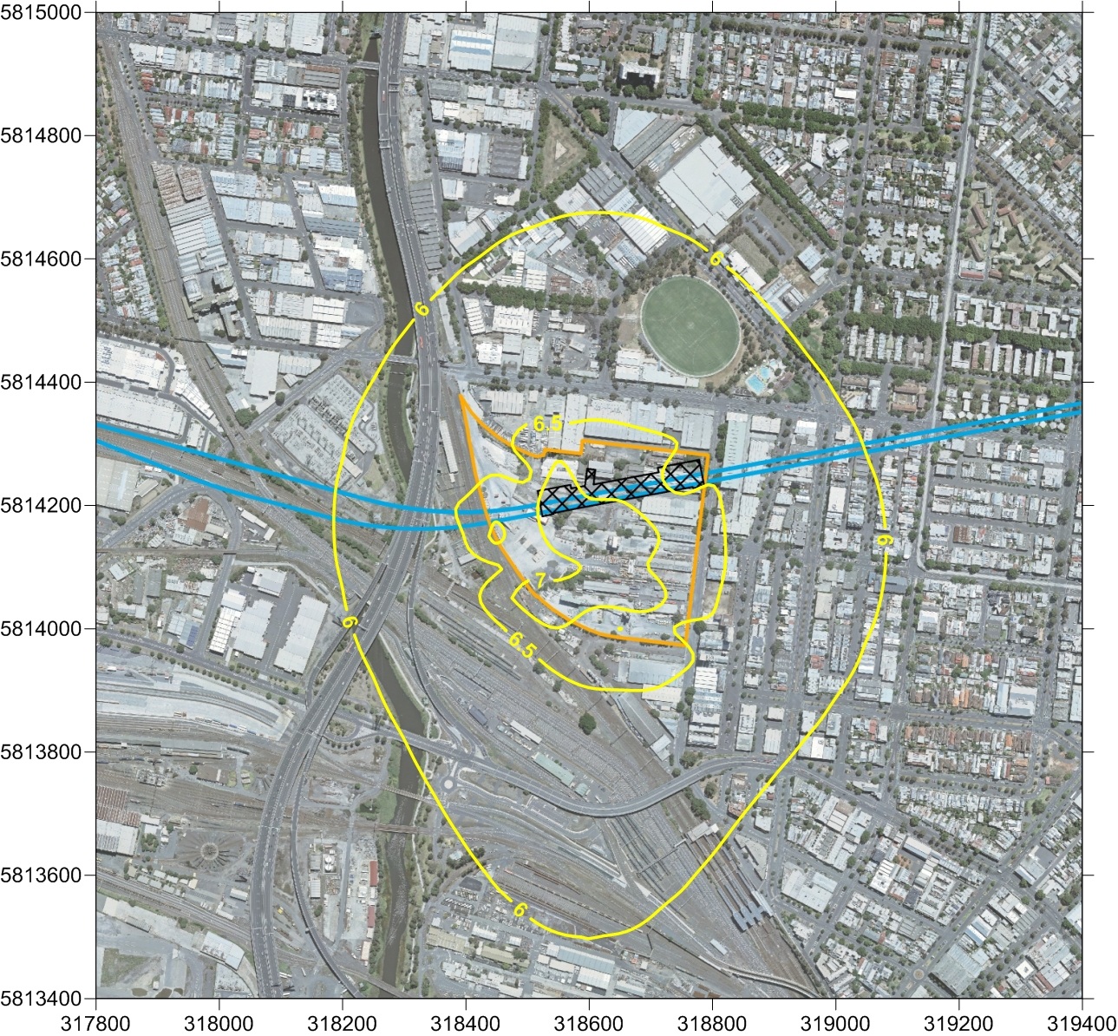

As Figure ‎12-4 shows, there were no predicted exceedances of the NEPM objective for annual PM2.5 GLC (of 8 µg/m³).
Figure ‎12-5 Air dispersion modelling results for Arden station for monthly average dust deposition
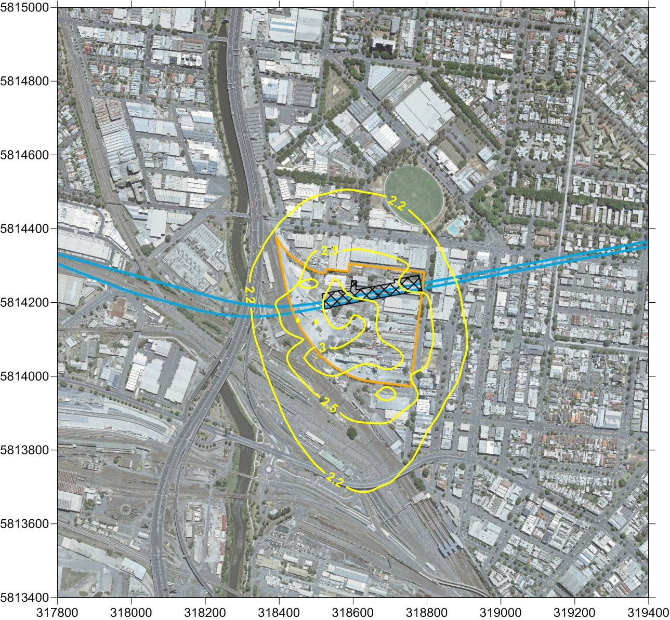

As Figure ‎12-5 shows, there were no predicted exceedances of the EPA objective of monthly average dust deposition (of 4g/m²/month).
Accordingly, it can be concluded that activities at the Arden construction work site would be unlikely to result in adverse air quality impacts at sensitive receptor locations. However, given that background particulate concentrations can occasionally approach and exceed SEPP and NEPM criteria, there would still be the potential for exceedances on days when background particulate concentrations are high.
Dust emissions in this precinct would be managed in accordance with the recommended Environmental Performance Requirements (see Section ‎12.16). The adoption of best practice mitigation measures would be required under legislation and would be necessary to minimise the risks of exceedances, particularly on those days with high background concentrations.
Best practice would be to minimise the potential for dust generation by reducing or eliminating sources of emissions where possible. This would be achieved by reducing the distance travelled by trucks on unsealed surfaces, by planning stockpile locations and haul road routing to minimise the distance travelled, and by sealing haul roads where possible. Wind erosion from exposed areas would be minimised by sealing or establishing vegetation on exposed surfaces or by enclosure with sheds if practicable. Chapter 13 Noise and Vibration recommends the possible use of acoustic enclosures (sheds) at some precincts, which would assist in reducing the area of exposed surfaces subject to wind erosion and, consequently, the volume of dust emissions from the work site.
In addition to these mitigation measures, temporary ventilation facilities would require suitable dust extraction and filtration systems where dust is being extracted to the surface.
Dust monitoring at sensitive receptors would also likely to be required to demonstrate compliance with the air quality criteria set for Melbourne Metro and to provide input for a reactive air quality management system that would allow site activities to be modified in response to adverse meteorological and environmental conditions.

Operation
The same operational issues would arise in this precinct as for Precinct 1 – Tunnels (see Section ‎12.8.2).

Precinct 4: Parkville Station

Construction
Activities that are likely to influence air quality in this precinct include cut and cover construction of the station and platforms, station entrance works, construction of the underground pedestrian access between the station and Grattan Street and a proposed temporary construction work site at 750 Elizabeth Street.
An estimated 299,000 m³ of spoil would be extracted from the Parkville station works. Maximum spoil handling and material deliveries are predicted to be 70 daily truck round trips.
During construction, the following activities would present the greatest risks for dust emissions:
- Handling, stockpiling and transport of excavated materials
- Wheel-generated dust from daily truck movements on unsealed site roads and local sealed roads
- Windborne erosion of exposed surfaces.
This precinct is potentially highly sensitive in relation to air quality due to the close proximity of medical facilities and education institutions to Melbourne Metro. The Peter Doherty Institute and the University of Melbourne’s Faculties of Medicine, Dentistry and Health Sciences are located within 50 m of the site and Royal Melbourne Hospital and Royal Women’s Hospital are located within 100 m of the site. Other sensitive receptors include commercial and residential properties to the south east. Dust emissions may affect these receptors for all wind directions.
These emissions would be managed in accordance with the recommended Environmental Performance Requirements (see Section ‎12.16).
Given that the frequency of truck movements and the distance travelled on unsealed surfaces is the greatest contributor to dust emissions, the lower intensity of these activities at Parkville station is expected to result in air quality being maintained within SEPP criteria. The sealing of haul roads, in line with best practice principles, would further reduce the likelihood of exceedances as would construction of acoustic sheds over the station box.
In addition to these mitigation measures, temporary ventilation facilities would require suitable dust extraction and filtration systems where dust is being extracted to the surface. The adoption of best practice mitigation measures would be required under legislation and would be necessary in order to minimise the risks of exceedances, particularly on those days with high background concentrations.
Best practice would be to minimise the potential for dust generation by reducing or eliminating sources of emissions where possible. This would be achieved by reducing the distance travelled by trucks on unsealed surfaces, by planning stockpile locations and haul road routing to minimise the distance travelled, and by sealing haul roads where possible. Wind erosion from exposed areas would be minimised by sealing or establishing vegetation on exposed surfaces or by enclosure with sheds if practicable.
Dust monitoring at sensitive receptors would be likely to be required to demonstrate compliance with the air quality criteria set for Melbourne Metro and to provide input for a reactive air quality management system that would allow site activities to be modified in response to adverse meteorological and environmental conditions.

Operation
The same operational issues would arise in this precinct as for Precinct 1 – Tunnels (see Section ‎12.8.2).

Alternative Design Option
The choice of construction method for Parkville station would make no difference to air quality impacts in this precinct.

Precincts 5 and 6: CBD North Station and CBD South Station
Similar air quality issues and impacts are associated with these two precincts.

Construction
Construction activities that may influence air quality impacts in Precincts 5 and 6 are:
- Spoil removal for mining of caverns for CBD North and CBD South stations
- Spoil removal for the CBD North to CBD South tunnelling works
- Excavated entrances for CBD North and CBD South stations
- Excavated connection to Melbourne Central Station from CBD North station
- Excavated connections to Flinders Street Station and Federation Square from CBD South station
- Major construction work site at City Square
- Several temporary construction work sites.
An estimated 438,000 m³ of spoil would be extracted from the CBD North station works. Maximum spoil handling and material deliveries are predicted to be 105 daily truck round trips.
Less spoil would be expected to be removed from the CBD South station works where an estimated 253,000 m³ of spoil would be removed. Maximum spoil handling and materials deliveries are predicted to be 105 daily truck round trips.
As these precincts are in a highly urbanised and dense inner urban area, construction works would be undertaken in close proximity to a number of highly sensitive receptors.
At the northern end of Swanston Street, RMIT University, Melbourne City Baths, Hardrock Climbing Gym and multi-storey residential apartments are within 50 m of the CBD North Station site, with the State Library within 100 m of the site. At the southern end of Swanston Street, Westin Hotel, Melbourne Town Hall, St Paul’s Cathedral and restaurants in City Square are within 50 m of the CBD South station site. To the west, medium- and high-rise residential, retail and offices are within 100 m of the site.
There would be potential for these receptors to be affected by dust emissions from construction activities for all wind directions and for an extended period of time, although these emissions would be likely to peak during early station construction works.
Dust emissions in these precincts would be managed in accordance with the recommended Environmental Performance Requirements (see Section ‎12.16). The adoption of best practice mitigation measures would be required under legislation and would be necessary to minimise the risks of exceedances, particularly on those days with high background concentrations.
Given that the frequency of truck movements and the distance travelled on unsealed surfaces is the greatest contributor to dust emissions, the lower intensity of these activities at CBD North and CBD South stations would be expected to result in air quality being maintained within SEPP criteria. The sealing of haul roads, in line with best practice principles, would further reduce the likelihood of exceedances, as would construction of acoustic sheds over the station entrance excavations.
Best practice would be to minimise the potential for dust generation by reducing or eliminating sources of emissions where possible. This would be achieved by reducing the distance travelled by trucks on unsealed surfaces, by planning stockpile locations and haul road routing to minimise the distance travelled, and by sealing haul roads where possible. Wind erosion from exposed areas would be minimised by sealing or establishing vegetation on exposed surfaces or by enclosure with sheds if practicable.
In addition to these mitigation measures, temporary ventilation facilities would require suitable dust extraction and filtration systems where dust is being extracted to the surface.
Dust monitoring at sensitive receptors is also likely to be required in this precinct, especially as atypical wind conditions due to the surrounding buildings may affect the dispersion of dust emissions. Monitoring would be used to demonstrate compliance with air quality criteria and to provide an input for a reactive air quality management system, allowing site activities to be modified in response to adverse meteorological and environmental conditions.

Operation
The same operational issues would arise in these precincts as for Precinct 1 – Tunnels (see Section ‎12.8.2).

Precinct 7: Domain Station

Construction
The main impacts on air quality in this precinct during construction would be associated with:
- Relocation and removal of traffic islands, tram stops and car parking spaces along St Kilda Road
- Temporary construction work sites, one on each side of St Kilda Road at Edmund Herring Oval and the Albert Road Reserve
- Tunnel and station box excavation
- Restoration of St Kilda Road and the parklands.
The Domain construction work sites would be required for the extraction and handling of spoil from TBM operations as well as site offices, equipment storage and materials laydown. A high number of truck movements and a high intensity of dust-generating activities are anticipated in this precinct.
An estimated 460,000 m³ of spoil would be extracted from the Domain precinct works. Maximum spoil handling and material deliveries are predicted to be 144 daily truck round trips.
A number of sensitive receptors are located within 50m of the site, including Melbourne Grammar School’s Wadhurst Campus and a number of residential and commercial properties. There is potential for these receptors to experience dust impacts for all wind directions.
The results of air dispersion modelling for the Domain station precinct are shown in the following eight figures. Figures ‎12-6 to ‎12-9 show the modelling results for the Domain only TBM launch option. Figures ‎12-10 to ‎12-13 show the results for the Domain and Fawkner Park TBM launch option, with both construction work sites operating concurrently.
Figure ‎12-6 Air dispersion modelling results for Domain station precinct for maximum 24-hour average PM10 GLC
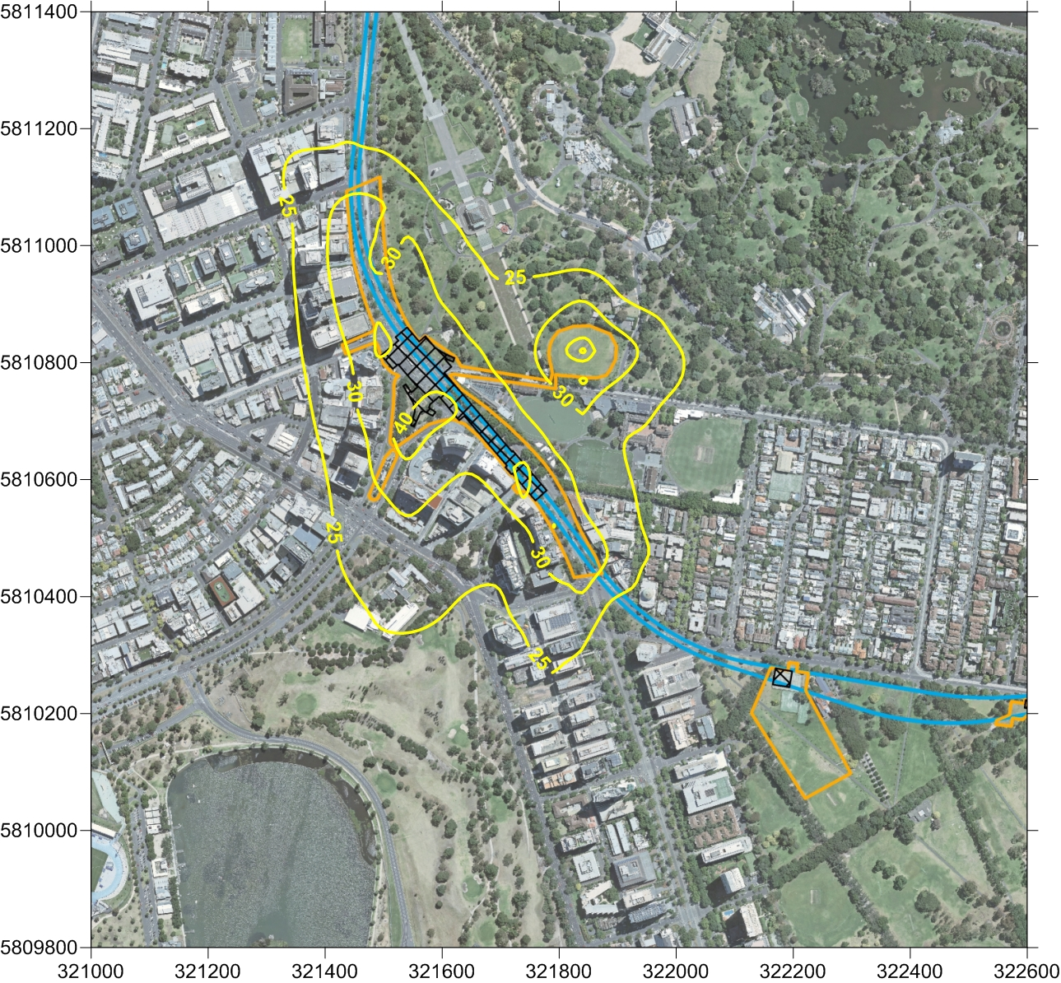

As Figure ‎12-6 shows, the air dispersion modelling results for maximum 24-hour average PM10 ground level concentrations, including the background concentration (of 20.9 µg/m³), found no predicted exceedances of the NEPM and SEPP objective (50 µg/m³).
Figure ‎12-7 Air dispersion modelling results for Domain station precinct for maximum 24-hour average PM2.5 GLC
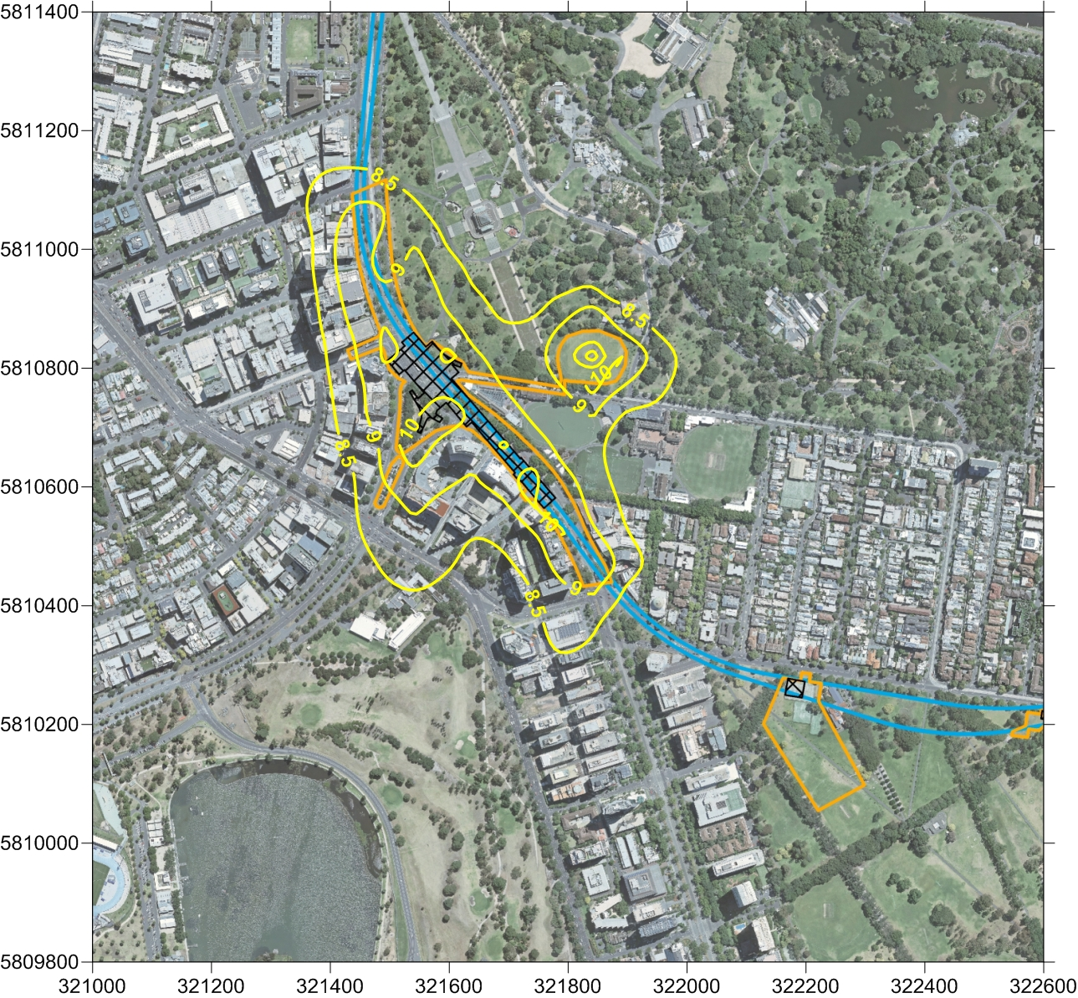

As Figure ‎12-7 shows, there were no predicted exceedances of the NEPM objective for maximum 24-hour average PM2.5 GLC (of 25 µg/m³).
Figure ‎12-8 Air dispersion modelling results for Domain station precinct for annual PM2.5 GLC
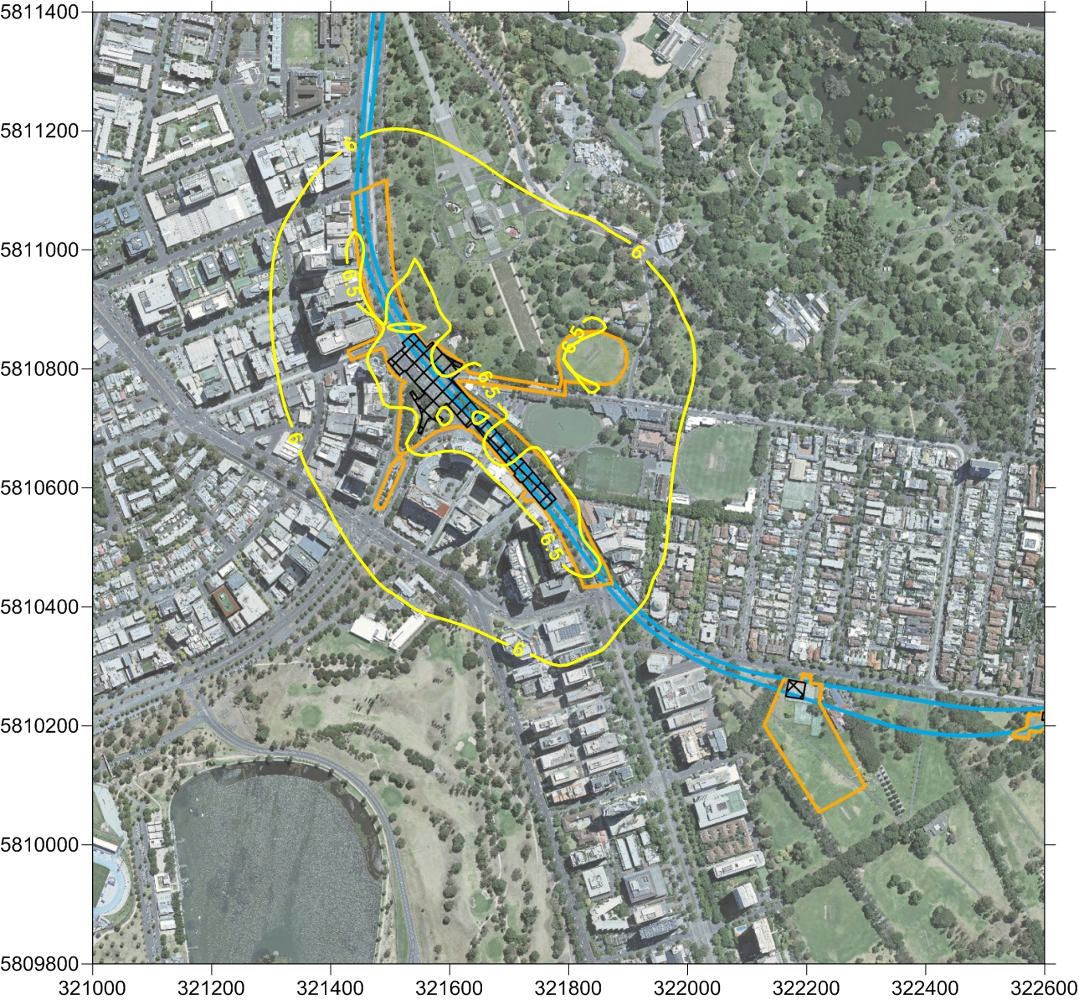

As Figure ‎12-8 shows, there were no predicted exceedances of the NEPM objective for annual PM2.5 GLC (of 8 µg/m³)
Figure ‎12-9 Air dispersion modelling results for Domain station precinct for monthly annual average dust deposition
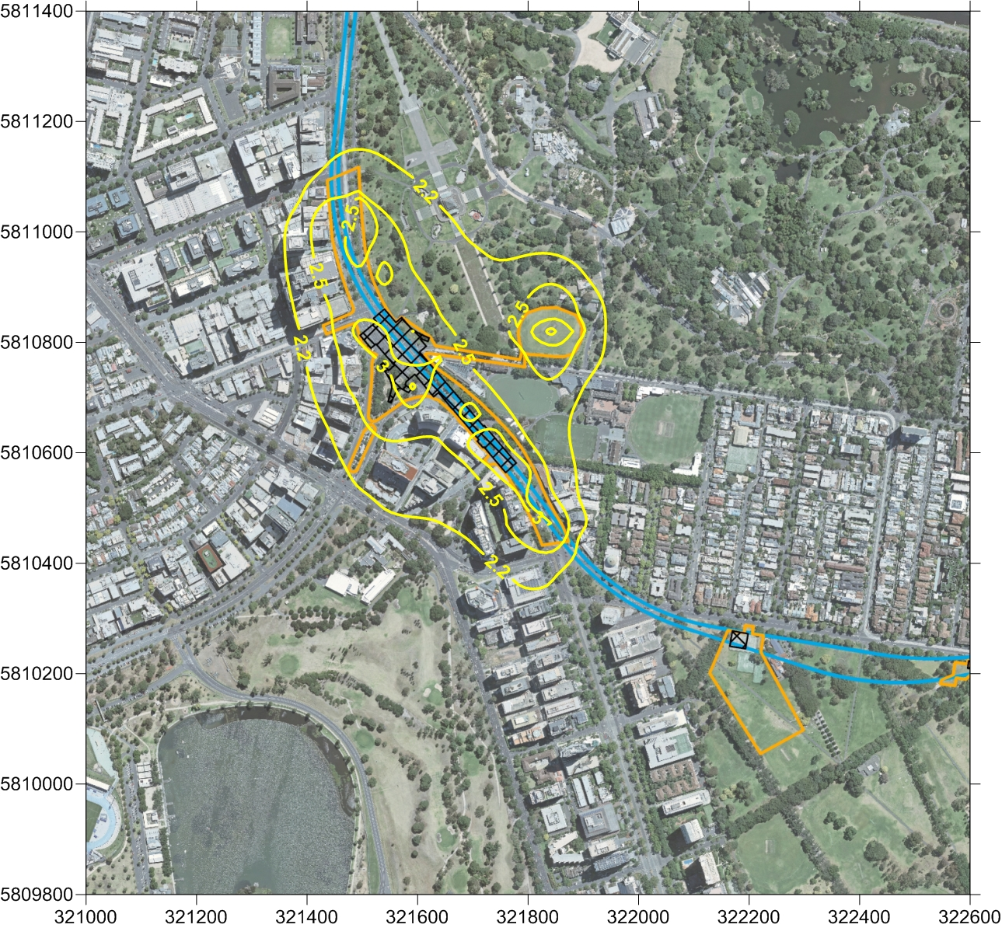

As Figure ‎12-9 shows, the air dispersion modelling results found no predicted exceedances of the EPA objective of monthly average dust deposition (of 4g/m²/month).
The Concept Design includes either a TBM launch site and major construction work site at Domain only, or a TBM launch site and major construction work site at both Domain and Fawkner Park. The two proposed work sites are less than 500 m apart and were therefore assessed concurrently.
Figure ‎12-10 Air dispersion modelling results for Domain and Fawkner Park for maximum 24-hour average PM10 GLC
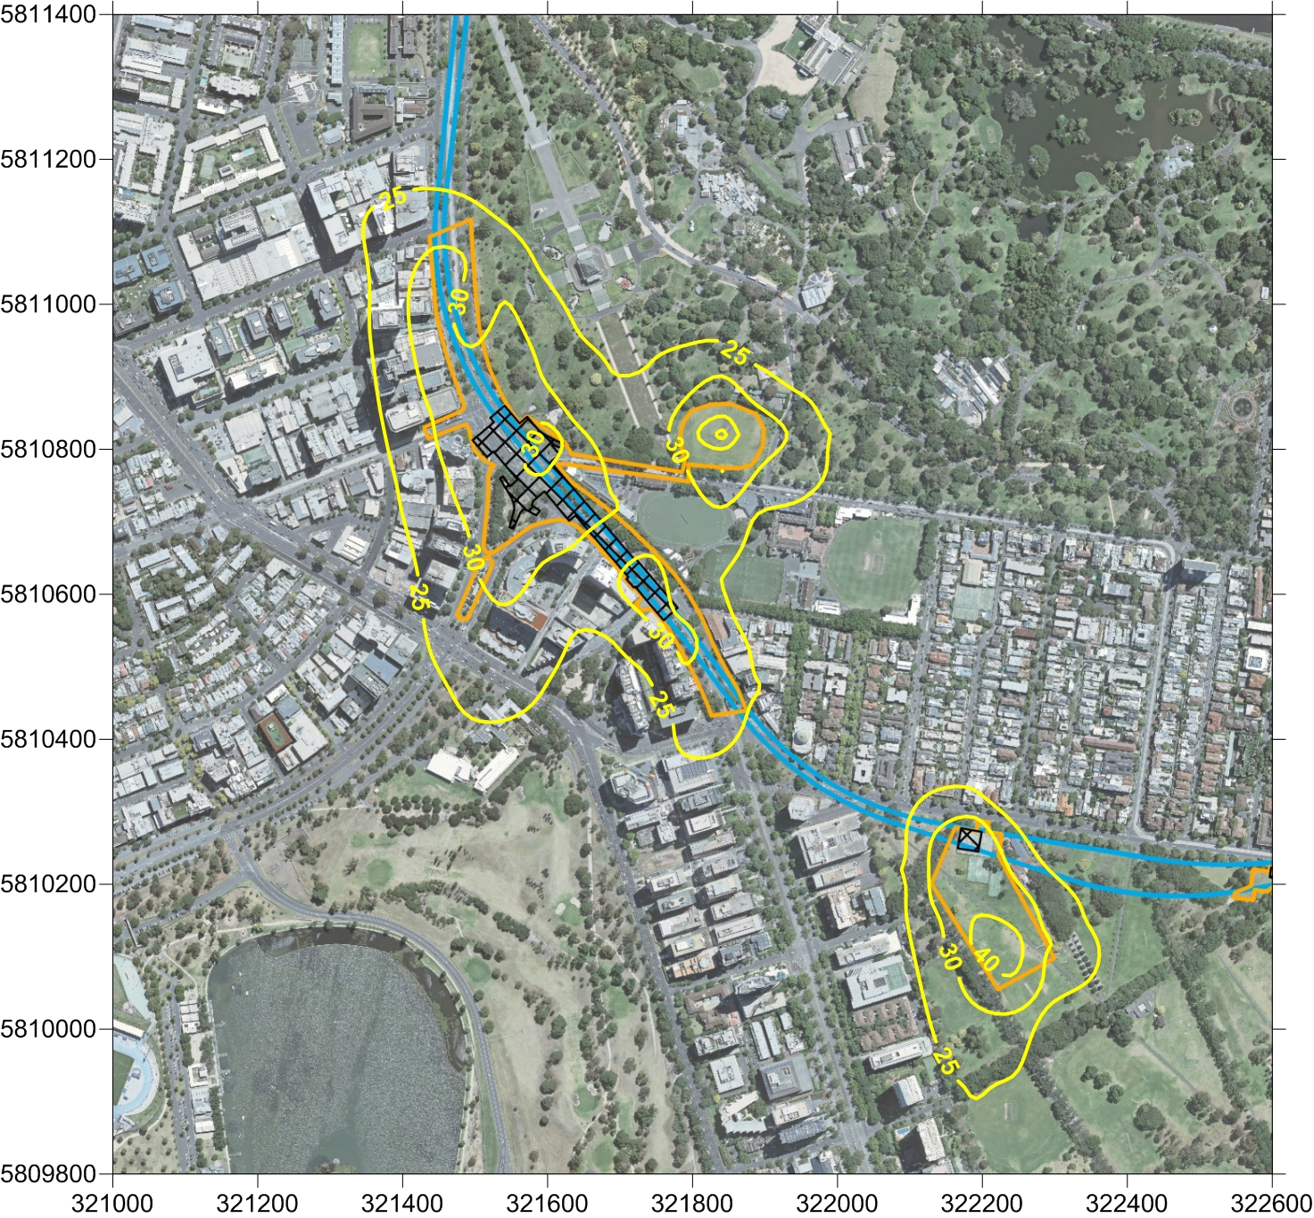

As Figure ‎12-10 shows, the air dispersion modelling results for maximum 24-hour average PM10 ground level concentrations, including the background concentration (of 20.9 µg/m³), found no predicted exceedances of the NEPM and SEPP objective (50 µg/m³).
Figure ‎12-11 Air dispersion modelling results for Domain and Fawkner Park for maximum 24-hour average PM2.5 GLC
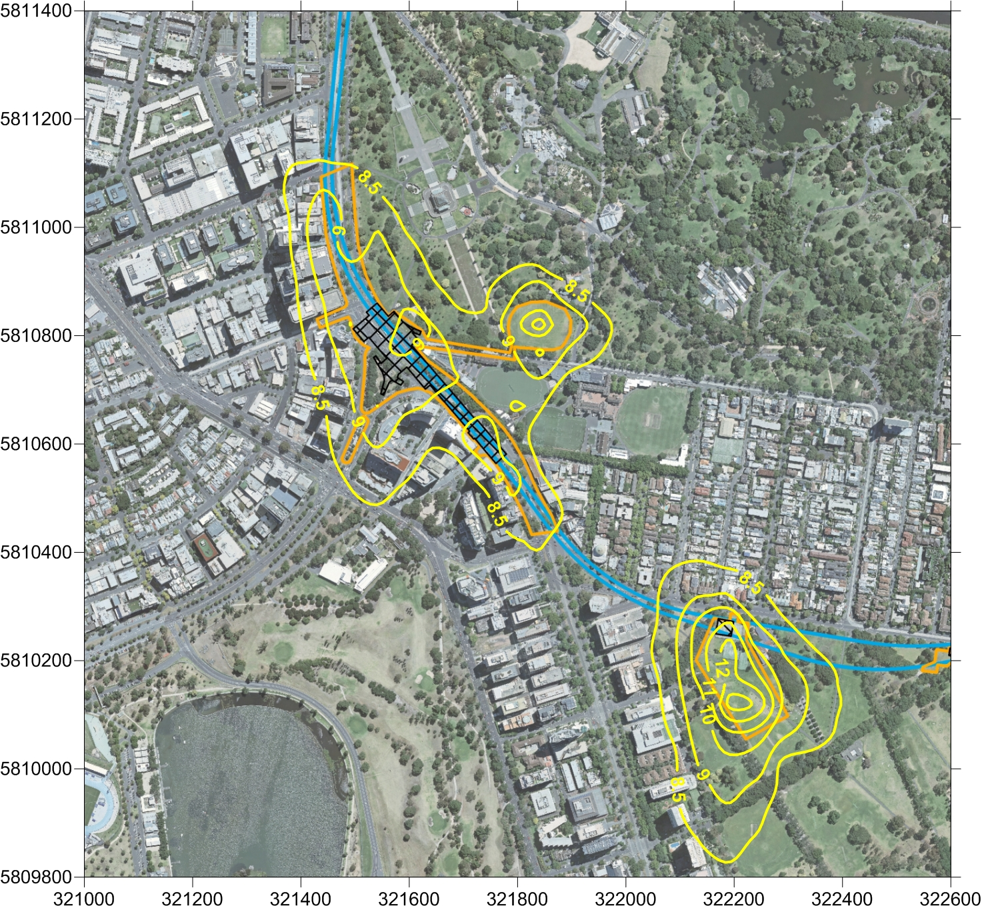

As Figure ‎12-11 shows, there were no predicted exceedances of the NEPM objective for maximum 24-hour average PM2.5 GLC (of 25 µg/m³).
Figure ‎12-12 Air dispersion modelling results for Domain and Fawkner Park for annual PM2.5 GLC
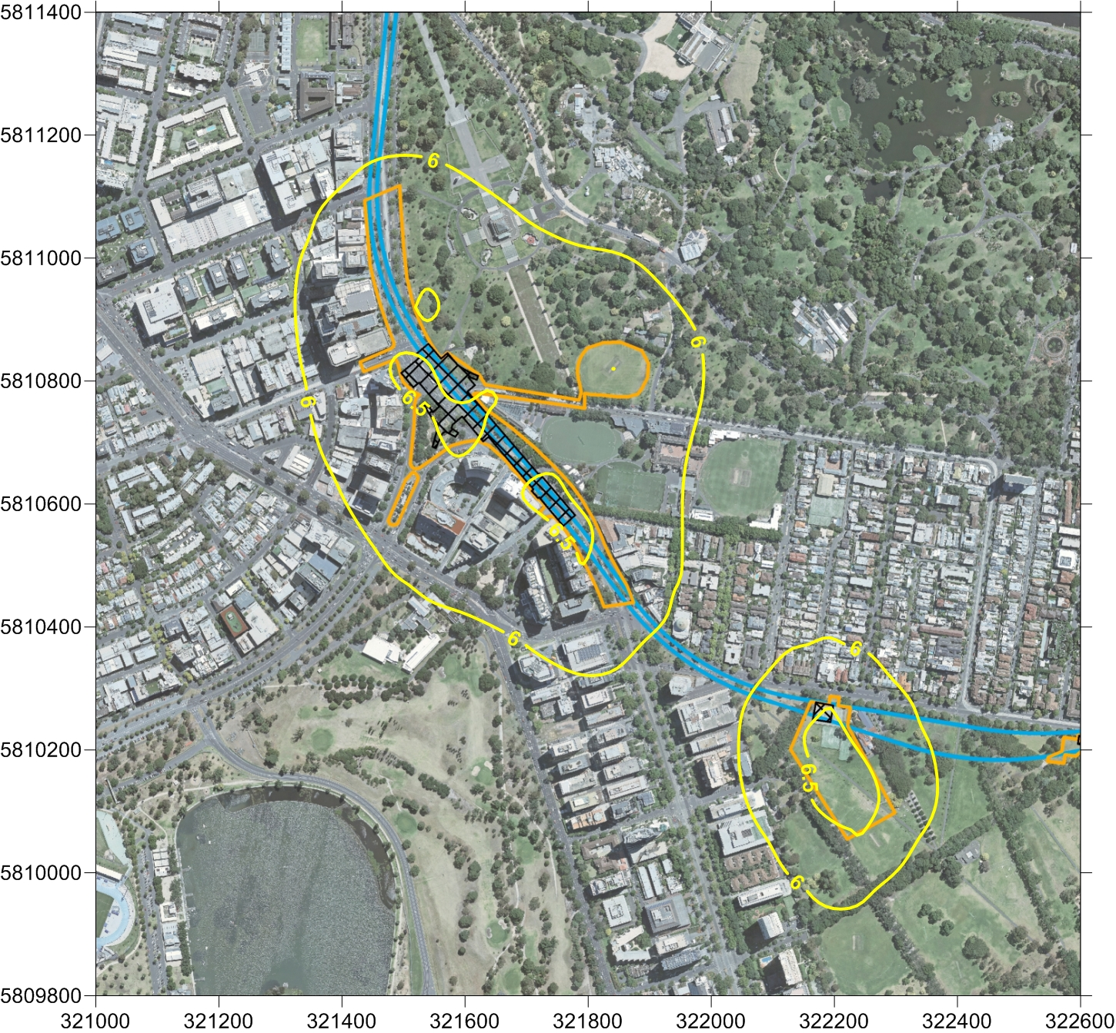

As Figure ‎12-12 shows, there were no predicted exceedances of the NEPM objective for annual PM2.5 GLC (of 8 µg/m³)
Figure ‎12-13 Air dispersion modelling results for Domain and Fawkner Park for monthly average dust deposition
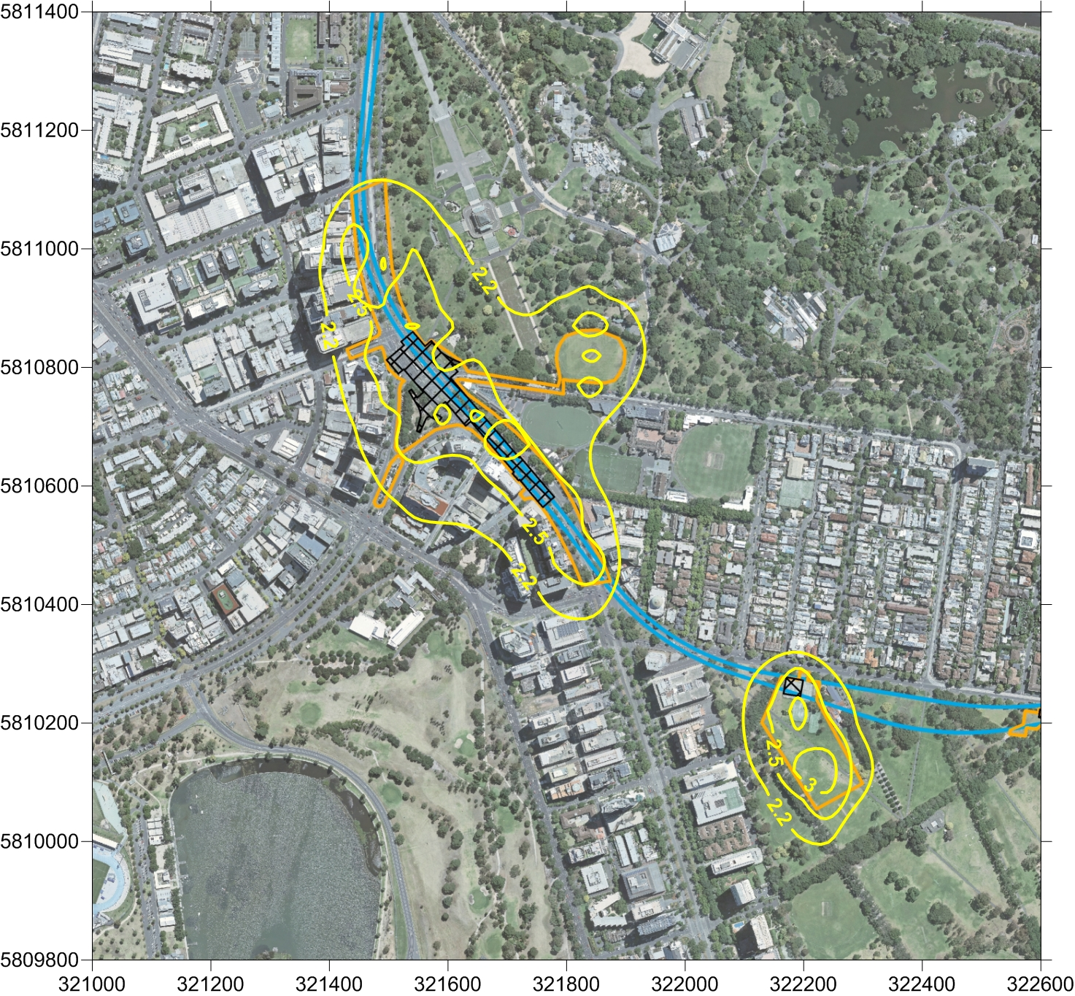

As Figure ‎12-13 indicates, the air dispersion modelling results found no predicted exceedances of the EPA objective of monthly average dust deposition (of 4g/m²/month).
The modelling results indicate that, with management, construction activities associated with the TBM launch facilities (both operating scenarios) are unlikely to result in any adverse air quality impacts at sensitive receptor locations and that, consequently, air quality would be maintained within SEPP criteria. However, given that background particulate concentrations can occasionally approach and exceed SEPP criteria, there would still be the potential for exceedances on days when background particulate concentrations are high.
Dust emissions in these precincts would be managed in accordance with the recommended Environmental Performance Requirements (see Section ‎12.16). The adoption of best practice mitigation measures is required under legislation and is necessary in order to minimise the risks of exceedances, particularly on those days with high background concentrations.
Best practice would be to minimise the potential for dust generation by reducing or eliminating sources of emissions where possible. This would be achieved by reducing the distance travelled by trucks on unsealed surfaces, by planning stockpile locations and haul road routing to minimise the distance travelled, and by sealing haul roads where possible.
Wind erosion from exposed areas would be minimised by sealing or establishing vegetation on exposed surfaces or by enclosure with sheds if practicable. Chapter 13 Noise and Vibration recommends the possible use of an acoustic enclosure (shed) over the TBM launch site, which would assist in reducing the area of exposed surfaces subject to wind erosion, and consequently the volume of dust emission from the construction work site.
In addition to these mitigation measures, temporary ventilation facilities would require suitable dust extraction and filtration systems where dust is being extracted to the surface.
Dust monitoring at sensitive receptors is also likely to be required in this precinct, especially as atypical wind conditions due to the surrounding buildings may affect the dispersion of dust emissions. Monitoring would be used to demonstrate compliance with air quality criteria and to provide input for a reactive air quality management system that would allow site activities to be modified in response to adverse meteorological and environmental conditions.

Operation
The same operational issues would arise in this precinct as for Precinct 1 – Tunnels (see Section ‎12.8.2).

Precinct 8: Eastern Portal (South Yarra)

Construction
The main construction activities that would potentially influence air quality in Precinct 8 are the widening of the existing rail corridor and construction of retaining walls, construction of an emergency access shaft and the TBM retrieval shaft, and the use of the South Yarra Siding Reserve and Osborne Street Reserve as major construction sites.
A relatively small volume of spoil – an estimated 47,000 m³ – would be extracted from the eastern portal works. Maximum spoil handling and material deliveries are predicted to be 31 daily truck round trips.
During construction activities, there would be short-term, localised increases in dust emissions, with the following activities presenting the greatest risks:
- Handling, stockpiling and transport of excavated materials
- Wheel-generated dust from daily truck movements on unsealed site roads and local sealed roads
- Windborne erosion of exposed surfaces.
The precinct is heavily urbanised, with nearby sensitive receptors (with 50 m of the site) including residential properties along Osborne, Arthur and William Streets. There would be potential for these receptors to experience short-term dust impacts for all wind directions during the construction of Melbourne Metro.
Dust emissions would be managed in accordance with the recommended Environmental Performance Requirements (see Section ‎12.16).
Given that the frequency of truck movements and the distance travelled on unsealed surfaces is the greatest contributor to dust emissions, the lower intensity of these activities at the eastern portal is expected to result in air quality being maintained within SEPP criteria. The sealing of haul roads in line with best practice principles, would further reduce the likelihood of exceedances.
Best practice would be to minimise the potential for dust generation by reducing or eliminating sources of emissions where possible. This would be achieved by reducing the distance travelled by trucks on unsealed surfaces, by planning stockpile locations and haul road routing to minimise the distance travelled, and by sealing haul roads where possible. Wind erosion from exposed areas would be minimised by sealing or establishing vegetation on exposed surfaces or by enclosure with sheds if practicable.
As with all other precincts where tunnelling excavation activities would be undertaken, temporary ventilation facilities would require suitable dust extraction and filtration systems where dust is being extracted to the surface.

Operation
The same operational issues would arise in this precinct as for Precinct 1 – Tunnels (see Section ‎12.8.2).

Precinct 9: Western Turnback (West Footscray)

Construction
Construction of a new platform at West Footscray station and new track and turnouts have the potential to generate dust emissions. These activities would be carried out approximately 50 m from a commercial and industrial area to the south and residential areas and recreation facilities (including the Whitten Oval) to the north on Cross Street.
There would be potential for nearby sensitive receptors to be affected by dust emissions in the short term for northerly and southerly wind directions. However, the low intensity of works at this site and greater separation distances than in other locations means that the risk of air quality impacts is low.
Dust emissions would be managed in accordance with the Environmental Performance Requirements (see Section ‎12.16).

Operation
As electric trains would operate on the western turnback, the probability of air quality impacts under normal operating conditions would be low.

Environmental Performance Requirements
As noted in Section ‎12.7, existing, regularly used measures are available to avoid or minimise the emission of dust from construction activities. The following table shows the recommended Environmental Performance Requirements for Melbourne Metro and proposed mitigation measures in relation to air quality.
The risk numbers listed in the final column align with the list of air quality risks provided in Technical Appendix B Environmental Risk Assessment Report.

Table ‎12–4 Environmental Performance Requirements for Air quality
Draft EES evaluation objective | Environmental Performance Requirements | Proposed mitigation measures | Precinct | Timing | Risk No.
Amenity  – To minimise adverse air quality effects on the amenity of nearby residents and local communities, as far as practicable, especially during the construction phase | Develop and implement plan(s) for dust management and monitoring, in consultation with EPA, to minimise and monitor the impact of construction dust.  The plan must address monitoring requirements for key sensitive receptors including, but not limited to:  - Residential and commercial properties  - Hospitals and research facilities within the Parkville precinct  - Universities, including the University of Melbourne and RMIT  - Schools, including Melbourne Grammar School (Wadhurst Campus) and Christ Church Grammar School  - Public parks including the Shrine of Remembrance Reserve and JJ Holland Reserve.  Undertake air modelling for construction to inform the dust management plan. |  | All | Construction | AQ001 to AQ008
 | Manage construction activities to minimise dust and other emissions in accordance with EPA Publication 480, Environmental Guidelines for Major Construction Sites (EPA 1996). | Minimise the distance travelled on unsealed surfaces by planning haul road routing to minimise the travel distance and by sealing haul roads where possible  Manage the size and siting of stockpiles to minimise risk to sensitive receivers and the local environment.  Manage unstable stockpiles with appropriate cover and/or fencing  Cover material that may create hazard or nuisance dust during transport  Use water trucks for the watering of unsealed and soiled roads  Use water sprays to protect stockpiles and unsealed surfaces from wind erosion  Use windbreaks to protect stockpiles and unsealed surfaces from wind erosion  Implement a high standard of engine maintenance to minimise vehicle emissions  Progressive re-vegetation of disturbed areas | All | Construction | AQ001 to AQ008
 | Control the emission of smoke, dust, fumes and other pollution into the atmosphere during construction and operation in accordance with the SEPPs for Air Quality Management and Ambient Air Quality. | Minimise the distance travelled on unsealed surfaces by planning haul road routing to minimise the travel distance and by sealing haul roads where possible  Implement a high standard of engine maintenance to minimise vehicle emissions | All | Construction/ Operation | AQ001 to AQ008

Conclusion
The main adverse impacts on air quality from Melbourne Metro would be expected to occur during the construction phase. These short-term, localised impacts would arise mainly from dust emissions and dust deposition associated with construction works and spoil removal, storage and transport.
The main impacts would be expected to occur at the proposed major construction work sites in precincts 1 (Tunnels – Fawkner Park), 3 (Arden station) and 8 (Domain station), where large volumes of spoil would be extracted, handled and transported. Air dispersion modelling conducted for the impact assessment showed that particulate concentrations have the potential to exceed air quality criteria beyond the work site boundaries and that dust generating activities would need to be managed carefully to ensure these criteria are met at sensitive receptor locations.
Modelling of emissions at these higher risk construction work sites was conducted assuming truck movements would be on unsealed surfaces and that the majority of construction work sites would be exposed to wind erosion. Mitigation methods were applied in the emissions inventory to reduce, but not remove, emissions from these sources. Results demonstrated that, with appropriate mitigation measures, air quality would be maintained within the SEPP criteria. However, given that background particulate concentrations can occasionally approach and exceed SEPP and NEPM criteria, there would still be the potential for exceedances on days when background particulate concentrations are high. A range of mitigation measures would be required to manage impacts on air quality, including the use of wind breaks and water sprays on stockpiles and exposed surfaces, and dust suppression on unsealed roads using water trucks. To minimise the contribution by construction activities on days with high background concentrations, the adoption of best practice mitigation measures would be necessary.
As the major contributor to dust emissions would be truck movements on unsealed surfaces and wind erosion of exposed areas, best practice would be to minimise the potential for dust generation from these processes by reducing and minimising the sources of the emissions. This would be achieved by reducing the distance travelled by trucks on unsealed surfaces by planning stockpile locations and haul road routing to minimise the distance travelled, and by sealing haul roads where possible. Wind erosion from exposed areas would be minimised through sealing or establishing vegetation on exposed surfaces or by enclosure with sheds if practicable.
Dust monitoring at key sensitive receptors sites would be required to demonstrate compliance with SEPP air quality criteria. In addition to providing a record of compliance, the monitoring program would provide the basis for a reactive air quality management system that would allow site activities to be modified in response to adverse meteorological and environmental conditions.
The impact assessment found that Melbourne Metro satisfies the draft EES evaluation objectives as it would meet air quality criteria and targets (as set out in the relevant legislation, standards and guidelines) and air quality impacts would be minimised by the adoption of mitigation measures to reduce dust and plant emissions.
Achieving the recommended Environmental Performance Requirements would also ensure that Melbourne Metro meets the requirements of air quality policies.

However, it is important to note that the demand for motor vehicle use in Melbourne is expected to increase along with population growth, potentially reducing the extent of this improvement.

