WES1809.01

6 September 2018

Works notification: Paringa Road long-term road closure

We’re continuing works to widen the West Gate Freeway, between Williamstown Road and the M80 interchange, which will require the long term closure to Paringa Road from Millers Road, to undertake important service investigation and relocations.
Long-term closure of Paringa Road
From 20 September 2018

Vehicle access to Paringa Road from Millers Road will be closed long-term from Wednesday 19 September, between Millers Road and Langshaw Street, to start a range of works to allow for the widening of the West Gate Freeway – please see the map over page for more details.

These works will include:
- scanning for services to gather information on utilities such as gas, electricity, stormwater and telecommunications along Paringa Road and minor excavation to expose any underground services in the immediate area;
- setting up a construction laydown area on the corner of Millers Road and Paringa Road;
- moving the 66kV power lines underground along Paringa Road - this will involve staged excavations along Paringa Road;
- trenching for the 22kV power line works adjacent to the 16 Shops on Millers Road and;
- relocating the gas line to Chambers Road and Waites Court.

We also need to relocate Telstra telecommunication lines from Millers Road to Paringa Road, north under the West Gate Freeway to Primula Avenue and then west to the Millers Road construction site – please see the map overpage for more details.

These works will include:
- a short-term closure of the footpath on the southern side of Primula Avenue will be required at night with a detour in place along the northern side of Primula Avenue; and
- overnight closures of Primula Avenue at Millers Road will also be required to safely undertake these works. A detour will be in place and we will advise residents closer to when these are required.

Detours and parking alternatives:
- detours will be in place for vehicles accessing Primula Avenue and Paringa Road from Millers Road;
- footpath access along Paringa Road will be maintained;
- the laneway behind the Millers Road 16 Shops will remain open, however the laneway exit to Paringa Road will be closed during our works;
- the carpark on Paringa Road behind the Millers Road 16 Shops will remain open and can be accessed from the driveway closest to Langshaw Street; and
- access to the West Gate Freeway from the Millers Road will remain open.

Some night works will be required as part of the 22kV power line relocation along the service road adjacent to the Millers Road 16 Shops. Some local changes may be implemented during these works.

Long-term closure of Paringa Road, short term closure of Primula Avenue, alternative access points and parking suggestions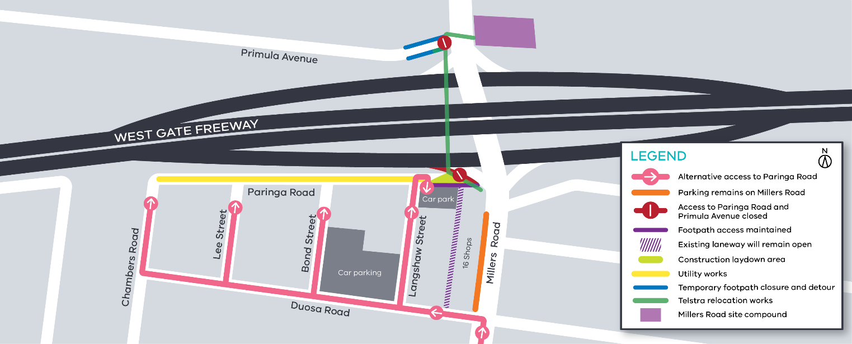

What to expect during these works:

- staged closures along Paringa Road will be in place during the works to move the 66kV power line underground. We will advise residents of any specific individual driveway access impacts;
- an increase in construction noise from our machinery and trucks;
- water spray trucks to help manage dust and dirt;
Contact us
Please contact us if you have any questions or feedback about these works.

 | westgatetunnelproject.vic.gov.au |  | facebook.com/westgatetunnelproject
 | westgatetunnelproject@wda.vic.gov.au |  | @westgatetunnel
 | 1800 105 105 |  | West Gate Tunnel Project  GPO Box 4509  Melbourne Victoria 3001
 | Interpreter service: 13 14 50
- equipment used for these works include heavy vehicles and trailers, excavators, jack hammers, compaction equipment and asphalt cutting saw; and
- traffic changes with signed detours – latest traffic updates are available at http://westgatetunnelproject.vic.gov.au/traveldisruptions/.

Please note that works may be rescheduled in the event of bad weather or other unavoidable circumstances.

Did you know?
There is onging tree and vegetation removal in the area, including on the freeway side of noise walls, however as part of the project we will plant more than 17,700 trees, of which 4000 will be mature trees. In addition, we will plant approximately 900,000 plants.

