09/12/2019 WES1912.03

Works notification: Overnight works on Beevers Street
From Monday 16 to Thursday 19 December, access to Beevers Street will be restricted overnight between 10pm and 4am. Beevers Street will be fully open during the day from 4am to 10pm.

We need to close Beevers Street to replace a freeway drainage line that is located across the entrance of the street. The work involves cutting a trench right across the road. This work was planned to be completed in November but due to unforeseen circumstances was delayed.

During the night closures:
- access to and from Beevers Street will be maintained for residents, however there might be a short wait while our team arranges access for your vehicle
- the freeway outbound exit ramp will be closed to allow a safe waiting space for vehicles entering Beevers Street. Please use the Grieve Parade outbound exit ramp during this time
- pedestrians heading south on the eastern side of Millers Road will be detoured as per the map below. Pedestrians entering Beevers Street will be escorted through the work site.

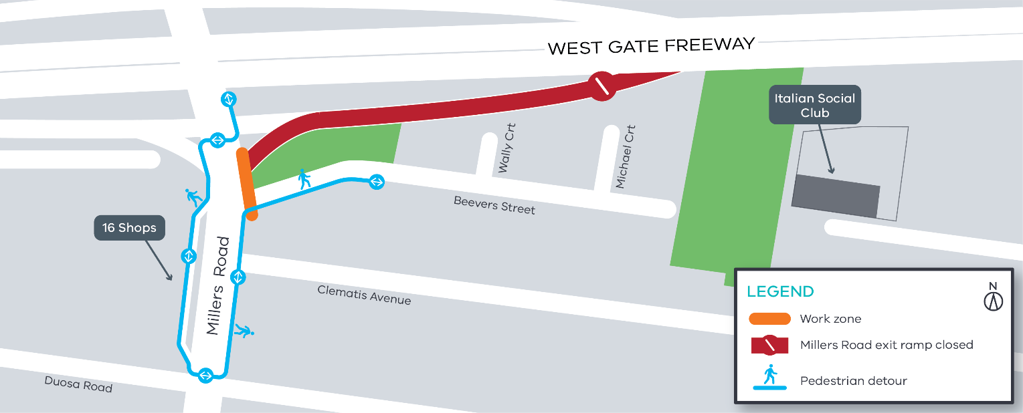

Location of work and pedestrian detour

What to expect during these night works

During these works, you might experience:
  - construction noise near the work site, including road cutting and excavating. Work crews will aim to complete the noisy activity earlier in the night
  - traffic impacts including ramp and lane closures
  - pedestrian detour
  - additional lighting for the work site
  - more construction vehicles in the area.

Traffic changes will be required, and signed detours will be in place. The latest traffic updates are available at www.westgatetunnelproject.vic.gov.au/

This work will be carried out during the night between 10pm – 4am.

Please note that works might need to be rescheduled in the event of bad weather or other unavoidable circumstances.

Thank you

We appreciate our work can be disruptive and thank you for your understanding and cooperation.

