14 December 2020

Works notification: Grieve Parade and West Gate Freeway summer road works
As part of the West Gate Tunnel Project, we are widening the West Gate Freeway from 8 to 12 through lanes to reduce congestion and travel times for motorists.
As we continue building the new lanes, there will be major disruptions this Summer.

WES2012.02

The West Gate Tunnel Project will carry out construction work along the West Gate Freeway from early January 2021 through to late March 2021 at the Grieve Parade bridge and at some bridges and ramps connecting to the M80 Ring Road.
Please note that during this time there will be occasional overnight freeway closures, lane closures and temporary changes to local roads.
The majority of the work will be completed in January and February. Most of the closures will occur during the summer holiday period to take advantage of typically lower traffic volumes.
Detours during works will primarily use Millers Road, Blackshaws Road and Geelong Road. For the most up to date traffic information, please visit bigbuild.vic.gov.au

6 January to 11 January – add an extra hour to your journey
Traffic changes at Grieve Parade include:
- The West Gate Freeway closed in both directions from the M80 to Grieve Parade for 4 days from 9pm, 6 January to 5am, 11 January to demolish the eastern side of the Grieve Parade Bridge. Detours will be in place for vehicles, pedestrians and cyclists.
- Grieve Parade closed over the West Gate Freeway at the same time
- Millers Road outbound entry ramp also closed at the same time.
- Lane closures along Grieve Parade, including no right turning movements to West Gate Freeway entry ramps from 5am, 11 January to 5am, 22 March.
- Intermittent overnight freeway closures to rebuild the new bridge until 22 March

11 January to 22 February – add an extra 30 minutes to your journey
Traffic changes along the West Gate Freeway – M80 Ring Road, Geelong Road
- From 9pm, 10 January to 5am, 22 February, the following ramps will be closed:
  - Princes Freeway to Geelong Road in both directions
  - M80 Ring Road Altona bound exit ramp to the West Gate Freeway
- Traffic changes at Boundary Road from M80 Ring Road to Little Boundary Road include:
  - Signalised and added an additional left- turn from the M80 Ring Road exit ramp to Boundary Road eastbound
  - Access to Spencer Street at Boundary Road will be a left-in / left-out arrangement compared to a left-out only arrangement previously provided.
  - Plummer Road will be closed at Boundary Road to stop motorists from making unsafe movements around the traffic barriers
  - Stop U-turn movements at Boundary Road and Somerleigh Road

During this time we will be demolishing and reconstructing a bridge.

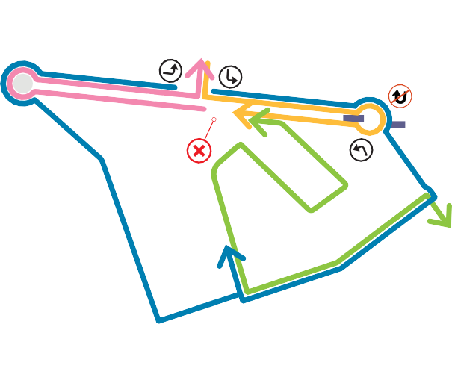
To see full detours go to bigbuild.vic.gov.au/disruptions
Localised traffic changes and closures around Boundary and Little Boundary Road from 6 January to 22 February
Ramps from M80 to West Gate Freeway closed from 6 January to 22 February
West Gate Freeway closed from 6 to 11 January
Grieve Parade Bridge closed from 6 to 11 January
Ramps between Princes Freeway and Geelong Road closed in both directions from 11 January to 22 February
Grieve Parade lane closures from 11 January to 22 March
LEGEND
Works area
Bus route changes
Changes to bus routes 232, 414 and 471. Please visit ptv.vic.gov.au/journey for changes to your bus service.

Detours:
Fully signed detour routes will be in place during
the freeway and ramp closures. Please allow an extra 30 to 60 minutes of travel time for your journey.

What we need you to do:
- If you’re travelling between Geelong and Melbourne, avoid using the West Gate Freeway as there will be major delays during our summer campaign of works.
- Give yourself plenty of time to get where you need and check the latest travel advice on the Big Build website.
- Where possible, avoid travelling in peak periods or take an alternative way to avoid works
- Before you get in the car check the latest travel advice on the Big Build website – bigbuild.vic.gov.au.
- While you’re on the road listen to radio traffic reports and look out for digital road signs that will give
you real-time advice on travel times and alternative routes.

Information for residents on Millers Road, Blackshaws Road and Geelong Road
- Residents along these roads should expect higher than normal traffic volumes while they are being used as detour routes
- There may at times be traffic congestion on these roads, particularly during peak periods so allow some extra time if you need to leave or return home
- We are mindful of the impact to residents during this time and will use a number of detour routes to reduce the number of vehicles on any one road
- The road closures are unavoidable because there are demolition and construction works that need to happen above the freeway

Residents near our works will be contacted in advance of works starting to discuss likely impacts.

We’ve launched a new Facebook Group for people to keep updated about works near them.
See more of what’s happening behind the barriers and join the discussion at facebook.com/groups/ westgatefreewayconstructionupdates.

Thank you
We appreciate our work can be disruptive and thank you for your understanding and cooperation.
Please note that works might need to be rescheduled in the event of bad weather or other unavoidable circumstances.
Please be aware, there are also delays expected between Boxing Day and early January for the annual West Gate Bridge maintenance works
The latest traffic updates are available at bigbuild.vic.gov.au/disruptions.

westgatetunnelproject.vic.gov.au info@wgta.vic.gov.au
1800 105 105
West Gate Tunnel Project Info Centre Corner of Somerville Rd and Whitehall St Yarraville VIC 3013

Follow us on social media Please contact us if you would like this
information in an accessible format.

Translation service – For languages other than English, please call 13 14 50.

Authorised by the Victorian Government, 1 Treasury Place, Melbourne

