EAS19JUN.001

02 July 2019

Works Update: E Gate and F Gate Sites July - September 2019
Works on the West Gate Tunnel Project, Port to City precinct are ongoing in the E and F Gate areas. The key activities that will take place during the next three months are as follows:

E Gate works

Civil Works
Site establishment works continue within E Gate, which will include fencing works, crib shed installation, vegetation removal and identification of existing services.
Once the site area is established adjacent to the MTM overflow carpark and V/Line Signaling Equipment Room, piling works will commence in this location (July to December). These works are the start of pier construction works for Bridge 84 (Dynon Road shared use path). The pedestrian path near the MTM carpark will be closed for the duration of works in the area (see map).
In addition, relocation works will continue for the 6.6kV underground cable at west end of E Gate.

Rail Works
Signal correlation works will also take place around E-Gate, South Dynon and Port of Melbourne on V/Line and ARTC tracks.
Further rail works will take place, which involve removing sections of the Reversing Loop (between July and August) and works will commence on Roads 8 and 13 in the wagon storage yard (mid to late August).
Ongoing geotechnical investigations will continue (throughout both E and F Gates), in consultation with the relevant rail operator.

F Gate works
Piling works will be ongoing throughout this quarter (see map). Piling is required to construct the foundations for the piers that will support the bridges to be constructed in this area.
Piling activity includes a combination of driven, bored and sheet piling, pile cap preparation, pile break back, excavation and pier erection.
Also taking place will be some investigations and drilling into the existing CityLink structure (July to December), at the connection points for our C2 ramp (which will go over CityLink and connect to the West Gate Tunnel).
Appropriate rail safeworking support will be in place, ensuring the separation and safety of workers near rail traffic.
The relocation works for the 66kV underground cable through South Dynon will continue through this period. Construction will also take place for a replacement storage track on the Standard Gauge Turntable (between July and August).

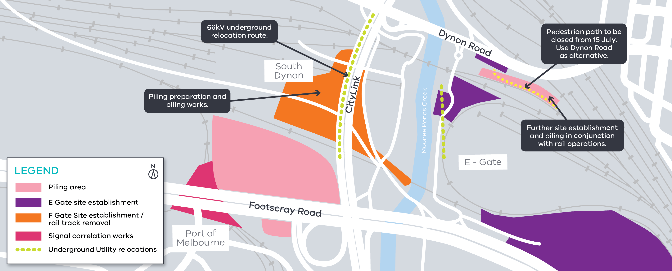

Piling preparation and piling works
Piling has commenced at various locations and will continue through the next quarter. This includes the delivery of piling equipment and piling rigs to site.
Piles will be constructed using a combination of driven, bored and sheet piling (where required to protect open excavation areas).
Pedestrian access will be restricted from July onward (see map).

Rail works
- Works to commence in the wagon storage yards (Roads 8-13)
- Signal correlation works
- Planned removal of V/Line Reversing loop
(E Gate)
- Relocation of standard gauge storage track (F Gate)

Construction works
- Piling preparation works adjacent to MTM Overflow
Car park (E Gate)
- Utilities relocation of 6.6kV power (E Gate)
- Utilities relocation of 66kV power at
South Dynon (F Gate)

GPO Box 4509, Melbourne Victoria 3001

Interpreter service: 13 14 50

If you are deaf, or have a hearing or speech impairment,
contact us through the National Relay Service.
For more information, visit: www.relayservice.gov.au.

What to expect during construction
  - Works completed both during the day and at night time.
  - We will notify you if there are any significant changes to the timing of our works.
  - Traffic management will be in place to manage changed conditions including temporary access changes to
car parking spaces and signage to guide road users and cyclists.
  - Dust managed on site
  - Piling works can create increased levels of noise and may also cause some vibration.
Assessments have been conducted, which indicate the noise levels are expected to remain within permissible levels as documented in the project’s Environmental Performance Requirements.

We thank you for your patience during these works.

Contact us
Please contact us if you have any questions or feedback about these works.
westgatetunnelproject.vic.gov.au info@wgta.vic.gov.au
1800 105 105
facebook.com/westgatetunnelproject
@westgatetunnel
West Gate Tunnel Project

