Chapter 20
Aboriginal cultural heritage

Chapter 20

Aboriginal cultural heritage
This chapter provides an assessment of the Aboriginal cultural heritage impacts associated with the construction and operation of North East Link. This chapter is based on the impact assessment presented in Technical report L – Aboriginal cultural heritage.
Aboriginal people have lived in southern Australia, including what is now Victoria, for thousands of years. During that time, the people living in these regions left physical evidence of their activities that survive as cultural heritage places and objects. Aboriginal cultural heritage values including places and objects are of significant value to Aboriginal traditional owners and the wider community. Aboriginal heritage places provide a connection between generations and help to connect landscapes with past and current traditional owners.
Construction of North East Link would involve clearance and ground disturbing works, which has the potential to impact Aboriginal cultural heritage places and values.
The EES scoping requirements set out the following evaluation objective:
- Cultural heritage – To avoid or minimise adverse effects on Aboriginal and historical cultural heritage values.
To assess the potential effects on Aboriginal cultural heritage from the project, an impact assessment was undertaken. The assessment included surveys of the Aboriginal cultural heritage values and places in the vicinity of the project to gain an understanding of historical disturbance and degree of Aboriginal heritage sensitivity. The assessment has been undertaken in close consultation with the Registered Aboriginal Party for the majority of the study area, the Wurundjeri Woi-wurrung Cultural Heritage Aboriginal Corporation ('WWCHAC').
Another aspect closely related to the Aboriginal cultural heritage evaluation objective includes historical heritage, which is addressed in the following technical report and chapter:
- Chapter 19 and Technical report K – Historical heritage.
The Cultural Heritage Management Plan (CHMP) currently being prepared for the project is the mechanism for managing impacts to Aboriginal cultural heritage. As a part of the CHMP process, consultation with the WWCHAC is ongoing. The CHMP involves desktop assessment, standard assessment (field survey) and complex assessment (sub-surface testing).
Being prepared in parallel to the CHMP is a cultural values mapping exercise which will provide for a greater appreciation of Aboriginal cultural heritage values in addition to those values more formally covered by the relevant legislative framework such as knowledge sharing and oral histories. This cultural values mapping exercise is being undertaken with WWCHAC and is ongoing. The outcomes of the cultural values mapping may be sensitive to Wurundjeri and as such, the use and public availability of information would be subject to the consent of WWCHAC.

Method
Informed by the risk assessment described in Chapter 4 – EES assessment framework, the Aboriginal cultural heritage assessment involved the following key tasks:

- The review of relevant national, state and local legislation and policy
- The establishment of a study area for Aboriginal cultural heritage. This was defined as the area within 300 metres of the CHMP activity area as shown in Figure 20-1
- A desktop assessment and baseline data review
What are the risk categories?
Risk levels were categorised as very low, low, medium, high or very high. When an impact is a known consequence of the project, the rating is indicated as ‘planned’. The results of the initial risk assessment were used to prioritise the focus of the impact assessments.

- Site visits and surveys to examine the study area and ground-truth results of desktop assessment which included sub-surface investigations
- Ongoing consultation with the WWCHAC and Aboriginal Victoria
- The characterisation of existing conditions, being Aboriginal heritage values and places
- A risk assessment to prioritise the impact assessment and development of controls
- An assessment of the potential impacts to Aboriginal cultural heritage places or values during the construction and operation of the project
- Environmental Performance Requirements (EPRs) were developed in response to the impact assessment. The residual risk ratings and the assessment of impacts presented in this chapter assume implementation of the EPRs. The full list of EPRs is provided in Chapter 27 – Environmental management framework.
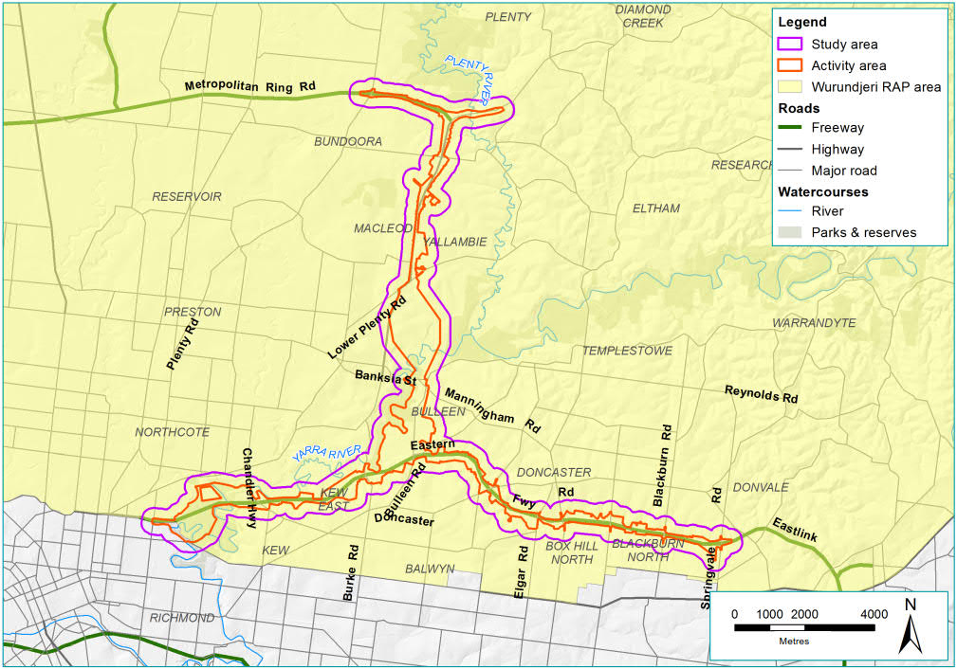
Figure 20-1 Aboriginal cultural heritage study area

Existing conditions

This section outlines the existing conditions of the North East Link study area that relate to Aboriginal cultural heritage.
The intent of the existing conditions assessment is to understand the land use history of the study area and the potential for presence of Aboriginal heritage places and values. This was undertaken by reviewing the current and historical landforms of the study area, accounts of Aboriginal occupation and the land use history of the study area as well as a desktop search for registered Aboriginal places and objects. Due to the ongoing nature of the assessment associated with the CHMP, the results of this fieldwork have only been included in this assessment where this has resulted in the identification of Aboriginal cultural heritage values of relevance in the study area.

Landforms and geomorphology
The study area is predominately located within the Victorian Eastern Uplands geomorphic land system and contains three dominant geomorphological units including:
- Terraces, fans and floodplains associated with major waterways
- Low relief landscapes at low elevation associated with the southern portion of the study area
- Moderately dissected ridge and valley landscapes associates with the northern part of the study area.
There is also a small section of the study area located in the Western Uplands geomorphic land system which includes a small section of the following geomorphological unit:
- Stony rises associated with Mount Eccles, Pomborneit and Mount Rouse.
There are three dominant geological units within the study area:
- Quaternary alluvium sediments associated with the major waterways
- Melbourne Formation sedimentary deposits of mudstone and very fine-grained sandstone associated with the north, west and centre-east of the study area
- Anderson Creek Formation, a marine mudstone.
The study area intersects with a number of waterways including:
- Yarra River
- Merri Creek
- Koonung Creek
- Banyule Creek
- Plenty River.

Historical and ethno-historical accounts of Aboriginal occupation in the region

Archaeological evidence within the Melbourne metropolitan region suggests an extensive history of Aboriginal occupation dating at least more than 31,000 years before present (BP). The Keilor archaeological area, which is an archaeological site located approximately 16 kilometres northwest of Melbourne, lies near the confluence of the Maribyrnong River and Dry Creek. This site has been determined to contain evidence of the earliest human occupation in Victoria.
What is an archaeological site?
An archaeological site refers to a place where evidence of past activity is preserved.

Contained within the site are Aboriginal stone artefacts of the Australian Small Tool tradition, which are no older than 5,000 to 6,000 years old, overlying deeper deposits containing older technological classes and megafauna remains. The Keilor archaeological site is most famously known for the discovery of a human cranium in 1940, the dating of which was calculated to be around 14,700 BP. Radiocarbon dates have found deposits at this site containing artefacts illustrating dates of around 31,600 BP.
As a result of the European establishment and expansion in the Melbourne area, and the subsequent disruption to the lives of Aboriginal people, little information is available regarding the pre-contact lifestyle of local Aboriginal people in this area. There are several problems concerned with correctly identifying and describing 19th century Aboriginal groups, due to discrepancies in early European accounts and the difficulties that early Europeans had with understanding Aboriginal languages. Furthermore, the devastating effects on Aboriginal people of European presence, including the loss of traditional lands and resources, spread of disease, social breakdown and removal of groups and individuals to reserves and Mission stations compounded the difficulties associated with accurately recounting an early ethno-history of the Aboriginal people of the Melbourne region.

Ethno-historical accounts
At the time of European colonisation, central and north-eastern Victoria was occupied by a collection of peoples known as the Kulin, who shared certain cultural, social and language characteristics. The Kulin were divided by distinctive language variations and organisational attributes, resulting in the definition of individual groups by contemporary observers as ‘tribes’. Today they are more consistently defined by ethno-historians as groups linked by commonalities of language, or ‘language groups’. In contemporary Aboriginal society in the Melbourne region, the terms ‘tribe’, ‘people’ or ‘nation’ are more commonly used by Aboriginal people to demonstrate a traditional identity or allegiance, beyond the strictly academic term ‘language group’. A language group consisted of independent groups of closely related kin, or ‘clans’, who were spiritually linked to designated areas of land through their association with topographic features connected to mythic beings or deities.
At the time of European contact, clans from two language groups, the Bun wurrung and the Woi wurrung, are believed to have occupied land in the study area. Most of the study area is within the traditional lands of the Woi wurrung, with the far western section of the study area potentially intersecting with the traditional lands of the Bun wurrung. It should be noted that the WWCHAC dispute the view that the Bun wurrung traditional lands intersect with the study area which is currently being assessed as part of the Wurundjeri/Woi wurrung Traditional Owner Settlement Act 2010.
The Woi wurrung are part of the Kulin Nation language group. The Woi wurrung clan most closely associated with the study are the Wurundjeri willam, who identify with the Yarra River and Plenty River. Three sub-groups have been identified of the Wurundjeri willam; Jacky Jacky’s group from the south bank of the Yarra, Billibellary’s group on the north bank of Yarra and Bebejan’s group, up Yarra toward Mount Baw, around Yering.
The two Bun wurrung clans thought to be most closely associated with the study area are thought to be the Yalukit willam, located east of the Werribee River, Williamstown, Sandridge and St Kilda, and Ngaruk willam at Brighton, Mordialloc, Dandenong and between Mount Eliza and Mount Martha.

Post-contact history
The development of Melbourne and its hinterland during the 19th century resulted in the rapid loss of traditional lands and resources, the spread of diseases and the removal of Aboriginal groups and individuals from traditional lands.
Various reserves were set up as refuges for Aboriginal people around Port Phillip and Westernport in an attempt to move Aboriginal people away from Melbourne. These included Arthurs Seat, Merri Creek, Mordialloc Creek and the Westernport Protectorate Station.
Aboriginal people have also been recorded camping in the vicinity of the Melbourne township, particularly along the Yarra River and Government Paddocks between the Princess Bridge and Punt Road.
Throughout the 1840s there are numerous historical references to Aboriginal people camping at Bolin Bolin Billabong, as well as other locations along the Yarra River close to the study area. In 1846 and 1848 a number of groups were noted camping at the confluence of the Plenty River and Yarra River and the confluences of Darebin Creek and Merri Creek and the Yarra River as well as further north in Heidelberg Road. Groups present included many from outside of the immediate area and were noted as ‘of the Devil River’, ‘Goulbourns’, ‘Western Port’, ‘Mount Macedon’ and ‘NW Blacks’. The historical observations from this time indicate frequent movements of people of Wurundjeri and other groups, throughout the region including movements between Melbourne and more distant camps along the Yarra River as well as to places further afield such as Narre Warren.
The Aboriginal population around Melbourne was impacted by an influenza epidemic around 1847. This caused many deaths and the dispersal of Aboriginal people from the Yarra River camps, causing a steep decline in the population.
Complaints from settlers, who wanted to exclude Aboriginal people from their newly acquired land and requests by Aboriginal people themselves for a ‘station’ of their own led to the establishment of an Aboriginal reserve known as Coranderrk near Healesville in 1863. The majority of Woi wurrung people lived at Coranderrk from 1863 to the early 1900s when the introduction of the Aborigines Act 1909 (Vic) required all ‘half castes’ to leave Mission stations, so Aboriginal people moved back to Melbourne attracted by work opportunities.

Land use history
The history of European land use in the study area is an important consideration for this assessment due to the likely disturbance of Aboriginal cultural materials associated with development of residential areas, infrastructure, industry and other land uses.
European interest in the Port Phillip region started around 1824 when exploration of the area by settlers began. Following this exploration, settlers began occupying the Heidelberg and Banyule areas to use the land for residential properties, growing fruit and vegetables, livestock grazing, dairy production and other pastoral uses. Other industries developed in the study area in the 20th century included quarrying, brickworks and timber cutting.
From an early date after the founding of Melbourne, many sites within the study area such as Abbotsford and Kew were reserved for a variety of purposes. For example, the Yarra Bend Park area had been viewed as a potential site for a prison or asylum, a purpose for which parts of the site was later used by the Kew Lunatic Asylum which operated from 1871 to 1988. Studley Park was permanently reserved for recreational purposes in 1877, although in a bid to raise funds the park was leased for grazing which continued until at least the 1930s. Following the 1926 closure of the Yarra Bend Lunatic Asylum, the north and south sides of the river were used primarily for recreational purposes. The Studley Park Boathouse, formerly Riversdale Boat House, was established in 1863 and during the 19th century was a popular picnic ground.
Infrastructure such as roads and bridges were an early focus of European settlers in the Heidelberg district. The earliest routes from Heidelberg to Melbourne, which largely follow the course of the Yarra River, would likely have been based on Aboriginal paths. Heidelberg Road was completed in 1842 and was the first major road in the district. By the mid‐1840s a coach service traversed areas from Melbourne to Heidelberg as well as to other nearby locations such as Templestowe. Road boards emerged and roadways gradually increased in quantity and quality. Other early roads included Lower Plenty Road in 1856 and a road through the Rosanna Estate which opened in 1861. Studley Road was constructed in 1881 to improve access between Ivanhoe and Heidelberg. The railway between Collingwood and Heidelberg was opened in 1901, extending to Eltham by 1904 and Hurstbridge by 1912. The railway was extended to Greensborough in the 1920s.
While some suburbs such as Heidelberg were well established by the 1900s, northern sections of the study area were sparsely settled. Suburbs such as Rosanna, Montmorency and Greensborough underwent subdivision from around 1920, with demand for residential development driven by the extension of the electric train to Heidelberg. Post-war property development caused dramatic suburban expansion in the outer suburbs of Melbourne, including the study area, transforming land from orchards and paddocks into residential properties.
From the 1970s, the construction of the Eastern Freeway and the M80 Ring Road (otherwise known as the Metropolitan Ring Road) continued to transform the study area. This caused significant changes to the natural environment and landforms, including modifying the Yarra River by shortening one of the bends. Expansions and upgrades of these roads continued into the 21st century. The first carriage of the M80 Ring Road (originally the Western Ring Road) that ran from Plenty Road to Greensborough opened in 1994. Construction of the Greensborough Bypass started in 1984 and the bridge over the Plenty River was built in 1988. The bypass was duplicated in 2005 with major alterations at the intersection with the M80 Ring Road. Construction techniques at that time would have resulted in significant ground disturbance within the carriageway.

Registered Aboriginal cultural heritage places and objects
As part of the desktop assessment a search was undertaken of the Victorian Aboriginal Heritage Register (VAHR) which holds information about known Aboriginal cultural heritage places and values within Victoria. At the time of the VAHR search, a total of 28 registered Aboriginal cultural heritage places and four historical references were registered in the activity area. These are listed in Table 20-1. There are also four heritage overlay (HO) places considered which are listed in Table 20-2. A greater number of places and values were identified within the study area than the activity area, as shown Figure 20-2, however these are well removed from project works and as such are not discussed in the impact assessment. These are presented in Technical report L – Aboriginal cultural heritage.
The assessment has been organised into the following areas:
- M80 Ring Road to northern portal – extends east along the M80 Ring Road and Greensborough Bypass from Plenty Road roughly to the Plenty River and south along Greensborough Highway to Blamey Road.
- Northern portal to southern portal – extends south adjacent to Greensborough Highway in cut and cover tunnels to Lower Plenty Road before proceeding in mined tunnels roughly south to Banksia Street. The alignment then proceeds in several sections of cut and cover and mined tunnels to emerge at the southern portal adjacent to Bulleen Road approximately 500 metres north of the Eastern Freeway.
- Eastern Freeway – extends along the Eastern Freeway east from Hoddle Street to Springvale Road.
What kinds of values are registered on the VAHR that are relevant to North East Link?
Scarred trees – A tree that has scars as a result of Aboriginal activities. Aboriginal people caused scars on trees by removing bark for various purposes. These scars vary in size and expose sapwood on the trunk or branch of a tree.
Artefact scatter – Artefact scatters are the remains of past Aboriginal activities. These scatters usually contain stone artefacts but can contain other materials.
Historical reference – A location important because of its associations with and cultural significance to Aboriginal people.

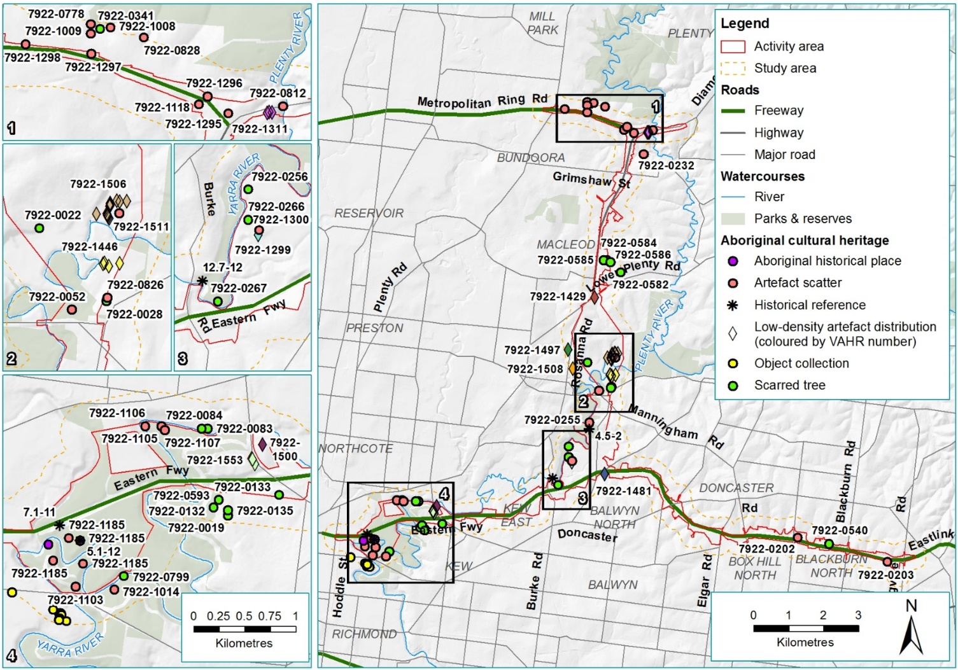
Figure 20-2 Map of the study area showing registered Aboriginal cultural heritage

Table 20-1 Registered Aboriginal places and historical references in the activity area
VAHR No. | Name | Type
M80 Ring Road to northern portal
7922-0584 | SAB 8 | Scarred tree*
7922-0585 | SAB 9 | Scarred tree*
7922-0812 | Greensborough Bypass IA1 | Artefact scatter
7922-1118 | M80 Greensborough Highway Interchange | Artefact scatter
7922-1295 | M80 Greensborough Highway Interchange 2 | Artefact scatter
7922-1296 | Goolgung Grove 1 | Artefact scatter
7922-1297 | Worcester Crescent 1 | Artefact scatter
7922-1298 | Enterprise Drive 1 | Artefact scatter
7922-1311 | Greensborough Bypass 2 | Low-density artefact distribution
Northern portal to southern portal
4.5-2 | Bulleen Lagoon | Historical reference
7922-0022 | Rosanna | Scarred tree
7922-0028 | Bulleen Scarred tree | Scarred tree
7922-0052 | Templestowe 4 | Artefact scatter
7922-0255 | Bolin Billabong 1 | Artefact scatter
7922-0256 | Yarra Flats 1 | Scarred tree
7922-1429 | Lower Plenty Rd IA1 | Low-density artefact distribution
7922-1446 | Bulleen LDAD | Low-density artefact distribution
7922-1506 | Banyule Flats Reserve LDAD 01 | Low-density artefact distribution
7922-1511 | Banyule Flats Reserve 01 | Artefact scatter
Eastern Freeway
5.1-12 | Yarra River Protectorate Station | Historical reference
7.1-11 | Merri Creek School Reserve | Historical reference
12.7-12 | Heidelberg To Healesville Travelling Route | Historical reference
7922-0133 | Willsmere tree B | Scarred tree
7922-0202 | Koonung 1 | Artefact scatter
7922-0203 | Koonung 2 | Artefact scatter
7922-0266 | Yarra Flats 2 | Scarred tree
7922-0540 | Boronia Grove 1 | Scarred tree
7922-1103 | Yarra Bend Park 2 | Artefact scatter
7922-1105 | Yarra Bend Park 4 | Artefact scatter
7922-1106 | Yarra Bend Park 5 | Artefact scatter
7922-1107 | Yarra Bend Park 6 | Artefact scatter
7922-1185 | Dights Falls 1 | Artefact scatter and Aboriginal historical places
7922-1299 | Yarra Flats 4 | Low-density artefact distribution
7922-1300 | Yarra Flats 5 | Artefact scatter
7922-1553 | Chandler Highway 2 | Low-density artefact distribution
*These trees have undergone assessment in consultation with the WWCHAC, finding that the scars are not cultural in origin. Steps are currently being undertaken to remove these trees from the VAHR.
Table 20-2 Heritage overlay places
Number | Name | Type
HO24 (Manningham) | River Red Gum, Bridge Street | Tree
HO30 (Manningham) | Bolin Bolin Billabong | Archaeological place
HO72 (Manningham) | Bullen Drive-in (former) | Archaeological place
HO181 (Manningham) | Archaeological site (Ref. VAS 7922/202) - | Archaeological places

Unregistered places and objects of Aboriginal cultural heritage
A number of places and objects were identified during the CHMP fieldwork as listed in Table 20-3. As these places have not yet been formally registered on the VAHR they have not been issued with numbers.
Table 20-3 Unregistered places
Number | Name | Type
7922-#### | Banyule Creek LDAD 1 | Low density artefact scatter
7922-#### | Banyule Creek Artefact Scatter 1 | Artefact scatter
7922-#### | Grimshaw Street LDAD1 | Low density artefact scatter
7922-#### | Kampman Street LDAD1 | Low density artefact scatter
7922-#### | Koonung Trail LDAD1 | Low density artefact scatter
7922-#### | Koonung Trail LDAD2 | Low density artefact scatter

Areas of cultural heritage sensitivity
The study area contains a number of areas of cultural heritage sensitivity, defined as follows.
      - Registered cultural heritage places
      - A registered cultural heritage place is an area of cultural heritage sensitivity
      - Land within 50 metres of a registered cultural heritage place is an area of cultural heritage sensitivity.
If part of the land within 50 metres of a registered cultural heritage place has been subject to significant ground disturbance, that part is not an area of cultural heritage sensitivity.
Waterways
      - A waterway or land within 200 metres of a waterway is an area of cultural heritage sensitivity
      - If part of a waterway or part of the land within 200 metres of a waterway has been subject to significant ground disturbance, that part is not an area of cultural heritage sensitivity.
These are shown in Figure 20-3.
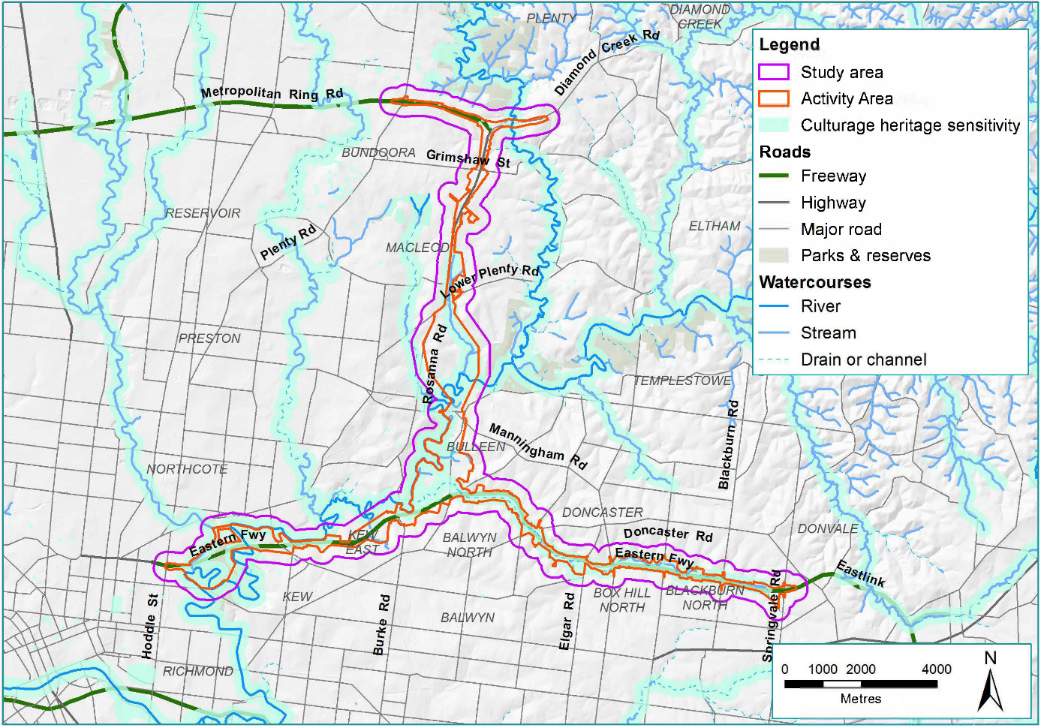
Figure 20-3 Areas of cultural heritage sensitivity

Construction impact assessment
This section discusses the construction impacts associated with North East Link that relate to Aboriginal cultural heritage.
Construction of North East Link would involve the clearance of land and ground excavation which has the potential to disturb or destroy Aboriginal cultural heritage places or values.
The risk pathways associated with construction impacts to registered Aboriginal cultural heritage places and values are described in Table 20-4 and potential impacts described below.
Table 20-4 Risk table – construction – Aboriginal cultural heritage places and values
Risk ID | Risk pathway | Risk rating
Risk AH01 | Disturbance/destruction of registered Aboriginal cultural heritage place(s) and/or associated cultural values in a deteriorated condition with a high degree of disturbance evident and some cultural heritage remaining | Medium
Risk AH02 | Disturbance/destruction registered Aboriginal cultural heritage place(s) and/or associated cultural values of common occurrence with a limited range of cultural materials, in fair to good condition with some degree of disturbance evident | Medium
Risk AH03 | Disturbance/destruction of registered Aboriginal cultural heritage place(s) and/or associated cultural values of rare occurrence and/or with a large number and diverse range of cultural materials and/or stratified deposits | Medium
Risk AH04 | Disturbance/destruction of registered Aboriginal cultural heritage place(s) and/or associated cultural values of exceptional value as identified by the RAP and/or Aboriginal Victoria and/or Traditional Owners, for example, a burial | Medium
Risk AH05 | Disturbance/destruction of previously unregistered Aboriginal cultural heritage place(s) and/or associated cultural values of exceptional value as identified by the RAP and/or Aboriginal Victoria and/or Traditional Owners, for example, a burial | Medium

The potential impacts associated with these risk pathways are discussed in the following sections which are divided up into the three study areas discussed in Section 20.2.4.

M80 Ring Road to the northern portal
Within the M80 Ring Road to the northern portal section of the study area, seven registered Aboriginal cultural heritage places and one unregistered place were identified as listed in Table 20-5 and discussed below. Where a place is shown as being impacted by a 'surface impact' this indicates there is likely to be a direct physical impact arising out of construction activities for the project. A reference to 'no impact' to a place is where the place is remote from the works and there would be no direct or indirect impacts. There is one reference to an indirect impact which is discussed below.
Table 20-5 M80 Ring Road to the northern portal – registered Aboriginal cultural heritage places
Number | Name | Type | Impact
7922-0812 | Greensborough Bypass IA1 | Artefact scatter | No impact
7922-1118 | M80 Greensborough Highway Interchange | Artefact scatter | Surface impact
7922-1295 | M80 Greensborough Highway Interchange 2 | Artefact scatter | Surface impact
7922-1296 | Goolgung Grove 1 | Artefact scatter | No impact
7922-1297 | Worcester Crescent 1 | Artefact scatter | No impact
7922-1298 | Enterprise Drive 1 | Artefact scatter | No impact
7922-1311 | Greensborough Bypass 2 | Low-density artefact distribution | No impact
7922-#### | Grimshaw Street LDAD1 | Low-density artefact distribution | No impact

Within the M80 Ring Road to northern portal area, the project works would mainly involve widening the existing road corridor above and at surface level, with new road interchanges at the M80 Ring Road and Grimshaw Street. Construction would generally involve surface works with some open cut construction methods.
Two artefact scatters would be impacted to construct the additional lanes and new ramps at the M80 Ring Road interchange (risk AH01)—the M80 Greensborough Highway interchange and M80 Greensborough Highway interchange 2. These may have been previously impacted through the construction of the M80 Ring Road and Greensborough Bypass.

Northern portal to southern portal
Within this section of North East Link there are eleven registered Aboriginal cultural heritage places, three heritage overlay places and two unregistered places, as listed in Table 20-6.
Table 20-6 Northern portal to southern portal – registered Aboriginal cultural heritage places
Number | Name | Type | Impact
4.5-2 | Bulleen Lagoon | Historical reference | No impact
7922-0022 | Rosanna | Scarred tree | No impact
7922-0052 | Templestowe 4 | Artefact scatter | Surface impact
7922-0255 | Bolin Billabong 1 | Artefact scatter | No impact
7922-0256 | Yarra Flats 1 | Scarred tree | No impact
7922-0584 | SAB 8 | Scarred tree | Indirect impact*
7922-0585 | SAB 9 | Scarred tree | Surface impact*
7922-1429 | Lower Plenty Rd IA1 | Low-density artefact distribution | No impact
7922-1446 | Bulleen LDAD | Low-density artefact distribution | No impact
7922-1506 | Banyule Flats Reserve LDAD 01 | Low-density artefact distribution | No impact
7922-1511 | Banyule Flats Reserve 01 | Artefact scatter | No impact
7922-#### | Banyule Creek LDAD 1 | Low-density artefact distribution | Surface impact
7922-#### | Banyule Creek Artefact | Artefact scatter | No impact
HO24 | River Red Gum, Bridge Street | Tree | Surface impact
HO72 | Bulleen Drive-in (former) | Archaeological place | Surface impact
HO30 | Bolin Bolin Billabong | Archaeological place | Indirect impact
*On the basis of on-site CHMP assessment, these items are expected be de-registered as non-cultural items.
Construction within the northern portal to southern portal area would mainly involve tunnelling. The majority of tunnelling would be bored so would not disturb the surface. Cut and cover techniques would be required in the southern part of this section. Due to ground conditions, some ground improvement works would also be required where the tunnel construction methodology changes from bored tunnels to cut and cover tunnels. A new road interchange would be required at Manningham Road.
There is potential to impact seven Aboriginal cultural heritage places listed above during construction.
One artefact scatter (Templestowe 4) may be impacted by ground improvement works to facilitate the construction of the tunnels (risk AH02).
One artefact scatter (Banyule Creek LDAD 1) may be impacted by the construction of a shared use path (risk AH02).
A River Red Gum (HO24, Manningham) on Bridge Street would be removed for the construction of a new interchange at Manningham Road (risk AH05). No evidence of cultural scarring was identified as part of the on-site CHMP assessment of this tree. The assessment of the local historical significance of this tree is presented in Chapter 19 – Historical heritage.

The Bulleen Drive-in would be impacted by work associated with the new Manningham Road interchange and tunnels, which would include excavations and surface works (risk AH05).
What is groundwater drawdown?
Groundwater drawdown is the lowering of the water table from the existing groundwater level.

One scarred tree in Simpson Barracks, SAB 9, would be removed for the construction of the cut and cover tunnels. There is also potential that SAB 8 may be indirectly impacted by groundwater drawdown caused by the excavations (risk AH03). Groundwater drawdown can occur when excavations intercept with the groundwater table, which could reduce the amount of water to trees relying on this groundwater. The groundwater assessment is summarised in Chapter 22 – Groundwater. Both these trees will likely be de registered and thus become non-registered sites. Until the de-registration of these places is confirmed they will be included in the impact assessment.
Bolin Bolin Billabong has potential to be impacted by groundwater drawdown (risk AH04). This has been determined to be an ‘indirect’ impact because there would be no construction works around the billabong, as this is a conditional no-go zone, which means that construction activities cannot occur in this area. However, tunnelling activities that are well separated from the billabong could cause groundwater drawdown.
The modelled change in groundwater level under Bolin Bolin Billabong has been estimated to be between 0.1 metres and 0.5 metres. As there is some degree of dependence between groundwater levels and the level of water in the billabong, surface water could lower during construction.
The existing levels of the billabong are highly variable with the flooding and drying cycle and depend largely on overland flooding from the Yarra River. As the level of water in the billabong is highly variable, this degree of drawdown is not anticipated to impact the heritage values of the place. The ecological impacts of lowering at Bolin Bolin Billabong have also been considered and are discussed in Chapter 25 – Ecology. Significant impacts to aquatic and terrestrial ecosystems at the billabong are not anticipated.
EPRs would be implemented to address this risk to Bolin Bolin Billabong as described Section 20.5. A groundwater dependent ecosystem monitoring and mitigation plan would be implemented for the project. Measures such as periodical filling and or topping can mitigate this impact. It is noted that negotiation with Melbourne Water (and Southern Rural Water, if groundwater is involved) would be required to establish suitable mitigation measures. Melbourne Water is actively managing the hydrological regime of the billabong. Groundwater drawdown is also a risk for operation, as summarised in Section 20.4.

Eastern Freeway
There are 15 registered Aboriginal cultural heritage places, one heritage overlay place and three unregistered places located in the Eastern Freeway section of the project, as listed in Table 20-7.
Table 20-7 Eastern Freeway – registered Aboriginal cultural heritage places
Number | Name | Type | Impact
5.1-12 | Yarra River Protectorate Station | Historical reference | No impact
7.1-11 | Merri Creek School Reserve | Historical reference | Surface impact
7922-0133 | Willsmere tree B | Scarred tree | No impact*
7922-0202 | Koonung 1 | Artefact scatter | No impact
7922-0203 | Koonung 2 | Artefact scatter | No impact
7922-0266 | Yarra Flats 2 | Scarred tree | No impact
7922-0540 | Boronia Grove 1 | Scarred tree | No impact
7922-1103 | Yarra Bend Park 2 | Artefact scatter | No impact
7922-1105 | Yarra Bend Park 4 | Artefact scatter | No impact
7922-1106 | Yarra Bend Park 5 | Artefact scatter | No impact
7922-1107 | Yarra Bend Park 6 | Artefact scatter | No impact
7922-1185 | Dights Falls 1 | Aboriginal historical place | Surface impact
7922-1299 | Yarra Flats 4 | Low-density artefact distribution | No impact
7922-1300 | Yarra Flats 5 | Artefact scatter | No impact
7922-1553 | Chandler Highway 2 | Low-density artefact distribution | No impact
7922-#### | Kampman Street LDAD1 | Low-density artefact distribution | Surface Impact
7922-#### | Koonung Trail LDAD1 | Low-density artefact distribution | Surface Impact
7922-#### | Koonung Trail LDAD2 | Low-density artefact distribution | Surface Impact
HO181 | Archaeological site (Ref. VAS 7922/202) | Archaeological paces | No impact
*The location of this place was registered within study area, but fieldwork has located it outside the study area.
Thirteen of the 19 places listed above would not be impacted by North East Link’s construction.
Two heritage places have the potential to be impacted by surface works for the widening of the Eastern Freeway—Dights Falls 1 and Merri Creek School Reserve.
Dights Falls 1 has previously been impacted by the construction of the Eastern Freeway and the bridging of Merri Creek (risk AH04). Works for North East Link would be contained within the freeway easement and so would unlikely materially increase impacts than has already occurred.
Merri Creek School Reserve has potential to be impacted by surface works along the Eastern Freeway (risk AH04).
Three other places identified during preparation of the CHMP would also likely be impacted. These three places are in open space proposed to be used as construction compounds or as the location of a flood mitigation infrastructure.

Unregistered and unknown Aboriginal cultural heritage places and values
The project’s construction has potential to come into contact with values and places that have not been registered under heritage overlays or the VAHR. This could be sub-surface artefact scatters or places where the heritage values have not yet been realised.
The potential for impacts to occur to as yet unidentified Aboriginal cultural heritage places is still under assessment. Due to the ongoing nature of investigations associated with preparation of a CHMP, the archaeological potential of the project area is still being determined. This archaeological potential would be fully developed through the completion of the standard and complex assessments of the CHMP process.
In addition, the CHMP would provide management measures and contingences in the event that previously unknown items of Aboriginal cultural heritage are uncovered during construction.

Operation impact assessment
One operational risk to Aboriginal cultural heritage values has been identified. The risk pathway is described in Table 20-8 and the potential impact discussed below.
Table 20-8 Risk table: Operation – unregistered Aboriginal cultural heritage places and values
Risk ID | Risk pathway | Risk rating
Risk AH04 | Disturbance/destruction of registered Aboriginal cultural heritage place(s) and/or associated cultural values of exceptional value as identified by the RAP and/or Aboriginal Victoria and/or Traditional Owners, for example, a burial | Medium

The results for groundwater drawdown at Bolin Bolin Billabong (risk AH04) during the project’s operation were found to be the same as construction, with an estimated lowering of between 0.1 metres and 0.5 metres, which may cause some change to water levels at the billabong although this is not anticipated to impact the values of the place. Measures such as periodical filling and or topping can mitigate this impact. It is noted that negotiation with Melbourne Water (and Southern Rural Water, if groundwater is involved) would be required to establish suitable mitigation measures. Melbourne Water is actively managing the hydrological regime of the billabong.

Environmental Performance Requirements
To manage impacts to Aboriginal cultural heritage values, a CHMP would be developed and implemented (EPR AH1). This would guide the detail of the assessment undertaken and provide recommendations to minimise, avoid or mitigate the impact to Aboriginal cultural heritage values. While in some cases harm to Aboriginal cultural heritage cannot be avoided, the CHMP would redress this harm to some degree by allowing the collection of scientific and cultural data that may otherwise be unrealised. The preparation of a CHMP would similarly allow for the implementation of management strategies to protect those places that would not be impacted by the proposed works from inadvertent harm.
Groundwater drawdown would be managed through the development of a groundwater model to predict changes in groundwater levels and the development of mitigation strategies (EPR GW1). A groundwater monitoring program would be implemented before, during and after construction (EPR GW2). The design of the tunnel drainage and selection of construction methods would be undertaken to minimise changes to groundwater. Measures would be implemented to manage, mitigate and minimise any impacts (EPR GW3). A groundwater dependent ecosystem monitoring and mitigation plan would be prepared and implemented (EPR FF6).
EPRs would also be implemented for shared Aboriginal cultural and historical heritage values. Through detailed design the works and permanent infrastructure would be undertaken to minimise impacts on heritage values where practicable (EPR HH1). Where works would involve subsurface disturbance, an Archaeological Management Plan would be required to guide appropriate investigation and management of the site to the satisfaction of the Executive Director, Heritage Victoria. The plan would detail measures to avoid, minimise, mitigate and manage impacts on archaeological sites and values (EPR HH2).
The Urban Design Strategy for North East Link provides guidance to the contractor on how to consider Aboriginal cultural heritage values in the detailed design. This is provided in EES Attachment II – Urban Design Strategy. The strategy includes a key direction to recognise the past, contemporary and shared indigenous and historical cultural values. This would guide how shared Aboriginal cultural heritage and historical heritage values could be embedded in the design of North East Link.

Conclusion
This chapter has identified and assessed existing conditions, impacts and associated risks to Aboriginal cultural heritage from North East Link.
The construction of North East Link would mean some impact to Aboriginal cultural heritage values and places.
The key findings of the assessment are:
- Potential impact to two artefact scatters within the M80 Ring Road to northern portal study area. These artefacts scatters may have been previously impacted by construction of the M80 Ring Road.
- Potential impact to seven places within the northern portal to southern portal study area. This includes two scarred trees which will likely be de-registered as non-cultural items, three heritage overlay places and two artefact scatters.
- Potential impact to five places in the Eastern Freeway study area. This is comprised of three artefact scatters, an Aboriginal historical place and a place of historical reference.
Impacts to Aboriginal cultural heritage values would be managed through the development and implementation of a CHMP for North East Link as well as EPRs described in full in Chapter 27 – Environmental management framework.
In response to the EES evaluation objective described at the beginning of this chapter, effects of the project on Aboriginal cultural heritage have been assessed and EPRs have been identified to minimise or avoid impacts to Aboriginal values and places.

