Introduction
Melbourne Metro would be one of the largest public infrastructure projects ever undertaken in Australia.
Melbourne Metro would facilitate the transformation of Melbourne’s rail network into an international-style metro system, boosting the capacity of the rail network to keep pace with Melbourne’s growing and changing travel needs as Melbourne's population grows to 6 million by 2031 and 7.8 million by 2051 (DTPLI, Victoria in Future 2015).
Melbourne Metro would provide the foundation for expanding Melbourne’s public transport network, helping to ensure Melbourne remains one of the world’s most liveable cities now and into the future. Melbourne Metro would also catalyse significant urban renewal, opening up opportunities for new housing, commercial development and jobs close to the city centre.

Project Overview

Project Scope
The infrastructure proposed for construction of Melbourne Metro and assessed in this Environment Effects Statement (EES) includes:
- Twin nine-kilometre rail tunnels from Kensington to South Yarra, connecting the Sunbury and Cranbourne/Pakenham railway lines to form a new Sunshine – Dandenong line (with the tunnels to be used by electric trains)
- Rail tunnel portals (entrances) at Kensington and South Yarra
- New underground stations at Arden, Parkville, CBD North, CBD South and Domain with longer platforms to accommodate longer High Capacity Metro Trains (HCMTs). The stations at CBD North and CBD South would feature direct interchange with the existing Melbourne Central and Flinders Street Stations respectively
- Train/tram interchange at Domain station.
The project would also require track work (a turnback) at West Footscray to enable trains using the Sunbury Line to turn around before reaching Sunbury and head back through the Melbourne Metro tunnels.
Figure ‎1–1 shows a broad schematic plan for the principal components of Melbourne Metro.
Figure ‎1–1 Melbourne Metro Rail Project
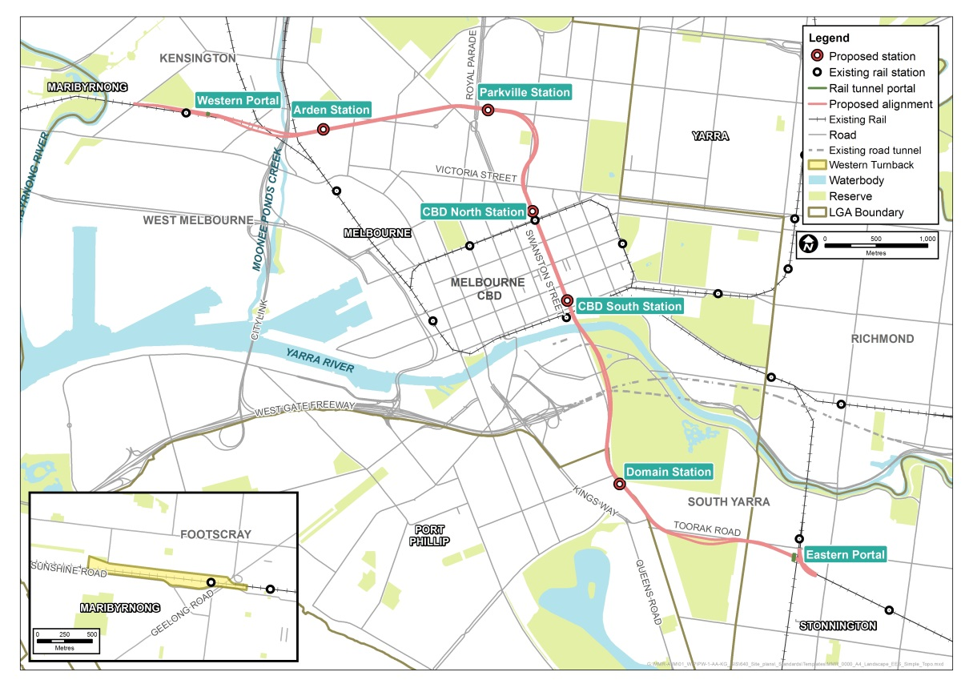
The portals for the twin nine-kilometre tunnels are located at Kensington in the west and South Yarra in the east:
- The western portal is generally in the vicinity of South Kensington station. The existing Sunbury Line tracks will be realigned to travel through the tunnels
- The eastern portal is generally in the vicinity of the South Yarra Siding Reserve, with the project tunnel tracks tying into the existing Cranbourne/Pakenham Line tracks west of Chapel Street.
The twin nine-kilometre tunnels generally follow an alignment from the western portal in Kensington passing below Moonee Ponds Creek and CityLink, under North Melbourne to Grattan Street, continuing under Swanston Street, St Kilda Road and Toorak Road through to the eastern portal.
The five new underground stations would be located at:
- Arden: under VicTrack land generally located near Laurens Street, North Melbourne
- Parkville: under the Grattan Street road reserve, generally between Royal Parade and Leicester Street
- CBD North: under the Swanston Street road reserve, generally between Franklin Street and La Trobe Street
A metro-style system for Melbourne
Metro-style systems are characterised by:
- Stand-alone, end-to-end lines, that prevent service disruptions on one line from cascading across other lines
- Simple timetables with ‘turn up and go’ frequency and consistent stopping patterns
- Frequent services designed to facilitate interchange with other train lines at stations, as well as connecting with trams and buses
- Separate train fleets, maintenance and stabling facilities for each line
- Modern high capacity signalling technology to maximise the number of trains that can operate on each line
- High Capacity Metro Trains (HCMTs) that are longer, can carry more passengers and are designed to minimise boarding and alighting times
- Grade separations of level crossings.
- CBD South: under the Swanston Street road reserve generally between Collins Street and Flinders Street
- Domain: generally under the road reserves of St Kilda Road and Albert Road, and including a train-tram interchange.
Ancillary temporary and permanent works would also be delivered to support the construction and operation of the tunnels, stations and interchanges. Emergency access shafts for safety purposes would be provided in a number of locations as required, which may include Fawkner Park and the Domain Parklands.
Melbourne Metro is an enabling project that will provide the foundation from which further improvements to the capacity and reliability of the rail network would be facilitated. To achieve even greater benefits, a range of wider network enhancements would allow for even more uplift in capacity across the rail network. These wider network enhancements are not within the scope of this EES.

Project Benefits
Melbourne Metro would result in a broad range of benefits. By boosting capacity and increasing the reliability of the metropolitan rail network, Melbourne Metro would deliver significant strategic benefits for Melbourne and the wider transport network.
Melbourne Metro would connect the Sunbury Line to the Cranbourne/Pakenham line to form a new Sunshine – Dandenong Line. This new line would bypass the City Loop, resulting in the removal of train services from the inner core of the rail network and thereby providing the opportunity for this inner core capacity to be used by other lines.
The dedicated metro-style line provided by Melbourne Metro would provide increased capacity across the new Sunshine – Dandenong Line as well as create additional capacity on the other five metropolitan lines. Overall, this would increase capacity in each morning and evening peak period by 39,000 passengers across the metropolitan rail network from Day One of operation.
In summary, Melbourne Metro would:
- Provide a new inner city rail route and capacity to accommodate services as part of the newly created Sunshine – Dandenong Line
- Remove unnecessary route interactions between train services on different lines by reconfiguring the Melbourne metropolitan network and streamlining train operations
- Release substantial capacity on the existing busy inner city rail network by moving the Cranbourne/Pakenham and Sunbury Lines from this network, thereby enabling new services on the Werribee, Sandringham, Craigieburn, Upfield and Frankston Lines
- Provide three new stations (Arden, Parkville and Domain) in areas not currently serviced by heavy rail with a combined catchment of over 200,000 jobs, residents and student enrolments
- Stimulate significant urban renewal in inner city areas such as
Arden-Macaulay
- Create 3,900 additional jobs across Victoria during construction
- Expand the inner core of the rail network to meet demand in the growth corridors to the north, west and south-east of Melbourne
- Upgrade rail capacity to and from existing and emerging national employment clusters (CBD, Parkville, Monash, Dandenong South, Sunshine, and East Werribee)
- Reshape travel demand to enable a future restructure of the tram network within the expanding CBD
- More evenly distribute passenger flow and ease overcrowding in the inner core of the network
- Relieve tram crowding and congestion on St Kilda Road and Swanston Street
- Increase the frequency, reliability and punctuality of services for train passengers
- Increase employment opportunities by improving access to the CBD and Parkville to support Victoria's growing knowledge economy
- Make it easier for customers to navigate the network by simplifying end-to-end service patterns.

Project Objectives
High-level project objectives have established the broad strategic direction for designing and developing Melbourne Metro. These project objectives have been informed by the transport system objectives set out in the Transport Integration Act 2010. The project objectives include:
- To provide additional capacity on Melbourne’s rail system to meet customer needs that, as part of a program of investment, meets projected medium-term demand and supports long-term patronage growth
- To optimise the efficiency and reliability of operations and improve the customer experience by moving towards a metro-style rail system
- To support the long-term plan and vision to develop and operate Victoria’s rail network
- To improve access and reduce congestion of the tram system in central Melbourne and the road network in the north, west and south east by diverting travel to the rail network
- To improve accessibility to jobs, education and other social and economic opportunities by enabling the growth and more effective use of land in Melbourne
- To deliver strong productivity, sustainability and liveability benefits by providing a value for money transport solution
- To contribute to a safe, accessible rail network that supports the health and wellbeing of users.

Project Timelines
The overall duration for construction of Melbourne Metro, from award of the main contract to commencement of passenger services, would be approximately nine years. Key milestones would include:
- 2016 EES process
- 2017 Commencement of early works
- 2017 Tunnels and stations contract awarded
- 2022/23 Civil and structural works at stations, portals and tunnels completed
- 2024/25 Station fit out and installation of rail systems completed
- 2025 Systems integration and operational readiness completed
- 2026 Commencement of passenger services.

Project Proponent
The Melbourne Metro Rail Authority (MMRA), on behalf of the Secretary of the Department of Economic Development, Jobs, Transport and Resources (DEDJTR), is the proponent for the Melbourne Metro EES. MMRA is responsible for the delivery of the Melbourne Metro infrastructure for the Victorian Government.
MMRA is an Administrative Office established in relation to DEDJTR and is one of several agencies assisting the State Government to achieve its integrated transport policy objectives.
MMRA is responsible for developing the Concept Design, coordinating the technical investigations and preparing this EES, engaging and informing stakeholders and the wider community, obtaining the key planning and environmental approvals, and coordinating the State’s procurement activities to contract the private sector construction industry to construct and commission Melbourne Metro.

Environment Effects Statement

Requirement for an EES
Victoria’s Environment Effects Act 1978 establishes a process under which the Minister for Planning may require the proponent of a project to prepare an Environment Effects Statement.
On 3 September 2015, the Minister for Planning declared Melbourne Metro to be ‘public works’ under Section 3(1) of the Environment Effects Act 1978. In doing so, the Minister determined that Melbourne Metro ‘could reasonably be considered to be capable of having a significant effect on the environment’. Under Section 4(1) of the Environment Effects Act 1978, the Minister determined that an EES must be prepared to enable the Minister to assess the environmental effects of the works.
The Minister issued a Public Notice on 2 September 2015 setting out the reasons for making the Order under the Environment Effects Act 1978:
- The project is a large scale infrastructure construction project, with construction effects to span several years and some potential effects lasting beyond the construction period, in an intensively developed area used by many residents, businesses, commuters and visitors, and featuring complex ground and hydrological conditions, possible contaminated soils and acid sulfate soils and important heritage, landscape and urban ecological values
- The works have the potential for significant environment effects on a range of environmental values, having regard to the nature of the area within which the project is proposed to be constructed and its dynamic and varied social and community setting
- An Environment Effects Statement process will provide a robust and transparent and integrated framework through which:
  - The potential environmental effects can be rigorously assessed, including in the context of the comparative effects of feasible design, scheduling and mitigation alternatives for planning and delivery of the project
  - The effectiveness of proposed measures to avoid, minimise, manage and offset environmental effects and related risks can be evaluated.
On 24 November 2015, a further declaration, made by the Minister for Planning, was published in the Government Gazette that exempted certain 'enabling works' from the 'public works' for which an EES is required. These enabling works are not considered capable of having a significant effect on the environment. These works fall into two categories:
- Design and investigation activities and works associated with designing Melbourne Metro and assessing its impacts through the EES process (such as establishing the location of existing utilities and services)
- Specified works to relocate utilities (such as gas and water mains, stormwater drains and communications cables). These works are listed in Schedule 1 of the Minister’s further declaration.

Scoping Requirements
The Minister’s Order provided for the preparation of draft Scoping Requirements, which set out in greater detail the specific matters to be investigated and documented in the EES. The purpose of the Scoping Requirements is to ensure that the EES:
- Properly responds to the Order made by the Minister
- Identifies what the environmental effects of Melbourne Metro would be
- Explains how the environmental effects of the works are proposed to be managed across the different stages and aspects of Melbourne Metro
- Provides sufficient and appropriate information to allow the Minister to conduct an assessment of the environmental effects of the works under the Environment Effects Act.
The EES may also address other significant issues that are not identified in the Scoping Requirements that emerge during the EES investigations.
The Department of Environment, Land, Water and Planning (DELWP) published the draft Scoping Requirements in October 2015 and invited public comment on the draft document. After considering public submissions, the Minister for Planning published final Scoping Requirements on 11 December 2015. This EES has been prepared in accordance with the final Scoping Requirements.

Evaluation Objectives
The Scoping Requirements set the following draft evaluation objectives for the EES:
- Transport connectivity – To enable a significant increase in the capacity of the metropolitan rail network and provide multimodal connections, while adequately managing effects of the works on the broader transport network, both during and after the construction of the project
- Built environment – To protect and enhance the character, form and function of the public realm and buildings within and adjacent to the project alignment, and particularly in the vicinity of project surface structures, having regard to the existing and evolving urban context
- Social, community, land use and business – To manage the effects on the social fabric of the community in the area of the project, including with regard to land use changes, community cohesion, business functionality and access to services and facilities, especially during the construction phase
- Amenity – To minimise adverse air quality, noise or vibration effects on the amenity of nearby residents and local communities, as far as practicable, especially during the construction phase
- Cultural heritage – To avoid or minimise adverse effects on Aboriginal and historic cultural heritage values
- Land stability – To avoid or minimise adverse effects on land stability that might arise directly or indirectly from project works
- Landscape, visual and recreational values – To avoid or minimise adverse effects on landscape, visual amenity and recreational values as far as practicable
- Hydrology, water quality and waste management – To protect waterways and waterway function and surface water and groundwater quality in accordance with statutory objectives, to identify and prevent potential adverse environmental effects resulting from the disturbance of contaminated or acid-forming material and to manage excavation spoil and other waste in accordance with relevant best practice principles
- Biodiversity – To avoid or minimise adverse effects on native terrestrial and aquatic flora and fauna, in the context of the project’s components and urban setting
- Environmental Management Framework – To provide a transparent framework with clear accountabilities for managing environmental effects and hazards associated with construction and operation phases of the project, in order to achieve acceptable environmental outcomes.
These draft evaluation objectives reflect the key matters to be investigated by the EES, relevant legislation and policies, and the objectives and principles of ecologically sustainable development and environmental protection.

Purpose of the EES
In accordance with the Minister for Planning's Order, the Scoping Requirements and the draft evaluation objectives, this EES describes the potential effects of Melbourne Metro on the environment. The EES describes the existing environment that may be affected by Melbourne Metro, identifies the potential environmental effects, and recommends Environmental Performance Measures to avoid, minimise or manage any adverse environmental effects. It also includes a proposed program for monitoring and managing environmental effects during the construction and operational phases of Melbourne Metro.
The EES is supported by a Community and Stakeholder Engagement Plan to inform the public and consult with individuals and groups who could be affected by Melbourne Metro. Implementation of the Community and Stakeholder Engagement Plan will provide opportunities for public comment on and input into the EES process, including raising particular issues of concern or interest, identifying likely impacts and suggesting potential mitigation measures. The Community and Stakeholder Engagement Plan includes a formal consultation process to support public exhibition of the EES, the public submissions process and subsequent hearings.
An EES is not an approval process in itself. An EES enables decision-makers (including relevant Ministers, local councils and statutory authorities) to make informed decisions about whether approvals and consents for Melbourne Metro should be issued and, if so, on what conditions. Irrespective of the requirement for an EES, specific statutory approvals are still required under the relevant legislation. Specific statutory approvals include a planning scheme amendment proposed to enable the development and use of Melbourne Metro under the Planning and Environment Act 1987.
This EES will be scrutinised by an independent inquiry before the Minister for Planning publishes his assessment of Melbourne Metro.

Subject Matter of the EES
Melbourne Metro incorporates four key components, which are evaluated in this EES:
- The Concept Design and specific alternative design options
- Proposed construction methodology
- The environmental impact assessment (underpinned by a risk assessment)
- Recommended Environmental Performance Requirements.
Each component has evolved as baseline investigations and technical assessments undertaken for the project have identified issues that required the Concept Design, indicative construction methodology or the recommended Environmental Performance Requirements to be refined.

Concept Design (including alternative design options)
The Concept Design and design options are assessed in this EES. However, during the further development and procurement phases of Melbourne Metro, the Concept Design may be further refined by the parties who are ultimately contracted by the State to deliver Melbourne Metro (the procurement process is summarised in Section ‎1.6.1 and addressed in more detail in Chapter 23 Environmental Management Framework). This approach is typical for an EES.
Refinements to the Concept Design and alternative design options are anticipated to occur primarily within the proposed project boundary (see Section ‎1.4.6). Consequently, the potential environmental effects of these refinements are contemplated and addressed by the EES process and would be managed through complying with the recommended Environmental Performance Requirements (see Section ‎1.4.5) and meet the Project Objectives.
The alternative design options demonstrate different ways the recommended Environmental Performance Requirements could be achieved. Inclusion of the options provides an opportunity for the community to be consulted during the EES process on the impact of each option. It also provides some flexibility for the construction industry, through the procurement process, to develop innovative solutions to the delivery of Melbourne Metro.
The EES and the supporting specialist reports have been prepared having regard to the Concept Design, the alternative design options and proposed construction methodology.
The Concept Design and design options are described in Chapter 6 Project Description. Design and engineering maps of the Concept Design and its components are provided in the EES Map Book.

Proposed Construction Methodology
Constructing Melbourne Metro would take a number of years and would potentially have significant environmental effects. For the purpose of assessing these potential effects and developing appropriate recommended Environmental Performance Requirements, a proposed construction methodology was developed by MMRA. This is described in Chapter 6 Project Description.
Some aspects of the construction methodology would be prescribed: for example, the use of tunnel boring machines (TBMs) to construct the rail tunnel outside the Melbourne CBD and for crossing of the Yarra River. Other aspects may be optimised or altered by MMRA’s contractors to undertake the detailed design and construction of Melbourne Metro. However, irrespective of the methodology adopted, the construction of Melbourne Metro must comply with the final approved Environmental Performance Requirements. The nature and purpose of the recommended Environmental Performance Requirements are described in Section ‎1.4.5.

Key Design and Construction Assumptions
Table ‎1–1 summarises the project components and the options (prescribed or with possible alternatives) set out in the Concept Design. As the table indicates, the specifications for most components would be prescribed to the contractors delivering the project for MMRA. However, for those components that are not prescribed, feasible options have been assessed to consider the potential impacts from different design or construction approaches and to inform the development of appropriate Environmental Performance Requirements to manage potential impacts. Allowing for alternative design options in some project components provides for flexibility and innovation from the construction industry, while still allowing for an integrated assessment of Melbourne Metro during the EES process.
If design options are proposed following completion of the EES process, these may not require additional assessment provided they are within the proposed project boundary and can comply with the approved Environmental Performance Requirements. However, if design options are proposed outside the proposed project boundary and create potential impacts not considered in this EES or cannot comply with the approved Environmental Performance Requirements, then such design options could be subject to applicable assessment and approval requirements.
Figure ‎1–2 maps the key Concept Design components.
Details of the proposed components and construction methods listed in
Table ‎1–1 are provided in Chapter 6 Project Description.

Table ‎1–1 Melbourne Metro proposed components and options
Components |  | Description of components and options
Tunnels | Vertical alignment | The vertical alignment of the Concept Design is largely prescribed by the grade line and connection to Melbourne Central station and Flinders Street Station.  The two tunnels would be 9 km long with a diameter of 7 m to 7.5 m. Along the tunnel alignment, the proposed rail level would be typically between 10 m to 40 m below ground level and pass under the existing City Loop tunnels.  The deeper vertical alignment within the CBD has been chosen to minimise disruption to the CBD during construction and to avoid the City Loop tunnels.  The Concept Design prescribes the use of tunnelling or mined construction methods (between CBD stations) for the tunnel to minimise surface impacts.
 | Yarra River crossing | The Concept Design requires a bored tunnel under the river with the alignment largely prescribed based on connection to the CBD South station.
 | Crossing of CityLink tunnels (options) | The Concept Design considers options to cross either above or below the CityLink tunnels between CBD South and Domain stations.
 | Emergency access shafts (options) | Two shafts may be required. The Concept Design considers alternative locations for each shaft:  - Fawkner Park  - North-east section of Fawkner Park or  - At the potential TBM southern launch site location at and surrounding the current Fawkner Park Tennis Centre  - Linlithgow Avenue  - Queen Victoria Gardens adjacent to Linlithgow Avenue or  - Tom’s Block adjacent to Linlithgow Avenue  The final location and requirement for emergency access shafts would be determined in consultation with the Metropolitan Fire Brigade.
 | TBM launch sites (options for southern launch site) | The Concept Design requires two TBM launch sites.  The western TBM launch site is to be at the Arden station site to support construction of the tunnels west of the Yarra River.  The southern TBM launch site considers alternative locations:  - Single launch site at Domain station box or  - Two launch sites at the Domain station box and a defined section in the north-east corner of Fawkner Park (where the tennis courts are located).  Both options for the southern TBM launch require tunnelling activities to be supported by a construction work site at Edmund Herring Oval.
Portals (tunnel entrances) | Western portal (Kensington) (options) | The western portal would be located immediately north of the South Kensington station.  The Concept Design considers two portal locations, which consider variations in vertical and horizontal alignments that are influenced by the position of the tunnel entrance / exit point (the portal). A number of options were considered, but only two options have been assessed in the EES (see Chapter 5 Project Development for further discussion of options considered).  One option positions the portal within the council reserve on the south side of Childers Street directly to the west of the South Kensington station subway entrance located opposite Ormond Street.  The second alternative design option positions the portal within the council reserve on the south side of Childers Street approximately 150 m west of the South Kensington station subway entrance located opposite Ormond Street, with a longer decline structure to enter the tunnel and a bridge over Kensington Road.
 | Eastern portal (South Yarra) | The Concept Design is prescribed regarding the location of the eastern portal and is influenced by design standards required for crossing of the Sandringham and Frankston rail lines.  A TBM retrieval box (incorporating other plant) would be required in the rail reserve between Osborne Street, South Yarra and the existing Sandringham Line.
Underground stations | Arden | The Concept Design is prescribed regarding station location (between Arden and Queensberry Streets, contained within publicly owned land) and construction method (bottom-up cut and cover station box construction).  Initially, the station would have an entrance located on Laurens Street. There would be provision for a future second entrance located approximately 120 m south of Arden Street, in line with a future southward extension of Fogarty Street.
 | Parkville  (construction options) | The Concept Design is prescribed regarding the station location (under the Grattan Street road reserve, to the east of Royal Parade) and considers two possible construction options: top-down cut and cover construction or bottom-up cut and cover construction.  Two entrances would be located at the University of Melbourne, one on the corner of Royal Parade and one on Grattan Street. A further entrance would be located outside the Victorian Comprehensive Cancer Centre (near the corner of Royal Parade).  A tram stop would be located in Royal Parade, just north of Grattan Street.
 | CBD North | The Concept Design is prescribed regarding the station location (under Swanston Street, between Franklin and La Trobe Streets) and construction method (mined cavern).  One entrance would be located on Franklin Street, to the east of Swanston Street, and another entrance would be located on the corner of Swanston and La Trobe Streets, with an underground connection to Melbourne Central station.  A plant room would be located under Franklin Street (between Swanston and Bowen Streets).
 | CBD South | The Concept Design is prescribed regarding the station location (under Swanston Street, between Collins and Flinders Streets) and construction method (mined cavern).  One entrance would be located on Collins Street at City Square and one entrance would be located on Flinders Street, opposite to and with an underground connection to Flinders Street Station.  There would be an underground entrance connection to Federation Square.
 | Domain | The Concept Design is prescribed regarding the station location (under St Kilda Road, adjacent to Albert Road) and proposed construction method (cut and cover, with a mix of top-down and bottom-up).  The station would have three entrances: within the Shrine of Remembrance Reserve, within the Domain tram interchange in St Kilda Road and within open space between Albert Road and St Kilda Road where the South African Soldiers Memorial is located.
Turnback | Western Turnback at West Footscray | The Concept Design is prescribed regarding the locations of the turnback and the requirement for a third platform and track at West Footscray station, with modifications to the existing concourse.
Electrical substation | Arden (options) | The Concept Design considers four options:  - North of Arden Street, between CityLink to the west and Langford Street to the east  - Co-location at Metro Trains Melbourne traction substation between CityLink and the Upfield line  - Southern section of the Arden Station precinct, between rail to the west and Laurens Street to the east  - In the existing 50 Lloyd Street Business Estate at the eastern corner of Childers and Tennyson Streets (dependent on the western portal option).

Figure ‎1–2 Concept Design key project components
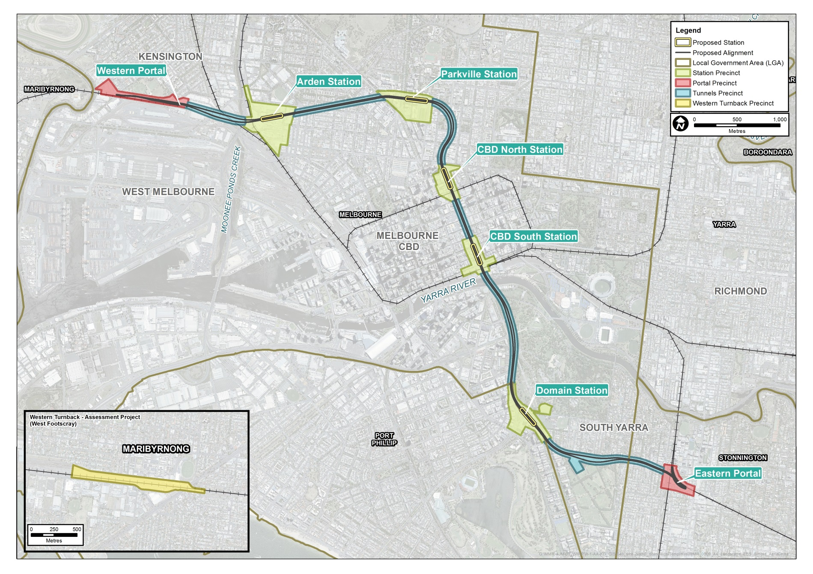

Environmental Impact Assessment
To ensure this EES addresses the Scoping Requirements, 18 specialist technical assessments have evaluated the environmental effects of the Concept Design, design options and proposed construction methodology. The specialists have also assessed how the environmental effects of Melbourne Metro could be mitigated and matters that should be considered for inclusion in the recommended Environmental Performance Requirements.
The technical assessments applied a systems and risk based approach to identifying and assessing potential environmental effects across interrelated specialist studies, and also considered potential cumulative effects.
The specialist impact assessments that support this EES are outlined in Section ‎1.8 and the approach is detailed in Chapter 4 EES Assessment Framework and Approach. The technical assessments are appended to this EES.

Environmental Performance Requirements
Melbourne Metro would be delivered in accordance with recommended Environmental Performance Requirements that define the project-wide environmental outcomes that must be achieved during the design, construction and operation regardless of the design solutions adopted.
The significance of the Environmental Performance Requirements
The final Environmental Performance Requirements would be included in the Project Agreement. The contracts that the State would make with contractors would require the contractors to implement and adhere to the Environmental Performance Requirements as part of the construction and operation of the project. The recommended Environmental Performance Requirements for the project are incorporated into the Environmental Management Framework, provided in Chapter 23 of the EES.
The inclusion of the approved Environmental Performance Requirements within the Project Agreement gives the State a contractual mechanism for ensuring the project delivers acceptable and required environmental outcomes. The statutory approvals issued for Melbourne Metro would also provide for the regulation and enforcement of the environmental performance of project-related activities under the relevant Victorian and Commonwealth legislation.
This performance-based approach aims to achieve outcomes that provide a net community benefit, while allowing for a delivery model with sufficient flexibility to encourage innovation by the private sector to determine how any recommended Environmental Performance Requirements would be achieved.
Measures identified in this EES to avoid, reduce or offset environmental impacts have formed part of the recommended Environmental Performance Requirements for Melbourne Metro.
These measures have been recommended by specialists through the EES impact assessment process. The approach adopted to develop these requirements and assess environmental impacts and risks is described in Chapter 4 EES Assessment Framework and Approach. Specific requirements are discussed in the relevant sections of Chapters 8 to 22. The proposed Environmental Management Framework for Melbourne Metro is set out in Chapter 23 Environment Management Framework and includes a full list of the recommended Environmental Performance Requirements. These requirements may be refined further during the EES process.
All recommended Environmental Performance Requirements would be implemented, through contractual agreements with contractors for the delivery of Melbourne Metro. Under the proposed planning scheme controls for Melbourne Metro, the Environmental Management Framework and Environmental Performance Requirements would also need to be approved by the Minister for Planning.

Proposed Project Boundary
The proposed project boundary encompasses the key locations that would be used for permanent structures and temporary construction work sites (above and below ground), with the exception of ancillary works associated with road functional layouts and tram diversions and service relocations.
The proposed project boundary provides the basis for the specialist assessments undertaken for the EES. For assessment purposes, the proposed project boundary has been divided into nine precincts to assess the potential impacts on local areas and the characteristics of surrounding area and communities (see Section ‎1.4.7 below).
For the purposes of the EES, the proposed project boundary is approximately 30 m either side of the proposed tunnel alignment, except around the stations, portals and construction work sites where the proposed project boundary is broader. Details of the proposed project boundary are provided in the EES Map Book appended to this EES.
Some of the assessments undertaken to inform this EES have adopted larger study areas than the proposed project boundary in order to appropriately characterise and understand relevant effects and to collect sufficiently detailed baseline information. Where this approach has been adopted, it is noted and described in the specialist impact assessment reports appended to the EES.

Project Precincts
For assessment purposes, the proposed project boundary has been divided into nine precincts, based on the location of project components and construction works, the potential impacts on local areas and the characteristics of surrounding communities.
Table ‎1–2 Assessment precincts for Melbourne Metro
Precinct | Summary description
Precinct 1 - Tunnels | This precinct covers the alignment of the two tunnels between the western portal at Kensington and the eastern portal at South Yarra, with the exception of the station and portal precincts.
Precinct 2 - Western portal (Kensington) | The western portal would be located in the vicinity of South Kensington station. The precinct contains housing, public open space and an industrial estate to the north, with railway lines and a freight terminal to the south.
Precinct 3 -  Arden station | This precinct is characterised by wide streets, low rise development and a mix of land uses, including light and heavy industrial and residential. Currently dominated by a 14 ha publicly owned industrial site managed by VicTrack, the area is expected to undergo extensive urban renewal over the next 20 years.
Precinct 4 - Parkville station | This precinct is dominated by health and education uses, including major hospitals, leading research institutes and the University of Melbourne. Land uses range from high density development to residential areas with a strong heritage character. The precinct features the historic, tree-lined boulevards of Royal Parade and Flemington Road.
Precinct 5 -  CBD North station | Initially a commercial and industrial precinct, this northern part of the CBD is now characterised by a range of land uses including RMIT University, apartment towers, Melbourne Central Shopping Centre and Melbourne Central Station, the State Library and Melbourne City Baths. The area is highly developed with a diverse mix of modern and heritage buildings.
Precinct 6 -  CBD South station | This precinct is a dense inner urban area, centred on the Swanston Street corridor between Collins and Flinders Streets at the southern edge of the CBD. It is the site of several Melbourne landmarks and visitor destinations, such as Federation Square, St Paul’s Cathedral, Melbourne Town Hall and Flinders Street Station. These landmarks are surrounded by laneways lined with bars, cafes and retail outlets.
Precinct 7 -  Domain station | This precinct is dominated by parks and gardens and the Shrine of Remembrance along the east side of St Kilda Road, north of Domain Road. Offices and residential apartments feature along the west side of St Kilda Road and Melbourne Grammar School and commercial premises are located along the east side of St Kilda Road.
Precinct 8 -  Eastern portal (South Yarra) | This precinct is highly urbanised and comprises mixed use development and a range of housing types, from detached housing to large residential apartment blocks. The area borders one of Melbourne’s busiest retail and entertainment precincts, centred on Toorak Road and Chapel Street.
Precinct 9 - Western turnback (West Footscray) | The proposed western turnback would be located at West Footscray within the existing rail reserve. The precinct is dominated by rail infrastructure, with a commercial and industrial area to the south and residential areas (and Whitten Oval) to the north.

Matters not addressed in the EES
The following matters are not addressed in this EES:
- Wider network enhancements – Melbourne Metro provides the ‘backbone’ for further improving the metropolitan rail network in the future by incorporating features, such as long platforms and high capacity signalling, that allow a staged approach to expanding the network. If further investments are made in the medium term (including extended HCMTs, longer platforms, Melton quad track, Melton electrification and power and signalling upgrades), this would enable further capacity for 41,000 passengers per peak period to be introduced on the Sunshine/Dandenong Line progressively from 2031 as required.
Wider network enhancements are not within the scope of this EES and are located outside proposed project boundary (see Section ‎1.4.6).
While ultimately a decision for the Minister for Planning, the wider network enhancements as developed at the time of preparing the EES include signalling upgrades, infrastructure to improve access to sidings, turnbacks, track works and changes to the operation of the tram network. The relatively smaller scale of these works means that their associated impacts would be assessed and managed adequately through the existing statutory processes that are applicable to rail corridor enhancements.
- Enabling works – As explained in Section ‎1.3.1, certain 'enabling works' have been exempted from the 'public works' for which an EES is required. Consequently, this EES does not address these enabling works.
- Temporary construction power – Undertaking the required assessment and obtaining approvals for the installation of the TBM (southern launch site) and roadheader construction power supply would be the responsibility of the relevant power utility.

Project Delivery

Project Procurement
The Victorian Government has announced the proposed procurement strategy for Melbourne Metro summarised in Table ‎1–3.
Table ‎1–3 Melbourne Metro procurement strategy
Works package | Procurement model | Description
Early works  Utility service relocations and protection, and works to prepare construction sites | Managing Contractor | Under a Managing Contractor approach, the State engages a head contractor (the Managing Contractor) who engages sub-contractors to deliver the works or self-performs certain aspects of the works. The Managing Contractor is responsible for administering the sub-contracts and accepts some delivery risks. Payment arrangements typically include reimbursement of costs plus allowances for management fees, margins and overheads.
Tram infrastructure works | Yarra Trams led | As part of the tram franchise arrangements, the State has entered into Project Agreements with the trams franchisee (Yarra Trams), which provide for Yarra Trams to deliver infrastructure works on behalf of the State for a cost-plus approach with a fixed margin.
Provision of construction power | Design and construct contract | The physical infrastructure works to provide power to the TBM launch sites would be delivered by either a utility service provider (USP) or a civil constructor through a design and construct contract with the State. The State would separately enter into a connection agreement with the appropriate USP to connect into its power network.  The location of power lines for supply to TBMs launched at Domain station or possibly Fawkner Park would be determined by the USP and the necessary approvals obtained.
Tunnels and stations  Main tunnelling works, construction of five underground stations, tunnels, station fit-out, mechanical and electrical systems, TBM extraction shafts at the portals, and specific station operations and maintenance services for the infrastructure delivered. | Public Private Partnership (PPP) (availability-based) | In an ‘availability-based’ PPP, a private party (usually a consortium) designs, builds and finances the facilities, and also operates and maintains them to specified standards in return for the State paying a service fee over an agreed term (usually 15 to 30 years).
Rail infrastructure  Works at the eastern and western portals including cut and cover tunnelling, decline structures and local reconfiguration and realignment of exiting lines. Construction of western turnback. | Competitive Alliance | Alliance contracting is a form of relationship contracting in which the State collaborates with one or more non-owner parties to share risks and responsibilities in designing and delivering a construction project. The alliances will be structured as competitive target outturn cost (TOC) alliances, whereby a TOC is developed competitively by more than one bidder.
Rail systems  Rail systems design (including conventional signalling and High Capacity Signalling, train and power control systems, and ICT), installation works, rail systems integration and commissioning. | Competitive Alliance | As above  (Rail systems within the tunnels, stations, portals and western turn back are within the scope of the EES. Rail systems across the broader network would be subject to obtaining the necessary approvals required.)
The metropolitan rail franchisee would operate the services using the infrastructure delivered by Melbourne Metro, as there would be significant advantages to maintaining a single operator across the network.
The HCMTs that would operate on the new Sunshine/Dandenong Line would be procured separately.
The proposed Melbourne Metro procurement strategy aims to attract broad market interest, provide a sound basis for allocation, pricing and management of risks and offer scope to the construction industry to propose innovative approaches to delivering Melbourne Metro.
Each works package would be required to comply with the approved Environmental Performance Requirements (see Chapter 23 Environmental Management Framework). The approved Environmental Performance Requirements would form a key element of each contractor’s obligations.

Project Delivery Mechanism
On 4 September 2015, the Premier determined Melbourne Metro to be a declared project to which the Major Transport Projects Facilitation Act 2009 applies, other than Part 3 (Assessment and Approval) and Part 8 (Assessment Committees). The Premier also appointed the Minister for Public Transport to be the Project Minister.
The project declaration is the first step in allowing the use of the project delivery powers of the Major Transport Projects Facilitation Act 2009. The next step will be the appointment of a project authority. The project authority will have the power to request the Minister for Planning to designate a Project Area, acquire interests in public and private land (including below ground stratum) and manage interfaces with utilities.
The anticipated use of project delivery powers under the Major Transport Projects Facilitation Act 2009 is discussed further in Chapter 3 Legislative Framework and Approvals Requirements.

Project Approvals

Victorian Approvals
The EES for Melbourne Metro is not an approval in itself. However, it will inform the Minister’s assessment of the environmental effects of the project and the acceptability of the recommended Environmental Performance Requirements.
Following the public exhibition of the EES, an Inquiry appointed by the Minister for Planning will consider the EES and public submissions. The Inquiry will then report to the Minister and make recommendations to assist the Minister’s assessment of the environmental effects of Melbourne Metro under the Environment Effects Act 1978. The Minister’s assessment, together with the Inquiry’s report, can be considered by Victorian decision-makers to inform project approvals, which include:
- Amendments to the relevant planning schemes under the Planning and Environment Act 1987
- Permits and consents under the Heritage Act 1995.
A Cultural Heritage Management Plan under the Aboriginal Heritage Act 2006 is being prepared in parallel to the EES.
A range of secondary approvals and consents may also be required. The relationship of these approvals and consents to the EES is described in Chapter 3 Legislative Framework and Approval Requirements.

Commonwealth Approvals
The Commonwealth Environment Protection and Biodiversity Conservation Act 1999 (EPBC Act) provides a legal framework to protect and manage designated ‘matters of national environmental significance’. If the Commonwealth Minister for the Environment decides under the EPBC Act that a project could potentially have a significant impact on a matter of national environmental significance, the project becomes a ‘controlled action’ that must be assessed and approved by the Minister before the project can proceed.
On 22 September 2015, the Commonwealth Minister for the Environment determined that Melbourne Metro is not a ‘controlled action’ that requires assessment and approval under the EPBC Act. This was on the proviso that the project be undertaken in a particular manner that avoids significant impact as a result of vibration on Commonwealth heritage listed structures within the Victoria Barracks site in St Kilda Road. These requirements are included in the recommended Environmental Performance Requirements.
No further assessment is required under the EPBC Act.

Structure of the EES
The structure and content of the EES aligns with the draft evaluation objectives set out in the Scoping Requirements (see Sections ‎1.3.2 and ‎1.3.3). The EES comprises a Summary Report, the Main Report, Technical Appendices and the EES Map Book, as illustrated in Figure ‎1–3 and Table ‎1–4.
The Map Book accompanying this EES comprises three sets of maps:
- Series 1: Construction phase – shows the areas of construction activity, including open excavation and subsurface works
- Series 2: Operational phase – shows above-ground infrastructure and proposed underground tunnel alignment post construction
- Series 3: Vertical alignment – shows the approximate elevation height/depth at points along the horizontal alignment.
The plans are indicative in scale and are intended to demonstrate the potential locations of construction activities and permanent infrastructure associated with Melbourne Metro. These locations may be subject to change as a consequence of detailed design and the Minister for Planning’s assessment.
Figure ‎1–3 Components of the EES
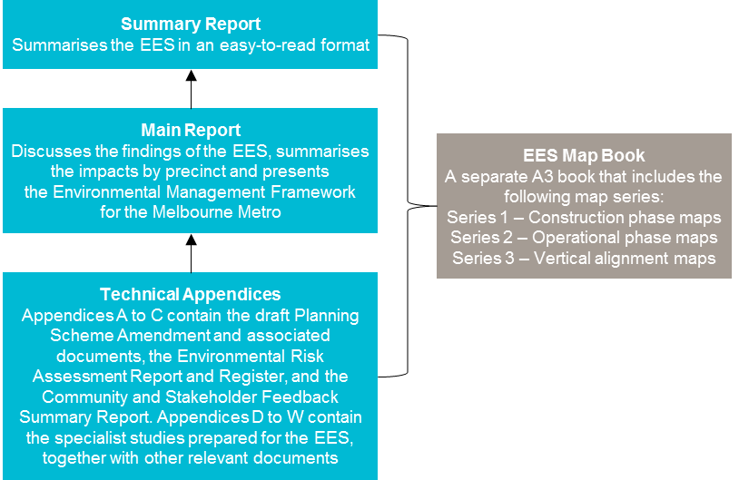
Table ‎1–4 Structure of main report and appendices
Chapter | Title | Content overview
Chapter 1 | Introduction | Provides an overview of the proposed Melbourne Metro and the EES
Chapter 2 | Project Rationale and Benefits | Sets out the broader policy context in which Melbourne Metro has been developed, outlines the underlying rationale for the project and describes the anticipated benefits and opportunities delivered by Melbourne Metro
Chapter 3 | Legislative Framework and Approval Requirements | Describes the EES process and other approval requirements
Chapter 4 | EES Assessment Framework and Approach | Describes the approach adopted to prepare the EES and assess impacts and risks associated with the project
Chapter 5 | Project Development | Outlines the process adopted to identify and assess options for Melbourne Metro
Chapter 6 | Project Description | Defines the Concept Design (and level of prescription) used as the basis for assessing risks and impacts, including a description of the project components located in each precinct
Chapter 7 | Community and Stakeholder Management | Provides an overview of the consultation approach being adopted for Melbourne Metro and responses to stakeholder and community feedback received to date
Chapter 8 | Transport | These chapters summarise the findings of the investigations undertaken by the relevant technical specialists, including:  Methodology followed  Existing baseline conditions  Risk assessment  Main impacts overall and by precinct  Potential mitigation measures  Recommended Environmental Performance Requirements
Chapter 9 | Land Use and Planning
Chapter 10 | Social and Community
Chapter 11 | Business
Chapter 12 | Air Quality
Chapter 13 | Noise and Vibration
Chapter 14 | Historical Cultural Heritage
Chapter 15 | Aboriginal Heritage
Chapter 16 | Landscape and Visual
Chapter 17 | Surface Water
Chapter 18 | Groundwater
Chapter 19 | Ground Movement
Chapter 20 | Contaminated Land and Spoil Management
Chapter 21 | Biodiversity
Chapter 22 | Greenhouse Gas
Chapter 23 | Environmental Management Framework | Presents the Environmental Management Framework to be adopted for delivering Melbourne Metro, including a full list of all recommended Environmental Performance Requirements
Chapter 24 | Conclusion | Provides a summary of the key findings of the EES

EES Technical Appendix | Study | Relevant EES chapter
Appendix A | Draft Planning Scheme Amendment and Associated Documentation | Chapter 3
Appendix B | Environmental Risk Assessment Report (Risk Register) | Chapter 4
Appendix C | Community and Stakeholder Feedback Summary Report | Chapter 7
Appendix D | Transport | Chapter 8
Appendix E | Land Use and Planning | Chapter 9
Appendix F | Social and Community | Chapter 10
Appendix G | Business | Chapter 11
Appendix H | Air Quality | Chapter 12
Appendix I | Noise and Vibration | Chapter 13
Appendix J | Historical Cultural Heritage | Chapter 14
Appendix K | Aboriginal Heritage | Chapter 15
Appendix L | Landscape and Visual | Chapter 16
Appendix M | Urban Design Strategy | Chapters 6 and 16
Appendix N | Surface Water | Chapter 17
Appendix O | Groundwater | Chapter 18
Appendix P | Ground Movement and Land Stability | Chapter 19
Appendix Q | Contaminated Land and Spoil Management | Chapter 20
Appendix R | Arboriculture (1) | Chapters 16 and 21
Appendix S | Arboriculture (2) | Chapters 16 and 21
Appendix T | Terrestrial Flora and Fauna | Chapter 21
Appendix U | Aquatic Ecology and River Health | Chapters 17 and 21
Appendix V | Greenhouse Gas | Chapter 22
Appendix W | Sustainability Principles and Approach | Chapter 6

