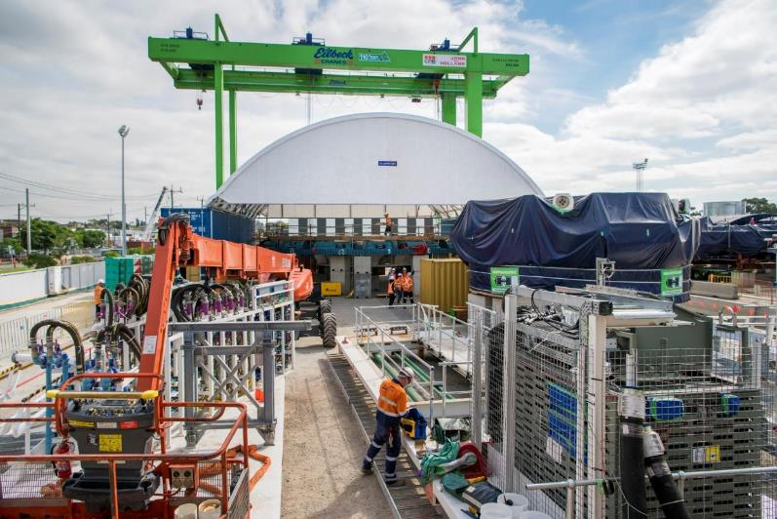





**TBM Bella being built at the northern portal.**

**May 2019**

**Building Bella**

## What takes teams of 30 people working around the clock 75,000 working hours to assemble?

Bella, the West Gate Tunnel Project’s first tunnel boring machine (TBM)!

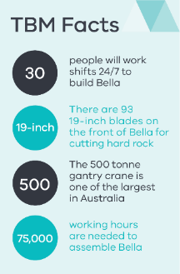

It took over 100 truck loads to deliver Bella to the Northern Portal in January and February.

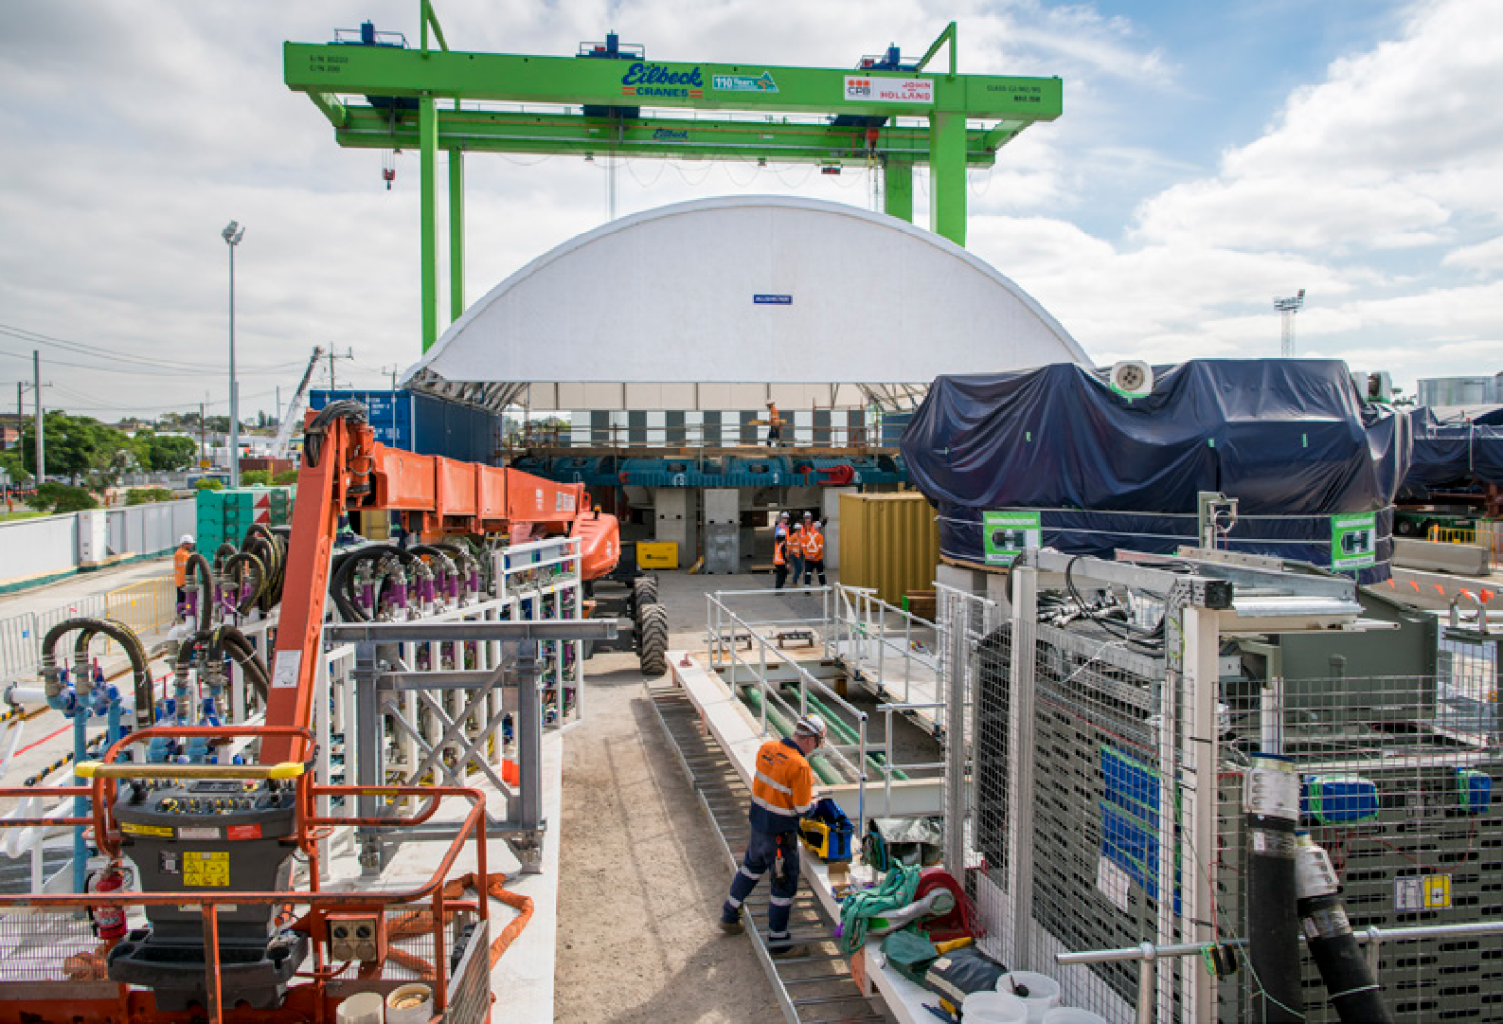

**TBM Bella being built at the northern portal.**

May 2019

Now that all of Bella’s components are on site, assembly of the 15.6m high and 90m long TBM is underway. Bella is going to dig the longer outbound tunnel, which once complete will take trucks off residential streets and provide an alternative to the West Gate Bridge.

Bella is being brought to life by two massive 250 tonne and 500 tonne gantry cranes.

Assembly has started at the rear of the TBM and will gradually progress forward, before she starts her journey

digging a 4 kilometre tunnel from Yarraville to the West Gate Freeway.

Meanwhile the project’s second TBM, Vida, will start arriving on site in May.

Tunnelling will start mid year.

**Did you know?**

To reduce disruption to local traffic, pedestrians and cyclists as works ramp up, an 11 tonne, 8 metre high footbridge for West Gate

Tunnel Project workers is now in place over Somerville Road at Yarraville between two of

our major work sites. At the peak of construction, there will be 500 people working between the two sites.

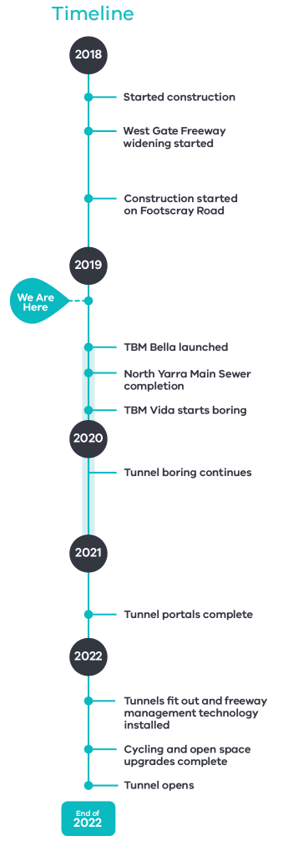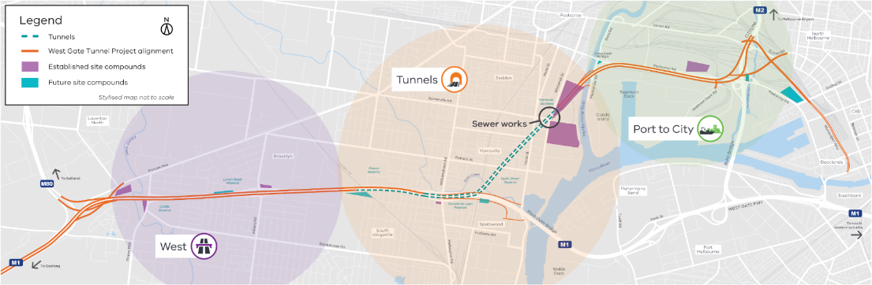

Faces of the West Gate Tunnel

Melbourne Rd

Grieve Pde

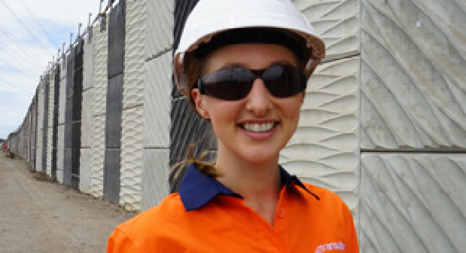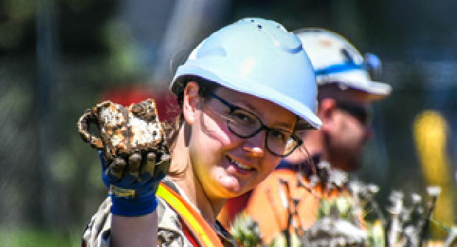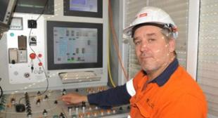

**West: Frances McNulty**

There’s more to noise walls than meets the eye, especially for West Gate Freeway precinct Design Manager Frances McNulty.

Noise walls need to significantly reduce traffic noise along the project corridor, but they also need to look good and fit in with the community around them.

Frances and a team of designers have worked through these challenges to design noise walls that are a combination of textured concrete and coloured acrylic panels that let sunlight through and reduce overshadowing, particularly for residents living next to the freeway.

Following years of community consultation and design work, Frances is excited to see the designs come to life later this year as construction gets underway to install the new noise walls.

### **Tunnels: Andrew Lawer**

Wondering what’s been going on while lanes are closed on Whitehall Street Footscray and

Yarraville? Well, Andrew Lawer is one of a team of operators who have been busy driving mini TBM Mollie, to divert the North Yarra Main Sewer.

Andrew started his career as a carpenter, but got into tunnelling in the early 2000s. He’s worked on seven tunnelling projects and says each is unique.

Over the four months that Mollie was working underground, a typical day for Andrew involved making sure that Mollie was ready to move her way through the ground. He made sure that Mollie was balanced as she cut, twisted and crushed everything in her path and kept tabs on the excavated material.

With Mollie’s work now done, Andrew is preparing for an even bigger job – getting ready to drive TBM Bella when she starts digging in the middle of this year.

### **Port to City: Meg Haas**

Meg Haas has developed her childhood love of history into a career, working as an

Archaeologist and Heritage Advisor on the West Gate Tunnel Project.

Meg works with the team that recovers and records any artefacts found at our sites, and has recently been involved in a dig close to the CityLink ramp on Footscray Road, with findings including ceramics, glassware and marbles.

The team pinpoints areas to excavate before digging carefully layer by layer, documenting, then transporting anything of significance that is found for safe keeping.

Meg’s job can be complicated, but she loves it because it provides a balance between her love of historical research and writing and working outdoors.

Meg works for the project’s archaeology consultant, Dr Vincent Clark & Associates.

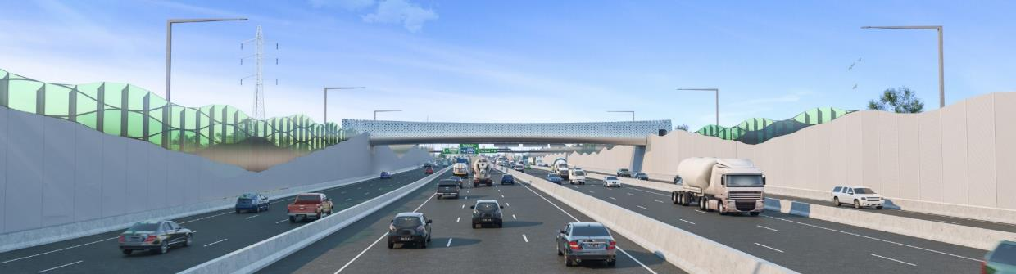

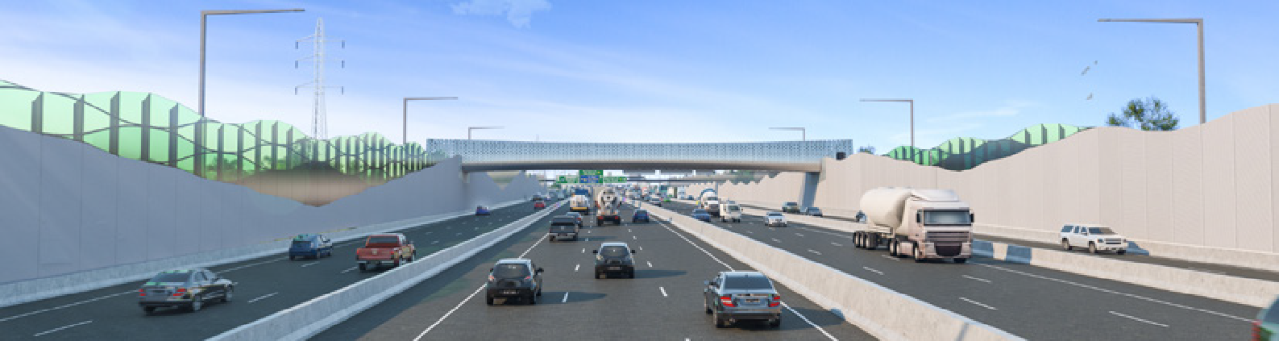

**What the West Gate Tunnel will bring you**

**Everyone’s travel made easy**

• 20 minutes in travel  
time savings

• 24 hour truck bans on  
six local roads

• New walking and cycling paths connecting communities

**Less noise and fewer trucks**

• Taking noise walls to the next level by upgrading and adding new noise walls

• Reduced noise at parks and popular sports grounds

• 9000 fewer trucks on residential streets

**Improving local amenity  
and the environment**

• Creating nearly 9 hectares of new parks and wetlands

• Planting more than 17,000 trees and tens of thousands of native and indigenous shrubs and grasses

• Enhancing waterway environments, with new plantings to rehabilitate creek banks and develop animal habitats

New pedestrian bridges take shape

Widening the West Gate Freeway from eight to 12 lanes means existing pedestrian bridges at Rosala Avenue and Muir Street need to be demolished and replaced.

We’ll keep the existing pedestrian overpasses open, unless they need to be closed for construction activity for a short period of time, until the

new ones are completed and open for use.

Work is well underway on the new pedestrian bridges, and you may have already

noticed our construction crews installing bridge footings on either side of the freeway.

Here’s a look at what the new pedestrian bridges will look like when they are complete.



Community representation important

The West Gate Tunnel Project has two Community Liaison Groups covering the western and northern geographic areas of the project and meetings are held monthly. The CLGs provide an avenue for community members to share local information and tell us how the project is tracking in the eyes of the community, to hear first-hand from our construction team about what’s happening and what’s coming up during construction, and to help support community engagement activities relating to the project.

If you are interested finding out more about the group, reading about the topics being discussed or even in becoming involved, find out more at: westgatetunnelproject.vic.gov.au/clg



**Contact us  
Do you have a question about the project? If you need more information or would like to provide feedback, please get in touch.**

westgatetunnelproject.vic.gov.au [info@wgta.vic.gov.au](mailto:info@wgta.vic.gov.au)

1800 105 105

facebook.com/westgatetunnelproject@westgatetunnel

West Gate Tunnel Project

GPO Box 4509, Melbourne Victoria 3001

 **Interpreter service: 13 14 50**

If you are deaf, or have a hearing or speech impairment, contact us through the National Relay Service. For more information, visit: [www.relayservice.gov.au.](http://www.relayservice.gov.au/)



### 