WES1810.07

2 November 2018

Works notification:
West Gate Freeway (outbound) between Chambers Road and Grieve Parade

Works to widen the West Gate Freeway between Chambers Road and Grieve Parade (on the residential side of the noise walls) will start this month. Construction along this section of freeway will be extensive and once completed, provide two extra lanes for motorists travelling outbound as well as new noise walls for residents.
This is a summary of the activities and what you can expect.
Local road closures
16 November 2018 – mid 2020
To allow our teams to undertake the works in your area safely and efficiently, some temporary road closures will be in place between:
- Freemans Road and Misten Avenue; and
- Rosala Avenue and Irwin Avenue.
Temporary site fencing with access gates will be established at the end of the following streets to create a safe working area between properties and our construction site:
- Freemans Road;
- Misten Avenue;
- Rosala Avenue; and
- Irwin Avenue.
Access to all properties will be maintained although some properties will experience changes to the way they access their property. We will discuss these changes with directly affected properties.
The pedestrian path from Freemans Road to Rosala Avenue and from Irwin Avenue to Chambers Street will be closed from Tuesday 13 November.
Access to the pedestrian overpass will be via Rosala Avenue. See map over page.

Waste collection service changes
16 November 2018 – late 2019
Residents in the following streets north of Glade Avenue are asked to please place their bins on the east side of their street from 13 November (See map over page):

- Freemans Road;
- Misten Avenue;
- Rosala Avenue; and
- Irwin Avenue.
The waste collection services for garbage, recycling and green waste have been advised to reverse their trucks into streets where local road closures are in place.

West Gate Freeway widening
November 2018 – ongoing
We are continuing work on the freeway side of noise walls between Chambers Road and Grieve Parade to construct two additional outbound lanes. These works include:
- roadworks to remove and rebuild road surfaces;
- general construction activities including earthworks and installing a drainage line; and
- installing services including water hydrants and electrical and communication cables.

Site establishment works
16 November 2018 – ongoing
Before we start construction on the temporary and permanent noise walls, we will be:
- investigating utility services that may be impacted by works and potentially require relocation; and
- conducting general construction activities including earthworks and piling pad construction.

Installation of temporary and new noise walls
20 November 2018 – ongoing
These works will include:
- installing a temporary noise wall between Freemans Road and Chambers Road;
- removing the existing noise wall between Freemans Road and Chambers Road following the installation of the temporary noise wall; and
- constructing foundations for the new permanent noise wall with piling commencing early next year.

Planned works area
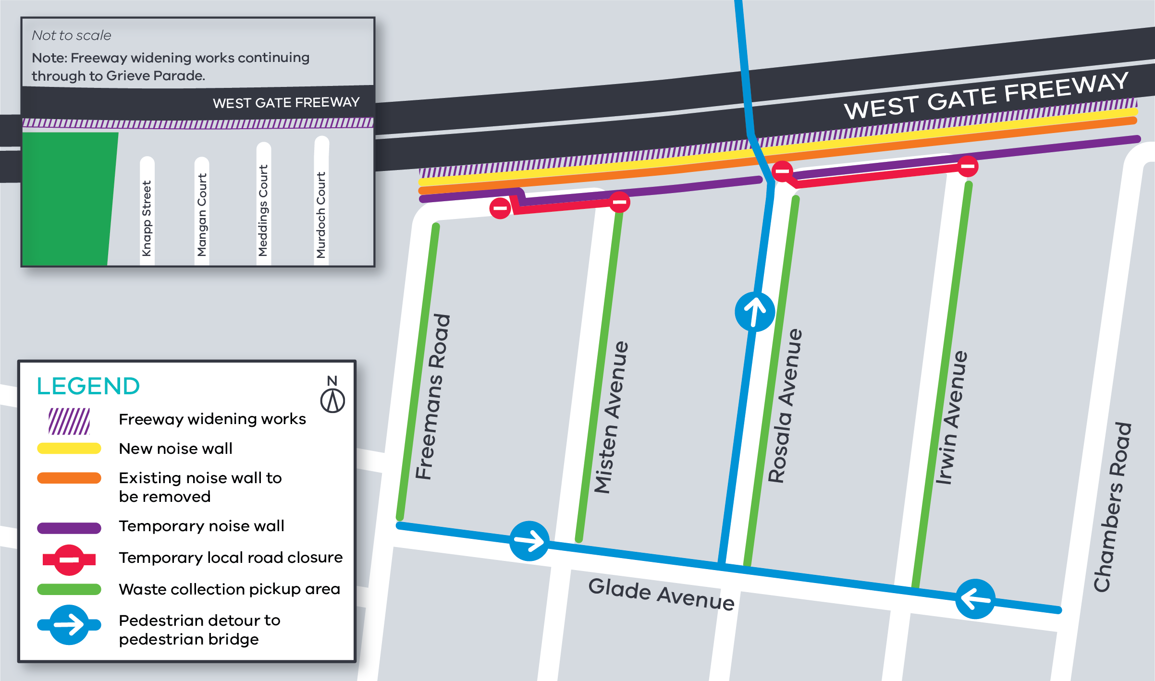

Works will be carried from Monday to Friday 7am-6pm and Saturday 7am-3pm, however some night works will be required.

When works are scheduled out of hours, or if you’re located close to the works, we will provide further information to you before works start.

What you could expect while we undertake these works:
- construction vehicles including excavators, tandem trucks, concrete trucks and pumps, earthmoving
- equipment and cranes will be moving in and out of the work areas;
- construction noise from trucks, piling rigs, compaction equipment, rock hammers, road saws, chainsaws and general construction machinery;
- dust and dirt will be minimised by using water spray trucks, street sweepers and covering dirt and rock when it is being transported;
- traffic management will be in place when large oversized machinery, equipment and materials need to be transported into work sites;
- a detour will be in place for footpath closures with wayfinding signage to enable access to the pedestrian overpass;
- the pedestrian overpass will remain open at all times with access to the bridge clearly signed via Rosala Avenue; and
- traffic changes including lane, road and ramp closures may be required – latest traffic updates are available at westgatetunnelproject.vic.gov.au/traveldisruptions

Please note that works may be rescheduled in the event of bad weather or other unavoidable circumstances.

For updates and more information about our works please visit westgatetunnelproject.vic.gov.au or contact us using the details below.

Contact us
Please contact us if you have any questions or feedback about these works.

 | westgatetunnelproject.vic.gov.au |  | facebook.com/westgatetunnelproject
 | westgatetunnelproject@wda.vic.gov.au |  | @westgatetunnel
 | 1800 105 105 |  | West Gate Tunnel Project  GPO Box 4509  Melbourne Victoria 3001
 | Interpreter service: 13 14 50

