WES1809.02

6 September 2018

Start of works notification: Buchanan Road and nearby reserve

We’re continuing works to widen the West Gate Freeway, between Williamstown Road and the M80 interchange, which will require us to complete important investigations and relocate services in Buchanan Road and the reserve adjacent to the West Gate Freeway and Carlsson Court including:
Moving 66kV power lines underground
20 September - December 2018

These works will include:

- scanning for services to gather information on utilities such as gas, electricity, stormwater and telecommunications along Buchanan Road and the reserve;
- moving the overhead 66kV power lines underground along a section of Buchanan Road – this will involve excavations along a short section of Buchanan Road with a local traffic detour in place;
- moving the overhead 66kV power lines underground along the reserve – this will involve excavations within the fenceline of the reserve and will not have access impacts on residents; and
- maintaining access to the Rosala Avenue pedestrian overbridge at all times.

These works will be carried out Monday to Friday between 7am - 6pm and Saturdays between 7am - 3pm.

Replacing 220kV tower with a monopole
Mid - 2019

We will also need to replace the 220kV lattice tower at the eastern end of reserve near Houston Court with a monopole. These works are expected to start in mid-2019. We will be in touch with residents closer to the time of works.

Lattice towers are the large freestanding power lines that transmit high voltage power around Australia’s network and monopoles are an alternative structure that have less visual impact and a smaller footprint.

These works will include:
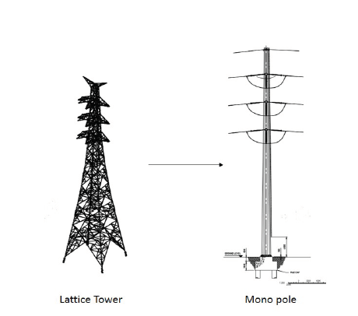
- pouring the concrete foundation for the new tower; and
- moving the 220kV power line from the exisiting tower to new a new monopole at the eastern end of the reserve near Houston Court.

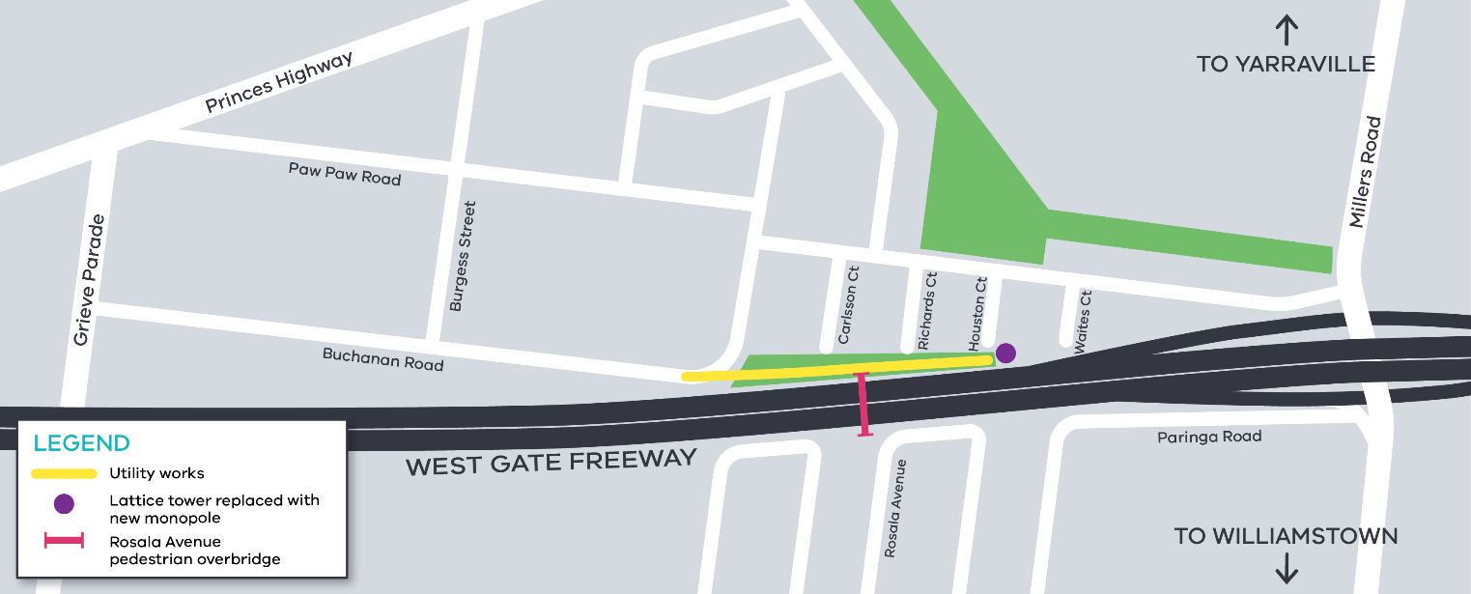Service investigation and power line relocation works area

What to expect during these works:

- an increase in construction noise from our machinery and trucks;
- water spray trucks to help manage dust and dirt;
Contact us
Please contact us if you have any questions or feedback about these works.

 | westgatetunnelproject.vic.gov.au |  | facebook.com/westgatetunnelproject
 | westgatetunnelproject@wda.vic.gov.au |  | @westgatetunnel
 | 1800 105 105 |  | West Gate Tunnel Project  GPO Box 4509  Melbourne Victoria 3001
 | Interpreter service: 13 14 50
- equipment used for these works include heavy vehicles and trailers, excavators, jack hammers, compaction equipment and asphalt cutting saw; and
- traffic changes, including a fully signed short term traffic detour on Buchanan Road – latest traffic updates are available at http://westgatetunnelproject.vic.gov.au/traveldisruptions/.

Please note that works may be rescheduled in the event of bad weather or other unavoidable circumstances.

For updates and more information about our works please visit westgatetunnel.vic.gov.au or contact us using the details over page.

Did you know?
There is onging tree and vegetation removal in the area, including on the freeway side of noise walls, however as part of the project we will plant more than 17,700 trees, of which 4000 will be mature trees. In addition, we will plant approximately 900,000 plants.

