Reference: WES1902.06
12 February 2019
Works update – Beevers Street closure

Construction is well underway on Beevers Street to relocate some existing overhead power lines that currently run along the West Gate Freeway underground, with stage two works nearing completion.
Stage three of these works are ahead of schedule and will begin shortly, and as part of these works, stage three shown on the map over the page will be closed to vehicles.
From Thursday 14 February, stage two works will be complete and access to your driveway will be reinstated.
Temporary closure of Beevers Street
Thursday 14 February – Saturday 23 February 2019
During this time:
- a section at the start of Beevers Street will be closed to vehicles – this is shown as stage three on the map over the page; and
- driveway and footpath access to your property will be maintained.

How to access your property and where to park your car:
- vehicle access to your property will be re-opened from Thursday 14 February and you will be able to drive on the temporary access track at the Italian Social Club and along Beevers Street to get to your home;
- temporary parking at the Italian Social Club will only be available to residents in stage three;
- please ensure you only park on the south side of Beevers Street and do not park your vehicle in the construction area (stage three) during this time as access will be blocked and you will be unable to access your vehicle; and
- please see the map over the page for location details.

What you could expect:
- your garbage collection will return to normal;
- an increase in construction vehicles within the area;
- an increase in construction noise during the day from our machinery and trucks; and
- water spray trucks to help manage dust and dirt and loads will be covered when dirt and rock are being transported.

These works will generally be carried out from Monday to Friday between 7am - 6pm and Saturdays between 7am - 3pm, however some night works may be required.

When works are scheduled out of hours and may have a direct impact on you, we will provide further information to you before works start.

Final asphalting works:

Once we conclude our trenching works on Beevers Street, we will need to do a final asphalt and seal of the road. To do this, in late February, Beevers Street will be temporarily closed to all vehicle traffic for up to five days to complete these works quickly and safely. More information will be provided on this in the next week.

Please note that works and timings may change in the event of bad weather or other unavoidable circumstances.
For updates and more information about our works please visit westgatetunnelproject.vic.gov.au or contact us using the details below.

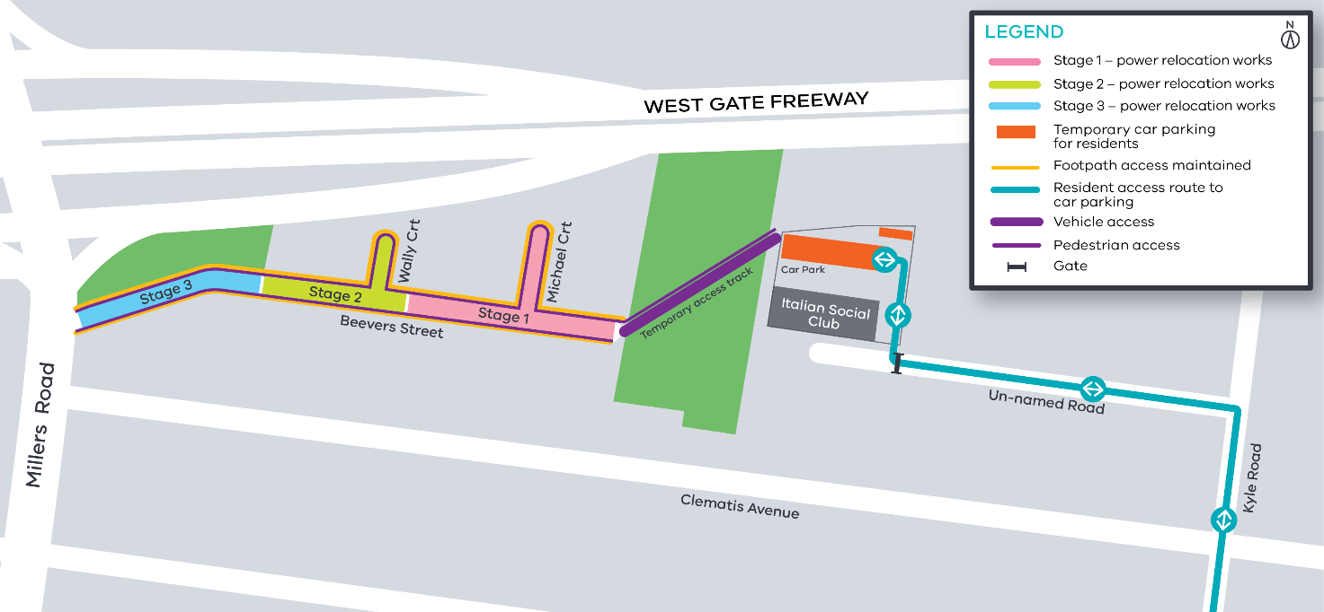
Contact us
Please contact us if you have any questions or feedback about these works.
 | westgatetunnelproject.vic.gov.au |  | facebook.com/westgatetunnelproject
 | info@wgta.vic.gov.au |  | @westgatetunnel
 | 1800 105 105 |  | West Gate Tunnel Project  GPO Box 4509  Melbourne Victoria 3001
 | Interpreter service: 13 14 50

