Reference: WES1902.10
22 February 2019
Works update – temporary driveway disruption

Construction is well underway on Paringa Road to safely relocate some existing power lines that currently run along the West Gate Freeway, to underground. As part of these works, sections of Paringa Road are being progressively closed to vehicles from 18 February until early May 2019.
Temporary disruption to your driveway access
As our team has discussed with you, vehicle access to your driveway will be temporarily blocked from Wednesday 27 February until approximately Monday 18 March 2019.
During this time:
- vehicle access to the staged works area on Paringa Road and some parking will be blocked;
- you can park your vehicle outside the construction area and walk to your property. Please see the map over the page for location details.
- footpath access to your property will remain open at all times; and
- the carpark behind the 16 shops will remain open.
If you require any assistance with carrying items to or from your vehicle during the day, please ask one of our friendly onsite team who will be able to assist you.

When you need to move your vehicle:
- please ensure your vehicle is moved out of your driveway by 10pm on Tuesday 26 February 2019 if you wish to use your car during the works.

Where to park your vehicle when driveway access to your property is blocked:
- it is recommended that you park your vehicle on Paringa Road outside of our construction area or in a neighbouring street.

Waste collection changes: Wednesday 27 February – Monday 18 March 2019
- while works are directly outside your property and vehicle access is blocked, please place your rubbish bins in Lee Street or Bond Street on the east side (the Millers Road side) so they can be collected by the waste contractor;
- please ensure that your bin is moved to this location by 11pm on Tuesday nights while the works are occurring, for collection by Council early on Wednesday mornings.

What you could expect:
- an increase in construction vehicles within the area;
- an increase in construction noise during the day from our machinery and trucks;
- water spray trucks to help manage dust and dirt and loads will be covered when dirt and rock are being transported.

These works will generally be carried out from Monday to Friday between 7am - 6pm and Saturdays between 7am - 3pm, however some night works may be required. When works are scheduled out of hours and may have a direct impact on you, we will provide further information before works start.

There are also underground bore works required under the West Gate Freeway at Chambers Road and under Millers Road across to Paringa Road from mid-February 2019. Some of these works will be undertaken at night, and if they will have a direct impact on you, we will provide further information before these works start.

Please note that works and timings may change in the event of bad weather or other unavoidable circumstances.
For updates and more information about our works please visit westgatetunnel.vic.gov.au or contact us using the details below.

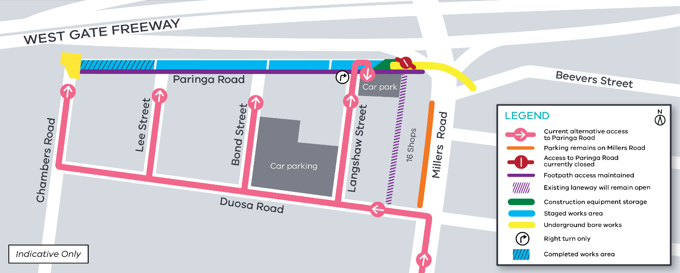

Contact us
Please contact us if you have any questions or feedback about these works.
 | westgatetunnelproject.vic.gov.au |  | facebook.com/westgatetunnelproject
 | info@wgta.vic.gov.au |  | @westgatetunnel
 | 1800 105 105 |  | West Gate Tunnel Project  GPO Box 4509  Melbourne Victoria 3001
 | Interpreter service: 13 14 50

