15 July 2020 WES2006.07

Works notification: West Gate Freeway from Williamstown Road to Newport Rail Bridge
Work is continuing to relocate the water and sewer main underneath the West Gate Freeway, widen and strengthen Newport Rail Bridge, and install noise wall posts and panels along both sides of the freeway.
We will also be working during the day and night to prepare the freeway traffic switches starting in late July. Once traffic has been moved on to the new outer lanes of the inbound carriageway, we will continue widening works in the middle lanes of the West Gate Freeway.
Below is a summary of the activities you can expect to see in the area from mid-July to October 2020.
Williamstown Road utilities and widening works
July to October 2020

We are relocating a sewer and water main pipe underneath the West Gate Freeway at the Williamstown Road inbound exit ramp and along Williamstown Road itself.
The works will require closing the Williamstown Road inbound exit ramp for 24 hours a day over one weekend in late July, requiring drivers to exit early at Millers Road. The works may be rescheduled to a later date in the event of bad weather.
These works will include:
- digging a trench and installing a new water main pipe
- preparation works at the sewer manholes in the reserve, east of Fogarty Avenue, Yarraville, and also at the end of Cullen Court, Spotswood, and
- connecting the new sewer and water main pipes to the existing network
Once the water main pipe has been replaced, work will start to widen the Williamstown Road northbound carriageway, which will include day and night works over two weekends in August 2020.
These works will include:
• installing new drainage pipes
• building new pavement along the western side of Williamstown Road
• constructing traffic islands, and
• installing new traffic lights.

The pedestrian detour on the east side of Williamstown Road will remain in place while these works are underway.
Night works will be required. Advance notice will be provided for noisy works likely to impact residents.

Ramp and freeway widening works
July - ongoing
We are nearing completion of the new Williamstown Road outbound entry ramp. The new ramp will be opened to traffic in late July 2020.
Once the new ramp is opened, work will carry on to widen the freeway in both directions between Williamstown Road and Newport Rail Bridge, which includes laying pavement to create new traffic lanes and installing new noise wall panels.
There will be day and night works in the inbound direction throughout July and August as we prepare to switch traffic to the left side of the carriageway. After the traffic switch, we will start on constructing the centre lanes.

These works will include:
- laying pavement to make new lanes
- installing new drainage pipes
- installing noise wall posts and panels
- installing concrete barriers

Existing and temporary noise walls will be removed after new or temporary noise wall panels have been installed.
Evening and night works will be required and include installing noise wall panels from the freeway. Advance notice will be provided for noisy works likely to impact residents.

Newport Rail Bridge

Ongoing until 2021
We are continuing to widen and strengthen the bridge over Newport Rail, including installing bridge beams and pouring concrete to make new lanes.
New bridge piers, for the additional lanes, are being built on either side of The Avenue, which will require ongoing traffic management at The Avenue during construction.
In addition, to safely lift and install large bridge beams over Newport Rail, we will need to close a section of The Avenue to vehicles, in September for approximately one week. During this time, local traffic will be able to access the south and north sides of the freeway via Williamstown Road.
Additional hydro-blasting work at night will also be required in September. This is noisy work and further information will be provided to residents closer to the date of works.
Night works will be required and advance notice will be provided for noisy works likely to impact residents.

Hours of work
Our usual hours of work are Monday to Friday between 7am-6pm, and Saturdays between 7am-1pm. However, for a number of the works outlined in this notification, night works will be required. When works are scheduled out of hours, or if you are located close to the works, we will provide you with further information before the works start.

What to expect during these works:
- work being completed during the day and at night
- work will be completed behind safety barriers
- construction vehicles including excavators, rollers, water trucks and concrete trucks will be moving in and out of the work areas via our access routes
- construction noise from work activities including machinery and trucks. Vibration might be experienced as we lay new pavement using a roller
- construction vehicles continuing to use designated routes, including local roads, within residential areas
- water spray trucks and road sweepers will be used to manage dust and dirt during works. Trucks removing dirt and rock from the site will be covered
- traffic changes including ramp, lane and road closures will be required. Signed detours will be in place.
For the latest traffic updates visit westgatetunnelproject.vic.gov.au/traveldisruptions.

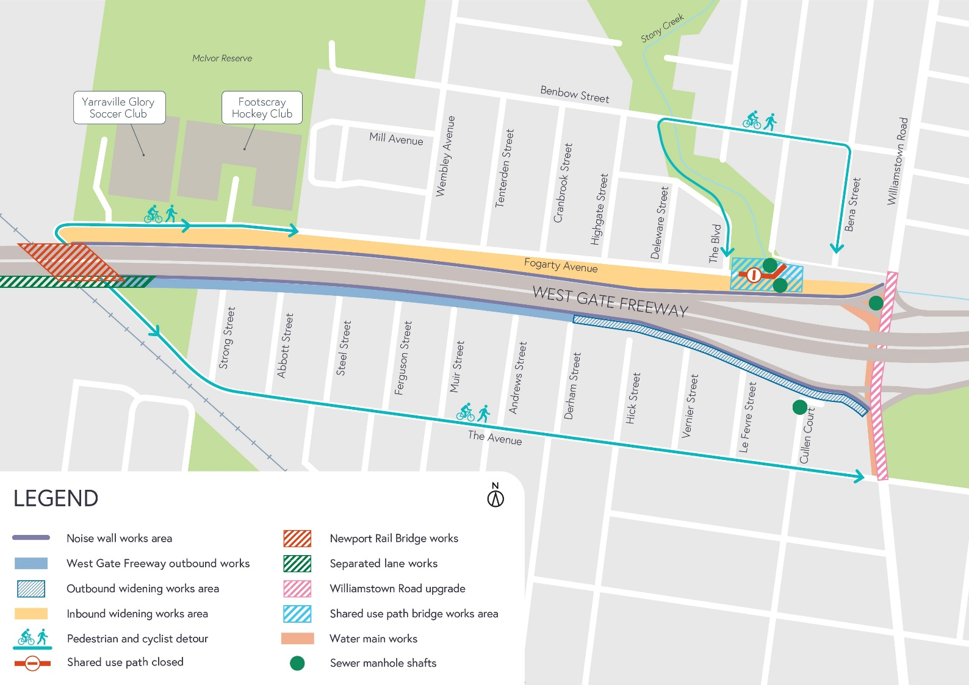
Works area

COVID-19 update
The health and safety of our workers is our key priority as we continue to deliver the West Gate Tunnel Project, as is supporting physical distancing measures in line with current health advice. We have strict protocols in place to protect the safety of our construction workforce and the community. These include enhanced industrial cleaning arrangements and measures to reduce staff contact including staggered shifts and physical distancing. For more information and advice about Coronavirus, please visit coronavirus.vic.gov.au.

Thank you
We appreciate our work can be disruptive and thank you for your understanding and cooperation, particularly during these unprecedented and challenging times.

Please note that works are subject to change and may be rescheduled in the event of unexpected impacts to the construction program. Thank you for your patience during these works.

For updates and more information about our works, please visit westgatetunnelproject.vic.gov.au or call us on 1800 105 105.

