West Gate Tunnel Project
GPO Box 33312
Melbourne Victoria 3004
1800 105 105
westgatetunnelproject.vic.gov.au
info@wgta.vic.gov.au

EAS19SEP.002

4 October 2019

Works notification: Footscray Road
You may have noticed works to build the new elevated roadway above Footscray Road are continuing, with
the first traffic switch (between Appleton Dock Road and Dock Link Road) completed in early August.
This traffic switch allowed the project to create a new work zone in the centre median, making room for the construction of the new launching gantry, which will eventually install the new overhead road segments.
In this works notification, we’ll provide you with a brief update of upcoming construction activities and potential impacts to be aware of over the coming months.

Upcoming traffic changes

Footscray Road

To ensure there is sufficient space in the centre median to facilitate construction activities, a second traffic switch for vehicles travelling westbound on Footscray Road between Dock Link Road and Shepherds Bridge is required.
Importantly, drivers are not expected to experience disruption from the switch. This switch will facilitate:
- Construction of a temporary road surface;
- Installation barriers in this section to separate road users from construction;
- Relocation of underground utilities and removal of light poles; and
- Piling works and construction of piers in the centre median for the elevated road.
Where: Between Dock Link Road and Shepherds Bridge
When: Late October until project completion.

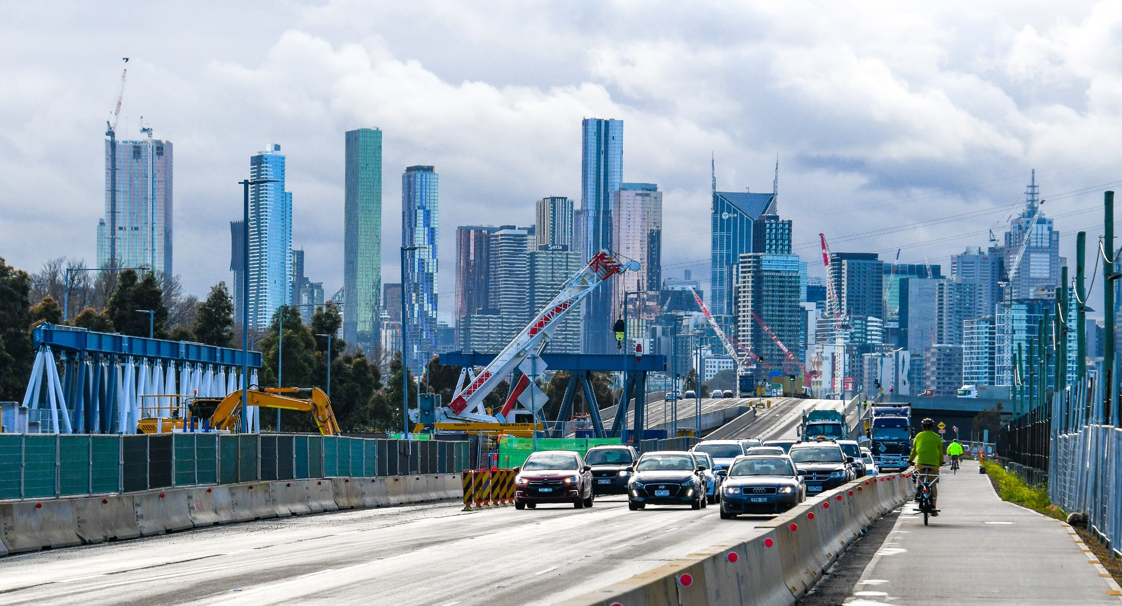
Figure 1: Launching Gantry on the Footscray Road centre median work zone

Appleton Dock Bridge
In early November, you will notice some traffic changes on Appleton Dock Bridge to allow for construction of the ramp from the elevated road to the Appleton Dock Road intersection.
Barriers will be installed and changes will be made to the traffic island and line markings.

MacKenzie Road and Sims Street Ramps
While construction progresses on MacKenzie Road and the Sims Street ramps, there will be some minor traffic changes between mid and late October along Sims Street and MacKenzie Road. These will include:
- Ongoing piling and works to remove traffic islands from the Sims Street loop, making space for more piling and pier construction.
- Works will start on MacKenzie Road to build a temporary roadway, making space for the future rebuild of the permanent MacKenzie Road that will accommodate the entry and exit ramps for the new tunnel.

Shared use path changes

Other works in the area

Utility relocations

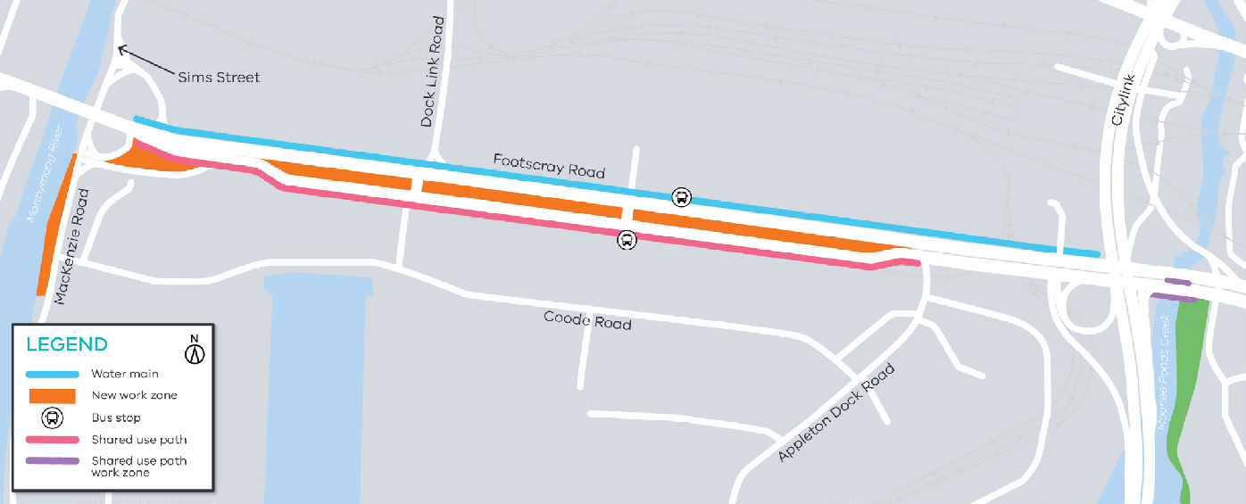
Figure 2 Footscray Road traffic alignment

To safely conduct construction works for the new CityLink off-ramp connecting to the Footscray Road elevated road, we are required to divert the shared use path (SUP) onto a new alignment and temporary structure between CityLink and elevated Appleton Dock Road Bridge.
This will ensure cyclists and pedestrians are separated from construction.
Where: On the existing SUP, between the horse-shoe bend under CityLink and the elevated Appleton Dock Road Bridge
When: The detour will be implemented from mid-October and is expected to be in place for six months.
Additional temporary changes along the Footscray Road shared use path may be in place as we complete works along the southern side.
Shared use path switches and ongoing maintenance will take place during off-peak periods and will be well signed for users.

What to expect for all the upcoming traffic changes:
- Road users will experience minor traffic changes, road closures and signalisation works, which will be undertaken at night time or off-peak periods to minimise the impact for motorists and local businesses.
- Vegetation and tree removal will be required to allow for the new work areas to be established. These areas include the remaining trees in the centre median between Dock Link Road and Shepherd Bridge and on the northern verge.
- Works are undertaken both during the day at night, Monday to Saturday between 7am to 5pm and 7pm to 5am.
Utility relocation works are ongoing along Footscray Road in our work zones and adjacent to local roads.

Work is being undertaken both during the day and at night between 7am to 5pm and night shift between 7pm and 5am.

Night shift works are required to minimise impacts to motorists, especially when works are adjacent to the road.

Piling works and pier construction
Piling works are ongoing between the Maribyrnong River and CityLink with new work areas being established along Footscray Road. Noise and vibration may be noticeable during these works and ongoing noise and vibration monitoring will be in place during these works.
How are piers built?
Once piling is completed, pier works start with pile cap construction which is done by sheet piling around the pile group, excavating to the designed depth and pouring a concrete base known as blinding.
Piles are then broken back to expose the reinforcement steel and additional reo and stress bars are placed before the pile cap is poured.
Piers can then be built in place with FRP- form, reo, pour or precast segments are placed and post tension stressed.
The pier capital can then be built in situ using the FRP method or a pre-cast segment can be installed. Your pier is then ready for your bridge elements.

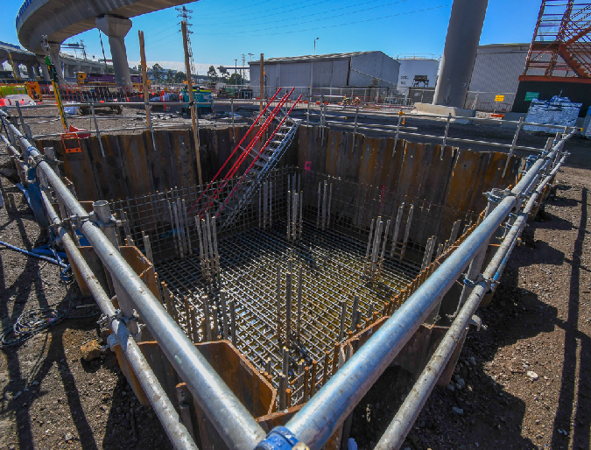
Figure 3: A pile cap ready for concrete to be poured



Footscray Road at Moonee Ponds Creek
As part of the West Gate Tunnel Project, we will be widening the Footscray Road Bridge over Moonee Ponds Creek and constructing a new, dedicated pedestrian and cyclist shared use path, which will be separated from the newly widened bridge.
Preparation works are expected to commence from November and will include;
- Site investigations including electronic scanning of roads, non-destructive digging to identify services and drilling boreholes;
- Vegetation removal;
- Establishment of work zones; and
- Utility relocation works.
When: From November, during the day and at night, Monday to Saturday between 7am to 5pm and 7pm to 5am.

What to expect during construction:
- Works completed both during the day and at night time.
- We will notify you if there are any significant changes to the timing of our works.
- Traffic management will be in place to manage changed conditions including temporary access changes and signage to guide road users and cyclists.
- Dust will be managed on-site.
- Piling works can create increased levels of noise and may also cause some vibration.
- Assessments have been conducted, which indicate the noise levels are expected to remain within permissible levels as documented in the project’s Environmental Performance Requirements.
We thank you for your patience during these works.

Contact us
Do you have a question about the project? If you need more information or would like to provide feedback, please get in touch.

westgatetunnelproject.vic.gov.au info@wgta.vic.gov.au
1800 105 105
facebook.com/westgatetunnelproject @westgatetunnel
West Gate Tunnel Project
GPO Box 4509, Melbourne Victoria 3001
 Interpreter service: 13 14 50
If you are deaf, or have a hearing or speech impairment, contact us through the National Relay Service.
For more information, visit: www.relayservice.gov.au.

