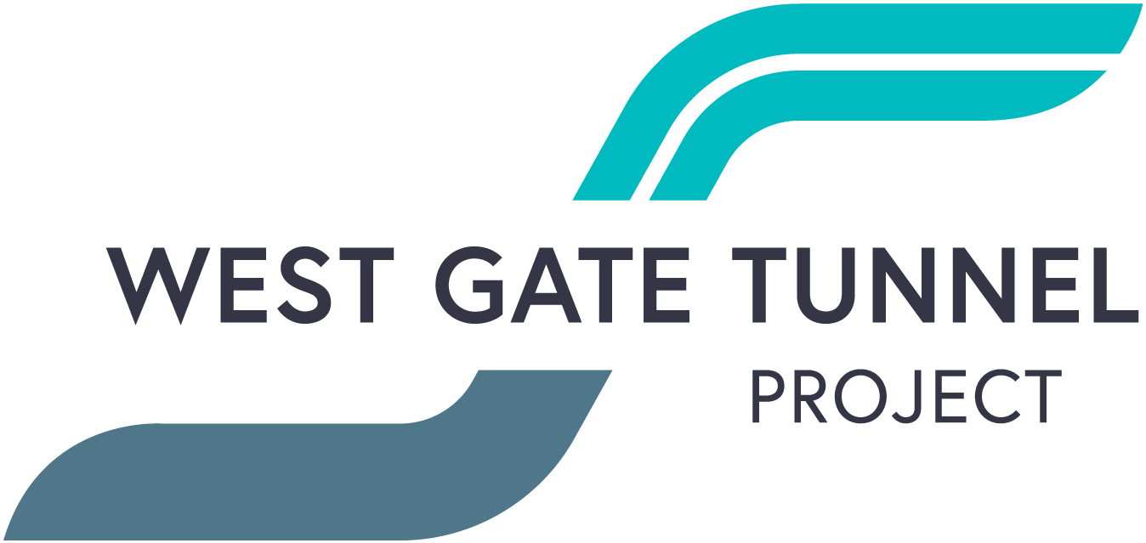
West Gate Tunnel Project
GPO Box 33312
Melbourne Victoria 3004
1800 105 105
westgatetunnelproject.vic.gov.au info@wgta.vic.gov.au

Reference: EAS1904.3

April 2019
WORKS NOTIFICATION REMINDER: Site investigation works
Site investigations May – November 2019
Over the coming months we will be continuing site investigation works within the Port to City precinct. This is to further identify utility services located within the project and better understand ground and road conditions before we commence construction in the area.
Investigation works will include:
- electronic scanning of roads and footpaths
- non-destructive digging to identify underground services such as gas and water
- drilling bore holes up to 40 metres in depth
- removing some vegetation in work zones if required

What to expect:
- Works completed both during the day and at night time. Works that are required to be undertaken on roads and intersections will be completed at night to reduce the impact for motorists.
- Traffic management will be in place to manage changed conditions including temporary access changes to car parking spaces and signage to guide road users and cyclists
- Potential traffic lane closures at night will be in place at times. All lanes will remain open during the day. For the latest traffic updates visit westgatetunnelproject.vic.gov.au/traveldisruptions/
- We will notify you if there are any significant changes to the timing of our works

Please note that works may be rescheduled in the event of bad weather or other unavoidable circumstances.
For updates and more information about our works please visit westgatetunnelproject.vic.gov.au or contact us using the details over the page.

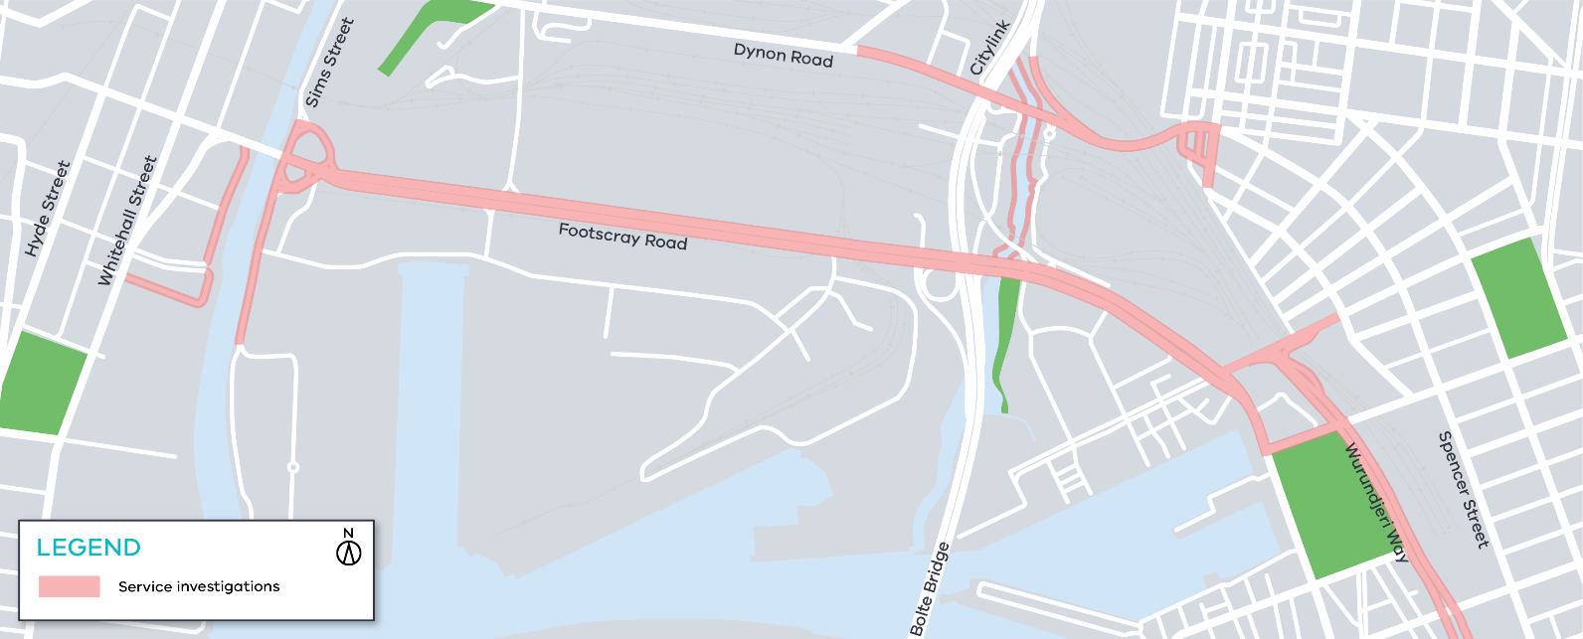
Figure 1 investigation works will occur at various locations in this area

Contact us
Please contact us if you have any questions or feedback about these works.

westgatetunnelproject.vic.gov.au info@wgta.vic.gov.au
1800 105 105
facebook.com/westgatetunnelproject
@westgatetunnel
West Gate Tunnel Project GPO Box 4509
Melbourne Victoria 3001
Interpreter service: 13 14 50

