February 2020

Works notification: E and F Gate sites

February – April 2020
Construction of the new elevated road for the West Gate Tunnel Project is ongoing, as piling and pier construction works continue throughout E and F gate.

The West Gate Tunnel Project will provide a direct link from Dynon Road to Flinders Street via the new Wurundjeri Way extension. It will also offer upgraded shared use paths for pedestrians and cyclists in the area.

F Gate works
Extensive piling works will continue throughout next three months (see map). Piling is one of the first steps in building the foundations for the piers that will support the bridges and ramps to be constructed in this area.
Investigations, preparations and drilling will also take place for the future connections to CityLink.

Piling preparation and piling works
Piling is ongoing at a number of locations across E and F Gate. This includes the mobilisation of piling equipment and piling rigs to site.
Piles will be installed using a combination of driven, bored and sheet piling (as required to protect open excavation areas). When pile and pile cap works are complete, piers will be installed using pre-cast segments.

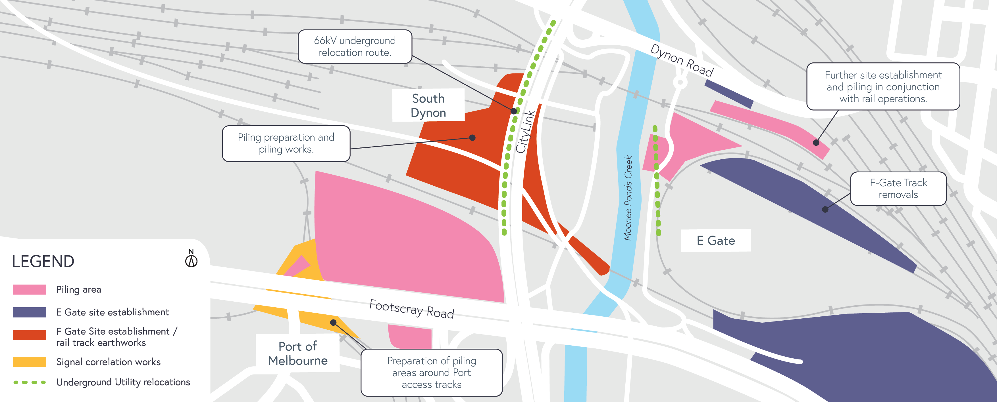

Rail works
Rail works in the F Gate area include:
- Track earthworks – bulk cut and fill works under Melbourne Operations Terminal track formation
- Track drainage – installation

Civil works
- F Gate access road works
- Cut and fill works along access road alignment (Ongoing)
- Drainage – installation (Ongoing)

Utility works
- Ongoing utility relocation works including 66KV installation in F Gate

E Gate rail works
The following rail works will take place during the next quarter:
- Relocation of 6.6kV power lines which distribute power to all tenants in E Gate and South Dynon
- Removal of Wagon Storage Yard and South Hump Track
- Continuation of works in and around Dynon Road precinct, including piling
- Relocation of V/Line from E Gate to new West Melbourne Maintenance Facility
- VicTrack to commence relocation of fibre optic cables in and around E Gate area
- Removal of overhead rail pedestrian crossing and construction of temporary crossing

Appropriate rail safe working support will be in place, ensuring the separation and safety of workers near rail traffic.

What to expect during construction:
- Works completed both during the day and when required at night time
- We will notify you if there are any significant changes to the timing of our works
- Traffic management will be in place to manage changed conditions including temporary access changes to car parks
- Parking spaces and signage to guide road users and cyclists
- Dust will be managed on site with water carts
- Piling works can create increased levels of noise and may also cause some vibration

Assessments have been conducted, which indicate the noise levels are expected to remain within permissible levels as documented in the project’s Environmental Performance Requirements.

We thank you for your patience during these works.

westgatetunnelproject.vic.gov.au info@wgta.vic.gov.au
1800 105 105
West Gate Tunnel Project Info Centre Corner of Somerville Rd and Whitehall St Yarraville VIC 3013
Follow us on social media Please contact us if you would like this
information in an accessible format.

Translation service – For languages other than English, please call 13 14 50.

Authorised by the Victorian Government, 1 Treasury Place, Melbourne

