15 June 2020

Works notification: Footscray Road
Works are progressing to build the new elevated road above Footscray Road with ongoing piling works and elevation of the Launching Gantry taking place in the centre median. Works on the new shared use paths are also taking place near Moonee Ponds creek and Docklands.

Launching Gantry assembly
The Launching Gantry or elevated road builder will continue to be assembled above Footscray Road throughout June. Gradually, you will see more pieces being installed on the top of the support piers.
The two biggest pieces will be the main trusses. These were lifted in place on the night of 3 June, and once the full assembly of the launching gantry is complete, we will begin the commissioning process.
The diagram below shows the worksite layout in the current traffic lane configuration on Footscray Road.
When: June – July 2020. These works will be completed during the day between 7am and 5pm and some nights between 7pm and 5am.
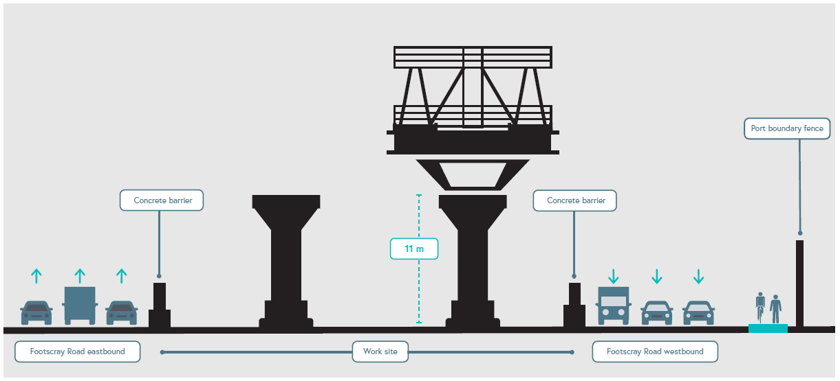

Pier construction
Concrete foundation works for the piers are ongoing along Footscray Road between CityLink and the Maribyrnong River. Works will also continue to assemble segments for the elevated road columns along Footscray Road.
Concrete foundation and pier works continue during the day and will also take place at night. Further notification for night works will be provided to directly impacted residents and businesses.
Noise and vibration may be noticeable during these works and ongoing monitoring will be in place.

These works will result in intermittent closures of the shared use path and partial/full closures of Footscray Road. Please see website for updates, and follow signage and advice from onsite traffic controllers.

When: These works will be completed during the day between 7am and 5pm and ongoing at night between 7pm and 5am.

Drainage works

Drainage works will take place on Footscray Road near Appleton Dock Bridge. This work will take place over the weekend between 8pm Friday 19 June and 5am Monday 22 June to minimise the impact on commuters. A double lane closure is required to deliver these works safely, and will also require a closure of the shared use path at this location. Cyclists will need to detour as per the map below.

When: These works will be completed between 8pm Friday 19 June until 5am Monday 22 June.

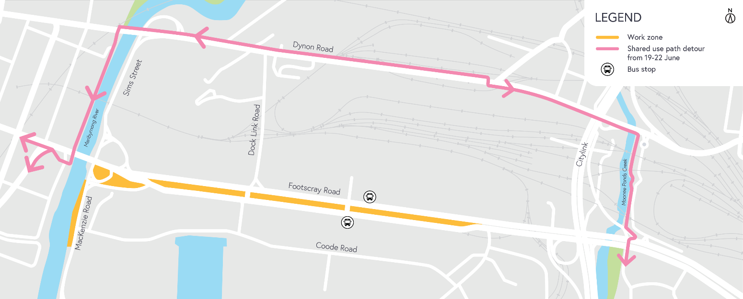

What to expect during construction
- Works completed both during the day and at night time
- We will notify you if there are any significant changes to the timing of our works
- Traffic management will be in place to manage changed conditions including temporary access changes and signage to guide road users and cyclists
- Dust will be managed on-site with suppression methods
- Assessments have been conducted, which indicate the noise levels are expected to remain within permissible levels as documented in the project’s Environmental Performance Requirements.

We thank you for your patience during these works.

westgatetunnelproject.vic.gov.au info@wgta.vic.gov.au
1800 105 105
West Gate Tunnel Project Info Centre Corner of Somerville Rd and Whitehall St Yarraville VIC 3013
Follow us on social media Please contact us if you would like this
information in an accessible format.

Translation service – For languages
other than English, please call 13 14 50.

Authorised by the Victorian Government, 1 Treasury Place, Melbourne

