Key dates and times
The crane will be setup adjacent to the reserve, arriving on site on Thursday 4 February at 8pm. The crane set up will continue through to 6am on Friday 5 February. Preparation works will continue throughout the day.
To allow for the setup and arrival of the crosshead (bridge support), a westbound closure of Dynon Road will be in place from 11pm on Friday 5 February until 5am on Saturday 6 February.
The crosshead (bridge support) installation will occur from 1:30am on Saturday 6 February until 4am.
Mobile crane ‘pack-up’ will occur between 7am and 5pm on Saturday 6 February.

19 January 2020

Works Update: Railway Place & Miller Street Reserve works
Works are progressing at the reserve near Railway Place and Miller Street for the shared user path which will provide a new dedicated bridge that will ensure a safe path separating vehicles from pedestrians and cyclists traveling along Dynon Road to North Melbourne.

Stage one: Site establishment and preparatory works are ongoing until February 2021
The first stage of site establishment took place in December 2019 and works were completed adjacent to and in the Railway Place Reserve area.
The below summary of works has recommenced following this year's restrictions:
- Fencing works and closure of skate park area.
- Pedestrian and cycle detours.
- Closure of bus stop at Dynon Road Bridge.
- Identification of existing services.
- Piling preparations and piling works.
- Construction of a crane pad which will allow the mobilisation of a crane to erect precast bridge piers and crosshead (bridge support) segments, in February of 2021. A reminder will be issued closer to the commencement of works as night works will be required.

Stage two: Construction and foundation piling works starting early 2021 to the end of 2021
Stage two of these works will be established in the remaining reserve area.
Works will commence on the bridge support and Dynon Road approach barriers during the first quarter of 2021 which includes foundation piling and structural concrete construction activities.
The entire reserve will remain closed till the end of 2021

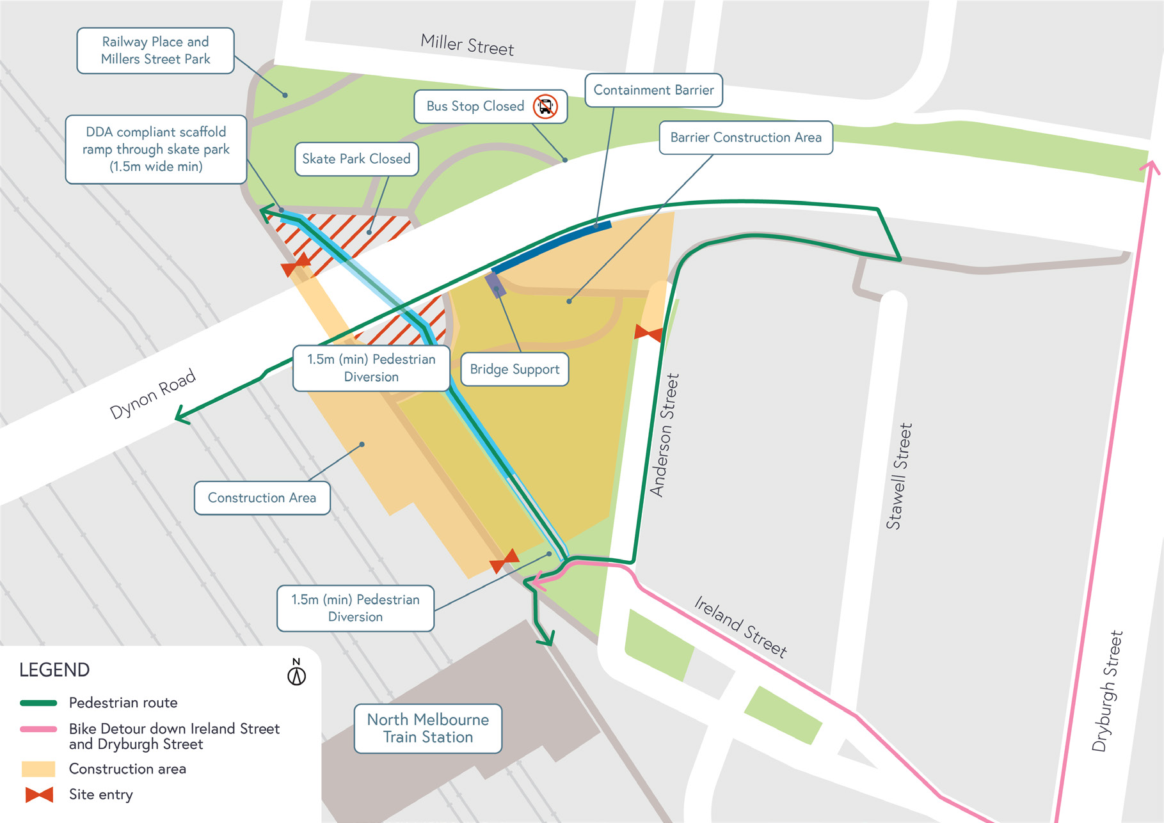

What to expect during construction
- Works will be completed both during the day and at night.
- We will notify you in advance if there are any significant changes to the timing of our works, particularly any possible night works.
- Traffic management will be in place to manage changed conditions including temporary access changes.
- Signage will be in place to guide road users and cyclists through the detours.
- Dust will be managed on-site.

We understand the need for open spaces and recreation in the area and we will be working hard to ensure the works are completed in a timely manner in order to avoid extended park closures. We thank you for your patience during these works.

Nearby parks and reserves:
- 550 m - Adderley Street Park – 211 Adderley St, West Melbourne VIC 3003
- 800m - Hawke Street Reserve – 2A Hawke St West Melbourne VIC 3003
- 1.2km - Eades Place Park – 1 Chetwynd St, West Melbourne VIC 3003
Once construction is completed, the park and skate area will be completely reinstated.

westgatetunnelproject.vic.gov.au info@wgta.vic.gov.au
1800 105 105
West Gate Tunnel Project Info Centre Corner of Somerville Rd and Whitehall St Yarraville VIC 3013

Follow us on social media Please contact us if you would like this
information in an accessible format.

Translation service – For languages other than English, please call 13 14 50.

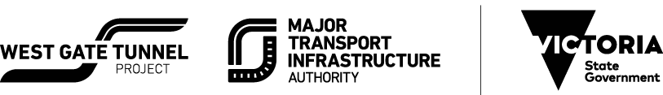

Authorised by the Victorian Government, 1 Treasury Place, Melbourne

