Chapter 13
Land use planning

Chapter 13

Land use planning
This chapter provides an assessment of the land use planning impacts associated with the construction and operation of North East Link. This chapter is based on the impact assessment presented in Technical report E – Land use planning.
North East Link would traverse a range of land uses in north-eastern Melbourne. Construction and operation of North East Link would require permanent acquisition and temporary occupation of land. It would also involve activities with the potential to result in changes to current and ongoing land uses, land use character, consistency with strategic planning policy, and future land redevelopment potential.
The EES scoping requirements set out the following evaluation objective:
- Social, business, land use and infrastructure – to manage effects of the project on land use and the social fabric of the community with regard to wellbeing, community cohesion, business functionality and access to services and facilities.
To assess the potential effects of the project on land use, a land use planning impact assessment was undertaken. Other aspects covered in the above evaluation objective are traffic and transport, business and social. These are addressed in the following EES chapters and technical reports:
- Chapter 9 and Technical report A – Traffic and transport
- Chapter 14 and Technical report F – Business
- Chapter 17 and Technical report I – Social.
The land use planning assessment looks at whether acquisition, temporary occupation, traffic, air, noise, visual and overshadowing impacts associated with construction and operation activities impact the ongoing use of open space, commercial, industrial, residential and community facility land uses.

Method
Informed by the risk assessment described in Chapter 4 – EES assessment framework, key steps taken in assessing the impacts to land use planning included:

- Definition of a study area for land use planning. This was defined as land generally within a 300-metre buffer of the reference project to capture potentially impacted land uses in the vicinity of the project. Broader consideration was also given to significant land uses, known significant redevelopments and planning scheme amendments outside the study area which have the potential to influence the project and vice versa. See Figure 13-1 below for an overview of the study area used for the land use planning impact assessment.
- Desktop assessment and baseline data review, which included a review of relevant existing planning controls, planning schemes (including the Planning Policy Framework which comprises state, regional and local policy), relevant strategic planning documentation, relevant planning scheme amendments and planning permit applications.

What are the risk categories?
Risk levels were categorised as very low, low, medium, high or very high. When an impact is a known consequence of the project, the rating is indicated as ‘planned’.
The results of the initial risk assessment were used to prioritise the focus of the impact assessments.

- A site visit and review of publicly available aerial imagery.
- Consultation with Banyule, Boroondara, Manningham, Whitehorse, Yarra and Nillumbik councils.
- Assessment of the potential land use planning impacts during construction and operation of the project.
- Development of Environmental Performance Requirements (EPRs) to set the required environmental outcomes for North East Link. The residual risk ratings and the assessment of impacts presented in this chapter assume implementation of the EPRs. Refer to Chapter 27 – Environmental management framework for a full list of EPRs.
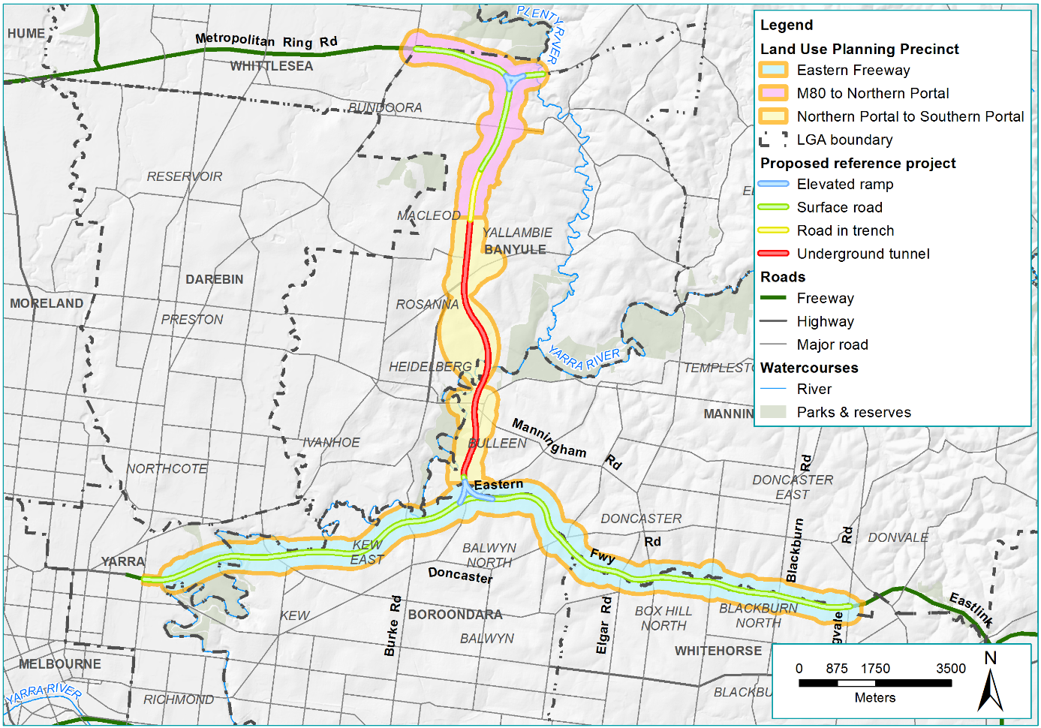
Figure 13-1 Land use planning study area

Existing conditions
This section outlines the existing conditions of the North East Link study area that relate to land use planning.
The proposed North East Link works are located across six municipal areas shown in Figure 13-1 above. The provisions of each local planning scheme govern the use, development, protection and conservation of land within each municipality. Consistency with land use planning policy and planning schemes is assessed in Section 13.3.5 below. A summary of relevant legislation and policy is provided in Appendix A of Technical report E – Land use planning.
For this assessment, the project has been considered according to three land use planning precincts that align with the three project elements being the M80 Ring Road (otherwise known as the Metropolitan Ring Road) to the northern portal, the northern portal to the southern portal and the Eastern Freeway.

M80 Ring Road to northern portal
Located within the City of Banyule and the Shire of Nillumbik, the northern precinct is principally characterised by residential, open space and commercial land uses. Figure 13-2 shows the planning zones from the relevant planning schemes.
Residences in this precinct generally fall within particular neighbourhood character types as defined by local planning policy. ‘Garden Court’ as defined in the Nillumbik Neighbourhood Character local planning policy features two storey dwellings with mostly low hipped or split gable roof forms. The residential style of Watsonia and Rosanna is defined in Banyule’s Neighbourhood Character planning policy as ‘Garden Suburban’, which is ‘a spacious leafy character’ in formal garden settings, with space around and between dwellings that are of a scale and architectural style that is sympathetic with existing dwellings in the precinct.
The Banyule planning scheme identifies ‘Incremental’ areas that provide for medium density and single dwellings with some opportunities for higher density. ‘Accessible’ residential areas are located close to activity centres and generally provide for medium to high density development. In the southern portion of the precinct, there are some residences that are located that abut the defence site, Simpson Barracks, which is located on Commonwealth Land (not subject to the planning scheme).
This precinct is also characterised by a number of active open spaces including the AK Lines Reserve, Winsor Reserve and Gabonia Avenue Reserve. Large tracts of passive open space are also prominent in this precinct, located beyond residential land use north of the M80 Ring Road along the Plenty River (Plenty Gorge Parklands and Maroondah Aqueduct Reserve).
While there are limited industrial land uses within this part of the study area, there are a number of commercial land uses. Key commercial areas include the Watsonia Neighbourhood Centre, major activity centres in Greensborough and Heidelberg, as well as the La Trobe National Innovation and Employment Cluster (NEIC) west of the study area.
A number of community facilities are located throughout this precinct, with a cluster in the vicinity of Grimshaw Street towards Watsonia railway station including a number of schools. A number of aged care facilities, as well as hospitals and health services in Heidelberg are also located in the precinct.
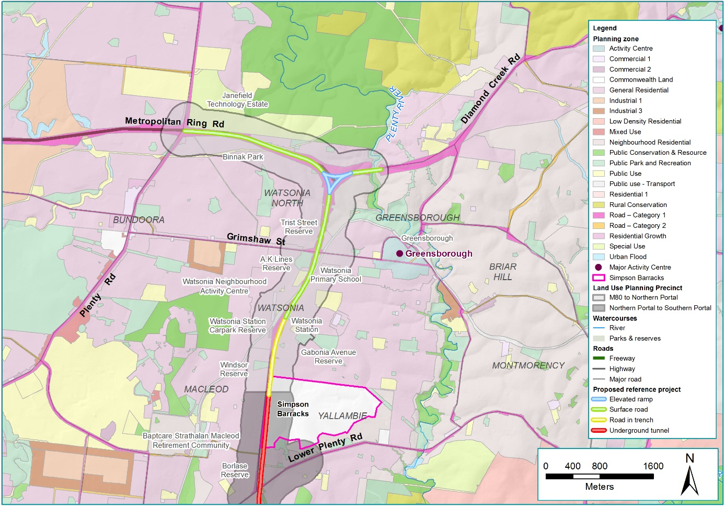
Figure 13-2 M80 Ring Road to northern portal planning zones

Northern portal to southern portal
This precinct traverses the City of Banyule and City of Manningham and principally contains significant open space areas and residential land uses. The precinct also includes a locally significant cluster of commercial and industrial land uses located within the Bulleen Industrial Precinct in Manningham. Figure 13-3 shows the planning zones from the relevant planning schemes.
Generally, residential land use in this precinct is characterised by low-density, detached dwellings, with the size of the residential blocks increasing closer to Banyule Flats Reserve and Warringal Parklands in the suburbs of Heidelberg and Viewbank. Banyule local planning policy generally seeks to limit development that deviates from the current residential character, except in identified areas generally surrounding activity centres including the Heidelberg Major Activity Centre.
Open spaces form a large component of this precinct and these are of high ecological and social importance to the surrounding communities. These include Banyule Flats Reserve, Warringal Parklands, Yarra Flats Park and Banksia Park, Koonung Reserve, Bulleen Park and Bolin Bolin Billabong. These areas have varied active, passive and conservation open space land uses. For example, the riparian corridors along the Yarra waterway have high biodiversity and habitat values, reflected in the Public Conservation and Resource Zone (PCRZ). Elsewhere, the Heide Museum of Modern Art is located within Banksia Park represents a significant cultural and tourism attraction, while areas such as Warringal Parklands features cultural (eg Banyule Theatre Complex) and sporting uses (tennis, cricket, football and soccer).
Commercial and industrial land uses within this precinct are generally limited to the Bulleen Industrial Precinct in the City of Manningham. This area contains a number of light industrial businesses including a number of automotive repair premises. These businesses are generally housed within single or two-storey warehouses. The Bulleen Plaza neighbourhood centre is located east of the study area within the City of Manningham. Similarly, the Heidelberg Major Activity Centre lies to the west beyond the Yarra River and Banksia Park, outside the study area. The Activity Centre forms part of the La Trobe NEIC and features a mixture of commercial uses including retail outlets and a cluster of medical premises.
Community facility land uses are a feature of the precinct with a cluster located west of Lower Plenty Road in the City of Banyule including St Martin of Tours Catholic Primary School, Interlaken Kindergarten, Rosanna Library and the Japara Rosanna Nursing Home. North of the Eastern Freeway within the City of Manningham, community facility land uses include educational (Marcellin College and the Kalker Montessori School), sporting (Boroondara Tennis Club, Bulleen Swim Centre, David Barrow Stadium), and mixed sporting clubs (such as the Veneto Club and the Yarra Valley Country Club) land uses.
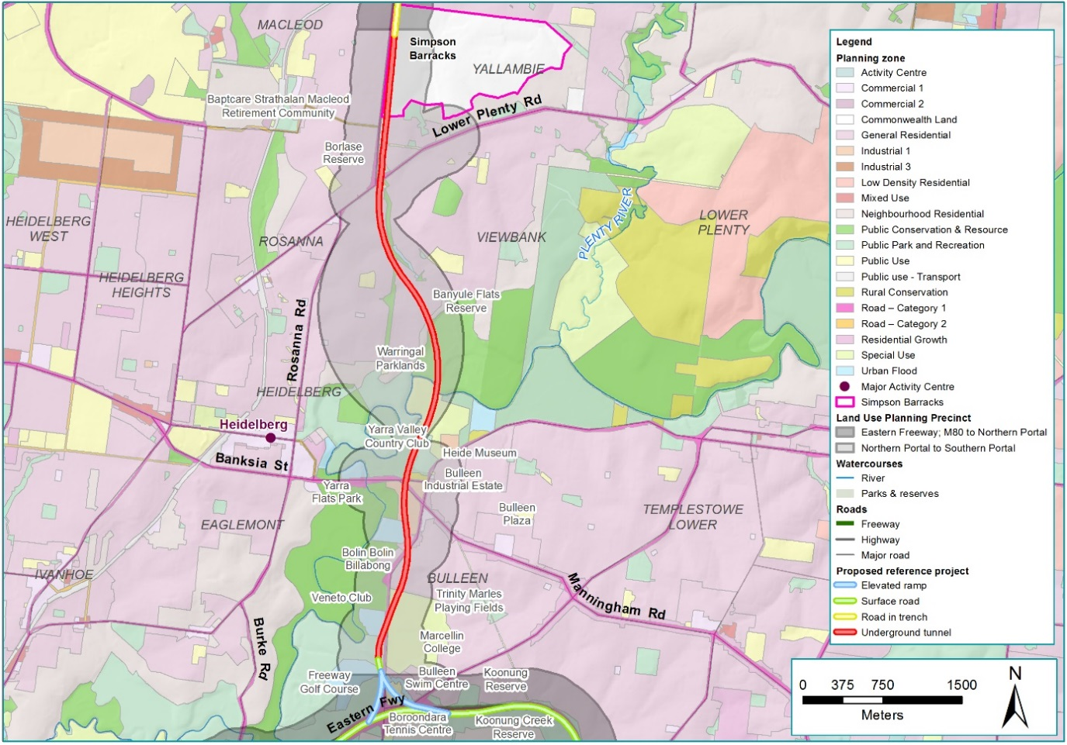
Figure 13-3 Northern portal to southern portal planning zones

Eastern Freeway
Located within the City of Manningham and City of Whitehorse in the east and City of Boroondara and City of Yarra in the west, this precinct features predominately residential and open space land uses. Figure 13-4 and Figure 13-5 shows the planning zones from the relevant planning schemes.
Residential built form in the precinct is typically characterised by one and two-storey detached dwellings set in well-established landscaped gardens. Boroondara and Whitehorse local planning policy consider these residential land uses as examples of low density ‘Garden Suburb’, ‘Garden Suburban' and ‘Bush Suburban’ development. Generally, Manningham, Whitehorse and Boroondara planning policy refer to the desire for limited change within these residential areas, with a focus on higher density development surrounding activity centres. However, residential land uses (including land zoned for mixed uses) are becoming increasingly dense within the City of Yarra.
There are a number of active and passive open space land uses located north and south of the Eastern Freeway. These linear open spaces provide an important interface between the freeway and adjacent residential properties. Key open space land uses south of the freeway include Elgar Park, Slater Reserve, Koonung Creek Reserve South and the Eastern Freeway Linear Reserve. North of the freeway, key open spaces include the Koonung Creek Linear Reserve, Fairlea Reserve and Boronia Grove Reserve. Larger tracts of open space also border the Yarra River north and south of the freeway (including Yarra Bend Park and a number of golf courses).
Commercial land uses within this precinct include a neighbourhood centre south of the Eastern Freeway at Woodhouse Grove and Station Street, Box Hill. A number of larger Activity Centres are located outside this precinct, including the Doncaster Hill Major Activity Centre within the City of Manningham, the Kew Junction Major Activity Centre within the City of Boroondara and the Box Hill Metropolitan Activity Centre and Nunawading Major Activity Centre within the City of Whitehorse.
Industrial land uses include the Joseph Street Industrial Estate south of the Eastern Freeway within the City of Whitehorse which includes a number of light industrial and commercial uses and a power substation located adjacent to the Eastern Freeway, also within Whitehorse.
There are a number of community facility land uses in this precinct adjacent to the Eastern Freeway, including the Boroondara Tennis Club and a number of schools and retirement and nursing homes. These are largely surrounded by residential land uses.
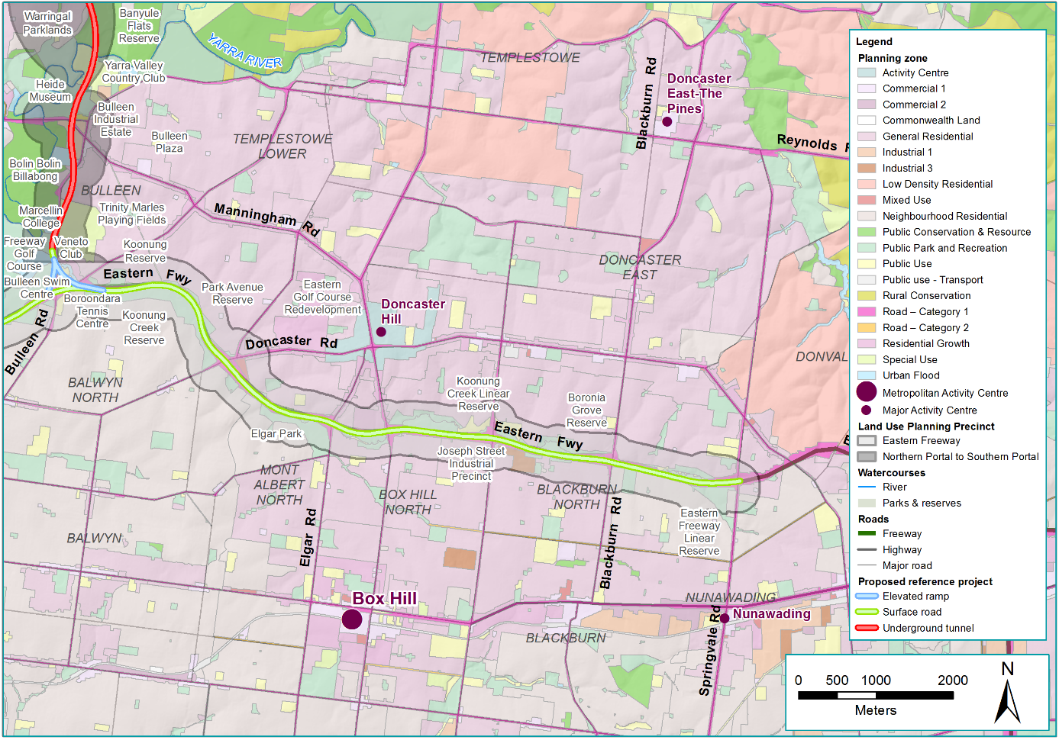
Figure 13-4 Eastern Freeway (east) planning zones and activity centres
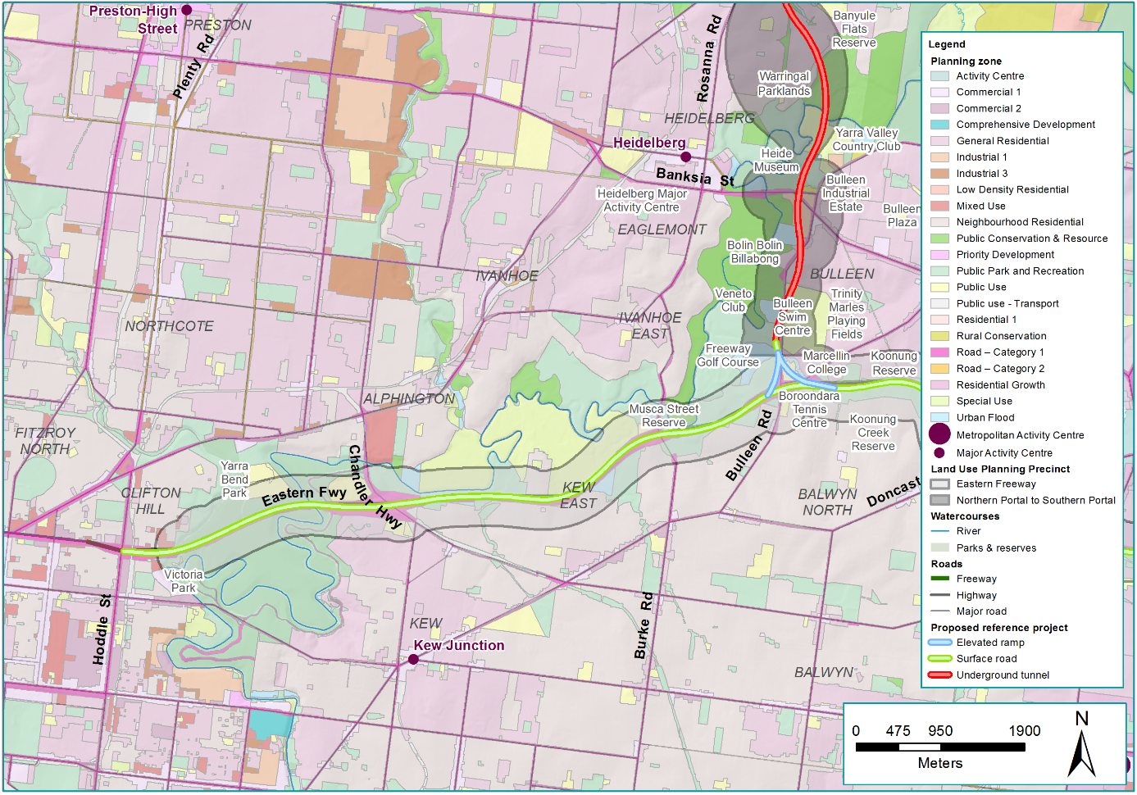
Figure 13-5 Eastern Freeway (west) planning zones and activity centres

Construction impact assessment
This section discusses the construction impacts associated with North East Link that relate to land use planning.
Key land use planning impacts during the construction phase have been categorised into five main themes, these are:
- Permanent land acquisition
- Temporary occupation
- Impacts on the ongoing use of land
- Impacts on land use character
- Consistency with planning policy.
The potential for impacts associated with these main themes are discussed below.

Acquisition
Residential, business and open space land would be permanently acquired to facilitate the construction and operation of the project. Property acquisition has been assessed in the construction phase as this is when the risk would occur.
The risk pathways associated with acquisition are described in Table 13-1 and discussed below.
Table 13-1 Risk table: Construction – acquisition
ID | Risk pathway | Level
Risk LU01 | Construction activities require permanent acquisition of residential properties, resulting in permanent change in land use | Planned  (Moderate consequence)
Risk LU02 | Construction activities require permanent acquisition of open space and public conservation land uses, resulting in permanent change in land use | Planned  (Moderate consequence)
Risk LU03 | Construction activities require permanent acquisition of commercial and industrial land, resulting in permanent change to commercial and industrial land use | Planned  (Moderate consequence)

This chapter presents the acquisition requirements associated with the reference project. The approach taken is considered to be conservative and it is possible that the eventual project footprint determined during detailed design may be smaller.

M80 Ring Road to northern portal
This assessment has considered the potential for construction activities to result in a permanent change in land use due to acquisition (risks LU01, LU02 and LU03).
Permanent land use changes in this precinct generally include sections where project infrastructure (including widening) is proposed and residential and commercial properties would be acquired to facilitate the project. These properties are mostly adjacent to the existing road corridor.
The project would permanently acquire 18 residential properties and six commercial properties, including privately-owned retail businesses operating on land owned by VicRoads and a fuel service station. The project would partially acquire nine other types of properties, including part of the Simpson Barracks (Commonwealth land), part of the Watsonia Primary School grounds, VicRoads land, government land and common property on residential land.
In most cases, land would be required to accommodate widening of the road corridor and other road infrastructure including viaduct structures and shared use paths. In instances where partial acquisition would be required, the majority of the remaining land use would remain available.
Within this precinct, some portions of open space would also be utilised for project structures or facilities such as shared use paths. However, the impact on these land uses are considered to be minor as the land utilised would be relatively small in area, and in the case of proposed shared use path infrastructure, it would fit in with the overall recreation land use. The public open spaces affected in this way are:
- Frensham SEC Reserve
- Gillingham Reserve
- AK Lines Reserve
- Watsonia Road Reserve
- Watsonia Station Carpark Reserve
- Trist Street Reserve.
In this precinct, the potential to permanently change residential, commercial and open space land uses present along the road corridor would be reduced to the extent practicable (EPR LP1).

Northern portal to southern portal
The proposed project infrastructure in the tunnel section is predominantly below ground, minimising permanent acquisition requirements and protecting existing residential, and both ecologically and culturally sensitive land uses.
The proposed above-ground project infrastructure would generally be concentrated to the north and south of the precinct and associated with tunnel portal structures such as ventilation structures and substations. The precinct would also contain the construction of cut and cover tunnels and a new interchange at Manningham Road, which would impact commercial properties at the Bulleen Industrial Precinct.
At the northern end of the precinct, 18 residential properties would be acquired, predominantly to construct the trench and cut and cover sections of the projects. Following construction, the redevelopment of land above the infrastructure could provide opportunities to enhance the local area, resulting in a change in land use (risk LU01).
At the southern end of the precinct, 97 commercial properties (the majority of which are located within the Bulleen Industrial Precinct). This would permanently change the land use from industrial to road corridor, which would be contrary to local land use policies (refer to Section 13.3.5 for a discussion on planning policy and Section 13.4.2 for a discussion on future redevelopment) (risk LU03).
In addition, the physical removal of developed land providing significant employment would present a substantial land use change in this location. Chapter 14 – Business provides an assessment of the impacts on the industrial precinct and subsequent impacts to the local availability of employment.
16 other land uses would be impacted due to permanent acquisition in the northern portal to southern portal precinct. At the northern end of the precinct, the project would require permanent acquisition of part of the Simpson Barracks (Commonwealth land), Borlase Reserve (VicRoads and Council owned), an. At the southern end of the precinct, the project would require permanent acquisition of part of the Veneto Club car park, access/entrance, a plant nursery, and the former Bulleen Drive-in site. Part of Bulleen Park, part of the Carey Grammar sporting facility, the Bulleen Swim Centre would also need to be permanently acquired for the project. As noted in Section 13.2.2, land zoned PCRZ in the vicinity of the Manningham interchange would be permanently acquired for the project. As this land has been developed and is currently occupied by a plant nursery, the conservation values of this land are considered minimal, although being zoned PCRZ.
North East Link Project (NELP) is working with relevant local councils, facility operators and Victorian Government agencies to identify opportunities for relocation of displaced facilities to maintain the continuity of those recreational activities, where practicable. A range of relocation options are being evaluated to identify a preferred option.

In addition to surface acquisition, the construction of the tunnels would require the strata acquisition of 227 residential properties, one private commercial property and nine areas of open space (to the north of Warringal Parklands and to the south of Banksia Park). Strata acquisition may lead to some land use planning impacts by limiting any future redevelopment that requires excavation below a certain level below ground. However, the tunnels are very deep where the strata acquisition occurs, and the properties are not located where intensive development is encouraged by planning policy or the current planning controls.
What is strata acquisition?
Strata acquisition refers to the acquisition of land below ground surface where tunnel infrastructure would pass beneath properties. Properties or buildings above-ground are not required for this type of acquisition.

The diversion of the Yarra East Main sewer would impact 21 properties either in sub-surface strata or Easement. This includes impacts to Trinity Grammar and Marcellin College. As these works are in close proximity to the mined tunnel, some of these properties are also counted in the strata number identified above.

Eastern Freeway
This precinct would principally involve widening of the Eastern Freeway, viaduct structures at key interchanges, and several new shared use paths along the freeway. While construction along this precinct would involve surface works, much of the work would be carried out along the existing road corridor. As the Eastern Freeway is currently a dominant land use in this precinct, the project would generally be consistent with the existing land use (predominantly Road Zone Category 1: RDZ1). In this precinct, the potential to permanently change existing residential, commercial and open space land uses along the road corridor would be reduced to the extent practicable. No residential properties would need to be permanently acquired in this precinct.
Towards the southern end of Bulleen Road at the Eastern Freeway interchange, the project would permanently acquire three Council-owned parcels including part of the Freeway Public Golf Course, the Boroondara Tennis Centre and tennis courts located to the east of Bulleen Road, and part of Koonung Creek Linear Park located to the north of Boroondara Tennis Centre and bordered by Dan Murphy's and the Bulleen Swim Centre. The impact on that part of Koonung Creek Linear Park located to the north of Boroondara Tennis Centre is considered to be minor as the land utilised by the project would be relatively small and the majority of the remaining land use would remain available, minimising the scale of impact. However, the impact upon the Boroondara Tennis Centre and the tennis courts to the east of Bulleen Road would result in a significant land use change from community sporting facility and open space (Public Use Zone 6 – Local Government (PUZ6)) to road corridor and a public transport terminal. This is also contrary to the intent of the existing public purpose zone which envisages the use of the land for sporting and recreational purposes (risk LU02).
An area of land south of Estelle Street and north of the Eastern Freeway is currently used for open space purposes and the Koonung Creek Trail. The majority of this land would be required for freeway widening, a designated bus lane and a shared use path which would change the land use. However, the proposed infrastructure would not require all the land, with the existing open space land use to continue on the remaining land. The new shared use path would also assist in improving east-west connectivity for pedestrians and cyclists along the Eastern Freeway and adjacent open spaces.
Within this precinct, sections of open space and public conservation would also be utilised for project structures or facilities such as shared use paths and would not be publicly accessible during operation, permanently altering the land use (risk LU02). However, the impacts on these land uses are considered to be minor as the amount of land proposed to be utilised by the project would be relatively small. This would mean that overall, the existing functionality of the open spaces would be maintained even though some of the physical space would be lost. The proposed shared use path also complements the overall recreational land use. The areas of open space affected in this way are:
- Koonung Creek Linear Reserve
- Koonung Reserve
- Part of Koonung Linear Reserve (behind the Boroondara Tennis Centre, bordered by Dan Murphy’s and the Bulleen Swim Centre)
- Unnamed reserve (south-west of the Eastern Freeway interchange)
- Elgar Park
- Koonung Creek Linear Park
- Park Avenue Reserve
- Stanton Street Reserve
- Tram Road Reserve
- Fairlea Reserve
- Koonung Koonung Creek Reserve adjacent to Doncaster Park and Ride, south of Doncaster Road.
In this precinct, the potential to permanently change existing residential, commercial and open space land uses present along the road corridor would be reduced to the extent practicable. Whilst no residential properties would require permanent acquisition, there would be a number of open space and community facility land uses that would be impacted due to property acquisition in this precinct.

Environmental Performance Requirements
Acquisition would also be undertaken in accordance with the Land Acquisition and Compensation Act 1986 (Vic) and the Major Transport Projects Facilitation Act 2009 (Vic).
Impacts associated with a change in land use due to permanent acquisition, as informed by the risk pathways in Table 13-1, would be managed through the implementation of EPRs and identified mitigation measures in consultation with the stakeholders and minimising disruption to owners and users of land to the extent practicable.
Key measures include minimising the design footprint (EPR LP1), minimising impacts that are inconsistent with strategic land use plans and policy (EPR LP3), and locating new above-ground services and utilities infrastructure in appropriate locations that considers impacts to existing residential areas and recreational facilities (EPR LP2). These have been identified to avoid permanent acquisition of parks and reserves, significant landscapes, recreational and community facilities, residential properties and commercial and industrial sites.
Residential property acquisition would be undertaken in a manner that reduces disruption to residential land, as far as is practicable (EPR SC1). The project would work in collaboration with facility operators, local Councils and relevant State authorities to identify relocation opportunities with the objective of accommodating displaced facilities and maintaining the continuity of those recreational activities, where practicable (EPR SC4).
The disruption to businesses from permanent acquisition or temporary occupation of land would be minimised as much as practicable and consultation with affected businesses and land owners undertaken to endeavour to reach agreement on the terms for possession of the land in accordance with relevant legislation (EPR B2). Prior to construction, business support would be provided to affected businesses including regular updates of the planning and design progress for the project. The North East Link Project would also be required to work with councils to identify alternative location options for displaced businesses. (EPR B1). Where land would be acquired for the project but not occupied by permanent physical infrastructure, there would be opportunity to improve the local area after construction. It is not yet determined what form these enhancements would take, and these would be subject to a separate approvals process to this EES.

Temporary occupation
Temporary occupation of private and public land uses would be required to facilitate construction activities, resulting in a temporary change in land use.
The risk pathways associated with temporary changes in land use as a result of temporary occupation are described in Table 13-2 and discussed below.
Table 13-2 Risk table: Construction – temporary occupation
ID | Risk pathway | Level
Risk LU04 | Construction activities require temporary occupation of open space resulting in a temporary change in land use | Planned  (Moderate consequence)
Risk LU05 | Construction activities require temporary occupation of education and community facilities resulting in a temporary change in land use | Planned  (Moderate consequence)
Indicative construction locations have been identified but are subject to change. Consultation with key stakeholders, including local councils, regarding temporary occupation requirements (including the location of construction compounds and potential post construction opportunities) is ongoing.

All precincts
Generally, temporary occupation would likely involve partial occupation of areas of passive and active open space and Commonwealth land. However, in some cases all the existing land use may be required for temporary occupation.
Initial consultation has been undertaken with Councils about the use of land for construction. Detailed consultation would be undertaken following planning approval and prior to the commencement of construction. This would include consideration of temporary occupation and reinstatement requirements.
Overall, a temporary change in land use due to temporary occupation would cause an adverse impact, as the current land use would temporarily no longer be able to occur. However, this impact would not be permanent and implementation of EPRs would reduce the impact to the extent practicable. In some instances, where partial temporary occupation would occur, the majority of the remaining land use would continue to be viable therefore minimising the scale of impact. Further detail on the social implications of these impacts is provided in Chapter 17 – Social.

Environmental Performance Requirements
Impacts associated with a change in land use due to temporary occupation would be managed through the implementation of EPRs and identified mitigation measures in consultation with the appropriate stakeholders and minimising disruption to owners and users of land to the extent practicable.
Temporary and permanent impacts on affected land uses would be reduced with the design footprint avoiding, to the extent practicable, permanent acquisition and temporary occupation particularly of parks and reserves, significant landscapes around the Yarra River (northern portal to southern portal precinct and Eastern Freeway precinct), other sensitive land uses such as educational facilities, recreational and community facilities, residential properties, and commercial and industrial sites (EPR LP1). This would also be mitigated through the project requirement to minimise impacts that are inconsistent with strategic land use plans and policies, and to consult with land managers or agencies responsible for implementing the policies (EPR LP3).
Where recreation facilities are displaced by the construction or operation of the project, the project would be required to work in collaboration with facility operators, local Councils and relevant State authorities to identify relocation opportunities with the objective of accommodating displaced facilities and maintaining the continuity of those recreational activities, where practicable (EPR SC4).
Overall a temporary change in land use would cause an adverse impact. However, this impact would not be permanent (approximately seven years) and this impact would be reduced through implementation of the project EPRs.

Impacts on the ongoing use of land
Traffic, noise, air quality, visual and overshadowing impacts can impact the ongoing use of land during the project's construction. As such, the land use planning assessment has examined whether these amenity-related impacts would likely affect the ongoing use of sensitive land uses (open space, residential, community facilities and conservation). Potential amenity impacts associated with traffic, noise, air quality and visual impacts are addressed in the relevant technical assessments and associated chapters (Technical report I – Social, Technical report A – Traffic, Technical report H – Landscape and visual, Technical report B – Air quality and Technical report C – Surface noise and vibration.
The risk pathways associated with impacts to the ongoing use of land are described in Table 13-3 and discussed below.
Table 13-3 Risk table: Construction – impacts on the ongoing use of land
ID | Risk pathway | Risk rating
Risk LU06 | Construction activities result in impacts associated with traffic, noise and vibration, air quality, visual and connectivity considerations, impacting the ongoing use of residential land | Medium
Risk LU07 | Construction activities result in impacts associated with traffic, noise and vibration, air quality, visual and connectivity considerations, impacting the ongoing use of open space and public conservation land | Low
Risk LU08 | Construction activities result in impacts associated with traffic, noise and vibration, air quality, visual and connectivity considerations, impacting the ongoing use of education and community facility land | Low

Across all precincts, construction activities have the potential to impact the ongoing use of sensitive land uses. This could occur if construction activities were to increase traffic, air and noise emissions, visual permeability or overshadowing to the point that the ongoing use of land was no longer possible (risks LU06, LU07, LU08). To explain the potential impacts, this section has been divided according to discipline.

Surface noise and vibration
Construction activities have the potential to increase noise levels in areas close to the project. Works such as excavation, existing bridge structure demolition and viaduct earthworks and construction have the potential to cause significant noise impacts for a period of time. For these works, mitigation strategies such as physical mitigation of plant, equipment and operations, limits to the hours of operation (for some operations) and consultation with the community would assist in managing the surface noise impacts. In addition, noise impacts would decrease and become less noticeable as the distance from the construction works increased. For further detail, see Chapter 11 – Surface noise and vibration.
Construction surface noise impacts due to the project are not expected to change the ongoing use of residential, open space and community facility land uses. This would largely be due to the temporary nature of construction activities and implementation of project EPRs that address construction surface noise impacts, as outlined in the EPR discussion below.

Air quality
Construction works have the potential to impact on air quality in the form of particulate matter, odour and products of combustion. However, these are not expected to affect the ongoing use of residential, open space and community facility land. This is due to the localised, intermittent and temporary nature of construction activities and implementation of mitigation measures. These measures include the preparation and implementation of Dust and Air Quality Management Plan(s), which sets out the requirements to minimise and monitor the impacts on air quality during construction. For further detail on air quality impacts during construction is provided in Chapter 10 – Air quality.

Traffic and transport
Construction activities would generate a number of traffic impacts including additional truck traffic, temporary lane and road closures, detours to ensure continual flow of traffic and access, and changed signalling arrangements. Generally, haulage routes would depend on the location of the work zone and are predicted to include EastLink, Bulleen Road, Chandler Highway, Sydney Road, High Street, Plenty Road and Greensborough Road. Key truck generating sites would likely be from Kempston Street to the northern portal and the TBM launch site at Manningham Road. Further discussion and details of locations where these changes would occur are provided in Chapter 9 – Traffic and transport.
It is expected that traffic changes associated with the project during construction would not impact the ongoing use of residential, open space and community facility land. This is largely because the changes would be temporary and existing truck curfews would be implemented. Furthermore, mitigation measures that address traffic impacts including a Transport Management Plan would be implemented. Relevant traffic-related EPRs are identified in the EPR discussion below.

Landscape and visual
Across all precincts, construction activities are expected to result in direct views of works and equipment for nearby residential, open space and community facility land uses. In areas where the existing environment becomes highly modified, or existing screening trees and vegetation are removed, residents, facility users and staff members would experience visual change. Night-time works may also lead to light spill impacts to sensitive receptors, such as residential properties located within close proximity to construction areas. For further detail on the specific visual impacts, see Chapter 16 – Landscape and visual.
While these activities may impact the visual amenity of the landscape, they would be temporary. Through the implementation of project EPRs that address visual impacts, the project is not expected to change the current or future (planned) use of the land. Relevant landscape visual-related EPRs are outlined in the EPR discussion below.

Overshadowing
The installation of noise walls and elevated structures (including shared use overpasses) have the potential to result in overshadowing at a number of locations including along the M80 Ring Road to northern portal precinct and the Eastern Freeway. While these noise walls and elevated structures would be permanent project infrastructure, the timing of their construction could mean that impacts would be experienced during the construction phase, before North East Link is operating. These impacts are therefore assessed as occurring during construction.
Overshadowing is expected to occur in locations where noise walls and elevated structures are proposed to be constructed in close proximity to existing dwellings and with direct abuttal to private open space. Shading from the ventilation structures has also been considered, however, there are minimal shading impacts on residential properties and open space. Overshadowing has been assessed for 22 September.
Where overshadowing is increased and extends into areas of private open space, this has the potential to reduce the usability of the space and adversely affect the amenity of the dwelling. Furthermore, there may be some circumstances where overshadowing affects existing solar panels and could potentially impact the energy efficiency of a dwelling.
26 dwellings in the M80 Ring Road to northern portal precinct to the south of the project would be affected by overshadowing where areas of secluded private open space abut a proposed noise wall located on the northern boundary of the site. Six dwellings to the south of elevated shared use paths would be impacted by overshadowing from these structures. This overshadowing would occur in the morning with solar access returning in the early afternoon. Within this precinct there are also 10 houses to the east of the project with areas of open space orientated to the west. In these instances, the afternoon shadow from project structures would extend into areas of secluded private open space and reduce their amenity. For properties along the Greensborough Bypass, noise walls are proposed on the eastern and western boundaries of the project, in close proximity or directly abutting area of secluded private open space. As result, the overshadowing is expected to affect 10 properties.
For properties on the west, the noise walls would restrict morning solar access until midday and for properties on the east, the noise walls would restrict the afternoon sun.
Within the northern to southern portal precinct, there would be little overshadowing to private properties from project structures.
Within the Eastern Freeway precinct, overshadowing is expected to extend into 19 properties. The majority of the overshadowing would impact properties to the south of the project with areas of private open space orientated to the north of the dwelling. A small group of houses east of Blackburn Road to the north of the project would experience afternoon shadow from the noise wall.
For further detail on the locations of overshadowing, see Appendix D of Technical report E – Land use planning.
The majority of the alignment preserves solar access to areas of open space for adjoining dwellings due to the land use separation from project structures. However, increased overshadowing that extends into areas of private open space has the potential to reduce the usability of that space and adversely impact the amenity of the dwelling.
There are a number of ways the extent of overshadowing could be reduced through the design and construction of the project. This includes changing the location of the structure(s) causing the overshadowing, reducing the height, or selection of materials to allow solar access to areas of open space and solar panels. Implementing these measures must also have regard to other EPRs and standards to be achieved. With the implementation of project EPRs, a change in the current or future (planned) use of the land as a result of overshadowing is unlikely.

Environmental Performance Requirements
To mitigate potential impacts to the ongoing use of land during construction, identified mitigation strategies together with project EPRs that address construction traffic, air and noise emissions and visual and overshadowing impacts, would be implemented.
The project would be required to minimise the design footprint and avoid temporary and permanent impacts on affected land uses to the extent practicable (EPR LP1). Impacts to existing residential areas and recreational facilities would be minimised by locating new above-ground services and utilities infrastructure with consideration for impacts on adjoining properties (EPR LP2). Inconsistencies with planning policies and strategic plans due to land use changes brought about by the project would be minimised by the design and development of the project having regard to strategic land use plans and policies and consult with land managers and/or authorities responsible for implementation of the relevant policies (EPR LP3). Overshadowing from elevated structures and noise walls to residential properties (including existing solar panels) community facilities, open spaces, waterways and valuable natural habitats would also be required to be minimised through the project's detailed design (EPR LP4).
EPRs to minimise the impact on the ongoing use of land due to more specific impacts including construction traffic, noise and vibration, air quality, visual and connectivity impacts are identified in Technical report A – Traffic, Technical report B – Air quality, Technical report C – Surface noise and vibration, Technical report F – Business, Technical report G – Arboriculture, Technical report H – Landscape and visual, and Technical report Q – Ecology (EPRs EMF2, AQ1, NV4, NV8, NV9, NV10, NV13, SC2, B3, B4, LV1, LV2, LV3 and T2).
In addition to the requirements described above, mitigation through established standards and project EPRs should minimise the likelihood of any change in land use due to amenity changes associated with construction activity.

Impacts on land use character
Character is the interaction between land uses and their built form, architectural style, subdivision patterns, land use activities, and environmental considerations such as topography, vegetation and waterways. While character applies to all land uses, it is particularly important to the fabric of more sensitive land uses which typically include residential and open space land uses. This is because character forms a significant part of what makes these land uses distinctive and purposeful.
Acquisition of open space and residential land changes the land use, which increases the potential for existing land use character to be altered.
The risk pathways associated with permanent changes in open space and residential land use character as a result of acquisition requirements, are described in Table 13-4 and discussed below.
Table 13-4 Risk table: Construction – impacts on land use character
ID | Risk pathway | Risk rating
Risk LU09 | Construction activities require permanent acquisition of residential properties, resulting in permanent changes to residential land use character | Planned  (Moderate consequence)
Risk LU10 | Construction activities require permanent acquisition of open space and public conservation land uses, resulting in permanent change in open space and public conservation land use character | Planned  (Moderate consequence)

M80 Ring Road to northern portal
This precinct is characterised by a lower density pattern of dwellings with extensively vegetated gardens, contributing towards a leafy, spacious residential character that has remained largely unchanged since the second half of the 20th century. This is defined in the Nillumbik Neighbourhood Character Statement and Banyule Neighbourhood Character Policy
The change in land use due to acquisition would affect the interplay between the residential land use character considerations such as land use activities and built form, potentially impacting the long-established neighbourhood character conditions of the area (risk LU09). However, by minimising residential acquisition requirements to the extent practicable, changes to the overall residential land use character in this precinct would be reduced.
Open space land use adjacent to the project is characterised by a number of linear active and passive recreation open space areas located along the M80 Ring Road and Greensborough Road. As a result of permanent acquisition and temporary occupation as described in Sections 13.3.1 and 13.3.2 above, a change in land use would potentially impact the land use character elements that make the purpose of each open space distinctive (risk LU10).
Overall, the impacts to land use character would be minimised given that some areas would still be made available to the public during construction and in some cases the provision of new shared use path infrastructure would enhance the recreational character of the open space land use. The project would also provide a contribution to the overall open space land use character in this precinct through a series of land bridges for open space purposes. The location and design of the land bridges would be generally in accordance with the project's Urban Design Strategy and determined during the project's detailed design.

Northern portal to southern portal
Residential land uses in the municipalities of Banyule and Manningham are characterised by relatively lower-density, detached dwellings in a tree-dominated landscape with little development occurring in these residential areas since establishment in the mid-20th century. The change in land use as a result of acquisition has the potential to impact the character of these residential areas (risk LU09). However, the reference project minimises the impact to residential land use in this precinct given much of the infrastructure would be underground in tunnels.
Open space and public conservation land uses in this precinct are generally characterised by the environmentally and culturally significant riparian environment around the Yarra River and Banyule Creek. This character is also evident in the community facilities and recreational land uses associated with active open spaces such as ovals (risk LU10). Open space in the vicinity of sections of Banyule Creek would be permanently acquired or utilised by the project. However, the impact to open space land use character would be minimised, as much of the infrastructure in this precinct would be underground. Sub-surface tunnel boring construction would avoid at-surface works which could potentially impact culturally and ecologically sensitive areas of open space and public conservation land uses surrounding the Yarra River.
Therefore, the land utilised by the project (and the change in land use) would be relatively small and the remaining areas of the open spaces land uses would be available to the public during construction.

Eastern Freeway
In this precinct, the residential land uses are typically characterised by one and two-storey detached dwellings set in well-established landscaped gardens. Local planning policy (City of Manningham in the north and City of Whitehorse and City of Boroondara in the south) envisages limited change from the existing character in these areas with increasing residential development density more apparent to the western end of the precinct in the City of Yarra and around activity centres. There would be no impact to residential land use character due to land use changes from acquisition, given no residential properties would need to be acquired in this precinct (risk LU09).
Open space in this precinct is characterised by linear open space along Koonung Creek and the Yarra River. While the project would require permanent acquisition of open space surrounding parts of the Koonung Creek that would require diversion and enclosure, the impact on the land use character is considered to be minor. This is because the land utilised by the project would be relatively small and the remaining areas of the open spaces would be available to the public during construction (risk LU10).

Environmental Performance Requirements
Overall, land acquisition diminishes the land use character elements that make open space and residential land uses distinctive and purposeful. However, the impact would be reduced with implementation of the EPRs, including the requirement to minimise the footprint to the extent practicable (EPR LP1) and to locate new above ground services and utility infrastructure in a way that minimises impacts to existing residential areas and recreational facilities (EPR LP2). There would also be a project requirement to minimise impacts that are inconsistent with strategic land use plans and policy (EPR LP3).
Potential impacts from a change in residential land use character would also be managed through the requirements within the Urban Design Strategy (EPR LV1), which the design response needs to be generally in accordance with (refer to EES Attachment II – Urban Design Strategy). Appropriate consideration of the character of local areas within the project boundary would reduce the potential for impacts during construction and from the project’s permanent structure and elevated roadways.
Subject to a separate approval process to the EES, the project may also provide opportunities to enhance the acquired open space land, with potential to improve local open space character. These opportunities have not been determined.

Land use planning policy
Land use changes brought about by the project may potentially result in inconsistencies with planning policy and strategic plans across the project.
Related risk pathways are described in Table 13-5 and discussed below.
Table 13-5 Risk table: Construction – impacts on land use planning policy
ID | Risk pathway | Risk rating
Risk LU11 | Land use changes brought by the project may result in inconsistencies with planning policies and strategic plans | Planned  (Major consequence)

State-wide planning policy
From a land use perspective, North East Link is considered to be generally consistent with state-wide strategic policies and strategies. These are discussed below.
Plan Melbourne is the Victoria's Government's long-term planning strategy to guide the development and growth of Melbourne over the next 35 years and is the key strategy for supporting jobs, housing and transport. Plan Melbourne seeks to integrate long-term land use, infrastructure and transport planning. North East Link is recognised in Plan Melbourne as a project that would contribute to an integrated transport system connecting people to jobs and services.
Victoria's 30-Year Infrastructure Strategy (December 2016) sets out a vision for Victoria in 2046, with accompanying objectives and needs. North East Link is identified in the strategy to address multiple needs, and to provide accessibility through some of the most congested parts of the road network.
The Yarra River Protection (Wilip-gin Birrarung murron) Act 2017 (Vic) provides an overarching policy and planning framework to coordinate and harmonise planning for the use, development and protection of the Yarra River, its parklands and other land in its vicinity. A purpose of the Act is to protect the Yarra River and the surrounding parcels of public land as one living and integrated natural entity. The Yarra River Action Plan documents the Victorian Government's response to the Yarra Ministerial Advisory Committee report. The Yarra Strategic Plan and the Yarra River – Bulleen Precinct Land Use Framework are both currently under preparation and represent key Victorian Government directives affecting land located near the Yarra River. An exemption from the provisions of the Act applies for projects declared under Victoria’s Major Transport Projects Facilitation Act 2009 (including North East Link). However, NELP has been consulted by DELWP on the preparation of the land use framework plan and Melbourne Water of the Yarra Strategic Plan, as well as having regard to the Yarra Protection Principles set out in the Act.
The Planning Policy Framework (PPF), particularly the objective of Clause 11.01-1R (Metropolitan Melbourne) recognises North East Link as a potential transport project of regional importance in the ‘Melbourne 2050 plan’. This states the need ‘to strengthen transport links on national networks for the movement of commodities as well as improving transport connection in and between regional cities, town and Melbourne to encourage delivery of high quality integrated settlements’. The tunnel component running below the Yarra River aligns with the objectives of Clause 12.03-1R (Yarra River Protection) which seeks to ‘maintain and enhance the natural landscape character of the Yarra River corridor’.
Through the implementation of the relevant EPRs relating to noise and air emissions, the project would align with the Clause 13.05 – 1S (Noise abatement) which seeks to ‘assist the control of noise effects on sensitive land uses’ and Clause 13.06 – 1S (Air Quality Management) which seeks to ‘assist the protection and improvement of air quality’.

The project would also work towards meeting the aim of relevant parts of Clause 18 (Transport) as it would assist in creating ‘a safe and sustainable transport system by integrating land use and transport’ and contributing to the management of the road system ‘to achieve integration, choice and balance by developing an efficient and safe network’ (Clause 18.02 –3S Road System).
The PPF at Clause 18.01 – 2S (Transport system), also seeks to ‘locate and design new transport routes and adjoining land uses to minimise disruption or residential community and their amenity'.
What is the Planning Policy Framework (PPF)?
The Planning Policy Framework is planning policy that is consistent for each municipality and applies to all parts of North East Link, except for Commonwealth land (Simpson Barracks).

With the implementation of the project mitigation measures to address traffic, noise, air quality, visual and overshadowing impacts during construction, the amenity of residential areas would be protected.
It is also noted that sections of Victorian Planning Provisions include reference to specific objectives and standards to measure overshadowing in Clause 54 (One Dwelling on a Lot) and Clause 55 (Two or more dwellings on a lot and residential buildings). These provisions are not applicable to major transport projects, however, it is considered that the overshadowing to open space objective provides guidance in the assessment of the impact of overshadowing on adjacent residential land. As noted above, the implementation of mitigation measures and EPR LP4 would minimise overshadowing from noise walls and elevated structures to enable the project to be consistent with the PPF.
Notwithstanding the above, the project is inconsistent with the objectives and relevant strategies of Clause 17.03-1S (Industrial Land Supply) which seeks to ‘ensure the availability of land for industry’, specifically the strategy in relation to the need to ‘ensure the availability of land for industry’. The project would require land in the Bulleen Industrial Precinct, resulting in significant impact for this locally significant industrial land use for cut and cover construction of tunnel infrastructure. Further discussion surrounding industrial policy and the Bulleen Industrial Precinct is outlined in the Manningham local planning policy discussion below.

Banyule
Local planning policy within the Banyule Planning Scheme recognises the municipality is principally developed for residential purposes. This is with the notable exception of large areas of publicly-owned land (primarily in the vicinity of waterways), public and private golf courses, commercial centres (including the La Trobe NEIC and Watsonia Neighbourhood Centre), identified industrial areas such as Heidelberg West and Greensborough and large-scale institutional uses such as the Austin and Mercy Hospitals, the Austin Repatriation Hospital and the Simpson Army Barracks
Banyule's Municipal Strategic Statement (MSS) recognises the municipality has a generally well-connected transport system with many of the municipality’s regional arterial roads providing access to the western suburbs and the Melbourne Airport and linkages to residential areas in the northern Growth Corridor and other inner suburban places of employment and industrial areas of south-east Melbourne. Nonetheless, Clause 21.07 Transport and Infrastructure identifies the following relevant key issues for transport:
- Many arterial roads that perform a regional function are congested. Future changes that affect Banyule’s road networks need to be monitored and assessed
- Residents have a high dependency on private vehicles
- Expected population growth will increase travel demand within and across Banyule
- Adverse impacts resulting from increasing freight movements across the Banyule road network.
While the project would result in changes to private vehicle use, it would likely reduce congestion across Banyule’s local road network and as well as the adverse impacts from existing freight-related travel across the municipality. Impacts due to changes in traffic are assessed in Chapter 9 – Traffic and transport.
North East Link would pass through a number of suburbs within the central corridor of Banyule. The Banyule City Council Neighbourhood Character Strategy (2012), Clause 22.02 – Residential Neighbourhood Character Policy, Clause 21.04 – Land use, and Clause 21.06 – Built Environment detail the important attributes of each suburbs respective neighbourhood character, and their respective development guidelines. Clause 21.05 – Natural Environment is also relevant to North East Link in identifying the following key issue to ‘discourage land use and development that detrimentally effects Banyule’s environmental or conservation values’.
North East Link is also relevant to a number of local strategies and plans including:
- Banyule Integrated Transport Plan 2015-2035 – North East Link as an orbital road connection is identified as a key transport infrastructure improvement for the municipality.
- Heidelberg Structure Plan (2010) – provides statutory policy recommendations to change the land use of Heidelberg to enhance its liveability and sustainability. The project responds to the Plan’s objectives around enhancing access and connection to Heidelberg.
- Picture Watsonia – A Vision for Watsonia Village 2014 – Banyule Council passed a resolution in June 2018 to refresh the Plan to include consideration of North East Link in developing a revised vision for Watsonia town centre. It is acknowledged that there are opportunities within this area, and in particular to improve east-west connectivity. NELP is working with Transport for Victoria, Banyule Council, traders and other stakeholders to identify these improvements.
- Banyule Open Space Plan (2016-2031) – identifies a number of the open spaces which are adjacent or in close proximity to the reference project. A number of recommendations in the Plan relate to improving access to open space for residents, increasing natural habit corridors and ecological diversity, providing new play experiences and strengthening pedestrian and cycling links in these open spaces. In some cases, North East Link would require some of Banyule’s open space for permanent and temporary project requirements. The impacts of acquisition and occupation would be minimised by applying the appropriate EPRs (refer to the EPR discussion below). Guidance on the use of open spaces has been included in the project’s Urban Design Strategy, which has incorporated feedback from local councils.
It is also acknowledged there are opportunities to improve east-west connectivity. NELP is working with Transport for Victoria, Banyule council, traders and other stakeholders to identify these improvements.

Boroondara
Boroondara City Council and the community consider the protection of neighbourhood amenity and heritage a key priority along with the development of 20-minute neighbourhoods around its major activity centres and the preservation and enhancement of Boroondara’s open space network and neighbourhood amenity.
Clause 21.06 – 3 refers to the road system and relevant to the project identifies that:
- The Yarra River creates pinch points, with east-west traffic movements funnelled into several crossing points
- Boroondara’s local road network can create traffic issues. Long straight, roads can encourage motorists to seek alternative routes to more congested arterial roads. Some local streets also suffer from high traffic speeds.
Relevant key issues include:
- Traffic congestion and capacity issues on key arterial roads, particularity in the morning peak
- Road safety on the arterial and local road networks.
North East Link aligns with the general intent of the road planning policy and may assist in reducing traffic pinch points and improving safety of arterial and local road network.
North East Link is also relevant to a number of local strategies including:
- Boroondara Open Space Strategy (2013) – includes open space and includes reserves that are within or adjacent to the study area, such as Koonung Creek Reserve, Yarra Flats Reserve
- Boroondara Housing Strategy (2015) – reviews the existing character of the municipality’s suburbs and identifies where future population growth would occur, typically in areas surrounding activity centres. North East Link would abut a number of residential suburbs in the northern region of Boroondara which are generally identified as areas envisaged to support minimal change.
NELP has commenced discussions with the City of Boroondara to explore options about how the project could make a positive contribution to public spaces and respond to these strategies.

Nillumbik
Nillumbik local planning policy identifies that the municipality contains good road linkages to the north and west of Melbourne. However, arterial routes within the shire are experiencing pressure for improvements to the road network to allow for better access to and from non-urban and urban areas.
Clause 21.05 – 5 refers to Infrastructure with relevant objectives including the need to:
- Provide safe and efficient roads and road links within the municipality and to the wider region.
North East Link would progress this objective by improving road links to the wider region.
North East Link is also relevant to a number of local strategies including:
- Diamond Creek Major Activity Centre Structure Plan and Leisure Facilities Plan (2006) – deals with land use, buildings and landscape, community and leisure facilities, and transport and mobility considerations at the Diamond Creek Activity Centre.
- Nillumbik Green Wedge Management Plan (2010-2025) – sets out the concept of green wedges as rural landscapes and natural areas separating corridors of urban development.
- Nillumbik Housing Strategy (2001) – refers to the need to provide a diversity in housing stock, maintains neighbourhood character and consolidates residential growth to protect the green wedge.
While North East Link has been designed to avoid the green wedge and the Diamond Creek Major Activity Centre, the project would address some of the transport and accessibility actions included in the strategies. NELP has commenced discussions with the Shire of Nillumbik to explore options about how the project could make a positive contribution and respond to these strategies.

Manningham
The City of Manningham has one of the largest networks of parks and open space, and its local planning policy encourages strategic landscaping and community infrastructure improvements. Residential policy generally seeks to limit development that deviates from the current residential character except in identified areas such as activity centres and key strategic locations. Local industrial policy recognises there are no further opportunities for the development of new industrial centres within the municipality and encourages consolidation of existing centres.
Clause 21.02-10 relates to Industry and describes the limited potential for future industrial development due to a lack of vacant land available. Furthermore it is envisaged that industrial uses in Doncaster Hill will be phased out over time as the area is developed for higher density living.
Clause 21.08 refers to Industrial land use and provides the following relevant policy guidance:
- Council will discourage the establishment of non-industrial uses in the Bulleen and Templestowe areas to consolidate the role of these light industrial areas
- It is envisaged that industrial uses within Doncaster Hill will be phased out over time as the area is developed for higher density living.
Relevant objectives and strategies include:
- To retain opportunities for industrial uses within existing industrial areas
- Consolidate the role of the Bulleen and Templestowe industrial estates to minimise the need to rezone additional land for industrial purposes
- Discourage the further expansion of industrial uses within the Doncaster Hill Activity Centre.
Clause 22.10 refers to the Bulleen Gateway Policy and identifies that:
- Bulleen is a major gateway to Manningham and adjoins the Yarra Valley Parkland and the Yarra River
- The Municipal Strategic Statement encourages the improvement and enhancement of the visual amenity and function of the Bulleen Gateway area.
Relevant objectives of this policy include:
- To encourage appropriate built form to enhance this gateway to the municipality
- View lines between development and adjoining parklands be protected and enhanced through the sensitive siting and design of buildings and works
- The role of the industrial area to be consolidated by discouraging non-industrial uses.
Clause 22.16 is the Industrial Areas Policy and applies to all land in an Industrial 1 Zone and identifies:
- Clause 21.08 of the Manningham Municipal Strategic Statement recognises that there are no further opportunities for the development of new industrial centres in the municipality. It is therefore important to discourage the establishment of non-industrial uses in the Bulleen and Templestowe industrial centres and consolidate the industrial role of these centres. It is also important that use and development in the industrial centres does not have a detrimental impact on existing landscape and/or environmental values and/or nearby residential areas.
Relevant objectives of this policy include:
- To ensure that land use and development in industrial centres is compatible with the surrounding landscape and/or environmental qualities
- To ensure that use, development and/or redevelopment of sites within the industrial centres are for industrial uses.
A total of 112 commercial properties at the Bulleen Industrial Precinct (out of which 90 businesses operate) would be acquired for North East Link, resulting in a change of land use from industrial to road corridor and is inconsistent with the council’s local planning policy framework. The project would adversely impact the vision and intent of the Bulleen Industrial Precinct to provide future opportunity for industrial development within the City of Manningham. Refer to the Technical report F – Business for detail on the impacts and performance requirements in this area.
North East Link is also relevant to a number of local strategies and plans including:
- Manningham Open Space Strategy (2014) – outlining Council’s vision and implementation strategies for key open space in the municipality, such as future landscaping and community infrastructure improvements at Koonung Reserve and Bulleen Park within and adjacent to the study area.
- Koonung Creek Linear Park Management Plan (2011) – sets out priorities and guidelines for the protection, development and use of public open space in the municipality over ten years.
- Manningham Activity Centre Strategy (2005) – sets out the future planning needs for the municipality’s activity centres including strategies surrounding public transport.
NELP has commenced discussions with the City of Manningham and affected businesses regarding the loss of industrial land uses in Bulleen as well as options for positive contributions to public spaces, activity centres and their associated strategies.

Whitehorse
Whitehorse City Council's local planning policy identifies the key themes of environment, housing, economic development and infrastructure. A key aim of the planning policy is to protect and enhance the municipality's open spaces including the Koonung Creek and surrounding parkland. Local planning policy also identifies the range of land uses in the municipality are supported by extensive public transport and freeway linkages, which provide strong links to the wider metropolitan region.
Clause 21.08 refers to Infrastructure and notes that:
- Whitehorse City is committed to providing a safe and high quality transport network for the benefit of all users, including drivers of freight transport, motorists traversing the City, motorists on local trips, pedestrians, cyclists, public transport users, and those in the community with limited mobility. This requires an arterial road network designed to operate at capacity and not beyond, but also a road network that makes safety a priority. The local road network also needs to be protected from traffic that is not generated from the immediate neighbourhood.
- Several arterial roads serve the City, with freeways located to the north and south and to the east. Completion of the freeway network has had some impact upon the main arterials that traverse the City by reducing traffic on other main roads. With the completion of EastLink it is hoped that there will be a long term reduction in freight traffic, and to an extent some private vehicle traffic. This will enable the arterial roads in Whitehorse to operate more efficiently and possibly enable greater consideration of local issues in the operation of the network.
Relevant key issues include:
- To ensure that future roads are only constructed where they provide a net benefit to the community. New roads must be designed and developed in a manner which is environmentally sensitive, whilst minimising impacts on abutting land uses, particularly if they abut residential uses.
- In order to preserve residential amenity, it is vital that non-residential traffic travelling on residential streets is minimised. This is an ongoing and significant issue that faces this Council. Council is therefore committed to investigate and implement traffic management measures that will reduce through traffic.
Appropriate project EPRs would be implemented to minimise off-site amenity impacts on abutting land uses, particularly residential uses.
North East Link is also relevant to a number of local strategies including:
- Whitehorse Industrial Strategy (2011) – identifies the importance of freight access and logistics in the delivery of goods and services to industrial areas of the municipality such as the Joseph Street Industrial Estate located directly south of the reference project on the Eastern Freeway
- Elgar Park Master Plan (2016) – identifies future landscaping and community infrastructure works at Elgar Park, located south of the reference project on the Eastern Freeway
- Whitehorse Open Space Strategy (2007) – refers to key linear tracts of open space adjacent to the project along the Eastern Freeway
- Box Hill Structure Plan (2007), Nunawading Megamile Major Activity Centre and Mitcham Neighbourhood Activity Centre Structure Plan 2008 and Megamile (west) & Blackburn Activity Centres Urban Design Framework 2010 – a key vision similar to all the plans is to ensure the activity centre is serviced by good transport and road connections.
NELP has commenced discussions with the City of Whitehorse to explore options about how the project could make a positive contribution to public spaces and activity centres and respond to these strategies.

Yarra
Yarra City Council's local planning policy aims to increase residential density around Major Activity Centres and along transport corridors while preserving existing historic heritage and open space in the municipality. The council particularly focuses on boosting sustainable transport use and reducing car dependence.
Clause 21.06 refers to transport and identifies that:
- Yarra needs to reduce car dependence by promoting walking, cycling and public transport use as viable and referable alternatives. This is also a key message of Melbourne 2030 and fundamental to the health and well-being of the community.
Relevant objectives include:
- Objective 32 – To reduce the reliance on the private motor car
- Objective 33 – To reduce the impact of traffic.
North East Link responds to this policy through upgrades to shared use path infrastructure including the North East Bicycle Corridor located in areas near the City of Yarra. The project would also improve access to public transport in the City of Yarra through the Doncaster Busway which includes bus stops on Hoddle Street. Further opportunities for improved cycling and walking infrastructure would be created during the project's detailed design.
North East Link is also relevant to a number of local strategies including:
- Yarra Business and Industrial Land Strategy (2012) – identifies land in vicinity to the project around Hoddle Street and Alexander Parade East with the potential to be converted into mixed use land uses
- Yarra Open Space Strategy (2006) – guides the future provision, planning, design and management of public land reserved for recreation and nature conservation purposes, including the parklands surrounding the Yarra River. The Strategy is currently being updated and is undergoing community consultation.
NELP has commenced discussions with Yarra City Council to explore options about how the project could respond to these strategies.

Environmental Performance Requirements
Minimising the design footprint of the project (EPR LP1) would reduce the temporary and permanent impacts on affected land uses to the extent practicable to avoid inconsistencies with land use planning policy. This particularly relates to parks and reserves, significant landscapes around the Yarra River, recreational and community facilities land uses, residential properties, and commercial and industrial sites.
Land use changes due to the project would lead to some inconsistencies with planning policies and strategic plans. These inconsistencies would be minimised through ongoing consultation with land managers and/or agencies responsible for implementing the relevant strategic land use policies during the development, construction and operation of the project (EPR LP3).
Acquisition would also be undertaken in accordance with the Land Acquisition and Compensation Act 1986 (Vic) and the Major Transport Projects Facilitation Act 2009 (Vic).
Residential property acquisition would be undertaken in accordance with EPR SC1 and where recreation facilities are displaced by the construction or operation of the project, the project would be required to work in collaboration with facility operators, local Councils and relevant State authorities to identify relocation opportunities with the objective of accommodating displaced facilities and maintaining the continuity of those recreational activities, where practicable (EPR SC4).
The disruption to businesses from permanent acquisition or temporary occupation of land would be minimised as much as practicable and consultation with affected businesses and land owners would endeavour to reach agreement on the terms for possession of the land in accordance with relevant legislation (EPR B2). Business support would also involve regular updates to affected businesses of the project's planning and design progress, and consultation with local councils would help to identify alternative location options for displaced businesses (EPR B1).

Operation impact assessment
This section discusses the impacts associated with the operation of North East Link that relate to land use planning.
Key land use planning impacts due to the project once it is operating have been categorised into two main themes:
- Impacts on the ongoing use of land
- Impacts on future redevelopment.
The potential for impacts associated with these main themes are discussed below.

Impacts on the ongoing use of land
Across all precincts, above-ground operation activities (such as traffic movements and presence of project structures) have the potential to result in traffic, noise, air quality and visual impacts. This could impact the ongoing use of residential, open space and community facility land adjacent to the project.
Potential amenity impacts associated with traffic, noise and vibration, air quality, visual and connectivity impacts are addressed in the relevant technical assessments and associated chapters (Technical report I – Social, Technical report A – Traffic and transport, Technical report H – Landscape and visual, Technical report B – Air quality, Technical report C – Surface noise and vibration).
The risk pathways associated with impacts to the ongoing use of land are described in Table 13-6 and discussed below.
Table 13-6 Risk table: Operation – impacts on the ongoing use of land
ID | Risk pathway | Risk rating
Risk LU13 | Operation activities result in impacts associated with traffic, noise and vibration, air quality, visual and connectivity considerations, impacting the ongoing use of residential land | Low
Risk LU14 | Operation activities result in impacts associated with traffic, noise and vibration, air quality, visual and connectivity considerations, impacting the ongoing use of open space and public conservation land | Low
Risk LU15 | Operation activities result in impacts associated with traffic, noise and vibration, air quality, visual and connectivity considerations, impacting the ongoing use of education and community facility land uses | Low

To explain the potential impacts, this section has been divided according to discipline.

Surface noise
During operation, the diversion of traffic to North East Link is expected to reduce traffic on a number of local and arterial roads in the surrounding road network, and reduce traffic-related noise (see Chapters 9 – Traffic and transport and 11 – Surface noise and vibration for further detail). This would include Greensborough Road, Rosanna Road and Manningham Road, Lower Plenty Road, Banksia Street and Bulleen Road based on noise modelling for years 2026 and 2036.
Overall, the underground tunnel components of the project would reduce surface traffic noise, benefiting the majority of ongoing uses of residential, open space and community facility land.
However, the operation of North East Link has been predicted to increase surface noise due to new road infrastructure and increased traffic volumes along some feeder routes to North East Link and some arterial roads south of the Eastern Freeway.
This increase is predicted to be generally unnoticeable and so surface noise impacts due to North East Link are not expected to change the current or future (planned) use of the land. Furthermore, the implementation of measures such as low noise-generating pavement, noise walls and potentially at-receiver noise abatement would assist in managing the surface noise impacts and potential implications for ongoing use of land.

Air quality
Potential air quality impacts during operation are not expected to change the current or future (planned) use of land. This is due to improved air quality because of reduced traffic expected in many locations, and through the implementation of project EPRs that address operation air quality impacts.

Traffic and transport
North East Link is expected to improve travel times and congestion across the north-east with the redistribution of traffic from local and arterial roads. Truck volumes are generally forecast to decrease, the Doncaster Busway would improve travel times for users and shared use path upgrades would improve accessibility and travel time for pedestrians and cyclists.
However, traffic is anticipated to increase on a number of feeder routes across the precincts including the M80 Ring Road, Eastern Freeway, near some arterial roads south of the Eastern Freeway and near the Greensborough Bypass and Grimshaw Street interchange. For further detail, see Chapter 9 – Traffic and transport.
A change in ongoing land uses is not expected due to traffic impacts, through the implementation of project EPRs addressing operation traffic-related impacts, such as optimising design performance and undertaking traffic monitoring. Overall, the improved traffic times and reduced congestion would likely benefit ongoing residential, open space and community facility land uses.

Landscape and visual
North East Link would include new infrastructure such as noise walls and elevated structures (including shared use overpasses) and lighting. The presence of new road infrastructure such as ventilation structures, noise walls and viaducts would expose nearby adjacent residences, community facilities and open space land uses to views of the infrastructure, leading to altered views and light spill. Visual impacts could also be associated with loss of vegetation and loss of open space, such as along the Eastern Freeway. Further details of locations where these changes would occur and a discussion of the visual impacts are provided in Chapter 16 – Landscape and visual.
With the implementation of project EPRs that address visual impacts, including through the design process, the visual impacts are not expected to change the current or future (planned) use of the land. Visual impacts would also decrease as distance from the project increased.

Environmental Performance Requirements
Temporary and permanent impacts on affected land uses (particularly parks and reserves, significant landscapes around the Yarra River, sensitive land use including residential, recreation and community facilities) would be avoided to the extent practicable through minimising the design footprint (EPR LP1).
For all precincts, impacts on the ongoing use of land during operation would be managed through implementation of project EPRs relating to air quality, noise and vibration, social and landscape and visual. More information on these is provided in the EES technical reports and associated chapters: Technical report A – Traffic and transport, B – Air quality, C – Surface noise and vibration and H – Landscape and visual (EPRs EMF2, AQ2, AQ4, AQ5, NV1, NV2, NV6, NV7, SC2, LV1, LV4, T1 and T5).

Impacts on future redevelopment
Future redevelopment of residential, commercial and industrial land use in the study area has been assessed in relation to the project via review of strategic policy, major development applications and relevant planning scheme amendments.
The risk pathway associated with the impact of the project on future redevelopment of land is described in Table 13-7 and discussed below.
Table 13-7 Risk table: Operation – impacts on future redevelopment
ID | Risk pathway | Risk rating
Risk LU12 | Impact of project on future redevelopment of land (ie redevelopment for residential, commercial and industrial land use) | Medium

M80 Ring Road to northern portal
In this precinct, future redevelopment is principally associated with the La Trobe National Employment and Innovation Cluster (NEIC), located west of the study area. Identified within State strategic policy (Plan Melbourne) as the key location for growth of employment and business in Melbourne’s north east, the La Trobe NEIC includes La Trobe University, Heidelberg Major Activity Centre, Northland and Heidelberg West.
North East Link would have a positive impact on the redevelopment potential of the La Trobe NEIC. A key Strategic Outcome for the La Trobe NEIC includes the need for a ‘transformed transport network that supports the economic growth of the cluster’. North East Link is specifically mentioned within Plan Melbourne, which recognises that determining potential links between North East Link and the cluster is a key action in the short term.
Other than the above, strategic policy at the state and local level concerned with future redevelopment of land and which has the potential to be impacted by the project has not been identified in the study area for this precinct.
Overall across the precinct, no known significant redevelopment or renewal proposals have been identified. Smaller proposals are identified and assessed in Technical report E – Land use planning.

Northern portal to southern portal
The Yarra Strategic Plan and Yarra River – Bulleen Precinct Land Use Framework Plan are Victorian Government directives affecting part of this precinct located near the Yarra River. These plans are currently in preparation.
As mentioned in previous sections, construction and acquisition requirements for North East Link may provide opportunity to improve the local area post-construction. This could include local enhancements to the Bulleen Industrial Precinct. This future strategic redevelopment would be subject to a separate approvals process and would need to have regard to policy and strategy documents including the Yarra Strategic Plan and Yarra River – Bulleen Precinct Land Use Framework Plan for key relevant strategic direction, as well as state and local strategic planning objectives and the views of relevant key stakeholders. These potential local enhancements have not been determined.
Other than the above, no key strategic policy concerned with future major redevelopment of land which has the potential to be impacted by the project has been identified in the study area.
Overall across the precinct, no known significant redevelopment or renewal proposals have been identified. Smaller proposals are identified and assessed in Technical report E – Land use planning.

Eastern Freeway
As above, the Yarra Strategic Plan (Melbourne Water) and Yarra River – Bulleen Precinct Land Use Framework Plan (DELWP) are currently in development. They cover part of this precinct as it is located in close proximity to the Yarra River.
As mentioned in previous sections, construction and delivery requirements of the project (such as to facilitate the proposed Bulleen Park and Ride and proposed upgrade to the Doncaster Park and Ride in this precinct) could provide opportunity post construction to improve the local area. Future strategic redevelopment has not been developed and would be subject to a separate approvals process and would need to have regard to local strategic planning objectives and the views of relevant key stakeholders, in the absence of a dedicated strategic plan or policy.
Other than the above, strategic policy at the state and local level concerned with future redevelopment of land and which has the potential to be impacted by the project has not been identified in the study area for this precinct.
Overall across the precinct, no known significant redevelopment or renewal proposals have been identified. Smaller proposals are identified and assessed in Technical report E – Land use planning.

Environmental Performance Requirements
Impacts associated with future redevelopment of land would be mitigated through the implementation of EPRs and identified mitigation and management measures in consultation with the appropriate stakeholders and minimising disruption to owners and users of land to the extent practical.
As required by EPR LP1, the project must be designed and constructed to minimise and avoid, to the extent practicable, temporary and permanent impacts on open spaces, and residential, commercial and industrial land. It would also be a requirement to minimise impacts that are inconsistent with strategic land use plans and policy (EPR LP3).
By minimising the footprint of the project through the implementation of the above EPRs, the project may leave surplus land parcels. Where surplus land parcels are considered appropriate for a new land use the relevant planning scheme provisions (including state and local policies) would apply and trigger the need to obtain separate planning approvals as required.

Conclusion
This chapter has identified and assessed existing conditions, impacts and associated risks to land use planning for North East Link.
The key findings of the assessment include:
- A permanent change in land use and land use character due to acquisition would cause an adverse impact. This is because land that is currently used for open space, residential, commercial, and industrial purposes would no longer be available for that purpose (Sections 13.3.1 and 13.3.4). This would be particularly experienced in the Bulleen Industrial Precinct, at the recreation facilities along Bulleen Road, residential land uses in the M80 Ring Road to northern portal precinct, and in open space areas across the project.
- The acquisition of land within the Bulleen Industrial Precinct would permanently change a locally significant industrial land use. This is inconsistent with the Victorian Government's and Manningham City Council's planning policies that seek to foster and maintain existing industrial land uses (Section 13.3.5).
- The installation of noise walls and elevated structures (including shared use overpasses) have the potential to cause overshadowing at locations along the M80 Ring Road to northern portal precinct and the Eastern Freeway. Increased overshadowing that extends into areas of private open space has the potential to reduce the usability of that space and adversely impact the amenity of the dwelling (Section 13.3.3).
The application of the project EPRs (described in full in Chapter 27 – Environmental management framework) would reduce the land that would need to be acquired. This includes the requirement for the project footprint to be minimised to the extent practicable (EPR LP1) (such as via tunnelling to avoid large areas of residential and ecological and culturally significant open space land uses), and to locate new above-ground services and utilities in appropriate locations (EPR LP2). Impacts which are inconsistent with strategic land use policy would also be required (EPR LP3) and overshadowing from elevated structures and noise walls would need to be minimised on residential properties (including existing solar panels), community facilities, open spaces, waterways and valuable natural habitats (EPR LP4).
The project is considered to be largely consistent with Victorian Government and local land use policy objectives that seek to provide an integrated transport system and maintain the natural landscape of the ecologically and culturally significant Yarra River. Subject to a separate approvals process to the EES, a change in land use due to acquisition also provides the opportunity to improve the local area post construction. These opportunities have not been determined.
In response to the EES evaluation objective described at the beginning of this chapter, effects of the project on land use have been assessed and EPRs have been identified to minimise or avoid impacts to land use.

