Reference: TUN1807.2

13 July 2018

##### **Works notification Geotechnical Investigations – Fredericks Street, Yarraville**

We are continuing a program of site investigations in Melbourne’s inner west and along the West Gate Freeway to help further inform the West Gate Tunnel Project’s development.

On Fredericks Street, geotechnical drilling is required to understand ground conditions, including ground water movement and changes in the ground conditions from one area to another.

**Location and timing:**

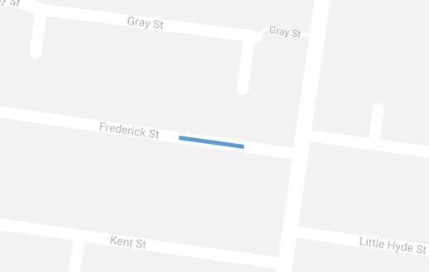We will be carrying out geotechnical investigations and drilling a borehole in Fredericks Street, Yarraville, over 4 days between Monday 30 July and Monday 6 August 2018, and a further one day between Monday 20 August and Monday 27 August, 2018.

Investigations will take place on weekdays from 7am to 5pm, and on Saturday from 7am to 3.30pm.

A small work zone will be created on southern side of Fredericks Street with traffic management in place and access to properties will be maintained at all times.

Traffic management will be in place during works to assist with managing changes in the site area.

These investigations may be rescheduled in the event of bad weather or other unavoidable circumstances.

*The blue line shows the approximate location*

**What to expect:**

This activity will involve a crew setting up traffic management with signage and shuttle flow of traffic to create a safe work area. Access to all properties will be maintained and local traffic will be able to access Fredericks Street at all times.

Following completion of the works, the road surface will be reinstated.

Investigations will involve:

* minor excavation to expose any underground services in the immediate area;
* drilling a bore hole up to 50 metres deep, to collect ground samples and perform geotechnical tests;
* installing a small monitoring well cap to allow for further testing; and
* revisiting the investigation site for sampling over one day (normally two weeks after the initial testing).

We expect this work will have minimal impacts and low level associated noise. We have taken steps to minimise noise and will monitor any impacts.

An example of the setup used to carry out these investigations is shown below.

**Thank you for your patience while we undertake these important activities**

**Please note that works are subject to change and be rescheduled in the event of bad weather or updates to the construction scheduled.**

**Stay informed:**

**For updates and more information about our works please visit westgatetunnel.vic.gov.au or contact up using the details below.**

|  |  |
| --- | --- |
| **Contact us**  Please contact us if you have any questions or feedback about these works. | |
| westgatetunnelproject.vic.gov.au | facebook.com/westgatetunnelproject |
| westgatetunnelproject@wda.vic.gov.au | @westgatetunnel |
| 1800 105 105 | West Gate Tunnel Project  GPO Box 4509  Melbourne Victoria 3001 |
| **Interpreter service: 13 14 50** |