Reference: TUN1908.1

1 August 2019

WORKS UPDATE: PLANNED WORKS FOR KENT AND CAMPBELL STREET
Recharge well installation – from mid-August 2019
In April 2019, works commenced on the installation of the groundwater recharge system in Yarraville. Due to ground conditions, changes to the locations and some rescheduling of the program, works are planned to continue for the recharge well installation on Kent and Campbell Street from mid-August.
Works will include drilling a well, excavation to install covered pits, and running water and electricity connections to nearby above ground panel boxes.
The recharge system is designed to manage any impact to groundwater around the tunnel alignment during construction. The recharge wells will be in operation throughout tunnel construction and will remain in place until the permanent tunnel structures are complete, which will be approximately 12 – 24 months.

What to expect on Kent Street:
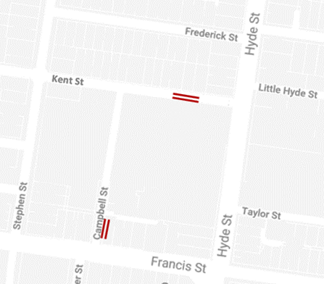
- Temporary road closures in a section of Kent Street for up to two weeks in mid-August;
- Work hours 7am-6pm, Monday – Saturday;
- On street parking inside the work zone will be temporarily removed for the duration of the road closure;
- Access to properties will be maintained under traffic management;
- Pedestrian footpath closures may be required at times.
Construction activity:
      - Installation of traffic island, above ground system including solar panels;
      - Excavation for pit installation and water and power connections;
The red area shows the approximate location for the Kent Street and Campbell Street recharge well works from mid-August.
Ongoing requirements:
      - Removal of one on-street car space for the duration of the well operation;
      - Every 3 months, we may require access to the panel box and recharge well for maintenance.

What to expect on Campbell Street:
- Temporary road closures in a section of Campbell St for up to two weeks in late August.
- Work hours 7am–10pm, Monday – Friday;
- On street parking inside the work zone will be temporarily removed for the duration of the road closure;
- Local traffic detour in place via Kent Street to maintain access to residential properties and businesses;
- Pedestrian footpath closures may be required at times.
Construction activity:
      - Minor excavation to expose any underground services in the immediate area;
      - Drilling one borehole to approximately 60 metres deep over 4 days;
      - Excavation for pit installation and water and power connections;
      - Construction of traffic island, installation of above ground system including solar panels on traffic island.
Ongoing requirements:
      - Removal of one on-street car space for the duration of the well operation;
      - Every 3 months we may require access to the panel box and recharge well for maintenance.
WANT TO BE KEPT IN THE LOOP FOR ROAD CLOSURES OR WORKS IN KENT AND CAMPBELL STREETS?
If you would like email updates for the works in this notification please email the project team at info@wgta.vic.gov.au and type “Kent/Campbell St Updates” in the subject line.

While we expect this work will have some low level associated noise, we will take steps to minimise noise and will monitor any impacts.

Thank you for your patience while we undertake these important activities.
Please note that works are subject to change and could be rescheduled in the event of bad weather or there are updates to the investigations scheduled. For more information about the upcoming works and traffic changes, please contact us.
Contact us
Please contact us if you have any questions or feedback about these works.
westgatetunnelproject.vic.gov.au info@wgta.vic.gov.au
1800 105 105
facebook.com/westgatetunnelproject
@westgatetunnel
West Gate Tunnel Project GPO Box 4509
Melbourne Victoria 3001
Interpreter service: 13 14 50

