Historical Cultural Heritage

Overview
This chapter provides an assessment of the historical cultural heritage impacts associated with the construction and operation of Melbourne Metro. The chapter is based on the impact assessment presented in Technical Appendix J Historical Cultural Heritage. All relevant references are provided in Technical Appendix J.
Melbourne Metro would extend through areas of dense and constrained urban environments with high concentrations of heritage places including buildings and structures, sites, gardens and other landscapes, precincts and archaeological sites. These include heritage places included in the Victorian Heritage Register (VHR) and Victorian Heritage Inventory (VHI) under the Heritage Act 1995 and in the Heritage Overlay (HO) in planning schemes. In this context, it is almost inevitable that construction activities and permanent infrastructure would interact with places of cultural heritage significance, including archaeological sites. Potential impacts could include:
- Demolition and alteration of heritage places – a number of buildings would be demolished. These are locally listed buildings in heritage precincts and on individual sites. Construction works would also require the removal of some significant trees within heritage places, although these could be replaced. In addition, a number of heritage places would be altered as a result of their interface with Melbourne Metro’s new permanent infrastructure and this could result in an adverse impact on the heritage values of these places
- Removal of or damage to archaeological sites – multiple archaeological sites would be impacted, particularly in the central city, although their research value could be realised through testing and other archaeological management techniques
- Vibration and ground movement affecting the fabric of heritage buildings – potential impacts on the fabric of heritage places as a result of vibration and/or ground movement in proximity to construction works
- Visual impacts as the result of the introduction of permanent infrastructure – where permanent above-ground structures would be constructed, there would be the potential for adverse impacts on the heritage value of affected or any nearby heritage places through the juxtaposition of new structures of contrasting or atypical form in proximity. To mitigate these impacts, design refinements would give consideration to the heritage context and values.
The majority of these impacts would be appropriately managed in detailed design to avoid or minimise adverse impacts to the historical cultural heritage. However, there would be some instances in which impacts could not be fully avoided or mitigated. These would include:
- Potential adverse impact on the heritage values of the South African Soldiers Memorial (VHR H1374 and HO12 in the Port Phillip Planning Scheme) due to its relocation to allow for the construction of a station entry for Domain station
- Minor impact on Flinders Street Station complex (VHR H1083 and HO649 in the Melbourne Planning Scheme) related to the connection to the new CBD South station
- Demolition of graded residences within the Kensington Precinct (HO9 in the Melbourne Planning Scheme)
- Demolition of graded buildings in the Flinders Gate Precinct (HO505 in the Melbourne Planning Scheme) including the Port Phillip Arcade (potentially of significance in its own right) and 27–29 Swanston Street and 65 Swanston Street (both of which provide contributory value to the precinct)
- Impacts through tree removal and other works in heritage landscapes including Royal Parade (VHR H2198 and HO977 in the Melbourne Planning Scheme), the Domain Parklands (VHR H2304 and HO398 in the Melbourne Planning Scheme), Fawkner Park (within HO6 in the Melbourne Planning Scheme) and St Kilda Road (St Kilda Road is not currently subject to statutory heritage controls in this location). The impacts on heritage landscapes would be temporary as it is proposed to reinstate trees in accordance with relevant policies and guidelines.
- Removal or damage to multiple Victorian Heritage Inventory listed archaeological sites, and potentially other unknown archaeological sites. However, as noted, the management of this process offers the opportunity to realise the research potential of the sites through investigation and management.
While not considered to be an impact, it is noted that in the case of Victoria Barracks (which is included in the Commonwealth Heritage List under the EPBC Act), there is an express requirement for survey and monitoring in relation to noise and vibration impacts associated with the determination of the Federal Minister for the Environment that the proposed works do not constitute a controlled action if undertaken in a particular manner.
Despite the identified impacts, Melbourne Metro is generally consistent with the EES draft evaluation objective for Cultural Heritage in that adverse effects on historical cultural heritage values would be avoided or minimised as far as is practicable.
Considering the scale, location and complexity of the project, the potential historical cultural heritage impacts of Melbourne Metro would be well managed. The majority of the project is underground and on this basis, significant impacts would be avoided on heritage places and areas across inner Melbourne. Where the project is at surface, there is the potential for heritage impacts. However, with appropriate mitigations and management measures in place, Melbourne Metro would be constructed in a manner in which adverse impacts are avoided or minimised to a level that would be considered acceptable from a heritage perspective.
The project also offers some heritage benefits and opportunities. These include:
- Historical archaeology – the research value of sites that are to be removed or damaged would be realised through testing, monitoring and salvage and this would have the benefit of adding to current knowledge of past practices and developments
- Repair and conservation works – there is an opportunity to undertake active conservation works to heritage places in association with the project works
- Interpretation – a heritage interpretation strategy is recommended to be developed for the project as a whole, which offers opportunities to explore historical and Aboriginal cultural heritage themes.

EES Objectives
The EES Scoping Requirements set the following draft evaluation objective for the EES:
- Cultural Heritage –To avoid or minimise adverse effects on … historical heritage values.
Consistent with this objective and the EES Scoping Requirements, the existing conditions, potential impacts and associated risks to historical cultural heritage within the proposed project boundary were assessed. Using this information, specific management measures were identified to ensure that adverse effects to historical cultural heritage values would be avoided or minimised.

Legislation and Policy
As discussed in Chapter 4 EES Assessment Framework and Approach, historical cultural heritage impacts associated with the construction and operation of Melbourne Metro would be managed and monitored in accordance with Commonwealth and Victorian legislation, policies and guidelines. The main legislation, policies and guidelines are set out in Table ‎14–1.
Table ‎14–1 Historical cultural heritage legislation relevant to Melbourne Metro
Legislation/policy | Comments
Commonwealth
Environment Protection and Biodiversity Conservation Act 1999 | A person proposing to take an action that has, will have or is likely to have a significant impact on matters of national environmental significance, including the heritage values of a national or world heritage place, must refer the proposed action for determination as to whether it is a controlled action required approval under the Act.  MMRA referred the project to the Australian Government Minister for the Environment for determination as to whether it requires approval under the EPBC Act. On 22 September 2015, the Minister determined that the proposed Melbourne Metro is ‘not a controlled action if undertaken in a particular manner’ to avoid significant vibrational impacts to the Commonwealth Heritage listed structures within the Victoria Barracks site in St Kilda Road.
State
Heritage Act 1995 | The Act provides for the protection and conservation of places and objects of cultural heritage significance. It also provides for the registration of such places and objects through two registers; the Victorian Heritage Register and the Victorian Heritage Inventory. The Act provides a useful description of what heritage places can encompass, including buildings, gardens, trees, shipwrecks, archaeological sites, precincts, sites and associated land. Monuments and memorials can also be considered, whether as heritage places (or as part of a heritage place) or as objects.  Permits are required for all Victorian Heritage Register places where subdivision or physical works are proposed. Permit exemptions may be sought under s. 66(3) for works on Victorian Heritage Register sites where there is little or no impact. There are also enforcement provisions for unlawful activities in relation to archaeological relics and places.  In the case of sites on the Victorian Heritage Inventory where subsurface disturbance is proposed that may affect the archaeological record, consents to excavate (for testing) or consents to damage (for disturbance/removal) are required. It is also noted that all archaeological sites more than 50 years in age in Victoria are protected by the Heritage Act 1995, regardless of whether they are included on the Victorian Heritage Inventory.
Planning and Environment Act 1987 | In Victoria, planning schemes and the Planning and Environment Act 1987 require planning approval for any works in the Heritage Overlays and Environmental Significance Overlays (ESO Schedule 2).  Numerous site-specific and precinct-based Heritage Overlays are included within the proposed project boundary and are likely to be affected by Melbourne Metro. Planning approval would be required for all external works, including demolition, alteration and new development (excluding sites which are on the Victorian Heritage Register, which are controlled under the Heritage Act 1995). Heritage places in the Heritage Overlays can include a range of typologies, including buildings, structures, gardens, landscapes and trees, as well as monuments and memorials.  The ESO Schedule 2 establishes an Exceptional Tree Register for trees of historic (and environmental) value to the City of Melbourne. There are a number of sites that fall partly within the proposed project boundary that would be affected by the ESO Schedule 2. Subdivision, or removing, destroying or lopping a tree that falls within an ESO would require planning approval.

Methodology

Assessment Approach
The approach adopted to assess potential impacts to historical cultural heritage from Melbourne Metro comprised:
- Identification of all heritage places that are subject to statutory heritage controls under Australian or Victorian legislation (including planning scheme overlays)
- Desktop review of relevant studies and assessments
- Site inspections to identify additional places and sites that may have historical cultural heritage value but are not currently subject to statutory heritage controls and either have been or could be proposed for such controls
- Historical research and site inspections to identify and assess sites or precincts of potential archaeological sensitivity for historic cultural heritage values
- Consultation with stakeholders including Heritage Victoria, City of Melbourne, City of Port Phillip, City of Stonnington and the Shrine of Remembrance Trustees
- Targeted site inspections, including internal inspections of specific places, required to inform impact assessment
- Additional historical research on individual sites to inform predictive archaeological work and impact assessment
- Review of relevant legislative and policy frameworks relevant to specific heritage places and issues
- Review of place-specific documentation and heritage studies (including conservation management plans where these existed)
- Preliminary predictive archaeological modelling and assessment for particular locations/sites considered to have some archaeological potential
Technical Appendix E Land Use and Planning, Technical Appendix I Noise and Vibration, Technical Appendix P Ground Movement and Land Stability, and Technical Appendices R and S Arboriculture have been prepared and are relevant in that they assisted in providing information about the nature and extent of any adverse impacts that Melbourne Metro may have on historical cultural heritage within the proposed project boundary and also in developing measures through which the impacts could be avoided or minimised.

Baseline and Background Data
Data sources used in the historical cultural heritage assessment included:
- Current statutory listings and controls including:
  - Australian Places on the World Heritage List
  - National Heritage List
  - Commonwealth Heritage List
  - Victorian Heritage Register
  - Victorian Heritage Inventory
  - State and Local Planning Policy Frameworks
  - Heritage Overlays and associated schedules in the Melbourne, Port Phillip, Stonnington and Maribyrnong Planning Schemes
- National Trust of Australia (Victoria) register
- Register of the National Estate (non-statutory database maintained by the Australian Heritage Council and which was frozen in 2007)
- Various municipal, thematic and other studies for the Cities of Melbourne, Port Phillip and Stonnington that address sites and locations within the proposed project boundary
- City of Melbourne – Heritage database (undated)
- City of Melbourne Heritage Places Inventory (2015)
- Victorian Heritage Database (an online database containing information about local and state listed heritage places)
- University of Melbourne Heritage Documentation (Main Campus Datasheets).
Further details of the desktop investigation are provided in Technical Appendix J Historical Cultural Heritage (see Section 4.1, Existing Conditions).

Historical Archaeology
Wherever ground disturbance works occur, there is the potential for impacts on listed and unlisted archaeological sites and relics. Identified archaeological sites and relics may be included in the Victorian Heritage Inventory, but sites and relics that have not been identified or listed previously are also protected by the Heritage Act 1995.
What is historical archaeology?
Historical archaeology is the study of the past since European contact through archaeological evidence on or beneath the land or seabed.
By their very nature, archaeological sites are concealed and many are unknown. As such, there are likely to be places within the proposed project boundary that have archaeological potential and may be of significance, but have not been previously identified. The greatest potential for historical archaeological sites is in the central city, where evidence may survive of the earliest phases of Melbourne’s post-contact history.
For Victorian Heritage Inventory sites, archaeological investigations would be undertaken prior to and in association with ground disturbance. These may include research, testing, salvage and conservation of relics or artefacts. Archaeological investigations may also be required when ground disturbance unexpectedly exposes previously unknown archaeological sites or relics.
While the preference is for archaeological sites to remain intact, archaeological investigation is inherently valuable in that it can inform historical research and knowledge of past practices and patterns of development. Providing the process of disturbance is appropriately managed, the values of the archaeological sites and relics are not necessarily lost. In this way, any adverse impact on these sites and values can be mitigated.
Preliminary predictive archaeological modelling was undertaken for particular locations/sites within the proposed project boundary that were considered to have some archaeological potential. The objective of the predictive modelling work was to identify sites that may warrant inclusion in the Victorian Heritage Inventory and to allow for management consistent with their archaeological values. As a result of the modelling, additional sites were referred to Heritage Victoria and three new sites have been included in the Victorian Heritage Inventory.
For all sites included in the Victorian Heritage Inventory, requirements have been set out for the preparation of more detailed archaeological management plans consistent with Heritage Victoria’s requirements. These plans would include recommendations for investigation such as testing, monitoring and salvage as part of the works. Sites and areas that require the preparation of archaeological management plans are identified and discussed in the precinct summaries in Sections ‎14.8 to ‎14.17.
Beyond this predictive modelling, there may be further sites or relics uncovered in the course of works. On this basis, a protocol has been developed setting out requirements for stop work, protection, reporting and management of any such sites or relics. Technical Appendix J contains a description of the approach to the archaeological management plans and investigations and for the project-wide protocol where sites are encountered during works (see Section 6.2.1, Historical Archaeology). The predictive archaeological assessment is included within Appendix B of Technical Appendix J Historical Cultural Heritage.

Existing Conditions

Regional Context
Melbourne has seen approximately 180 years of urban development since European contact. The city and inner suburbs feature a large number of historical heritage places, including buildings, structures, heritage precincts, trees, landscapes and infrastructure such as roads, lanes, bridges and transport-related structures. Evidence of residential development and housing types is also an important aspect of Melbourne’s built heritage. Archaeological sites contain valuable evidence of past practices and material culture. Collectively, these features reflect historical patterns of development and land use, and a variety of themes encompassing industry, commerce, civics, politics, commerce, defence, recreation, education, politics and others. Heritage places also provide evidence of changing fashions, aesthetics, architecture and other design practices. Melbourne’s heritage is an important part of its identity.

Risk Assessment
An Environmental Risk Assessment has been completed for impacts of Melbourne Metro in relation to historical cultural heritage. Further information about the risk assessment approach adopted for Melbourne Metro is included in Chapter 4 EES Assessment Framework and Approach.
Impact assessment must be informed by a risk assessment so that the level of mitigation action relates to the likelihood of an adverse impact occurring.
A number of historical cultural heritage risks were assigned very high and high initial risk ratings. As a result of the impact assessment, project-specific Environmental Performance Requirements – combined with the implementation of identified mitigation measures – have been recommended to reduce the identified impacts. Effective implementation of these requirements would be expected to reduce the residual risk ratings of the majority of risks to medium or low.
A number of risks remain at a high residual risk rating, with some adverse impacts (demolition, loss of significant fabric or compromised presentation) that could not be fully mitigated and have a high likelihood rating (‘almost certain’). Notwithstanding these residual ratings, the impacts associated with these risk pathways are not considered to be of such severity as to be considered unacceptable in heritage terms, particularly in the context of a project of this scale, complexity and importance. Impacts across the project area are considered to be moderate.
Historical cultural heritage risks with a residual rating of high or medium are shown in Table ‎14–2. A full list of historical cultural heritage risks, showing the initial and residual rating of each risk, is provided in Technical Appendix B Environmental Risk Assessment Report and Technical Appendix J Historical Cultural Heritage.
The recommended Environmental Performance Requirements are listed in Section ‎14.18.
Table ‎14–2 Historical cultural heritage risks
Impact pathway |  | Project phase | Precincts | Residual risk rating
Category | Potential event
Subsurface disturbance | Damage or destruction of site of archaeological significance included in the VHI | Design/ Construction | All | Medium
Ground improvement works (CityLink tunnels crossing – above City Link tunnels) | Loss of trees, potential to constrain future landscape reinstatement works, potential impact on significant memorials within the Domain Parklands (VHR H2304), Boer War Memorial (VHR H0382), Marquis of Linlithgow Memorial (VHR H0366) | Construction | 1 - Tunnels | Medium
Emergency access shaft and associated construction work site - Queen Victoria Gardens (Concept Design) | Loss of trees, visual impact of new structure within the Domain Parklands (VHR H2304) | Design/ Construction | 1 - Tunnels | Medium
Emergency access shaft and associated construction work site – Tom’s Block within Alexandra Park | Tree removal, visual impact of new structure within park, access may disrupt significant elm row within the Domain Parklands (VHR H2304) | Design/ Construction | 1 - Tunnels | Medium
TBM Southern Launch site: located in Fawkner Park open space and tennis courts | Tree removal within Fawkner Park (within HO6) | Design/ Construction | 1 - Tunnels | Medium
Emergency access shaft – Fawkner Park north-east location (Concept Design) | Tree removal and visual impact of permanent structure within Fawkner Park (within HO6) | Design/ Construction | 1 - Tunnels | Medium
Emergency access shaft – Fawkner Park location of the Fawkner Park TBM launch site (alternative design option) | Visual impact of permanent structure within Fawkner Park (within HO6) | Design | 1 - Tunnels | Medium
Operations within the western portal construction work site | In Concept Design, demolition of four (4) graded buildings in Childers Street and Ormond Street, Kensington (within HO9)  Adverse impact on local heritage precinct | Design/ Construction | 2 - Western portal | High
Construction work site - VicTrack lease and private property acquisition and demolition at Laurens Street and construction of Arden station | Demolition of buildings in the proposed Railway Reserve Precinct (proposed HO1093)  Complete loss of a locally significant heritage place | Design/ Construction | 3 - Arden station | High
Station box under Grattan Street, to the east of Royal Parade | Removal and reinstatement of four (4) trees in Royal Parade (VHR H2198) | Design/ Construction | 4 - Parkville station | Medium
Road functional layout of Royal Parade | Removal and reinstatement of six (6) trees in Royal Parade (VHR H2198) and permanent changes to medians, replanted trees in proximate locations | Design/ Construction | 4 - Parkville station | Medium
Station box under Grattan Street, to the east of Royal Parade | Physical impact on University of Melbourne Main Entrance Gate (Gate 6) Pillars and Fence (VHR H918)– potential to dismantle and reconstruct | Design/ Construction | 4 - Parkville station | Medium
Station located under Swanston Street, between Franklin and La Trobe streets | Visual impact on City Baths (VHR H0466) of new station entry in Franklin Street | Design/ Construction | 5 - CBD North station | Medium
Flinders Street entrance including Port Phillip Arcade with underground connection to Flinders Street station | Loss of significant fabric and impact of new works on Flinders Street Railway Station (VHR H1083) | Design/ Construction | 6 - CBD South station | Medium
Collins Street entrance at City Square. Flinders Street entrance including Port Phillip Arcade with underground connection to Flinders Street station | Demolition of five graded buildings in Flinders Gate Precinct (HO505) | Design/ Construction | 6 - CBD South station | High
Collins Street entrance at City Square (*potential to include 65 and 67 Swanston Street).  Flinders Street entrance including Port Phillip Arcade with underground connection to Flinders Street station | New development in Flinders Gate Precinct (HO505) may have an adverse visual impact on the precinct and registered buildings in it including Young and Jackson Hotel | Design/ Construction | 6 - CBD South station | Medium
Collins Street entrance at City Square (*potential to include 65 and 67 Swanston Street) | Relocation of Burke and Wills statue (within HO505) | Design/ Construction | 6 - CBD South station | Medium
Station located under St Kilda Road, adjacent to Albert and Domain Roads | Detrimental visual impact of entry in Shrine Reserve (Shrine of Remembrance, VHR H0848) | Design/ Construction | 7 - Domain station | Medium
 | Relocation of South African Soldiers Memorial (VHR H1374) and loss of trees with adverse impact on setting and presentation | Design/ Construction | 7 - Domain station | High
Construction work site with or without TBM launch site | Tree loss in St Kilda Road (not listed but of state significance) for construction work site, trees to be replanted consistent with road functional layout | Design/ Construction | 7 - Domain station | Medium
 | Tree loss and other impacts in Shrine Reserve (Shrine of Remembrance, VHR H0848) | Design/ Construction | 7 - Domain station | Medium
Construction of portal, cut and cover construction works, works activities on the construction work site to the eastern portal (South Yarra) | Potential impact of works within the railway reserve and changes to elements which contribute to the Toorak Road precinct (HO150) (Lovers Walk, railway cutting, South Yarra Siding Reserve) potential. Impact on heritage values associated with the precinct | Design/ Construction | 8 - Eastern portal | Medium

Impact Assessment
Throughout the construction phase of Melbourne Metro, the main historical cultural heritage impacts expected would be:
- Removal or modification of heritage places – in some instances, unavoidable removal or modification of heritage buildings, structures or landscapes would occur. While the impacts cannot be fully mitigated in all cases, specific Environmental Performance Requirements have been recommended that would ensure the impacts are minimised through detailed design and construction planning. In some cases, these include the reinstatement of heritage structures or fabric. Re-establishment of significant landscapes is also proposed, including tree reinstatement or replacement. In addition, heritage places would be documented through archival photographic recording where changes are proposed to heritage places, including demolition. The recording would be undertaken to the technical standards specified by Heritage Victoria.
- Subsurface excavation would result in the damage or removal of listed archaeological sites – archaeological management plans consistent with Heritage Victoria’s requirements would be developed and implemented for these sites and investigations, including undertaking testing, monitoring and salvage. Excavation works may also have an impact on unknown and unidentified historical archaeological sites. A protocol has been developed setting out requirements for stop work, protection, reporting and management of unknown sites or artefacts should these be encountered during works.
- Vibration and ground movement affecting the fabric of heritage buildings – the predicted impacts on heritage places within the project alignment have been assessed in Technical Appendix I Noise and Vibration and Technical Appendix P Ground Movement and Land Stability. These assessments conclude that the potential for damage to such places is low to very low. Both assessments are predicated on certain construction methodologies being adopted and should these methodologies vary, the potential for damage may also vary. In a limited number of cases, it is anticipated that the relevant targets may be exceeded. In these cases, mitigation is proposed, which could include monitoring, consultation, varying the construction schedule or changing the nature of the construction methodology. In all cases, both assessments conclude that a survey and monitoring regime should be adopted.
Neither Technical Appendix I Noise and Vibration or Technical Appendix P Ground Movement and Land Stability indicate that there are unacceptable or unmanageable risks to heritage places within the proposed project boundary. Both identify the need for a rigorous process of surveying and monitoring of impacted heritage places where exceedances of guideline targets are anticipated and the implementation of appropriate mitigation.
- Visual impacts as the result of the introduction of permanent infrastructure in or close to heritage places – where permanent above-ground structures are erected, there would be the potential for these to have an adverse impact on the presentation or understanding of the affected heritage places through the introduction of built form that may obstruct views, be of contrasting form or design or be otherwise unsympathetic to the values of the heritage place. To mitigate these impacts, design refinements would occur that are directed at minimising such impacts and that respond to and are respectful of the heritage context and any affected heritage place or places.
Sections ‎14.8 to 14.17 discuss these impacts in greater detail for each of the relevant project precincts and for early works (with the exception of the issues of construction vibration and ground settlement, which are considered on a project-wide basis).

Key Benefits and Opportunities
There are a number of potential benefits or opportunities from the project:
- Historical archaeology – Testing, monitoring and salvage activities would occur in instances where damage or removal to historical archaeological sites cannot be avoided. This applies to both listed and unlisted sites. This offers significant benefits in terms of realising the research potential of these sites and adding to current knowledge of past practices and developments, particularly in the central city where the archaeological potential is high
- Historical archaeology – there would be opportunities for community involvement in archaeological investigations, including viewing and potentially being involved in excavation work
- Repair and conservation works – there would be likely to be opportunities to undertake repair and/or active conservation works where physical interventions are required or relocation of structures occurs; this could also include heritage landscapes
- Interpretation – there would be the opportunity to develop a heritage interpretation strategy for the project as a whole. This would explore historical and Aboriginal cultural heritage themes and recognise heritage places through the design of the new stations.

Precinct 1: Tunnels

Issues and Potential Impacts
As the proposed tunnels are located underground, direct surface impacts resulting from the construction or operation of the rail tunnels would be limited. However, Precinct 1 also includes a number of proposed construction activities at ground level that would interact with heritage values and places. The potential impacts of these works in relation to historical cultural heritage have been assessed and occur at:
- Domain Parklands (Queen Victoria Gardens or Tom’s Block), as a result of the construction of an emergency access shaft
- Domain Parklands (Tom’s Block), as a result of potential ground improvement works associated with the CityLink tunnels crossing (if the crossing is above the CityLink tunnels)
- Fawkner Park, as a result of the construction of the proposed TBM launch site (in association with Domain – the impacts of which are discussed in Section ‎14.14) and emergency access shaft.
These works would interact with the following heritage places:
- Domain Parklands (VHR H2304 and HO398 in the Melbourne Planning Scheme) – bounded by St Kilda Road, Domain Road, Anderson Street and Alexander Avenue (see Figure ‎14-1, Figure ‎14-2 and Figure ‎14-3). The Parklands, in its entirety, is included in the Victorian Heritage Register as a heritage place and an archaeological place. It incorporates the Alexandra Gardens, Alexandra Park (Tom’s Block), Queen Victoria Gardens, Kings Domain North and Kings Domain South and features numerous memorials, avenue plantings and rockery fountains in a mature garden landscape. Parts of the Domain Parklands were reserved for a variety of uses from as early as the 1840s and it was developed and managed as parklands from the later nineteenth century. The place as a whole and/or its component parts are considered to be of historical, archaeological, aesthetic, architectural, scientific and social significance and potentially of spiritual significance to the Aboriginal community. It also has archaeological values.
In the Concept Design, the location of an emergency access shaft is on the southern edge of the Queen Victoria Gardens fronting Linlithgow Avenue. If this site were selected, temporary impacts would be associated with the establishment of a construction work site and the removal of a number of trees that would subsequently be replanted. The permanent impact in this location would be that of the structure required to provide access to the shaft. While located on the edge of the park, this would have an adverse visual impact in some views including towards the nearby King Edward VII Memorial (see Figure ‎14-4). The impacts of the permanent structure may be partly mitigated through detailed design of the structure and associated landscaping works. An alternative emergency access shaft option is located in Tom’s Block and is discussed in Section 14.8.1.
If required, ground improvement works at Tom’s Block within the Domain Parklands would be likely to have an adverse impact on existing trees and potentially could limit the extent to which new trees could be replanted. Although the mature palms within the precinct could be removed and replanted at the end of works, a number of trees identified of primary and contributory heritage significance within Tom’s Block would require removal. This would have an adverse visual impact on this part of the Parklands. This impact could be mitigated over time with the requirement to reinstate soil depth and profile to allow for replanting.
Given the scale and diversity of the Domain Parklands and the multiple heritage values that have been ascribed to the place, any one of the construction activities or permanent works for Melbourne Metro would be unlikely to have a major adverse impact on the significance of the heritage place when considered as a whole. The historical associations, architectural qualities, and scientific and social values would remain and would not be diminished in any fundamental way. There would be an initial adverse impact on the aesthetic qualities, however this would be only in localised areas and would reduce over time. Considered together, the proposed works would have a cumulative aesthetic impact. However, a range of appropriate controls and mitigation measures would be implemented to ensure adverse impacts are controlled and minimised.
Figure ‎14-1 Elm avenue on Linlithgow Avenue, on the eastern edge of Tom’s Block
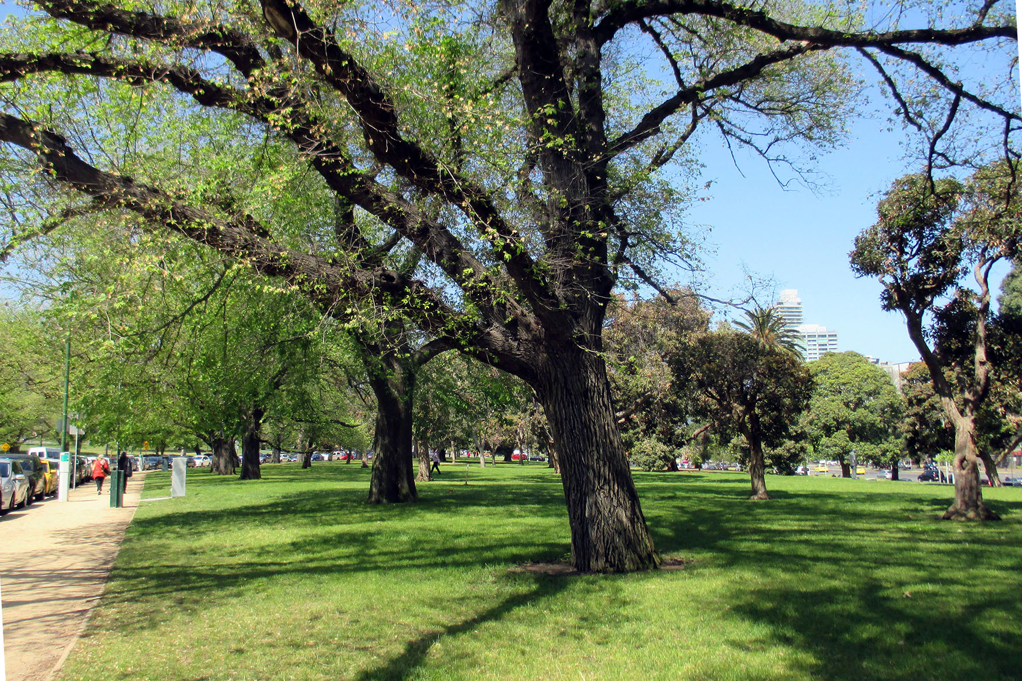

Figure ‎14-2 Plan of Domain Parklands (VHR H2304) showing key areas within the registered place and the context including abutting Victorian Heritage Register–registered places (Government House, the Royal Botanic Gardens, the Observatory and the Shrine of Remembrance)
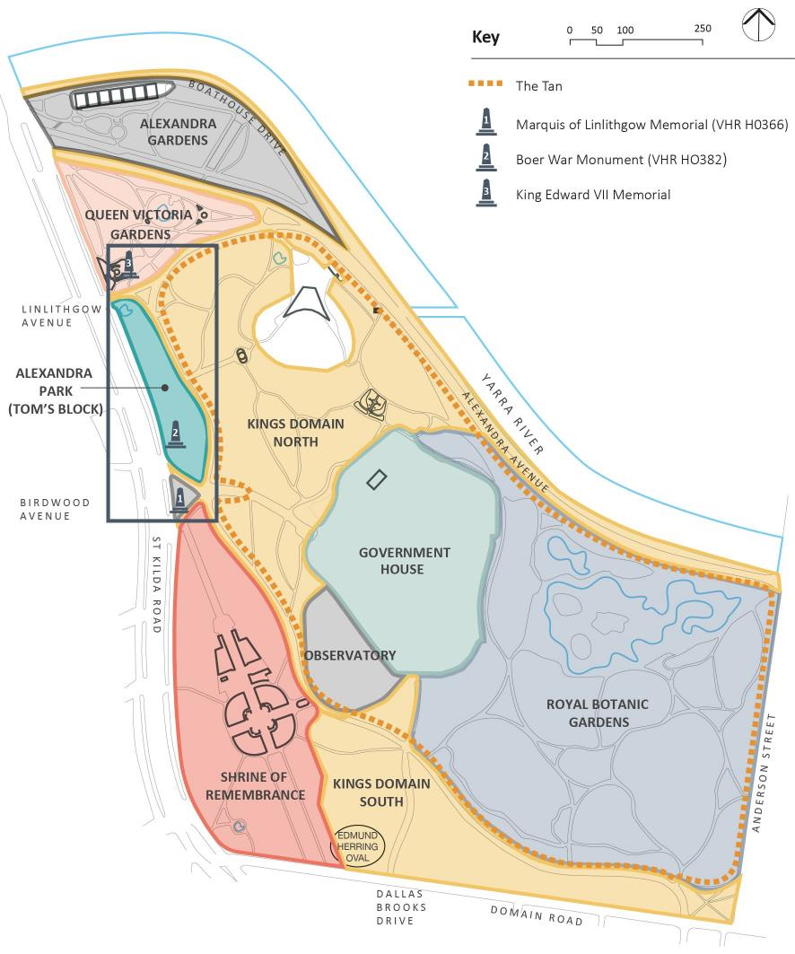

Figure ‎14-3 Key heritage places within the Tunnels precinct as it passes through and adjoins the Domain Parklands
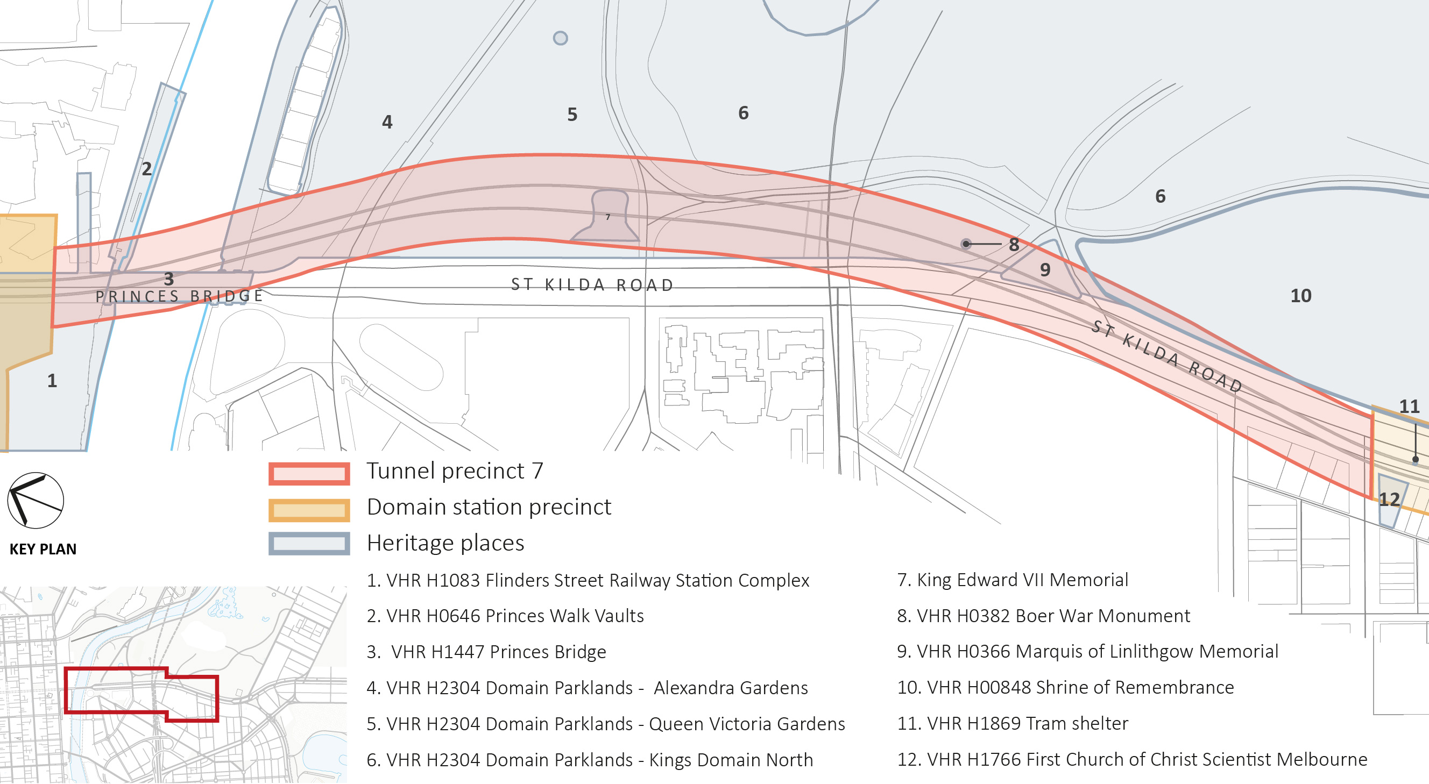

Figure ‎14-4 Key heritage places within the Tunnels precinct as it passes through and adjacent to the Domain Parklands – showing the location of the King Edward VII Memorial (7) within the Queen Victoria Gardens (5)
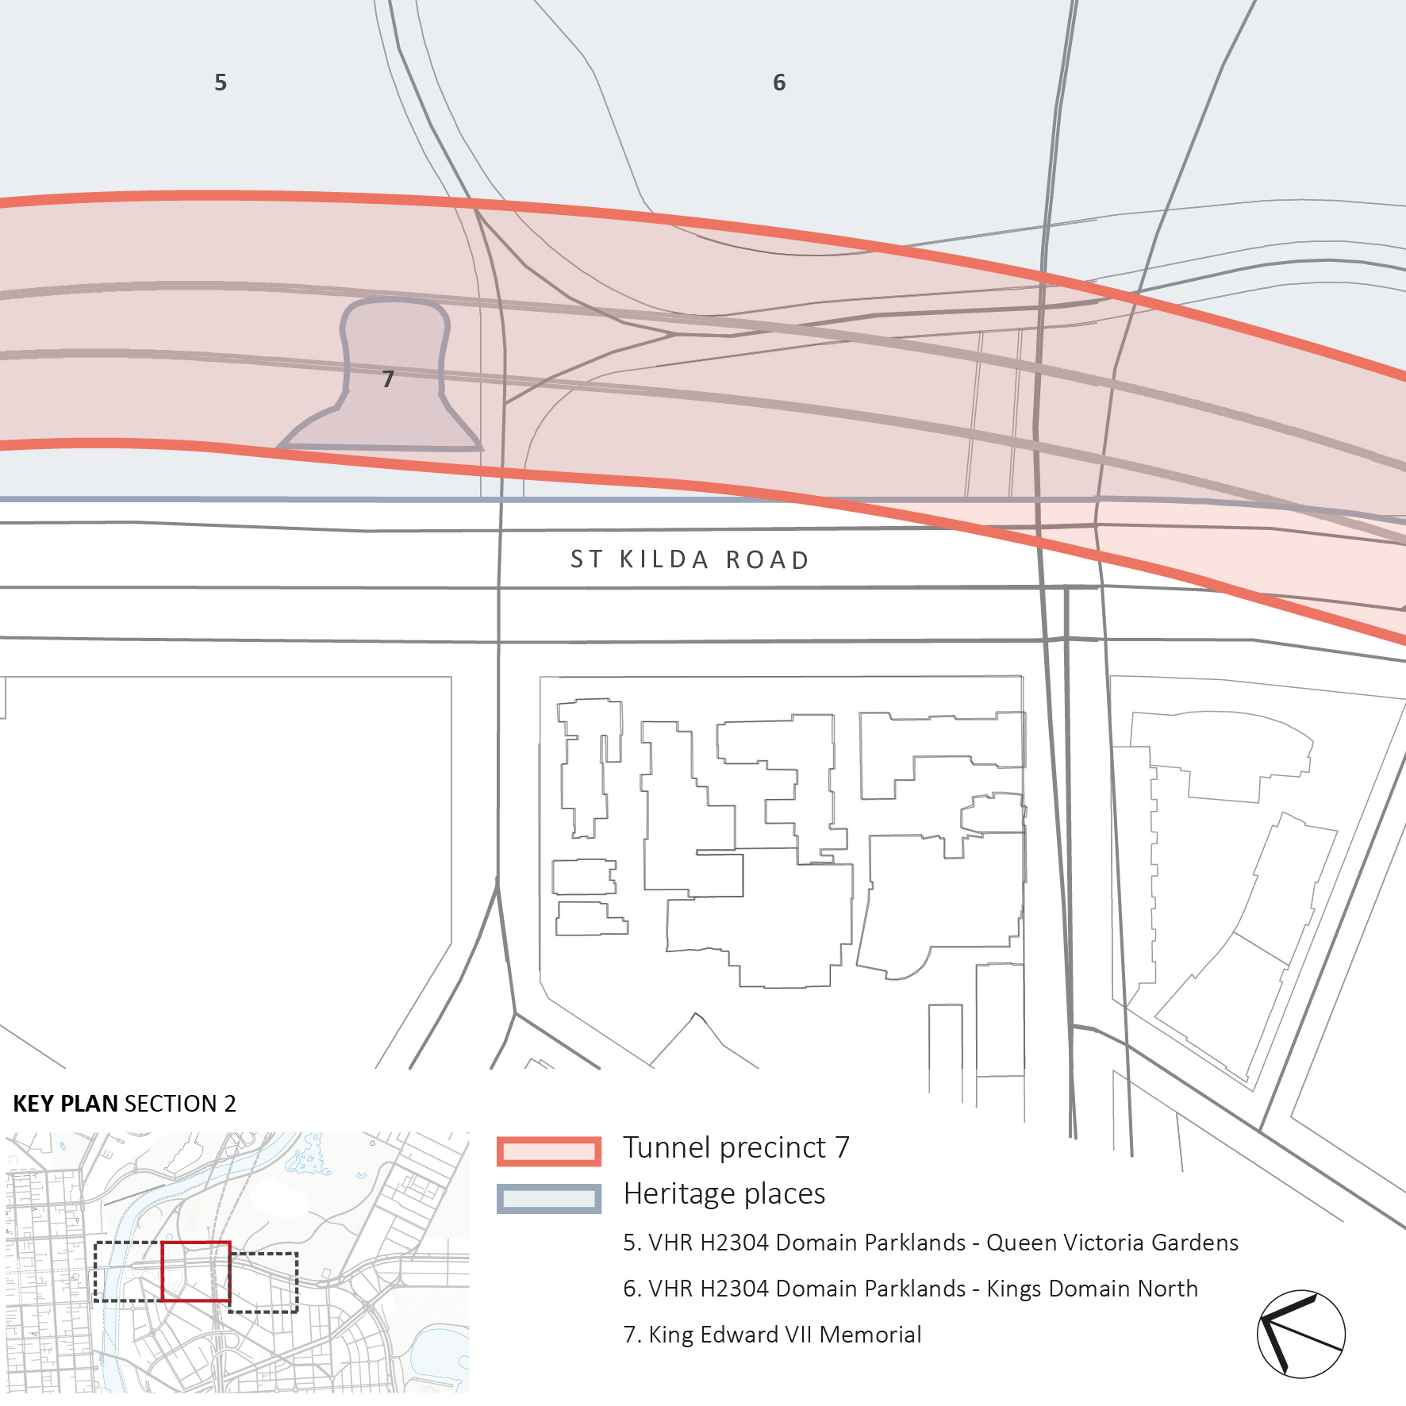
Figure ‎14-5 Key heritage places within the Tunnels precinct as it passes through and adjacent to the Domain Parklands – showing the location of the Boer War Monument (8) and the Marquis of Linlithgow Memorial (9)
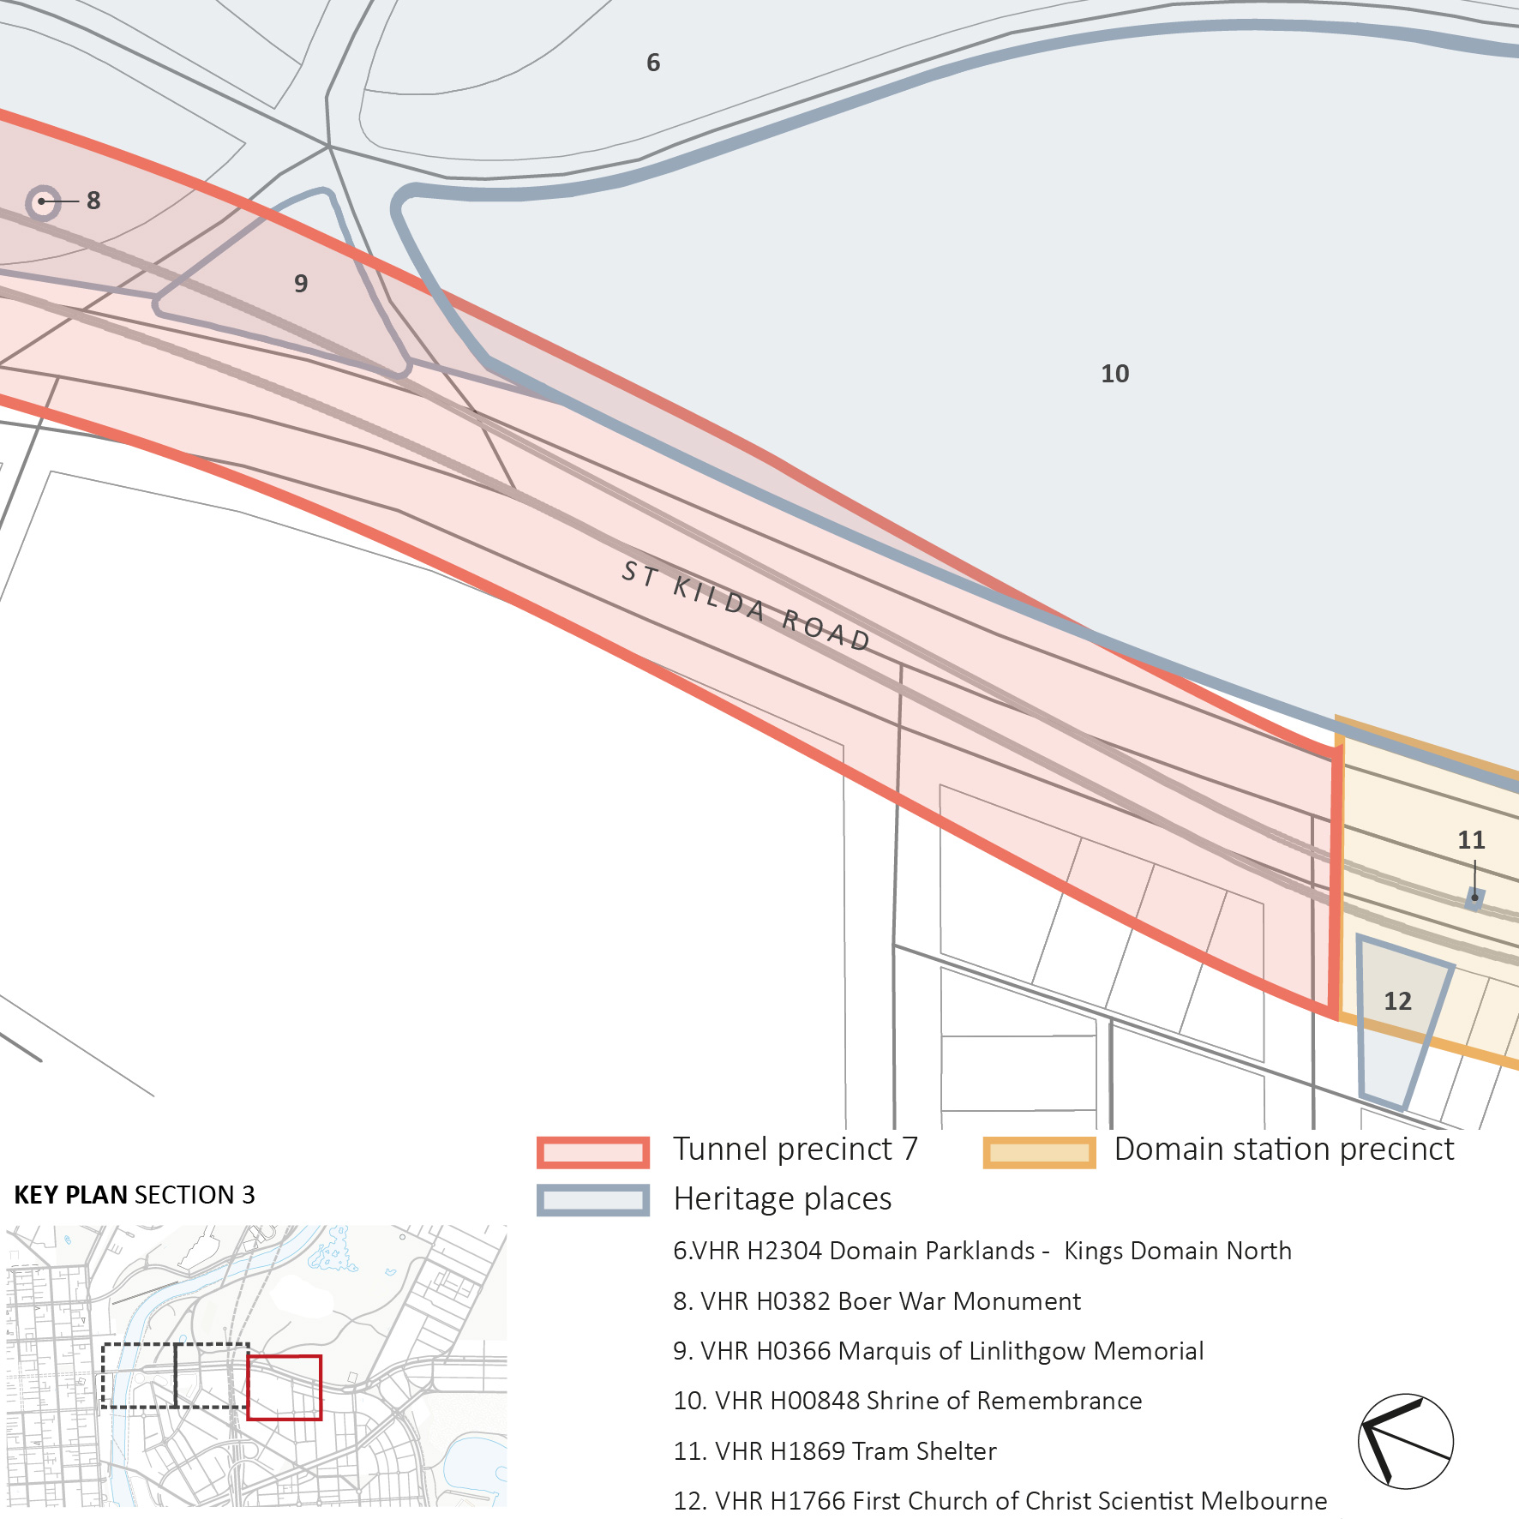

- The Boer War Monument (VHR H0382 and HO948 in the Melbourne Planning Scheme) – located within Alexandra Park (Tom’s Block) overlooking St Kilda Road (see Figure ‎14-5 and Figure ‎14-7). The monument was erected by the Victorian Mounted Rifles Regiment shortly after the end of the Boer War in 1903. It has been relocated from its original location on St Kilda Road to the current position in the Domain. It is a distinctive sandstone memorial on a bluestone base and is of State historical and aesthetic significance. Ground improvement works may be required in the immediate vicinity of the monument to manage the risk of ground movement. It is possible the monument would need to be temporarily removed and stored, to be reinstated following the completion of works. If this is required, a conservation specialist/materials conservator would need to develop an appropriate methodology and oversee the works. Assuming the risk of damage is appropriately managed and the works are undertaken to the required standard, there would be no adverse impact.
- The Marquis of Linlithgow Memorial (VHR H0366 and HO946 in the Melbourne Planning Scheme) – located at the driveway entrance to Government House, between St Kilda Road and Government House Drive and Anzac Avenue (see Figure ‎14-5, Figure ‎14-6 and Figure ‎14-7). The Memorial was erected in 1911 and honours John Adrian Louis Hope Hopetoun (the Seventh Earl of Hopetoun), Victorian Governor (1889–1895) and first Governor-General of Australia (1901–1903). A collection of mature Canary Island Palms form part of the setting of the memorial. As for the Boer War Monument, ground improvement works may be required in the immediate vicinity of the memorial. If temporary removal of the memorial is required, it would similarly require specialist conservation input to document and oversee the works. The palms could be stored and replanted to re-establish the setting to the memorial following completion of the works. Assuming the risk of damage is appropriately managed and the works are undertaken to the required standard, there would be no adverse impact.
The preference in both cases is for the retention in situ and protection of the monuments. Temporary relocation and reinstatement would be undertaken only if required to ensure the protection of the fabric.
Figure ‎14-6 Marquis of Linlithgow Statue, view from St Kilda Road
Figure ‎14-7 Detail plan of Alexandra Park (Tom’s Block) within the Domain Parklands showing memorials in this location
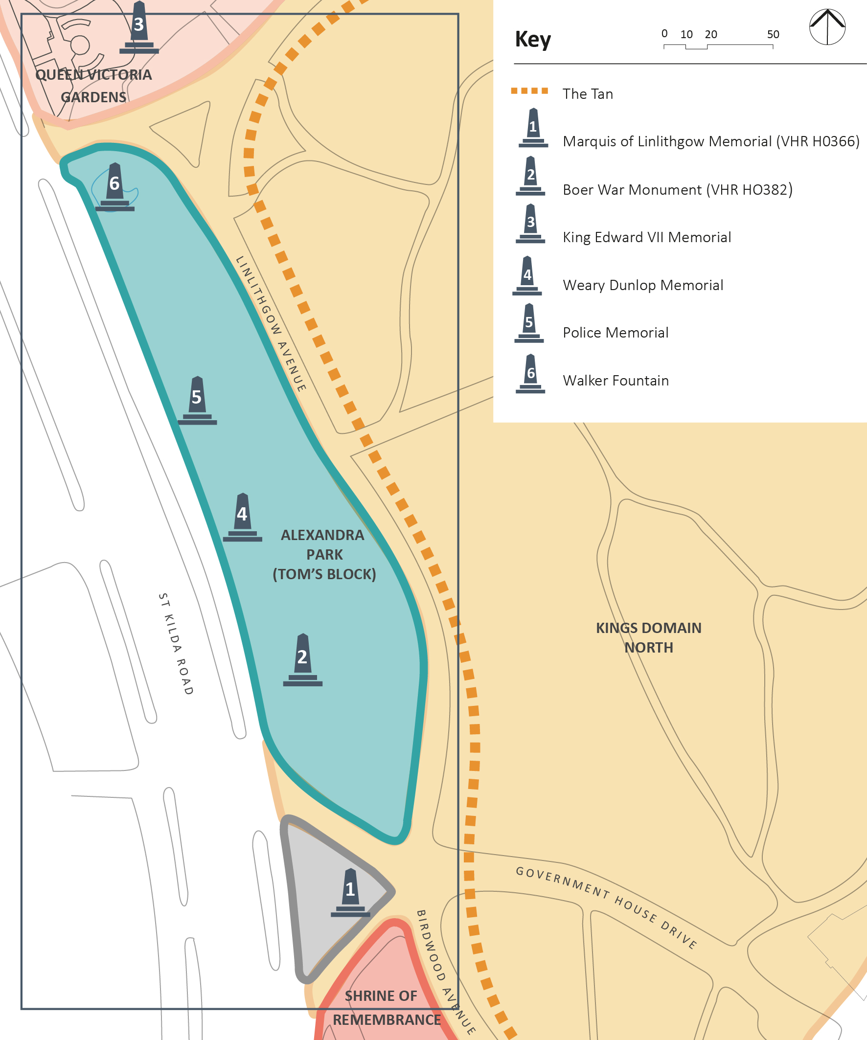
- Fawkner Park (within HO6 South Yarra Precinct in the Melbourne Planning Scheme) – Toorak Road West, South Yarra (see Figure ‎14-9). The park has been assessed as being of State historical, aesthetic and social significance due to the early origins of the park, its layout and mature trees, and particular associations (including with World War II activities). It was first reserved in 1862, with the pathway system and avenues laid out in 1875 by the City of Melbourne Parks and Gardens Curator, Nicholas Bickford. While the park has undergone a series of phases of development since the nineteenth century, it retains its early path system and mature plantings. Fawkner Park has been nominated to the Victorian Heritage Register.
The proposed alternative TBM launch site in Fawkner Park (to be used in association with the Domain launch site only) would impact on the north side of the park, to the west of the existing Fawkner Park Tennis Centre and Fawkner Park Community Centre. If this alternative site was selected, the area would accommodate a construction work site – this would require the removal of a number of tennis courts and juvenile trees that have recently been planted by Council. Following completion of the works, the existing park would be reinstated consistent with its heritage values and in accordance with the requirements of the City of Melbourne and the Fawkner Park Draft Masterplan. This would be a relatively straightforward process given that the majority of trees to be removed are juvenile trees and these could be replaced with new trees of similar age. The valued landscape character and plantings could be re-established following the completion of the works, and the tennis courts could also be reinstated if required by Council. On this basis, while the establishment of the TBM launch site in Fawkner Park would have a major physical and visual impact, it would be a temporary one.
Figure ‎14-8 View of the paths and mature trees within Fawkner Park
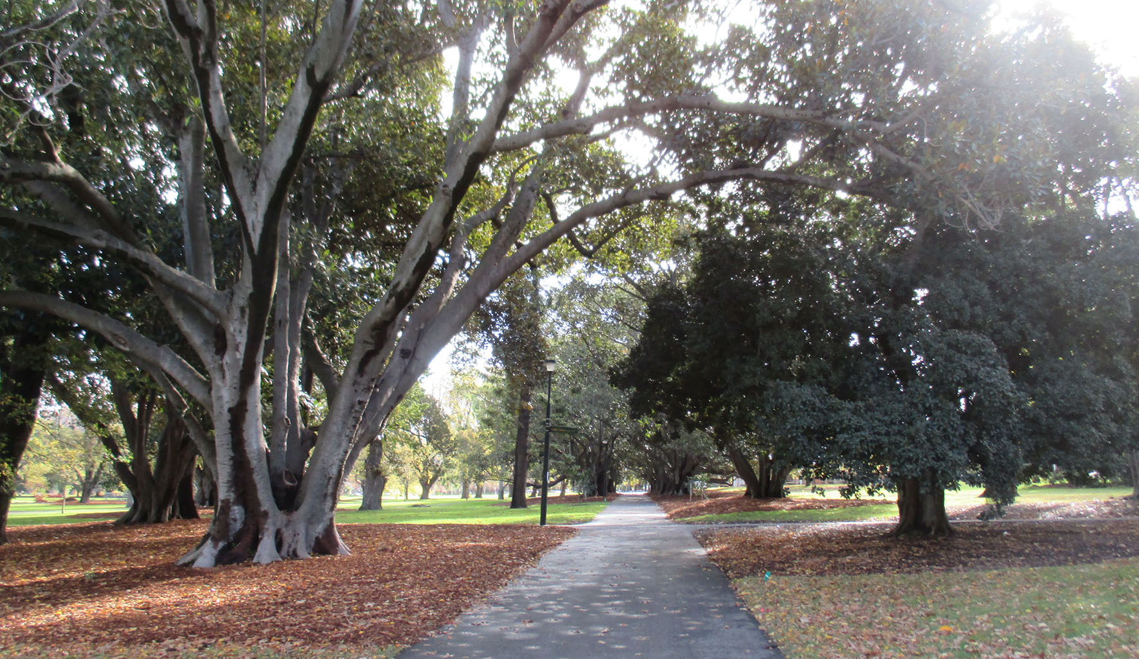
An emergency access shaft would be located within Fawkner Park along the Toorak Road West frontage to the east. A limited number of trees would require removal to accommodate construction and vehicular access to Toorak Road West, which is largely confined to a relatively open lawn area. A large bunya bunya pine (Araucaria bidwillii) is part of a significant group planting which would be within the proposed construction work site. Ideally, the footprint of the construction area would be adjusted so that the tree can be managed and retained. The emergency access shaft structure would likely be required to accommodate toilet facilities to replace an existing toilet block in this location. Combining the two functions into a single building potentially offers an opportunity to rationalise the design and would avoid the need for two separate buildings in the same general location within the park. While it would be a larger building when compared with the existing toilet block, it would not be of a scale that would dominate the Toorak Road West frontage; nor would it detract from the landscape qualities of Fawkner Park as a whole. Ultimately, the shaft would have a minor physical and visual impact, with no significant impact on the heritage values of the park.
Considered as a whole, the proposed works would have no adverse impact on the historical values of Fawkner Park. Similarly, the aesthetic qualities of the park would be maintained through avoiding impacts on significant elements and the reinstatement of landscape where change is required. In terms of the social value of the place, the temporary loss of parts of the park would be expected to have an adverse impact on the experience and enjoyment of the place by those who use it. Recognising the impact would vary and would be felt more keenly by some than others, it is considered that the social value of the place and the community’s attachment to place as a whole would be unlikely to be significantly diminished. Any impact on these values would be temporary only.
Figure ‎14-9 Fawkner Park showing the extent of existing VHI and HO controls
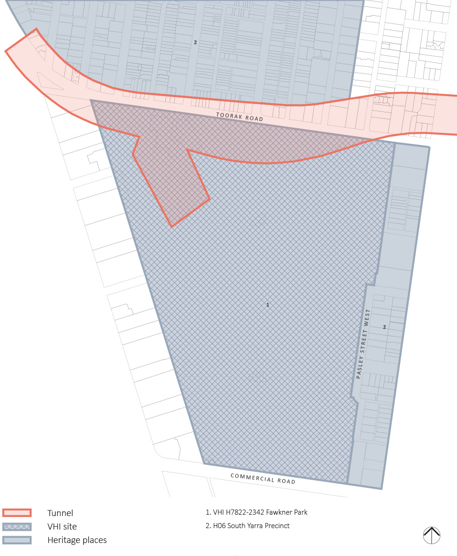

The tunnels precinct contains numerous other heritage places in addition to those discussed above, including Victoria Barracks, located on the south side of St Kilda Road between Wadey and Coventry Streets. As discussed in Section ‎14.3, the heritage values of Victoria Barracks are protected under the EPBC Act. MMRA referred the project to the Commonwealth Minister for the Environment. On 22 September 2015, the Minister determined that the proposed Melbourne Metro is ‘not a controlled action if undertaken in a particular manner’ to avoid significant vibration impacts to Commonwealth Heritage listed structures within the Victoria Barracks. Impacts to the Victoria Barracks would be avoided through the measures set out in Section ‎14.18. These measures would ensure the protection of fabric from construction activities would be managed, with impacts being minimised or eliminated.

Historical Archaeology
As previously identified, the tunnels precinct would affect Fawkner Park, which is considered to be an area of some historical archaeological potential. The following site would be partially disturbed as a result of the construction of the proposed TBM launch site and emergency access shaft:
- VHI H7822-2342 Fawkner Park – Toorak Road West, South Yarra.
Despite the relatively unchanged nature of the layout of Fawkner Park, there is a likelihood that early paths, garden beds or other features not documented in historical plans exist beneath the current ground surface. The occupation of the park during World War II may also have seen the deposition of artefacts (such as domestic items, food-related items, personal items), though disturbance of these may have occurred during removal of the World War II camp in 1951. There may also be evidence of the ‘community’ air raid shelter trenches that are known to have been dug in the park in 1942, including along the Toorak Road frontage of the site. Recent archaeological testing in the park saw the discovery of a range of historical artefacts, including ceramics.
In order to mitigate the impacts on the Fawkner Park archaeological site, an archaeological management plan would be prepared and further investigations would be undertaken in association with the works in accordance with Heritage Victoria’s requirements.

Alternative Design Options
Three alternative design options to the Concept Design have been proposed that would result in different interactions with historic places.
The first alternative design option proposes an alternative to the proposed Domain Parklands emergency access shaft (Queen Victoria Gardens). This site would be located in Tom’s Block, west of Linlithgow Avenue. This would similarly require the removal of trees for the construction site and there would be a visual impact associated with the permanent above-ground structure in the park setting. Depending on the requirements for emergency vehicle access to the shaft, there may be a permanent impact on the elm row on the west side of Linlithgow Avenue (likely the removal of one tree). This would result in an adverse visual impact as row plantings are important to the structure and overall presentation of the parklands and contribute to its aesthetic value.
The second alternative design option for the tunnels precinct would involve crossing below the CityLink tunnels, as opposed to above as for the Concept Design. If this were to occur, ground stabilisation would not be required. Consequently, there would be no need to consider temporary relocation of the Marquis of Linlithgow Memorial and the Boer War Monument and impacts to trees in Tom’s Block within the Domain Parklands associated with these works would also be avoided.
The third alternative design option would be to locate the proposed Fawkner Park emergency access shaft at the site of the proposed Fawkner Park TBM launch site (to be used in association with the Domain launch site only). This is an area of the park in which considerable development has already occurred and been successfully accommodated (including the expanded community centre complex). In this context, the proposed permanent structure would have a relatively minor impact. Additionally, this option would have the benefit of not requiring any additional tree removals (beyond those required for the TBM launch site).

Precinct 2: Western Portal (Kensington)

Issues and Potential Impacts
Historical cultural heritage impacts related to the western portal precinct would occur at:
- Childers Street and Ormond Street as a result of the establishment of a construction work site (site compounds/ laydown area)
- 1-39 Hobsons Road as a result of the establishment of a construction work site.
Figure ‎14-10 Key heritage places at the western portal precinct
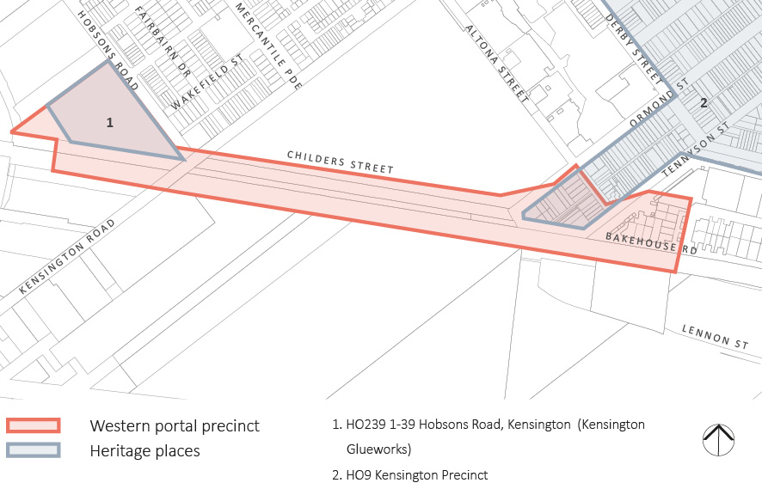
These works would interact with the following heritage places (see Figure ‎14-10):
- Former Kensington Glue Works site (HO239 of the Melbourne Planning Scheme) – located at 1-39 Hobsons Road. The site is of local historical and architectural significance as an example of an interwar factory complex associated with the meat and by-products industry. The proposed construction work site would be located on land at the southern end of the site where there are no buildings or structures of heritage value. The works would be temporary and there would be no impact on the heritage values of the place.
- Kensington Precinct (HO9 of the Melbourne Planning Scheme) – this is a large heritage precinct located to the north of the western portal precinct. The proposed works would affect the precinct through the demolition of six residential buildings. Of these, four Edwardian residences – a group of three on Childers Street (1, 3, 5-7 Childers Street) and a single residence on Ormond Street (133 Ormond Street) – are considered of heritage value as graded buildings within the Kensington Precinct.
Graded buildings have been assessed in local municipal heritage studies on the basis of their relative contribution to a precinct or area. For example, the City of Melbourne has historically used an alphabetical system where A graded buildings are of the highest level of significance (typically considered to be of state significance in their own right) ranging to D graded buildings which contribute to the precinct in a different way and at a local level. Refer to Technical Appendix A and Technical Appendix J for a more detailed explanation of gradings in the Melbourne Planning Scheme.
The loss of the four graded residences would reduce the stock of contributory buildings within the Kensington Precinct and effectively reduce its extent on the southern edge. While demolition of any contributory buildings is an undesirable action, in this case it is one that would not compromise the core values of the precinct. As the residences are located on the edge of the precinct, the contribution the buildings make is less critical to the cohesion of the place than if they were located more centrally. The demolition of the ungraded properties would have no impact.

Historical Archaeology
The predictive archaeological modelling has found that there is only limited potential for historical archaeology to be present within the western portal precinct. The project-wide protocols would apply in the event that any unknown site or relics are uncovered in the course of works.

Alternative Design Option
The heritage impacts of the alternative design option for the western portal precinct would differ in that the alternative design option would not require the demolition of any graded buildings in the Kensington Precinct (HO9). One ungraded residence (135-143 Ormond Street) is proposed for demolition. There would be no resultant adverse impact on the Kensington Precinct.

Precinct 3: Arden Station

Issues and Potential Impacts
While there are no places that are currently listed with statutory heritage controls within the Arden station precinct, a number have been proposed for heritage overlay controls.
The City of Melbourne has prepared Amendment C207 to the Melbourne Planning Scheme, which is currently with the Minister for Planning awaiting approval. The amendment seeks to introduce heritage controls over a series of predominantly industrial sites and precincts in the north-west and west of the municipality. In light of this amendment, potential historical cultural heritage impacts related to the Arden station precinct would occur at:
- Publicly owned (VicTrack) land west of Laurens Street as a result of the establishment of a construction work site (site compounds/ laydown area), the station box and the TBM launch site
- North of Arden Street, between CityLink and Langford Street to the east as a result of the construction of a substation (option 1).
Figure ‎14-11 Key heritage places at the Arden station precinct
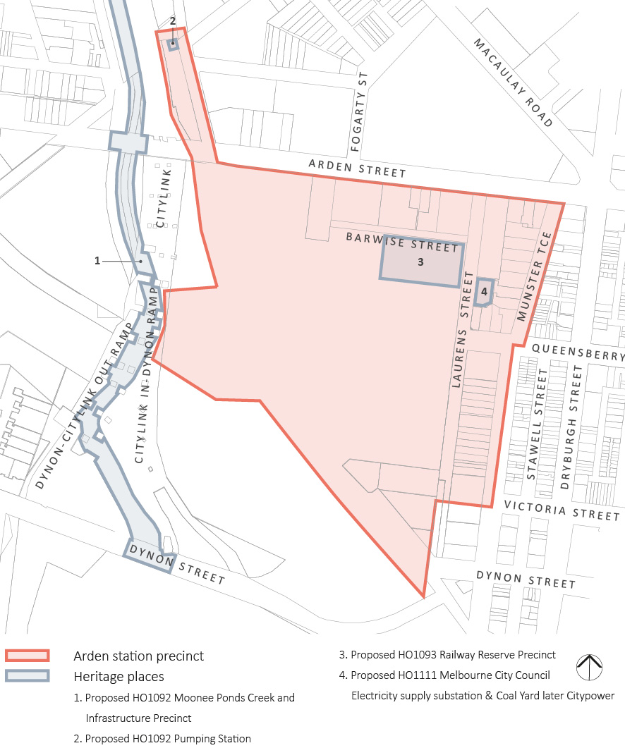
These works would interact with the following proposed heritage places that are included within the Amendment C207 (see Figure ‎14-11):
- Railways Reserve precinct (proposed HO1093 in the Melbourne Planning Scheme) – located at 173–199 Laurens Street. This is the site of a group of buildings which housed the former Victorian Railways Carpenters Shop and later the Victorian Railways Printing Works. The buildings were part of a much larger railways complex extending to the south and west. The proposed precinct has been assessed as historically significant as it demonstrates a major phase of railways expansion in Victoria in the early twentieth century. It has aesthetic value deriving from the utilitarian industrial structures with their form and materiality typical of the period and use. Construction of the proposed Arden station would require the demolition of these buildings and the removal of the associated pepper trees. The impact would be complete loss of heritage values (historical and aesthetic). While in a general sense the association with rail transport would be maintained through the establishment of a new station, the early origins of this would no longer be evident through the physical fabric of the place. The buildings would be recorded prior to demolition and it is recommended that the history of the place as a railways facility be recorded and an interpretation strategy developed on site.
Figure ‎14-12 Railways Reserve Precinct, 173-199 Laurens Street, North Melbourne (proposed HO1093), the below building is the Former Victorian Railways Carpenters Shop, later Victorian Railways Printing Works (workshop 1), viewed from the north-west
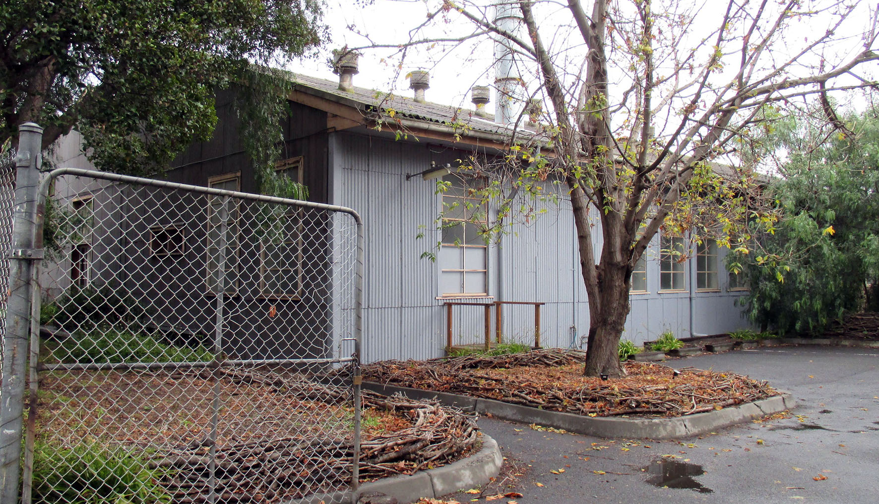
- Pumping Station (proposed HO1092 in the Melbourne Planning Scheme) – a brick pumping station located in Langford Street. The pumping station forms part of the Moonee Ponds Creek and Infrastructure Precinct (proposed HO1092). This large and diverse precinct comprises a length of the Moonee Ponds Creek and its associated infrastructure including the road bridges, pylons, pumping stations and bluestone levees. The retention of the pumping station would be preferred and detailed design could co-locate the new substation on the same site, and the impact would be avoided. Equally, in the event demolition is required, this would have only a minor impact on the heritage values of the wider precinct. It is one of a number of these structures included in the precinct and is of no intrinsic significance in itself.
There are three other location options for the proposed substation. These would have no heritage impact.

Historical Archaeology
The predictive archaeological modelling has found that there is only limited potential for historical archaeology to be present within the Arden station precinct. The project-wide protocols would apply in the event that any unknown site or relics are uncovered in the course of works.

Precinct 4: Parkville Station

Issues and Potential Impacts
Historical cultural heritage impacts related to the proposed Parkville station precinct would occur at:
- Grattan Street, Barry Street and Royal Parade as a result of construction of the station box, entrances, ventilation structures, fire egress and public lifts
- University Square as a result of the establishment of a construction work site (site compounds/ laydown area)
- City Ford car yard (bound by Pelham Street, Berkeley Street and the Haymarket roundabout/ Elizabeth Street) as a result of the establishment of a construction work site.
Figure ‎14-13 Key heritage places at the proposed Parkville station precinct
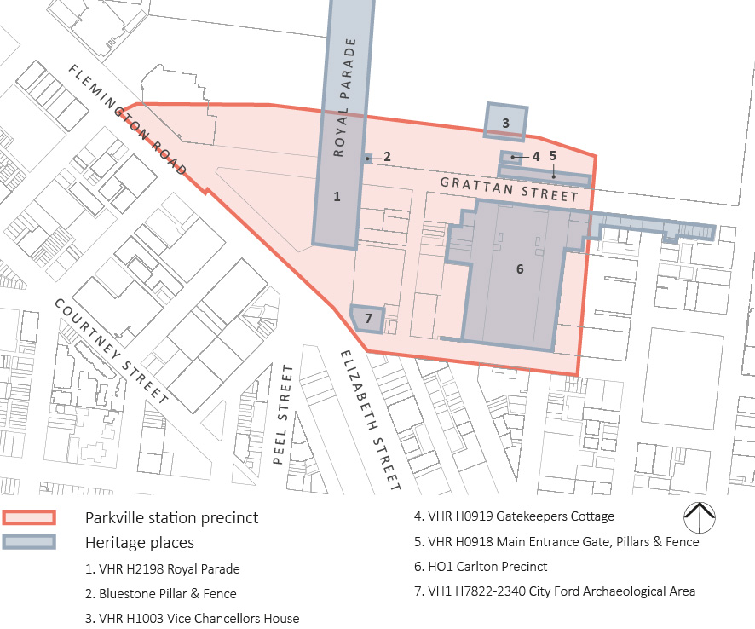
These works would interact with the following heritage places (see Figure ‎14-13):
- Royal Parade (VHR H2198 and HO977 of the Melbourne Planning Scheme) is identified as being of historical, social and aesthetic significance to the State of Victoria. The extent of registration extends between Park Street in the north and Elizabeth Street to the south. Royal Parade is a major urban landscape characterised by a generous width and boulevard layout with service roads, grassed medians and English elm (Ulmus procera) avenues either side of a broad central carriageway. As noted in the Victorian Heritage Register statement of cultural heritage significance, historically it is important as the ‘road to Sydney’ and as the traditional approach to Melbourne from the north. It is aesthetically significant as it demonstrates the ‘City Beautiful’ design qualities and is one of Victoria’s finest boulevards, providing ‘shade in summer, autumn colour and sunlight penetration in winter’.
Construction of Melbourne Metro would require the removal of up to ten English elms, permanent changes to the arrangement and physical fabric of the medians and removal of parts of the pitched bluestone gutters. Six of the elms would be affected by changes to the functional road layout required for the proposed new tram superstop while four trees would be affected by construction works for the station itself. All would be replaced with large specimens of the same species following the works to reinstate the significant boulevard layout and character. Although there would be some permanent changes to the aesthetic qualities of the place associated with changes to the road layout and medians, the landscape qualities would be largely recoverable over time as the replacement trees mature. In the context of the scale and extent of Royal Parade, the changes proposed are relatively modest in scale and can be accommodated without compromising the significance of the heritage place in any fundamental way. The overall layout would be maintained, remaining legible and broadly consistent with the balance of Royal Parade. The extent of change would be temporary and limited in consideration of the overall scale and the impact localised to one end of the heritage place.
- Main Entrance Gates, Pillars and Fence (VHR H0918 and HO343 of the Melbourne Planning Scheme) – located at the University of Melbourne, 156-292 Grattan Street (see Figure ‎14-14). The heritage place is identified as being the extent of the gates and the whole of the fence, and is of historical and architectural significance. The gates and fence mark the original main entry to the University and are architecturally significant for their Gothic Revival styling. Subject to detailed design, the wall of the proposed Parkville station box and its associated construction works may abut or be below the registered fence. Depending on detailed design and to avoid the risk of damage, it may be necessary to dismantle and reinstate the fence and pillars, either in part or in full. This would be a temporary measure with the structure being reinstated following construction. An industry standard which is most frequently referenced as a guide to best practice management of cultural heritage places in Australia is the Australia ICOMOS Burra Charter, 2013 (Burra Charter). The Burra Charter establishes principles for the conservation of heritage fabric. The works would be documented to accepted conservation standards with reference to the Burra Charter and with specialist input, and there would be no adverse impact on the significance of the registered place.
Figure ‎14-14 View along the western portion of Main Entrance Gates (Gate 6), Pillars and Fence, University of Melbourne (VHR H0918); this portion is to the front boundary of Gatekeeper’s Cottage, University of Melbourne (VHR H0919)
- The Gatekeeper’s Cottage (VHR H0919, HO338) and Vice Chancellor’s House (VHR H1003, HO821) – both these University of Melbourne sites are located north of Grattan Street. The Gatekeeper’s Cottage (1860) is included on the Victorian Heritage Register for its historical and architectural significance. The cottage is one of the earliest surviving buildings at the University. It adopts a distinctly picturesque styling and is an early design by the architect Joseph Reed. The Vice Chancellor’s House (1937–8) is located set into the University grounds on Kernot Road. It is of State historical and architectural significance as an example of housing provided on campus, as a fine Georgian Revival residence and as a reference to the links between the architect Harry Norris and the philanthropist George Nicholas, as associated with the University.
For both these heritage places, there would be a potential visual impact associated with the new station entry on the north side of Grattan Street. In the case of the Gatekeeper’s Cottage, the new entry would be to the west on the Grattan Street frontage, and providing a suitable separation and boundary treatment to the Gatekeeper’s Cottage is maintained or reinstated, there would be no adverse impact. For the Vice Chancellor’s House, the visual impact would be to obscure some views of the building from Grattan Street. While this is a change, there is not considered to be an adverse heritage impact. The building originally was sited internally to the University fronting Kernot Road and related to other residences formerly on the site to its west.
- Carlton Precinct (HO1 in the Melbourne Planning Scheme) – located predominantly east of the proposed Parkville station precinct, throughout Carlton, and includes the south side of Grattan Street between Barry and Leicester Streets, University Square and the University of Melbourne underground carpark. The precinct is of historical and architectural significance as an important early area in Melbourne and for its rich history and subsequent layers of development. Construction of Melbourne Metro would require the establishment of a temporary construction work site over the University of Melbourne carpark in the north of University Square in Barry Street. The proposed permanent above ground infrastructure would include a series of vent shafts (3 m in height) on the south side of Grattan Street and mechanical services (chiller plant and generator) in Barry Street.
The proposed construction work sites do not occupy significant fabric and there would be no adverse impacts arising from their establishment and temporary use. The locations where the new above ground infrastructure would be built are also not considered to pose an adverse impact. The vent structures would be positioned in the footpath on the south side of Grattan Street and would receive urban design treatment, where they would be viewed in association with the contemporary landscape of the University of Melbourne’s underground carpark. In Barry Street, the services structures would be located on the east side of the street on the carpark frontage. While located opposite the graded Victorian terraces on the west side of Barry Street, they would have no adverse impact on these or on the HO1 precinct.
An additional potential impact to heritage values would be the removal of a remnant bluestone pillar and section of cast iron fencing, located on the corner of Royal Parade and Grattan Street. This is a remnant of the boundary fencing to the University of Melbourne which was taken down in sections beginning in the 1930s. The extant section was reinstated in 1982 and is of interest in the context of the University’s own history. The removal of this feature would not have a major heritage impact but consideration should be given to its incorporation into the design for the new station entry as it provides an historical marker defining the boundary.
Figure ‎14-15 Terrace houses in Barry Street, Carlton, Carlton Precinct HO1
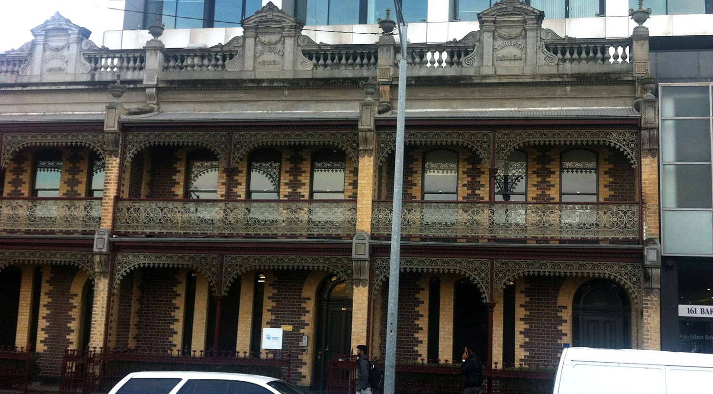

Historical Archaeology
There is limited potential for historical archaeology to be present within the proposed Parkville station precinct, with the exception of the City Ford archaeological area. Remains of the nineteenth century Junction Hotel and adjacent residential dwellings are likely present in the asphalted car yard area. This is a result of the nature of the original construction of the hotel and no evidence to suggest subsequent construction has occurred apart from an open asphalted car yard. Archaeological remains may provide insight into the operations and patrons of the early city-fringe hotel on the route to the Victorian goldfields and the changing social nature of the surrounding area. Additionally, there may be the potential to provide information of early domestic occupation of the Melbourne city fringe, including an understanding of early domestic activities and lifeways of nineteenth century Melbourne residents. The site was identified in the predictive archaeological modelling for the project (see Section 8 in Appendix B of Technical Appendix J) and as a result, it has been added to the Victorian Heritage Inventory as VHI H7822-2340.
There may also be some evidence of earlier road treatments or surfaces in the Royal Parade road reserve that could provide information about early road construction techniques.
In the case of the City Ford archaeological area, an archaeological management plan would be prepared to guide the archaeological investigation of this site, while archaeological monitoring is recommended for works in the Royal Parade road reserve.

Precinct 5: CBD North Station

Issues and Potential Impacts
Historical cultural heritage impacts related to the CBD North station precinct would occur at:
- Franklin Street as a result of construction of station entrance and establishment of a construction work site
- The corner of Swanston Street and La Trobe Street as a result of construction of a station entrance.
Figure ‎14-16 Key heritage places at the CBD North station precinct
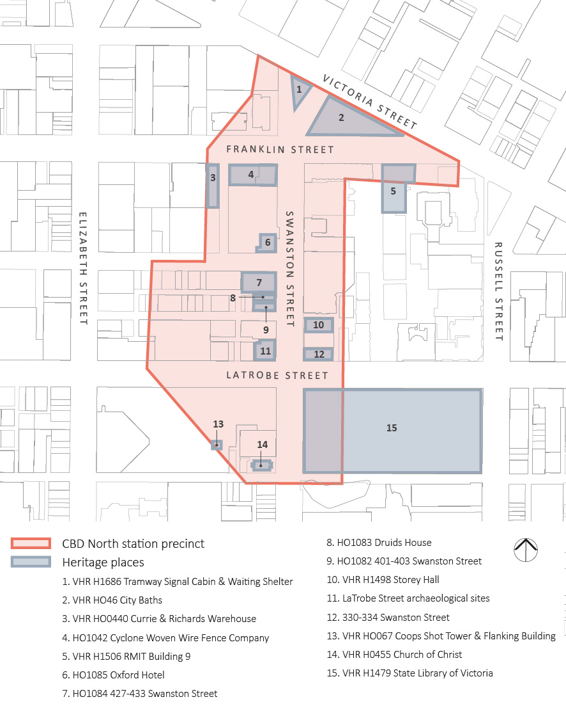
These works would interact with the following heritage places (see Figure ‎14-16):
- City Baths (VHR H0466 and HO493 of the Melbourne Planning Scheme) – located at 420 Swanston Street, 39-41 Victoria Street and 2-6 Franklin Street. Designed in the Edwardian Baroque style, the City Baths are of state architectural and historical significance. They are an important work of architect J.J. Clark and serve as a reminder of the role of bathing establishments in the early twentieth century. Construction of the proposed CBD North station would involve cut and cover works immediately adjacent to the baths in Franklin Street. Appropriate protection measures would be developed to ensure that there are no resultant impacts on the heritage fabric.
Construction of the proposed CBD North station would also involve the erection of permanent infrastructure associated with the new station. This would include a vent structure with access stairs on Franklin Street (east end) and a station entry east of the intersection of Swanston Street. While the proposed infrastructure is outside the registered place, there would be a visual change and impact in some views to the City Baths. Careful detailed design in terms of the scale, height and materiality of new structures where close to the registered building, would assist in mitigating the impact.
Figure ‎14-17 City Baths, corner of Swanston and Franklin streets (VHR H0466)
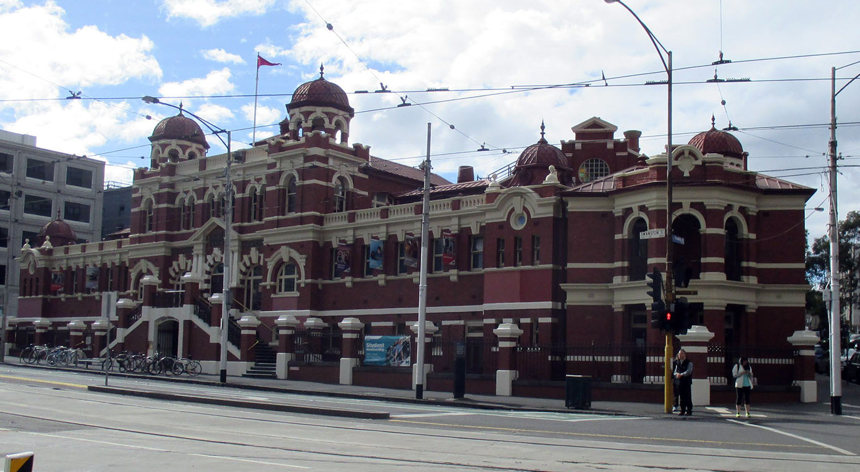
Although there are many other heritage buildings within the precinct that are of a high level of significance, including the State Library of Victoria, these would not be directly affected by Melbourne Metro. Note that the issues of construction vibration and ground movement for buildings in the vicinity of works would be managed on a project-wide basis, with potential impacts being minimised or eliminated.

Historical Archaeology
The CBD North station precinct is considered to be an area of very high historical archaeological potential. There are 41 Victorian Heritage Inventory sites within the CBD North station precinct. Of these, 37 are unlikely to be impacted due to the nature and depth of the proposed works in this precinct. The remaining four Victorian Heritage Inventory sites would require complete removal to allow for the construction of the La Trobe Street station entrance on the corner of Swanston Street and La Trobe Street (see Figure ‎14-18). These are:
- VHI H7822-2128 – located at 204-206 La Trobe Street
- VHI H7822-2129 – located at 208-210 La Trobe Street
- VHI H7822-2130 – located at 377-391 Swanston Street/188-196 La Trobe Street
- VHI H7822-2082 – located at 22-44 A’Beckett Street.
Figure ‎14-18 Victorian Heritage Inventory sites at the CBD North station precinct
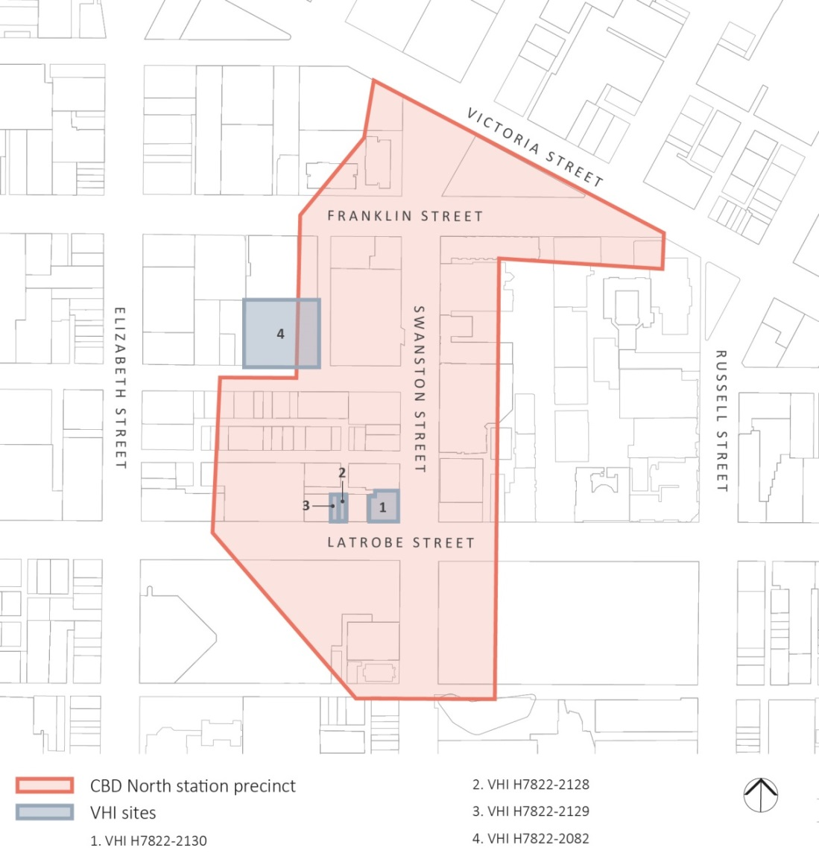

By the mid-1850s, the three sites at La Trobe and Swanston Streets had been developed with a number of one and two-storey brick or stone buildings. They were constructed to the street frontage, with a central laneway running parallel to La Trobe and Little La Trobe Streets, and were occupied by businesses including merchants, provision stores and light industry, such as ironmongers. The built form of these sites is predominantly twentieth century, but given the lack of basements as shown on the 1962 Mahlstedt fire insurance plans, there is potential for the archaeological remains of nineteenth century commercial and residential occupations of the sites.
The A’Beckett Street site (H7822-2082) had been developed by the late 1850s with a number of small buildings, and had an early character of light industrial and residential buildings. This type of use of the site continued through the nineteenth century with workshops, forges, factories, sheds and residences being present. Between 1910 and 1920, the site was acquired by the British and Australasian Tobacco Company and the cigar manufacturers, States Tobacco Company.
To mitigate the loss of the archaeological values of these Victorian Heritage Inventory sites, an archaeological management plan would be prepared to detail the archaeological investigation of the area. As for all such plans prepared as part of Melbourne Metro works, the archaeological management plan would be prepared in accordance with Guidelines for Investigating Historical Archaeological Artefacts and Sites (Heritage Victoria 2014) and in consultation with Heritage Victoria.

Precinct 6: CBD South Station

Issues and Potential Impacts
A number of Melbourne’s most significant heritage buildings, dating from the 1850s to the early 21st century, are located within or close to the CBD South station precinct. Historical cultural heritage impacts related to the precinct would occur at:
- City Square as a result of construction of a station entrance
- Swanston Street, between Flinders Lane and Flinders Street, as a result of construction of a station entrance
- Flinders Street, between Swanston Street and 236 Flinders Street, as a result of construction of a station entrance
- Flinders Street Station as a result of construction of the underground connection to the proposed station.
Figure ‎14-19 Key heritage places at the CBD South station precinct
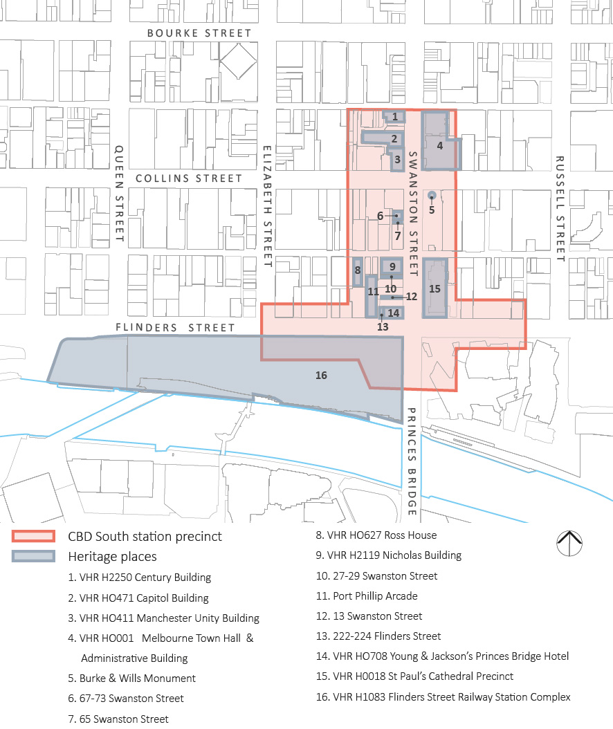
Note: Buildings that fall within HO505 Flinders Gate Precinct and could be affected by the project are numbered.
These works would interact with the following heritage places (see Figure ‎14-19):
- Flinders Street Station Complex (VHR H1083 and HO649 of the Melbourne Planning Scheme) – located at 207-361 Flinders Street. Completed in 1910, the Victorian Heritage Register statement of cultural heritage significance notes that it is ‘one of the most important and eclectic public buildings in Victoria’ and ‘is an excellent example of a twentieth century railway building’. It is of historical, aesthetic, architectural, technical and social significance. Impacts to the complex from Melbourne Metro would be related to the connection from the new CBD South station. They would include the removal of two non-original shop fronts at ground level at the eastern end of the north elevation (currently occupied by Scissors and Cignall) and internal demolition and new works including the introduction of escalators to enable access to the concourse and pedestrian links within the station building.
The impact on the heritage values of the complex is considered to be limited, with the majority of the works occurring within spaces defined as being of little or no significance. Impacts would include the loss of the significant pressed metal ceilings within the shops and the introduction of the new escalators at level one would require the removal of internal walls and floors in an area of primary significance. However, given the extent of the change would be limited to a confined area and can be managed through careful design, the heritage impact would be limited. Importantly, there would be no impact on significant external fabric.
The impact to the overall presentation and fabric of the railway station, and its aesthetic and architectural qualities, would be minor. While the detail of some of the spaces would be removed, the overall planning and layout of the station building and complex as a whole would remain clear and largely unaffected. Importantly, the works are directed at supporting the ongoing role of the station as the heart of Melbourne’s suburban railway network. Its status as a commuter hub would be confirmed and enhanced as a result.
In summary, the heritage impacts to the Flinders Street Station Complex are relatively minor and limited to a small number of locations.
- Young and Jackson’s Princes Bridge Hotel (VHR H0708 and HO744 of the Melbourne Planning Scheme) – located at 1-7 Swanston Street (see Figure ‎14-20). The building is of historical significance as one of Victoria’s oldest, most important and successful hotels. Young and Jackson Hotel retains components dating to its establishment in 1853 and redevelopment at that time. Whilst not directly interacting with the building, extensive excavation works, followed by construction of a new building, would abut the heritage building on the north side. The potential for vibration and ground movement impacts from the related construction would need to be considered. As discussed earlier, these issues are to be managed on a project-wide basis. There would also be the potential for the new building to have an adverse visual impact on the presentation of the hotel. Due to the highly sensitive location, care would be taken in detailed design to ensure the new development would not overwhelm the hotel or detract from its prominence on the key corner site.
Figure ‎14-20 Young and Jackson’s Princes Bridge Hotel (VHR H0708) Swanston and Flinders streets as viewed from the south
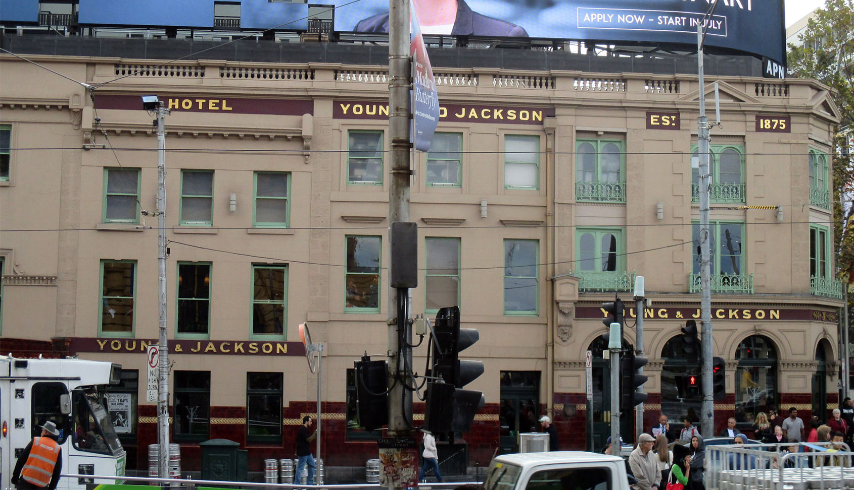
- Nicholas Building (VHR H2119 and HO745 of the Melbourne Planning Scheme) – located at 31-41 Swanston Street. The Nicholas Building is a nine-storey office building constructed in 1925–26 and designed by Harry Norris, a prominent commercial architect during the interwar period. The building is of architectural and historical significance and is an outstanding example of the Commercial Palazzo style. As part of the proposed development of CBD South station, the building immediately adjacent to the Nicholas Building to the south (27-29 Swanston Street) would be demolished, followed by construction of a new building. Existing connections between the two buildings mean that there would likely be make good works (closing the current opening though infill works to match the walling) required to the southern wall to the Nicholas Building but these would have no adverse heritage impact.
- St Paul’s Cathedral Precinct (VHR H0018 and HO655 in the Melbourne Planning Scheme) located at the corner of Swanston and Flinders streets. St Paul’s Cathedral was constructed from 1884, with the towers and spire added in the 1920s. It is of architectural, historical and scientific (technical) significance and also of social/spiritual value. There may be works at depth within the registered site with no surface impacts. There is also a proposal for the temporary use of the carpark on the east side of the cathedral as public open space during the construction period. The St Paul’s carpark could be developed for this use to ameliorate the loss of the City Square during construction. Such temporary works could include hard and soft landscaping works, lighting and other temporary structures. These need to be carefully designed but assuming this, would not have an adverse impact.
- Flinders Gate Precinct (HO505 of the Melbourne Planning Scheme) – located at the southern edge of the CBD, covering a number of key buildings including St Paul’s Cathedral, Flinders Street Station and Young and Jackson Hotel. The precinct is significant as it is the historic gateway to the central city from the south and it includes many major nineteenth and twentieth century heritage buildings. The precinct would be impacted as a result of the demolition of a number of buildings that are graded within the precinct and contribute to its heritage values.
Graded buildings proposed for demolition in the Flinders Gate Precinct are as follows:
  - 27-29 Swanston Street – constructed in 1939-40, the building is of local architectural and historical significance. Its design is architecturally distinctive and of interest for its association with the architect, Harry Norris. The building itself is a modest, rather than a key contributor to the precinct, and its demolition would not compromise the core values of the precinct.
  - 65 Swanston Street – constructed in c.1904 as part of a larger group of four shops, this building demonstrates the historical development of retail within the precinct. Considered individually, it is of local significance as it is an example of an early twentieth century shop. In the more localised context, it is noted that this part of Swanston Street within the precinct is not particularly intact. Despite this, the demolition of the building would reduce the stock of contributory buildings within the precinct as a whole and consideration should be given in detailed design to the retention of the façade and incorporation into new build behind.
  - Port Phillip Arcade – located at 228-236 Flinders Street. The building was constructed in 1960-61 on the site of the Port Phillip Club Hotel. The demolition of the Port Phillip Arcade would mean the loss of a distinctive building of some individual significance, one which reflects on the continuing tradition of laneway arcades as a particular form of retailing in Melbourne. Accepting this, its demolition would not compromise the core heritage values or key attributes of the Flinders Gate Precinct. The distinctive Charles Bush Sculpture should be retained and incorporated into new build on the site and a site-specific interpretation plan should be developed and implemented.
While the works would involve substantial change, the loss of the identified buildings in the Flinders Gate Precinct would not significantly diminish the core heritage values of the heritage Precinct. New development within the area would be carefully designed to respond to the heritage context and significant heritage buildings in close proximity such as the Dangerfield building (222-224 Flinders Street).
Figure ‎14-21 Young and Flinders Street Railway Station (VHR H1083) viewed from the north-east
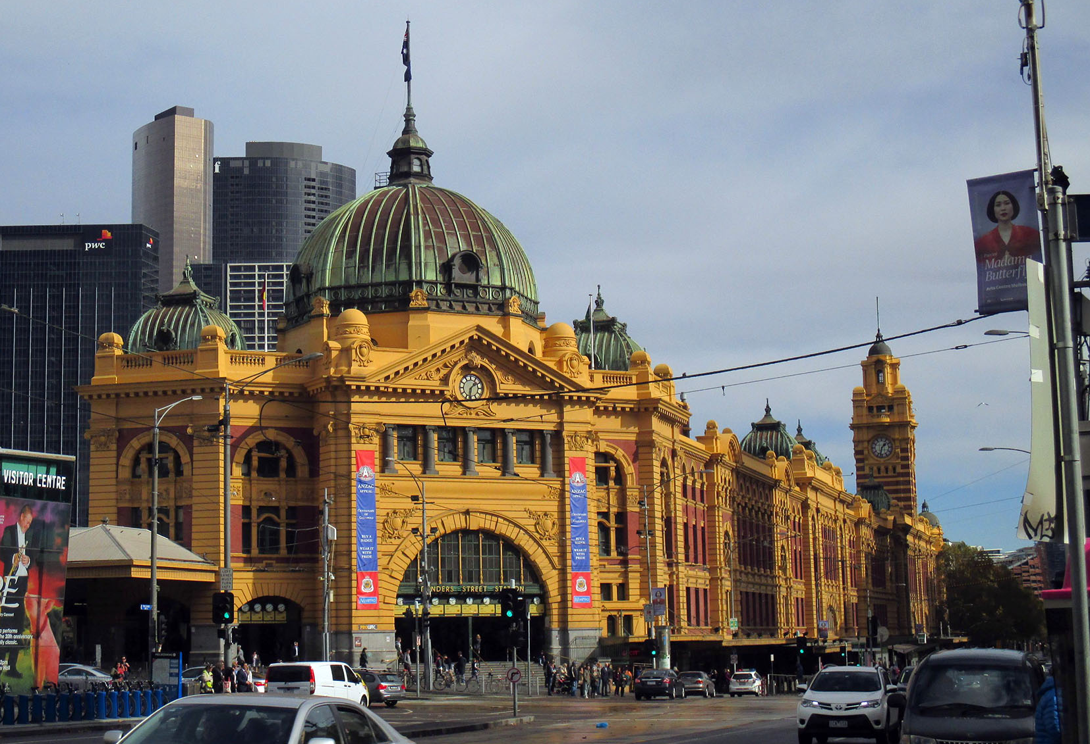
An additional impact would be the relocation of the Burke and Wills Monument, which is located at the north-east corner of Collins Street and Swanston Street. The monument is considered to be of a high level of significance, likely at a State level. Designed and created by sculptor Charles Summers, it was unveiled on 21 April 1865 and commemorates the famous expedition into the Australian interior. It was originally located on the corner of Collins and Russell Streets and has been relocated a number of times since. The monument and its heritage value would not be adversely impacted by Melbourne Metro. It may need to be removed prior to construction and reinstated post-completion in a suitable location. In this case, subject to the relocation works being undertaken to accepted conservation standards (with reference to the Burra Charter) and appropriate location being confirmed with the City of Melbourne, there would be no adverse impact. If the monument is retained in situ during construction, appropriate protection measures would be implemented.
The carriageway of the former warehouse at 222–224 Flinders Street (Dangerfield building) is proposed to be used as a pedestrian accessway to Flinders Street from the proposed new CBD South station. This is a building of significance in the precinct as early surviving bluestone warehouse, contemporary with the first stage of development of Young and Jackson Hotel to its east. The use of the carriageway (currently closed off to the public) would be consistent with the heritage values of the building and could enhance an understanding of its early form and use.

Historical Archaeology
The CBD South station precinct is considered to be an area of very high historical archaeological potential. There are 45 Victorian Heritage Inventory sites within the CBD South station precinct. 37 of these are unlikely to be impacted due to the nature and depth of the proposed works in the area. Of the remaining eight, five would require removal to allow for the station entrance and construction work site in Swanston Street and Flinders Street (see Figure ‎14-22). These are:
- VHI H7822-1904 – located at 9-11 Swanston Street
- VHI H7822-1905 – located at 13 Swanston Street
- VHI H7822-1906 – located at 15-19 Swanston Street
- VHI H7822-1907 – located at 21-25 Swanston Street
- VHI H7822-1908 – located at 27-41 Swanston Street/221-235 Flinders Lane (part – 27 Swanston Street only).
Another two sites would be affected if the option for a station entry at 65–73 Swanston Street was adopted. These are:
- VHI 7822-1811 – located at 65 Swanston Street
- VHI 7822-1812 – located at 67-73 Swanston Street.
Whilst not being completely destroyed, the following site would be partially disturbed through excavation for the pedestrian link under Flinders Street into the Flinders Street Station:
- VHI H7822-1959 – Flinders Street, near Batman’s Hill to Exhibition Street.
Figure ‎14-22 Victorian Heritage Inventory sites at the CBD South station precinct
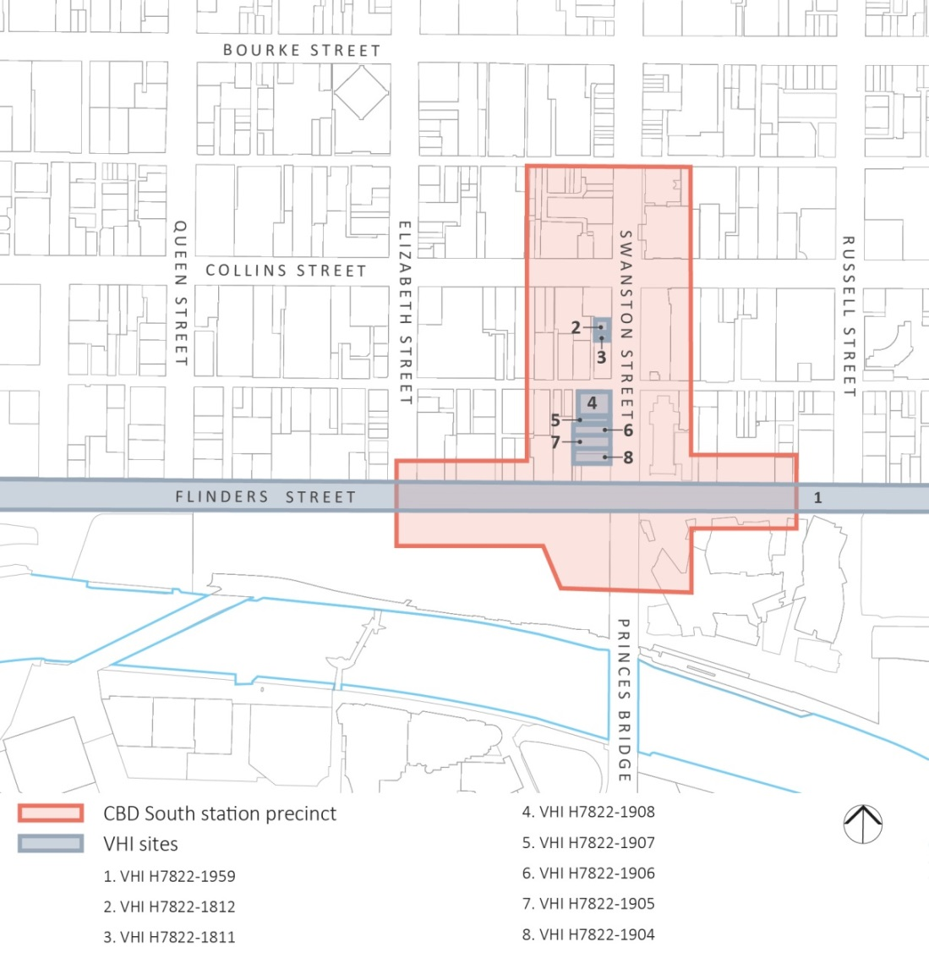

The Swanston Street sites (VHI H7822-1904 - H7822-1908 and VHI 7822-1811 – H1812) cover an area that has a history of commercial and retail occupation dating from the 1850s. While the archaeological potential would vary across the sites, there is potential for archaeological remains from the mid-late nineteenth and early twentieth centuries to exist in these locations.
The Flinders Street site (VHI H7822-1959) is situated in an area that has the potential to contain archaeological remains from the early post-contact period prior to the Hoddle Grid current street layout. While a range of potential historical structures are indicated along the entire length of Flinders Street, those of particular relevance to the proposed works area include two buildings near the corner of Swanston Street, significant services (such as hydraulics and water) and other peripheral undocumented structures such as privies and pits. While road and tram construction may have damaged or destroyed earlier evidence, there would be the potential for archaeological remains dating to the earliest phases in the post-contact development of Melbourne.
Archaeological remains found throughout the eight Victorian Heritage Inventory sites would likely provide information on the initial post-contact settlement and of the evolution and alteration of the city through known historic phases of settlement, expansion, rapid growth, urbanisation, and other activity. In order to mitigate the loss of the historic value of the sites, archaeological management plans would be prepared to detail the archaeological investigation of the three locations within the CBD South station precinct. The archaeological management plans would be prepared in accordance with Guidelines for Investigating Historical Archaeological Artefacts and Sites (Heritage Victoria 2014) and in consultation with Heritage Victoria.

Precinct 7: Domain Station

Issues and Potential Impacts
Historical cultural heritage impacts related to the Domain station precinct would occur at:
- Albert Road Reserve as a result of construction of the proposed station and the use of Domain as a TBM launch site
- Edmund Herring Oval as a result of establishment of a construction work site
- St Kilda Road as a result of construction of the station box and changes to road functional layouts
Figure ‎14-23 Key heritage places at the Domain station precinct
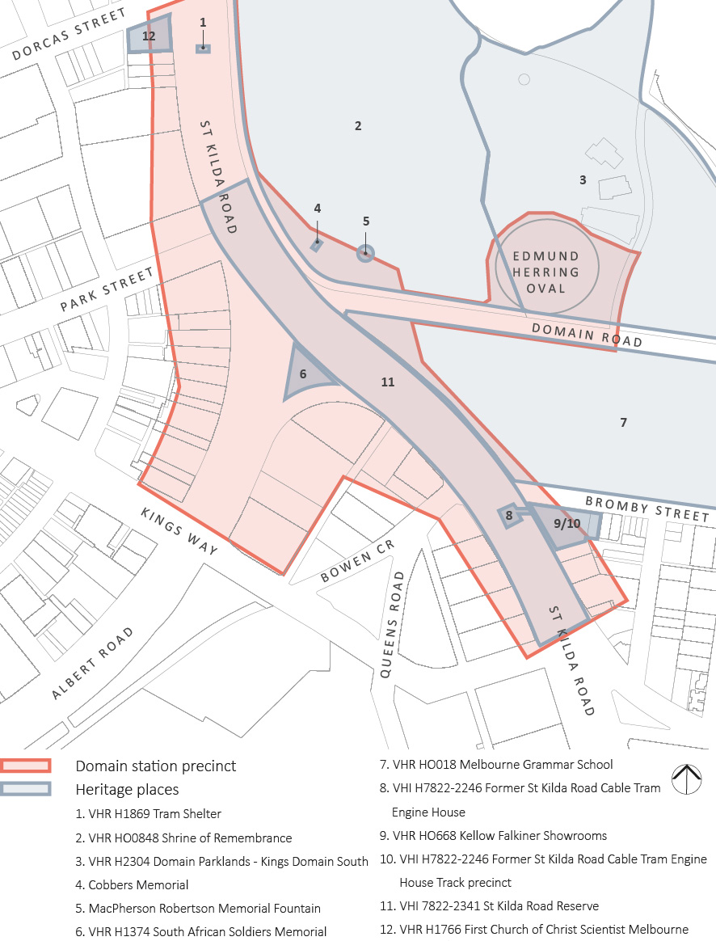
Note: While there are a number of heritage places within the Domain station precinct, they would not all be impacted by Melbourne Metro.
These works would interact with the following heritage places (see Figure ‎14-23):
- Domain Parklands (VHR H2304 and HO398 of the Melbourne Planning Scheme) – located in Kings Domain South, and taking in the Edmund Herring Oval north of Domain Road and east of the Shrine of Remembrance (in addition to the area discussed in Section ‎14.8). The existing physical features of Edmund Herring Oval, including the oval, are not of heritage significance, though its use by Melbourne Boys Grammar since 1919 for organised sport has been assessed as of social significance as part of the heritage value of the Domain Parklands. Construction of the proposed Domain station would have a major, but temporary, physical impact on Edmund Herring Oval, which would be occupied by a proposed construction work site. While the use of the oval would be interrupted for the period of construction, this would be temporary and its use would be reinstated at the completion of the works. As such, the historical and social significance of the site would be undiminished. The only elements of heritage significance affected by the works would be the removal of two elm trees identified to be of contributory significance. These are located within the southern boundary plantation and are within the extent of registration of the Shrine of Remembrance (see Figure ‎14-24).
Figure ‎14-24 Detail showing Edmund Herring Oval extending into the Shrine Reserve
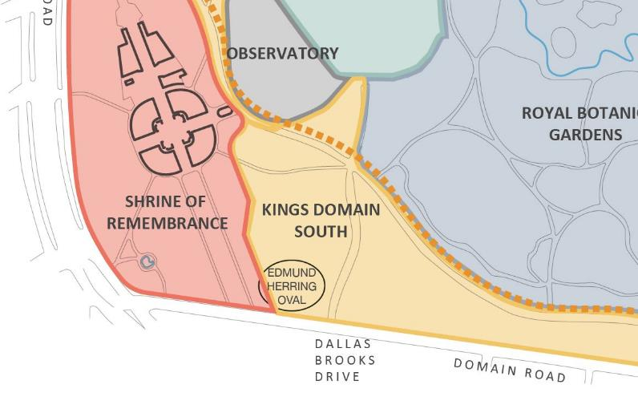

- Shrine of Remembrance (VHR H0848 and HO489 of the Melbourne Planning Scheme) – located at 2-42 Domain Road, Melbourne (see Figure ‎14-27). The historical place of the Shrine of Remembrance incorporates the full extent of the Shrine Reserve. It was constructed in 1934 and is Victoria’s principal war memorial. The building is of great historical, symbolic and cultural significance to the State of Victoria. The Shrine Reserve accommodates statuary and a symmetrical layout of paths and approaches of historical and aesthetic value. Many trees in the area are dedicated to specific squadrons, divisions, service corps, field units, and battalions. The construction impacts of Melbourne Metro are limited to works in the south-western corner of the reserve where a permanent station entrance is proposed to be located and some limited impacts on the Domain Road frontage for access to Edmund Herring Oval during construction (referenced above). These works would likely include the removal of a small number of trees, a construction work site for the proposed new entry in proximity to the Cobbers Memorial and the Macpherson Robertson Memorial Fountain, minor impacts to paths and roadways, and permanent changes to the presentation of the site as a result of the station entrance.
There would be no impact on the core heritage values and no significant impacts on the presentation of the Shrine of Remembrance or the Shrine Reserve more broadly as a result of the works. There would be localised impacts including changes to the visual character of the area for a period of time. For example, there may be an impact on the Cobbers Memorial: the proposed establishment of the construction work site in proximity could have an impact on the commemorative purpose and enjoyment of this memorial for a period of time and may even require the temporary removal of the memorial. However, this would be a temporary impact and the memorial could be reinstated or relocated elsewhere on the Reserve without adversely impacting on the heritage values of the Shrine. The tree removals in this location would also only be a temporary impact. The majority of trees proposed to be removed are juvenile specimens and new trees would be planted following works. Paths and roadways would be reinstated where affected.
Figure ‎14-25 The Shrine of Remembrance viewed from the north-west on the WWII forecourt
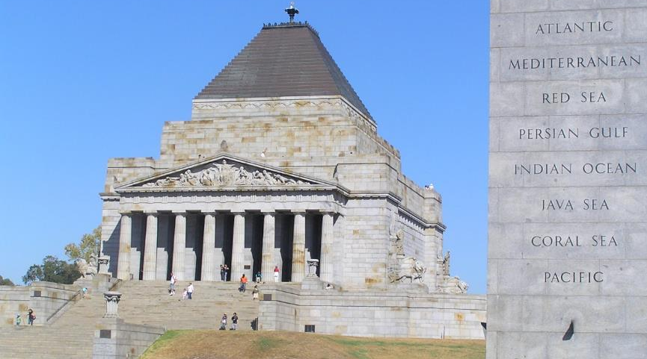
The key heritage issue is that of the introduction of the station entry at the edge of the Shrine Reserve. Assuming care in siting and detailed design, including materiality, to achieve a low-key presentation in this location, the entry would not impact on the significance or detract from an appreciation of the Shrine of Remembrance. It would have no impact on the historical associations and meanings of the place, nor on its commemorative and social values. The entrance would alter the presentation of the place in this location, but the change would be a relatively modest one (subject to sensitive and responsive detailed design). This is based largely on the fact that the entry is located at an edge of the reserve and away from the key views. Good separation would need to be achieved from the significant McRobertson Memorial Fountain, which is located close by, to avoid impacts on the setting of that element.
- South African Soldiers Memorial (VHR H1374 and HO12 of the Port Phillip Planning Scheme) – located at 29A Albert Road, South Melbourne. Originally completed in 1924, it comprises a grey granite obelisk set on a podium. Four sculpted sandstone lions were added in 1952. The memorial is significant for historical, social and aesthetic reasons. It is an important Victorian war memorial, and is strongly associated with the Boer War and the rise in nationalism and patriotism in the early twentieth century. The site also incorporates mature trees including perimeter planting and the Windsor Oak, a commemorative plaque (formerly marking a Queensland Fire Wheel Tree) and a drinking fountain. The latter pre-dates the memorial and is part of a larger collection of such fountains found in the City of Melbourne and the City of Port Phillip. Construction of the proposed Domain station would require the area to be cleared for the duration of the construction period including the removal of all existing trees, the memorial itself, the historic drinking fountain, and the hard and soft landscaping. There would be no additional impacts if the site were to be used for the TBM launch.
Following construction, the memorial is proposed to be reinstated on the site but in a different location, altering the presentation of the memorial and potentially reducing its prominence. The key impact to the memorial would be the potential diminishment of its aesthetic qualities. The focus in detailed design should be on achieving a siting that allows sufficient space around the monument for it to retain a level of prominence and retain a dignified character consistent with both its design and its commemorative purpose. The Concept Design for the re-siting of the memorial to the west of the station box with stairs and platforms immediately to its east appears to be an unsatisfactory outcome which compromises the setting of the structure. While a restoration to the western apex of the site may be an acceptable outcome, this needs to deliver the memorial with an appropriate open space in the extensive foreground and generous open axial viewing, which is not crowded out by maturing vegetation. The station design should be reviewed and alternatives considered to achieve an appropriate setting for the memorial on this site. It is considered this would be achieved through further design work.

Figure ‎14-26 The South African Soldiers Memorial viewed from the south (from Albert Road)
- Tram Shelter (VHR H1869 and HO460 of the Port Phillip Planning Scheme) – located at the corner of St Kilda Road and Dorcas Street (approximately 50m to the north). The tram shelter dates from 1917 and is one of a small number of timber shelters constructed in Melbourne between 1912 and 1927. It is of historical and architectural significance for its association with Melbourne’s cable tram network. Depending on the nature of works undertaken in proximity to this structure, it may be required to be relocated and stored during construction and reinstated in the same location following the completion of the works. Providing the work is documented and undertaken in accordance with accepted conservation standards (with reference to the Burra Charter), this would not have an adverse impact on the heritage values of the shelter.
- St Kilda Road (HO5 in the Melbourne Planning Scheme, part only) – located along St Kilda Road, extending from Princes Bridge in the north to St Kilda junction in the south. While not currently subject to heritage controls to its full extent, St Kilda Road has been identified as a place of historic cultural heritage significance, potentially at a State level. It is of historical and aesthetic significance as it demonstrates early traffic planning through the picturesque boulevard with consistent avenues of mature elm and plane trees separating traffic lanes. It was also the preferred location of many important public institutions from the 1850s and is a focus for ceremonial and other public activities including royal and vice-regal processions and political protests. St Kilda Road has been nominated to the Victorian Heritage Register.
Construction of the proposed Domain station would require full clearance of a defined area including extensive tree removal for the establishment of the construction work site and station box and removal of the existing tram stop and other infrastructure. There would also be an impact resulting from permanent infrastructure associated with the station within the roadway and from the two proposed new tram stops south of Domain Road and associated changes to road functional layouts.
These activities and the permanent infrastructure would not impact on the historic significance of this part of St Kilda Road but would impact on the aesthetic qualities. The impact can be managed in this location – on the basis that tree reinstatement and retention of the boulevard form to the greatest extent possible would be undertaken following construction. The affected area of St Kilda Road would be limited when considered in the context of the full length of the road. Of relevance, this section of St Kilda Road already has a somewhat different and more open character when compared with other sections of the boulevard, incorporating a sweeping curve in the road and the angled intersections with Domain Road to the east and Albert Road to the west. It is also an area that has had significant tram infrastructure, including junctions between different routes and the Domain Road tram interchange. It is also noted that as part of the works, the removal of the tram interchange between the Domain Road and Park Street intersections provides an opportunity to re-establish trees in an existing gap within the boulevard.
Given the extent and location of the works, the impact is one that can be accommodated without any adverse impact on the heritage values of the broader extent of St Kilda Road. While the impact would be significant in the short term, it could be mitigated through reinstatement of trees. Detailed design would need to include optimising opportunities to re-establish the boulevard character of St Kilda Road.
An old ‘bundy clock’ (not subject to any heritage controls) within the existing tram interchange should preferably be salvaged and retained onsite or relocated to an alternative site.

Historical Archaeology
The Domain station precinct is considered to be an area of some historical archaeological potential. There are three Victorian Heritage Inventory sites within the Domain station precinct. The following site would require complete removal as a result of the cut and cover construction technique:
- VHI H7822-2220 Former St Kilda Road Cable Tram Engine House Track Precinct – located at the intersection of St Kilda Road and Bromby Street, Melbourne.
The following sites have the potential to be partially disturbed as a result of the establishment of the construction work site:
- VHI H7822-2246 Former St Kilda Road Cable Tram Engine House – located at 375–385 St Kilda Road, Melbourne.
Both the tramways sites have the potential to contain significant nineteenth century archaeological remains such as double tram tracks, wood blocked and/or stone setts paving, deep concrete cable tunnels centred under each track, inspection manholes and cast iron covers, large brick pits for the historical sheaves and possibly traces of equipment. The remains in the Track Precinct and associated Engine House are significant as they have the potential to provide information on how Melbourne’s cable tram system operated.
In addition to these sites, there is also the potential for evidence of earlier road treatments within the St Kilda Road reserve. This potential was identified as part of the predictive archaeological assessment and the site was added to the Victorian Heritage Inventory:
- H7822-2341 St Kilda Road Reserve.
As one of the early major thoroughfares in Melbourne and the early construction of cable tramways, St Kilda Road is of historical significance. The presence of evidence of early road and tram infrastructure has the potential to provide information about the technology, construction and operation of the cable tramway, and of early road construction.
In order to mitigate the loss or disturbance of the Victorian Heritage Inventory sites, archaeological management plans would be prepared to detail the archaeological investigation of the area. The archaeological management plan would be prepared in accordance with Guidelines for Investigating Historical Archaeological Artefacts and Sites (Heritage Victoria 2014) and in consultation with Heritage Victoria.

Precinct 8: Eastern Portal (South Yarra)

Issues and Potential Impacts
Historical cultural heritage impacts related to the eastern portal precinct would occur at:
- Osborne Street Reserve as a result of construction of the ventilation shaft and TBM retrieval
- South Yarra Siding Reserve as a result of the eastern portal construction works site
- Osborne Street Reserve and the South Yarra Siding Reserve as a result of the construction of a new bridge
- Lovers Walk as a result of widening the existing rail corridor.
Figure ‎14-27 Key heritage places at the eastern portal precinct
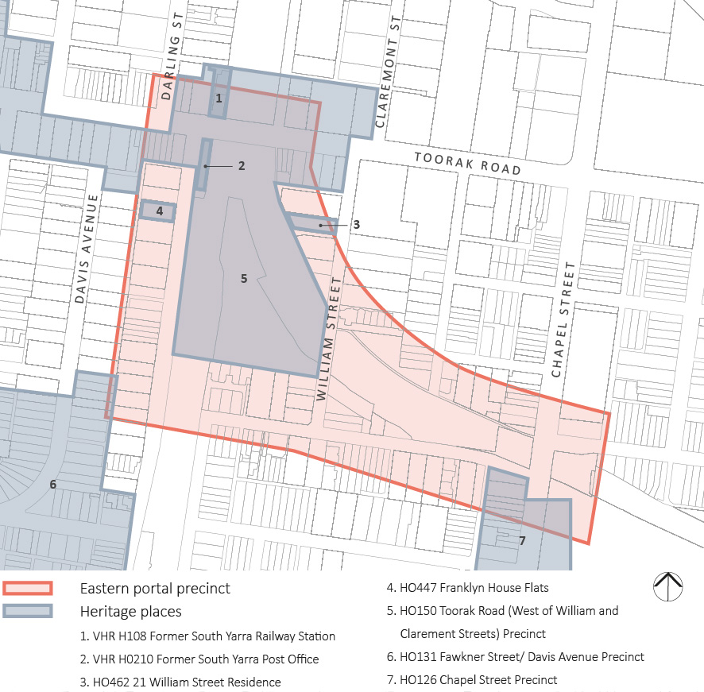
Note: While there are a number of heritage places within the eastern portal precinct, they would not all be impacted by Melbourne Metro.
These works would interact with a Heritage Overlay precinct (see Figure ‎14-27):
- Toorak Road (west of William and Claremont Streets) Precinct (HO150 of the Stonnington Planning Scheme) – extends from Punt Road in the west to the South Yarra rail cutting. Its historical significance lies in the relationship between the railway and the development of Toorak Road, demonstrating the development of South Yarra and the adjacent part of Toorak Road, and reflecting the expansion of the railway network in the latter part of the nineteenth century. In this context, the arrangement of cuttings and rail lines and Lovers Walk is part of the heritage fabric. The construction of the proposed eastern portal would require significant excavation works in the Osborne Street and the South Yarra Siding Reserves and the closure and subsequent reinstatement of Lovers Walk. A new bridge is proposed to link the Osborne Street Reserve with the South Yarra Siding Reserve (see Figure ‎14-28). These works would have no adverse impacts on the values and presentation of the Toorak Road Precinct. The works would change the appearance of the cutting and siding reserve, but would not affect the understanding and interpretation of the association between the railway and the balance of the Toorak Road Precinct. The reinstatement of Lovers Walk would also mitigate any permanent impacts. To the extent that there may be social heritage values associated with this pedestrian access, these would not be affected in the longer term.
Figure ‎14-28 South Yarra Siding Reserve, looking back toward William Street and the William Street bridge
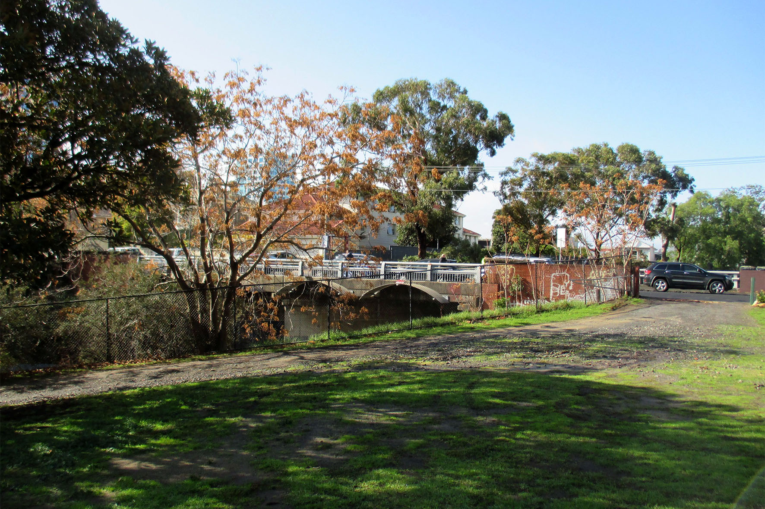

Historical Archaeology
The predictive archaeological modelling has found that there is only limited potential for historical archaeology to be present within the eastern portal precinct. The project-wide protocols would apply in the event that any unknown site or relics are uncovered in the course of works.

Precinct 9: Western Turnback (West Footscray)

Issues and Potential Impacts
Historical cultural heritage impacts related to the western turnback precinct could occur at Cross Street Substation as a result of establishment of a construction work site.
Figure ‎14-29 Key heritage places at the western turnback precinct
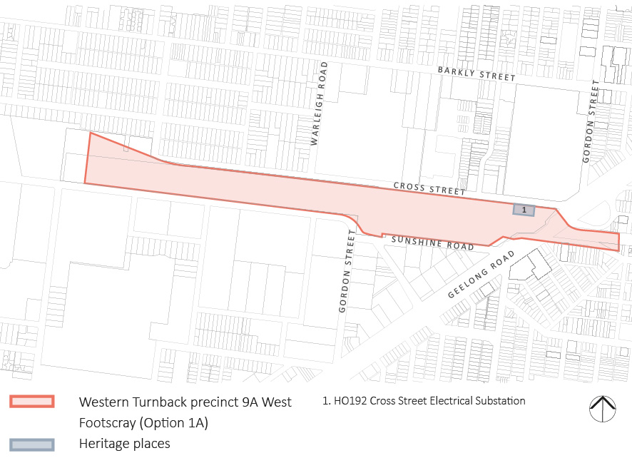
These works would interact with the following heritage place (see Figure ‎14-29):
- Cross Street Electrical Substation (HO192 of the Maribyrnong Planning Scheme) – located on part of the land known as Allotment 9, Section 13 in the Parish of Cut-Paw-Paw (Cross Street, Footscray) (see Figure ‎14-30). Constructed in 1937, the substation has been assessed for historical, technical and architectural reasons, including in a State context. It is related to a major historical theme of municipal provision of electricity and can be related historically to the expansion of the area in the interwar period and also to the widespread take-up of the use of electrical power in this period. It is also significant as a work of the architect Joseph Plottel and as an example of the Moderne style as applied to a utilitarian structure.
While the construction site includes the substation, demolition of the heritage place is not proposed. Land surrounding the structure would be occupied for construction purposes and it is recommended that measures be put in place to protect the heritage building.
Construction and operation of the proposed works and infrastructure at the western turnback precinct would otherwise have no heritage impact. While there are a number of heritage places in the surrounding area, none would interact with or be affected by Melbourne Metro.
Figure ‎14-30 Cross Street Electrical Substation (HO192) viewed from the north-west: the brick substation is at left with the concrete walls to the switching yard at right
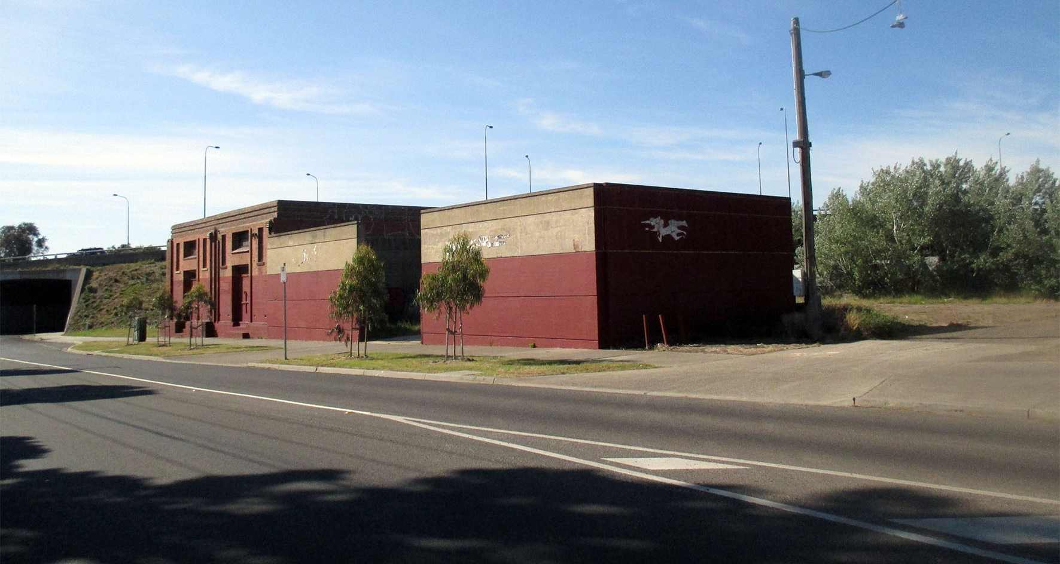

Historical Archaeology
The predictive archaeological modelling has found that there is only limited potential for historical archaeology to be present within the western turnback precinct. The project-wide protocols would apply in the event that any unknown site or relics are uncovered in the course of works.

Early Works

Issues and Potential Impacts
Early works seek to modify existing services relating to water, sewerage, drainage, power, telecommunications and tramways. Their impacts are largely archaeological (see below) with some non-archaeological impacts
Tram diversion works at St Kilda Road and Toorak Road West would require the removal of two additional elms from the St Kilda Road boulevard plantings (no statutory control applies). This would be additional to the tree removals for the TBM launch, construction work site and road functional layout.
There is the potential for early works to intersect with other (non-archaeological) heritage places through sub-surface services works. Where this occurs, non-destructive excavation measures would be used to ensure no impact on these places, including trees within heritage places.

Historical Archaeology
The implementation of early works activities would require subsurface excavation in a number of precincts. These works would likely intersect with VHI sites (particularly in the central city), though the extent and nature of the impact has yet to be determined. Refer to the discussion at Section 16, Early Works in Technical Appendix J.
Four Victorian Heritage Inventory sites that would be affected are located in major roadways:
- VHI H7822-1959 – Flinders Street (near Batman’s Hill to Exhibition Street). This may also be damaged by the proposed CBD South station works
- VHI H7822-1960 – Collins Street
- VHI H7822-1966 – Swanston Street
- VHI H7822-2341 – St Kilda Road reserve.
Archaeological remains found throughout these sites could provide information on the initial post-contact settlement and of the evolution and alteration of the city through known historic phases of settlement, expansion, rapid growth, urbanisation, and other activity. Archaeological management plans would be prepared to detail the archaeological investigation of the areas affected by works; these would be prepared in accordance with Guidelines for Investigating Historical Archaeological Artefacts and Sites (Heritage Victoria 2014) and in consultation with Heritage Victoria.

Environmental Performance Requirements
Table ‎14–3 shows the recommended Environmental Performance Requirements and the proposed mitigation measures for Melbourne Metro in relation to historical cultural heritage impacts.
The risk numbers listed in the final column align with the list of historical risks provided in Technical Appendix B Environmental Risk Assessment Report.
Note that in the case of the Victoria Barracks, the Commonwealth Minister for the Environment determined on 22 September 2015 that Melbourne Metro is ‘not a controlled action if undertaken in a particular manner’. The prescribed manner is as follows:
The following measures must be taken into avoid significant impacts on:
Commonwealth land (Sections 26 and 27A)
- To mitigate potential impacts to Commonwealth land, the person taking the action must implement the following vibration monitoring and measuring approach:
  - Conduct preconstruction dilapidation surveys of the nearest Commonwealth Heritage listed structures to the proposed action, including the Former Guardhouse (B Block), to record structural condition and structural integrity prior to commencement of tunnelling
  - Conduct preconstruction dilapidation surveys of the nearest Commonwealth Heritage listed structures to the proposed action, including the Former Guardhouse (B Block), to record structural condition and structural integrity prior to commencement of tunnelling
  - Conduct vibration monitoring at the commencement of tunnelling in geological conditions that are similar to those at Victoria Barracks in order to quantify the actual tunnel boring machine vibration characteristics (level and frequency) for comparison to the values derived from the literature and the German DIN target
  - Conduct continuous vibration monitoring at the nearest Victoria Barracks heritage structures to the proposed action, including the Former Guardhouse (B Block), to assess the actual tunnelling vibrations for acceptability, taking into account both the vibration frequency and condition of structures, until monitoring of vibration at the Former Guardhouse (B Block) shows measurements equivalent to preconstruction vibration readings at the Former Guardhouse (B Block)
  - If monitoring conducted according to Particular Manner C demonstrates the condition of heritage structures may be degraded as a result of vibration, ground vibration must be reduced by adjusting the advance rate of the tunnel boring machine until monitoring of vibration at the Former Guardhouse (B Block) shows consistent measurements equivalent to preconstruction vibration readings at the Former Guardhouse (B Block).
Chapter 13 Noise and Vibration recommends an Environmental Performance Requirement that requires compliance with the ‘particular manner’ requirements.

Table ‎14–3 Environmental Performance Requirements for historical cultural heritage
Draft EES Evaluation Objective | Environmental Performance Requirements | Proposed mitigation measures | Precinct | Timing | Risk No.
Cultural heritage  - To avoid or minimise adverse effects on Aboriginal and historic cultural heritage values | Design permanent and temporary works to avoid or minimise impacts on the cultural heritage values of heritage places.  Consult as required with Heritage Victoria and/or the responsible authority (as applicable). | In detailed design for permanent and temporary works including construction activities, review the impact assessment in this report, obtain specialist heritage advice and consult with Heritage Victoria and/or the responsible authority where applicable | All | Detail design | All
 | To avoid or minimise impacts on the cultural heritage values of heritage places:  - Perform works in accordance with the following noise and vibration and ground movement Environmental Performance Requirements as related to heritage places: NV2, NV5, NV6, NV11, GM2, GM4, GM5, GM6  - Undertake condition assessments of heritage places prior to commencement of construction where located within the identified vibration and ground settlement zones of sensitivity and monitor as per NV6, GM4 and GM5.  Should damage occur to a building or structure on the Victorian Heritage Register or that is subject to a Heritage Overlay’ as a result of works, undertake rectification works in accordance with accepted conservation practice (with reference to the Australia ICOMOS Burra Charter 2013) to the satisfaction of Heritage Victoria or the responsible authority, as applicable. | Should construction vibration be determined to be a risk to a heritage place mitigation measures may include, as relevant, use of alternative construction equipment/construction methodology as identified in the Noise and Vibration (Technical Appendix I)  Should ground movement be determined to be a risk to a heritage place mitigation measures may include, as relevant, permeation grouting, underpinning and structural strengthening or other techniques as identified in the Ground Movement Impact Assessment (Technical Appendix P)  See Section 6.2 | All | Prior to and during construction | HH03
 | Prior to construction undertake archival photographic recording in accordance with Heritage Victoria Technical Note: Photographic Recording for Heritage Places and Objects where heritage places are to be demolished or modified. | Lodge copies of archival photographic records with the State Library of Victoria and other suitable local repositories as appropriate for each affected heritage place  Archival photography may also be used to support site interpretation | All | Prior to construction commencing | HH04, HH05, HH06, HH07, HH08, HH09, HH10, HH13, HH14, HH15, HH16, HH22, HH23, HH26, HH27, HH28, HH29, HH32
 | Prior to construction of main works or shafts that affect heritage structures or places, develop detailed methodology in accordance with Australia ICOMOS Burra Charter and to the satisfaction of Heritage Victoria or the responsible authority (as applicable) where heritage fabric is required to be dismantled, stored and reconstructed. Work is to be documented and overseen by an appropriately qualified conservation practitioner. | Where dismantling and reconstruction works are required document and perform these works with specialist input (this would likely include an assessment of condition, detailed methodology for the work, recording of the structure prior to dismantling, dismantling methodology, the numbering of component parts for storage, specification of secure storage arrangements, details of required repair and conservation works, if required, and method for reinstating fabric including appropriate materials in the event fabric is required to be renewed or replaced) | 1 – Tunnels  3 – Arden station  6 – CBD South station  7 – Domain station | Prior to construction, reinstatement at an appropriate time during or after the main construction works | HH04, HH17, HH19, HH23, HH25, HH27, HH31
 | Prior to construction of main works or shafts that affect heritage structures or places, develop and implement appropriate protection measures for heritage places and objects including sculptures, memorials, monuments and associated heritage fabric where retained in proximity to works. This is to be done to the satisfaction of Heritage Victoria or the responsible authority (as applicable). | Physical protection works to be designed as part of construction management plan  Risk assessment to be undertaken for all heritage places in proximity to works | All | Prior to construction commencing | HH04, HH05, HH18, HH25, HH26, HH29, HH31
 | To the satisfaction of Heritage Victoria:  - Develop archaeological management plans to manage disturbance of archaeological sites and values affected by the project  - Undertake investigation in accordance with the Guidelines for Investigating Historical Archaeological Artefacts and Sites, Heritage Victoria 2014 (as amended or updated) and to the satisfaction of the Executive Director, Heritage Victoria.  Develop and implement a protocol for managing previously unidentified historical archaeological sites discovered during project works. | For any archaeological sites or artefacts revealed or discovered during construction, the following measures would be implemented:  - Stop any activity which may impact on the discovery  - Ensure that other people working in the area are aware of it and have also stopped work in the area  - Protect the artefact, or site feature(s) by, for example, erecting temporary fencing or other suitable enclosure  - Consult with a qualified cultural heritage consultant to determine the appropriate course of action  - Advise Heritage Victoria where the discovery was made and provide a description or photograph of the discovery  - Determine how to manage the find through consultation with Heritage Victoria and the heritage consultant  - Obtain the necessary consent under the Heritage Act 1995 or other necessary approvals to protect, recover or remove the find  Archaeological management may require a combination of testing, excavation, salvage and monitoring and related reporting | All | Pre-construction | HH01, HH02
The archaeological management plan will include the following:
- Description and background history of Archaeological Area
- Statement of significance of Archaeological Area, in accordance with Guidelines for Conducting Historical Archaeological Surveys (Heritage Council of Victoria and Heritage Victoria 2008), Criteria for Assessing Cultural Heritage Significance (Heritage Council of Victoria 2008) and Victoria’s Framework of Historical Themes (Heritage Council of Victoria 2010)
- Research design, including research questions which will be addressed as a result of any archaeological investigations
- Excavation methodology, including method to be used to excavate deposits, record spatial and stratigraphic information and recover artefacts and how these will help address the research design
- Artefact retention policy, including how and why individual artefacts and types of artefact will be retained, discarded or sampled during the archaeological investigation
- Artefact management proposal, including details of how recovered artefacts will be managed in the field and post-excavation (including materials conservation if required)
 | To the satisfaction of Heritage Victoria and the responsible authority, develop and implement a heritage interpretation strategy as part of detailed design as a whole which seeks to explore historical and Aboriginal cultural heritage themes. This must include but not be limited to the exploration of opportunities for interpretation at Arden station (referencing the use of this land for railways workshops and sidings), and at CBD South station (referencing the Port Phillip Arcade and the early Port Phillip Club Hotel). | Site interpretation at different locations would take a wide range of forms, from conventional plaques, panels and markers to installations and interactive digital presentations and online resources. Structural elements, reclaimed materials, salvaged artefacts and commissioned artworks are other options. Choices are informed by the use of the place, audience expectations, physical constraints and other place-specific considerations. Explore opportunities for oral and community history sources  To be developed in consultation with relevant stakeholders and with reference to any conservation management plans or other policy documents | All | Design/ Construction | Specific risks include HH13 and HH23 but the opportunities apply across the project.
 | To the satisfaction of Heritage Victoria and the responsible authority (as applicable) undertake all underground service works beneath or within heritage places or tree protection zones (TPZs) for trees as part of heritage places to avoid, minimise and mitigate impacts to the heritage fabric. | Obtain specialist arboriculture / heritage advice on works methodology to ensure significant fabric is protected  Subsurface works to take place non-destructively and at depths consistent with the protection and preservation of heritage fabric and tree roots including at depths nominated in the City of Melbourne Tree Protection Fact Sheet, or utilising preliminary non-destructive excavation, to determine the location of existing roots | All | Construction | HH33, HH34
 | To the satisfaction of Heritage Victoria and the responsible authority (as applicable), ensure new development is responsive to heritage places in terms of height, massing, form, façade articulation and materials. | Design of new works within and in proximity to heritage places to be developed with specialist heritage advice and with reference to relevant planning scheme policies and conservation management plans as applicable, and consistent with the Urban Design Strategy | All | Detailed design | HH05, HH06, HH08, HH18, HH20, HH21, HH22, HH24, HH26, HH27,
 | To the satisfaction of the responsible authority, ensure no direct impact on heritage buildings on the former Glueworks site in Kensington. | Protect heritage buildings from physical impacts, physical protection work to be designed as part of construction management plan | 2 – Western portal | Construction | HH12
 | To the satisfaction of the responsible authority, retain and protect Langford Street pumping station (part of proposed Moonee Ponds Creek and Infrastructure Precinct) as part of the design for the new substation. | Review siting of new substation to allow retention and protection of the heritage building in situ  Protect heritage building from physical impacts, physical protection work to be designed as part of construction management plan | 3 – Arden station | Detailed design | HH14
 | To the satisfaction of Heritage Victoria and the responsible authority, replace removed Elm trees in Royal Parade as part of project delivery using appropriate species and re-establish the boulevard formation.  Provide suitable soil conditions to facilitate the growth of new trees to reach the size of the existing mature trees in the boulevard. | The location of each tree proposed to be removed would need to be surveyed and photographed prior to removal. Replacement to be undertaken in consultation with the City of Melbourne  In detailed design further review road functional layout to minimise impact on the significant trees and optimise the opportunities for replanting | 4 – Parkville station | Construction | HH15, HH16
 | To the satisfaction of Heritage Victoria, in detailed design ensure the eastern Parkville station entry is set no less than 8–10 metres from the original Gatekeeper’s Cottage and an appropriate boundary treatment is retained or re-established for the heritage building. | The design should be developed consistent with the Urban Design Strategy and the referenced EPRs and with specialist heritage advice to achieve a sympathetic relationship with the heritage place | 4 – Parkville station | Detailed design | HH18
 | To the satisfaction of the responsible authority, in detailed design for the CBD South station, incorporate the Charles Bush sculpture into the design for the new building on the Port Phillip Arcade site, preferably in a prominent position on the Flinders Street façade. | The sculpture should be integrated into the architectural design and be the subject of active interpretation as part of a developed interpretation strategy for the site | 6 – CBD South station | Detailed design | HH23
 | In the event the permanent relocation of the Burke and Wills Monument from its current site is required, resolve the final location of the monument to the satisfaction of the appropriate responsible authority and/or in consultation with the City of Melbourne prior to the commencement of construction. | If relocation on this site or an alternative site is proposed the site should be appropriate to the status of the memorial and resolved with the City of Melbourne  If temporary relocation is required in order to protect significant fabric, document and undertake works according to accepted conservation standards  A detailed methodology for the recording, dismantling, storing and reconstruction of the statue would be required. This should include a condition assessment and specify active conservation and repair works, should these be required | 6 – CBD South station | Detailed design | HH25
 | Integrate the bluestone pillar and cast iron fencing at the corner of Grattan Street and Royal Parade into the design for the station entry and surrounds in consultation with the University of Melbourne. | Incorporate the feature into the design for the entry and preferably develop active site interpretation which references the historical boundary treatment to Parkville campus | 4 – Parkville station | Detailed design | HH19
 | Replace removed trees as part of project delivery in accordance with relevant policy documents and to re-establish valued landscape character and in consultation with the City of Melbourne, the City of Port Phillip, the Shrine of Remembrance and Shrine Trustees and Heritage Victoria as applicable. Policy documents are as follows:  - Domain Parklands: Domain Parklands CMP (in preparation, context, draft 2015–16) and the Domain Parklands Masterplan (in preparation)  - Shrine of Remembrance: Shrine of Remembrance CMP (Lovell Chen, 2010) or any future review and the Shrine of Remembrance Landscape Improvement Plan (rush Wright Associates, 2010)  - South African Soldiers Memorial Reserve: Any relevant CMP for the South African Soldiers Memorial  Fawkner Park: Fawkner Park Conservation Analysis (Hassell, 2002) and the Fawkner Park Masterplan (City of Melbourne, 2005). | Re-establishment of valued heritage landscape quality consistent with the heritage values of the affected place/s and in consultation with Heritage Victoria, the responsible authority, land managers and other stakeholders. Strategies would include the reinstatement of quality soils and volumes to support long-term viable growth of replacement trees, design of permanent infrastructure to support landscape reinstatement | 1 – Tunnels  7 – Domain station | Construction | HH04, HH05, HH06, HH07, HH08, HH09, HO27, HH29, HH30
 | To the satisfaction of Heritage Victoria, review the siting and design of the eastern Domain station entry in detailed design to ensure it is as recessive as possible in this location and has only a limited presence on the edge of the Reserve.  The design needs to allow for the maintenance of an appropriate setting to the Macpherson Robertson Memorial Fountain. | All affected paths and roadways and any soft landscaping to be reinstated to match existing  If required for construction purposes, the Cobbers Memorial is to be carefully dismantled and relocated or stored and reinstated in accordance with good practice and in consultation with the Shrine of Remembrance. The preference is to retain and protect in situ  In detailed design and with specialist heritage input, review the siting height, scale and materiality of the design to limit its visual presence within the Reserve. Review functional requirements as part of this work. Consider the use of the Tynong granite (traditional material in use at the Shrine) in the new design | 7 – Domain station | Detailed design | HH26
 | To the satisfaction of Heritage Victoria, review the siting and design of the western Domain station entry in detailed design to ensure the South African Soldiers Memorial has an appropriate landscaped setting if relocated on this site. If no appropriate setting can be established, consider options for relocation of the memorial to an alternative site. | Re-establish an appropriate siting and setting on this site in preference to relocation to alternative site, ensuring a level of prominence for the structure and design for the surrounding reserve that can appropriately cater for the ongoing commemorative use and enjoyment of the memorial  Consider the findings and recommendations of the CMP for the heritage place (City of Port Phillip) in detailed design, and obtain specialist heritage advice to inform the design process  If temporary relocation is required in order to protect significant fabric, document and undertake works according to accepted conservation standards  A detailed methodology for the recording, dismantling, storing and reconstruction of the memorial would be required | 7 – Domain station | Detailed design | HH27
 | To the satisfaction of the City of Melbourne, City of Port Phillip and/or the responsible authority, as applicable replace removed trees in St Kilda Road to re-stablish the boulevard formation. | With specialist arboricultural and heritage inputs, seek to reinstate boulevard character and ensure road functional layout and station design are responsive to this requirement, allowing for the replacement of trees and reinstatement of medians to the greatest extent possible | 7 – Domain station | Detailed design | HH28
 | Retain and protect the Cross Street Electrical Substation in situ within or abutting proposed construction site. | Ensure building is adequately protected during works through appropriate definition of works area and physical barriers as part of construction management plan | 9 – Western turnback | Construction | HH35
Refer also to the recommended Environmental Performance Requirements and proposed mitigation measures in relation to Chapter 13 (Noise and Vibration), Chapter 17 (Ground Settlement and Land Stability) and Arboriculture (see Chapter 16 Landscape Visual)

Conclusion
Melbourne Metro is generally consistent with the draft EES evaluation objective for Cultural Heritage as adverse effects on historic cultural heritage values would be avoided or minimised as far as is practicable. The heritage impacts are considered to be well managed, especially when considering the scale and complexity of the project, which extends through areas of very high heritage sensitivity (Parkville, CBD and South Yarra).
With the exception of potential construction vibration or ground settlement impacts, all non-archaeological impacts associated with the project would be localised to particular heritage places and sites. Impacts would occur at and around the portals, the stations and emergency access shafts. There would also be impacts associated with the construction process itself, including construction work sites and the TBM launch sites.
Some adverse heritage impacts would be likely to occur despite all mitigation measures. However, in most cases, these impacts would be relatively limited in their scope and severity, relating to the demolition of limited numbers of buildings of local heritage significance and to the alteration or other adverse impact on places of State significance. In the case of locally listed or recognised places to be demolished, there are a mix of individual sites and sites in larger Heritage Overlay precincts and the majority are relatively low in terms of their local study grading. Their demolition represents a loss but one that is localised and of limited scale. For the Victorian Heritage Register registered sites – Royal Parade, Flinders Street Station Complex, the South African Soldiers Memorial, the Shrine of Remembrance and the Domain Parklands – the impacts and issues vary. In all cases, further detailed design and planning work would occur directed at minimising the heritage impacts of the works.
In terms of historical archaeology, there would be significant impacts. A series of archaeological sites would be completely removed as part of the works and a number of others damaged. Despite this, management measures would mitigate these impacts through ensuring all sites would be recorded, adding to current knowledge of past practices and developments, particularly in the central city.
Ultimately, with implementation of the mitigation measures specified, the impacts of Melbourne Metro are not considered to be of such severity as to be considered unacceptable in heritage terms, particularly in the context of a project of this scale and importance.

