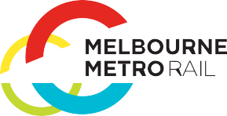
Melbourne Metro Rail Project
ENVIRONMENT EFFECTS STATEMENT
SUMMARY REPORT

Introduction
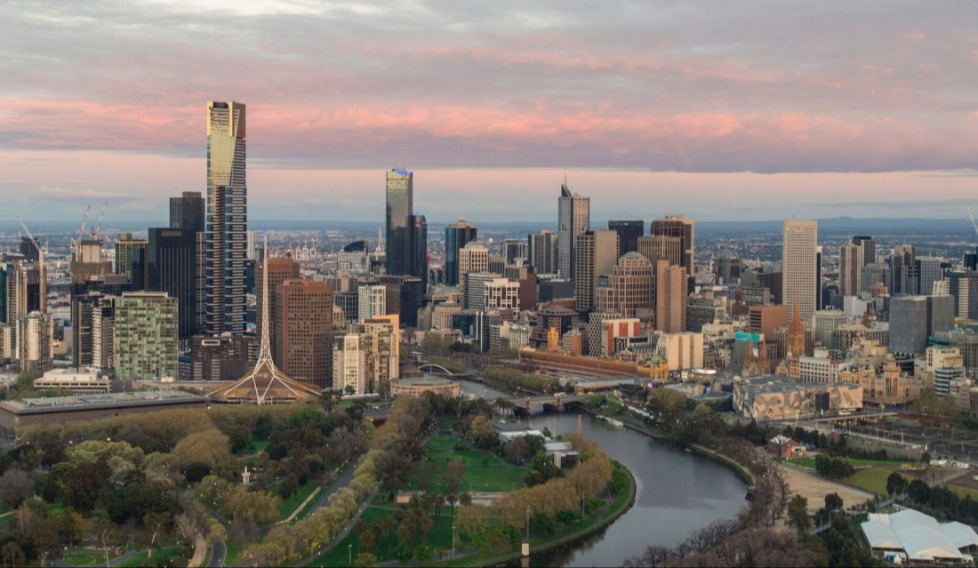
The Victorian Government is proposing to build the Melbourne Metro Rail Project to connect the Cranbourne/Pakenham Line to the Sunbury Line through the construction of new twin nine-kilometre rail tunnels and five new underground stations.
Melbourne Metro would facilitate the transformation of Melbourne’s rail network into an international-style metro system, boosting the capacity of the rail network to keep pace with Melbourne’s growing and changing travel needs as the city’s population grows to 6 million by 2031 and nearly 8 million by 2051 (DTPLI, Victoria in Future 2015).
Melbourne Metro would provide the foundation for expanding Melbourne’s public transport network, helping to ensure Melbourne remains one of the world’s most liveable cities now and into the future. Melbourne Metro would also catalyse significant urban renewal, opening up opportunities for new housing, commercial development and jobs close to the city centre.
In September 2015, the Minister for Planning determined that Melbourne Metro required assessment under the Environment Effects Act 1978.
The Environment Effects Statement (EES) for Melbourne Metro provides an assessment of the potential environmental, social and business impacts associated with the proposed construction and operation of the project.
The EES evaluates the potential effects of the project on a local and project-wide basis and recommends Environmental Performance Requirements that define the project-wide environmental outcomes that must be achieved during the design, construction and operation of Melbourne Metro to avoid, manage or mitigate these impacts.
Overall, the EES has concluded that achieving the outcomes set by the recommended Environmental Performance Requirements would ensure Melbourne Metro achieves acceptable environmental, social and economic outcomes.

Melbourne Metro Rail Project
Melbourne Metro would be one of the largest public infrastructure projects ever undertaken in Australia.

New Tunnels and Stations
The infrastructure proposed for construction and assessed in this EES includes:
- Twin nine-kilometre rail tunnels from Kensington to South Yarra, travelling beneath Swanston Street in the Melbourne CBD and connecting the Sunbury and Cranbourne/Pakenham railway lines
- Five new underground stations at Arden, Parkville, CBD North, CBD South and Domain, with CBD North and CBD South stations featuring direct interchanges with the existing Melbourne Central station and Flinders Street Station respectively
- A new transport interchange at Domain
- Rail tunnel portals (entrances) at Kensington and South Yarra.
The project would also require track work (a turnback) at West Footscray to enable trains using the Sunbury Line to turn around before reaching Sunbury and head back through the Melbourne Metro tunnels.

Reconfigured Rail Network
The new Melbourne Metro rail corridor would create a dedicated line from Sunbury in the city’s west to Cranbourne/Pakenham in the south-east. This line would be operated using the latest generation of High Capacity Metro Trains (HCMTs).
Creating a dedicated pathway through inner Melbourne for the Cranbourne/Pakenham and Sunbury Lines would provide capacity in the existing City Loop to increase services on five other lines: Werribee, Craigieburn, Upfield, Sandringham and Frankston.
Melbourne Metro would also create the opportunity to reconfigure the metropolitan rail network into a coordinated network of simple metro lines, with separate facilities and dedicated tracks for each line – removing unnecessary interactions between train services on different lines and enabling higher levels of reliability and greater capacity.
The project would help enable the reconfiguration of the current Northern Loop and Caulfield Loop Lines into four independent groups:
- Sunshine – Dandenong Line via Melbourne Metro – creates a new pathway through the inner core of the network for the Sunbury and Cranbourne/Pakenham Lines, connecting to new stations at Arden, Parkville, CBD North, CBD South and Domain and creating more capacity for new services
- Northern Loop Line – removes Sunbury services from the Northern Loop, freeing up capacity on the Northern Loop to operate additional services on the Upfield and Craigieburn Lines
- Frankston Loop Line – provides a dedicated pathway through the City Loop for Frankston services, providing additional capacity for growth and new services on the Frankston Line
- Cross-City Line – connects the Werribee Line with the Sandringham Line via North Melbourne, Southern Cross, Flinders Street, Richmond and South Yarra, enabling more services to run on this line.
Melbourne Metro would also release a track pair between South Yarra and Flinders Street (currently used by Cranbourne/Pakenham Line services) for use by V/Line and freight services, providing a staging area for these services to operate independently from suburban trains.
While other rail lines would remain unchanged by the project, Melbourne Metro would give passengers the opportunity to interchange easily in the CBD (via Melbourne Central station or Flinders Street Station) to the Sunshine – Dandenong Line for access to the new stations at Parkville, Domain and Arden.
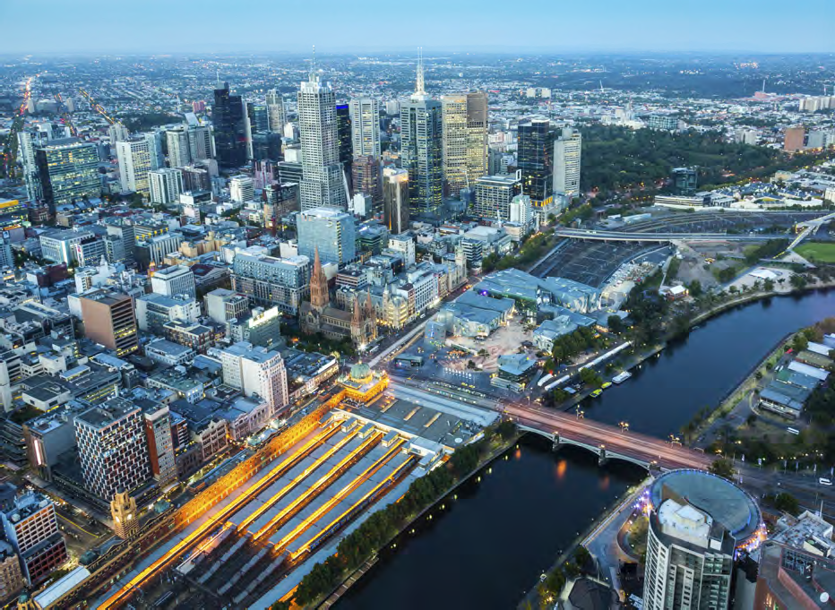

Melbourne Metro Rail Project
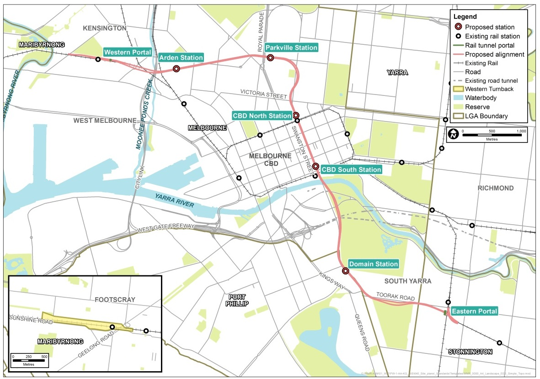
A metro-style system for Melbourne
Metro-style systems are characterised by:
- Simple timetables with ‘turn up and go’ frequency and consistent stopping patterns
- Frequent services that interact seamlessly with other train lines, trams and buses, enabling convenient interchange
- Stand-alone, end-to-end lines where service disruptions on one line do not affect other lines
- Separate train fleets, maintenance and stabling facilities for each line
- Modern high capacity signalling technology to maximise the number of trains that can operate on each line
- High Capacity Metro Trains that can carry more passengers and are designed to minimise boarding and alighting times
- Grade separations of level crossings for an integrated and more efficient transport network.
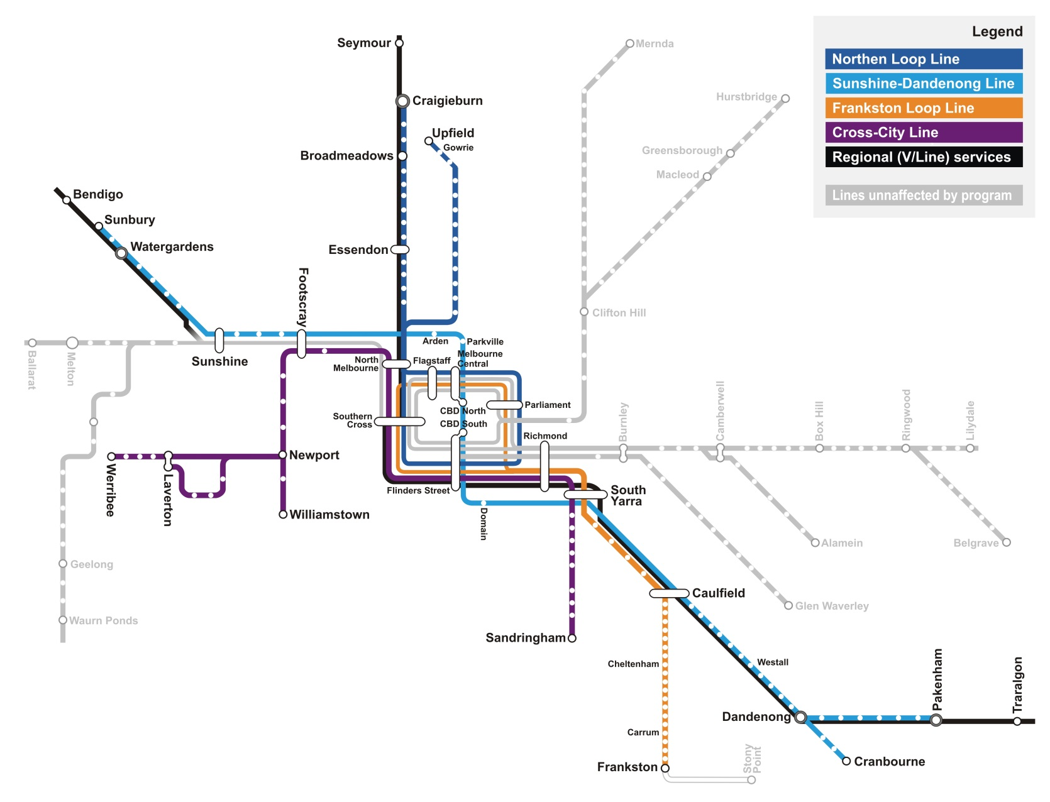
Reconfigured rail network with Melbourne Metro

Project Rationale
As Melbourne’s population grows, the city’s public transport system is feeling the strain.
Melbourne is growing strongly, with the city’s population expected to reach 7.8 million by 2051. At the same time, Melbourne’s economy continues to move towards one based around services and knowledge-based industries. The distribution of employment across the metropolitan area is also changing, with growth in service-based jobs increasingly concentrated in the CBD and manufacturing-based industries moving to the city’s outer growth areas.
These changes in the pattern of population and jobs growth are already straining Melbourne’s infrastructure and services, with a growing demand for travel putting the city’s transport networks under pressure.
The rail network is carrying more passengers than ever before, the fastest growing train lines are rapidly approaching capacity and many peak period services suffer from overcrowding and unreliability.
By 2031, average weekday boardings on metropolitan trains are forecast to double from 750,000 to 1,500,000. This unprecedented patronage demand would exceed the capacity of the city’s metropolitan rail services during peak times and exacerbate overcrowding and delays.
By 2031, over 40 per cent of Melbourne’s population growth is expected to occur in greenfield residential developments in the north, west and south-eastern growth corridors. The highest levels of employment growth will continue to be recorded in central Melbourne. Existing inner city train stations and associated transport infrastructure will be incapable of managing the shifts in travel patterns generated by these changes.
If the rail network cannot keep up with the growing and changing demand for travel, this will affect Melbourne in a number of ways:
- Access to jobs, services and important economic centres will be reduced, undermining Melbourne’s reputation for liveability and making it harder to attract new businesses, investors and skilled workers.
- The misalignment between the city’s public transport networks and growing job catchments will constrain the mobility of the labour force, reducing Melbourne’s economic prosperity and productivity.
- Insufficient public transport will limit access to central Melbourne – Victoria’s strongest jobs and economic hub and potentially Australia’s largest commercial and residential centre by 2040. This constrained access will affect employment and business growth and restrict the potential for development in inner urban renewal areas such as the Arden-Macaulay precinct.
Melbourne Metro would deliver a substantial uplift in capacity across the rail network, allowing more people to travel by train in morning and evening peak periods. It would give more people more public transport options to access work, education and important services across the city. Importantly, the project would facilitate the transition of Melbourne’s rail network into an international-style metro system and provide the foundation for further improvements to the rail network, ensuring that the network keeps pace with a growing and changing Melbourne.

Developing Melbourne Metro
Project objectives
High-level project objectives set by the Melbourne Metro Rail Authority (MMRA) have established the broad strategic direction for designing and developing Melbourne Metro:
- To provide additional capacity on Melbourne’s rail system to meet customer needs that, as part of a program of investment, meets projected medium-term demand and supports long-term patronage growth
- To optimise the efficiency and reliability of operations and improve the customer experience by moving towards a metro-style rail system
- To support the long-term plan and vision to develop and operate Victoria’s rail network
- To improve access and reduce congestion of the tram system in Central Melbourne and the road network in the north, west and south east by diverting travel to the rail network
- To improve accessibility to jobs, education and other social and economic opportunities by enabling the growth and more effective use of land in Melbourne
- To deliver strong productivity, sustainability and liveability benefits by providing a value for money transport solution
- To contribute to a safe, accessible rail network that supports the health and wellbeing of users.
Options to increase Melbourne’s rail capacity have been under development for several years. Following extensive transport planning and a comprehensive assessment process, substantial new investment in rail infrastructure has been assessed as the best solution to provide the required uplift in public transport capacity to support Melbourne’s needs over the coming decades. Melbourne Metro was assessed as being the most cost-effective way to expand the core of the metropolitan rail network while providing for further capacity uplifts in the future.
Once Melbourne Metro was identified as the preferred solution, alignment options and potential train station locations were identified, developed and assessed. The criteria used for this assessment included customer experience (such as ease of interchange between transport modes), transport system outcomes (such as the reliability and frequency of services), disruption (such as the impacts during construction on the transport network, open spaces, residences and businesses) and cost (such as construction, operation and property costs, and value for money).
The assessment of options, carried out in collaboration with Public Transport Victoria and other stakeholders, has progressively refined and improved the design of Melbourne Metro to minimise impacts and achieve the greatest potential benefits. Particular attention has been given to reducing disruption in central Melbourne and to moving construction activities in and out of the CBD as quickly as possible.
The outcomes of the EES assessments lead to refinements of the Concept Design to further minimise potential impacts.
Changes include:
- Refining works at the western tunnel entrance to be contained within Childers Street and not within JJ Holland Park
- Shifting the Parkville station location to reduce impacts on Royal Parade and Royal Melbourne Hospital and shifting the CBD North station location to avoid impacts on the State Library forecourt and La Trobe Street
- Opting for mined cavern station construction for the CBD stations (rather than cut and cover) to remove the need to ‘open up’ Swanston Street
- Boring the tunnels under the Yarra River to avoid direct impacts on the river
- Revising the layout for the construction of Domain station to reduce the impact on the Shrine of Remembrance Reserve.
Elements of the project will continue to be refined through detailed design development.

Planning for Melbourne Metro
Melbourne Metro is being assessed under the Environment Effects Act 1978, which provides for the assessment of projects that the Minister for Planning has determined could have a significant effect on the environment.
Project proponent
MMRA, on behalf of the Secretary of the Department of Economic Development, Jobs, Transport and Resources (DEDJTR), is the proponent responsible for delivering Melbourne Metro.
MMRA is an administrative office established in relation to DEDJTR and is one of several agencies assisting the State Government achieve its integrated transport policy.
MMRA is responsible for all aspects of Melbourne Metro, including developing a Concept Design, conducting site investigations, engaging with stakeholders and the community, obtaining planning and other approvals and procuring the project – through to construction delivery and project commissioning.

The EES
On 3 September 2015, the Minister for Planning determined that the Melbourne Metro Rail Authority (MMRA), as the project proponent, must prepare an EES to allow the Minister to assess the environmental effects of the works proposed to be carried out for the project. The Minister’s reasons for this determination included the potential impacts of a large scale infrastructure construction project in an intensely developed urban area, and the importance of subjecting the project to a robust and transparent assessment of the potential environmental effects and the effectiveness of measures to manage and mitigate these effects.
The Minister published Scoping Requirements to guide the preparation of the EES. These requirements identify specific issues that must be addressed, the approach to be adopted in assessing the project’s risks and impacts, the content and style of the EES and evaluation objectives to focus the impact assessment.
The EES for Melbourne Metro outlines the proposed alignment for the project, as well as the proposed locations of the new train stations and above ground structures. It describes the proposed construction methods that would be used. It includes detailed assessments of the potential impacts of the project and possible measures to avoid, minimise, manage or offset impacts. It identifies the potential benefits delivered by Melbourne Metro and opportunities that could be leveraged from the project.
The EES also incorporates recommended Environmental Performance Requirements that would guide the project’s detailed design, construction and operation. Importantly, it provides the basis for determining whether the project can meet the approvals required under Victorian and Commonwealth legislation.
MMRA has consulted widely in preparing the EES, using a range of communication methods to provide information to the public, seek input from stakeholders, address community concerns and respond to feedback about the project.
The EES assessment process is shown over the page.

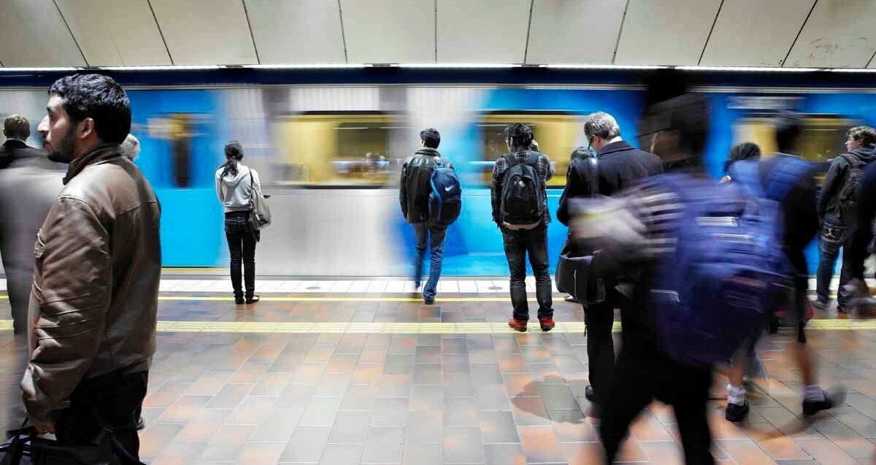
Assessment process for Melbourne Metro
Referral to the Minister for Planning: In August 2015, MMRA provided the Minister for Planning with a Project Outline and requested that the Minister declare the project to be 'public works' under the Environment Effects Act 1978.
Minister's decision on the need for an EES: In September 2015, the Minister for Planning determined that an EES was required for the Melbourne Metro and published Scoping Requirements in December 2015 setting out the matters to be investigated in the EES.
Preparation of the EES: From September 2015 to March 2016, MMRA prepared the EES and consulted with the public and stakeholders. A Technical Reference Group, with representatives from key government agencies and councils and statutory authorities, provided guidance and advice to MMRA during the preparation of the EES.
Public exhibition: The EES is on public exhibition for 30 business days. During this
time, stakeholders and members of the public can make written submissions.
We are here
Public hearings: The Minister appoints an Inquiry to evaluate the effects of Melbourne Metro, having regard to the EES and public submissions. Formal public hearings are likely to be held over 20 to 30 business days where MMRA and people who have made submissions can make presentations.
Minister's Assessment: The Minister prepares an Assessment considering all relevant information including the EES, public submissions, MMRA's response to submissions and the Inquiry report. This Assessment is normally provided within 25 business days of the Inquiry report being finalised.
Planning Scheme Amendment: Planning Scheme Amendment prepared by MMRA and approved by the Minister for Planning.
Decision-makers consider the Minister's Assessment: The relevant decision-makers (such as local councils and statutory agencies) consider the Minister's Assessment in granting approvals for the project under Victorian law or authorising public works. While the recommendations of the Assessment carry considerable weight, they are not binding on decision-makers who could impose further requirements for the project to proceed.
Review of EES by DELWP: DELWP reviewed the draft EES (in consultation with relevant agencies) to determine it was adequate for public exhibition
Authorisation by Minister: The Minister for Planning authorised DELWP to invite public comments on the EES.

Project Approvals

Victorian approvals
The EES in itself is not an approval for a project to proceed. However, it informs the principal approvals required for Melbourne Metro, which include:
- Amendments under the Planning and Environment Act 1987 to the Melbourne, Port Phillip, Stonington and Maribyrnong Planning Schemes
- Permits and consents under the Heritage Act 1995, which regulates the protection and conservation of places of heritage significance and archaeological sites and relics.
Where an EES is required under the Environment Effects Act 1978, the project proponent must also prepare a Cultural Heritage Management Plan (CHMP) under the Aboriginal Heritage Act 2006 for the area where the proposed works would be carried out. In parallel to the EES, MMRA has prepared a CHMP in consultation with the Office of Aboriginal Affairs Victoria and the Traditional Landowners.
A range of secondary approvals and consents may also be required under other legislation, such as works approvals, licences and permits in relation to construction activities.

Commonwealth approvals
The Commonwealth Environment Protection and Biodiversity Conservation Act 1999 provides the legal framework to protect and manage matters of National Environmental Significance. The approval of the Commonwealth Minister for the Environment is required in some circumstances before a project can proceed.
On 22 September 2015, the Commonwealth Department of the Environment determined that Melbourne Metro is not a ‘controlled action’ under the Act, subject to the project being undertaken in a particular manner to avoid significant impacts as a result of vibration on Commonwealth Heritage-listed structures within the Victoria Barracks site in St Kilda Road. These requirements are included in the recommended Environmental Performance Requirements for the project.
No further assessment is required under the Environment Protection and Biodiversity Conservation Act 1999.
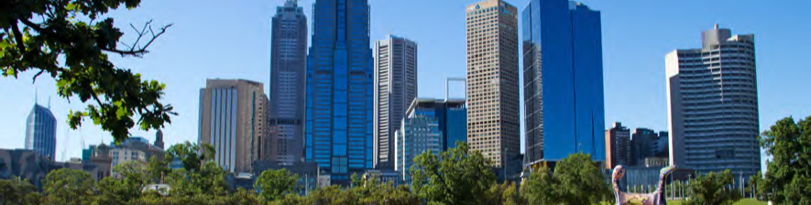

Subject Matter of the EES
Melbourne Metro incorporates four key components that are evaluated in this EES:
- The Concept Design and alternative design options
- Proposed construction methodology
- Environmental impact assessments underpinned by a risk assessment
- Recommended Environmental Performance Requirements.
These components have been assessed within a proposed project boundary (see below).
Each of these components has evolved as baseline investigations and impact assessments undertaken for the project have identified issues that required further refinement of the Concept Design, the proposed construction methodology or the recommended Environmental Performance Requirements.

Concept Design
The Concept Design and alternative design options are assessed in the Melbourne Metro EES. The main components of the Concept Design are shown in the figure on page 16. Engineering maps of all components are included in the EES Map Book.
As is typical for an EES, the Concept Design is not the final design for Melbourne Metro. Further refinements could be made by the companies contracted to develop and deliver the project as detailed design is developed and finalised. These design refinements are anticipated to occur primarily within the proposed project boundary. Consequently, the potential effects of these refinements have been contemplated by the EES and would be managed through complying with the Environmental Performance Requirements (see below).
The EES also assesses a number of alternative design options to the Concept Design. These options demonstrate different ways the recommended Environmental Performance Requirements could be achieved. Inclusion of these options provides an opportunity for the community to be consulted during the EES process on the impacts of each option.

Proposed construction methodology
Constructing Melbourne Metro would take a number of years and potentially have significant environmental effects. For the purpose of assessing these effects and developing appropriate Environmental Performance Requirements, a proposed construction methodology was developed by MMRA.
Some aspects of the construction methodology would be prescribed: for example, the use of tunnel boring machines (TBMs) to construct the rail tunnels outside the Melbourne CBD and for crossing under the Yarra River. Other aspects may be optimised or altered by the companies contracted by the Victorian Government to undertake the detailed design and construction of Melbourne Metro. However, irrespective of the methodology adopted, the construction of Melbourne Metro must comply with the Environmental Performance Requirements.

Environmental impact assessment
To ensure this EES addresses the Scoping Requirements, 18 specialist technical assessments have evaluated the environmental effects of the Concept Design, alternative design options and proposed construction methodology. The specialists have also provided an assessment of how the environmental effects of Melbourne Metro could be mitigated and the matters that MMRA should consider for inclusion in the Environmental Performance Requirements.
The technical assessments applied a systems and risk based approach to identifying and assessing potential environmental effects across interrelated specialist studies, and also considered potential cumulative effects.

Environmental Performance Requirements
Melbourne Metro would be delivered in accordance with Environmental Performance Requirements that set the environmental outcomes the project must achieve during its design, construction and operation (regardless of any particular design solutions that are adopted).
These requirements are designed to ensure that the project’s contractors adopt measures to avoid, manage or reduce the project’s environmental impacts by defining the outcomes to be achieved rather than specifying the approach to be taken. The Environmental Performance Requirements are based on the recommendations of the specialists who have undertaken the impact assessments for the EES.
The final Environmental Performance Requirements approved by the Minister for Planning are expected to be based on the requirements recommended in the EES. The contractor would have to meet these requirements in designing, constructing and operating the project. This approach ensures Melbourne Metro achieves acceptable and required environmental outcomes, while still allowing flexibility for the contractor to determine how best to achieve the Environmental Performance Requirements.

Proposed project boundary
The proposed project boundary encompasses all the key locations that would be used for permanent structures and temporary construction work sites (above and below ground). This area provides the basis for the specialist impact assessments undertaken for the EES. For assessment purposes, the proposed project boundary has been divided into nine precincts to assess the potential impacts on local areas and surrounding communities.
Some of the assessments undertaken for the EES have adopted larger study areas than the proposed project boundary in order to fully understand the relevant effects, collect sufficiently detailed baseline information and investigate any broader implications.
The proposed project boundary and assessments undertaken for the EES have informed the ‘draft Project Land’ being exhibited with this EES, which is contained in the draft Planning Scheme Amendment provided in Technical Appendix A.

Melbourne Metro EES evaluation objectives
The Scoping Requirements issued by the Minister for Planning include evaluation objectives against which the project must be assessed, were developed specifically for Melbourne Metro and have guided the assessments undertaken for the EES.
Transport connectivity – To enable a significant increase in the capacity of the metropolitan rail network and provide multimodal connections, while adequately managing effects of the works on the broader transport network, both during and after the construction of the project
Built environment – To protect and enhance the character, form and function of the public realm and buildings within and adjacent to the project alignment, and particularly in the vicinity of project surface structures, having regard to the existing and evolving urban context
Social, community, land use and business – To manage the effects on the social fabric of the community in the area of the project, including with regard to land use changes, community cohesion, business functionality and access to services and facilities, especially during the construction phase
Amenity – To minimise adverse air quality, noise or vibration effects on the amenity of nearby residents and local communities, as far as practicable, especially during the construction phase
Cultural heritage – To avoid or minimise adverse effects on Aboriginal and historic cultural heritage values
Land stability – To avoid or minimise adverse effects on land stability that might arise directly or indirectly from project works
Landscape, visual and recreational values – To avoid or minimise adverse effects on landscape, visual amenity and recreational values as far as practicable
Hydrology, water quality and waste management – To protect waterways and waterway function and surface water and groundwater quality in accordance with statutory objectives, to identify and prevent potential adverse environmental effects resulting from the disturbance of contaminated or acid-forming material and to manage excavation spoil and other waste in accordance with relevant best practice principles
Biodiversity – To avoid or minimise adverse effects on native terrestrial and aquatic flora and fauna, in the context of the project’s components and urban setting
Environmental Management Framework – To provide a transparent framework with clear accountabilities for managing environmental effects and hazards associated with construction and operation phases of the project, in order to achieve acceptable environmental outcomes

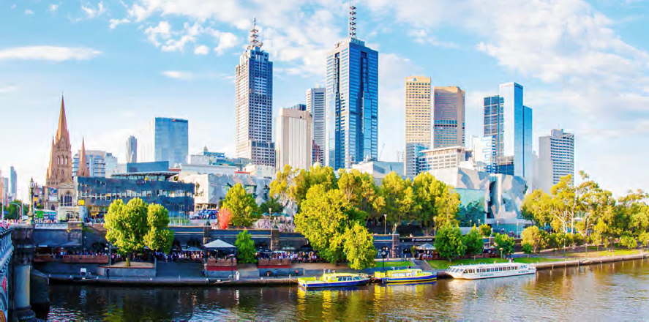

Melbourne Metro Components and Precincts
The Melbourne Metro EES identifies potential impacts at regional and local levels. For assessment purposes, the proposed project boundary has been divided into nine precincts based on the location of project components and construction works, the potential impacts on local areas and the characteristics of surrounding communities.
The specification for most Melbourne Metro components is prescribed. For the small number of components that are not prescribed, feasible alternative options have been assessed to consider the potential impacts of adopting different design or construction approaches.
If other design options are proposed following completion of the EES process, these may not require any additional assessment provided they are within the final Project Area and can comply with the Environmental Performance Requirements. However, if design options are proposed outside the final Project Area, create potential impacts not considered in this EES or cannot comply with the Environmental Performance Requirements, they could be subject to a separate impact assessment and approval process.
The main Concept Design components and precincts adopted for the EES assessment of Melbourne Metro are shown in the figure on the next page. The following sections summarise the components (and alternative design options), construction activities and work sites within each precinct.

Wider network enhancements
Melbourne Metro would create additional capacity in the inner core of the metropolitan rail network, allowing more trains from the northern, western and south eastern lines to access inner Melbourne.
The project would also facilitate further enhancements to the network to capitalise on this additional capacity and deliver more frequent services on the new Melbourne Metro alignment and on other metropolitan rail lines.
These works would be subject to separate planning approvals processes and are not part of the Melbourne Metro EES.
The wider network enhancements as understood at the time of preparing the EES include signalling upgrades, infrastructure to improve access to sidings, turnbacks, track works and some changes to the operation of the tram network. While ultimately a decision for the Minister for Planning, the small scale of these works means that their associated impacts are likely to be assessed and managed through the existing statutory processes that apply to rail corridor enhancements and they are not expected to be subject to an EES.

Reconfigured rail network with Melbourne Metro in 2031
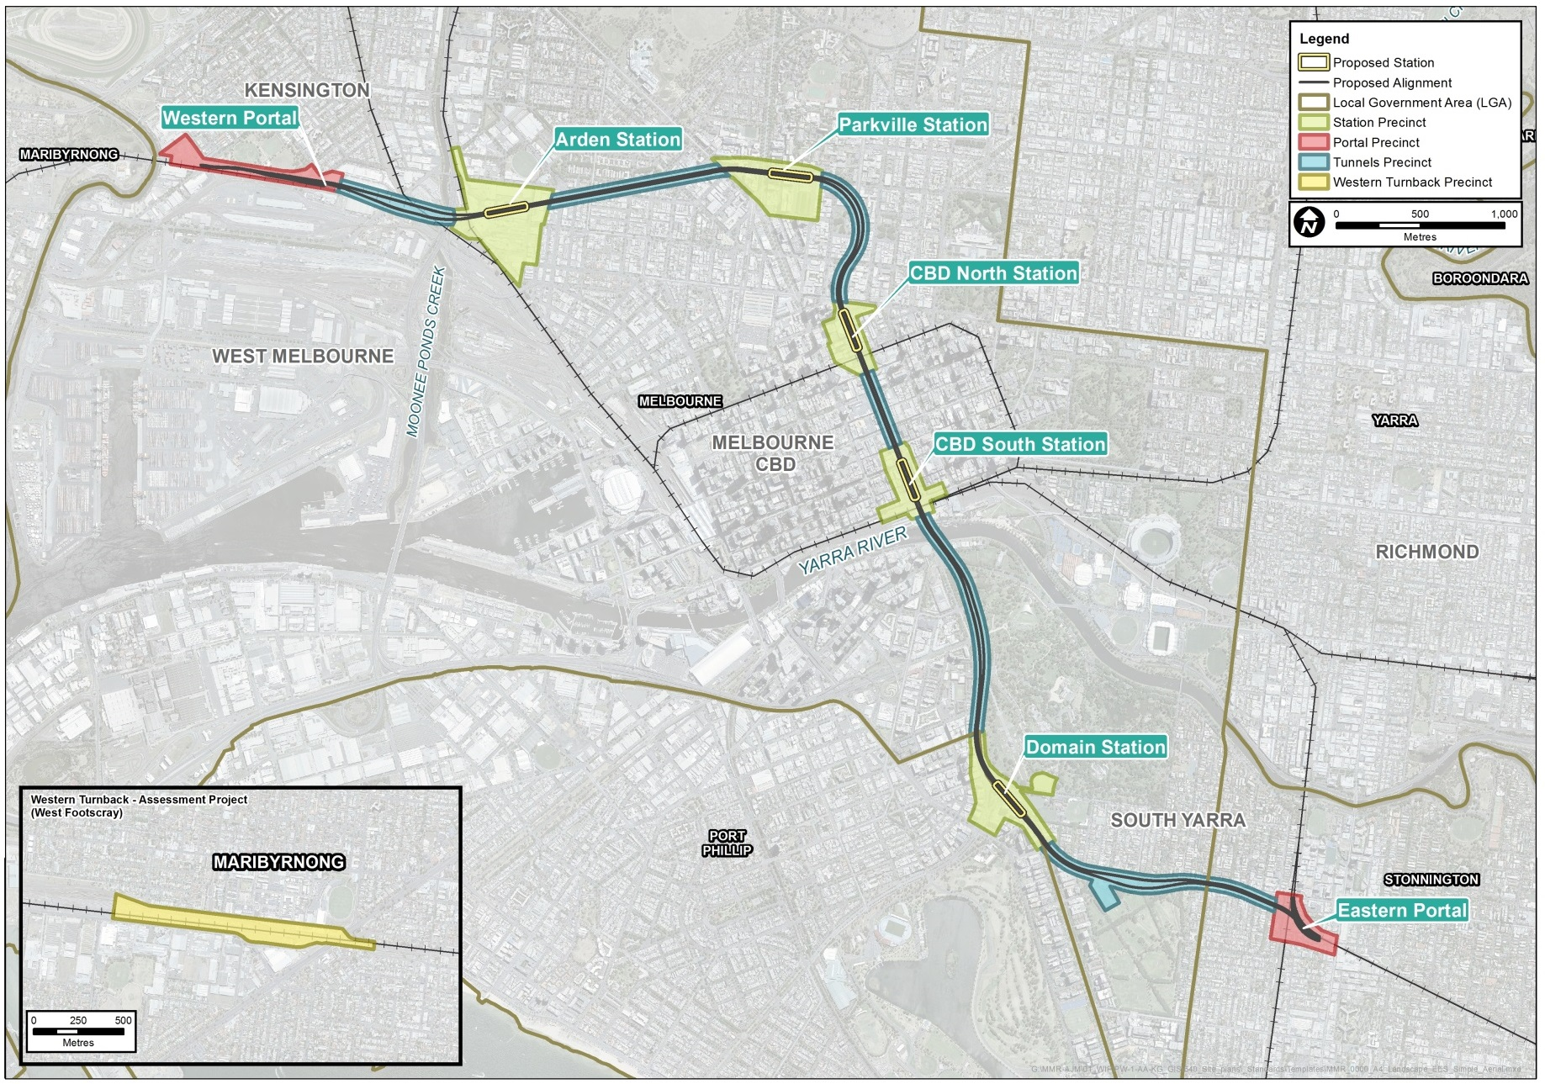

Precinct 1 – Tunnels
This precinct covers the alignment of the twin tunnels between the western portal at Kensington and the eastern portal at South Yarra, with the exception of the station and portal precincts.

Concept Design
Melbourne Metro’s twin tunnels would be nine kilometres long with a diameter of 7 to 7.5 metres.
From the western portal in Kensington to Arden station, the tunnels would pass beneath the Craigieburn and Upfield railway lines, Moonee Ponds Creek and CityLink. The tunnels would then run in a relatively direct line between Arden and Parkville stations before turning south adjacent to Swanston Street to CBD North station.
From CBD North station to CBD South station, the tunnels would pass beneath the Swanston Street road reserve. They would then pass beneath the Yarra River to the east of Princes Bridge and continue under the Domain Parklands (above or below the CityLink tunnels) before entering the St Kilda Road road reserve and approaching Domain station.
South of Domain station, the tunnels would generally remain beneath the St Kilda Road road reserve. They would then turn east to pass under Fawkner Park adjacent to Toorak Road before entering and remaining under the Toorak Road road reserve until approaching the eastern portal in South Yarra where they would tie into the existing Dandenong rail corridor west of Chapel Street.
Two emergency access shafts may be required along the tunnels alignment, with the Concept Design considering alternative locations for each shaft:
- In the north-east section of Fawkner Park or in Fawkner Park at the possible TBM launch site location (see below) at the current Fawkner Park Tennis Centre
- In Queen Victoria Gardens adjacent to Linlithgow Avenue or in Tom’s Block adjacent to Linlithgow Avenue.
The permanent above ground structures associated with these shafts would have footprints of approximately 12 square metres and 4.6 metres high.
The final location and requirement for emergency access shafts would be determined in consultation with the Metropolitan Fire Brigade.
The tunnels also include the rail track and rail systems required for signalling, train control, communications, ventilation, traction power supply and safety systems.

Construction activities and work sites
Two sections of the Melbourne Metro tunnels would be bored using TBMs: from the western portal to CBD North station, and from CBD South station to the eastern portal. The section of the tunnels between CBD North and CBD South stations would be mined using roadheaders.
Launching the TBMs would require a range of support services, such as a grouting plant, gantry crane, spoil handling system, water treatment plant, power infrastructure and services, and facilities to assemble the TBM.
The western TBM launch site would be located at the Arden station site (on Government owned land that would also be used as a major construction site).
The preferred eastern TBM launch site would be at the Domain station site, with the option of an additional launch site in the north-west section of Fawkner Park also under consideration (where the tennis courts are located).
Both eastern TBM launch options would require the use of Edmund Herring Oval as a support site. This site would also be used for construction activities such as site offices, materials laydown, equipment storage and maintenance.

Constructing Melbourne Metro
The main construction activities would be civil and structural works, including general earthworks, tunnel excavation and portal construction, station and platform construction, storage and removal of excavated material, drainage and water management, and tunnel and station fit-out.
Different methods would be used to construct the tunnels, stations and portals. These methods have been selected to minimise potential impacts, construction costs and the duration of construction.
The majority of the tunnels would be constructed using TBMs. TBMs can be configured to excavate safely through a variety of soil and rock strata, with the permanent tunnel lining constructed in segments from within the machine as the excavation progresses.
Cut and cover construction would be used for the Arden, Parkville and Domain stations. This form of construction uses either a ‘top down’ or ‘bottom up’ approach. Top down means the roof slab is constructed prior to excavation; bottom up means the permanent structure is constructed after excavation. The mined cavern method would be used for the two CBD stations, which involves constructing the stations from underground using roadheaders.
Several construction work sites would be required along the project alignment. Depending on their size and location, these sites would be used for materials and equipment storage, concrete batching, offices and for launching the TBMs. Sites have been carefully selected to minimise impacts on adjacent areas and avoid the need for property acquisition and tree removal. Fencing and screening would be provided at these sites to minimise the visual impacts. Measures such as noise walls, acoustic sheds and watering would minimise noise and dust impacts for nearby residences.
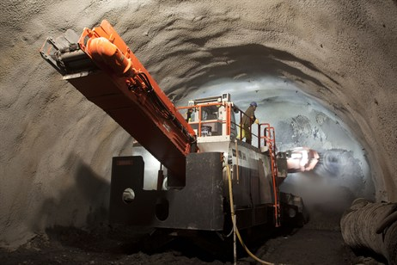
Roadheader (left) and tunnel boring machine (right)

Precinct 2 – Western Portal (Kensington)
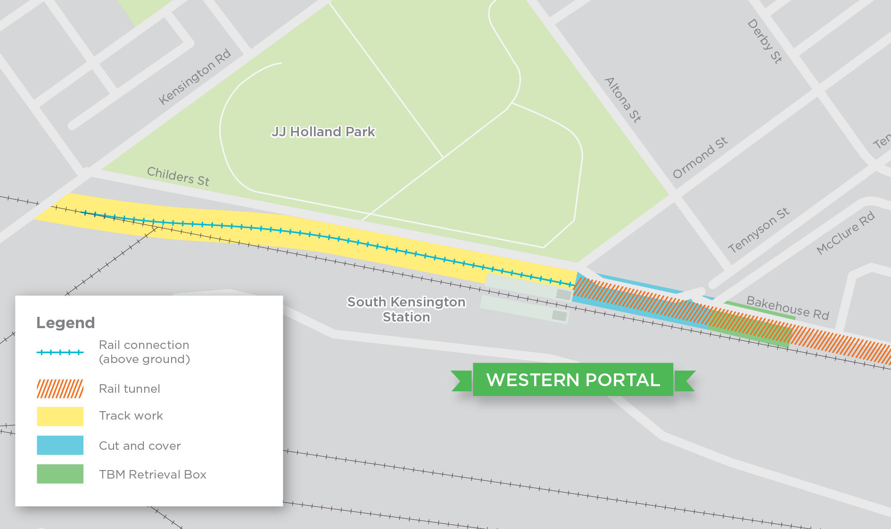
The precinct contains housing, public open space and an industrial estate to the north, with railway lines, South Kensington station and a freight terminal located to the south. JJ Holland Park is located to the north of the proposed portal and is a highly valued and well-used public open space. Several residential properties are located to the north of the proposed portal in Childers Street.

Concept Design
Melbourne Metro would connect to the existing rail network in the vicinity of South Kensington station. The portal includes the approach to the tunnels (the decline structure) and the tunnelling works that connect to the tunnels precinct (Precinct 1). Works would include:
More train services through South Kensington station
Once Melbourne Metro starts operating, the reconfigured network would mean that the Cross-City Line (the future line connecting Werribee and Sandringham) would stop at South Kensington station. This would allow more services to operate through the station, increasing the number of peak hour services for local residents.
- Track works to the east of the Maribyrnong River to connect the existing surface level Sunbury Line tracks to the new Melbourne Metro tracks
- Twin track decline structure and retaining wall along Childers Street in Kensington to carry the Melbourne Metro tracks from embankment level to below ground
- Twin cut and cover tunnels from the decline structure to the bored tunnel entrance
- A TBM retrieval box.
The Concept Design considers two options for the location of the TBM retrieval box. The first option is located adjacent to the industrial estate at the eastern corner of Childers and Tennyson Streets, with a shorter decline structure to enter the tunnel.
Under the second option, the TBM retrieval box would be located immediately west of the existing subway at the intersection of Ormond and Childers streets, with a longer decline structure to enter the tunnel and a bridge over Kensington Road.

Construction activities and work sites
The main construction activities in this precinct would be:
- Private property acquisition
- Early works, including the removal of trees, the relocation and protection of utilities, and land clearing
- Construction of a piled structure within the rail reserve in line with and to the east of the skate park in JJ Holland Park
- Construction of the decline structure within the rail reserve
- Cut and cover tunnel construction at the east end of Childers Street
- Relocation of public car parking and shared use path
- Cut and cover excavation and TBM retrieval
- Track works and installation of rail systems
- Site remediation, including landscaping and tree re-planting.
A construction site located at 1 - 39 Hobsons Road in Kensington would be used for site offices and facilities, laydown areas and materials and equipment storage.
During construction, Childers Street would be closed to traffic and used for construction activities. Car parks along Childers Street and the shared use path along the railway would be occupied during construction. The walking path in JJ Holland Park would be upgraded to a shared use path at the start of construction to provide an alternative to the occupied shared use path. Other than works associated with the new shared use path, no construction activities would be undertaken in JJ Holland Park.
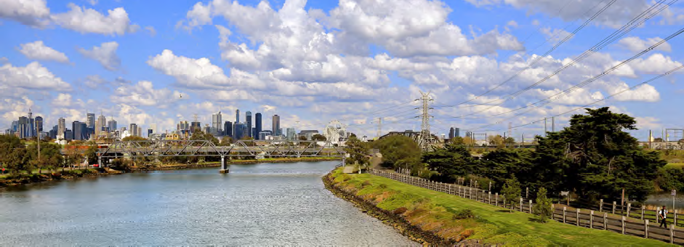

Precinct 3 – Arden Station
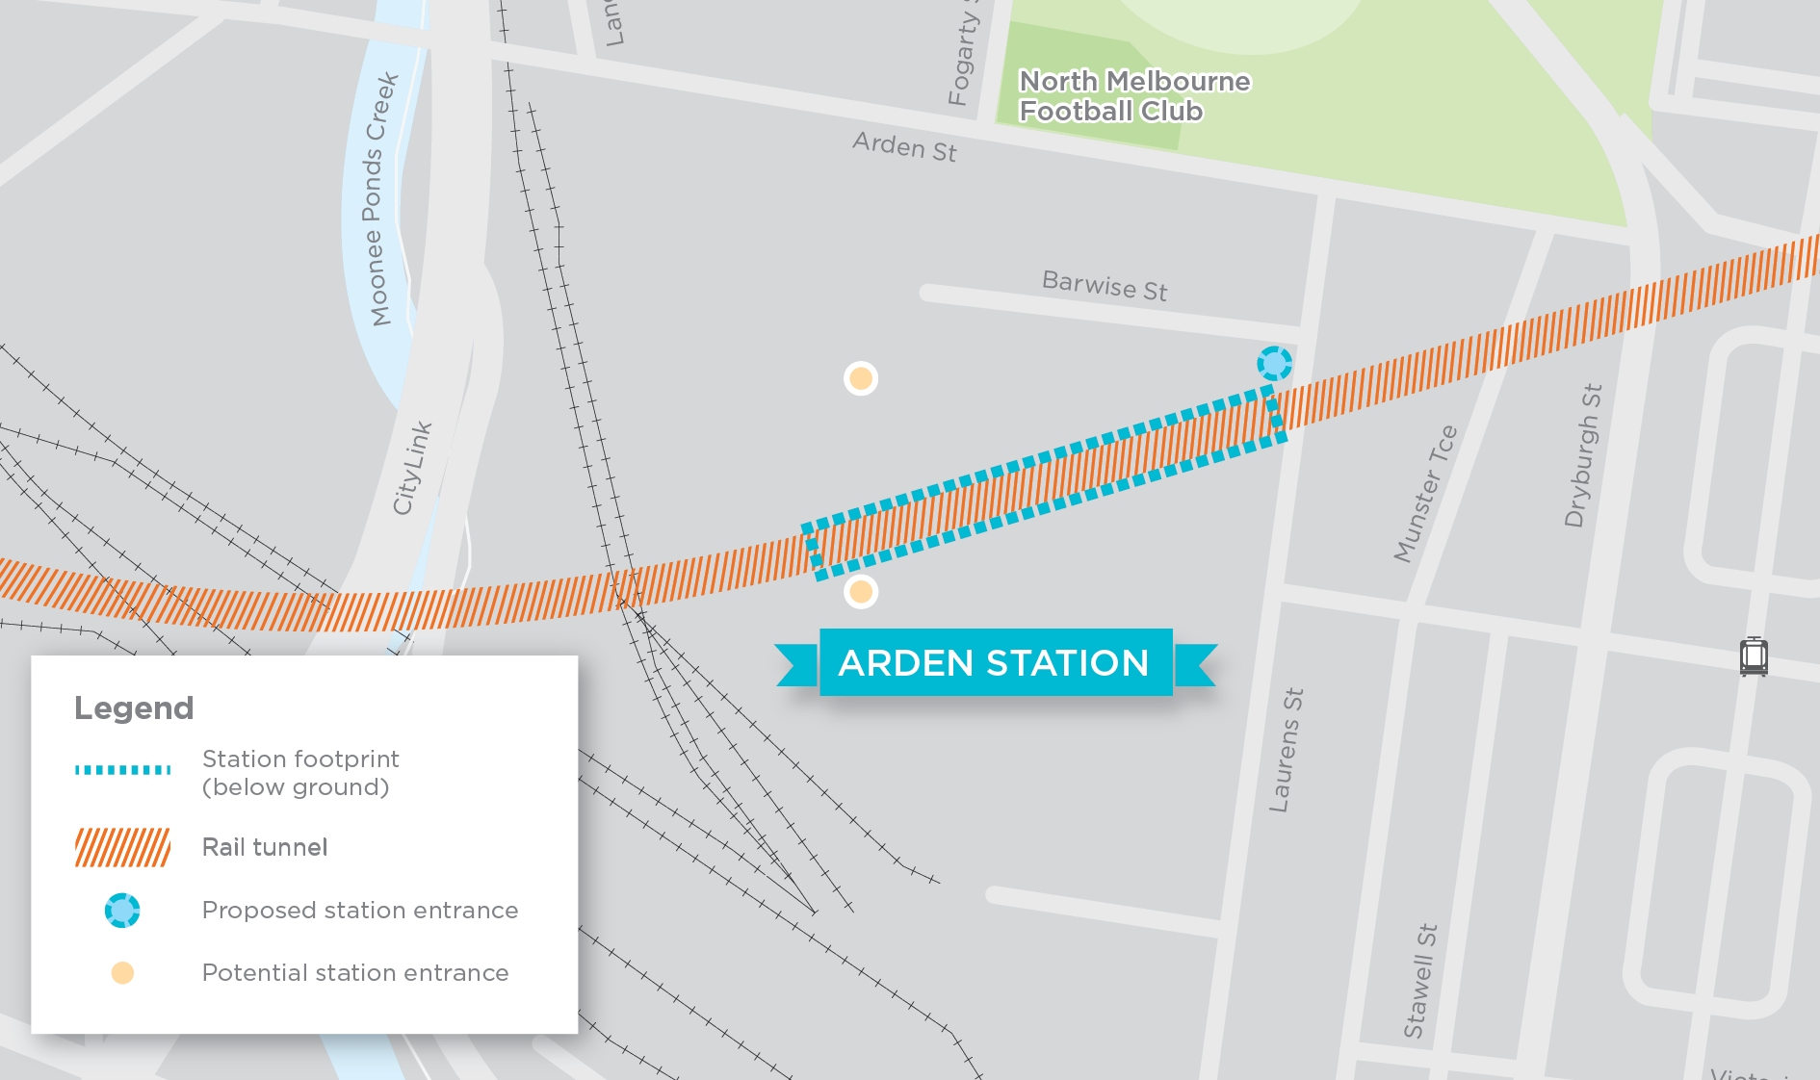
The Arden station precinct is characterised by wide streets, low rise development and a mix of land uses, including light and heavy industrial and residential. Currently dominated by a 14 hectare Government owned industrial site, the area is expected to undergo extensive urban renewal over the next 20 years.

Concept Design
New businesses and jobs in Arden
A new underground station in the Arden area would improve the accessibility of the precinct, increasing its attractiveness to potential businesses, particularly professional services businesses. As a result, a steady rise in population and employment is anticipated within this precinct alongside the operation of Melbourne Metro.
By 2031, Arden station is expected to provide heavy rail access to 12,000 jobs and 7,000 residents (within 800 metres of the station).
Overall, Melbourne Metro would have a highly positive impact on business and economic activity in the precinct, leading to additional annual production of $1.8 million for the precinct and the creation of 3,700 new jobs (compared to the project not proceeding).
Arden station would be located underground on a diagonal alignment (from south-west to north-east) west of Laurens Street between Arden and Queensberry streets, wholly within the Government owned industrial site currently managed by VicTrack. An initial station entrance would be located on Laurens Street, with provision made for a future second entrance located approximately 120 metres south of Arden Street, in line with a potential future southward extension of Fogarty Street.
A substation to provide power for the operation of the Melbourne Metro tunnels and stations would also be located in the area. The preferred site for the substation is on Government owned land to the north of Arden Street (between CityLink to the west and Langford Street to the east).

Construction activities and work sites
The station would be constructed using the bottom up cut and cover construction method. The main construction activities at the site would be:
- Private lease acquisition
- Early works, including the removal of trees, the relocation and protection of utilities, and land clearing
- Construction of a concrete batching plant and precast segment facility
- Station box excavation and TBM launch site
- Station structural works
- Station architectural, mechanical and electrical fit-out
- Track works and installation of rail systems
- Site remediation, including landscaping and tree re-planting.
The Government owned land at Arden would be the major staging area for works associated with the western section of Melbourne Metro and would include site offices and staff amenities, fabrication sheds, major storage areas and spoil extraction and handling facilities. Provision for floodwater storage and a tunnel air ventilation and extraction plant would also be located on the site. The site would be required for the full construction period.
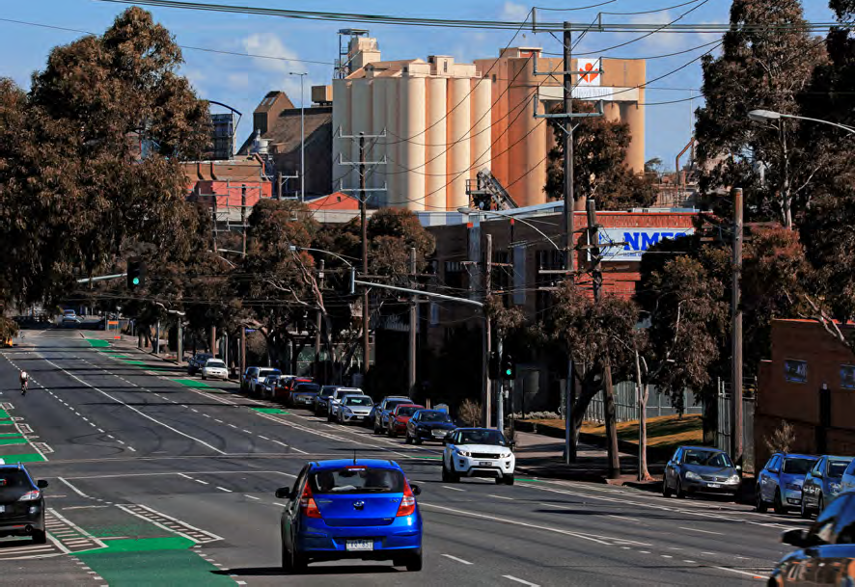
Arden Street looking west from CityLink

Precinct 4 – Parkville Station
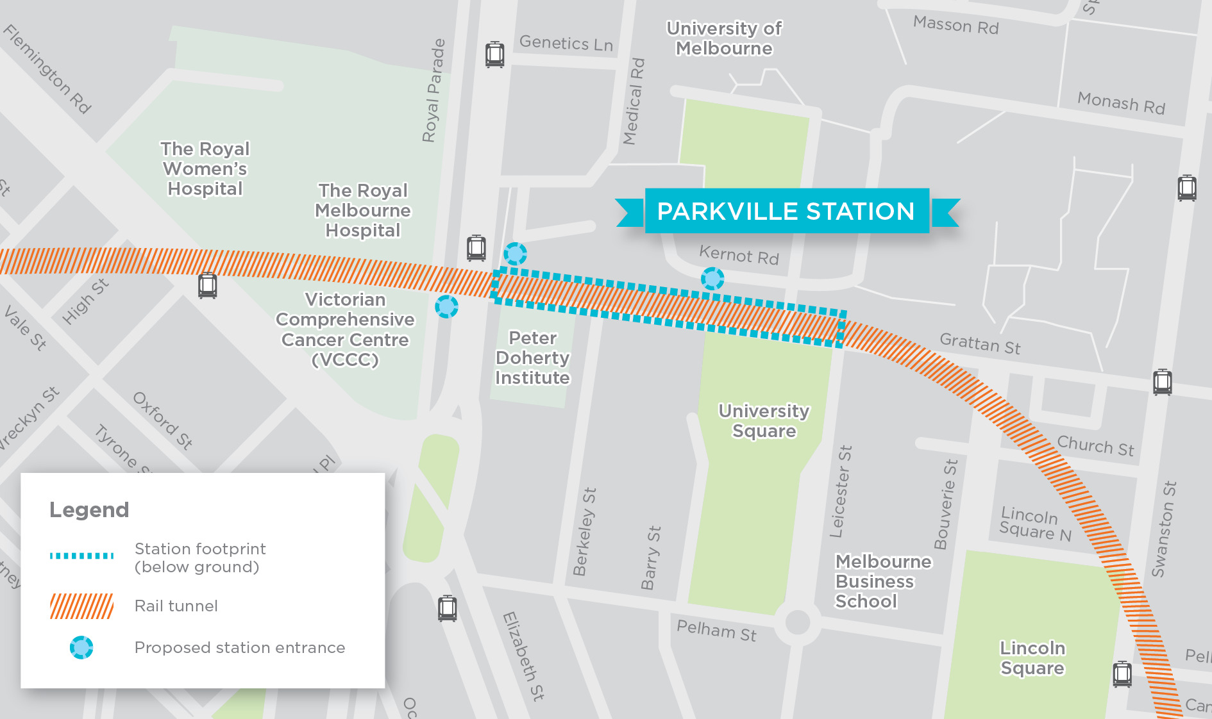
The Parkville station precinct is dominated by health and education uses, including major hospitals, leading research institutes and the University of Melbourne. Many of these land uses feature high density development, while the residential area of Parkville to the north-west retains a strong heritage character and less intense development. Royal Parade and Flemington Road are major historic boulevards that define the precinct’s layout, as well as being major gateways into central Melbourne from the north.

Concept Design
New businesses and jobs in Parkville
The potential commercial and residential uplift from Parkville’s first train station – and the greater accessibility provided by Melbourne Metro – would be significant.
Once operational, Parkville station would provide access to around 45,000 jobs, 14,000 residents and 70,000 tertiary students (within 800 metres of the station).
Overall, Melbourne Metro would have a positive impact on business and economic activity in the precinct, leading to additional annual production of $2 million for the precinct and the creation of 2,000 jobs (compared to the project not proceeding).
The new Parkville station would be located under the Grattan Street road reserve, to the east of Royal Parade. The station’s footprint would occupy the full width of Grattan Street and extend from the intersection of Grattan Street and Royal Parade to Leicester Street. The station would include two entrances located at the University of Melbourne (one at the corner of Royal Parade and the other on Grattan Street) and a third entrance located outside the Victorian Comprehensive Cancer Centre (on the opposite side of Royal Parade).
A tram superstop in the centre of Royal Parade, just north of Grattan Street, would provide easy interchange between the station and tram services, and improve access to the wider area.
Permanent changes to the road layouts at Parkville associated with the design include the narrowing of Grattan Street to one lane in each direction and two lanes in each direction on Royal Parade/Elizabeth Street (north of Haymarket roundabout).

Construction activities and work sites
The station would be constructed using either the top down or bottom up cut and cover construction method. The main construction activities at the site would be:
- Temporary property occupation
- Early works, including the removal of trees, the relocation and protection of utilities and land clearing
- Tunnel excavations through the station box
- Station structural works and station entrance connections across Royal Parade
- Construction of underground pedestrian access between the station and the west side of Royal Parade
- Station architectural, mechanical and electrical fit-out
- Track works and installation of rail systems
- Site remediation, including landscaping and tree re-planting, and the restoration of Grattan Street, Royal Parade and University Square.
During construction, Grattan Street would be closed to traffic between Royal Parade and Leicester Street, with the potential for temporary closures between Royal Parade and Flemington Road.
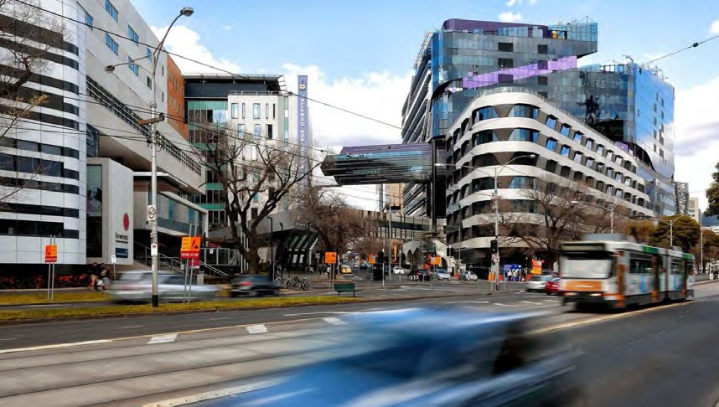
Existing view of Parkville from Flemington Road

Precinct 5 – CBD North Station
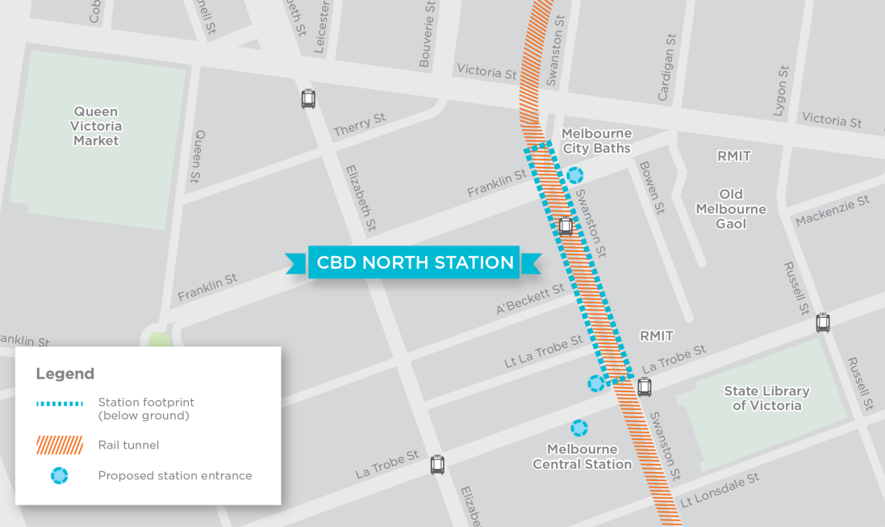
Formerly a predominantly commercial and industrial precinct, the northern part of the CBD is now characterised by diverse land uses and destinations, including RMIT University, residential apartment towers, Melbourne Central Shopping Centre and Melbourne Central station, the State Library of Victoria and Melbourne City Baths. The area is highly developed and includes a diverse mix of modern and heritage buildings.

Concept Design
The new CBD North station would be located directly beneath Swanston Street, extending from La Trobe Street to north of Franklin Street. A southern entrance would be located on the corner of Swanston Street and La Trobe Street, with a direct underground pedestrian link to Melbourne Central station. The northern entrance would be located on the east side of Franklin Street and extend to Bowen Street, with Franklin Street being closed east of Swanston Street.

Construction activities and work sites
The station would be constructed using the mined cavern construction method. The main construction activities at the site would be:
- Private property acquisition
- Early works, including the removal of trees, the relocation and protection of utilities, and land clearing
- Excavation of the twin interconnecting tunnels between the two CBD stations
- Station structural works
- Construction of station entrances and connection to Melbourne Central station
- Station architectural, mechanical and electrical fit-out
- Track works and installation of rail systems
- Site remediation, including landscaping and tree re-planting along Swanston Street and Franklin Street.
Several areas adjacent to the station site would be used as construction work sites, including either part of the RMIT basketball courts or A’Beckett Street. During construction Franklin Street and A’Beckett Street would be closed to traffic at Swanston Street.
Early works
Early works are essential for Melbourne Metro’s construction to proceed. These works would be undertaken prior to the main construction works and could include:
- Tram diversions
- Work site preparation, such as tree removals, access arrangements, construction power supply and building demolitions
- Protection and relocation of utilities.
Some of these works would be carried out through a Managing Contractor approach; other works would be led by Yarra Trams or carried out by utility service providers. These works would be required to comply with the Environmental Performance Requirements for Melbourne Metro.
Enabling works
Enabling works are specific small scale works that would be initiated earlier than the major Melbourne Metro works (and potentially before the conclusion of the EES process) to minimise disruption to businesses and residents during construction of the project. These works include the protection and relocation of utilities in specified locations, such as telecommunications conduits, gas and water mains, sewers and stormwater drains.
The Minister for Planning has determined that these specific works would not have significant effects on the environment and would not need an EES to proceed. MMRA would still need to obtain and comply with all required statutory approvals in undertaking these works.
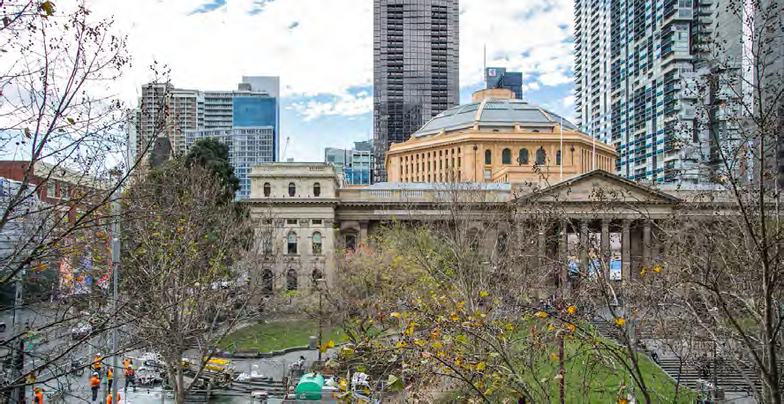
State Library of Victoria

Precinct 6 – CBD South Station
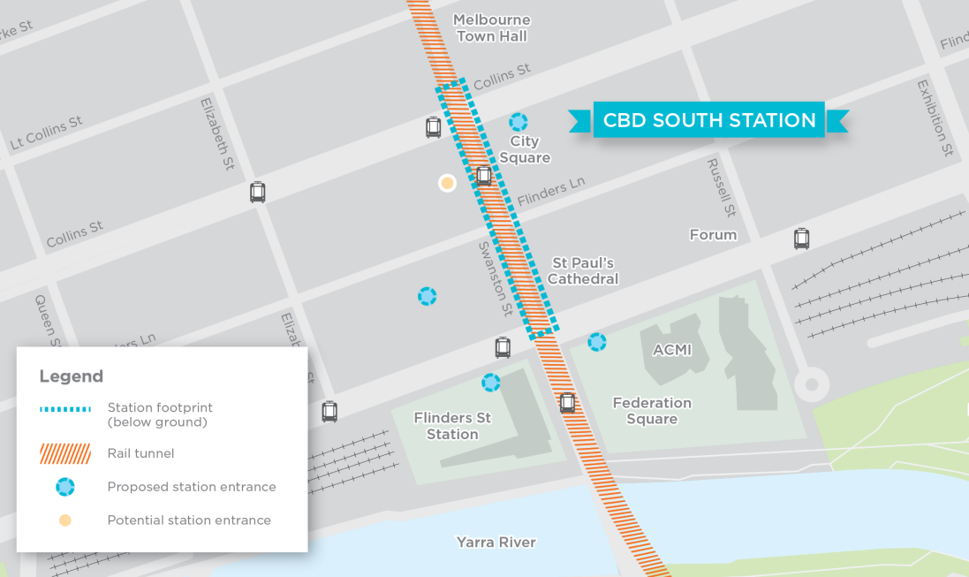
This precinct is a highly urbanised and dense inner urban area, centred on the Swanston Street corridor between Collins Street and Flinders Street at the southern edge of the CBD. It is the site of several Melbourne landmarks and visitor destinations, including Federation Square, St Paul’s Cathedral, City Square, Melbourne Town Hall, Young and Jackson Hotel and Flinders Street Station. These landmarks are surrounded by laneways lined with bars, cafes, restaurants and retail outlets.

Concept Design
The new CBD South station would be located at the southern edge of the CBD directly beneath Swanston Street, running between and partially under Flinders Street and Collins Street. The southern entrance to the station would include a pedestrian link running beneath Flinders Street directly into the main concourse at Flinders Street Station, with another direct underground connection to Federation Square. The northern entrance would be located on Collins Street at the northern end of City Square. Another smaller entrance would be located on Flinders Lane at the southern end of City Square.

Construction activities and work sites
The station would be constructed using the mined cavern construction method. The main construction activities at the site would be:
- Private property acquisition
- Early works, including the removal of trees, the relocation and protection of utilities, the relocation and protection of the Burke and Wills statue, and land clearing
- Excavation of the twin interconnecting tunnels between the two CBD stations
- Construction of station entrances and connections to Flinders Street Station, Federation Square and City Square
- Station structural works
- Station architectural, mechanical and electrical fit-out
- Track works and installation of rail systems
- Site remediation, including tree re-planting along Swanston Street and the restoration of Swanston Street, Flinders Street, City Square and Federation Square.
Construction work sites would be located at the station entrances in City Square, Federation Square and the southern entrance fronting Swanston Street. During construction there would be partial and temporary closures of Flinders Street for construction of the pedestrian link to Flinders Street Station.
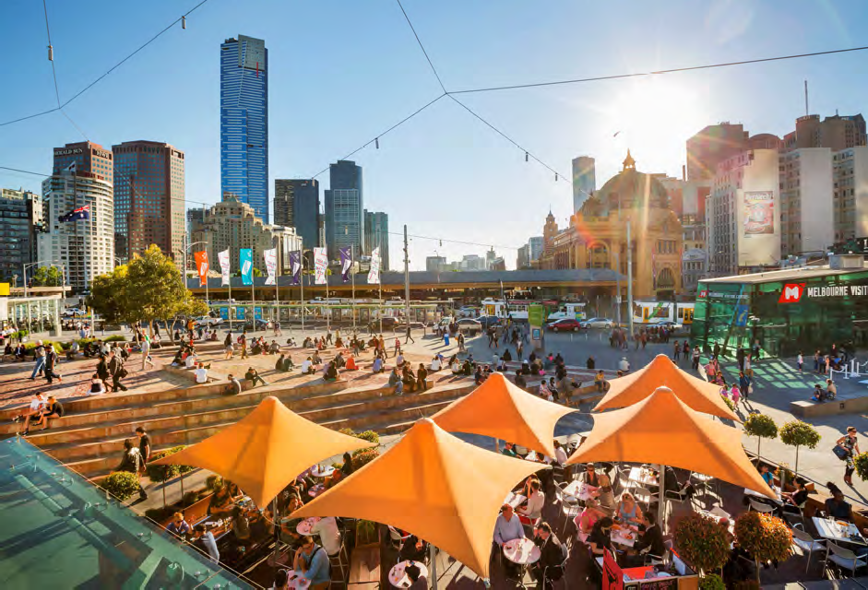
Federation Square

Precinct 7 – Domain Station
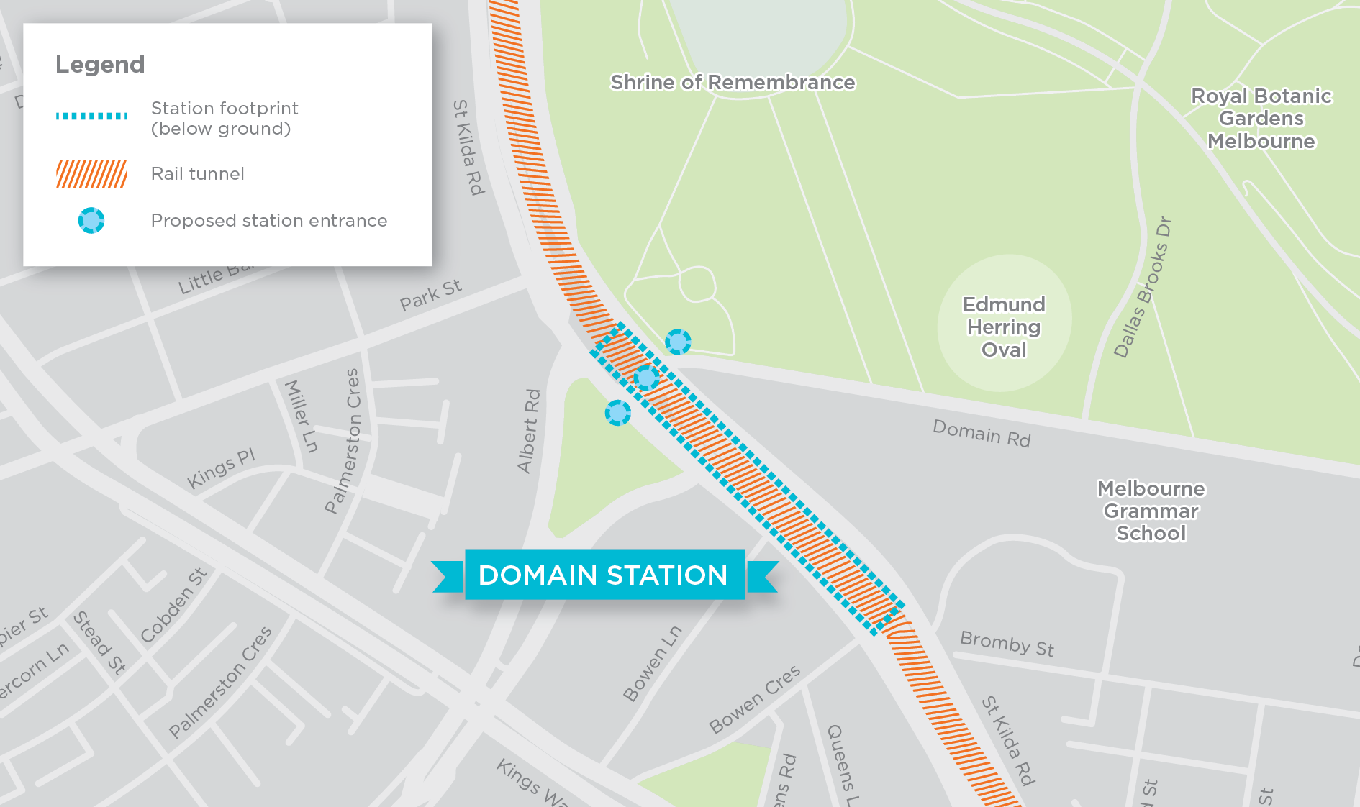
This precinct is dominated by parks and gardens and the Shrine of Remembrance along the east side of St Kilda Road north of Domain Road. Offices and residential apartments feature along the west side of St Kilda Road and Melbourne Grammar School and commercial premises are located along the east side of St Kilda Road to the south of Domain Road. The precinct is also the gateway to Albert Park and the South Melbourne – Kings Way corridor.

Concept Design
New businesses and jobs in Domain
While there would be limited opportunity for commercial development in the immediate vicinity of the new Domain station, the station would improve the accessibility and relative attractiveness of the South Melbourne district, which is expected to result in a change in the property mix of the immediate area.
When operational, Domain station would provide access to 33,000 jobs and 17,000 residents (within 800 metres of the station). Almost 40,000 people are expected to use the station each day in 2031, making it busier than Flagstaff station is today.
Overall, Melbourne Metro would have a positive impact on business and economic activity in the precinct, leading to additional annual production of $2 million for the precinct and the creation of 800 new jobs (compared to the project not proceeding).
The new Domain station would be located under St Kilda Road, adjacent to Albert Road. The station would have three entrances: within the Shrine of Remembrance Reserve, within the relocated Domain tram interchange in the centre of St Kilda Road and within open space between Albert Road and St Kilda Road where the South African Soldiers Memorial is currently located.

Construction activities and work sites
The station would be constructed using a mix of top down and bottom up cut and cover construction. The main construction activities at the site would be:
- Early works, including the removal of trees, the relocation and protection of utilities and the relocation and protection of the South African Soldiers Memorial located within the Albert Road Reserve
- Relocation, removal or upgrade of traffic islands, trams stops and shelters along St Kilda Road, including the Domain tram interchange
- Station structural works
- Station architectural, mechanical and electrical fit-out
- Track works and installation of rail systems
- Site remediation, including landscaping and tree re-planting, and the restoration of St Kilda Road (including tram stops)
- Restoration of Edmund Herring Oval and Albert Road Reserve.
As a minimum, one tram track, one bike lane and one traffic lane in each direction would be provided along St Kilda Road during construction.
Construction work sites would be required on each side of St Kilda Road, at Edmund Herring Oval and Albert Road Reserve, as well as within the St Kilda Road construction footprint.
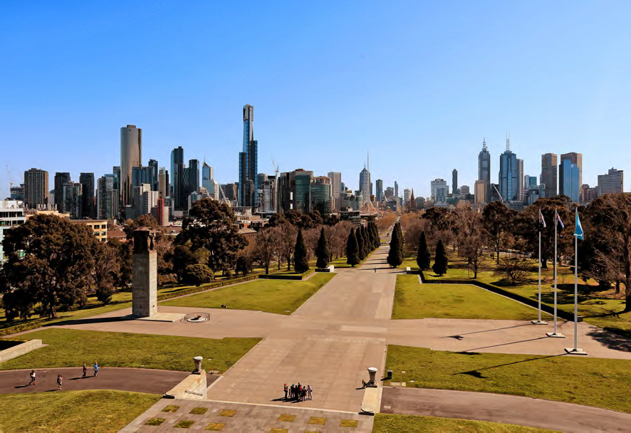
View from the Shrine of Remembrance to Melbourne CBD

Precinct 8 – Eastern Portal (South Yarra)
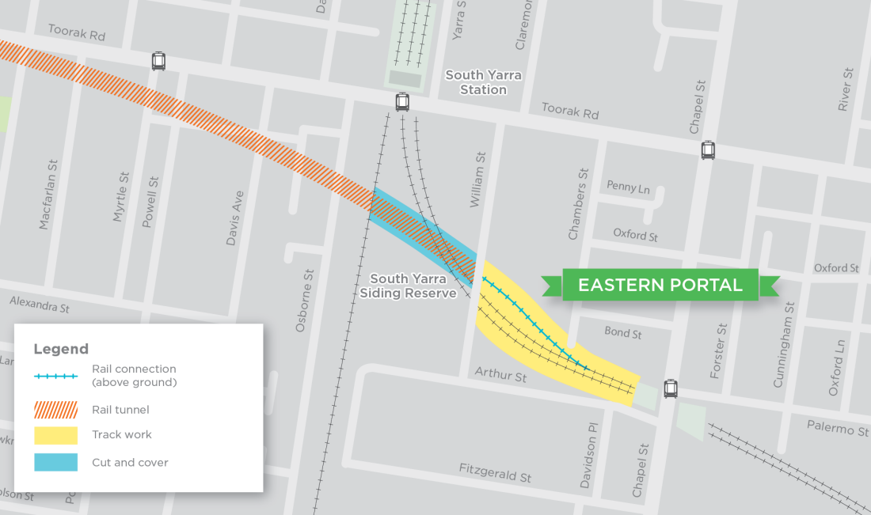
This highly urbanised precinct comprises mixed use development and a diverse range of housing types, from low density detached housing to large residential apartment blocks. The area borders one of Melbourne’s busiest retail and entertainment precincts, centred on Toorak Road and Chapel Street.

Concept Design
The eastern portal would connect the Melbourne Metro tunnels to the existing Dandenong rail corridor just west of Chapel Street. The portal includes the approach to the tunnels (the decline structure) and the tunnelling works that connect to the tunnels precinct (Precinct 1). Works would include:
- Cut and cover structure (under the Sandringham and Frankston Lines and a freight and regional line) and a decline structure to bring the Melbourne Metro tracks to the same vertical level as the existing rail corridor
- Turnouts at the tie-in to the Cranbourne/Pakenham Line to allow freight and regional services to travel along the existing surface city-bound tracks via Richmond station, while Cranbourne/Pakenham Line services access the Melbourne Metro underground alignment
- A TBM retrieval box located in the Osborne Street Reserve between Osborne Street and the existing Sandringham Line
- Permanent realignment of the existing Cranbourne/Pakenham and Frankston Line tracks between Toorak Road and Chapel Street.

Construction activities and work sites
The main construction activities in this precinct would be:
- Private property acquisition
- Early works, including the removal of trees, the relocation and protection of utilities, and land clearing
- Cut and cover excavation of the TBM retrieval box
- Widening of the existing rail corridor and construction of retaining walls
- Construction of a ventilation shaft, emergency access shaft and substation in Osborne Street Reserve
- Construction of a construction vehicle access bridge from Osborne Street to the construction work site in South Yarra Siding Reserve, to be converted to a pedestrian bridge post-construction
Less congestion and more frequent train services at South Yarra station
Once Melbourne Metro starts operating, only the Frankston and Sandringham Lines would stop at South Yarra station.
Cranbourne/Pakenham services would no longer go through South Yarra station, but through the Melbourne Metro tunnels. This would reduce congestion at the station and enable more frequent trains from Sandringham and Frankston into Flinders Street Station and the City Loop respectively.
- Retrieval of the TBMs from Osborne Street and the adjoining rail reserve
- Track works and installation of rail systems
- Site remediation, including landscaping and tree re-planting, and the reinstatement and upgrading of William Street bridge, South Yarra Siding Reserve, Osborne Street Reserve and Lovers Walk.
The South Yarra Siding Reserve and Osborne Street Reserve would be occupied temporarily as major construction work sites, housing site offices, staff amenities, materials laydown and equipment storage.
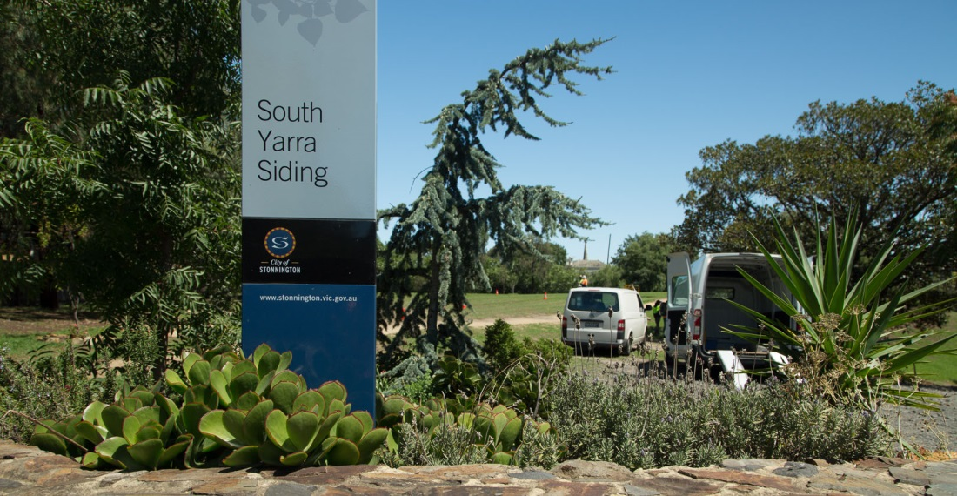
South Yarra Siding Reserve

Precinct 9 – Western Turnback (West Footscray)
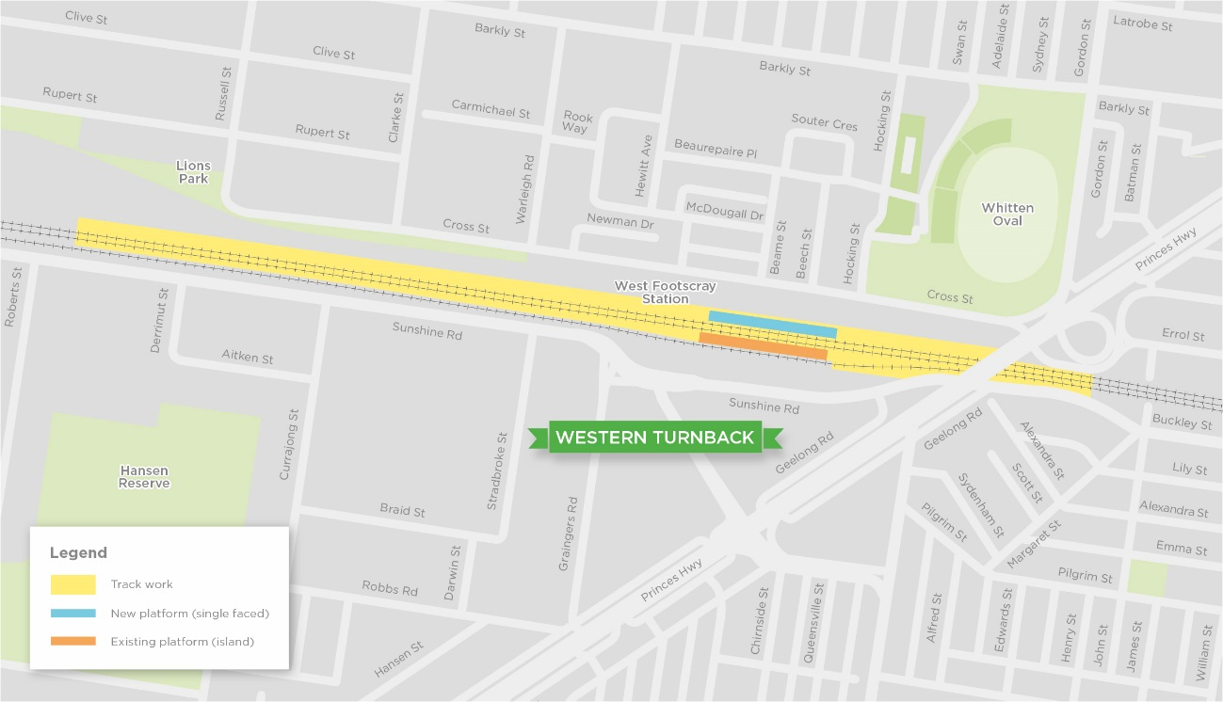
The western turnback would be located at West Footscray within the existing rail reserve. The precinct is dominated by rail infrastructure, with a commercial and industrial area to the south and residential areas and recreation facilities to the north.

Concept Design
The operation of Melbourne Metro would require some trains on the Sunbury Line to turn around at West Footscray and run back towards the CBD to optimise the efficient service of the Melbourne Metro corridor. The western turnback would be located within the existing rail reserve and require:
- Realignment of regional, suburban and freight lines
- Construction of new track and turnouts
- Construction of a third passenger platform at West Footscray station and modifications to the existing concourse.

Construction activities and work sites
All construction activities in this precinct would be carried out within Government owned railway land. Approximately 26 car parks would be occupied temporarily during the construction phase.

Benefits and Opportunities
Melbourne Metro would directly deliver substantial benefits to Melbourne and Victoria. There would also be opportunities to leverage further benefits from the ongoing operation of Melbourne Metro. The project’s potential transport, social, business and urban development benefits and opportunities are outlined below.

Transport Benefits
As the first major capacity upgrade of the inner core of the Melbourne metropolitan rail network in 30 years, Melbourne Metro would be the critical first step in enabling the independent operation of all lines and supporting the transformation of the rail network into a metro-style service.
On its first day of operations, Melbourne Metro would expand the capacity of the network, allowing over 39,000 additional passengers to travel in each of the morning and afternoon peak periods. Approximately one third of this increased peak period capacity would be delivered on the new Sunshine – Dandenong Line. The remaining capacity uplift would benefit lines operating via the existing network, using capacity released by the move of Sunshine – Dandenong Line services out of the existing City Loop into the new Melbourne Metro tunnels.
Over the longer term (after making further investments in the network), Melbourne Metro would provide the foundation for moving around 80,000 additional passengers in each peak period.
Other transport benefits as a result of Melbourne Metro would include:
- More reliable and more frequent train services
- Less crowded services, especially on the Sunbury, Cranbourne/Pakenham, Upfield, Craigieburn, Werribee and Williamstown Lines
- Enabling more people to travel from the suburbs to reach jobs and education in central Melbourne and other activity centres such as Sunshine, Footscray, Monash and Parkville
- Taking pressure off existing congested CBD stations, especially Flinders Street and Melbourne Central, by adding two new CBD stations
- Reducing crowding at the key inner city interchange stations of North Melbourne, Richmond and South Yarra
- Making it easier for customers to navigate the network by simplifying end-to-end service patterns
- Relieving the busy Swanston Street tram corridor and easing crowding on trams along Swanston Street, St Kilda Road and Elizabeth Street
- Providing the opportunity to move tram services to better align with jobs growth in the western end of the CBD
- Encouraging more people to shift from car travel to public transport, improving operating conditions on the road network.

Active Transport Connections
The construction of Melbourne Metro would provide opportunities to encourage walking and cycling. Improvements that would occur directly as a result of the project include:
- Station designs that accommodate high levels of pedestrian activity with a high degree of safety, comfort and amenity
- New shared use path in JJ Holland Park, Kensington
- Landscaping and tree re-planting to improve Grattan Street in Parkville as an attractive, pedestrian-friendly zone and on-road bicycle lanes on Grattan Street and the Royal Parade- Elizabeth Street corridor
- A re-design of Franklin Street in the CBD to maximise pedestrian space and amenity
- New pedestrian underpasses under Flinders Street to Flinders Street Station and Federation Square
- New pedestrian underpass on St Kilda Road, aligned with the new Domain station
- An upgrade to Lovers Walk in South Yarra to improve amenity for pedestrians
- New pedestrian bridge from Osborne Street to South Yarra Siding Reserve.
All Melbourne Metro stations would be fully compliant with the Victorian Disability Discrimination Act 2006, with specific consideration being given to disability access for Parkville station, including high capacity lifts at each station entrance. DDA-compliant tram superstops would be provided in Royal Parade and St Kilda Road.
Once operational, the new stations would provide opportunities for local councils to invest in pedestrian and bicycle infrastructure to encourage people to walk or ride to the stations as part of their journeys.

Social Benefits
Melbourne Metro would deliver a large social benefit to the wider community, as it would increase the capacity of the metropolitan transport network to cater to the anticipated growth in travel demand. This would enable people to continue to access jobs, education, services and valued places across Melbourne, as well as maintain their social networks, as the city grows.
Other potential social benefits provided by the project include:
- Improved access to wider Melbourne for the communities hosting new train stations
- Increased residential and commercial development opportunities and greater housing options in established inner urban areas
- Opportunities to reinvigorate areas adjacent to the new stations
- Better access to growing employment areas, such as the CBD, Parkville, Monash, Sunshine and Footscray
- Improved access to facilities such as hospitals and universities and valued places such as the Shrine of Remembrance and the Domain Parklands.

Business Benefits
The accessibility improvements delivered by Melbourne Metro would have significant implications for business activity in the expanded CBD and surrounds. Businesses would be able to locate outside the CBD, but still have ready access to the benefits it provides. They would have better access to customers, suppliers and professional services.
Businesses would also benefit from the new retail and commercial development opportunities that are likely to be created through higher density residential development in and around train stations and well-connected activity centres.
Improved accessibility for workers to the city centre would reduce commute times and travel time costs, impacting positively on labour output. This could widen the employee pool available to businesses in the expanded CBD, ensuring more appropriate matching of worker skills to jobs and increasing productivity. These improvements would improve business profitability and attract greater levels of investment into the city – driving further business and jobs growth.
Melbourne Metro would also be likely to transform the business mix of some areas, as improvements in accessibility spark shifts in the locational preferences of firms, particularly knowledge-intensive and creative firms.
Following the construction period, the number of jobs located in areas close to the new stations would be expected to increase gradually over time. The uplift in commercial development would be determined largely by the change that each station makes to the relative attractiveness of the district to residents and businesses, and the development potential of the area.

A Sustainable Project
MMRA is committed to achieving excellent environmental and sustainability outcomes throughout design, delivery and operation of Melbourne Metro.
Specific actions include:
- Embedding sustainability across all phases of the project to ensure sustainability is integrated throughout the project life cycle. MMRA has developed a sustainability policy and quantifiable sustainability targets that focus on climate resilience, resource efficiency, waste, water, sustainable procurement and workforce strategies.
- Actively monitoring and driving sustainability performance. MMRA will require the use of two key sustainability rating tools to benchmark and monitor performance against the sustainability policy and sustainability targets. These tools include the Infrastructure Sustainability Council of Australia’s IS rating scheme and Green Building Council of Australia’s rating scheme, which has been adapted for application to the 5 underground stations. MMRA aims to achieve a minimum ‘Excellent’ certified rating for ‘Design’ and ‘As-built’ with the IS rating scheme and a minimum 5 star ‘Design’ and ‘As-built’ rating for the stations.
- MMRA will maintain a Sustainability Management System that will be integrated into all project deliverables and activities.
While the construction of the project would require trees to be removed in a number of locations, as many mature trees as possible would be reinstated post-construction. In the Parkville station and Domain station precincts, tree reinstatement and new plantings would be undertaken in accordance with the City of Melbourne’s and City of Port Phillip’s Urban Forest Strategies.
All parkland impacted by construction activities would be returned to a condition that is equal to or better than its existing condition. There would be opportunities to significantly improve the landscape quality, amenity and tree canopy cover of a number of parks and reserves. This would include improvements to the Albert Road Reserve and the South Yarra Siding Reserve.

Urban Renewal and Development
Melbourne Metro would enhance connectivity across metropolitan Melbourne. By 2046, a significant convergence of population and jobs is anticipated in areas that have an improved ability to access economic activity across the city as a result of the project – with the west and north of Melbourne expected to see the biggest uplift.
By reshaping accessibility throughout the metropolitan area, Melbourne Metro would enable businesses to achieve higher levels of productivity. The greatest impacts would occur in the Arden, Parkville and Domain station precincts, as commercial and residential development is redirected to these areas due to their increased accessibility.
These improvements in connectivity and accessibility would potentially lead to a shift to higher value land uses in a number of locations, which would in turn attract new residents and businesses and create renewal and redevelopment opportunities. Potential opportunities include:
- Generating renewal and development in the Arden-Macaulay area – The Arden-Macaulay area is a major urban renewal area with the potential to accommodate significantly more residents, businesses and jobs over the next 30 years. The proposed new Arden station would support and facilitate this renewal.
- Supporting the Parkville research, medical and education precinct – Melbourne Metro would connect the Parkville research, medical and education precinct to the metropolitan rail network for the first time. Improving access to this area would make it an even more attractive location for businesses working in health, medical research, education and related areas, potentially boosting the already substantial health, social and economic benefits this precinct delivers to Melbourne, Victoria and Australia.
- Partnering with the University of Melbourne – Melbourne Metro would provide a direct opportunity to integrate the new Parkville station with future projects being planned by the university, including the redevelopment of the Faculty of Medicine building and the redevelopment of the former City Ford site on Elizabeth Street.
- Strengthening the development potential of the northern part of the CBD – The new CBD North station would support efforts to encourage more intensive development in the northern part of the CBD and make the area a more lively and attractive destination for residents, students, businesses and visitors.
- Creating new development opportunities around and over the new stations – The five new Melbourne Metro stations offer opportunities to develop new urban landmarks and precincts, and attract new residential and commercial development.
High quality urban design
The Urban Design Strategy developed for Melbourne Metro sets a high standard and quality of design for the entire project. The strategy aims to ensure that Melbourne Metro achieves urban design excellence that benefits rail passengers and local communities, creates attractive public spaces and supports integrated urban redevelopment.
The strategy includes best practice urban design principles, sets the key design directions for the project and describes the design outcomes and quality expected for Melbourne Metro. The strategy has a strong focus on providing a high calibre, welcoming and safe public realm around stations. It also applies good design practices to manage construction activities to maintain the amenity, vibrancy, economic activity and accessibility of surrounding areas and to protect valued features such as trees and monuments. The strategy directs Melbourne Metro to be ‘designed for the future’, with structures and features that can accommodate population growth, respond to climate change and that are durable and easy to maintain.
Specific elements to be incorporated into the Melbourne Metro station designs are:
- Buildings and open spaces of high design quality that set a benchmark and act as a catalyst for surrounding future development
- Integration with surrounding areas, ensuring high levels of accessibility between the station and nearby land uses
- Protection of the heritage qualities of nearby buildings and spaces
- Prioritising integrated, safe and high quality pedestrian routes
- Enhancing and increasing green space
- Incorporating water sensitive urban design initiatives and energy efficient technologies
- Integrating public art to enrich the experience for people using the spaces.
The contractor for Melbourne Metro would be required to comply with the Urban Design Strategy.

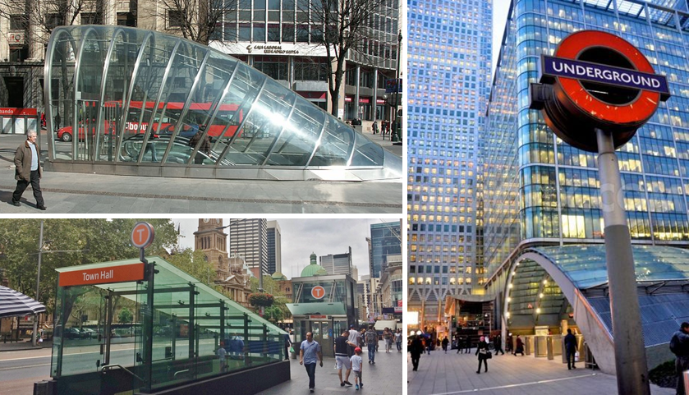
Examples of high quality urban design for train stations

Assessing Melbourne Metro’s Impacts
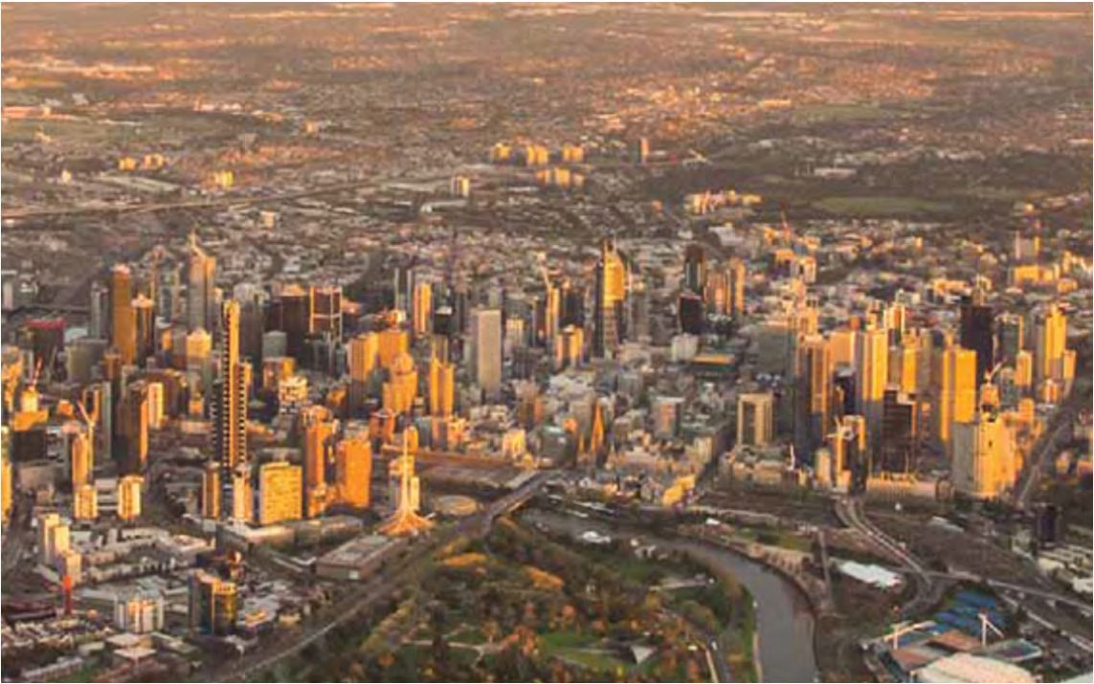
The progressive design and development of Melbourne Metro has resulted in a Concept Design that largely avoids major adverse impacts and provides significant benefits to Melbourne during the project’s operation. The key impacts arising from Melbourne Metro would occur during construction and have been the focus of the EES.
The specialist studies conducted for the EES assessed the project’s potential environmental and social risks and the likelihood of adverse impacts occurring across 18 disciplines, aligned with the Scoping Requirements set by the Minster for Planning.
Environmental Performance Requirements – which have been informed by possible mitigation measures – define the outcomes to be achieved to avoid, manage or mitigate the identified impacts. Achieving these Environmental Performance Requirements would result in a manageable number of adverse impacts occurring during the construction and operation phases of Melbourne Metro. Most of these impacts would be temporary and would occur during construction.
There would be opportunities to mitigate the remaining adverse impacts even further during the detailed design phase of the project.
The key impacts associated with Melbourne Metro are summarised below. Further details are provided in the main EES report and in the specialist impact assessments appended to the EES.

Transport
The Melbourne Metro alignment traverses a dense, inner city transport network that includes motorways, major arterial roads, key local roads, residential streets, railway lines, the city’s busiest tram corridor, high frequency and well-patronised bus routes, and major cycling trails and routes. However, as most construction and operational activities associated with Melbourne Metro would take place underground, the impacts of the project on traffic operations and transport connectivity would be minimised significantly.
The main construction-related impacts would be:
- The temporary closure of a number of roads for extended periods, which would have an impact on local traffic patterns, walking and cycling routes, and some bus and tram services
- Construction activity generating truck movements for removing excavated material and delivering materials and equipment, which would add to existing local traffic
- The presence of a large construction workforce, which would generate additional traffic that could impact the local and wider road network at times.
Managing and minimising these temporary impacts would be a critical component in the delivery of Melbourne Metro. The recommended Environmental Performance Requirements developed for the project would mandate the implementation of detailed traffic management plans for each precinct that would include measures to:
- Identify construction traffic routes for each precinct to move this traffic away from local areas to the arterial road / motorway network as quickly as possible.
- Divert road traffic away from construction work sites to alternative routes and encourage motorists to use the alternative routes
- Minimise truck movements during peak periods to reduce impacts on peak period traffic
- Minimise truck movements near residential areas at night time to reduce impacts on residents.
As a result, most of the transport connectivity risks associated with the project would be reduced to low or very low, and any delays and travel time increases associated with construction activities are not expected to be substantial.
However, the closure of Grattan Street (in the Parkville station precinct) and the closure of Domain Road and the reduction in St Kilda Road to one lane in each direction (in the Domain station precinct) during construction would have a potentially significant impact on traffic operations. Traffic would be encouraged to divert around these road closures and use alternative routes available in these locations.
Construction impacts on public transport operations would vary across the Melbourne Metro alignment. The most significant impacts would be the re-routing of the 401 and 402 bus services along Grattan Street (with associated longer travel times along these routes) and the re-routing of the route 8 tram from Domain Road to Toorak Road West.
The contractor for Melbourne Metro would be required to minimise any disruption to rail, tram and bus networks (in collaboration with PTV and service providers) and develop a communications strategy to advise road and public transport users of any changes to traffic conditions and public transport services.
Compared to other locations, there would be a higher number of truck movements in the three precincts where the major construction work sites would be based: the Tunnels (in relation to the proposed Fawkner Park construction work site), Arden station and Domain station precincts. While this traffic would cause some disruptions, the key access roads in the vicinity of the work sites in these precincts have sufficient capacity to accommodate the additional traffic, particularly as it would be spread across a number of routes. Daily traffic volumes on many of these roads are already very high and the additional truck movements generated by Melbourne Metro’s construction would represent a very small increase (of around one to two per cent) in traffic volumes. Trucks would then move out of the local area onto the arterial road and motorway network, with most of this activity occurring outside peak periods when these roads have adequate spare capacity to accommodate the additional traffic.
Impacts on walking and cycling routes during construction would vary across the Melbourne Metro alignment. The contractor would be required to minimise disruption to these routes, provide safe alternative routes around work sites, maintain walking and cycling access to train stations, bus stops, hospitals and other important destinations, and reinstate routes post- construction. In the two CBD precincts, the very high levels of walking and cycling mean that construction activities would need to be carefully managed to minimise disruption to pedestrians and cyclists, especially during peak periods. All existing bicycle lanes in the CBD would remain open. In the Domain station precinct, the high volumes of bicycle traffic along St Kilda Road during weekdays mean that cyclists would be travelling on lower standard facilities (such as temporary paths around work sites) during construction.
The contractors would be required to minimise disruption to car parking, provide alternative car parks where parking is lost due to construction activities, prevent construction vehicles from parking at undesignated locations on local roads and reinstate or offset car parking post- construction.
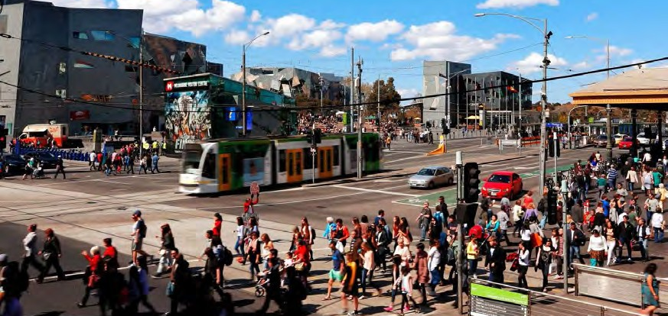
Existing view of the corner of Flinders Street and Swanston Street
The operation of Melbourne Metro would require a small number of permanent changes to the road network, with the main changes being:
- Grattan Street reduced to one lane in each direction between Flemington Road and Leicester Street (Parkville precinct)
- Permanent closure of part of Franklin Street between Swanston Street and Bowen Street (CBD North precinct)
- Reconfiguration of St Kilda Road, between Domain Road and Toorak Road to optimize the thoroughfare for all modes of transport (Domain precinct).
Following the adoption of the recommended Environmental Performance Requirements and proposed mitigation measures (such as the provision of advisory signs, diversion routes and replacement car parks), the risk of these permanent changes affecting transport connectivity has been assessed as low or very low. While there would be some increases in travel times and delays along parts of the road network in these areas, the overall network would continue to operate to acceptable standards.

Land Use and Planning
The main impacts associated with land use are related to the acquisition or temporary occupation of private property and public open space.
There would be a temporary loss of public space and parkland as a result of the project's construction, which would require the occupation of City Square in the CBD, a small part of Federation Square, part of University Square in Carlton, the Albert Road Reserve and Edmund Herring Oval in Melbourne, the South Yarra Siding Reserve and potentially part of Fawkner Park in South Yarra. This would affect users of these spaces and adjacent properties during construction, although access to and through these spaces would be maintained where possible.
At the end of construction, all parkland impacted by the project would be returned to a condition that is equal to or better than its existing condition. Reinstatement of areas would be carried out in accordance with the Melbourne Metro Urban Design Strategy.
There would be opportunities to improve the landscape quality, amenity, tree canopy cover and accessibility of a number of parks and reserves.
Land temporarily occupied during construction would be reinstated and redeveloped in accordance with the Urban Design Strategy and requirements of the relevant local planning schemes.
Where land is permanently acquired for a station entrance, such as in City Square and the Shrine of Remembrance Reserve, the areas would be small, located on the edges of these spaces and not compromise the overall use of the land for public open space in the longer term.
As most of Melbourne Metro's structures would be underground, this would be a benefit in itself as the project would deliver important transport benefits while avoiding many land use conflicts and built form impacts.
The new Arden station would present a significant opportunity to stimulate urban renewal in Arden- Macaulay, supporting the area's potential for growth as a major employment destination built around a high capacity public transport connection.
Melbourne Metro would also provide an opportunity for over-site development at the CBD North and CBD South station entrances. While any development proposed by the contractor would be subject to separate planning and approval processes, this would be an opportunity for a high quality built response that integrates with and complements the expansion of the transport network.
The land use and planning impact assessment conducted for the EES determined that the project's impact on the central Melbourne area, within the proposed project boundary, would be positive. This is due to the majority of land use and built form impacts being temporary in nature and the land use changes associated with Melbourne Metro providing benefits to existing land uses or having the potential to be reinstated post-construction.
Generating development in the Arden-Macaulay Urban Renewal Precinct
The Victorian Government and the City of Melbourne have identified the Arden-Macaulay area as a major urban renewal site with the potential to accommodate 25,000 residents and more than 43,000 jobs.
While a range of actions and interventions is required to facilitate urban renewal in the area, a new train station located at the heart of the precinct would present a significant opportunity to stimulate residential and commercial development.
Currently, a coordinated approach is underway to facilitate more intensive development in Arden-Macaulay, including preparation of a structure plan (led by the Metropolitan Planning Authority), development of an integrated flood management and development scheme, and finalisation of the Arden-Macaulay Partnership Blueprint between the Victorian Government, City of Melbourne, Department of Education and Training, Office of Housing, VicTrack and other major land owners and stakeholders in the precinct.
The new station would support these efforts and strengthen Arden-Macaulay’s potential to become one of Australia’s premier transit-oriented developments. Additional rail access, combined with integration with other transport modes, would result in Arden-Macaulay having ‘CBD like’ levels of accessibility to the broader Melbourne labour market, increasing the attractiveness of the area to investors.
With Melbourne Metro connecting Arden-Macaulay directly to major health and education institutions in Parkville and the CBD, the precinct would also offer opportunities for business and jobs growth focused around high value knowledge sectors.

Social and Business
While Melbourne Metro traverses a highly urbanised, densely populated and diverse area, most of the project’s construction and operational activities take place below ground – meaning that a range of social and business impacts can be avoided. However, some activities would interact with social values and the community in a number of places, particularly where there are significant surface construction activities proposed.
Once Melbourne Metro is operational, many of these interactions would result in benefits to, or generate opportunities for, local communities and the broader metropolitan area. Notably, the project would benefit users of the wider transport network and enable the community to continue accessing employment, social infrastructure, valued places and wider social networks.
Without Melbourne Metro (and other projects designed to increase the capacity of Melbourne’s transport network), it is likely the community would face a deterioration of social opportunities as projected population growth outstrips road and rail capacity and transport networks find it increasingly difficult to keep pace with rising travel demand.
Private land acquisition
A limited number of residential and commercial buildings would need to be acquired to enable construction of the project.
Across the entire alignment, up to 19 residential buildings (including an apartment block with 49 separate titles) and 32 commercial buildings would need to be acquired permanently.
Residential buildings would only need to be acquired adjacent to the tunnel entrances (Kensington and South Yarra) and in the CBD North station precinct.
Commercial building acquisition would result in up to approximately 90 businesses having to relocate. This would include around 60 businesses in the CBD along Swanston Street, La Trobe Street and Flinders Street, and in Port Phillip Arcade. No businesses would be displaced in the Domain, South Yarra and West Footscray areas.
While the impacts on these business owners and their employees could be significant, most of these businesses would be likely to relocate within or near to their existing locations and retain their employees.
Across the Melbourne Metro alignment, underground strata (the part of the land that is beneath the surface and buildings) would need to be acquired from up to 3,500 titles where the train tunnels would pass beneath properties. The property at surface level is not required in this type of acquisition.
Landowners and tenants with an interest in buildings and land being acquired (including strata acquisition) would be compensated in accordance with the Land Acquisition and Compensation Act 1986.
MMRA would provide a high level of assistance to displaced businesses, including help with finding new premises and with the logistics of relocating, and assistance with signage, advertising and other requirements arising from a changed business location and address.
While the wider community would benefit from Melbourne Metro when it is operational, there would be adverse impacts during construction. These impacts relate to private property acquisition, temporary amenity impacts (such as traffic disruption, noise, vibration and dust emissions), loss of access to public spaces and the temporary modification of valued streetscapes along sections of St Kilda Road, Royal Parade and Grattan Street. Amenity impacts would be managed in accordance with the outcomes defined by the Environmental Performance Requirements.
While the Concept Design developed for Melbourne Metro has minimised the amount of private land acquisition required for the project, the impacts of acquisition on individual landowners, households, tenants and businesses would potentially be significant.
In addition to the businesses displaced as a result of the acquisition of commercial buildings, the construction of Melbourne Metro would potentially disrupt businesses in close proximity to work sites as a result of changed amenity and traffic conditions, reductions in passing foot traffic and constrained access for customers, deliveries and staff.
The operations of some businesses in the CBD would be disrupted to a significant extent during construction, with those located at or near City Square, in Scott Alley and around the Flinders Street and Swanston Street intersection likely to experience the greatest disruption. Depending on the nature and location of the business, disruption could occur as a result of less foot traffic, reduced access to customers or noise and dust impacts.
Businesses in the Parkville station precinct could also experience higher levels of disruption than in other precincts due to the large number of businesses in the area that rely heavily on passing foot traffic for a proportion of their sales and the presence of the University of Melbourne, hospitals and medical research facilities that have particular access needs and operate sensitive equipment.
Measures would be taken to support businesses in close proximity to construction activity, including providing signage indicating they remain open, keeping businesses informed about planned construction activities and maintaining access for customers, deliveries and waste removal. In all precincts access would be maintained for delivery vehicles, services and workers to maintain operation. In the Parkville precinct, access to hospital emergency departments would be maintained at all times.
In some precincts, the large number of workers present on a daily basis during the construction phase would generate demand for goods and services that may benefit local retail, food and beverage businesses. Local businesses may also be able to provide some of the materials and services required for the construction, maintenance and operation of Melbourne Metro.
While a rail project of the scale of the proposed Melbourne Metro has not been undertaken in Melbourne since the City Loop, there have been many recent large construction projects that can be used to help understand the potential business impacts from Melbourne Metro. These projects have generated disruptions (such as noise, dust and changes to traffic and pedestrian movements), but surrounding businesses have continued to operate.

Air Quality
Air quality is a key factor that contributes to the amenity of an area. Melbourne Metro is located in an area with high traffic levels and where major projects are often underway in different stages of development, which contribute to existing air quality impacts. A key requirement for Melbourne Metro is to minimise additional impacts on air quality that could affect the community in which the project is located.
Above ground construction activities would generate dust, with the greatest temporary impacts likely to occur at locations where the largest volumes of material would be excavated and transported (the major construction work sites at Arden station and Domain station, and potentially Fawkner Park). Management of air emissions would also be particularly important at sensitive receptors, such as hospitals and medical research institutes close to construction work sites in the Parkville station precinct.
The contractor for Melbourne Metro would be required to develop and implement a dust management and monitoring plan, in consultation with EPA Victoria, to minimise and monitor the impact of construction dust. The plan would include the use of well-tested measures across all construction work sites, such as minimising the extent of spoil stockpiles, applying water to unsealed surfaces to suppress dust, sealing surfaces where possible, covering trucks and stockpiles, minimising double handling of material, re-vegetating areas of disturbed soil as soon as practicable and modifying activities according to weather conditions.
Dust monitoring would also be undertaken at key sensitive receptors such as hospitals, hotels and residences close to the major construction work sites to ensure compliance with the air quality criteria set for the project.
As Melbourne Metro would use electric trains, air emissions associated with the routine operation of the project would be insignificant.
Regional air quality impacts due to the operation of the project were also found to be insignificant, although Melbourne Metro could be assumed to indirectly result in a marginal improvement in regional air quality through people shifting from using their cars to travelling by train.
The impact assessment undertaken for the EES demonstrated that Melbourne Metro would be constructed and operated in compliance with applicable air quality regulatory standards and best practice guidelines.

Noise and Vibration
As a large, busy and dynamic city, Melbourne hosts a range of activities – such as major construction projects, heavy vehicle traffic, train and tram operations and outdoor events – that generate varying types and levels of noise and vibration. The construction and operation of Melbourne Metro would occur within this context.
The extent of noise and vibration impacts associated with Melbourne Metro would depend on a range of factors. Some factors would be influenced by the project (such as the construction methods adopted and the mitigation measures implemented). Others would depend on the sensitivity of the receiver to noise and vibration impacts (such as the structural condition of an affected building or the nature of the activities undertaken on a particular site).
Guideline targets for noise and vibration have been set for Melbourne Metro’s construction and operation to minimise adverse impacts on residents, communities, structures and sensitive equipment and areas, as far as practicable. Well-tested construction methods and management processes would be used to meet these targets. Where levels of noise and vibration are predicted to be higher than the targets, additional management actions would be taken to reduce impacts. These actions could include close liaison with potentially affected receivers, modifying construction methods, additional vibration attenuation and offering temporary respite accommodation in particular circumstances. Detailed community consultation would be undertaken during construction in areas predicted to be affected.
Levels of vibration during construction are predicted to comply with the structural guideline targets. Accordingly, no structural damage to buildings and structures is anticipated due to vibration arising from the construction of Melbourne Metro. Property condition assessments and ongoing vibration monitoring would provide the basis for managing potential structural damage.
There are anticipated to be relatively short periods during construction when additional management actions would need to be taken to address impacts to human comfort as a result of vibration and ground-borne noise. Over the course of the construction program for the tunnels and stations, the most-affected sensitive receivers (those located immediately above or in very close proximity to the tunnel alignment) may experience vibration levels above the guideline targets for approximately 10 days on two occasions as the TBM for each tunnel passes by. As roadheader-mined tunnels progress more slowly than TBM-bored tunnels, sensitive receivers at a limited number of locations within the CBD may experience vibration levels higher than the targets on one occasion of up to 32 days.
Vibration and ground-borne noise would also be generated by roadheader excavation of the station caverns. Guideline targets for human comfort may not be met at several locations in the CBD for periods of up to six weeks, up to three times over the course of station cavern construction.
Specific guideline targets have been set for construction activities in close proximity to the healthcare and education institutions within the Parkville and CBD North station precincts. These institutions support uses, and contain equipment, that are highly sensitive to the impacts of vibration and ground borne noise. A comprehensive management response, including consultation with affected stakeholders, would be implemented to ensure that impacts of construction at these locations are managed appropriately.
Airborne noise generated by construction activities would be managed in accordance with the applicable EPA Victoria guidelines, which are based on protecting residential premises from unreasonable noise. Construction is expected to be audible at times but – with appropriate mitigation – is not anticipated to give rise to unreasonable impacts on nearby residents in any of the Melbourne Metro precincts.
Once Melbourne Metro is operational, airborne noise during operation would only be experienced as trains enter and exit the tunnel portals and at the western turnback. The effects of this noise would be mitigated where required through permanent treatments (such as noise walls) in accordance with the Victorian Passenger Rail Infrastructure Noise Policy. The long-term noise and vibration effects of Melbourne Metro are predicted to be low to negligible.

Historic and Aboriginal Heritage
Melbourne Metro would extend through areas of dense and constrained urban environments with high concentrations of heritage places including buildings and structures, sites, gardens and other landscapes, precincts and archaeological sites. In this context, it is almost inevitable that the construction activities and permanent infrastructure would interact with places of heritage significance and archaeological sites.
Melbourne Metro has been developed to avoid impacts on significant historic buildings and places where practicable. There would be no direct impacts on state significant heritage places such as the City Baths, the State Library of Victoria, St Paul's Cathedral, Princes Bridge, Young and Jackson Hotel, Melbourne Town Hall or the Shrine of Remembrance.
Interactions with sites of heritage or archaeological significance include:
- Demolition and alteration of heritage places – A number of buildings could be demolished that are locally listed in heritage overlay precincts or on individual listed sites. Construction would also require the removal of some significant trees within heritage places, although these could be replanted. A number of heritage places would be altered as a result of their interface with the new permanent Melbourne Metro infrastructure and this could result in an adverse impact on the heritage values of these places. Multiple historical archaeological sites would be impacted, particularly in the central city.
- Vibration and ground settlement affecting the fabric of heritage buildings – There would be potential impacts on the fabric of heritage places as a result of vibration and/or ground settlement in proximity to construction works. These impacts would be modelled and managed throughout the project's construction phase.
- Visual impacts as the result of the introduction of permanent infrastructure – Where permanent above-ground structures would be constructed, there would be the potential for adverse impacts on the heritage value of the affected or any nearby heritage place through the juxtaposition of a new built form of contrasting or atypical form. To mitigate these impacts, design refinements would give consideration to the heritage context and values of places in proximity to new Melbourne Metro structures. These impacts would also be managed through compliance with the Melbourne Metro Urban Design Strategy.
Overall, the impact assessment conducted for the EES concluded that the potential historical cultural heritage impacts of the Melbourne Metro are acceptable and would be appropriately managed, especially when considering the scale, location and complexity of the project.
The Melbourne Metro alignment covers an area that historically had a rich and extensive history of Aboriginal occupation. However, there has been significant ground disturbance and development over many decades that has significantly reduced the presence of Aboriginal cultural heritage along the alignment. Throughout the construction phase of Melbourne Metro, the main Aboriginal heritage impact would be disturbance or removal of unknown Aboriginal cultural heritage values within sub-surface construction works. This could occur where construction is within natural soil deposits that may not have been disturbed.
A Cultural Heritage Management Plan (required under the Aboriginal Heritage Act 2006) has been prepared alongside the EES in consultation with the Office of Aboriginal Affairs Victoria and the Traditional Landowners. This Cultural Heritage Management Plan assesses the potential impact of the project on Aboriginal cultural heritage values and outlines measures to manage and protect Aboriginal cultural heritage discovered during construction. No impacts to Aboriginal cultural heritage are envisaged from the operation of Melbourne Metro.
Opportunities to enhance heritage values would include conservation works (where structures need to be protected or relocated) and the development of a heritage interpretation strategy for Melbourne Metro as a whole that would include recognition of historical and Aboriginal cultural heritage themes and places in the design of the new stations.

Landscape and Visual
While Melbourne Metro would have a substantial construction footprint, the landscape and visual impacts of this footprint would be ameliorated by a large proportion of construction activities being carried out underground. A small number of locations in close proximity to surface construction sites and activities would experience high level landscape and visual impacts during the project’s construction phase. These temporary impacts would mainly be the result of tree removals, overlooking of work sites from elevated viewpoints or where views would be obstructed by construction work sites and activities.
An Urban Design Strategy has been developed to manage landscape and visual impacts during construction and to set a high standard and quality of design for the entire project.
While aesthetic hoardings and other measures would mitigate construction impacts at ground level, medium to high temporary visual impacts would occur at a number of locations, most notably:
- The University of Melbourne, the Victorian Comprehensive Cancer Centre and University Square in Parkville
- High rise residential apartments and hotels with views over construction sites in the CBD
- City Square in the CBD
- Views to St Paul’s Cathedral, Flinders Street Station and Federation Square in the CBD
- Views along Swanston Street and St Kilda Road to the Shrine of Remembrance
Tree removal and replacement
A broad range of tree species, including native and exotic, would be potentially impacted by Melbourne Metro. The project would adopt a keen focus on protecting trees in construction zones, with a view to minimising the numbers that need to be removed where possible.
Within the eastern portal precinct, the trees that would likely be removed are largely introduced and comprise numerous sucker weeds. In the Arden station precinct, there are numerous native trees within the publicly owned land managed by VicTrack that is currently used for light industrial purposes. Around 20 per cent of these trees have been assessed as reaching their Useful Life Expectancy (ULE) within 10 years.
In the remaining precincts, the trees are largely introduced exotic plantings contained in boulevards such as Royal Parade and St Kilda Road, and in parklands such as the Domain Parklands.
Up to around 900 trees could require removal during Melbourne Metro’s construction phase - although this number would reduce under some options being considered. Of these trees, nine palm trees could be suitable for relocation. Around half the trees likely to be removed within the public realm are either juvenile trees that do not contribute strongly to the biodiversity of the region, or trees that have been assessed as over-mature or in decline and already likely to be subject to removal within the timeframe of the construction phase of the project.
In recognition of the significant contribution trees make to Melbourne's public realm, measures would be taken to re-establish canopy cover, restore the continuity of tree-lined avenues and reinstate trees in public open spaces as quickly as practicable. In some places, tree re- planting could commence during the construction period.
- Residences adjoining South Yarra Siding Reserve and Lovers Walk in South Yarra.
Melbourne Metro would involve the removal of trees associated with the construction of the stations, emergency access shafts and the eastern and western tunnel portals. The landscape and visual impacts caused by the removal of trees would be high in some locations – particularly in the Parkville station precinct, where trees would be removed from sections of Grattan Street and Royal Parade, and in the Domain station precinct, where trees would be removed from sections of St Kilda Road and Albert Road.
The restoration of parkland, the integration of Melbourne Metro’s permanent above ground structures and station entrances into their surrounding environments and the remediation of construction work sites would restore these views post-construction and ensure that ongoing landscape and visual impacts would be low. This includes the restoration of views down Swanston Street towards the Shrine of Remembrance.
Post-construction, high quality design in accordance with the Melbourne Metro Urban Design Strategy and compliance with the Melbourne Planning Scheme would ensure that over-site development at CBD North and South stations does not have major adverse impacts on nearby apartments or the heritage buildings in the CBD.
The Urban Design Strategy will require all surface structures to be of a high quality design and finish, integrate with their location and settings, and have appropriate footprints. The design of Melbourne Metro would also take into account neighbourhood character and the local community’s aspirations for each precinct as set out in the relevant planning polices and strategies, and identified through consultation with local councils and other stakeholders.
Recreational areas would be affected by the temporary occupation of public open space during construction, including Edmund Herring Oval and possibly Fawkner Park in the Domain station precinct and South Yarra Siding Reserve and Lovers Walk adjacent to the eastern portal. The Environmental Performance Requirements would require the contractors to explore opportunities to provide alternative public open space during construction, where possible. Recreational areas would be reinstated and enhanced and in accordance with the Melbourne Metro Urban Design Strategy.

Surface Water
There would be no direct impacts on water quality or flows in the three major waterways traversed by Melbourne Metro. Crossing beneath the Yarra River and Moonee Ponds Creek would be via bored tunnels and there would be no direct impacts on these waterways. The construction footprint does not cross the Maribyrnong River and there would be no construction activity in the immediate vicinity of the riverbank.
Protecting the tunnels, portals and stations from flooding
The underground components of Melbourne Metro would potentially be subject to flooding during large flood events or very high rainfall events.
While these events are rare, the tunnels, portals and stations would be designed to provide protection against flooding during construction and operation. Proposed protective measures include:
- Constructing barriers to intercept overland surface water flows and divert them away from excavation sites and cavern entrances
- Using retaining walls or similar barriers to protect the portals from flooding during construction
- Raising station entrances to be well above the expected flood levels during the life of the project
- Developing emergency measures to manage the impacts of larger flood events, including a flood warning system and emergency evacuation procedures.
During Melbourne Metro’s construction, there would be exposed surface areas at construction work sites. During high volume rainfall events, runoff from these surfaces could affect water quality in waterways via stormwater drainage systems. Standard construction site management practices – including minimising the area of exposed ground, isolating site runoff from the existing drainage system and bunding (using retaining walls and similar structures) – would minimise the risk of contaminated runoff entering the stormwater drainage system.
Once Melbourne Metro is operational, drainage runoff from permanent above ground structures (such as the station and tunnel entrances) would be discharged into existing local drainage systems. The rate at which this runoff is discharged would be controlled. The impacts of stormwater runoff from structures across the alignment would be minimised by collecting runoff and treating it to EPA Victoria and Melbourne Water standards before discharge to receiving waterways.

Adopting water sensitive design principles and meeting EPA Victoria requirements in the design of the project’s stormwater treatment system would minimise the potential impacts of Melbourne Metro’s operations on surface water quality.

Groundwater
Groundwater would be encountered across almost the entire Melbourne Metro alignment. Most of the tunnels, stations and other underground structures would be located below the watertable. Excavation below the watertable provides a pathway for groundwater to seep into the excavations and result in groundwater drawdown during construction and operation unless tanking (sealing to minimise groundwater inflow) of the excavations is undertaken to reduce groundwater inflow to negligible rates. Groundwater drawdown can potentially cause ground settlement or the movement of contaminant plumes or affect groundwater dependent ecosystems.
The groundwater impact assessment found that existing groundwater quality within the proposed project boundary is variable, with high salinity levels in the west and some known groundwater contamination plumes along the alignment. The assessment undertaken for the EES has been informed by detailed groundwater modelling to assess the potential effects of groundwater drawdown and movement.
The key potential impacts of Melbourne Metro on groundwater arise from the tunnels, stations and other sub-surface infrastructure being located below the watertable.
Excavations would be tanked prior to completion of construction and the bored tunnels would be tanked as the TBMs progress, so groundwater inflows to excavation areas would be negligible. For any mined sections of the tunnels and other excavations, the drawdown would be short- term and groundwater levels would recover after tanking of the structures. As all proposed tunnels and station structures associated with Melbourne Metro would be tanked for operation, groundwater drawdown would be insignificant post-construction for all structures.
Impacts to groundwater levels during the construction of Melbourne Metro from dewatering (the process of moving unwanted water away from a construction site to create dry working areas) would be temporary and localised. Mitigation measures such as tunnel grouting and temporary recharge bores (to enable injection of water into the aquifer) would avoid significant drawdown impacts. Compliance with the Environmental Performance Requirements would prevent significant adverse impacts to regional groundwater from the construction or operation of Melbourne Metro.
The removal, storage and transport of groundwater (especially in areas with known groundwater contamination) would be carried out using best practice treatment, management and disposal measures and in accordance with Melbourne Water’s specifications and requirements.
The Environmental Performance Requirements for the project would require the contractor to undertake further detailed groundwater modelling based on the final detailed design to demonstrate that ground drawdown would be minimised and impacts managed acceptable levels.

Ground Movement and Land Stability
The Concept Design for Melbourne Metro has been informed by a substantial amount of geotechnical investigation. Detailed modelling of the potential ground movement impacts has demonstrated that the project can be constructed and operated with negligible to minor effects to buildings, civil infrastructure, utilities or the natural environment. Negligible to minor impacts on buildings are defined as no damage or at worst, aesthetic damage, comprising hairline or visible small cracks that can be treated during normal decoration or where some external repointing could be required.
The impact assessment conducted for the EES concluded that any excavation-induced ground settlements associated with the Melbourne Metro tunnels would be small and unlikely to cause major distress to nearby surface or underground structures.
Ground movement impacts would be minimised by adopting sound engineering practices, including excavation support systems, appropriate controls on TBM operations and ground improvement measures at some locations.
The Environmental Performance Requirements for the project would require the contractor to undertake further modelling based on Melbourne Metro’s final detailed design to demonstrate that predicted ground movements would be minimised to acceptable levels. Detailed condition surveys of potentially affected structures would also be conducted prior to construction commencing. These surveys would confirm that predicted ground movements would be acceptable or identify the need for further mitigation measures to ensure there would be no impacts worse than minor.
In addition, the contractor would be required to undertake comprehensive ground movement and groundwater monitoring programs from the start of construction and to prepare contingency plans to manage any issues that may arise during construction.

Contaminated Land and Spoil Management
Major tunnelling projects in urban environments have the potential to encounter contaminated soil, rock and groundwater – the legacy of many years of commercial and industrial development combined with poor environmental management and waste disposal practices in the past. Melbourne Metro is no exception, with many known and potentially contaminated sites along or near the proposed project boundary.
Most of the spoil material generated from the construction of Melbourne Metro would be ‘clean fill’ (material that can potentially be re-used or recycled). In all precincts where excavation and tunnelling activities would occur, there would be very limited opportunities to reuse this clean fill on-site, so most spoil would have to be removed off-site. However, this material could be directed for reuse at another site in accordance with EPA Victoria guidelines.
The urban and industrial history of the areas through which the alignment would pass − and the prevailing geological conditions − increases the likelihood of the project encountering hazardous waste and asbestos containing materials. Construction at depth and crossing waterways would also generate acid sulfate soils and rock. The excavation, storage, management and disposal of these materials would be undertaken in accordance with EPA Victoria and WorkSafe Victoria guidelines.
Well-tested construction techniques and management processes would be used to mitigate and avoid the potential impacts of encountering gases and vapours during construction and operation and to protect the durability of buildings and structures from sources of contamination.
The Environmental Performance Requirements would mandate development and implementation of a management plan for spoil and other wastes generated through construction. MMRA’s draft Spoil Management Strategy (provided in this EES) identifies the estimated volumes and categories of spoil from construction in each precinct and outlines potential measures to store, classify, treat and dispose of spoil. Management of spoil has been taken into account in the transport, air quality and surface water impact assessments.
The health and safety of construction workers would be protected in accordance with Commonwealth and Victorian laws and policies, and with EPA Victoria and WorkSafe Victoria requirements.
The impact assessment conducted for the EES demonstrated that achieving the recommended Environmental Performance Requirements would reduce all contaminated land risks associated with the project to low or very low ratings.

Biodiversity
The highly developed urban area along Melbourne Metro’s proposed alignment means that most areas have a long history of disturbance and have been cleared of native vegetation.
No threatened flora species are present within the proposed project boundary.
The Domain station and eastern portal precincts are the only areas where threatened fauna species are known to be present. In the Domain station precinct, the Grey Goshawk, Powerful Owl and the Grey-headed flying fox may forage in some of the larger mature trees in the area. Similarly, in the eastern portal precinct, the Grey Goshawk and the Grey-headed flying fox may forage in larger trees when they are flowering. However, as all three species are highly mobile and similar habitat is present throughout the Royal Botanic Gardens and in parks and backyards throughout suburban Melbourne, Melbourne Metro would have a negligible to minor impact on these species.
Flora and fauna values would also be protected by Environmental Performance Requirements that would ensure any water entering stormwater drains or surface water bodies is of acceptable quality.
In the Arden station precinct, a small number of scattered indigenous trees would need to be removed from the proposed station site. These trees are unlikely to be remnant vegetation and their loss is considered to have a negligible consequence in relation to biodiversity. However, suitable offsets would have to be provided in accordance with Victoria’s Biodiversity Assessment Guidelines.

Greenhouse Gas
Carbon dioxide (CO₂) is considered to be the most important greenhouse gas (GHG) contributing to climate change, being responsible for approximately 77 per cent of total global GHG emissions, primarily from fossil fuel use. CO₂ is the most significant GHG associated with Melbourne Metro, with major sources of CO₂ emissions likely to be indirect emissions associated with the consumption of purchased electricity during the project’s construction, and indirect carbon emissions associated with embodied carbon in construction materials.
Best practice GHG avoidance, reduction and mitigation measures would be incorporated into the construction and operation phases of Melbourne Metro, including the use of building products with less embodied carbon and the purchase of accredited GreenPower. With the adoption of these measures, Melbourne Metro would contribute to a slight increase in transport GHG emissions over time (largely due to the relatively high energy requirements to operate the extended 10-car HCMTs that would commence operating after the first several years of the project).
Overall, Melbourne Metro would have a negligible impact on regional GHG emissions and GHG emissions from the project would be likely to reduce further as a result of the ‘greening’ of the electricity grid in Victoria over the next 30 years.
By 2046, Melbourne Metro is expected to remove 281.8 million VKTs (vehicle kilometres travelled) of cars and, as a consequence of more direct routes being made available following removal of those VKTs, nearly 4.4 million VKTs of trucks from Melbourne roads each year. This is due to people opting to travel by train rather than by motor vehicle. This equates to a substantial reduction of road transport GHG emissions (compared to a scenario where Melbourne Metro is not constructed).
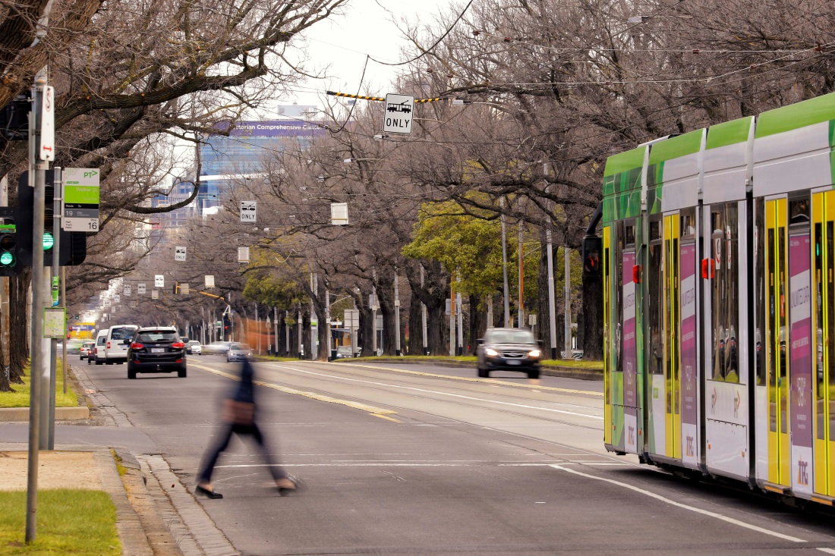
Royal Parade, Parkville

Delivering Melbourne Metro
The Victorian Government has announced that Melbourne Metro would be procured through four separate works packages:
- Early works – A Managing Contractor approach (where a head contractor is responsible for overseeing delivery of the works) would be used for utility service relocations and the preparation of construction sites. Yarra Trams would deliver tram infrastructure works via a Project Agreement. Separate agreements would be entered into with individual utility service providers to provide construction power for the project.
- Tunnels and stations – Construction, operation and maintenance of the tunnels and stations would be procured using a Public Private Partnership (PPP). A PPP is a long-term service contract between the Government and a private party (usually a consortium) to deliver infrastructure and related services over an agreed period of time and to specified standards.
- Rail infrastructure – Rail infrastructure works at the eastern and western portals would be procured via a Competitive Alliance, where the Government would collaborate with one or more parties to share risks and responsibilities during construction.
- Rail systems – A Competitive Alliance would also be used to procure the design, installation, integration and commissioning of the rail systems for Melbourne Metro.
A project authority appointed by the Minister for Public Transport, with MMRA's support, would deliver the project using the delivery powers of the Major Transport Projects Facilitation Act 2009, which include commissioning transport infrastructure that needs to be developed as part of the project, closing roads to traffic and realigning roads, acquiring public and private land (including below ground stratum) and managing the interface with utilities.
At the completion of construction and project commissioning, Public Transport Victoria would become responsible for the ongoing operation and maintenance of the train services and infrastructure delivered by the project, other than any infrastructure which is to be operated and maintained by the PPP Contractor for the term of the PPP Contract. The metropolitan rail franchisee, currently Metro Trains Melbourne, would operate the train services using the proposed Melbourne Metro infrastructure.
Project timelines
The overall duration of Melbourne Metro, from award of the main contract to commencement of passenger services, would be approximately 10 years. Anticipated key milestones are:
2016 / 2017 – Early works (following planning approvals)
2017 – Tunnels and stations contract awarded
2022 / 23 – Civil and structural works at stations, portals and tunnels completed
2024 / 25 – Station fit out and installation of rail systems completed
2025 – Systems integration and operational readiness completed
2026 – Commencement of passenger services

Managing impacts
Melbourne Metro would be designed, constructed and operated in accordance with the Environmental Management Framework (EMF) documented in this EES, which will be endorsed by the Minister for Planning following assessment of the EES. The EMF is a transparent framework that outlines the accountabilities for managing the environmental aspects of the project and avoiding or minimising potential impacts. The EMF incorporates the recommended Environmental Performance Requirements that are exhibited as part of this EES.
A project-specific Environmental Management System (EMS) would be developed consistent with relevant Australian standards and aligned with MMRA’s Sustainability Policy and Environmental Policy. The EMS would ensure monitoring, reporting and compliance with the Environmental Performance Requirements, the EMF and relevant Victorian legislation, standards and guidelines.
The contractors delivering the project would be required to comply with the EMF and develop, implement and maintain an EMS for the design, construction and operation phases of the project. The EMF requires Construction Environmental Management Plans (CEMPs) and Site Environmental Implementation Plans (SEIPs). These plans would set out in detail how the contractors would meet the Environmental Performance Requirements and manage and mitigate environmental risks during design and construction.
MMRA would review, approve and audit compliance with the CEMPs and SEIPs for the early works, rail infrastructure and rail systems elements of Melbourne Metro. Compliance by the PPP contractor for the tunnels and stations would be audited and approved by an independent reviewer and auditor, with audit reports provided to MMRA, the Minister for Planning and relevant regulators and agencies. All major revisions to the EMF and CEMPs would be approved by MMRA.
Compliance with the Environmental Performance Requirements approved for the project would be assured through the EMF having regulatory status as a condition of the Incorporated Document proposed under the planning scheme amendment for Melbourne Metro. The EMF would inform all of MMRA’s contractual arrangements for the delivery of Melbourne Metro and the relevant Environmental Performance Requirements would be contractual requirements for all contractors.
The specialist impact assessments undertaken for the EES have identified potential mitigation measures to avoid, reduce or manage environmental impacts. These measures are current and commonly adopted mitigation measures, and have been taken into account when developing the Environmental Performance Requirements. The contractors may adopt these measures or may choose to use additional or different measures, provided they achieve the Environmental Performance Requirements.
The EMF and the recommended Environmental Performance Requirements would be updated by MMRA prior to awarding the Melbourne Metro contracts to ensure all requirements specified by the Minister for Planning as a consequence of the EES and the subsequent planning scheme amendments are included.

Engaging with the Community and Stakeholders
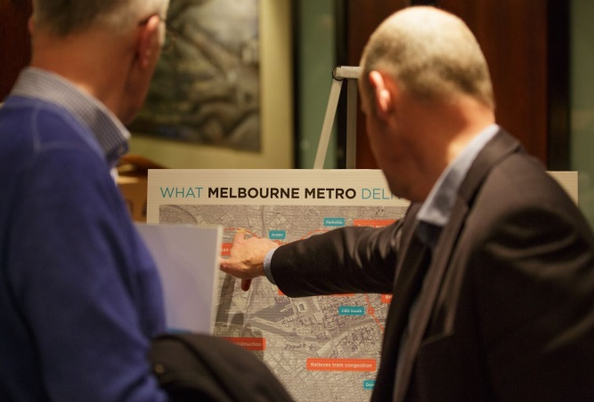
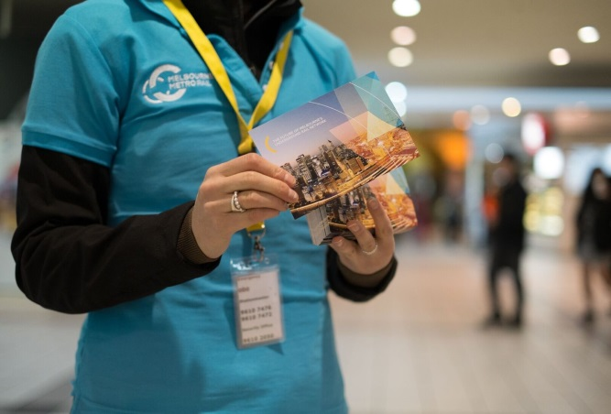
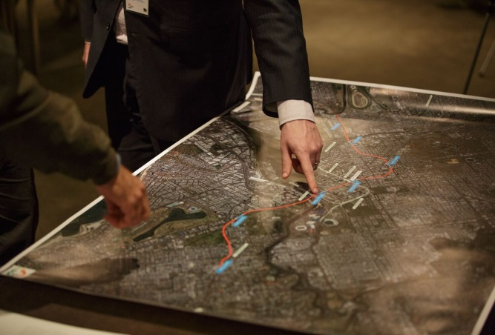
MMRA recognises that consultation across all phases of Melbourne Metro is essential to delivering a project that meets community expectations and addresses community concerns. MMRA also recognises that the design, development and delivery of the project will be greatly enhanced by talking with the community and interested parties, including residents, businesses, local councils, government agencies, industry groups and community organisations.
MMRA is undertaking a comprehensive program of public engagement that includes raising awareness about Melbourne Metro, seeking input into the development and design of the project, responding to community concerns and undertaking formal consultation associated with the EES.

Informing the Public
Activities to date include distribution of newsletters to around 100,000 properties along the Melbourne Metro alignment, 15 community drop-in sessions with more than 1,500 people attending, information stands and pop-up sessions at train stations and in the CBD, advertisements in local newspapers and a survey completed by around 3,000 people. There have been more than 8,000 visits to MMRA’s online engagement portal and over 3,300 downloads of information brochures about the project.
MMRA has made direct contact with landowners and tenants whose properties would be acquired under the proposed Concept Design and with business owners who may need to relocate, providing information about the possible impacts on their properties and businesses and advising them of their legal rights. MMRA staff have held 180 presentations and meetings with key stakeholders to brief them on the project and obtain feedback on its proposed design. MMRA staff have also conducted a drop-in session for traders in the CBD to discuss issues associated with construction activities in the CBD.

Responding to Feedback
Feedback from the community and stakeholders has resulted in changes to Melbourne Metro's design and proposed construction methodology, including moving the location of Parkville station to minimise impacts on Royal Parade, Royal Melbourne Hospital and the VCCC; adopting a mined cavern construction methodology in the CBD to reduce disruption to businesses and tram services; and tunnelling under the Yarra River to reduce impacts to commercial and recreational river users and aquatic life.
Technical Reference Group
MMRA was assisted in preparing the EES by a Technical Reference Group convened by the Department of Environment, Land, Water and Planning.
The group comprised representatives of Cities of Melbourne, Port Phillip and Stonnington, EPA Victoria, VicRoads, Heritage Victoria, Office of Aboriginal Affairs Victoria and Melbourne Water.
As well as participating in briefings and workshops, the group reviewed all specialist impact assessment reports and the EES main report.
Feedback was also an important part of developing the EES. Throughout the EES public engagement program, various methods were used to provide community and stakeholder feedback to the specialists conducting the impact assessments and to the Melbourne Metro design team:
- 'Key issues reports' and workshops were used to discuss issues raised by the community and stakeholders that required attention. Where necessary, further investigations were conducted into particular issues of community concern.
- Technical specialists and designers attended drop- in sessions to engage directly with the community in their areas of expertise and hear concerns and suggestions.
- Technical specialists and designers worked with stakeholders (in workshops and meetings), applying their insights and input to achieving optimal outcomes in the EES impact assessments and refining the recommended Environmental Performance Requirements.
- A Community and Stakeholder Feedback Summary Report, prepared by MMRA, summarised the feedback received. For some issues identified in this report, workshops were conducted involving the technical specialists, designers and relevant stakeholders. This provided a further opportunity to incorporate feedback into the specialist assessments and the Concept Design.

Ongoing Public Engagement
Once the EES process is completed, MMRA will use a range of communication methods to maintain a high level of awareness about Melbourne Metro and its benefits and impacts throughout the approval and procurement process. Activities during this phase would include supporting landowners and tenants through the property acquisition process, providing updates about the project and explaining any variations to the Concept Design.
Community and stakeholder engagement would continue throughout the construction and operational phases of the project. The contractor delivering the project would be required to implement plans to keep the public informed about the project's progress, provide opportunities for community involvement in the project's design and set up mechanisms to respond quickly and effectively to issues raised by the public.

Next Steps

Viewing the EES
The EES will be on public exhibition for 30 business days from 25 May 2016 to 6 July 2016. During this time, members of the public can inspect the EES and make written submissions.
The EES can be viewed in full on the Melbourne Metro website at melbournemetro.vic.gov.au. Hard copies of the EES can be inspected at any of the places listed below from 25 May 2016 to 6 July 2016.
EES exhibition locations
State Library of Victoria  328 Swanston Street, Melbourne | City of Melbourne – Town Hall  Administration Building  120 Swanston Street, Melbourne
City of Melbourne – CBD Library  253 Flinders Lane, Melbourne | City of Stonnington – South Yarra Library  340 Toorak Road, South Yarra
City of Melbourne – North Melbourne Library  66 Errol Street, North Melbourne | City of Port Phillip –Emerald Hill Library  95 Bank Street, South Melbourne
City of Maribyrnong – Administration Building
61 Napier Street, Footscray

Obtaining a Copy of the EES
Free copies of the EES Summary Report and DVD containing all the EES documentation are available at the exhibition locations or from MMRA.
To obtain copies of the EES, contact MMRA on 1800 551 927 (Monday to Friday, 9am to 5pm) or use the online contact form at melbournemetro.vic.gov.au.
Hard copies can be purchased:
- EES Main Report – $50
- Map book – $25
- Technical appendices (specialist impact assessments) – $75 each.

Making a Submission
Submissions on the EES must be made in writing and received by 5:00pm on 6 July 2016.
Online submissions are preferred and can be lodged via an online form at www.delwp.vic.gov.au/melbourne-metro-rail-hearing
Written submissions must be accompanied by a coversheet (relating to privacy), which can be obtained from www.delwp.vic.gov.au/melbourne-metro-rail-hearing or by calling the DELWP Customer Service Centre on 136 186. Written submissions will not be processed unless accompanied by the coversheet.
Written submissions can be posted to:
Melbourne Metro EES Submissions
c/o Planning Panels Victoria
GPO Box 2392
Melbourne VIC 3001
To be considered, submissions must relate to the information and topics covered in the Melbourne Metro EES and be within the scope of the terms of reference for the Public Inquiry (see below), which are available at melbournemetro.vic.gov.au.
There is no minimum or maximum length for submissions, and all submissions will be considered equally.
For assistance with the online submission form or other matters related to making a submission, contact the DELWP Customer Service Centre on 136 186.

Public Inquiry
The Minister for Planning will appoint an independent Inquiry to consider the environmental effects of Melbourne Metro, having regard to the EES, the proposed planning scheme amendment and public submissions.
A Directions Hearing will be held on 26 July 2016 and formal public hearings will be held in August and September 2016 at which MMRA and submitters can make presentations. Requests to be heard by the Inquiry at the public hearings must be received by Planning Panels Victoria by the end of the Directions Hearing.
Following receipt of the Inquiry’s report, the Minister will prepare an assessment of the environmental effects of the proposed project that includes the EES documents, public submissions, and the Inquiry report. This assessment is usually provided within 25 days of the Inquiry’s report being finalised. The Minister’s assessment may conclude that the project will or will not have an acceptable level of environmental effects or will need major modifications and/or further investigations to ensure that acceptable effects outcomes will be achieved.
Once the Minister is satisfied that the project is ready to proceed, other relevant statutory decision-makers (such as local councils and public authorities) will consider the Minister’s assessment in granting approvals for the project under Victorian law.

