WES1809.03

6 September 2018

Start of works notification: Kyle Road and Italian Social Club Altona

We’re continuing works to widen the West Gate Freeway, between Williamstown Road and the M80 interchange, which will require us to complete important investigations and relocate services on Kyle Road and the access road adjacent to the Italian Social Club Altona.
Moving 66kV power lines underground
20 September 2018 - December 2018
We need to move the overhead 66kV power lines underground from Kyle Road to beneath the Italian Social Club Altona. These works will include:

- scanning for services to gather information on utilities such as gas, electricity, stormwater and telecommunications along a section of Kyle Road and the local access road adjacent to the Italian Social Club Altona. This will require minor excavation to expose any underground services in the immediate area;
- moving the overhead 66kV power lines underground, from the Brooklyn Terminal Station (BLTS) to the west of the Italian Social Club Altona. This will involve excavations along a section of Kyle Road and underground boring under the reserve adjacent to the Italian Social Club Altona - please see the map for details;
- moving the overhead 66kV power lines under the Department of Environment, Land, Water and Planning (DELWP) compound. We will then trench along the northern boundary of the Italian Social Club Altona carpark, through the reserve and bore underneath the West Gate Freeway. Trenching will then continue west towards Millers Road – please see the map for details;
- access to properties and businesses will be maintained at all times; and
- temporary traffic changes will be required at the northern end of Kyle Road. Please observe the signage and traffic management in place during this time.

These works will be carried out Monday to Friday between 7am - 6pm and Saturdays between 7am - 3pm.

Replacing 220kV towers with monopoles
Starting late 2018

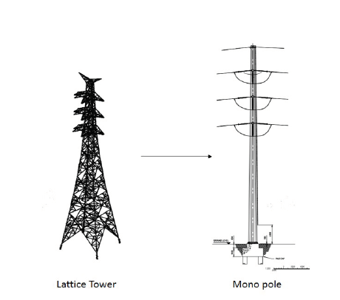
We will also need to replace three existing 220kV lattice towers in the DELWP compound at the north end of Kyle Road with monopoles.

Prepartory works, including pouring the foundations, are expected to start later this year before we replace the towers in mid- 2019.

Lattice towers are the large freestanding power lines that transmit high voltage power around Australia’s network and monopoles are an alternative structure that have less visual impact and a smaller footprint.

Utility relocation work between the Brooklyn Terminal Station and Italian Social Club Altona
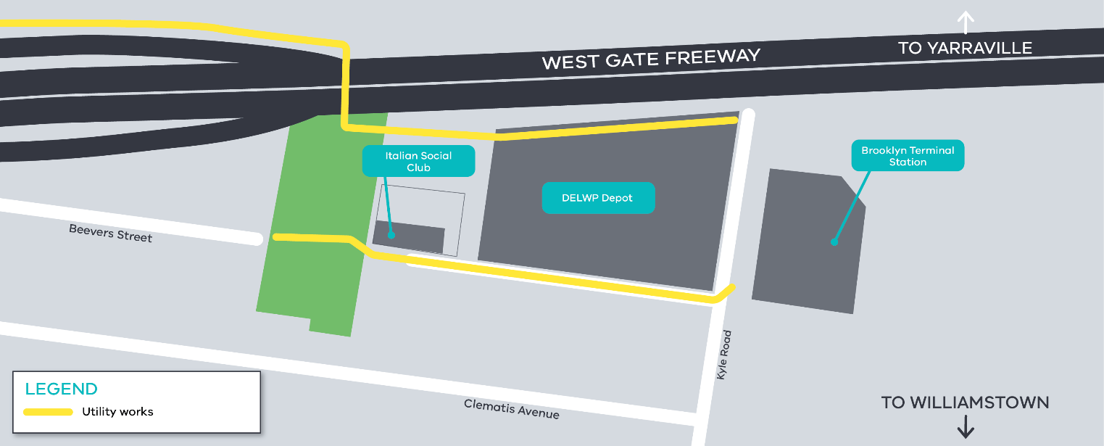

What to expect during these works:

- vehicle access to the Italian Social Club Altona will be maintained. If temporary access changes are required we will provide advance notification;
- an increase in construction noise and potential vibration from our machinery and trucks;
- water spray trucks to help manage dust and dirt; and
Contact us
Please contact us if you have any questions or feedback about these works.

 | westgatetunnelproject.vic.gov.au |  | facebook.com/westgatetunnelproject
 | westgatetunnelproject@wda.vic.gov.au |  | @westgatetunnel
 | 1800 105 105 |  | West Gate Tunnel Project  GPO Box 4509  Melbourne Victoria 3001
 | Interpreter service: 13 14 50
- equipment used for these works include heavy vehicles and trailers, excavators, jack hammers, compaction equipment and asphalt cutting saw.

Please note that works may be rescheduled in the event of bad weather or other unavoidable circumstances.

For updates and more information about our works please visit westgatetunnel.vic.gov.au or contact us using the details over page.

Did you know?
There is onging tree and vegetation removal in the area, including on the freeway side of noise walls, however as part of the project we will plant more than 17,700 trees, of which 4000 will be mature trees. In addition, we will plant approximately 900,000 plants.

