25 January 2020 WES2101.03
Works notification: Installation of new noise walls

The West Gate Tunnel Project team will start installing concrete noise wall panels from early February, between Deleware Street and Eirene Street, Yarraville.
The works will take place for approximately three weeks and will be undertaken at night. To safely install the panels the Williamstown Road inbound exit ramp will be closed.
The new noise walls will be around eight-to-nine metres high. In some sections, they will be topped with pale blue and green coloured acrylic panels. Where space permits, planting will be used to screen the noise walls.
The new noise walls will provide you much better protection from freeway noise than the old noise walls. They have been designed to achieve a daytime average noise level of 63dB(A) at nearby houses, which will mean a significant reduction in noise levels for many residents.
What to expect during these works:
- works will be carried out at night, between 9pm and 5am, Monday to Friday. This is so we can safely install the noise wall panels while the freeway exit ramp is closed
- construction vehicles will be moving in and out of the work area at night
- low level noise at night from lifting and installing the concrete panels
- the main access to the installation site will be via the freeway
- ramp closures will be required. The latest traffic updates are available at westgatetunnelproject.vic.gov.au/traveldisruptions
Location of noise wall panels:
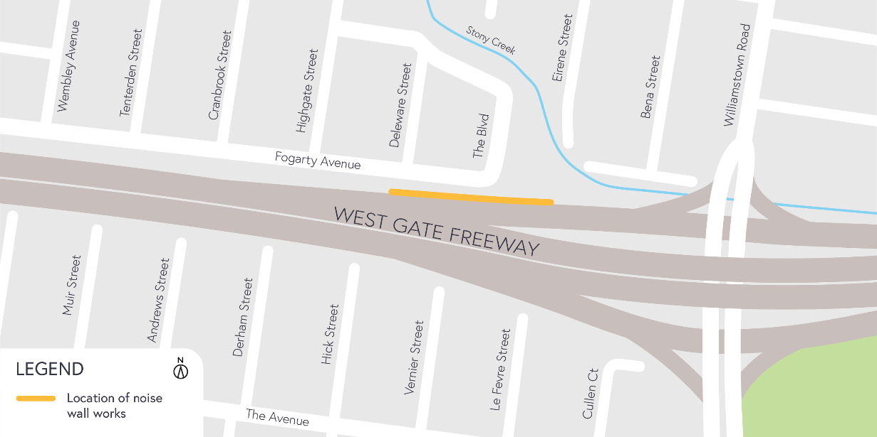

IMPORTANT: If you require more information, you’re welcome to contact us to arrange a phone catch up. Contact details over page.

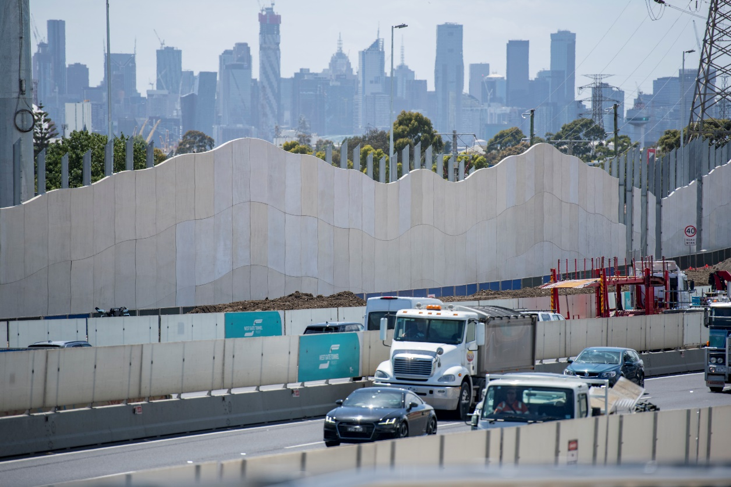
New noise walls installed along Fogarty Avenue, Yarraville

Please note that works are subject to change and could be rescheduled in the event of unexpected impacts to the construction program.
If you have any questions about these night works or want to get in touch with the project team, please contact us on 1800 105 105.
For updates and more information about our works please visit westgatetunnelproject.vic.gov.au.

