2 November 2020 WES2011.02

Reminder notification: Opening of new Rosala Avenue walking and cycling overpass and access route

We recently installed the new walking and cycling overpass over the West Gate Freeway. Since then we’ve been busy getting it ready to open to the community.

While there will be people working on the overpass until December to install the remaining cladding and lighting, we are pleased to let you know that from **Monday 9 November the overpass will be open for use.**

The new overpass provides an improved and safer connection for the community – with new lighting, security cameras and accessibility for all users.

It can be accessed via the new ramps on the south side of the freeway via Rosala Avenue, Altona North, and on the north side of the freeway via Carlsson Court, Brooklyn.

Please note that while there are new staircases, these will not be available for use at this time. As we will continue to be working on the overpass, a temporary set up will be in place which will require cyclists to dismount while using the overpass.

**Courtesy shuttle bus service**

From Monday 9 November when the new Rosala Avenue overpass is open, the courtesy shuttle bus service will stop operating in this area.

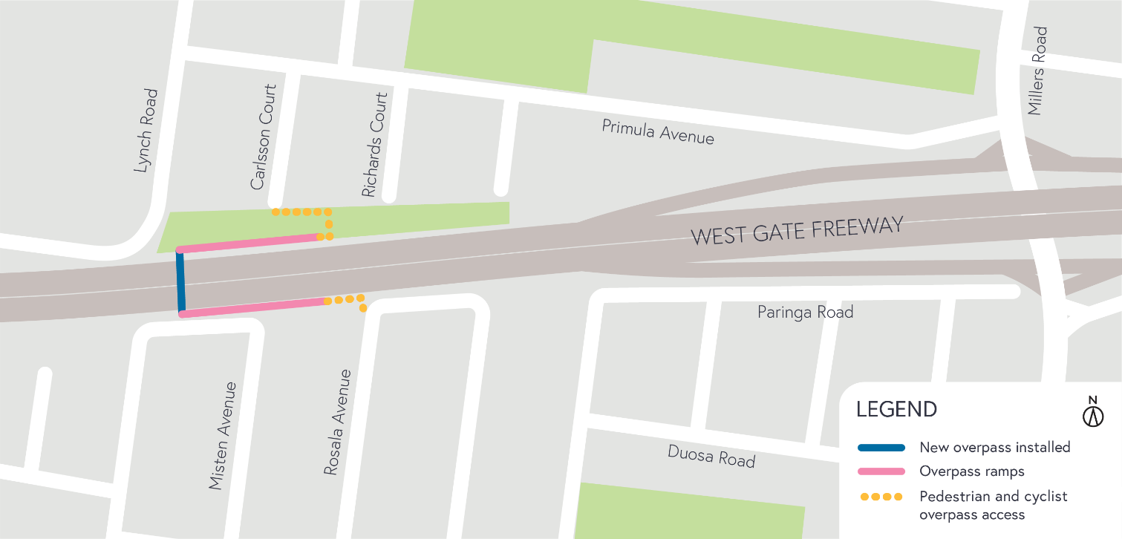

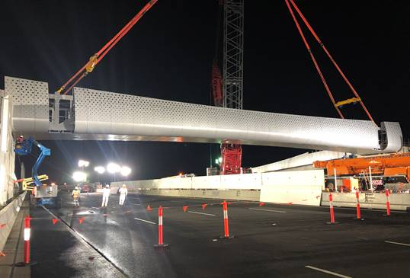

*Rosala Avenue overpass is safely positioned across the West Gate Freeway.*

**Thank you**

We appreciate our work can be disruptive and thank you for your understanding and cooperation while we replaced these important community overpasses, particularly during these unprecedented and challenging times.

**For updates and more information about our works, please visit westgatetunnelproject.vic.gov.au or call us on 1800 105 105.**