26 March 2021 WES2103.01

Works notification: West Gate Freeway from Williamstown Road to Newport Rail Bridge
Construction will soon move to the next phase of works, as we start constructing the new walking and cycling path bridge at Fogarty Avenue, complete works on the Muir Street overpass and move outbound traffic to new freeway centre lanes.
Below is a summary of construction activities you can expect to see in the area from April to June 2021. A map has also been provided on the back page.
Williamstown Road interchange
We are continuing to build the new Hyde Street ramps in this area. These works will include:
- establishing a new worksite on Williamstown Road under the West Gate Freeway
- drilling six piles on Williamstown Road, three each on the north and south side of the freeway
- installing protection around the new piles and bridge piers, including barriers
Nightly closures at Williamstown Road
Williamstown Road will be closed regularly in both directions (under the West Gate Freeway), from 9pm to 5am. This is so we can build the new Hyde Street ramps safely. Fully signed detour routes will be in place during the road closure. Millers Road will also be closed at the same time. We will keep you updated on the progress of works and closures.
For latest updates, dates of closures and detour route information visit: bigbuild.vic.gov.au/disruptions.
Freeway widening works
We are continuing to widen the freeway in both directions between Williamstown Road and Newport Rail Bridge.
Current freeway widening works have focused on creating new lanes in the centre median. Once these works are complete in mid-2021, outbound traffic will switch to the new lanes in the centre, opening up space for works to continue along the outbound shoulder.
Freeway widening works include laying new cables for lighting, installing light poles, new drainage, putting down a new road surface and installing barriers.
Evening and night works will be required. Advance notice will be provided for noisy works likely to impact residents.
Muir Street walking and cycling overpass
Finishing works are expected to be completed by the end of April, including installing cladding, handrails and protective screens on top of the bridge. The stairs at Steel Street, Spotswood and Fogarty Avenue, Yarraville are expected to open in mid-2021 once access to the stairs have been completed.
You may have also seen corflutes being installed along the residential side of the overpass ramps. This is part of our temporary solution for the noise being created during high winds.
These corflutes will be in place for at least three months while we work to identify and install an appropriate permanent solution.
Noise wall installation between Derham and Hick Streets
In May and June we will be installing new concrete noise wall panels between Derham Street and Hick Street. In order to have enough space to install the new noise wall panels, we will need to take down the temporary noise wall first.
This will mean that there will be up to one week where this section will have no noise wall in place - between taking the temporary noise wall down and installing the new ones.
More information about this will be provided before works begin.
Walking and cycling path bridge
We have started building the new walking and cycling path bridge on Fogarty Avenue, near the reserve. These works include piling to support the new bridge, constructing piers and installing beams.
Please note that the SUP that runs through the reserve at Fogarty Avenue will stay closed while works take place. Signed detour route is in place via Benbow Street.
We expect to complete these works in late 2021.
Newport Rail Bridge
We recently completed some major construction activities at this location, including installing beams and pouring concrete on the Newport Rail Bridge.
Over the next few months we will be assembling scaffolding on the underside of the existing bridge, so we can repaint the old steel beams. After this time, we will then need to dismantle the scaffolding and install railings on the bridge.
Intermittent road closures and pedestrian changes will be required on The Avenue during these works.
Other milestone construction activities, including demolishing and rebuilding the northern bridge, will restart in late 2021. We will provide further details of works closer to the time.
For latest updates, dates of closures and detour route information visit: bigbuild.vic.gov.au/disruptions.
Tunnels - Southern Inbound Portal

We are continuing to excavate the southern inbound tunnel entrance structure and removing excavated material from site.
We will be using trucks that are lined and covered and will travel via designated truck routes.
Hours of work
Our usual hours of work are Monday to Friday between 7am-6pm, and Saturdays between 7am-1pm. However, for a number of the works outlined in this notification night works will be required. When works are scheduled out of hours, or if you are located close to the works, we will provide you with further information before the works start.

What to expect during these works:
- work being completed during the day and at night
- work will be completed behind safety barriers
- construction vehicles including excavators, rollers, water trucks and concrete trucks will be moving in and out of the work areas via our access routes
- construction vehicles will continue to use designated routes, including local roads such as Highgate Street, The Avenue and Fogarty Avenue, within residential areas
- construction noise, including intermittent short-term noise at night, from work activities including machinery and trucks. Vibration may be experienced from piling works and when we lay new pavement using a roller
- water spray trucks and road sweepers will be used to manage dust and dirt during works. Trucks removing dirt and rock from the site will be covered
- traffic changes including freeway, ramp, lane and road closures will be required. Signed detours will be in place.

For the latest traffic updates visit bigbuild.vic.gov.au/disruptions

Thank you
We appreciate our work can be disruptive and thank you for your understanding and cooperation.
If you would like to be kept informed via other methods such as email or phone calls, you can also send us your details at info@wgta.vic.gov.au.
Please note that works are subject to change and may be rescheduled in the event of unexpected impacts to the construction program. Thank you for your patience during these works.
For updates and more information about our works, please visit westgatetunnelproject.vic.gov.au or call us on 1800 105 105
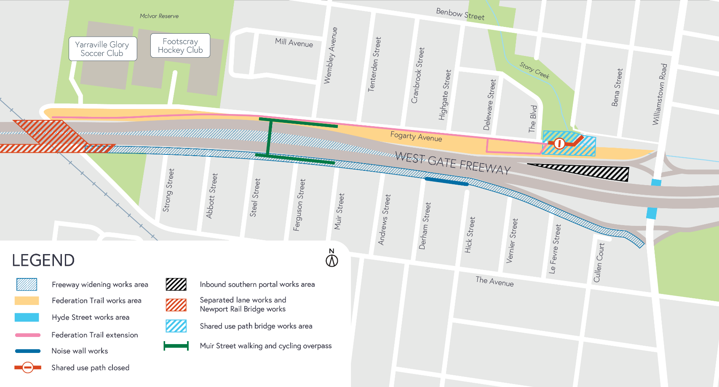
Works area

