Reference: EAS1806.2

25 June 2018

WORKS NOTIFICATION: Site investigations on Wurundjeri Way
Ongoing until September 2018
Over the coming months we will be undertaking site investigation works on Wurundjeri Way to identify utility services and better understand ground and road conditions in the area.
Investigation works will include:
- electronic scanning of roads and footpaths
- non-destructive digging to identify underground services such as gas and water
- drilling bore holes up to 40 metres in depth
- removing some shrubs in work zones if required

What to be aware of
- Night time traffic lane closures will be in place at times. All lanes will remain open during the day. For the latest traffic updates visit westgatetunnelproject.vic.gov.au/traveldisruptions/
- We will notify you if there are any significant changes to the timing of our works.

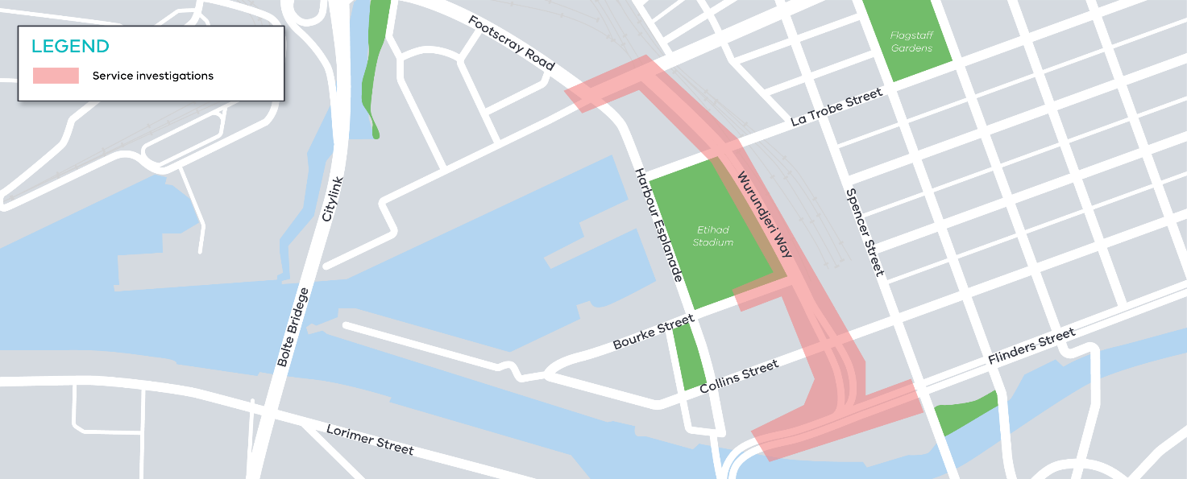
Figure 1 investigation works area
Please note that works may be rescheduled in the event of bad weather or other unavoidable circumstances.
For updates and more information about our works please visit westgatetunnel.vic.gov.au or contact us using the details over the page.

Contact us

Please contact us if you have any questions or feedback about these works.
westgatetunnelproject.vic.gov.au
westgatetunnelproject@wda.vic.gov.au
1800 105 105
facebook.com/westgatetunnelproject
@westgatetunnel
West Gate Tunnel Project
GPO Box 4509
Melbourne Victoria 3001

Interpreter service: 13 14 50

