EAS19APR.003

29 April 2019

Works Update: E Gate and F Gate Sites April - June 2019
Works on the West Gate Tunnel Project, Port to City precinct are ongoing in the E and F Gate areas. The key activities that will take place during Q2 2019 are as follows:

Site establishment and site investigations across E and F Gate
Site establishment continues in both E and F Gate, which will include setting up the sites, installation of fencing and the removal of vegetation where required. Site investigations continue within the E and F gate areas, to further identify utility services located in the project areas.
Site investigation works include:
- electronic scanning of roads and footpaths
- non-destructive digging to identify underground services such as gas and water
- drilling bore holes up to 40 metres in depth
- removing some vegetation in work zones if required

Construction site establishment across E and F gate areas, including:
- fencing works
- vegetation removal
- crib shed installation.
Locations can be found on the map below/ overleaf

E Gate works
- Removing remnant steel terminal rail tracks to facilitate E Gate site establishment (April-May).
- Planning and investigations for the removal of the V/Line Reversing loop.
- Developing the traffic access arrangement into E Gate from Dynon Road.
- Commence piling preparation adjacent to MTM Overflow car park, in conjunction with rail operators.
- Commence utilities relocation (6.6kV underground) at west end of E Gate.
- Commence civil works in E Gate including new MTM and Yarra Trams locations (May-July).

F Gate works
- Relocation of standard gauge locomotive storage track (May).
- Undertaking of Track works in the Melbourne Operations Terminal (MOT) area to facilitate the 66kV route (May, see map).
- Closure of K Gate access road from 1 May till end 2019, to facilitate piling and construction activities. Access to remain via Footscray Road (F Gate).
- Commencement of piling preparation and piling works (April-June, see map).
- Commence utilities relocation (66kV underground) through South Dynon (end of April).

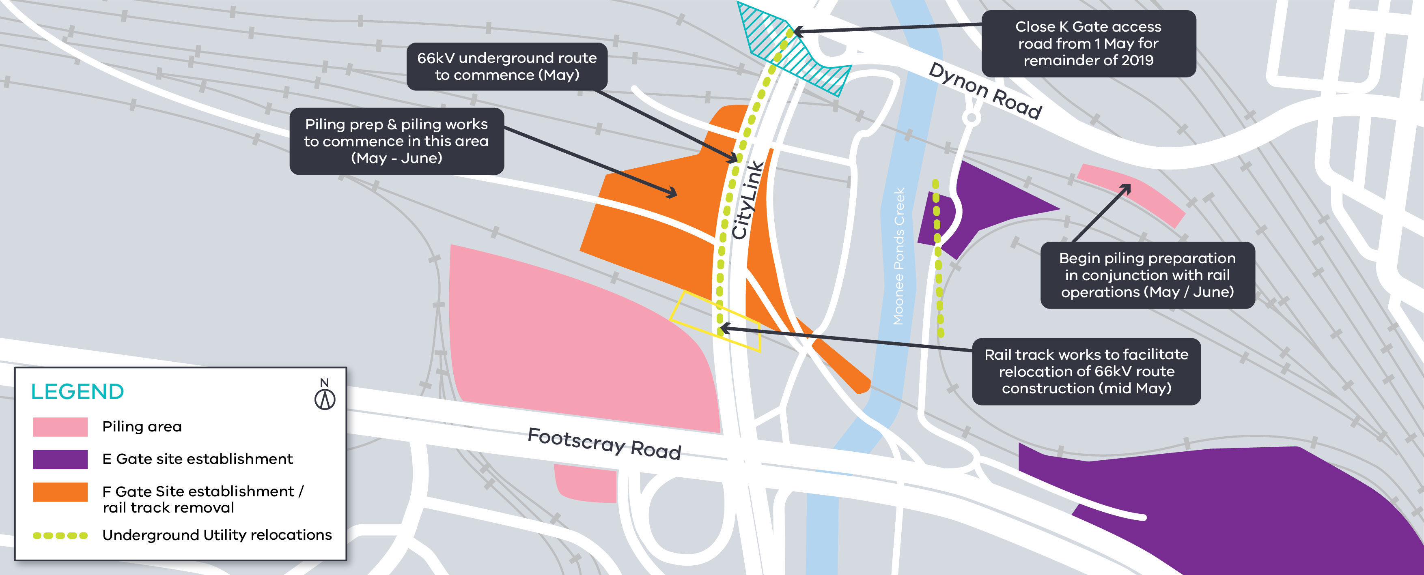

6kV underground route

Piling preparation and piling works
Piling preparation and piling works will commence at various locations, including the old fish market site from May 2019. This will include the delivery of piling equipment and piling rigs to site.

Piles will be constructed using a combination of driven and bored piling. Sheet piling will also be implemented where required to protect open excavation areas.

Rail works
- Removal of remnant steel tracks to facilitate site establishment (E Gate)
- Preliminary investigation and planning of V/Line Reversing loop removal (E Gate)
- Relocation of standard gauge storage track (F Gate)
- Track works in the MOT (F Gate)

Construction works
- Piling preparation works adjacent to MTM Overflow
Car park (E Gate)
- Utilities relocation of 66kV power (E Gate)
- Utilities relocation of 66kV power at South Dynon (F Gate)
- Civil works within E Gate including MTM and Yarra Trams locations
- Closure of K Gate access road
- Piling preparation works (F Gate)

What to expect during construction
- Works completed both during the day and at night time
- Traffic management will be in place to manage changed conditions including temporary access changes to
car parking spaces and signage to guide road users and cyclists
- We will notify you if there are any significant changes to the timing of our works
- Delineation fencing to be installed during removal works
- Dust managed on site

We thank you for your patience during these works.

Contact us
Please contact us if you have any questions or feedback about these works.
westgatetunnelproject.vic.gov.au info@wgta.vic.gov.au
1800 105 105
facebook.com/westgatetunnelproject @westgatetunnel
West Gate Tunnel Project
GPO Box 4509, Melbourne Victoria 3001
Interpreter service: 13 14 50
If you are deaf, or have a hearing or speech impairment, contact us through the National Relay Service.
For more information, visit: www.relayservice.gov.au.

