Chapter 23
Contamination and soil

Chapter 23

Contamination and soil
This chapter provides an assessment of the contamination impacts associated with the construction and operation of North East Link. This chapter is based on the impact assessment presented in Technical report O – Contamination and soil.
Past and current commercial, industrial and quarrying activities combined with historically poor environmental management and waste disposal can potentially leave a legacy of contamination, posing potential impacts to human health, the environment and amenity. | What is contamination?  Contamination is the degradation of land or water from human activities.
Construction and operation of North East Link has the potential to encounter contamination in soil and rocks and in groundwater. The associated impacts of contamination disturbance therefore need to be monitored and controlled.
The EES scoping requirements set out the following draft evaluation objectives:
- Waste management – To manage excavated spoil and other waste streams generated by the project in accordance with the waste hierarchy and relevant best practice principles
- Catchment values – To avoid or minimise adverse effects on the interconnected surface water, groundwater and floodplain environments.
To assess the potential impacts of North East Link a contamination and spoil impact assessment was undertaken. The assessment involved investigating the geological conditions together with historical and existing land uses within the study area to understand the potential sources of contamination and how human health, the environment and amenity may be affected.
Other aspects relevant to the above evaluation objective include impacts to groundwater and surface water. Assessment of these aspects is addressed in the following technical reports:
- Chapter 22 and Technical report N – Groundwater
- Chapter 24 and Technical report P – Surface Water.

Method
Informed by the risk assessment described in Chapter 4 – EES assessment framework, the contamination and soil assessment entailed the following key tasks:
- A review of relevant national, state and local legislation and policy
- The establishment of a study area for the contamination and soil assessment – the focus was on areas identified to have higher potential for contamination based on their former or current land uses around the North East Link elements as shown in Figure 23-1
- A desktop assessment to characterise the existing geological conditions, historical and existing land uses, and known potential sources of contamination
- Consultation with councils and relevant land owners to obtain other information relevant to the contamination and soil assessment

- Site visits, where access was available, to provide a better understanding of historical and existing potential sources of contamination
- Limited field assessments involving collection and analysis of soil and water samples to better understand the presence of contamination with the study area
- A spoil assessment included preliminary characterisation of the spoil generated by the project, developing the objectives for the Spoil Management Strategy and requirements for the Spoil Management Plan
- A qualitative risk assessment to prioritise the impact assessment and development of controls
What are the risk categories?
Risk levels were categorised as very low, low, medium, high or very high. When an impact is a known consequence of the project the rating is indicated as ‘planned’. The results of the initial risk assessment were used to prioritise the focus of the impact assessments.

- An assessment of the potential contamination and soil impacts during construction and operation, and maintenance of the project
- Development of Environmental Performance Requirements (EPRs) in response to impact assessment. The residual risk ratings and the assessment of impacts presented in this chapter assume implementation of the EPRs. Refer to Chapter 27 – Environmental management framework for the full list of EPRs.
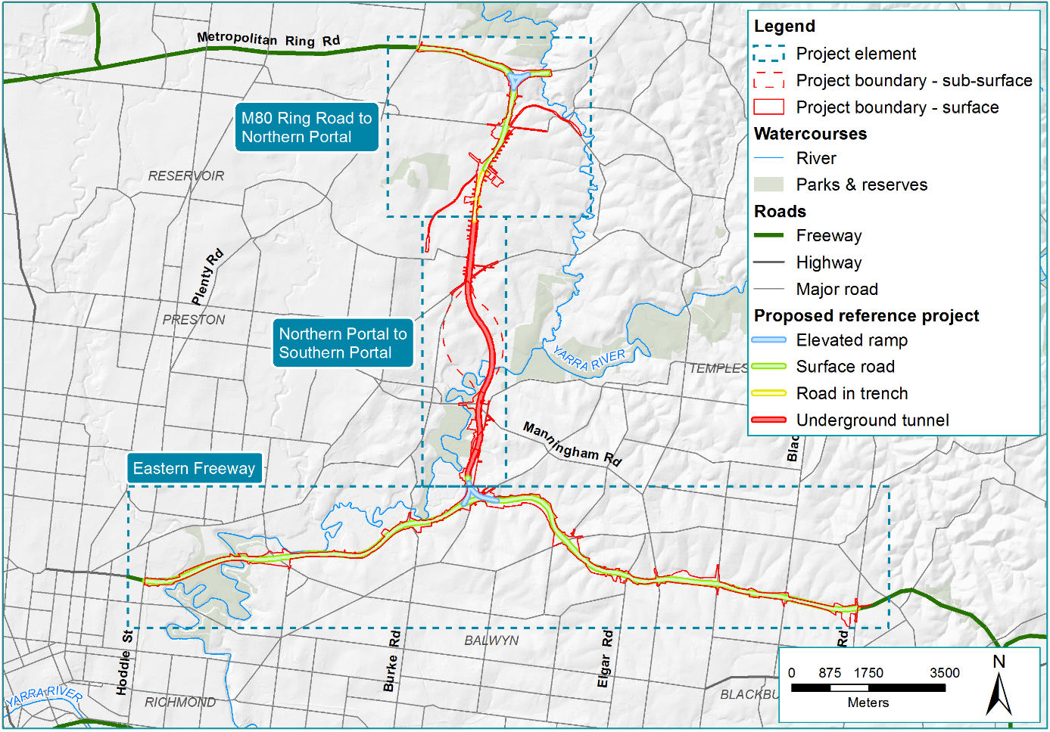
Figure 23-1 Contamination and soil study area

Existing conditions
This section outlines the existing conditions of the North East Link study area that relate to contamination and soil.
The existing conditions information in this section complements the information on geology and hydrogeology presented in Chapter 22 – Groundwater and hydrology presented in Chapter 24 – Surface water.
It contains information on naturally occurring acid sulfate soil and rock and potential areas of contamination relating to existing and historical land use.

Acid sulfate soil and rock
The geological conditions present around North East Link have the potential for acid sulfate soil and rock. The presence of acid sulfate soils and acid sulfate rock (ASR) may pose a risk to human health and the environment.
The study area is located within an area that has low probability of acid sulfate occurrence as defined by the Atlas of Australian Acid Sulfate Soils and presented in Figure 23-2. This is due to the two main geological units around the project being Silurian siltstone and sandstone formations (Sxa, Sxm) and Quaternary alluvial deposits along the river plains (Qa1, Qa2). These units shown in Figure 23-3 have a low probability of containing acid sulfate soil and ASR.
What is acid sulfate soil and rock?
Acid sulfate soil is the common name given to soils containing metal sulphide minerals, which can occur naturally in coastal environments such as estuarine systems, mangrove swamps, backswamps and in inland environments such as river and stream channels, lakes, wetlands, billabongs, floodplains and marshes.
In general, acid sulfate soil can be classified into two broad types:
- Potential Acid Sulfate Soils (PASS) containing pyrite and/or monosulphides that are still waterlogged but have the potential to produce acid if oxidised; or
- Actual Acid Sulfate Soils (AASS) containing sulphuric acid and pyrite, which has already been oxidised.
These soils may either contain sulphuric acid or have the potential to form sulphuric acid when the iron sulphide minerals are exposed to oxygen. The acid can have a lasting effect on the soil characteristics, cause deoxygenation or enhance the mobilisation of some contaminants, notably metals.
The occurrence of metal sulphides in rocks, however, is not restricted to any particular rock type, depositional environment or age. Metal sulphides can be found in most rocks, although they generally occur at very low concentrations where the risk of adverse environmental impact due to acid generation is minimal. Metal sulphides are associated with many ore deposits, including metals such as gold, silver, platinum, copper, lead, tin, zinc and uranium and in coal deposits. Such ore deposits do not exist within the North East Link project boundary. The presence of actual or potential acid sulfate conditions relates not to contamination but to the underlying geology.
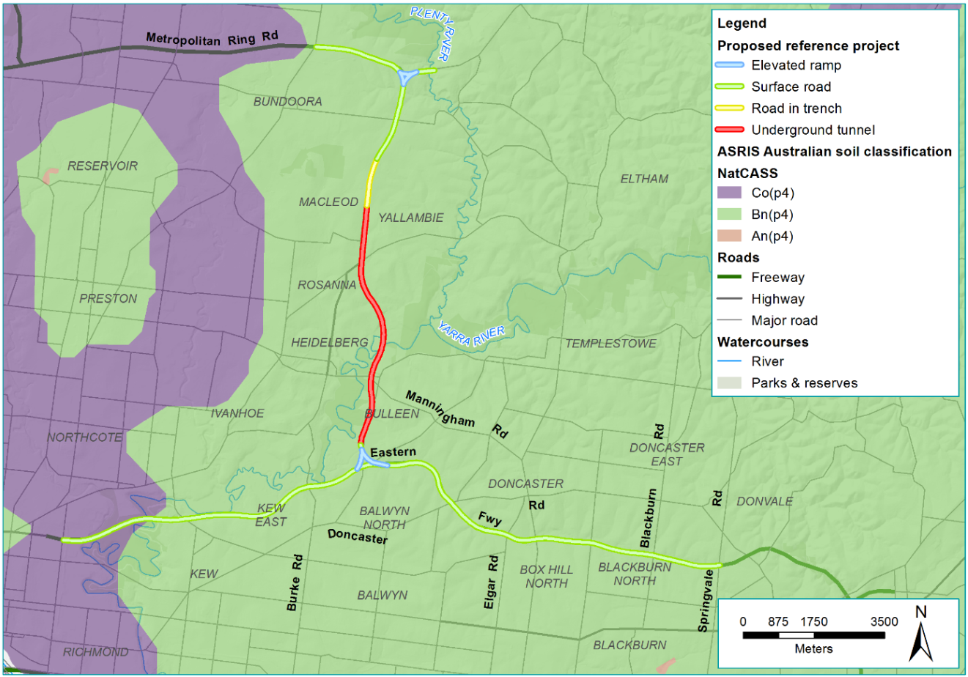
Figure 23-2 Acid sulfate potential around North East Link
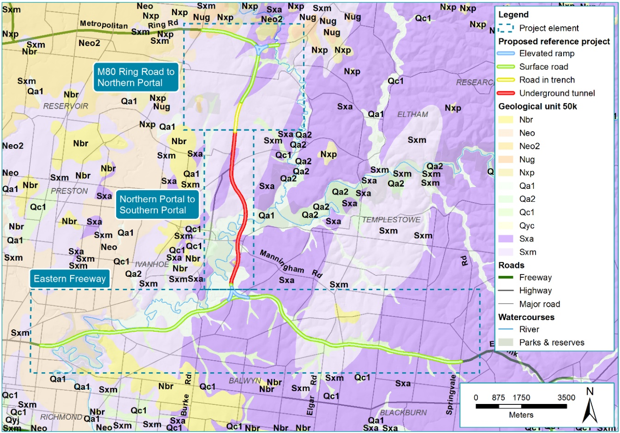
Figure 23-3 Geological map of North East Link

Existing and historical land use
The potential sources of contamination identified within the study area are summarised in Table 23-1 and their locations shown in Figure 23-4, Figure 23-5, Figure 23-6 and Figure 23-7. The identified sites are within or immediately beyond the project boundary. Locations outside the project boundary would not be directly affected by project works.
Table 23-1 Potential sources of contamination
Project element | Potential source of contamination
M80 Ring Road to northern portal | Within the project boundary:  - Former quarry near the junction of the M80 Ring Road (otherwise known as the Metropolitan Ring Road) and Greensborough Bypass  - Former landfill at AK Lines Reserve  - Active fuel service station at Yallambie Road  - Former fuel service station at Watsonia Road  - Former fuel service station near the Watsonia railway station  - Defence activities at Simpson Barracks.  Outside the project boundary:  - Dry cleaners at Watsonia Road  - Active fuel service station at Watsonia Road  - Automotive service and repair on Watsonia Road  - Timber and hardware outlet on Watsonia Road  - Electricity substation on Todman Street.
Northern portal to southern portal | Within the project boundary:  - Defence activities at Simpson Barracks  - Former landfill at Borlase Reserve  - Dry cleaners at the Bulleen Industrial Precinct  - Two active fuel service stations within the Bulleen Industrial Precinct on Manningham Road  - Garden supply outlet within the Bulleen Industrial Precinct  - Vehicle storage yard in the Bulleen Industrial Precinct  - Mower sales and service centre within the Bulleen Industrial Precinct  - Timber and hardware outlet within the Bulleen Industrial Precinct  - Concrete supplier within the Bulleen Industrial Precinct  - Former quarry located near Rocklea Road and Yarraleen Place, Bulleen  - Former landfill at Bulleen Park (partly within the Eastern Freeway project element)  - Former landfill on the eastern section of the Freeway Golf Course (Camberwell landfill).  Outside the project boundary:  - Two active fuel service stations at the Bulleen Industrial Precinct on Bulleen Road  - Former fuel service stations at the Bulleen Industrial Precinct on Bulleen Road  - Multiple automotive service and repair locations within the Bullen Industrial Precinct.
Eastern Freeway | Within the project boundary:  - Former landfill at Bulleen Park (partly within the Northern portal to southern portal project element)  - Former landfill at Musca Street Reserve and Freeway Golf Course, Balwyn North (former Camberwell Landfill)  - Former landfill at Koonung Creek Linear Park  - Former landfill at the corner of Doncaster Road and the Eastern Freeway (former Greythorn landfill).  Outside the project boundary:  - An area with a long history of commercial and industrial land use at Clifton Hill  - Electricity substation in Box Hill North.

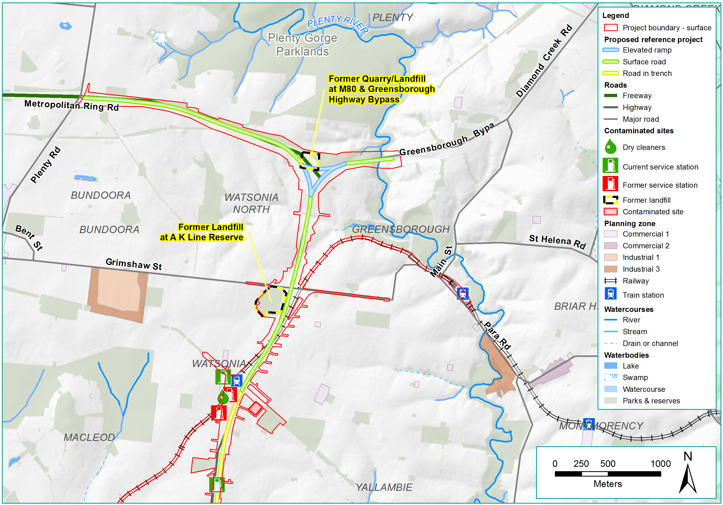
Figure 23-4 Potential contamination areas from the M80 to northern portal
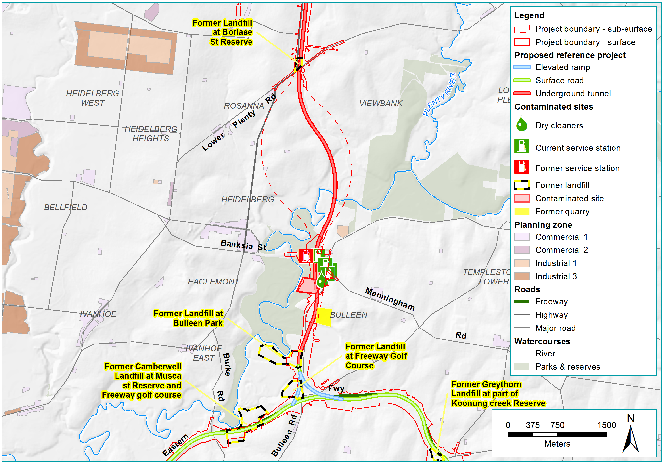
Figure 23-5 Potential contamination areas from the northern portal to the southern portal
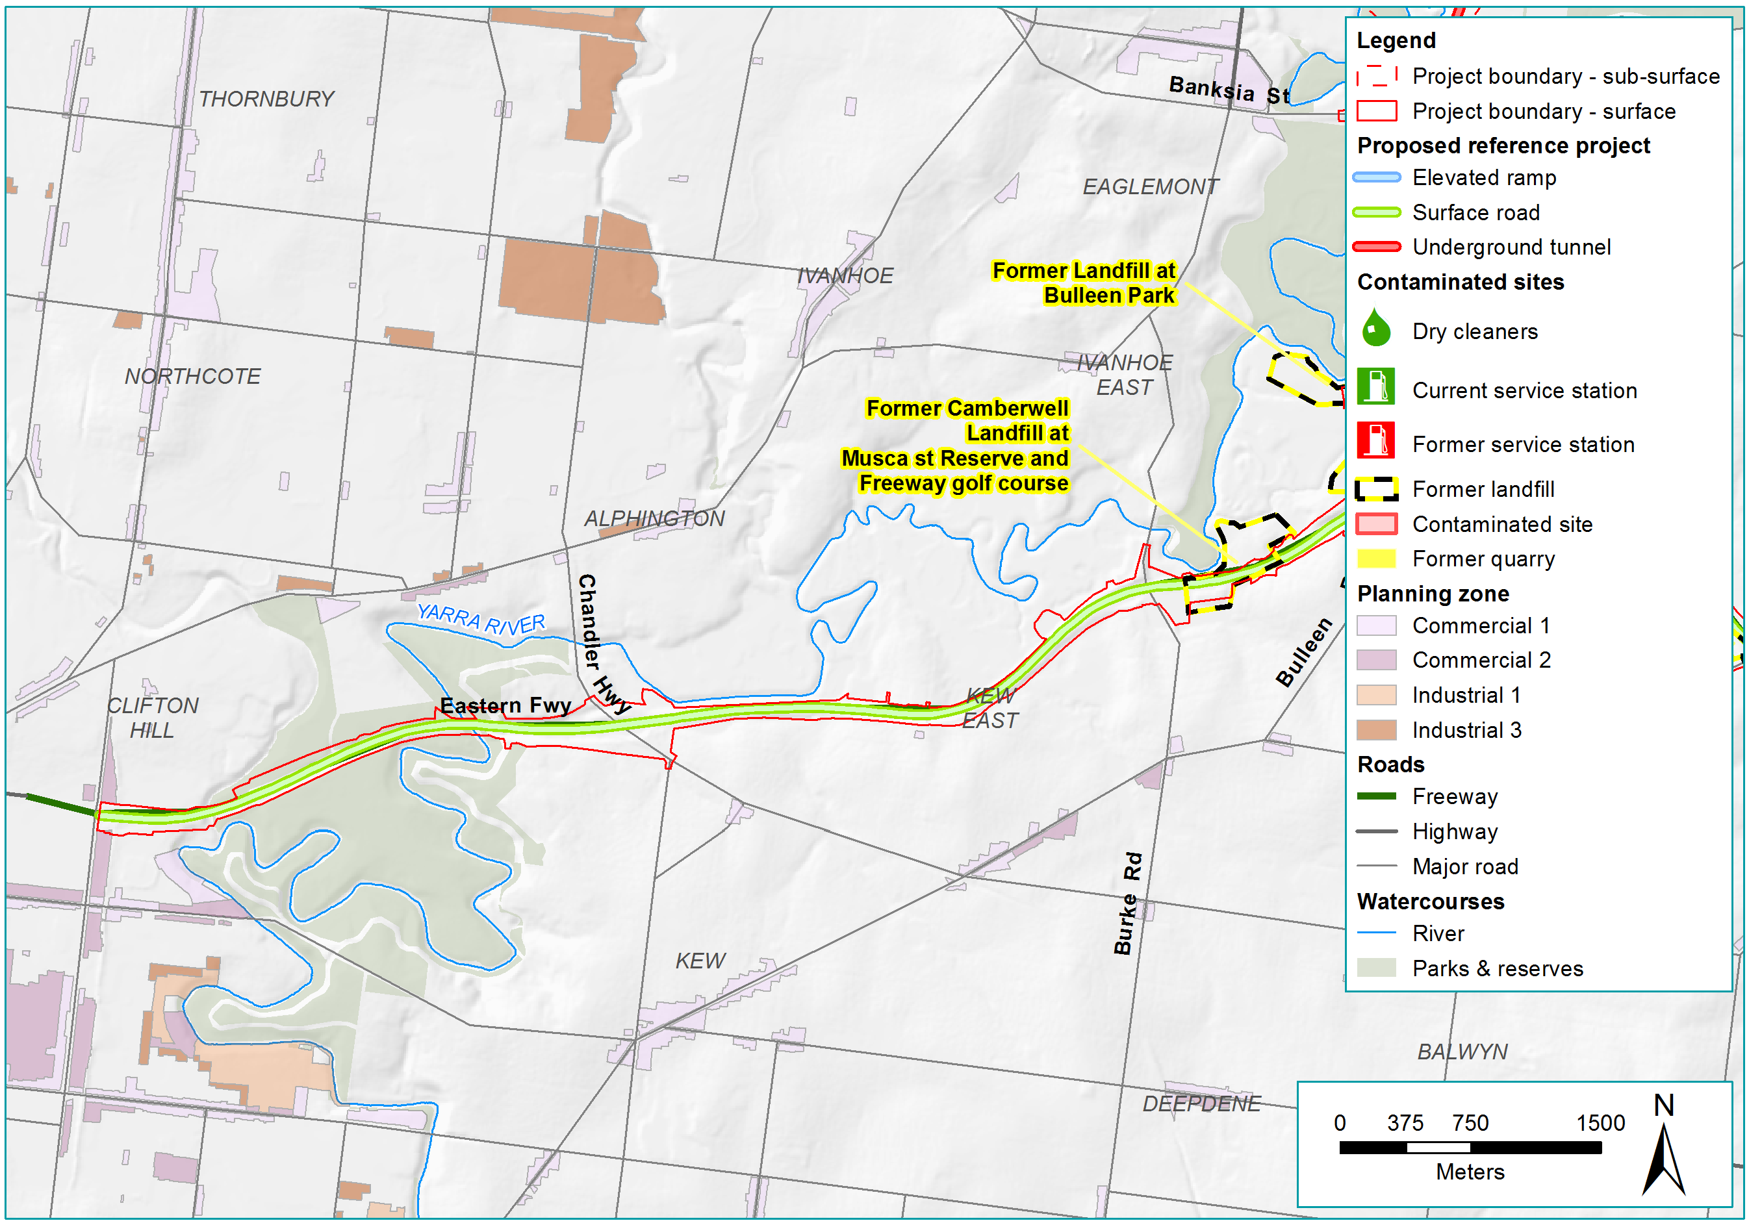
Figure 23-6 Potential contamination areas around the Eastern Freeway (west)
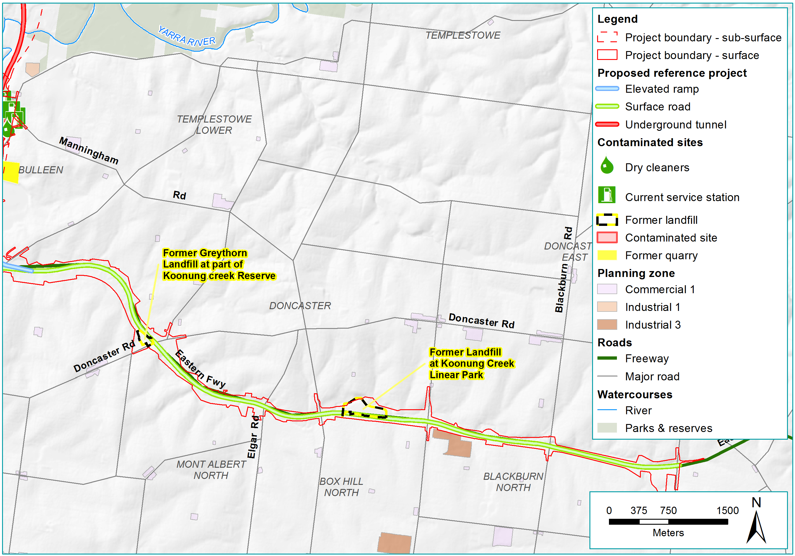
Figure 23-7 Potential contamination areas around the Eastern Freeway (east)

Construction impact assessment
This section discusses the construction impacts associated with North East Link that relate to contamination and soil.
The potential impacts associated with the construction of North East Link that relate to contamination and soil are grouped into the following aspects:
- Soil and rock
- Asbestos, chemicals and waste
- Odour, gas and vapours
- Groundwater.
The assessment considered the risk of contamination with respect to public health, the environment and amenity and where needed has identified environmental performance requirements that would minimise impacts. Risks associated with contamination would be managed by the appointed contractor during the project’s construction. The potential for impacts associated with these aspects are discussed in the following sections.

Soil and rock
Excavation of soil and rock during construction has the potential to disturb contamination and cause impacts on public health, the environment and amenity. The risk pathways associated with contaminated soil and rock are described in Table 23-2 and potential impacts are discussed below.
Table 23-2 Risk table: Construction – contaminated soil and rock
Risk ID | Risk pathway | Risk rating
Risk CT01 | Earthworks requiring excavation, stockpiling, transport and treatment/disposal of contaminated soil causes impacts to human health (via direct contact and vapour inhalation) and the environment. | Low
Risk CT02 | Earthworks requiring excavation, stockpiling, transport and treatment/disposal of acid sulfate soil and rock causes impacts to human health (via direct contact and vapour inhalation) and the environment. | Low
Risk CT10 | Disturbance of contaminated soil in long term stockpile or disturbance of contamination that remains in situ, notably within landfills, causes impacts to human health (via direct contact and inhalation) and the environment. | Low

Contaminated soil
Earthworks involving excavation, transport and storage of contaminated soil have the potential to impact human health and the environment (risk CT01 and CT10). Potential risk to human health may occur from direct contact between skin and contaminated soil or water, ingestion of contaminated soil or water or inhalation of contaminated dust, vapours or gases. Potential risk to the environment may occur where contaminated soil in stockpiles and open excavations are exposed and runoff passing over these areas transports contamination into stormwater, watercourses and drains.
Earthworks associated with road widening and construction of elevated roads and land bridges for the project would involve limited surface excavation. However, earthworks associated with the construction of the trench and tunnels would generate large amounts of spoil. Based on the historical and existing land uses it is expected that some of the excavated soil encountered would be contaminated.

It is estimated that approximately 6.1M m³ (in situ) of spoil would be generated for the construction of North East Link, primarily from tunnel and trench excavations. Spoil has been categorised as prescribed industrial waste or Fill Material (also commonly referred to as ‘clean fill’) in accordance with the EPA Victoria Industrial Waste Resource Guideline (IWRG) Publication 621 Soil hazard categorisation and management. The estimated spoil volumes by spoil type are presented in Table 23-3.
The majority of the spoil is expected to be Fill Material. However, some spoil, notably the Silurian siltstone, would be classified as Category C, predominantly due to the levels of fluoride present.
What is Prescribed Industrial Waste (PIW)?
Hazardous waste is called ‘prescribed industrial waste’ in Victoria. A prescribed industrial waste can include:
a) waste arising from commercial, industrial or trade activities or from laboratories; or
b) waste containing substances or materials which are potentially harmful to human beings or equipment.
EPA Victoria's Industrial Waste Resource Guidelines (Soil Hazard Categorisation and Management) classifies contaminated soil as Category A, Category B or Category C Prescribed Industrial Waste. Prescribed industrial waste excludes materials such as concrete, green waste, timber and paper.
What is Fill Material?
Fill material is non-hazardous soil material that may include soil, rock and gravel.

This fluoride is likely to be naturally occurring and so the majority of the material may be able to be reclassified as Fill Material. For this to occur, reclassification would need to be approved by EPA Victoria, through an application demonstrating that fluoride levels are equivalent to background concentrations and that historical activities in the area do not indicate any sources of this substance.
Further sampling would be undertaken during the detailed design of the project in accordance with EPA Victoria Publication IWRG 702 Soil Sampling to achieve at least, the minimum sampling density required to categorise site soils for waste management purposes. Further details of spoil categorisation are discussed in Technical report O – Contamination and soil.
Table 23-3 Spoil volume estimates by spoil type (m³)
Project element | Fill material | Estimated volume (m³ in situ)
 |  | Prescribed industrial waste category |  |  |  | Total spoil
 |  | Category A | Category B | Category C | Total
M80 Ring Road to northern portal | 2,120,000 | - | 3,000 | 32,000 | 35,000 | 2,155,000
Northern portal to southern portal | 3,111,000 | 5,500 | 11,500 | 137,000 | 154,000 | 3,265,000
Eastern Freeway | 612,000 | 500 | 1,500 | 66,000 | 68,000 | 680,000
Total | 5,843,000 | 6,000 | 16,000 | 235,000 | 257,000 | 6,100,000

Contaminated soil may be present around the former quarry at the junction of the M80 Ring Road and the Greensborough Bypass, the fuel service station at the corner of Greensborough Road and Yallambie Road, and from a former landfill site at AK Lines Reserve in Watsonia. The tunnel sections constructed by bored and mining techniques would pass well below the ground surface and avoid potential contamination associated with the former quarry at Borlase Reserve between Blamey Road and Bridge Street. However, the tunnel sections constructed by cut and cover technique together with the former and current land use (service stations, dry cleaners and automotive service facilities) at the Bulleen Industrial Precinct have a higher potential for disturbance of contamination due to the sources of contamination being found generally close to the ground surface. Closer to the Eastern Freeway, contamination could be encountered at Bulleen Oval, the former City of Camberwell landfill, the Camberwell Public Golf Course, the former Greythorn Landfill located at the intersection of the Eastern Freeway and Doncaster Road and the former landfill located at Koonung Creek Linear Park.
Disturbance of any contamination including waste materials would be managed through the preparation and implementation of a Spoil Management Plan, developed in consultation with EPA Victoria, to include processes and measures to manage spoil (EPR CL1). Preparation of the Spoil Management Plan would require more investigations to further characterise spoil and identification of best practice measures to manage spoil. The Spoil Management Plan would define roles and responsibilities and include requirements and methods for:
- Identifying the nature and extent of spoil (clean fill and contaminated spoil)
- Design and management of temporary stockpile areas, which may include management measures such as:
  - Lining and bunding of spoil stockpile areas to prevent leaching to groundwater
  - Covering of spoil stockpiles or provision of suitable sediment controls to prevent pollution of waterways
  - Covering of spoil stockpiles to prevent dust and odour generation and reduce the risk of inhalation of contaminated dust
  - Scheduling to prevent long-term stockpiling of spoil
  - Contingencies for management of any PFAS-impacted spoil
- Identifying locations and extent of any prescribed industrial waste (PIW), other waste, and the method for characterising PIW and other waste prior to excavation.
Opportunities for reuse onsite and offsite would be investigated and spoil that is unable to be reused would be transported to landfill via designated haulage routes. Further details of spoil management are discussed in Technical report O – Contamination and soil.
Transport companies must be licensed by EPA Victoria to carry contaminated soil and must ensure loads are appropriately secured and covered to reduce the chance of releases along the transport route that might impact communities. Truck haul routes have been selected to minimise the potential for impact to communities. These routes are presented in Chapter 9 – Traffic and transport.

Acid sulfate soil and rock
Earthworks could expose acid sulfate soil and rock (acid sulfate materials) and this has the potential to impact human health and the environment (risk CT02). The occurrence of acid sulfate materials is dictated by geological conditions and level of oxidation/weathering of the disturbed soil and rock and the degree of disturbance depends on the nature of works.
Spoil proposed for removal has been categorised in accordance with EPA Victoria Publication 655.1 Acid Sulfate Soil and Rock. It is estimated that approximately 2,630,000 m³ of acid sulfate materials could be produced mostly from construction of the tunnels. Because of the geological conditions, acid sulfate materials are not expected to occur in the project’s M80 Ring Road to northern portal element. Similarly, it is expected that works along the Eastern Freeway would encounter only minor quantities of acid sulfate soil and rock. Acid sulfate material volume estimates, broken down by soil and rock, are presented in Table 23-4. The estimates are based on limited sampling and a number of assumptions regarding distribution and so have considerable uncertainty.
Most of this material is categorised as Fill Material although some meets the definition of Category C Prescribed Industrial Waste, in accordance with IWRG classification. The classification of Category C is based on elevated naturally-occurring fluoride and it is envisaged that EPA Victoria approval could see most of this reclassified as Fill Material (see Section 23.3.1 Contaminated soil).
Table 23-4 Acid sulfate soil and rock estimate (m³)
Location | Estimated volume (m³ in situ)
 | Acid sulfate soil | Acid sulfate rock | Total
M80 Ring Road to northern portal | - | - | -
Northern portal to Lower Plenty Road | - | 442,000 | 442,000
Lower Plenty Road to Bridge Street | - | 1,185,000 | 1,185,000
Manningham Road interchange | 207,000 | 227,000 | 434,000
Mined tunnel at Bulleen Road | - | 139,000 | 139,000
Cut and cover tunnel to southern portal | 387,000 | 43,000 | 430,000
Eastern Freeway | - | - | -
Total | 594,000 | 2,036,000 | 2,630,000

Acid sulfate materials excavated during the project’s construction would be managed in accordance with the Acid Sulfate Soil Management Plan that would be prepared and implemented for North East Link (EPR CL2). This could include but would not be limited to:
- Development of appropriate stockpile areas including lining, covering and runoff collection to prevent release of acid to the environment
- Addition of neutralising compounds to prevent acid formation
- Preventing oxidation through scheduling practices; that is, ensuring that acid sulfate materials are transported to licensed receiving facilities and not left in stockpiles onsite.

Asbestos, chemicals and waste
Releases of asbestos, chemicals and waste materials have the potential to impact public health, the environment and amenity. The risk pathways associated with these forms of contamination are described in Table 23-5 and potential impacts are discussed below.
Table 23-5 Risk table: Construction – asbestos, chemicals, and waste materials
Risk ID | Risk pathway | Risk rating
Risk CT03 | Earthworks requiring excavation, stockpiling, transport and treatment/disposal of asbestos containing materials that had not been assessed and identified prior to/during excavation results in adverse health (via direct contact and vapour inhalation) and the environment impacts | Low
Risk CT04 | Encountering waste materials containing hazardous substances in former landfill(s) and/or uncontrolled fill site(s) (known or unknown) causes impacts to human health | Low
Risk CT07 | Spills and leaks from construction equipment cause contamination of soil leading to impacts to public health and the environment. | Low

Asbestos
Asbestos-containing materials such as bonded cement sheet are commonly found within commercial, industrial and residential properties and these situations generally present a low risk to human health and environment. Asbestos is also regularly found in construction waste.
The main risk from asbestos is human inhalation of the fibres (risk CT03). Asbestos bonded with materials is considered to be a low risk to human health, however the disturbance of these may release fibres into the air.
Asbestos has been detected in soil samples taken from boreholes at Bulleen Oval and may occur at other locations around the project. The areas most likely to contain asbestos are the Bulleen Industrial Precinct (given the building types present) and landfills (due to the acceptance of waste in the past).
There is potential for construction works, particularly demolition, excavation and earthworks to disturb asbestos. This risk would be mitigated by conducting works in accordance with a Spoil Management Plan (EPR CL1) and in accordance with EPR CL5 which identifies requirements that must be included in the Construction Environment Management Plan and the Operation Environment Management Plan for management of chemicals, fuels and hazardous materials. This would include adherence to procedures such as:
- Identification of areas where asbestos-containing materials may be present before construction works start
- Identification of asbestos-containing materials in the field
- Reporting of asbestos-containing materials when detected
- Appropriate personal protective equipment
- Engaging an occupational hygienist to assess risks and guide storage and handling of asbestos-containing materials.

Chemicals
Chemical and fuel spills may occur during the refuelling of vehicles, plant and machinery or the use of chemicals during construction (risk CT07).
The risk of chemical and fuel spills would be reduced by implementation of a Spoil Management Plan (EPR CL1) and Management of Chemicals, Fuels and Hazardous Chemicals (EPR CL5). This would include measures to manage chemicals and fuels to avoid release into the environment or public exposure in accordance with relevant regulations, standards and best practice guidelines. These would include procedures for monitoring and reporting of any incidents.

Waste materials or unknown contamination
Waste materials containing hazardous substances (including asbestos) or unknown contamination could be encountered during construction and pose a risk to human health and the environment (risk CT04).
Contamination from waste materials left exposed after excavation works could potentially occur at known or other unknown locations. The following locations, mostly historic landfill sites, around the project have been identified as places waste materials could be encountered:
- Former quarry at the junction of the M80 Ring Road and Greensborough Bypass
- Former landfill at AK Lines Reserve
- Borlase Reserve
- Bulleen Oval
- Rocklea Road
- Former Camberwell Landfill, the Camberwell Public Golf Course
- Freeway Public Golf Course
- Former Greythorn Landfill
- Former landfill at Koonung Creek Linear Park.
This risk would be managed through more detailed geotechnical and contamination investigations before construction work started in accordance with a Spoil Management Plan (EPR CL1). The plan would include measures for the management of any hazardous substances found in accordance with relevant regulations, standards and best practice guidelines. It would also require that mitigation measures be put in place to ensure that waste materials and unknown contamination do not remain exposed after construction and does not pose a hazard to human health or the environment.
What about other waste streams?
Other waste streams generated would include wastewater, solid inert wastes and organic waste. The management of wastewater is covered by Technical report P – Surface water, and the management of waste groundwater is covered in Technical report N – Groundwater. For the management of solid inert waste, such as demolition waste and materials such as concrete, it is recommended that they be separated from spoil and recycled where possible.
All waste streams, including organic waste and litter (that would be produced in significantly lower volumes to spoil or wastewater), would be managed in accordance with the waste hierarchy, as required by EPR SCC4, specified in EES Chapter 27 – Environmental management framework.

Odour, gas and vapours
Excavation and earthworks have the potential to release odour, gases and vapours which may affect public health and amenity. The risk pathways associated with these forms of contamination are described in Table 23-6 and potential impacts are discussed below.
Table 23-6 Risk table: Construction – odour, gas and vapours
Risk ID | Risk pathway | Risk rating
Risk CT05 | Excavation of contaminated soil generates offensive odour causing impacts to human health and loss of amenity to sensitive receptors | Low
Risk CT06 | Earthworks leading to movement of underground gases that have the potential to build up in enclosed spaces and present a public safety risk. | Low
Risk CT09 | Underground construction causes migration of hazardous vapours, ground gases and/or dissolved methane and causes an impact to human health and the environment. | Low

Odour
Disturbance of contaminated soil, including acid sulfate materials, and wastes may generate offensive odours, impacting on amenity (risk CT05). Odours may come from soils containing natural occurring sulphides that when exposed to the air produce hydrogen sulphide, a gas that smells similar to rotten eggs. Disturbance of wastes such as soils holding petroleum hydrocarbons may also lead to release of unpleasant odours.
Odours may be released where excavation disturbs contaminated soil and wastes at the fuel service station on the corner of Yallambie Road and Greensborough Road, former landfills or waste dumping at uncontrolled sites including Borlase Reserve, the proposed area for the Manningham Road interchange, Bulleen Oval and other landfill locations along the Eastern Freeway. Following disturbance, unpleasant odours may continue to be emitted from open excavations, exposed faces and stockpiles into the surrounding area. The odour could also spread outside the study area as material is transported off-site or during windy conditions.
Odours generated during the construction would be managed in accordance with specific measures contained in the Spoil Management Plan (EPR CL3). The measures would be developed giving consideration to the following:
- State Environment Protection Policy (SEPP) Air quality management, 2001
- State Environment Protection Policy (SEPP) Ambient air quality, 1999
- EPA Victoria Publication 1666.1 Determination of odour concentration by dynamic olfactometry, 2018
- EPA Victoria Publication 440.1 A guide to the sampling and analysis of air emissions and air quality, 2002
- Standards Australia, AS4323.3 Stationary source emissions. Part 3: Determination of odour concentration by dynamic olfactometry, 2001.
The measures would address capture and treatment of odours using odour barriers and odour extraction to be implemented at certain trigger values. Procedures would also be developed for:
- Identification of the potential areas of contamination that may pose an odour risk
- Monitoring of the excavated material for odour risk
- Implementation of management measures to minimise odour such as:
  - Conducting excavations in an enclosed ‘tent’ with appropriate odour and vapour collection and scrubbing systems
  - Immediate removal of odorous material from site
  - Additives to neutralise odours.

Gas and vapours
Excavation and other construction activities could release underground gas and vapours impacting human health and the environment. Exposure to gas and vapours can impact human health and the environment by explosion or through direct inhalation (risk CT06 and CT09). Excavation of soils during construction may expose volatile contamination and create a pathway for gas and vapours to migrate from below the grounds surface into buildings and other enclosed spaces. Volatile contaminants may also be present in groundwater.
Potential sources of vapour include current and former fuel service stations and dry cleaners. Other sources include the former landfills located at the M80 Ring Road and the Greensborough Bypass, AK Lines Reserve, Borlase Reserve and Bulleen Oval. No elevated concentrations of gas have been found at these locations with the exception of methane at AK Lines Reserve and in a service pit at Bulleen Oval. While the concentration of the gas at AK Lines Reserve was below the levels considered to be explosive, the methane could migrate into service pits.
These risks would be mitigated by adoption of measures to minimise risk from vapour and ground gas intrusion, such as designing and constructing in ways that prevent ingress of vapours and gases with any interfaces with former landfills (EPR CL4). The Spoil Management Plan (EPR CL1) would include requirements for assessing, monitoring and managing vapour, such as monitoring of vapours and odours while excavations are open or while stockpiles remain onsite. The plan may also include requirements for the management of residual vapours and gases left in situ, where necessary, including setting of trigger values that require action and establishing contingencies to address any breaches of trigger values.
Risks associated with the potential release of gas and vapours during the project’s operation are discussed in Section 23.4.2.

Groundwater
Where contaminated groundwater exists, dewatering during construction may mobilise contamination, potentially impacting human health and the environment. The risk pathway associated with groundwater during construction is described in Table 23-7 and the potential impacts are discussed below.
Table 23-7 Risk table: Construction – groundwater
Risk ID | Risk pathway | Risk rating
Risk CT08 | Abstraction of groundwater causes migration of contamination onto sites that otherwise may not have been impacted, resulting in soil impact off site and causes an impact to human health and the environment | Low

Groundwater
Groundwater in the vicinity of North East Link may have become contaminated by leaks and spills, such as from dry cleaning facilities, automotive service centres, car parks and landfills. Investigations conducted to date have not found significant areas of groundwater contamination (see Chapter 22 – Groundwater). However, the abstraction of groundwater during construction may create a pathway for contamination to migrate to new areas and potentially impact human health and the environment (risk CT08).
Where groundwater contamination exists, works underground such as the construction of the road trench and tunnels have the potential to increase the likelihood of exposure to contamination and potentially mobilise contamination. Based on the investigations, petroleum hydrocarbons were identified in groundwater south of the service station at the intersection of Yallambie Road and Greensborough Road and per- and poly-fluoroalkyl substances (PFAS) at the former Bulleen Drive-in. Elevated concentrations of metals were also found at the Bulleen Drive-in although these materials are likely to be naturally occurring.
Modelling has been undertaken to assess the potential for known groundwater contamination to migrate due to groundwater dewatering associated with construction. The results indicate that the petroleum hydrocarbon and PFAS contamination identified above may move toward the North East Link underground structures and be intercepted at that point. However, this contamination is not predicted to migrate offsite.
The risk of mobilising contaminated groundwater would be further investigated before construction started to characterise existing groundwater contamination in accordance with a Spoil Management Plan (EPR CL1). The plan would ensure management of contamination in accordance with relevant regulations, standards and best practice guidelines.
To mitigate the potential for movement of any existing groundwater contamination, the tunnels would be designed and construction methods would be adopted to minimise changes to groundwater levels during construction (EPR GW3). Additionally, a groundwater monitoring program would be implemented to characterise and check groundwater quality (EPR GW2). Further, a Groundwater Management Plan would be established to outline the procedures for the management of any intercepted contaminated groundwater (EPR GW4). Chapter 22 – Groundwater presents a summary of the assessment for the potential effects on groundwater as a result of the construction of North East Link.

Operation impact assessment
This section discusses the operational impacts associated with North East Link that relate to contamination and soil.
The impacts identified for the operational phase of North East Link that relate to contamination and soil are grouped according to the following themes:
- Soil and rock
- Odour, gas and vapours
- Groundwater.
The assessment considered the risk of contamination with respect to human health, the environment and amenity. It included Environmental Performance Requirements (EPRs) that would minimise impacts. The potential for impacts associated with these themes are discussed in the following sections.

Soil and rock
Disturbance of incorporated contaminated soil that has been reused in the design and any contamination left in situ has the potential to impact on public health, the environment and amenity during operation. The risk pathway for disturbance of these materials is described in Table 23-8 and the potential impacts are discussed below.
Table 23-8 Risk table: Operation – contaminated soil
Risk ID | Risk pathway | Risk rating
Risk CT10 | Disturbance of contaminated soil in long term stockpile or disturbance of contamination that remains in situ, notably within landfills, causes impacts to human health (via direct contact and inhalation) and the environment | Low

Contaminated soil
Disturbance of reused contaminated soil and any contamination left in situ during the project’s operation has the potential to impact human health through direct contact and inhalation or be released into the wider environment (risk CT10).
Reuse of contaminated material in the project design may include incorporation into landscaping mounds or earthen embankments. Contaminated spoil classified as Category C or Category B prescribed industrial waste can potentially be reused in these ways subject to EPA Victoria approval. These sites would be established in accordance with the Spoil Management Plan (EPR CL1) to ensure that risks to human health and the environment are effectively managed, including containment where required.
During operation, there is a risk that parts of the project that incorporate reused contaminated material could be compromised by operations and maintenance activities. Accordingly, the long term management of these project elements would be controlled through the Operational Environmental Management Plan (EPR CL6), which would include requirements and methods for minimising contamination risks during operation and maintenance.
Contamination that is not disturbed or remains in situ after construction would have low potential to impact human health and the environment, as mitigation measures designed to ensure this material is not exposed would be incorporated into the design of the North East Link. Nevertheless, it would also be managed during the project’s operation in accordance with an Operation Environmental Management Plan to minimise contamination risks (EPR CL6).

Odour, gas and vapours
Following construction completion, there is potential for releases of odour, gases and vapours to persist during the project’s operation which may affect public health and amenity. The risk pathways associated with these forms of contamination are described in Table 23-9 and the potential impacts are discussed below.
Table 23-9 Risk table: Operation – odour, gas and vapours
Risk ID | Risk pathway | Risk rating
Risk CT06 | Earthworks leading to movement of underground gases that have the potential to build up in enclosed spaces and present a public safety risk. | Low
Risk CT09 | Underground construction causes migration of hazardous vapours, ground gases and/or dissolved methane and causes an impact to human health and the environment. | Low

Odour
Odours are generally associated with former landfills or waste dumping at uncontrolled sites. In Section 23.3.3, the potential for release of gas and vapours from below-ground construction works is described and the associated impacts evaluated (risk CT06). This potential impact would be managed through the Spoil Management Plan which must include management measures to minimise odour (EPR CL3).
Most odorous material would be removed from works areas during the project’s construction. However, there remains a possibility that odours could persist post-construction. This would be addressed through the implementation of an Operational Environment Management Plan that provides mitigation and contingency measures for the generation of odours during the project’s operation (EPR CL6).

Gas and vapours
Gas and vapours are generally associated with former landfills and areas subject to hydrocarbon contamination. In Section 23.3.3, the potential for release of gas and vapours from below-ground construction is described and the associated impacts evaluated (risk CT09). This potential impact would be managed through measures to minimise vapour and gas intrusion (EPR CL4).
While the potential is much greater in during the project’s construction, there remains a possibility that gas and vapours could persist from the site post-construction. This would be addressed through the implementation of an Operational Environment Management Plan that provides mitigation and contingency measures for the release of gas and vapours during the project’s operation (EPR CL6).

Groundwater
Where contaminated groundwater exists, dewatering during operation may mobilise contamination, potentially impacting human health and the environment. The risk pathways associated with groundwater are described in Table 23-10 and the potential impacts are discussed below.
Table 23-10 Risk table: Operation – groundwater
Risk ID | Risk pathway | Risk rating
Risk CT11 | Ongoing abstraction of groundwater causes migration of contamination onto sites that otherwise may not have been impacted, resulting in soil contamination off site and causes an impact to human health and the environment | Low
Risk CT12 | Ongoing abstraction of groundwater causes migration of hazardous vapours, ground gases and/or dissolved methane and causes an impact to human health and the environment. | Low

Contamination migration and vapour release from groundwater movement
In Section 23.3.4, the potential for existing contaminated groundwater to be mobilised during construction is described and the associated effects are evaluated. Post-construction completion, groundwater conditions would continue to change as the aquifer reaches a new equilibrium and some inflow occurs during the operation of the tunnels. The abstraction of groundwater during operation has the potential to cause migration of contamination and the potential to impact public health and the environment (risk CT11). Additionally, the displacement of groundwater may cause the release of vapour and gases (risk CT12).
Following implementation of EPRs applicable during construction, the potential for encountering groundwater contamination during the project’s operations is considered to be low. Accordingly, the prospect of the migration of known groundwater contamination during operation is highly unlikely. Nevertheless, this potential impact would be managed through measures required for monitoring and disposal of contaminated groundwater (EPR GW5).
With the potential for encountering groundwater contamination during the project’s operations considered to be low, the risk of release of gas and vapours by this means is also considered to be low. However, if gas and vapours continue to emanate post-construction, they would be addressed through the Spoil Management Plan (EPR CL4) that provides monitoring and contingency measures for the release of gas and vapours. Furthermore, the OEMP must include requirements and methods for minimising contamination risks during operation and maintenance of North East Link including for vapours (EPR CL6).

Cumulative impact assessment
The disposal of excess spoil to landfill and the capacity of the existing landfills to accept the spoil generated during the construction of North East Link may be impacted by other major infrastructure projects being constructed at the same time.
Other major infrastructure projects currently proceeding within the Melbourne region that would require significant landfill space include the Metro Tunnel, the West Gate Tunnel Project and the Edithvale and Bonbeach Level Crossing Removal Projects. Given North East Link is scheduled to start construction in 2020, there is expected to be some overlap in the construction period between each of these projects and North East Link. For the West Gate Tunnel Project, it is expected the majority of the spoil-generating activities and associated disposal would be concluding before the major spoil-generating activities for North East Link are progressed.
The landfill capacity challenge primarily relates to spoil that is prescribed industrial waste (Categories A, B and C) as the availability of landfill space for these materials is regulated by EPA Victoria and further capacity can only be provided with EPA Victoria approval. However, disposal of Fill Material (also known as 'clean fill') does not face these constraints as the movement and disposal of Fill Material is not regulated and Fill Material is a commodity with many viable uses. It is estimated that more than 95 per cent of the spoil generated for the construction of North East Link or around 5,840,000 m³ (in situ) would be Fill Material.
Further analysis was undertaken in relation to the disposal outlook for prescribed industrial wastes. Based on preliminary estimates, there is considered to be sufficient capacity within EPA Victoria licensed landfills to accommodate the approximately 660,000 m³ (ex-situ) of Category C prescribed industrial waste to be generated during construction of North East Link and the Edithvale, Bonbeach, Metro Tunnel and West Gate Tunnel projects. North East Link is estimated to produce approximately 300,000 m³ (ex-situ) of Category C waste.
In relation to Category B prescribed industrial waste, there may be insufficient existing landfill capacity to accommodate the approximately 78,000 m³ (ex-situ) estimated from this combination of projects of which North East Link would contribute around 20,000 m³ (ex-situ). Similarly, the estimate of Category A prescribed industrial waste to be generated by these projects also exceeds the available space with North East Link expected to contribute less than 10,000 m³ (ex-situ). This is assuming it is treated to Category B levels or better, as landfills do not receive Category A material directly,
The volume of available landfill space for prescribed industrial wastes would be verified by the contractor with the market closer to the start of construction works. Based on the current constraints in relation to Category A and Category B prescribed industrial wastes and notwithstanding the requirement for EPA Victoria approval, it is anticipated the market would respond to the demand with new disposal or treatment facilities. However, since this is not certain, the Spoil Management Plan required under EPR CL1 would require the contractor to develop contingencies in the event that landfill capacity was exceeded. These contingencies would be expected to include treatment of Category A and Category B prescribed industrial wastes to achieve Category C status.

Spoil Management Strategy
This section describes the key features of the Spoil Management Strategy with the complete strategy presented in Technical report O – Contamination and soil.
A Spoil Management Strategy has been developed for North East Link to outline the approach for further characterisation of spoil and effective management. The objectives of the Spoil Management Strategy are to:
- Provide guidance regarding spoil management and disposal during the project and to inform the future preparation of a Spoil Management Plan
- Identify feasible options for the management of spoil that mitigate potential human health and environmental risks.
Management of spoil would be undertaken in accordance with the EPA Victoria waste hierarchy. The waste hierarchy is defined under the Environmental Protection Act 1970 and is depicted in Figure 23-8.
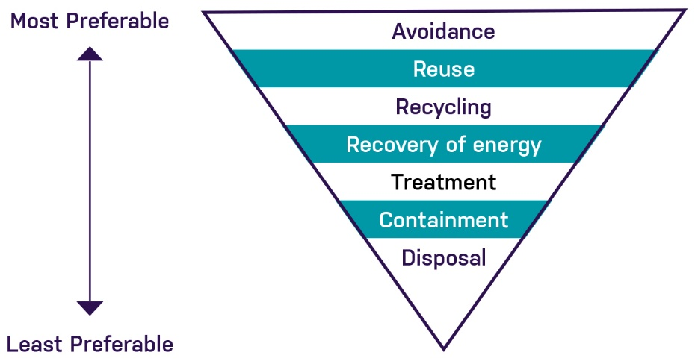
Figure 23-8 EPA Victoria waste hierarchy
The management of spoil is highly dependent upon the categories and volumes of spoil generated during the construction of the project. Management options and the assessed feasibility are summarised in Table 23-11.
Table 23-11 Summary of spoil management options for North East Link
Option | Description | Assessed feasibility
Avoidance | Avoidance of excess spoil generation, for example, by optimising the design. | Preferred and applied where possible however, it is limited for this project.
Reuse | Reuse of spoil at the site of origin is possible where it meets human health and environmental criteria. | Preferred and applied where possible.
Recovery of energy | The recovery of energy stored in waste materials through combustion | Unlikely to be practicable.
Treatment | A process to ensure waste has the least practicable impact on human health and the environment. | Preferred option, using offsite facility for Category A and Category B and WASS.
Containment | Measures taken to store waste at a specific location. | Unlikely to be practicable, however would be subject to further investigation at detailed design.
Disposal | Removal of waste from site of origin to landfill | Least preferred option, however offsite disposal would be required.

Conclusion
This chapter has identified and assessed existing conditions, potential impacts and associated risks to contamination and soil for North East Link.
Overall, the existing and historical land use within the study area is relatively benign from a contamination perspective. Past pastoral land uses have given way to urban development with minor commercial and industrial uses. Heavy industry is absent from the area around the project as are other sources of major contamination.
The impacts to human health, the environment and amenity were assessed to be low. Within the limitations of the investigations, the assessment indicated there was no broad-scale contamination within the study area and the greater majority of excavated spoil is likely to be classified as Fill Material.
Application of the project EPRs (described in full in Chapter 27 – Environmental management framework) would minimise impacts associated with contamination and soil such that associated impacts on human health or the environment are not anticipated. A Spoil Management Plan would be developed to manage storage, transport and disposal of spoil, and would include contingencies for possible remediation and management of residual contamination exposed or caused or exacerbated during the project’s construction and operation.
Based on the EES evaluation objective described at the beginning of this chapter, effects of the project on contamination and soil have been assessed and EPRs have been identified to minimise or avoid impacts to human health, the environment and amenity.

